Encryption Techniques and Wireless Power Transfer Schemes

Nur Hazwani Hussin¹, Azizan, M.M., Ali, A., Albreem, M. A. M.
Centre of Excellence for Renewable Energy (CERE), School of Electrical System Engineering, Universiti Malaysia Perlis.
¹Corresponding author, e-mail: nurhazwanihussin@yahoo.com

Abstract
Wireless power transfer (WPT) is one of the most useful ways to transfer power. Based on power transfer distances, the WPT system can be divided into three categories, namely, near, medium, and far fields. Inductive coupling and capacitive coupling contactless techniques are used in the near-field WPT. Magnetic resonant coupling technique is used in the medium-field WPT. Electromagnetic radiation is used in the far-field WPT. This paper reviews the techniques used in WPT. In addition, energy encryption plays a major role in ensuring that power is transferred to the true receiver. Therefore, this paper reviews the energy encryption techniques in WPT. A comparison between different techniques shows that the distance, efficiency, and number of receivers are the main factors in selecting the suitable energy encryption technique.

Keywords: Capacitive Coupling; Energy Encryption; Inductive Coupling; Magnetic Resonant Coupling; Wireless Power Transfer.

Copyright © 2016 Institute of Advanced Engineering and Science. All rights reserved.

1. Introduction
Wireless power transfer (WPT) technologies can be categorized into inductive coupling, capacitive coupling, magnetic resonance, and electromagnetic radiation [1]. WPT requires different optimization criteria for two uses, namely, continuous power delivery and periodic charging. However, for continuous charging of vehicles, whether under the stationary or moving states, wireless communication should be fast, reliable, and energy efficient [2]. The WPT system is increasingly attracting attention in various fields, such as charging portable electronic devices, implanting medical devices, using integrated circuits, and energizing solar power satellites [3]. WPT is suitable for electric vehicles (EVs), such as battery charging for normal vehicular operation and energy exchange [4-5]. The concept of WPT is a growing plug-in feature in the EV market [6].
Encryption in wireless communication channels is more vital and necessary in the present than in the past. Data have to be well encrypted during transmission of data securely over the wireless medium. Energy is expected to transfer to specific receptors and switch off other unauthorized energy transmission channels. Thus, the security of energy transmission is an important issue [7]. In [8], the frequency characteristics of resonance were investigated. When the frequency of the source of the transmitter equals the resonant frequency of the entire system, the load will achieve maximum energy. However, the transmitted power of load power constraints actions to minimize load power by using the charging control algorithm for optimizing the receiver loads resistance. In addition, chaos theory technique of encryption is applied in WPT for security performance. This review examines the techniques used in different methods of WPT and the energy encryption techniques used in WPT systems [9]. Finally, this paper explores the advantages and disadvantages of the inductive and capacitive coupling, magnetic resonant coupling and electromagnetic radiation techniques in the WPT system. Recommendations on future research are also listed.

2. Techniques for Energy Encryption and WPT System
This section presents the energy encryption techniques and concepts in the near-field, medium-field, and far-field WPT systems.

2.1. Techniques of WPT
WPT techniques are divided into three which is near field, medium field and far field. Each technique will be discussed in detail in the subsequent sections.

2.1.1. Near-Field WPT
Near-field WPT consists of inductive coupling and capacitive coupling.

2.1.1.1. Inductive Coupling
Inductive coupling uses magnetic field induction theory as transmission technique [10]. For the WPT system utilizing the inductive coupling technique, the rotating magnet is applied to transfer power. However, the inductive coupling technique has a limit for power transfer of up to 275 mW over the 1 cm distance [11]. Then, the technique will delivered 678 mW wirelessly over the 1 cm distance [10]. The electrodynamics induction wireless transmission technique for the near field is non-radiative. In the electrodynamics induction technique, two copper coils are set up, in which the primary coil is at the transmitter and the secondary coil is at the receiver. The primary coil is attached to the power source and the receiver coil is attached to the load. For high efficiency, the two wires increased by winding into coils and placing closer together on a common axis, such that the magnetic field of one coil passes through the other coil [11]. Figure 1 shows the flow of the inductive coupling process. In this technique, universal wireless charging pads for portable electronic devices, such as cellphones, are suitable [10-11].

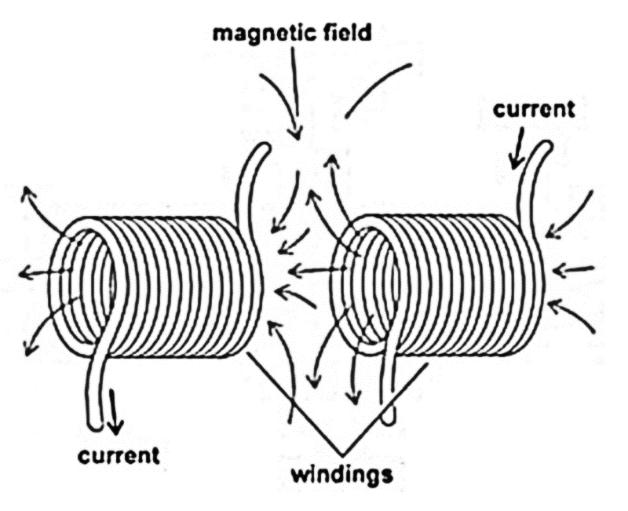
Figure 1. Inductive Coupling Process [10-11]

Figure 1 shows the circuit model of the inductive coupling technique for WPT. In this circuit, the parameters used for $LC$ resonance frequencies of all coils are the same as [12]
$f_{o}= \frac{1}{\sqrt{LC}}$ (1)

where $L$ is inductance and $C$ is the capacitance.

2.1.1.2. Capacitive Coupling
The capacitive power transfer technique have been conducted because of the small power density compared with other methods [13]. The advantages of the capacitive coupling technique include the simple structure of couplings, light weight, low cost, position flexibility, and high frequency. This technique could use LC resonance to enhance power transfer. However, the disadvantage of capacitive coupling system is the small power density of the small coupling capacitance [13]. Figure 2 shows the circuit for capacitive coupling of WPT as well as the process of WPT in capacitive coupling technique [13].
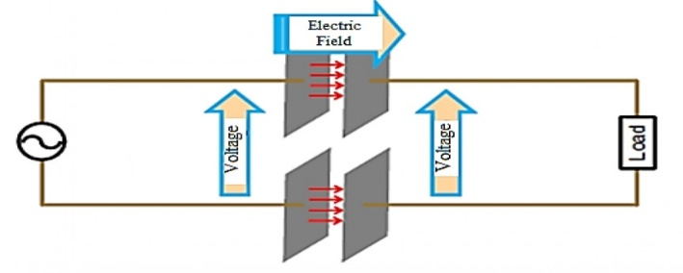
Figure 2. Capacitive Coupling of Wireless Power Transfer [13]

The capacitive coupling technique utilizes several methods, such as using a higher voltage source and a higher frequency and decreasing the impedance of coupling.

2.1.2. Medium-Field WPT
The technique used for the medium-field WPT is magnetic resonant coupling, which is based on wireless transfer of energy to multiple small receivers and power over long transmission distances [14]. Thus, magnetic resonant coupling in WPT does not emit radiation [14]. Therefore, the magnetic resonant coupling method of WPT has several advantages which is can transfer power in long transmission distance and it’s no radiation. However, during the process of WPT, adjusting the resonant frequency for multiple receivers in magnetic resonant coupling is difficult, which is one of the weaknesses of this method [14]. Figure 3 shows the circuit design for magnetic resonant coupling of WPT. This circuit shows how the magnetic resonant coupling of WPT works to transfer power from the transmitter to the receiver. The circuit is divided in three parts, namely, power supply, transmission channel, and load. In the power supply, DC power goes through the DC/AC inverter [15]. The DC/AC inverter transforms DC power to AC power supply. Then, the input voltage will supply the primary unit, which is composed of the resistance, capacitor, and inductance. All these variables together are known as impedance. Impedance is calculated, as shown in Equations (3), (4), and (5), for each part of the circuit [15].
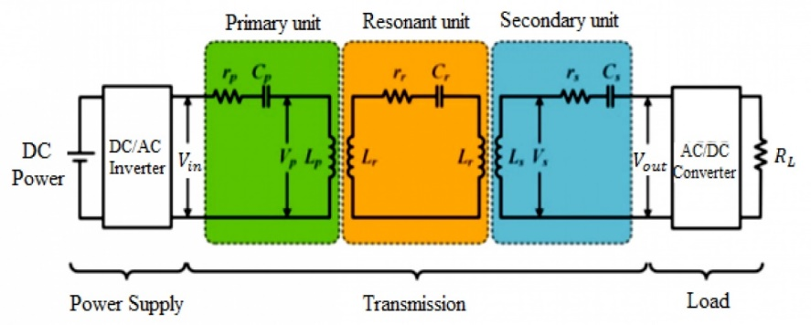
Figure 3. The Circuit Design for Magnetic Resonant Coupling of Wireless Power Transfer [15]

${ Z}_{p} = jωL_{p}+ \frac{1}{jωC_{p}} I_{p} + r_{p}$ (3)
$Z_{r} = jωL_{r}+ \frac{1}{jωC_{r}} I_{r} + r_{r}$ (4)
${ Z}_{s} = jωL_{s}+ \frac{1}{jωC_{s}} I_{s} + r_{s}$ (5)
Therefore, from Equations 3-5, determine the impedance in the primary, resonant, and secondary units, respectively. In the equation 3-5, $ω$ indicates the switching frequency. The current is maintained at a constant value in that circuit. The same equation is used for the resonant and secondary parts to derive the value of impedance [15]. Sequentially, the resistance in the circuit acts to reduce the current flow and to lower the voltage level. The capacitor can store electric energy when it is connected to its circuit. Inductance work is observed in the electric circuit in which a change in current flows through it and induces an electromotive force in the conductor. Thus, impedance is the effective resistance of an electric circuit to AC arising from the combined effects of resistance and reactance [16]. Furthermore, each of the primary, resonant, and secondary units yields a certain voltage. The output voltage at the secondary unit can go through the load. At the load, the AC/DC converter changes the AC voltage in the circuit to the DC voltage for transferring power from the transmitter to the receivers. The process is known as a rectifier. However, the resonant unit is one medium that transmits the power to the receiver. At a particular resonant frequency of the electric circuit, parts of the impedance of the circuit element cancel each other. Moreover, the resonant circuit can generate higher voltages and currents, which makes the circuit suitable for use in wireless transmission in the transmitter and receptor [17].

2.1.3. Far-Field WPT
Far-field WPT is a system with long-range power transfer, such as for low-power sensors, networks, and space applications [18]. In general, far field has the advantage of using a low-frequency antenna, where simple pattern measurement is required [18]. In addition, far-field powering has several practical advantages over inductive powering, which is the accurate alignment of primary and secondary coils for efficient operation. The far-field system is an alternative wireless powering scheme for the receive power capabilities of implantable devices [19]. Moreover, the far-field system must be aimed at the receiver to transmit power. In long distances or in the far-field system, electromagnetic radiation is used to transmit power. The exposure to radiation of people and other living things is a disadvantage of the far-field system [20-21]. Moreover, the efficiency and performance of the far-field system are the most important issues in obtaining a higher transmitting antenna array [22]. Improving the transfer efficiency decreases the risks of human exposure to electromagnetic fields, thus leading to better performance of the far-field system. By contrast, the efficiency of the near-field system depends on the coupling coefficient. Then, the larger the value of the coupling coefficient, the stronger the ability of the system to carry energy [22]. In addition, the natural systems of the frequency and quality factor are improved. Reducing the system inherent loss rate is a way to improve the power transfer efficiency [22]. Furthermore, the efficiency and performance of the far-field system depend on the antenna array [23].

2.1.4. Comparisons
Table 1 shows a comparison between the fields in terms of efficiency, performance and characteristics of distance, frequency and number of turns. Table 1 shows that, the energy efficiency of wireless power transfer in near field is high compared to medium and far fields. The performance of power transfer is high for the near and medium fields compared to the far field. Last, the characteristics of distance, frequency and number of turn is more complex to transfer power in far fields system.

Table 1. Comparison between near, medium and far fields of WPT
Aspect | The Near Field | The Medium Field | The Far Field
The Energy Efficiency | High [10] | High [15] | Low [21]
The Performance of power transfer | High [11] | High [16] | Low [22]
The Characteristic of distance, frequency and number of turn | Easier to transfer power [13] | Easy to transfer power [17] | More complex to transfer power [22]

Table 2 lists the advantages and disadvantages for each technique. In inductive and capacitive coupling techniques, the system of WPT is simple safe with a short transmission distance. Thus, the applications of inductive coupling is implement for battery charging and electric tooth brush, while for capacitive applications is charging portable devices. In magnetic resonant coupling technique, the WPT system is long transmission distance and no radiation. However, in this technique the disadvantages is difficulties to adjust the resonant frequency. The applications of magnetic resonant coupling is car charging. In electromagnetic radiation technique, the WPT system is very high transmission percent over long distance but the radiation need line of sight. The applications of this technique is implements in biomedical [23].

Table 2. Advantages and disadvantages of wireless power transfer techniques
The Wireless Power Transfer Technology | Advantages | Disadvantages | Applications
The Inductive Coupling | Simple safe, high efficiency in short range [10] | Short transmission distance [11], need accurate alignment [11] | Electric tooth brush and razor battery charging, induction stovetops and industrial heaters [11]
The Capacitive Coupling | Simple structure of couplings, lightweight, low cost, position flexibility and high frequency [12] | Small power density of the small coupling capacitance [12] | Charging portable devices, power routing in large scale integrated circuits, Smartcards [12]
The Magnetic Resonant Coupling | Long transmission distance, no radiation [15] | Difficult to adjust resonance frequency for multiple devices [15] | Cars charging [17]
The Electromagnetic  Radiation | Very high transmission percent over long distance [21] | Radiation need line of sight [21] | Implement in biomedical [23]

2.2. Encryption Technique for WPT
This section discusses the encryption techniques of the WPT system. Previous research presented several techniques, such as chaos theory, password security system, and RF signal, applied in the WPT system. Each technique will be discussed in detail in the subsequent sections.

2.2.1. Chaos Theory
Chaos theory is used to encrypt the transfer energy of magnetic, inductive, and electromagnetic resonant coupling based on WPT [9]. During the process of chaos for the security key, mathematics is used to generate discrete-time chaotic values. The power factor of transfer energy should be maintained at the maximum value to achieve maximum power at the load [9]. Thus, reactive power will be reduced in the transmission power. Thus, the resonant frequency will remove the irrelevant reactive power at the primary circuit [9]. Moreover, capacitor arrays are used to improve security performance. Therefore, maximum power transfer energy can be utilized, where the resonant, primary, and secondary units have resonant frequency. On the other hand, the encrypted switching frequency can be obtained as

$ω=δ_{i}ω_{o}$ (7)
where $δ_{i}$ is the chaotic security and can be expressed as

$δi = a + (b - a)ξi , 0 < a < b$ (8)

Switching frequency can be controlled to change the range array $\left(b-a\right)ω_{o}$ chaotically [9]. According to the power level and transmission distance, the regulating range can be generally selected. So that, to maximize the transfer power, the chaotic security key, primary, resonant and secondary capacitors can be regulated which is expressed as
$Cp = \frac{1}{δ_{i ²}} . \frac{1}{ω_{0}²L_{p}}$ (9) $Cr = \frac{1}{δ_{i ²}} . \frac{1}{ω_{0}²L_{r}}$ (10)
$Cs = \frac{1}{δ_{i ²}} . \frac{1}{ω_{0}²L_{s}}$ (11)

The chaotic sequence is utilized as the security key to encrypt transfer energy. The logistic map is utilized to generate the 1-D discrete-time chaotic series as given by [9]

$ξi+1 = Aξi(1 - ξi), A ∈ [0, 4]$ (12)

where $ξi$ denotes the sequence and A denotes the bifurcation parameter. The phase portraits of $ξi$ and $ξi+1$ exhibit various topological structures along with the increase in A. Moreover, $ξi$ acts as a constant value for $A∈[0, 1)$, a period 1 oscillation for $A∈[1, 3)$, a period n oscillation for $A∈[3, 3.57)$, and a chaotic oscillation for $A∈[3.57, 4]$. In addition, the largest Lyapunov exponent diagram as a mathematical expression of the chaotic behavior. Thus, the largest Lyapunov exponent becomes positive when$A>3.57$ it is because of in chaotic oscillation period and at same time the chaotic behavior occurs if $A=3.9$ [24]. Therefore, $A=3.9$ is selected to generate the random bounded security key $ξi∈(0, 1)$ for the energy encryption scheme [24].

2.2.2. Password System
The password security WPT system is the integration into wireless electrical power design in which a separate power design from source to load is controlled by a password controller. In [25], the design developed a password security system by using the Arduino Deumilanove microcontroller that was based on an authentication technique to control the wireless power system. However, the frequency generator used to construct the password protection system and to generate the high-frequency signal resonator was specific at the 130 kHz frequency. This process achieved successful power transfer from the transmitter to the receiver for the activation load. The controller only allows the authorized user with password to activate the wireless power system for the constructed password protection system. The transfer process in high frequency is at megahertz, and the maximum power transfer between source and load of wireless power system can be developed using the resonance inductive coupling WPT technique [25]. For the resonant frequency, the impedance is oscillated between input and output. Equation (7) shows the resonant frequency.

${ f}_{r = \frac{1}{2π \sqrt{LC}}}$ (13)

Figure 4 shows the password block diagram of the security wireless power system. The frequency generator circuit uses IC and LM555 to generate high-frequency oscillation at 130 kHz. The DC to AC inverter circuit is used to convert the timer DC output to AC output oscillating at 130 kHz. According to the design of the password security wireless power system, four pins act as external triggers with input signals from the password controller.
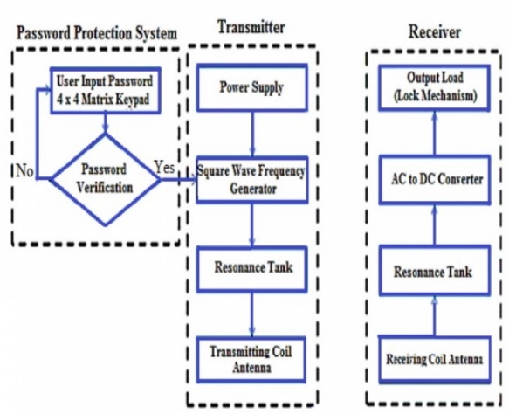
Figure 4. Password Security Wireless Power System Block Diagram [25]

Moreover, the efficiency at the output for no load of the WPT system is 60% and for load is 36% [25]. The maximum output at the coil intersection for the range between 5 cm and 6 cm diameter. The coil escalates to a corner, and the intersection area decreases.

2.2.3. Radio Frequency Signal
In [26], the concepts of security centers on the transmitted power signal to be received by a receiver in wireless power transmission system. By using the RF signal, the concept of the encryption–decryption algorithm is introduced to achieve the security of power transfer. For improving efficiency, a low switching frequency is used to drive the gate of the MOSFET.
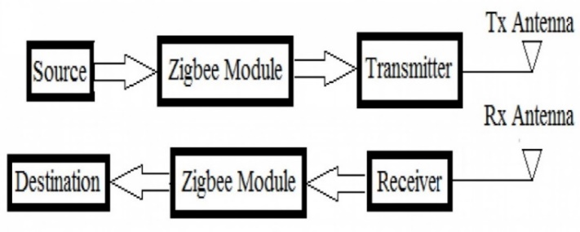
Figure 5. Block Diagram of Wireless power Transceiver [26]

Figure 5 shows the block diagram of the wireless power transceiver. The process of the block diagram is where the signal flows without any interruption to the transmitter input. The RESET switch resets the programming codes in the PIC microcontroller. The signal given to the PIC microcontroller PIC16F877A with 40 pins and 5 input–output pins and 15 interruptions and stability will be maintained with crystal oscillator circuit. The signal is controlled by the PIC microcontroller. This signal is transferred to the RF module through MAX 232. MOSFET switches are connected to each other and the current will pass through by switching between ON and OFF states. The passcode can be generated in MAX 232 and sent through the RF transmitter. The receiver process is the reverse of the transmitter process. From this technique, the result of power transferred from the transmitter to the receiver is maximum at the closest position with distances of 3, 2, 1, and 0.5 feet, which are increased, and the power received in the receiver is reduced. Thus, the receiver has matched the passcode to receive the power signal successfully [26].

3. Conclusion
WPT is among the most commonly used technologies of this century. Thus, WPT must employ security measures to protect the system from unknown receptors or receivers. This review examined the various techniques for energy encryption of the WPT system by focusing on medium-field or medium-range WPT. Clearly, many methods of magnetic resonant techniques have been proposed to reduce complexity, but at same time perform IM methods well. Resonant frequency and free positioning methods have low complexity and performance disadvantages. The most useful method is the strongly coupled resonance method because of its advantage in complexity and performance on the magnetic resonant coupling technique. This review presented encryption techniques for WPT, but the discussion was limited to chaos theory. As an encryption technique for WPT, chaos theory is complex, but exhibits good performance.

4. Acknowledgements
This study was supported by Universiti Malaysia Perlis (UniMAP) and the Ministry of Higher Education (MoH) under a Grant Number UniMAP/ RMIC/ FRGS/ 9003-00-00562.

References
- X. Mou and H. Sun, “Wireless power transfer: Survey and roadmap,” IEEE Vehicular Technolology Conference, vol. 2015, pp. 1–13, 2015.
- J. Hirai, K. Tae-Woong, and A. Kawamura, “Wireless transmission of power and information and information for cableless linear motor drive,” IEEE Transactions on Power Electronic, vol. 15, pp. 21–27, 2000.
- O. H. Stielau and G. a Covic, “Design of loosely coupled inductive power transfer systems,” International Conference on Power System Technology Proceedings, vol. 1, pp. 85–90, 2000.
- W. Chwei-Sen, O. H. Stielau, and G. A. Covic, “Design considerations for a contactless electric vehicle battery charger,” IEEE Transaction on Industrial Electronics, vol. 52, pp. 1308–1314, 2005.
- A. Woojin, J. Sungkwan, L. Wonkyum, K. Sangsik, P. Junseok, S. Jaegue, K. Hongseok, and K. Kyoungchoul, “Design of coupled resonators for wireless power transfer to mobile devices using magnetic field shaping,” IEEE International Symposium on Electromagnatic Compatibility, pp. 772–776, 2012.
- Agbinya, Johnson I., "Wireless power transfer," River Publishers, vol. 45, 2015.
- R. A. Bercich, D. R. Duffy, and P. P. Irazoqui, “Far-field RF powering of implantable devices: Safety considerations,” IEEE Transactions on Biomedical Engineering, vol. 60, pp. 2107–2112, 2013.
- S. Bhuyan, K. Sivanand, S. K. Panda, R. Kumar, and H. Junhui, “Resonance-Based Wireless Energizing of Piezoelectric Components,” IEEE Magnetics Letters, vol. 2, pp. 6000204, 2011.
- V. Cirimele, S. G. Rosu, P. Guglielmi, and F. Freschi, “Performance evaluation of wireless power transfer systems for electric vehicles using the opposition method,” IEEE 1st International Forum on Research and Technologies for Society and Industry Leveraging a better tomorrow, pp. 546-550, 2015.
- M. K. Juniotja and P. Kumar, “A Study on Contactless Energy Transfer,” International Conference of Advance Research and Innovation, pp. 557–561, 2014.
- S. A. Khidri, A. A. Malik, and S. H. Memon, “WiTricity : A Wireless Energy Solution Available at Anytime and Anywhere,” vol. 2, pp. 26–34, 2014.
- J. Kim and F. Bien, “Electric field coupling technique of wireless power transfer for electric vehicles,” IEEE 2013 Tencon - Spring, TENCONSpring 2013 - Conference Proceedings, vol. 1, pp. 267–271, 2013.
- H. Funato, H. Kobayashi, and T. Kitabayashi, “Analysis of transfer power of capacitive power transfer system,” Proceedings of the International Conference on Power Electronics and Drive Systems, pp. 1015–1020, 2013.
- T. C. B. T. C. Beh, T. Imura, M. Kato, and Y. Hori, “Basic study of improving efficiency of wireless power transfer via magnetic resonance coupling based on impedance matching,” IEEE International Symposium on Industrial Electronics, pp. 2011–2016, 2010.
- T. Imura, H. Okabe, and Y. Hori, “Basic experimental study on helical antennas of wireless power transfer for electric vehicles by using magnetic resonant couplings,” 5th IEEE Vehicles Power and Propulsion Conference, pp. 936–940, 2009.
- Z. Wang, X. Wei, and H. Dai, “Principle elaboration and system structure validation of wireless power transfer via strongly coupled magnetic resonances,” 9th IEEE Vehicle Power and Propulsion Conference, pp. 261–266, 2013.
- S. Das Barman, A. W. Reza, N. Kumar, M. E. Karim, and A. B. Munir, “Wireless powering by magnetic resonant coupling: Recent trends in wireless power transfer system and its applications,” Renewable and Sustainable Energy Reviews, vol. 51, pp. 1525–1552, 2015.
- E. Falkenstein, D. Costinett, R. Zane, and Z. Popovic, “Far-field RF-powered variable duty cycle wireless sensor platform,” IEEE Transactions on Circuits Systems II Express Briefs, vol. 58, pp. 822–826, 2011.
- H. Visser, “Far-Field RF Energy Transport,” IEEE Radio and Wireless Symposium, 2013, pp. 34–36, 2013.
- S. S. Valtchev, E. N. Baikova, and L. R. Jorge, “Electromagnetic field as the wireless transporter of energy,” Facta Universitatis - Series Electronics and Energetics, vol. 25, pp. 171–181, 2012.
- A. A. Thorat and S. S. Katariya, “Solar Power Satellite,” IOSR Journal of Electronics and Communication Engineering, vol. 5, pp. 59–64, 2013.
- T. Linlin, H. Xueliang, L. Hui, and H. Hui, “Study of Wireless Power Transfer System Through Strongly Coupled Resonances,” International Conference on Electrical and Control Engineering, pp. 4275–4278, 2010.
- M. Xia and S. Assa, “On the Efficiency of Far-Field Wireless Power Transfer,” IEEE Transactions on Signal Processing, vol. 63, pp. 2835–2847, 2015.
- K. T. Chau and Z. Wang, "Chaos in Electric Drive System," John Wiley Publishers, 2001.
- K. O. K. H. O. E. Keat, “Wireless Power Transfer for Small Scale Application,” IEEE Conference Paper Scored, vol. 2009, pp. 16–17, 2013.
- B. R. Randy and R. A. Kumar, “Secured Wireless Power Transmission Using Radio Frequency,” International Journal of Information Sciences and Techniques, vol. 4, pp. 115–122, 2014.

