**Behavioral Tracking in E-Learning by Using Learning Styles Approach**

**Amira Fatiha Baharudin, Noor Azida Sahabudin*, Adzhar Kamaludin**

Faculty of Computer Systems & Software Engineering, Universiti Malaysia Pahang,

26300 Gambang, Pahang, Malaysia

*Corresponding author, e-mail: azida@ump.edu.my

***Abstract***

*Currently, e-learning is becoming an option as it can save the cost of education, time, and more flexible in its implementation. The main problem that arises is how to create e-learning content that is interesting and really fit the needs of the users. One way that can be done to optimize the content of e-learning is to analyze the user behavior. This study aims to analyze user (student) behavior in KALAM UMP, based on logs report (activity history), which is often called as behavioral tracking. First, the learning style of the students is determined based on Honey and Mumford Learning Styles Model by using Learning Styles Questionnaire. The analysis is done using SPSS 16.0 for Windows. The results shows that student with Reflector and Theorist learning styles access e-learning materials the most. From Spearman Correlation analysis, the relationship between learning styles and students’ behavior in e-learning is found to be very weak (rs=.276, p=.000), but statistically significant (p<0.05). In other words, students’ learning styles and behavior in e-learning have significant impacts on the improvement or degradation of students’ performance. Therefore, from the results of this study, an adaptive KALAM e-learning system which can suits the learning styles of UMP students is proposed. In adaptive e-learning system, students can access learning materials that match the students' learning needs and preferences.*

***Keywords****: E-Learning, LMS, Learning Styles, Log Data, Correlation, Behavioral Tracking*

***Copyright*** © ***2016 Institute of Advanced Engineering and Science. All rights reserved.***

**1. Introduction**

Learning Management System (LMS) or often referred to as e-learning, is a web-based system of software applications, which is designed to manage learning content, student interaction, assessment tools, and feedback learning progress and student activitie [1]. LMS allows learning content to be obtained through online, which allows students to view and interact with the learning materials via a web browser using any operating system, computer and mobile device[2].

The use of learning analytics can assist users in ensuring every component of LMS courses can help them to achieve their goals and objectives[3]. When learning is supported by the LMS, then the log files of LMS offers an opportunity to understand the students and teachers activities[4].

Learning styles cannot be ignored because it is part of the process of interaction of teachers and students[5]. It has been argued that if a learner has a strong proclivity for a particular learning style, he or she may experience difficulties with learning material and learning environment that do not support the preferred learning style [6].

Individual difference factors have appeared as a main mediator in many models to predict behaviors of students in e-learning systems[7]. Most previous researches have indicated the typical factors are related to individual differences, including gender, age, experience and education, which significantly determined system implementation.

However, a limited number of studies have discussed the individual difference learning and teaching styles towards the adoption of e-learning in higher education sector especially in developing countries[7]. Teaching and learning styles are significant factors to affect students’ and teachers’ behavioral intention to use the e-learning systems[8].

As learning styles are related to the way that an individual prefers to learn, it is important that a good teacher recognizes the different learning styles of students in any class, and attempts to present information in ways which will meet individual learning needs[9]. Students from different learning environments tend to have different ideas about teachers, and their perceived teaching styles usually affect their learning behavior, particularly when using e-learning systems[8].

The main result expected from this user behavior analysis is to provide recommendations for the improvement and evaluation of e-learning content. The result of these recommendations can be implemented by institutions such as Universiti Malaysia Pahang (UMP), which uses e-learning in the learning activities.

This paper is organized as follows. In section 2, the learning styles based on Honey and Mumford model are reviewed. In section 3, the behavioral tracking in e-learning are presented. The data analysis and results are also presented in section 4. Finally, our work of this paper is summarized in the last section.

**2. Learning Styles**

Honey and Mumford defines learning styles as a description of the attitudes and behaviors that determine the likelihood of way of individual learning[10]. Every student who is studying in any school or university should have its own unique learning style[11]. Learning styles are independent in accordance with the individual's ability and it must satisfy the needs of the student until he or she reaches the desired level of understanding[12].

There are various models of learning styles that have been studied by the researchers since a long time ago, but in this study, we focused on Honey and Mumford model. Honey and Mumford developed their learning styles system as a variation on the Kolb Learning Cycle model as shown in Figure 1.



Figure 1. Honey and Mumford Variation on the Kolb System

Honey and Mumford assert that individuals can be classified based on their level of achievement in each stage of the learning cycle using the four classifications13. They also state that an individual changes his or her learning style with respect to the given task. Therefore, we conclude that learning styles are static but individuals tend to prefer one style over the others[13]. Characteristics of Honey and Mumford learning styles are illustrated in Table 1.

Table 1. Characteristics of Honey and Mumford learning styles [7]

|  |  |
| --- | --- |
| **Learning styles** | **Characteristics** |
| **Activists** | Involving themselves fully and without bias in new experiences, enjoys new challenges and solutions, enjoy here and now, have an open-minded approach to learning, enthusiastic about anything new, days are filled with activity |
| **Reflectors** | Careful, methodical, thoughtful, good at listening, stand back and ponder about experiences, collecting data and taking the time to work towards an appropriate conclusion |
| **Theorists** | Think in a logical manner, objectively and rationally, observe and make theories, they need models, concepts and facts in order to engage in the learning process. |
| **Pragmatists** | Keen on trying out new ideas, theories and techniques into practice, search for new idea and experimental, act quickly and confidently on ideas, go straight to the point. |

Honey and Mumford proposed the four types of learners react positively in learning environments to different stimuli and resources[9], as shown in Table 2.

Table 2. Learning Activities based on Learning Styles [9]

|  |  |  |  |
| --- | --- | --- | --- |
| **Learning Styles** | **Learning Activites** | | |
| **Activists react positively to** | Action learning  Business game simulations | Job rotation  Discussion in small groups | Role play  Training others  Outdoor activities |
| **Reflectors react positively to** | e-learning  learning reviews | Listening to lectures or presentations  Observing role plays | Reading  Self study/ self-directed learning |
| **Theorists react positively to** | Analytical reviewing  Exercises with a right answer | Listening to lectures  Self study/ self-directed learning | Solo exercises  Watching ‘talking head’ videos |
| **Pragmatists react positively to** | Action learning  Discussion about work problems in the organization | Discussion in small groups  Problem-solving workshops | Group work with tasks where learning is applied  Project work |

Of the four types, Reflectors and Theorists tend to do best in online environments, partly because an online environment might provide them more time to think about their tasks[14]. Activists and Pragmatists also have various characteristics that benefit from online instruction, but do well in face-to-face instruction as well. Table 3 presents e-learning activities for different learning styles[15].

Table 3. Honey and Mumford’s Learning Styles in E-Learning [15]

|  |  |  |
| --- | --- | --- |
| **Learning style** | **Needs in e-learning** | **Recommended e-learning activity** |
| **Activist** | Interaction between other students, free form exploration and observation, no strict schedules. | Group works, experimental problem-solving, real-time conversation. |
| **Reflector** | Organized studying methods, well outlined lectures, systematic instructions. | E-books, forum conversations. |
| **Theorist** | Traditional learning, clearly defined goals, well prepared exercises, tests measuring learning. | Assignments: case study or logical  cause-effect, problems and quizzes  during the course. |
| **Pragmatist** | Experimental possibilities. | Practical exercises, real-time  conversation. |

Based on Honey and Mumford learning style model, the learning materials for adaptive system are as shown in Table 4.

Table 4. Learning Materials based on Honey and Mumford Model

|  |  |
| --- | --- |
| Learning Style | Selected Learning Material |
| Activist | activity-oriented learning material with high interactivity level |
| Reflector | example-oriented learning material |
| Pragmatist | exercise-oriented learning material |
| Theorist | theory-oriented learning material |

**3. Behavioral Tracking in e-Learning**

Behavioral tracking is the tracking of user interaction (learning behavior) in e-learning. The parameter of the behavior description in this study is the total number of views of materials. The use of learning analytics can assist users in ensuring every component of LMS courses can help them to achieve their goals and objectives[3]. Logs Report is one of the learning analytics tool available in Moodle LMS, and thus, one method that can be used in learning analytics is log data analysis. When learning is supported by LMS, then the log data (tracks user interaction) of LMS offers an opportunity to understand the students and teachers activities4.

To determine the learning styles of the students, questionnaire had been distributed to the students by using Google Forms. The questionnaire was constructed based on Honey and Mumford Learning Styles Questionnaire (LSQ). It consists of four styles assessed by 80 items, 20 for each style. Each item requires the student to answer by YES or NO, and only YES will be calculated. A student is considered to be strong in a style if he or she gets 14 to 15 or more on the total items. As for the Activist style, a student will be strong in this style if he or she gets total of 10 YES or more. Distribution of items is according to four dimensions of Honey and Mumford learning styles[10], as shown in Table 5.

Table 5. Distribution of Items According to Honey and Mumford Learning Styles

|  |  |  |  |
| --- | --- | --- | --- |
| **No** | **Learning Styles** | **Total of Items** | **Item No.** |
| 1 | Activists | 20 | 2, 4, 6, 10, 17, 23, 24, 32, 34, 38, 40, 43, 45, 48, 58, 64, 71, 72, 74, 79 |
| 2 | Reflectors | 20 | 7, 13, 15, 16, 25, 28, 29, 31, 33, 36, 39, 41, 46, 52, 55, 60, 62, 66, 67, 76 |
| 3 | Theorists | 20 | 1, 3, 8, 12, 14, 18, 20, 22, 26, 30, 42, 47, 51, 57, 61, 63, 68, 75, 77, 78 |
| 4 | Pragmatists | 20 | 5, 9, 11, 19, 21, 27, 35, 37, 44, 49, 50, 53, 54, 56, 59, 65, 69, 70, 73, 80 |

The data from week 1 to week 7 of Semester II 2016/2017 is collected from FSKKP UMP students who take the Database System subject. The activities chosen are all materials from Week 1 to Week 7. The action chosen is View, since the students can only view the materials. Figure 2 shows the sample of data from logs report.

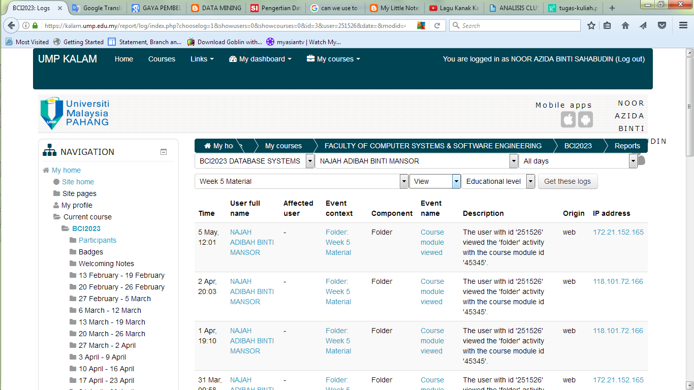

Figure 2. Sample of Data from Logs Report

The significant of the relationship in this study will be determined by calculating the correlation among the variables. Correlation is the most suitable method to determine the relationship between variables. The main purpose to use correlation analysis in this research is to understand whether the relationship is positive or negative and the strength of relationship.

Spearman’s Rho correlation measurement is one of the non-parametric statistics that is being employed in this study. The correlation between two variables is statistically significant if the significance value (Sig.) of the correlation is less than 0.05. Otherwise, the correlation between two variables is not statistically significant if the significance value (Sig.) derived from the correlation is greater than 0.05.

To gain a better understanding, the hypothesized model was created based on the proposed research hypotheses and observed variables. In this model, both independent and dependent variables are mapped according to the research objectives. Proposed hypothesized models to determine the association between learning styles and students’ behaviour in e- learning was created as shown in Figure 3.

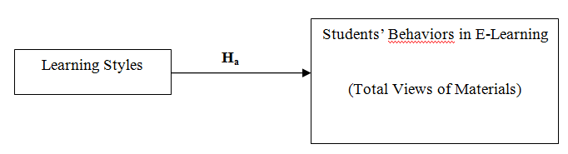

Figure 3. Proposed Hypothesized Models

Based on the hypothesis testing, the null hypothesis is rejected if the significance level is less than 0.05 (*p*<0.05) or else the null hypothesis is retained if the significance level is greater than 0.05 (*p*>0.05).

**4. Data Analysis and Results**

The study was conducted among undergraduates who enrolled in Database Subject from Faculty of Computer Systems & Software Engineering at University Malaysia Pahang. LSQ is distributed among the respondents by using the Google Form. However, from 242 responses, only 216 responses were valid for analysis. The rest were rejected due to incomplete answers and also incomplete data from logs.

Table 6 shows the distribution of the overall frequency and percentage for respondents’ learning style. The results of the analysis show that Reflector the highest value of percentage of 59.7%, followed by Theorists with 19.9%. Activist learning style is the third highest, where it recorded 17.1 %, and the least desirable learning style is Pragmatist with 3.2%.

Table 6. Learning Style Results

|  |  |  |
| --- | --- | --- |
| **LEARNING STYLE** | **FREQUENCY** | **PERCENTAGE (%)** |
| **Activist** | 37 | 17.1 |
| **Reflector** | 129 | 59.7 |
| **Theorist** | 43 | 19.9 |
| **Pragmatist** | 7 | 3.2 |

Based on the respondents’ gender, both male and female respondents have strong preferences in Reflector learning style as shown in Figure 4. However, from this result, we can see that most of the Computer Science students in UMP practiced the same learning style, which is Reflector.

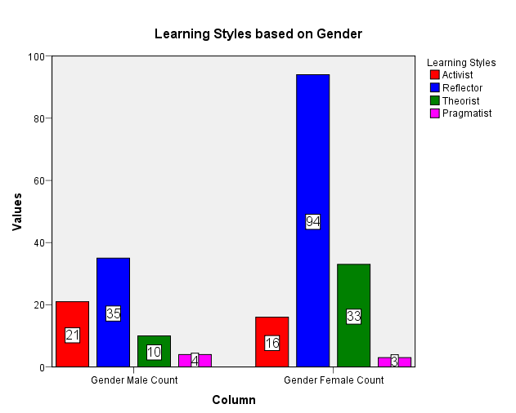

Figure 4. Learning Styles based on Gender

Figure 5 shows the frequencies of total views of materials for each student respective to their learning styles. From observations, students with Reflector and Theorist learning styles have higher number of views of materials compared to students with activist and pragmatist learning styles, since most of the high views are dominated by Reflector and Theorist only.

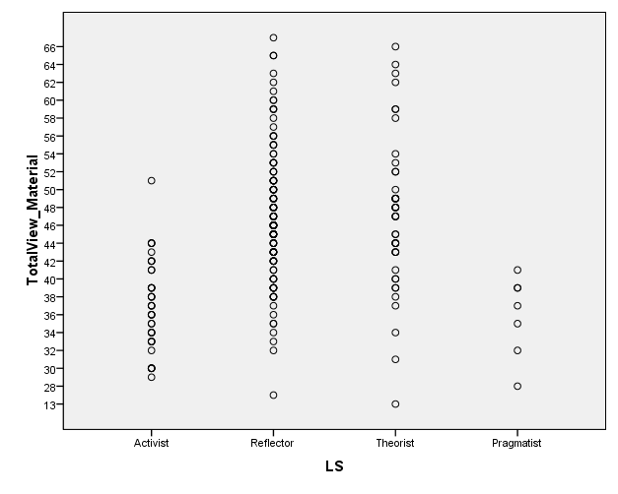

Figure 5. Total Views of Material for Each Student Respective to Their Learning Styles

This shows that student with Reflectors and Theorist learning styles access e-learning the most. The involvement of students in the e-learning system is closely related to the learning style, as this can attract students11. Students with Reflector and Theorist learning styles show good interest to e-learning system, while students with Activist and Pragmatist learning styles shows less interest in e-learning and tend to learn the traditional way. From at the findings of this study, it is proven by having Reflector type of learning style had the highest frequency in viewing the materials.

To select the suitable correlation analysis type, the normality test was performed at the first place involving the variables. As the result, the Shapiro-Wilk test found that the significant value (Sig.) is less than 0.05, which the data was not normally distributed (see Figure 6).

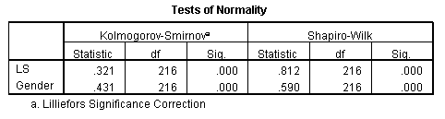

Figure 6. The Result of Shapiro-Wilk Test of Normality

About the normality test, it was found that learning styles and gender variables have deviated from the normal distributions. Therefore, it was decided to employ non-parametric statistical correlation measurement such as Spearman correlation to find the significant relationship between these variables.

As the result, the relationship between Learning Styles and Students’ Behavior in E-Learning is found to be very weak (*rs*=.276, p=.000), but statistically significant (*p*<0.05). The results of the correlation analysis are presented in Figure 7.

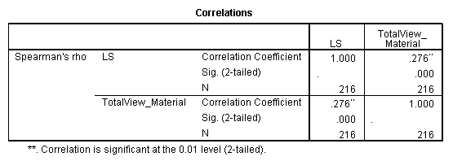

Figure 7. Correlation between Learning Styles and Students’ Behavior in E-Learning

Hypothesis testing is done based on the correlation analysis for the relationship between learning styles and students’ behaviors in e-learning. The result of the hypothesis testing is presented in Table 7.

Table 7. Hypothesis Testing Result

|  |  |  |
| --- | --- | --- |
|  | Research Hypothesis | Result |
| H0 | Student learning styles have no significant impact on student behavior in e-learning. | Rejected |
| Ha | Student learning styles have a significant impact on student behavior in e-learning. | Accepted |

The null hypothesis is rejected for the relationship between Learning Styles and Students’ Behavior in E-Learning, since the significance value of correlation was less than 0.05. In other words, Learning Styles have significant impacts on Students’ Behavior in E-Learning.

**5. Adaptive e-Learning System for UMP LMS (KALAM)**

An adaptive e-learning system which can suits the learning styles of the students is proposed. In adaptive e-learning system, students can access learning materials that match the students' learning needs and preferences16.

Basically, the system is an information system that has the function to provide recommendations for teaching materials, using the Honey and Mumford learning styles model. Students or users with their first time entering the system will be asked to fill out questionnaires and pre-test. The task of the teacher is to create a bank of questions and create learning materials.

After that, on system, the questionnaire is used to determine the learning style, and pre-test is used to determine the knowledge level. Learning styles and knowledge level including the learner model, used to build an adaptive e-learning system, which is a form of adaptive contents selection.

Pre-test is a test of the level of students' knowledge of the material to be delivered, which is conducted before the lesson given. The benefit of holding pre-test is to determine the ability of students about the lessons that will be delivered. Table 8 shows the learner attributes and learning object attributes.

Table 8. Learner Attributes and Learning Object Attributes

|  |  |  |  |
| --- | --- | --- | --- |
| **Learner Attributes** | | **Learning Object Attributes** | |
| **Learning Style** | **Knowledge Level** | **Learning Object Type** | **Learning Object Level** |
| 1.  Reflector | 1.  Apprentice | 1.  Graphic (image, charts, symbol) | 1.  Initial |
| 2.  Theorist | 2.  Beginner | 2.  Video (audio, animation) | 2.  Introductory |
| 3.  Pragmatist | 3.  Intermediate | 3.  Text (word, power point, excel) | 3.  Advance |
| 4.  Activist | 4.  Expert | 4.  XML (web, SCORM, LOM) | 4.  Professional |

Learning Object Attributes are the learning material that will be presented at the recommendation system of learning materials. Learning Object has two attributes, namely learning object type and learning object level. To determine the level of learning materials (Learning Object Level), we must first know the Knowledge Level of students17. From Table 8, there are 2 rules, which are MATCH and PARTIALLY MATCH.

1. **IF** *learner learning style = learning object type* **AND** *knowledge level = learning object level,* **THEN** it is “**MATCH**”.
2. **IF** (*learner learning style = learning object type* **AND** *knowledge level <> learning object level*)**OR** (*learner learning style <> learning object type* **AND** *knowledge level = learning object level*)*,* **THEN** it is “**PARTIALLY MATCH**”.

For example, if a student has “Reflector” learning style and “Beginner” knowledge level, recommended materials for the student is “Graphic” type with “Introductory” learning object level as shown in Figure 8. Besides that, other recommended materials which are PARTIALLY MATCH are “Video” type materials with “Introductory” level or “Graphic” type materials with “Initial” level as shown in Figure 9.

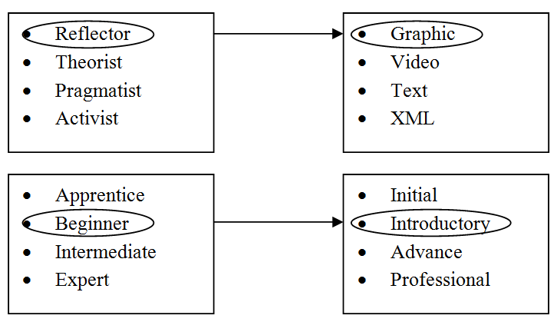

Figure 8. Recommended Learning Materials for MATCH rule

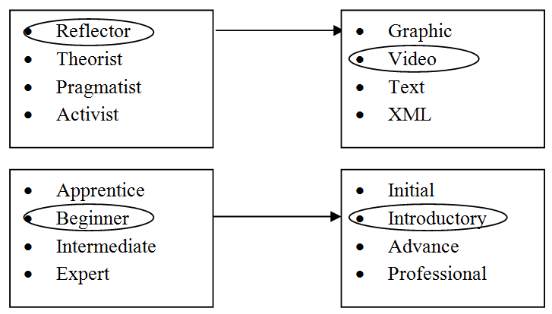

OR

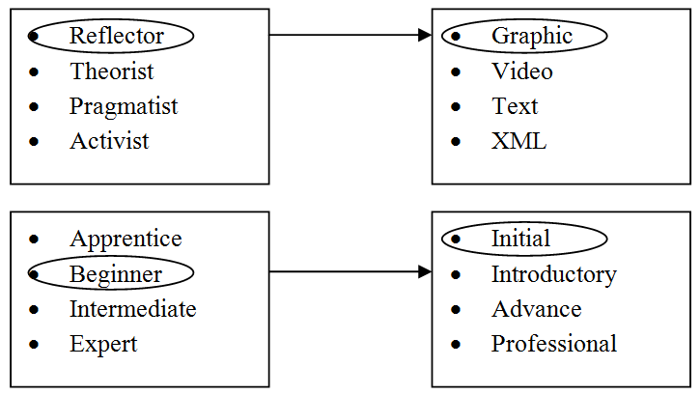

Figure 9. Recommended Learning Materials for PARTIALLY MATCH rule

The flow of this proposed adaptive KALAM e-learning is as shown in Figure 10.

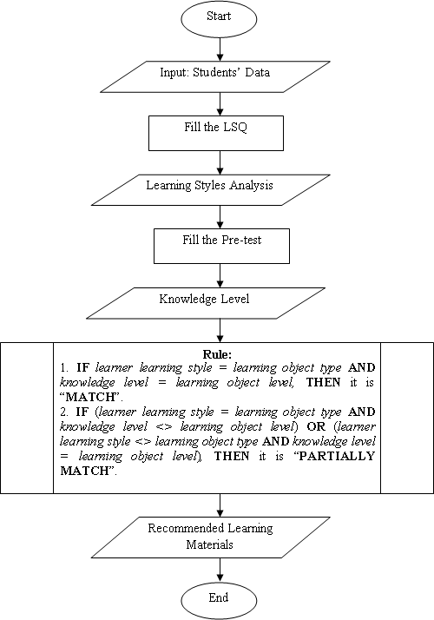

Figure 10. Proposed System Flow for Adaptive KALAM E-Learning

**5. Conclusion**

Based on the analysis, the study showed that most respondents prefer and have strength in terms of Reflector learning styles, followed by Theorists, Activists and Pragmatic. Students with Reflector and Theorist learning styles show good interest to e-learning system, while students with Activist and Pragmatist learning styles show less interest to e-learning system, and tend to learn the traditional way. Reflector broadly used e-learning in terms of viewing the materials uploaded by the lecturer.

However, few students are not engaged on e-learning for viewing the learning materials. The study found weak but significant relationship between learning styles on students’ behavior in e-learning. In other words, learning styles has influence on the increase or decrease of students’ behavior in e-learning. Therefore, from the results of this study, an adaptive KALAM e-learning system which can suits the learning styles of UMP students is proposed. In adaptive e-learning system, students can access learning materials that match the students' learning needs and preferences.

**References**

1. Srichanyachon, N. EFL Learners' Perceptions of Using LMS. TOJET: *The Turkish Online Journal of Educational Technology* 13(4) (2014).
2. Dahlstrom, E., Brooks, D.C. and Bichsel, J. The Current Ecosystem of Learning Management Systems in Higher Education: Student, Faculty, and IT Perspectives. *EDUCAUSE* (2014).
3. Oliveira, P.C.D., Cunha, C.J.C.D.A. and Nakayama, M.K. Learning Management Systems (LMS) and e-learning management: an integrative review and research agenda. *JISTEM-Journal of Information Systems and Technology Management*, 13(2)(2016) 157-180.
4. Bettoni, M., Sadiki, J., Mazzola, L. and Mazza, R. Didactical Interpretation of Log Data: The MOCLog Model. (2013)
5. Chong, O.S. and Mahamod, Z. Gaya Pembelajaran Pelajar Bahasa Melayu Berdasarkan Gaya Pembelajaran Grasha. *Journal of Applied Research in Education*, 18(2014) 52 – 66.
6. Alshammari, M., Anane, R. and Hendley, R.J. Adaptivity in e-learning systems. In Complex, Intelligent and Software Intensive Systems (CISIS), IEEE Eighth International Conference. (2014) 79-86.
7. Elkaseh, A., Wong, K.W. and Fung, C.C. The Impact of Teaching and Learning Styles on Behavioural Intention to Use E-learning in Libyan Higher Education. International Review of Contemporary Learning Research, 3(1)(2014) 25-34.
8. Lin, P.C., Lu, H.K. and Liu, C.H.I.A. Towards an education behavioral intention model for e-learning systems: An extension of UTAUT. *Journal of Theoretical and Applied Information Technology*, 47(3)(2013) 1120-1127.
9. Grimmer-Somers, K., Milanese, S. and Chipchase, L. Research into Best Practices in e-Learning for Allied Health clinical education and training. Brisbane: Clinical Education and Training Queensland. (2011).
10. Honey, P. & Mumford, A. The Manual of learning styles. Maidenhead: Peter Honey. (1992).
11. Manochehr, N.N. The influence of learning styles on learners in e-learning environments: An empirical study. Computers in Higher Education Economics Review, 18(1)(2006) 10-14.
12. Levy, H.M. Meeting the needs of all students through differentiated instruction: Helping every child reach and exceed standards. The Clearing House: *A Journal of Educational Strategies, Issues and Ideas,* 81(4)(2008) 161-164.
13. Aljaberi, N.M. University Students' Learning Styles and Their Ability to Solve Mathematical Problems*. International Journal of Business and Social Science,* 6(4)(2015).
14. Mestre, L. Accommodating diverse learning styles in an online environment. Reference & user services quarterty, 46(2)(2006), 27-32.
15. Kanninen, E. Learning styles and e-learning. Master of Science Thesis, Tampere University of Technology. (2008)
16. Shute, V. and Towle, B. Adaptive e-learning. *Educational psychologist,* 38(2)(2003) 105-114.
17. Yang, Y.J. and Wu, C. An attribute-based ant colony system for adaptive learning object recommendation. *Expert Systems with Applications*, 36(2)(2009) 3034-3047.