

Figure 1.Seven level cascaded inverter

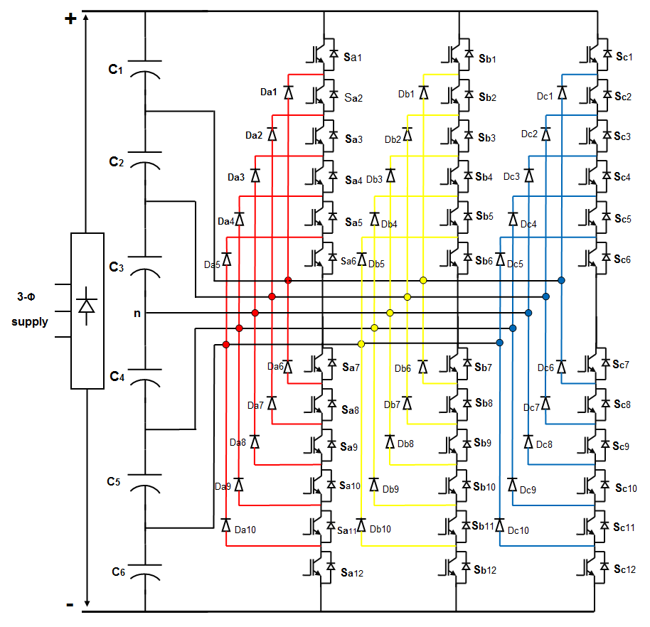

Figure 2.Seven level diode clamped inverter

Figure 4.Carrier based SVPWM

Figure 5. Linearization of the multilevel SVPWM in over modulation region

Figure 6. Linear and non linear characteristics of the multilevel SVPWM in modulation region

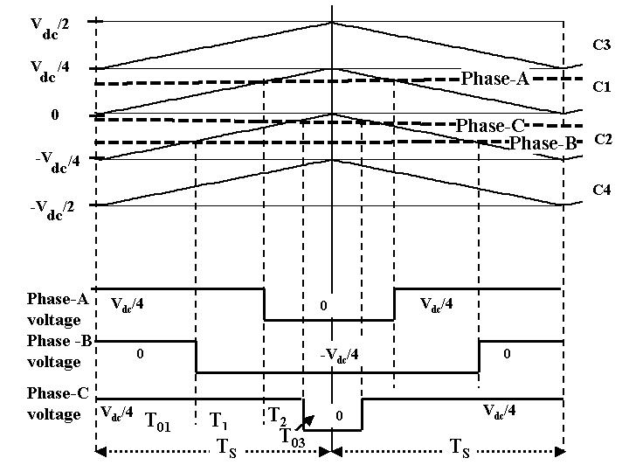

Figure 7. The inverter switching vectors and their switching time durations during sampling interval *TS* (Reference voltages are within the inner carrier region, M < 0.433)

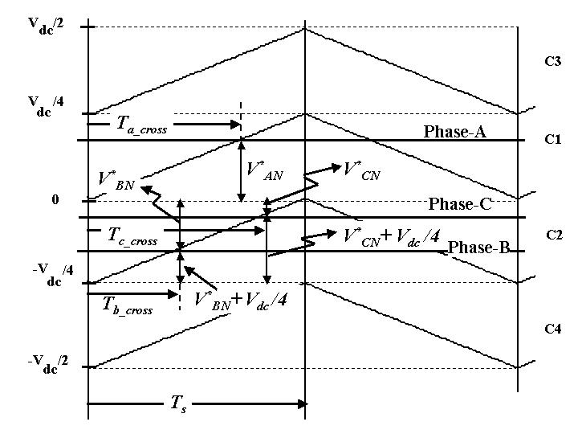

Figure 8. Determination of the *Ta_cross , Tb_cross* and *Tc_cross* during switching interval *TS* (When reference voltages are spanning the inner carrier region, M < 0.433)

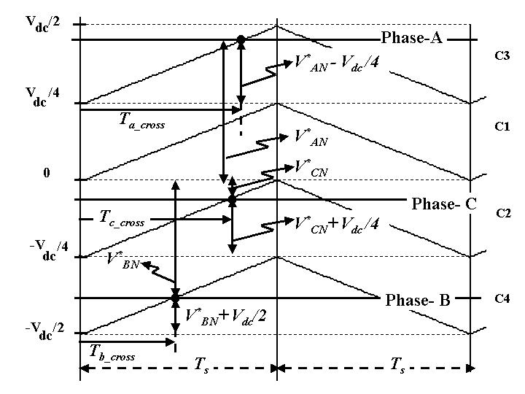

Figure 9. Determination of the *Ta_cross , Tb_cross* and *Tc_cross* during switching interval *TS* (When reference voltages are spanning the entire carrier region, 0.433<M < 0.866

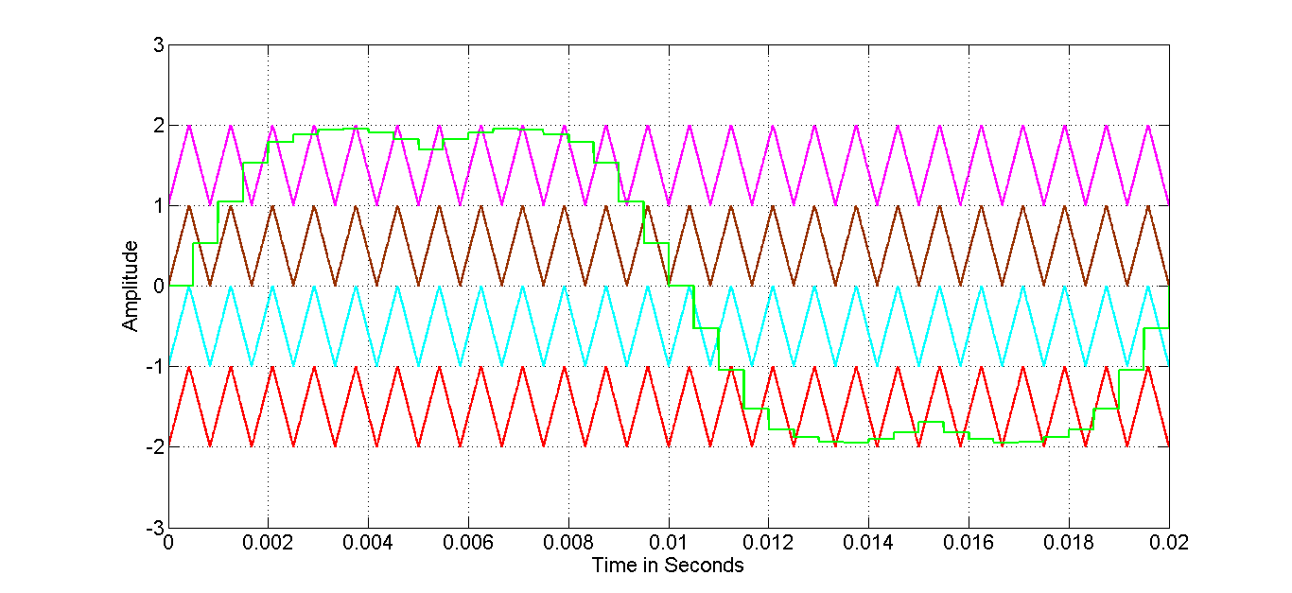

Figure 10. Down sampling based CSV PDPWM

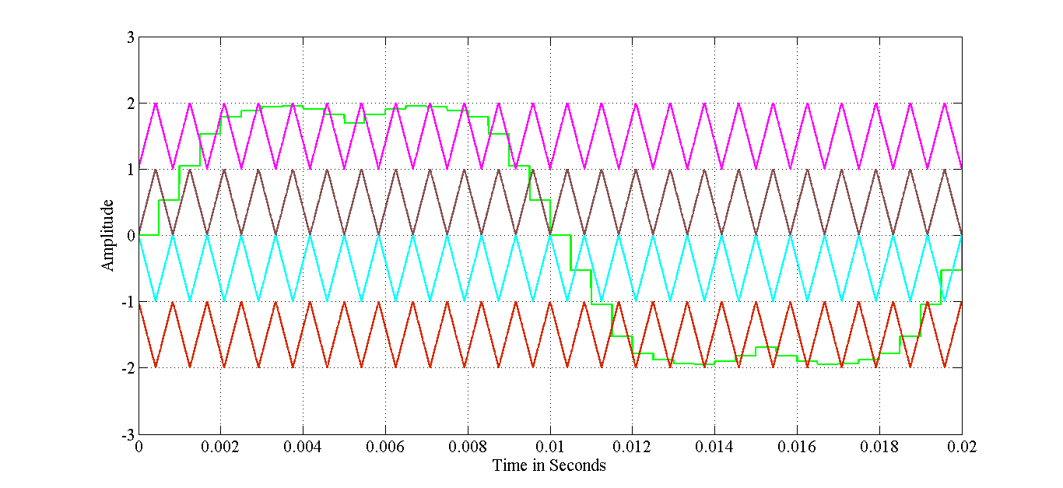

Figure 11. Down sampling based CSV PODPWM

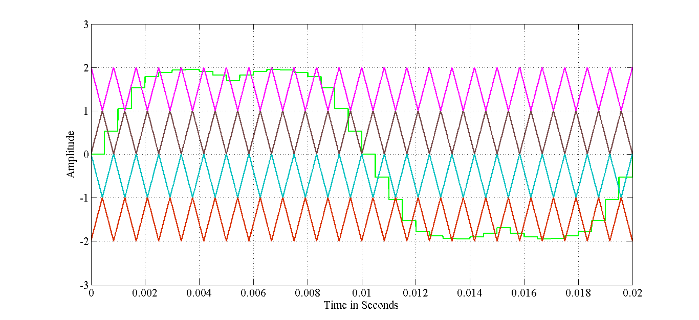

Figure 12. Down sampling based CSVAPODPWM

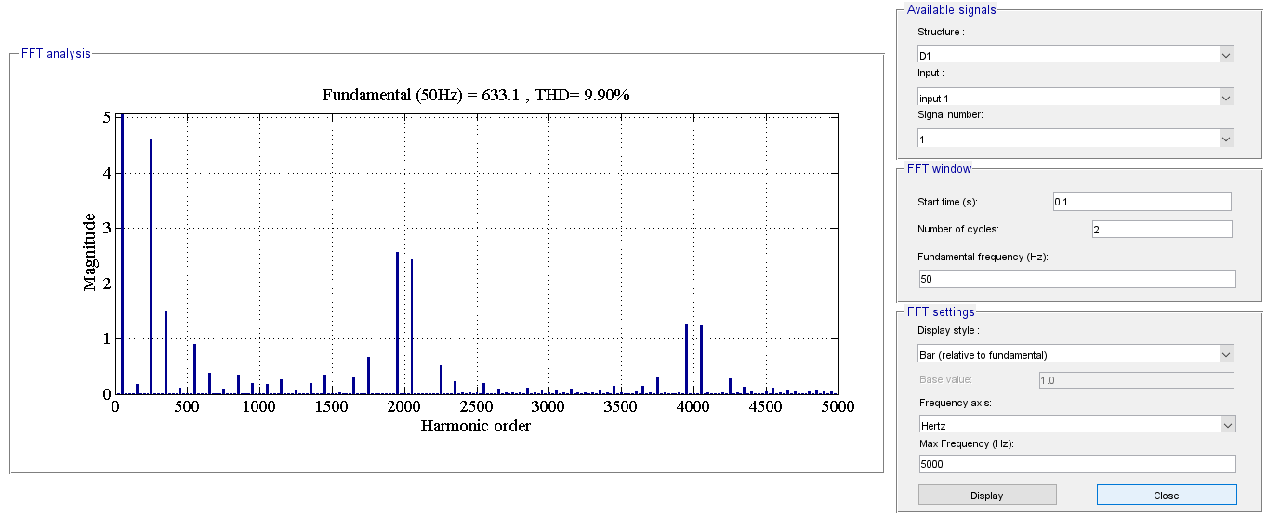

Figure 13.Seven level CHB CSV PDPWM

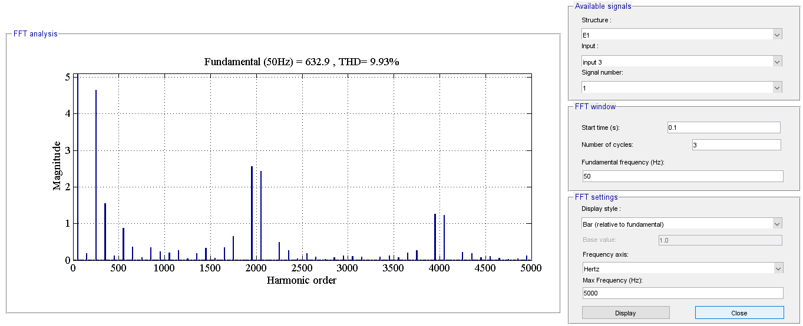

Figure 14.Sive level CHB CSV PODPWM

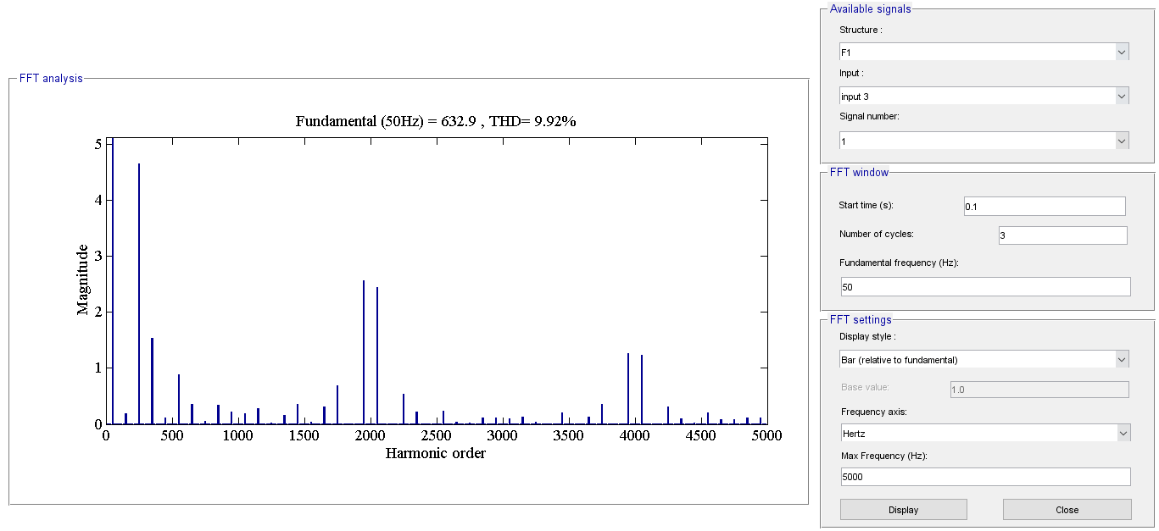

Figure 15.Seven level CHB CSV APODPWM

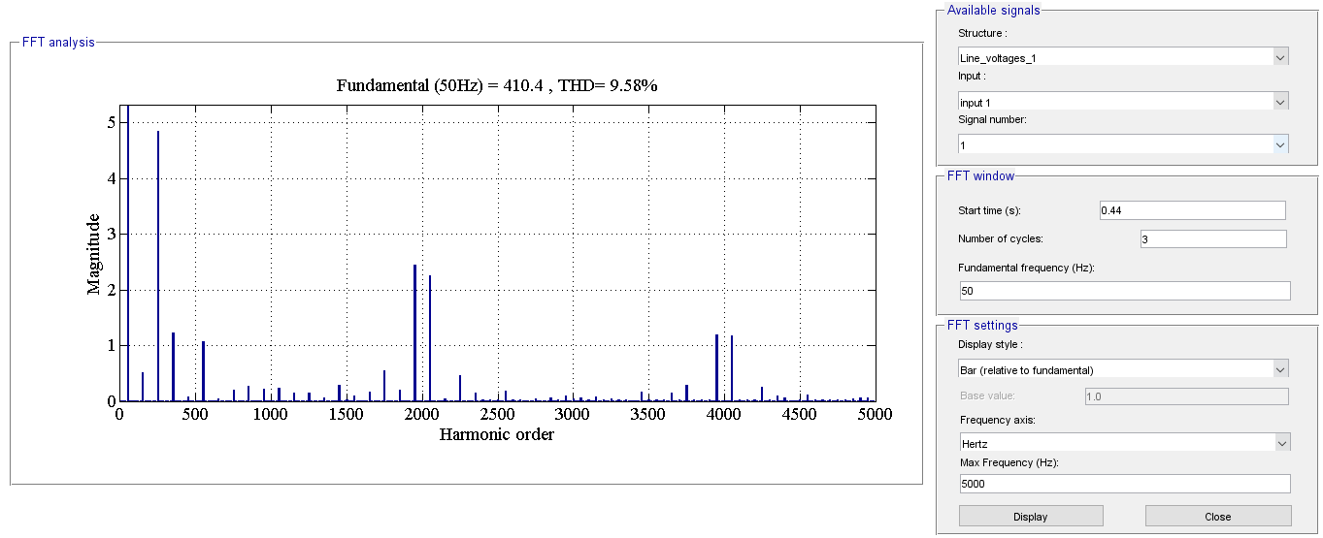

Figure 16.Seven level NPC CSV PDPWM

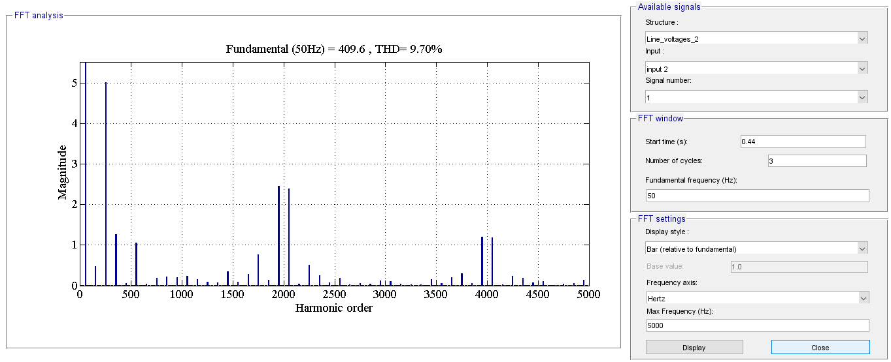

Figure 17.Seven level NPC CSV PODPWM

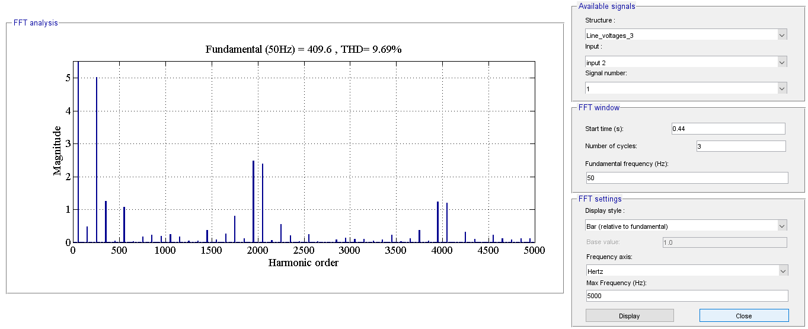

Figure 18.Seven level NPC APODPWM