Paper ID | 15944
Paper Title | Double PWM Fly-back Converter for LED Automotive Lighting
As per reviewer’s suggestions detailed and thorough revision is carried out and the technical errors are rectified.
New references [2, 7] published on IAES's Journals are integrated with the existing reference papers.
The corrections carried out for reviewer’s comments/suggestions are given in Table.
Sl. No. | Comments from reviewer A | Corrections/suggestions carried out
1 | It is said that the fly-back converter is operated in DCM, but equations 8, 9 and 10 are only valid in CCM. | In this work, the converter is operated in DCM because of dimming applications.  It can be operated in continuous conduction for high brightness. The standard formula is used to design the circuit components in continuous conduction mode.
2 | Some of the equations presented for the design are incorrect. | The equations are corrected and presented neatly. They are shaded with green colour.
3 | As some parameters are varying (D, input voltage), it is not clear how the equations presented for the converter design are manipulated to obtain the final values of the components (Table 1). | In this work, the input voltage is assumed to be constant and the duty cycle is varied. For change in input voltage, the duty cycle is adjusted accordingly.  The values are given for the rated voltage of 72 V, current of 350 mA in table 1.
4 | In a flyback converter a RCD snubber network must be used on the transformer primary to limit the high-voltage spike when the transistor turns off produced by the leakage inductance | The snubber circuit design is added in the design equation (Page 5 – step 9) marked with red font.
5 | An input voltage of 24V is considered, but the battery voltage most used in automotive applications is 12V. | 24 V is used by connecting two 12 V battery in series as per the requirement.
6 | In the simulations the mean value of the output voltage shows an ample variation (40V for D = 0.1 and 71V for D = 0.5). How many LEDs in series are? The authors should show the V-I characteristic of the LEDs used.  Has a resistor connected in series with LEDS? | The voltage rating of each LED is 3.0 V with a current rating of 350 mA.  24 LEDs are connected in series to obtain the rated voltage.  The standard V-I characteristics of 3.0 V LED is available in literature. It is repeated here for understanding and not presented in paper.  To limit the current through the LEDs, resistors are connected. It is given in Equation 11. The equivalent resistance is calculated and used in simulation.  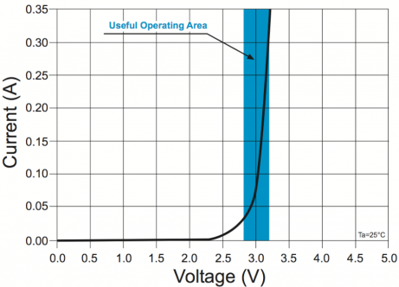
7 | It seems that the output capacitor needs to be larger, because when operating on DPWM it has a rather high low-frequency ripple. | The low frequency ripple depends upon the DPWM low frequency signal. It is considered as 200 Hz. It is not visible for human eyes. The flickering effect is negligible.
8 | Apparently the converter operates in open loop. If the battery voltage varies, the brightness of the LEDs will vary. | The results are provided in open loop only. In closed loop operations, the duty cycle is adjusted by the controller to maintain constant current for a particular brightness.

As per the reviewer’s suggestions, the article is reviewed thoroughly. The article is submitted for further process. The authors are thankful for the reviewers for their constructive comments and suggestions for further improvement.

