Notification of Data congestion Intimation [NDCI] for IEEE 802.11 Adhoc Network with Power Save mode
Azeem Mohammed Abdul^{#1}, Syed Umar^{#2}
^{# 1}M.tech Student, Department of Electronics and Communication Engineering, KL University, Vaddeswaram.
^{#2}Professor, Department Of Computer Science Engineering, GIST, Jaggayyapet
^{#1} mohammedazeem123@gmail.com ^{# 2} umar332@gmail.com

Abstract
IEEE 802.11-power save mode (PSM) independent basic service set (IBSS) Save, the time is divided into intervals of the signals. At the beginning of each interval signal and power saving alarm periodically all open windows (vocals). The station will be in competition with the rest of the frame window frame sent voice data leakage range. Element depends frame transmission IEEE CSMA / CA as defined in 802.11 DCF. A chance of transmit voice frames type of collision energy IBSS success. This article gives an analysis model with a chance of success output transmission window fixed size element. The results of the simulation analysis of the accuracy of the analysis.

Keywords: DCF, Adhoc netwoks. IEEE 802.11.

1. Introduction
IEEE 802.11 wireless LAN MAC Media Access Protocol widely used. This means that both are necessary to find the distribution channel coordination function (DCF) and the coordinates of the optional function (PCF). DCF based on Carrier Sense Multiple Access with Collision (CSMA / CA). CSMA / CA with double exponential regression (DER) [1] algorithm to avoid collisions online. Station-ll space ready to hit where the liquid can be heard in the vicinity of the big lottery DIF (Digital Distribution Frame), delays, otherwise delivery time DIF recorded medium. Then hold the station for calculation. Window minimum and maximum contention dimensions. Physical layer are determined by these values. Backoff counter is lost in the ear canal in the freezing cold and when the line is busy. After each unsuccessful transmission, CW will be doubled with eqn 1. (CWmin) is called the maximum duration of the suspension. CW is transmitted is reset CWmin. prepared by the IEEE 802.11 standard impact analysis DCF. Bianchi [2] at some point is a Markov model of the IEEE 802.11 DCF appropriate channel modes. [3] Bianchi described a modified version of the business model. Number of documents [4] [5] [6] [7] [8], the first model of Bianchi operator error, not the ideal diversion and prisoner treatment. All derived IEEE 802.11 DCF models frame transmission theoretical data. IEEE 802.11 power save mode (PSM) for IBSS, time is divided into intervals, each is divided into two parts, the element and the window data. IEEE 802.11 mode power saving interval, each node aware of the limited space called first element window DCF. Window element is used to wait for messages to describe food into energy saving mode. If the station has successfully delivered element email frame executives competition in the transfer of relevant data. wireless network services that are required. Wireless devices often rely on batteries. The design of the "energy" and "energy" of the wireless network are the main areas of research. More MAC protocol for the wireless LAN is designed to reduce energy consumption. [9] to improve the economic without powerful wireless MAC protocol selected public collection element of the size of the adjustment window and unusual bleeding after various window sizes. [10] proposed a short window Carrier Sense element component. But best of our knowledge, no model for success.
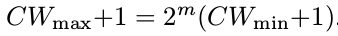
–--(1)
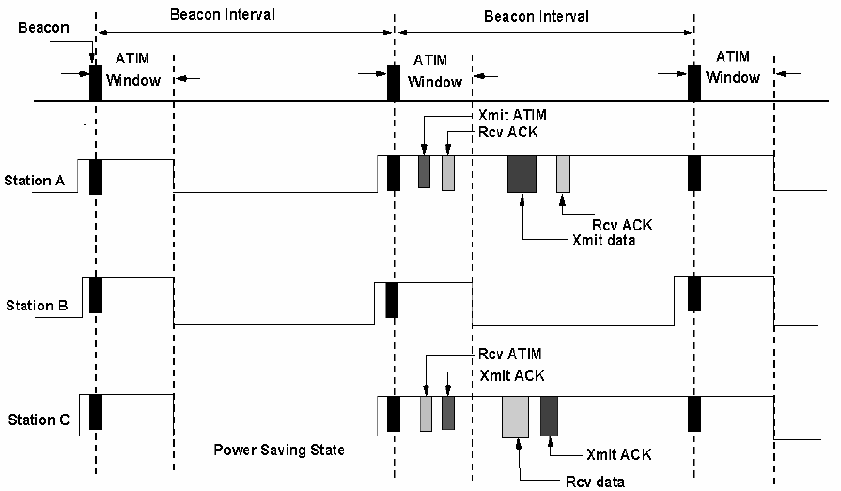

Fig. 1: PSM of IBSS [1]

IEEE 802.11 power save transmission frame member in IBSS mode. This book describes a discrete time Markov model was similar to a part of the element of success. Throughput IEEE 802.11 PSM therefore calculates the targeted element. The simulation tool NS-2 [11] is used to validate the models. The study says. The second part of the first a brief overview of the IEEE 802.11 PSM. Part III, we present a theoretical model to calculate the successful frame element of probability. IV confirms the accuracy of the simulation model. Finally, the fifth section presents conclusions.

2. IEEE 802.11 DCF in energy saving mode
IEEE 802.11 PSM two power settings, power and strength. Power, or to send the player and the current success of all time is. We hope that in the face of the synchronization hub. A saving mode in regular energy station to listen to the message and realized the element of the window period. Transmitter reduces each broadcast / multicast or unicast frame into energy saving mode and the belt element diffusion element. The sending of data packets from the window of the element to go to the station in a power saving mode or staying asleep by determining the transfer member data. Article transmission frame period algorithm CSMA / CA DCF, IEEE 802.11 [1]. A single transmission frame when the base member of the window frame member and sends a confirmation and alert to the end of the next point of the window. If confirmation is received and sent to traditional elements DCF process. If the drive letter of the frame member, can send, for example, when they are based buffer data and after trying to get another member of the frame. When receiving the channel or mail window frame, enter the government at the end of the window element. The product can last ACK frame or sent or received in the mail window. A buffer at the context of energy saving measures after the transfer station frame buffer over time. IEEE 802.11 [1], or the time of delivery, following the post when thrown. Depending on the point size of the transmission window is small, the limit of seven executives is a member is not required. [9] The system and try to get the transmission element and intended to charge two beacon frames with energy saving interval data. The energy saving mode is indicated by a stick. Fig. said sending placing executives and managers from one station to post. Ms Atim station B ACK to sleep at the train station and the rest of the series. C center number to save the state at the end part of the window, allowing energy savings.

3. Assumptions &Estimations of Network model
Modeling and analysis of transmission, try these ideas. Think of the machine. We look forward to the saturation state in which the stations are always sending packets. We thought the fixed voice size window. The channel is very long, that is to say, does not refer to [12]. When the data recorded by the sending of the input image of the police station. No broadcast frame member, but unicasting at Delivery. If the success of the replacement product B, and the pillar of fire units (the population), can send more affordable voice and central B-pillar of fire units. Before the central element, and determining the value of CW + 1 double CWmin unnecessary distractions CWmax CW + 1 and the value of the transmission CWmin CW n + 1. If the successful reset of the main center section B-frames face more police could send part of another object, in this case, part of the host transfer element. Three flagship voice test interval. Atim as ACK after three transmission, the beacon interval, and central data received re-buffered other subsequent headlights minute test. Try sending the voice three times in total center. re-buffered she can continue to save two Beacon intervals. When three beacon interval if the transmission fails the element frame for disposal. The algorithm is derived from the concept [9].

3.2 System Model
(S (t), B (t) (t)) is the stochastic field back-off circle AA, S (t), a backoff B (t) and low suspension (R) (beacon interval) T. It is a particular example, the top of the second row is a drive slot. Follow up co-ginning each goal. Backlog is the part number and try again cube element using a beacon, a beacon of successful federal units and the item number of the track arrested after all. We constructed a three-part system (S (t), B (t) (t)) as indicated in the special time Markov chains FIG. 2
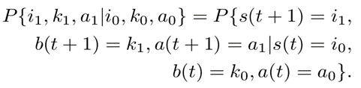

Let p be the conditional probability of collision, a fixed number of individual regardless of the number of retransmissions bus. The probability P that fights with the frame. Consider probability q window element ends with the existing space. This is regardless of the number of retransmission images. This is not to zero - evidence of a step in the chain of a Markov probability. 2 shows that (1) shows the comparison. 3
The first part shows the beginning of each hole and the window of the article to reduce the probability (1 - q). second part of death does not show table of Article window backlog retaining section, the protocol entry 0 article in the wings to another window. The third part shows the transmission. good show successful delivery, or to begin sending new framework for the item. Five-part shows that the conflict is the last test interval is a beacon, even attempting to send a frame in the sixth stage of another section 0 window default lighthouse flowers appear and the voice interval, a transmission fails

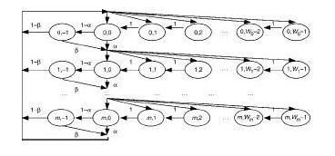

Fig 2 : Provide a framework for the subject Markov Model
4. Expected Model
Evaluation of the model in the ns-2 simulator [11]. Simulation of selected areas so that jumps, received intensity of the detection signal and therefore the total station. Assuming that about 20 percent of the time window position, and that the fire units column. The introduction of the distribution of the performance of IEEE 802.11 DCF access frequencies in direct main power mode (DSSSL) physical layer [1]. The system is used for the parameters listed in Table 1 calculation.
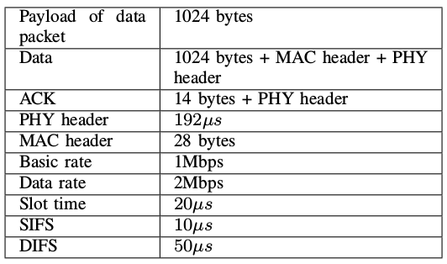

Table 1: parameters used for power save mode calculation
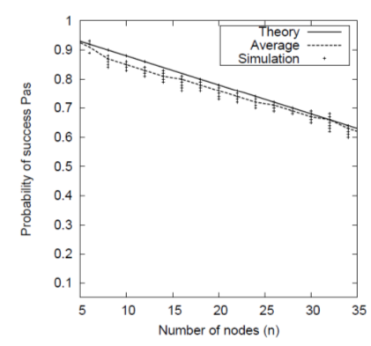

Fig: 4. Notification of Data congestion Intimation [NDCI] probability
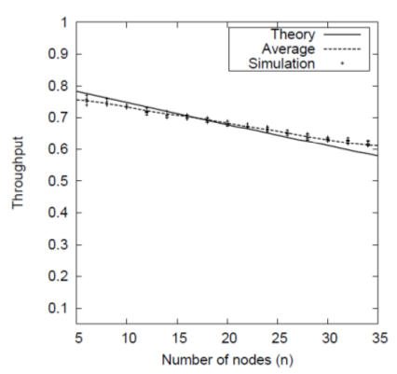

Fig : 5 802.11 psm throughput with different node.

Number of fixed stations, we run 10 different magic and random seed. all symbols that show the results of the simulation. Fig 3, shows that the likelihood of success of the delivery of costly average measuring element. Fig. 5. The solid line shows the results of calculation and Markov models broke the mean line of 10 pieces each. Statistics show that the theoretical results and simulation. . Figure 6 shows this expensive. Furthermore, according to the results of the simulation results. Note that the transmission of a model Bianchi slightly below the IEEE 802.11 PSM input window.

5. Conclusion
The article with the model based on Markov analysis of IEEE 802.11 DCF under the heading chain transmit the power saving mode. We are used to calculate the probability of IEEE 802.11 DCF throughput power save mode. The theoretical results are almost identical to the simulation results in terms of normal operation success probability.

References
- IEEE Std 802.11-2007, Part 11: Wireless LAN Medium Access Control (MAC) and Physical Layer (PHY) Specifications, Edition 2007, IEEE.
- G.Bianchi, “Performance analysis of the IEEE 802.11 distributed coordination function,” in IEEE Journal on Selected Areas in Communications, vol. 18, March 2000.
- H. Wo, Y. Peng, K. Long, S. Cheng, and J. Ma, “Performance of reliable transport protocol over IEEE 802.11 wireless LAN: Analysis and enhancement,” in INFOCOM, 2002.
- M. Ergen and P. Varaiya, “Throughput analysis and admission control for IEEE 802.11a,” in Mobile networks and Applications 10, 705-716, 2005.
- A. Alshanyour and A. Agarwal, “Three-dimenssional markov chain model for performance analysis of the IEEE 802.11 DCF,” in IEEE GLOBCOM., 2009.
- T. C. Hou, L. F. Tsac, and H. C. Lia, “Throughput analysis of the IEEE 802.11 DCF in multihop ad hoc networks,” in ICWN, pp.653-659., june 2003.
- V. M. Vishnevsky and A. I. Lyakhov, “IEEE 802.11 LANs: saturation throughput in the presence of noise,” in IFIP Netw., Pisa, ITALY, 2002.
- F. Daneshgran, M. Laddomada, and M. Mondin, “A model of the IEEE 802.11 DCF in presence of non ideal transmission channel and capture effects,” in IEEE GLOBCOM., 2007.
- E. S. Jung and N. H. Vaidya, “Energy efficient MAC protocol for wireless LANs,” in IEEE INFOCOM, 2002.
- M. J. Miller and N. H. Vaidya, “Improving power saving protocols using carrier sensing for dynamic advertisement windows,” in IEEE INFOCOM, 2005.

