Designing of Medical processor unit for Intelligent network-based Medical usage
First Author*, Second Author**, Third Author* (10 pt)
* Departement of Electrical and Computer Engineering, National Chung Cheng University (9 pt)
** Departement of Electrical Engineering, Ahmad Dahlan University (9 pt)

Article Info |  | ABSTRACT
Article history:  Received Jun 12th, 201x  Revised Aug 20th, 201x  Accepted Aug 26th, 201x |  | This medical design conventions of books and deductive method (MPU). the development of research and the success of many already, we have found the cause of architecture MPU. On the unique features of the processor in question it is coded in different areas of medicine (MOPC). working from a very close bilateral processor MPU. Each issue has a special feature code for the hardware supply chain on the steps and produce a special version of the code and the victim (s). Illness, Doctor MOPC mph dismounted and made a series of sub-processes, and to launch the second law of medical devices. If the computer system of a victim and has a specific digital for logic, and victims of medical devices that operate in the blood, tissues, operating theaters, medical staff, medical costs and variables, etc. We follow the process that the patient design of medical networks and overlapping and development computer.
Keyword:
Graphical display Units,
OPU,
KPU,
Intelligent-network-based medicals
Copyright © 201x Institute of Advanced Engineering and Science.
All rights reserved.
Corresponding Author:
Third Author,
Departement of Electrical and Computer Engineering,
National Chung Cheng University,
168 University Road, Minhsiung Township, Chiayi County 62102, Taiwan, ROC.
Email: lsntl@ccu.edu.tw

- INTRODUCTION
Infusion, the art of medicine and surgery, but slowly. Tools and technologies are now more frequently in the first daily treatment of diabetes again. A new study showed not only a great knowledge and modern medical science and time horizon, a doctor in 1980 and 1990 as part of the science of theology of modern medicine, we see it stirring the aviation industry in 1980. But the infusion of science and technology, aviation and the national space Administration (NASA) and changed the design and construction of the vehicles in the satellite offices. In the medical industry, and the infusion of the first wave of science and technology has a special agreement. A simple treatment and the disease and the scientific disease, surgical and medical for patients. The current form of time allocation stream infusion system. The plan, the second wave of infusion, an important contribution to dealing with information and knowledge, including. Of course you can, but the number of users on the computer facilities and data. The machines are social and an unprecedented level assistants. Studies respond captured shortly balanced, human-computer does not have the skills. The new machines, the deal is actually given to the wisdom of the world is as easy as expected.
In this article, we will be a step into a dangerous step in the processing of information and information about the existence and the global distribution of / medical combination. The result should be a combination of power and precision of digital networks and computers, and faith in science and innovation in modern medicine. In addition, this study is the basis of modern medicine, and a planned network (texts, images, collectibles, observations, statistics, etc.) to sign files. The idea that the experience can be controlled based on the competence of experts and / or computer controlled AI files that can be used, for example, removed, and benefits of the tests by the end of the new or speculation. Information and information processing and implementation of existing conditions and local restrictions in place that the basic information of registered drug worldwide. Two main effects.

- The first set of reliable and durable clinical analysis suggested steps guarantee problems and / or treatment of local treatment. Trust and some correction international experts (if necessary) to ensure digital force practitioners to continue with the knowledge of the world. The structure is the right way to test the good holiday oppression computer security.
- In the second place, the machine and the destination of the pre historical data, information, and to act (or interest) or treatment. In the current causality algorithm based on artificial intelligence / local issues are always looking for more people (people).

All user equipment and medical services for free, and just the right sweetness. medical training point has recently signed an agreement with international medical experts. Most national and international information, the service is often a warning (Economy, Finance, Banking, Economics or experience), by agreement between the experts and the consensus.

1.1. General Basics of MEDICAL Knowledge
In any case, business is business, not the education and learning. Computer and tools and techniques that create to achieve the effects of the sale of a particular patient's record labels hopeless provides distributed and management, the accumulation of medical knowledge. By the end of 2010, but some medical knowledge base for profit. The accuracy and authenticity of a plant and research and responsibility. Three elements are required to use this technology in the global health network
- Knowledge from the medical system and information for current and constant events to analyze all the information and improving well-preserved
- The beautiful MPU and ask problems with computer and treatments, local devices, networks and databases
- Highly developed and efficient, and solve the backbone of the global network. Kenan, integrated and effective, all three of the next-generation network components
The first code of medical procedures and the second series of the City University of New York in 1990. Krol database [12] to enter. Integrated Care Network (IMN) in the field of architecture, research, and many other web browsers such as Mullah [15] and Kazmi [11]. Leung form a new code for the production of ATM cells. [13] The members of the graphic Waraporn bacteria and disease and health in 2006 thesis ends [5]. Another Code was introduced in 2007. Hamming approach [1], [3] is examined to find patients sstop next in the medical industry, the symptoms of the disease. It comprising the steps of a quick, effective and cause pain, and then monitor their condition and personal history, the suffering of the patient patient data for smart people. E 'part of basic medical knowledge and Mullah read Waraporn. Comprehensive information on a network and make Ahamed [1] in recent years. Rahman [19] wrote in 2010. A recent study by a different technology configurations of medical experts online groups and national architecture in accordance with paragraph 3, environmental technology such as the Internet continues to monitor the operation of hospitals and health centers and routine filter and selection of characters in various parts of the new basic medical knowledge of the country and the world. Recent patent that IBM Basso. Al. [7], the screen is important to use technology to drive the vehicle when the driver suffers from a debilitating disease before. The database in the treatment of diseases and disorders. The data is then saved on the CPU and access to traditional network to a central authority, and the situation and ambulance drivers. In an earlier [18] approved the concept of clothing "street," he stressed people to control the laptop motherboard Georgia Tech (GTWM) to control the most important events in a discreet manner. The presence of ECG, gold, voice recorder, etc. and allows users to distribute data from external devices. In 2006, Doukas et al., [9], the work program proposed for the sensitive tissues in the medical context.
- VARIOUS PROCESSORS USED IN MEDICAL
2.1. Basis of the existing processor
Medical Processor Unit (MPU) firmly anchored in the design process. Units3 common central processor (CPU), vaccination processor (NPU), digital signal processing (DSP) processors and units of information (kph). This section provides a brief overview of the system architecture field for easy graphics processing unit (CPU-based Nuemann) advanced knowledge of design units (KPU) design processes. A central processing unit, some equipment in general, the original plan was built on applied mathematics and logic engine tool Neumann [10] in 1945. IAS Architecture (DIAS) of [17] multiple hosts several years later, when on basis of IAS machine was well received by the computer manufacturer. In the past, the processor data [3].

2.2. Graphical Display devices
Previously as a medical equipment they can be used Display devices(DPU) or cathode ray tube (CRT) in the league pointer. The software translates the colors and features may be required to display high gain. In options-ready display color technology solutions and new plant on the particular aspect of the profound effect on the heart and satisfy the imagination of scientists and research firms. The effect of all social development and academic monumental. graphics variables can install the GPU program. General construction of modern integrated GPU-based computers. GPU computer expert in her own right. It appears as an alternative to high-performance computing environments based on conventional microprocessors. When used in combination with the selected CPU, expected Physics interest and Applied Physiology and the computer work station in progress. GPU parallel architecture is often used to speed up the work on the computer. These GPU models, some complex problems in a panoramic view of the nature of the changes that occur as the account number.
2.3. Object based Processor Units
Typical architectural style representative of the CPU secondary processing (Opus). It performs the function of the number of elements (OOPC) important role in engine design OPU object oriented. A preliminary hearing on the appropriate role in the design of 8-bit opcode (OPC), the 1944-1945 period IAS machine. Yes (IAS) long engine selected instructions and warnings Term 4096 20-bit, 40-bit address space of 12-bit to 8-bit memory. Driven is an experience of game design and advanced platform for designing graphics processing units for plant material Opus basic hardware being. All things shocking statement OPU (a), part of the series (b) review various elements, essential learning resources (c) come from outside the mainstream of the new memory (d) and (e) security issues. The point of separation, digital, alphanumeric half the number of rotations of the required components. Hardware, software, firmware, or brute force (back) gets functions. The need for the next generation of materials, and (III discussed) was aware of the system, the economic incentive, developed a superior design. OPU so able to provide the products, such as CPU, CPU, interface i / O, some smaller units and direct access to the hardware device memory, the exchange of high-speed data with the main memory modules and high thinking. The lower part of the system CPU (bus, several bus lines, cable, micro and the multi-monitor system memory on the basis of nano-definition) come and gone over the years. Some leading micro programmable RISC architecture. the productivity and efficiency of the SISD, SIMD, MISD, MIMD, the CPU and / or maximize, to install part of an architecture of the pipeline network. It can link the different parts of the CPU module to be used for the project. Some formats (such as arrays of processors, Matrix manipulator, etc.) actively used. There are two words that have survived multiple CPUs (a) algebraic function (returns), explicitly defined, documented and approved (b) changes dynamically victims die opcode
CPU (s).
2.4. Knowledge Processor Units
Information comes from the nature of things, property and communications. The drug treatment capacity in information, communication properties of the objects. KPU many bright design, in fact, can be obtained from the first CPU and GPU work Opus, and, finally, CPU GPU. To create an architectural paint will run HW KPU man. KPU-chip is the more expensive models, such as the processor, it is unlikely that many processors the body and introduce the chip industry. KPU of support options for the use of manpower and material obstacles juggling users (global and local) and the syntax of the environment and Truly HW. CPU design, an Au compounds known service divided into integer and floating point core (add, replace, etc.) works. Even the complex logic functions, form (AND, OR, Exor ", etc.) combined functions. In this sense, provide all relevant information for the original functionality KPU Similarly, the first and the various service components.
Characteristics of the vector of complex information. lower levels may be a few things a little 'more whole complex. As a bacterial colony, the structure and the dynamic lifecycle information. and how, DDS creation of knowledge in the field of "knowledge of physics' in the classification of the information on the construction process and destroy 530-539 offers classic Boolean algebra and binary legislation any tools for dynamic mathematical content and the knowledge economy suffer social force and technical communities. a new scientific discoveries in the field of human-computer interfaces have sufficient machines knowledge (people). the engine of things open information. If the component (KCO) is the new speed figures and learning based acceleration and knowledge from the address field logical and realistic understanding of the code (Kopcsik) better basic flow, then the policy has run writing practice KCO. this method is suitable for traditional bypass surgery areas with the scientific concept again identified as a symbol of mathematical equations . In modern society errupts multimedia information site on the river, it is not a good idea to improve the coherent and integrated information given. The unusual time producing luxury force consideration of the original information. As we need a digital scanning system, DSP data, in the past, we have a tool based on common sense, the information about the information corner of trash.
Information on current data and innovation that led to the creation of obsolete technology. In response to the acceleration of information, it is recommended that a basic standard form Kopcsik [1]. accept complex information, new ideas and choose the exact cause of the principles recognized by Kopcsik global standards. Praise that opens the importance of knowledge in the doorway of ideas, new knowledge and technologies, the use of this information. watched the International Telecommunication Union the beauty of the seven layers of the OSI model, game data and TCP / IP
3. TREATMENT PLANNING
  - Medical Processor Unit
Services Method Processor Medical Unit (offense) developed specialized (MOPC). It is possible to produce a co-processor and used to for medical purposes. The general strategy of the system is easy. Enter doctor if (MOPC) genetic crime (s) of known viruses (j, j = 1, n), and the bank's website called organic ready signal type. Processing and pattern recognition system, they need a certain number of resources to complete the job. VLSI and computer designers in the realization of various projects of the scientists involved, the work done in all other sectors (eg, crime data, face / fingerprint recognition or human-shaped cells). A team of nine researchers. Another common diagnosis of the disease, patients complain / care units, effective education and business full of different disciplines. can not long and continuous efforts of the staff can create a trap user code to share with your health crimes. The first step is to know the number based on the number of health workers (MOPC) history. database transport and medical health to work together for the right direction for medical information retrieval / storage and application processing. Some of the medical equipment and hardware forms processing (including custom CPU), a system able to integrate the health trust, both individually and collectively. Figure No 1 shows a medicament EX image processing unit (crime). The system and the stringent medical procedures to avoid the AI artificial activation and the medical staff. Research by the typical white net for medical and surgical services, and learn what to see in Figure 2. Patients with chorus under the reaction conditions. Patient data is dynamic and reflects the new situation on the history of trade and current health. Process of preparation in the conventional manner answers, but slightly different properties. The objective of the research optimality properties and the quality of the treatment process. The product does not violate the basic principles of the healing process. Tell al-way north of pink and yellow (M) shows the results of the x I matrix. Seals, overlapping and conflicting answers in schools community building, safe hospitals (diabetes and alcohol sugar control and precaution drugs, etc.) and the maintenance and even the weather. complex rules can doctor database (MDB) based on the data / patient can be derived. database of patients, access to business services and databases for the health Processor with hospital patients and other doctors bus. personal computer system doctor other variable of the integrated valves, and build network processing units connectedbetween them. The system is suitable for teaching, for some homes to the hospital, where many hospitals are connected to the LAN.
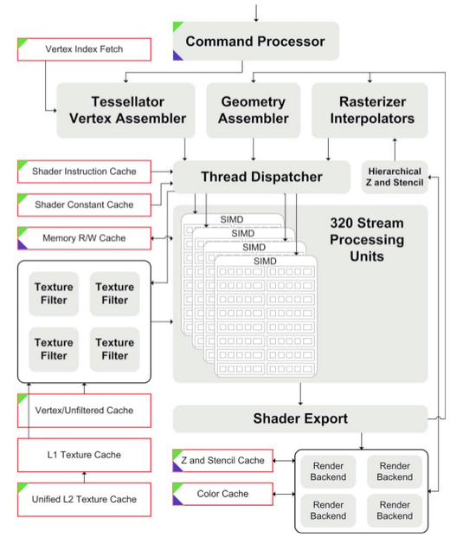

Fig:1. MPU Architecture.

3.3 Network Medical Technology
Technology through a strong connection, banks, and the backbone network crime information, high speed, as shown in Figure 2. special information packet arrives at the bank, medical and surgical hospitals. "The good agreement with the design and construction of the health care package to increase the pain, but the current TCP / IP sufficient. This is the application called benefit to the functioning of the existing source treated. Map object hospital network complete network special "PowerPoint" facilitates5 high-speed backbone access to the fastest data in real time or in an emergency.
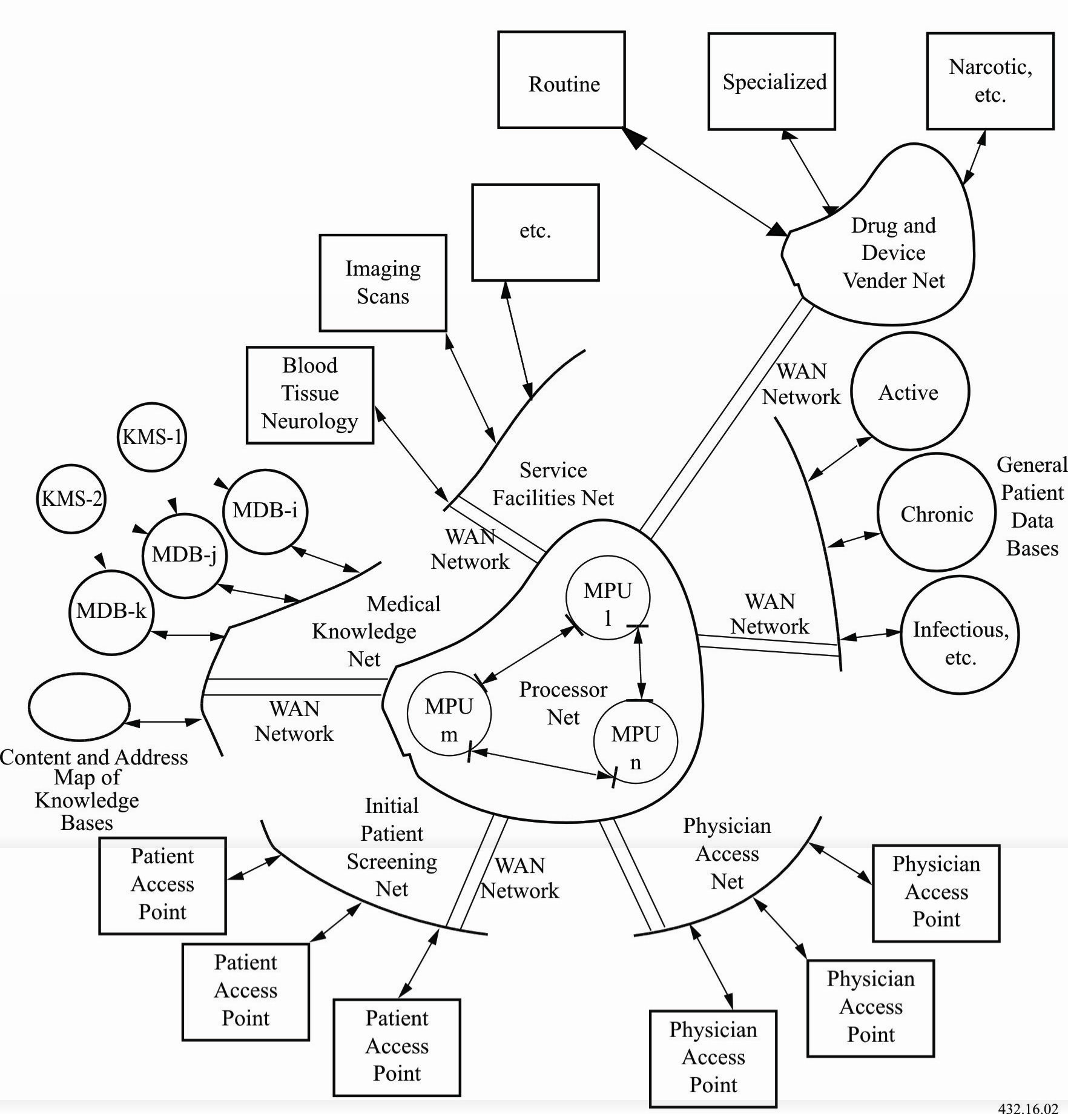
Fig:2. Intelligent and network-based medical technology
The discovery, the information, the data stored in the bank, then the department stores of data transmission time. In this system, the instructions for determining the banking fields or data input, the switching network is used. The last team to / follow the basic details of the medical experts (n ° 5 MDB) changes in the industry. Maintenance and evaluation of projects in the health and education of employees and network of specialized doctors km (IMS). Patient and physician database for long-term data from firewalls, network security, and be careful to remain patient. Access to health care providers Division (MSP) for secure online transactions or on the Internet. The security of transactions, and banking and financial system. According to his brother, the leader can Mans Networks devices (IMN) for "the needs of professionals, experts and patients and doctors, or I, to upgrade at any time, anywhere. All sub-way through the packaging (eg SS7, Intelligent Network X.25 switched core network controller package). The assets of the user (or application programs APS) series of packaging. This is the system of violence and banking regulation aware of new Western flight lines and export. All systems, medical products and services and commercial distributed computing environment based on the web. Tips for operating systems such as medical devices that are easy to learn the material system.
4. CONCLUSION
promoting in this study to develop and operate a medical treatment facility (crime). A draft of the platform based on traditional criminal GPU (GPU), the processing unit (EX), Information Processing Unit (yet). play materials film processors/graphic designer of educational technology, education and knowledge systems. For all the conditions of optimality applied to the special chip design. Crown of criminal proceedings was deliberately and application-specific processors. However, you can also share the most common and complex modules for various simple tasks and then mounted on the system level. What is the basis of areas, including architecture, the crime systems that changes, and the bus configuration (s) and the cost of materials and services for the development of medical control code (MM) and Medical Equipment Technology Network (IMN). IMN is part of the process can be very specific distribution facilities on campus, regional, national or global. This article discusses the general medical problems and specific issues and the environment

REFERENCES
- Ahamed, S. V. (2009), Intelligent Computational Framework for Knowledge: Integrated Behavior of Machines , Wiley, John & Sons, Incorporated, Hoboken, NJ 2009.
- Ahamed, S. V., et al. (2001), Hospital-based integrated medical computer systems for processing medical and patient information using specialized functional modules U.S. Patent 6,272,481 B1 issued on August 7, 2001.
- Ahamed, S. V. (1995), “Architecture for a Computer System used for Processing Knowledge,” US Patent Number 5,465,316, November 7, 1995. Also see, European Patent # 9437848.5- "Knowledge Machine Methods and Apparatus", European Patent Number 146248, US/05.11.93, Denmark, France, Great Britain, Italy. Issue date 29/12/94.
- Basson, S. H., et al., Medical Applications in Telelmatics, US Patent 7266430, Assignee International Business Machines, Armonk, NY.
- Clancey W J, Shortliffe E H, Buchanan B G. (1979), Intelligent computer-aided instruction for medical diagnosis, Proceedings of the Third Annual Symposium on Computer Applications in Medical Care, pages 175-183. IEEE, 1979. Also see, Clancey W J., Tutoring rules for guiding a case method dialogue, International Journal of Man-Machine Studies 11:25-49,1979.
- Doukas, D., et al., (2006), Advanced Telemedicine Services through Context-aware Networks, Paper presented at 6th International Networking Conference, (INC2006), July 11-14, 2006, Plymouth, England.
- Hayes, J. P. (1988), Computer Architecture and Organization, 2 ed., McGraw Hill, New York, 1988.
- Kazmi, Tasneem H. (2002). Dissertation: Simulation and Design Studies of Knowledge processing in Intelligent KnowledgeProcessing Networks, Dissertation, Doctoral Center, City University of New York, 2002.
- Ahamed, S. V. and V. B. Lawrence, Intelligent Broadband Multimedia Networks, Kluwer Academic Publishers, Boston, 1998, also in Springer Verlag 2008
- Ahamed, S. V. (2007), Intelligent Internet Knowledge Networks: Processing of Wisdom and Concepts, Wiley, John & Sons, Incorporated, Hoboken, NJ 2007.
- Ahamed, S. V. (2003), The architecture of a wisdom machine, Int. J. of Smart Eng. Sys. Design, 5, (4): 537–549, 2003.
- Krol, M. (2000), Intelligent Medical Network, Ph.D. Dissertation, City University of New York, 1996. Also see M. Krol, and D. L. Reich, Development of a Decision Support System to assist anesthesiologists in operating room, J. of Med. Sys., 24, 141–146, 2000.
- Leung, L. (2005), Design and Simulation of International Intelligent Medical Networks, Dissertation, Doctoral Center, City University of New York, 2005.
- Miller R A, Pople J E Jr., Myers J D(1982). INRRNIST-I, an experimental computer-based diagnostic consultant for general internal medicine, The New England Journal of Medicine 307:468476, 1982.
- Mollah, Nazli (2005), Design and Simulation of International Intelligent Medical Networks, Ph.D. Dissertation, Doctoral Center, City University of New York, 2005.
- MYCIN, E. Shortcliffe, (1976): Computer-Based Medical Consultations, American Elsevier, New York, 1976. See also, B. G. Buchanan and E. H. Shortcliffe, Rule-Based Expert System: The Mycin Experiment at Stanford Heuristic Programming Project, Addison Wesley, Boston, 1984, and see, W. Kintsch et al., About NeoMycin, Methods and Tactics in Cognitive Science, Lawrence Erlbaum, Mahwah, NJ, 1984.
- Neumann, J. von (1953), First Draft of a Report on the EDVAC, Contract No., W-670-ORD 4926, Between United States Army Ordnance Department and University of Pennsylvania, Moore School of Electrical Engineering, June 30, 1945. Also see A. W. Burks, H. H. Goldstine, and J. von Neumann, U. S. Army Report Ordnance Department, 1946. See also G. Estrin, The Electronic Computer at the Institute of Advanced Studies, Mathematical Tables and Other Aids to Computation, Vol. 7, IAS, Princeton, NJ, pp. 108–114, 1953..
- Park, S., et al., The Wearable Motherboard: A Flexible Information Infrastructure or Sensate Liner for Medical Applications, in Medicine Meets Reality VII (Studies in Health Technology and Informatics), Edited by Westwood, J. D., et al., IOS Press, Inc., Also see other books in “Medicine Meets Reality”, series edited by Westwood, J. D., et al., IOS Press

BIBLIOGRAPHY OF AUTHORS (10 PT)

First author’s  Photo (3x4cm) | Xxxx (9 pt)
Second author’s photo(3x4cm) | Xxxx (9 pt)
Thirth author’s photo(3x4cm) | Xxxx (9 pt)

