**Performance Evaluation of Elliptical-cylindrical Antenna Array (EcAA) using SaDE Optimized Hyper Beam**

**Gebrehiwet Gebrekrstos1**\***, Gebremichael T.Tesfamariam2, Mohammed Ismail3**

1,2,3Ethiopian Institute of Technology-Mekelle (EiT-M), School of Electrical and Computer Engineering,

Mekelle University, Mekelle, Ethiopia

*Tel*:* ***+251 910863777****; Email:* ***g.jcool.com@gmail.com***

**Abstract:**  For high performance communication systems, Side Lobe Level (SLL) reduction and improved directivity are the goal of antenna designers. In the recent years, many optimization techniques of antenna design are occupying demanding place over the analytical techniques. Though they have contributed attractive solutions, it is often obvious to select one that meets the particular design need at hand. In this paper, an optimization technique called Self-adaptive Differential Evolution (SaDE) that can be able to learn and behave intelligently along with hyper beam forming is integrated to determine an optimal set of excitation weights in the design of EcAA. Non-uniform excitation weights of the individual array elements of EcAA are performed to obtain reduced SLL, high directivity and flexible radiation pattern. To evaluate the improved performance of the proposed SaDE optimized hyper beam, comparison are done with uniformly excited, SaDE without hyper beam and Genetic Algorithm (GA). In general, the proposed work of pattern synthesis has resulted in much better reduction of SLL and FNBW than both the uniformly excited and thinned EcAA. The results of this study clearly reveal that the SLL highly reduced at a very directive beamwidth.

Keywords: SLL, directivity, optimization, hyper beam, elliptical cylindrical antenna array, SaDE.

1. **Introduction**

Unlike circular array pattern that doesn’t have any nulls in azimuth plane [1]; the proposed geometry has nulls in the azimuth directions. In smart antenna applications, to reject signal to interference ratio, the array pattern should have several nulls in the azimuth plane. One possible solution is to use the elliptical arrays instead of circular arrays [2]. Though, reduction of the distance of the arrays decreases the side lobes, the mutual coupling influence becomes more significant. To combat the SLL, concentric arrays are often utilized in [3]. The radiation characteristics of uniform circular array elements are analyzed [4]. The use of conical arrays [5, 6] have resulted better performance. The properties of linear and circular array combination were discussed in [7]. In all of the above papers, a simultaneous SLL reduction and mulling in the azimuth was not achieved.

Optimization techniques have recently taken a big endeavor in many antenna array synthesis problems where they specify the system design accuracy and reliability. This enabled effective radiation pattern possessing real applications. Adaptive beamforming is based on the desired signal maximization and interference minimization [8-10]. To obtain optimal patterns, a hyperbeam [11] is implemented on linear antenna arrays and it has resulted good SLL reduction. The conventional Particle Swarm Optimization (PSO) is influenced by premature convergence and stagnation problem [12–15]. For example, in 2014, Rajesh Bera *et.al* has thoughtfully investigated to design minimum side lobe levels of EcAA with the capabilities to scan the whole hemisphere, but the SLL reduction was only -31.72dB after optimized by PSO [16]. As more SLL reduction is still needed, new differential optimization techniques come in effect. A Differential Evolution (DE) introduced by Kenneth Price and Rainer Storn in 1995 [17] is a simple stochastic population-based evolutionary algorithm for global optimization purposes. This optimization technique results more accurate solutions than the ordinary deterministic way of antenna array synthesis. But the question of setting their control parameters is continued. The user is supposed to be able to change the parameter values according to the results of trial-and-error groundwork experiments. The Self-Adaptive DE automatically adapts the configuration so as to generate effective trial vectors during evolution. In this paper, the effect of SaDE optimized hyper beam EcAA performance is explored. As the SaDE requires the adjustment of only two parameters namely the population size and the number of iterations, it needs less manual involvement which indicates that it is faster and convenient to use.

For flexible pattern synthesis applications a hyper beam exponent can be utilized. The hyper beam is a spatial processing algorithm used to focus an array of distributed elements to increase the signal to interference and signal to noise ratio at the receiver. The hyper beamforming processing improves significantly the gain of the wireless link over a conventional technology, thereby increasing range, rate, and penetration capabilities of the signal.

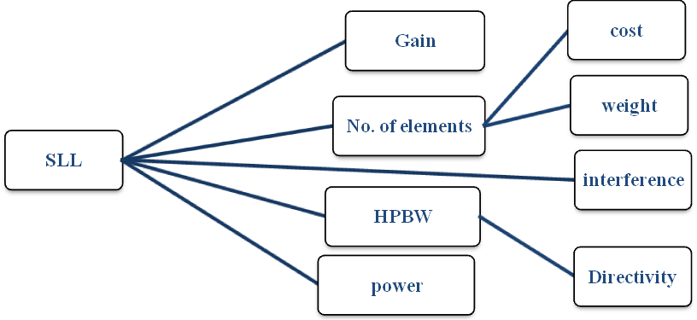

**Figure 1:** The interdependency of SLL, Gain, HPBW and the number of antenna elements

When the SLL is reduced, the gain increases and the power wastage decrease which are main intention of the study. Though the SLL reduction can be easily done by increasing the number of elements and by increasing beam width, they results reduction of directivity, cost and weight. Therefore, a comprehensive effort is given for the maximum possible system performance that results minimum SLL, cost, power and interference and maximum gain and directivity.

1. **Geometric Configuration**

As it is shown in Figure 2, the geometrical configuration of elliptical cylindrical antenna array is constructed from a linear antenna array directed towards the +Z-axis and elliptical antenna array encircling the Z- axis. The linear arrays are extended on the surface of the cylinder constructed from an ellipse over an ellipse build up towards the Z-axis. It is known that the far-field pattern is described by the Array Factor (AF) of a particular antenna array, the total AF of the EcAA is the multiplication of the linear array factor and elliptical array factor  as:

 (1)

Where the linear and elliptical array factors are described in the following statement, respectively



 (2)

Then, the whole array factor results the proposed type of antenna array which is called elliptical cylindrical antenna array. This is mathematically written as follows

 (3)



**An** is the excitation amplitude of the nth element of the elliptical component, **Am** is the excitation currents of the mth element of the linear array

The EcAA provides good geometrical flexibility that forms several families of antenna arrays and this result in radiation pattern flexibility which is achieved by slight modification of the eccentricity (e) and the linear array elements (M). When e = 0 with M >1, the circular cylindrical antenna array can be easily formed. When M = 1 with e ≠ 0 are applied, the elliptical antenna array will be created. Similarly when M =1 with e = 0 is employed, a circular antenna array will be produced.

*A* linear antenna array of *M* isotropic elements positioned parallel to the *z*-axis and are separated by a vertical distance *d*, and there exists a progressive phase excitation Pmbetween the elements. Here, the direction of the linear array is very important and directing it to the intended direction (+Z-axis) is formulated as

 (4)

The Am’s are the amplitude excitation coefficients and *β* is the total phase shift at the distance point contributed by the active elements. 𝜃 is the angle that the far-field point makes with the axis of the antenna. The terms θ0 and ϕ0 are the angles in the main beam direction. ϕn is the angular position of the nth element of the elliptical component in the xy-plane

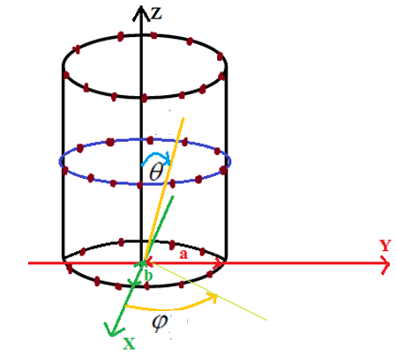

Figure 2: Elliptical-cylindrical Antenna Array

The basic idea behind EcAA is to radiate the pattern in a particular direction incorporating sufficient directivity to satisfy the intended service needs. Besides, this antenna array needs to be designed to generate a pattern with very low side lobe levels. To do this, the geometrical configuration of the EcAA must be reasonably designed for any operating frequency. Furthermore, the EcAA constituents like the ellipse major-axis (a), the ellipse minor-axis (b) and the vertical inter-element spacing must be thoughtfully specified. To do this, an iterative program or intensive trial and error is performed to get minimum SLL with good directivity at a particular operating frequency.

1. **Hyper Beam Formulation**

The hyper beam formulation is based on the difference and sum of the radiation pattern of the two half beams:

Ddifference(θ,ϕ) = |ELeft-ERight| and Ssum(θ,ϕ) = |ELeft|+|ERight| respectively. Then, the combined formulation of the hyper beam is: Ehyper = |ELeft|+|ERight|-|ELeft-ERight| and the final equation of the general hyper beam is a function of the hyper beam exponent k:

Ehyper= {(|ELeft|+|ERight|)k - (|ELeft-ERight|)k}1/k  (5)

The sum and difference patterns of the left beam and right beam are derived from the array factor of the proposed antenna array as follows. The array factor of EcAA is:



The left and right beams of the total radiation pattern are first determined by dividing the beams crossing the x-axis. Then, staring from the 0º azimuth (i.e. +x-axis) and covering up to the -180º azimuth (i.e. -x-axis) results the left side beam. Similarly, the right side of the beam is evaluated starting from the 0º azimuth up to +180º azimuth.

 (6)

 (7)

1. **System Model**

Antenna side lobe introduces interferences and results wastage of power. One solution of this problem is to reduce the number of turned on elements of the array. The optimal number of turned on elements has increases the gain and directivity of the antenna. Besides, this results in minimization of power wastage and at the same time it reduces the SLL of the antenna system. The system model defined below addresses the problem on how the SaDE algorithm is implemented to obtain optimal number of elements along with their position on the elliptical position of the proposed antenna array. This is done with a fitness function of maximum SLL reduction.

## **Description of the system model**

**Initiation:** this basically sets up the minimum and maximum values. These values are used in the starting and ending of the iterations and evolutionary generations. The sidelobe level is started by the worst case as a SLLold so as to compare this with the newly calculated sidelobe (SLLnew).

**Generate the population**: this generates the possible sets of solution, basically this holds very big array. The probability of best solution depends on the amount of the population generated though the higher the number of population leads to slower convergence as the total iteration increases. The population is bounded by a maximum and minimum allowable vectors stated as population = randi([0 1] 2MxN, MxN). Where the 0 and 1 are the minimum and maximum values used for the ON/OFF purpose of the elements. M and N are the number of elements in the linear antenna array and elliptical antenna array, respectively.

**Evaluate population:** this persistently selects sample space from the whole population for evaluating if it can satisfy the required SLL reduction. A sample space that doesn’t satisfy the required element reduction is simply computation cost. The success and failure memory is a place where good and bad results are recorded which is helpful for the next selection to take only similar patterns while rejecting those arrays with bad results.

**Trail-vector:** is a sample of a particular row and MxN columns to be evaluated if it could really results a good SLL reduction. The target vector stores values that are with good directivity and it replaces (mutation) by the new trial vector if the newly sampled pattern is directive than the previous.

**Calculate the SLL:** after searching a good radiation pattern, all the maximum values of the normalized array factor are determined then ignoring the first maximum (that is the main beam), the next maximum (the maximum SLL) is identified as 20*log10(maxSLL) and recorded as a SLLnew for comparison with the previous best SLL ever calculated (SLLold). Here, if good results of SLL reduction is recorded, the system is made to check if there can be achieved even much better results by a little bit modifying the patterns for small number sub-iteration.



Figure 3: SaDE optimization system skeleton

1. Simulation Specification

Table 1 specifies the parameters considered in this paper. The values and the corresponding symbols are clearly tabulated.

Table 1: Plot specification of EcAA with SaDE optimized hyper beam

|  |  |  |
| --- | --- | --- |
| **Parameter** | **Parameter Symbol** | **Parameter value** |
| Elliptical Eccentricity | e | 0.5 |
| Elliptical Major -axis | a | 1.15 |
| Elliptical Minor -axis | b | 0.9959 |
| Operating frequency | f | 305 MHz |
| Wavelength, lambda | λ | c/f |
| Free space Speed light | c | 3x108m/s |
| Wave number | k | 2π/ λ |
| Elevation angle in the main beam direction | θ0 | 0º |
| Azimuth angle in the main beam direction | ϕ0 | 0º |
| Vertical element spacing | *d* | 0.5* λ |
| angular position of the nth element | ϕn | 2π(n-1)/N |
| mth element of the linear array | M | 3 |
| 𝑛th element of the elliptical array | N | 12 |
| Excitation of mth element linear array | Am | 1 |
| Excitation of nth element in the ellipse | An | ON or OFF |

1. **Results and Discussions of the Performance Evaluation of EcAA Using SaDE Optimized Hyper Beam**

The SaDE optimized hyper beam keeps the number of actively turned on elements optimal while simultaneously reducing the SLL and increasing the directivity. A plot of the normalized Array Factor (AF) against theta for different values of the hyper beam exponent is simulated. A comparison of the results with and without the hyper beam is investigated. Finally, the amount of SLL reduction and First Null Beam Width (FNBW) under uniform excitation, uniform excitation with hyper beam, optimized without hyper beam and optimized with hyper beam are compared.

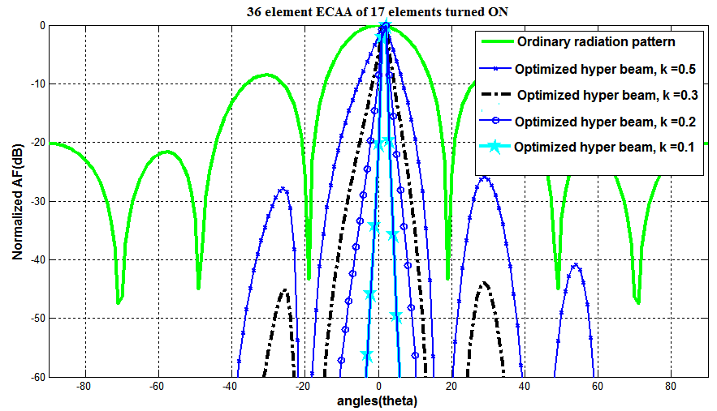

Figure 4: 36 elements ECAA with 17 elements turned-on

As it is shown in Figure 4, the side lobes decrease gradually as the optimized hyper beam exponent decreases from 0.5 to 0.1 and that will not only reduces the SLL but also reduces the FNBW of the EcAA. The optimized hyper beam has achieved excellent SLL reduction at good FNBW as shown in Table 2.

Table 2: SLL and beamwidth of 36 elements ECAA with 17 elements turned-on

|  |  |  |  |  |
| --- | --- | --- | --- | --- |
| Exp no. | 17/36 array elements | FNBW(deg) | SLL (dB) | HPBW(deg) |
| 1 | Ordinary(uniform) radiation pattern | 38 | -8.50 | 17.8 |
| 2 | Optimized Hyper beam exponent, k = 0.5 | 39 | -27.98 | <2 |
| 3 | Optimized Hyper beam exponent, k = 0.3 | 39 | -54.43 | <2 |
| 4 | Optimized Hyper beam exponent, k = 0.2 | 39 | -93.97 | <1 |
| 5 | Optimized Hyper beam exponent, k = 0.1 | 39 | -237.6 | <1 |

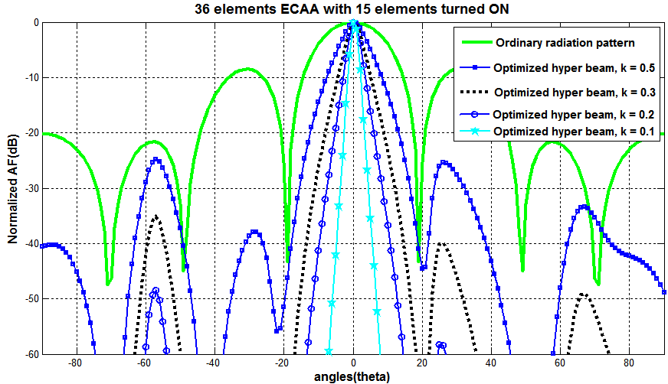

Figure 5: 36 elements ECAA with 15 elements turned-on

Similar to the 17 elements turned-on (shown in figure 4), Figure 5 illustrates deeper SLL reductions together with flexible radiation pattern are realized when only 15 out of 36 elements are active as the hyper beam exponent varies. Comparing Table 2 and Table 3, the former has more SLL reduction though the latter has increased turned-off excitation currents (i.e. more number of turned on elements results an interference and power wastage). Therefore, further increase in the number turning-off elements reduces the radiation intensity of the total array which is not desirable. Hence, the choice of optimal number of active elements is a trade-off between radiation intensity (i.e. gain) and interference. For this case, taking care needs for the total intensity while reducing the interferences by turning-off some of the elements. In this study, the 17 elements turned-on out of the total of 36 elements is found with better SLL reduction. When the number of turned-on elements increases, the interferences between the elements increases which results in less SLL reduction. On the other hand, when the numbers of turned-on elements are decreased, the combined pattern results in less intensity and therefore less SLL reduction. Finally, the 17 elements turned-on has achieved better SLL reduction and sharper beam width.

Table 3: SLL and beamwidth records of 36 elements ECAA with 15 elements turned-on

|  |  |  |  |  |
| --- | --- | --- | --- | --- |
| Exp No. | 15/36 array elements ON | FNBW | SLL (dB) | HPBW |
| 1 | Ordinary radiation | 38o | -8.50 | 17.8 o |
| 2 | Optimized Hyper Beam, k = 0.5 | 42.5 o | -23.23 | 7 o |
| 3 | Optimized Hyper Beam, k = 0.3 | 42 o | -31.71 | <3 o |
| 4 | Optimized Hyper Beam, k = 0.2 | 42 o | -42.63 | <2 o |
| 5 | Optimized Hyper Beam, k = 0.1 | 40 o | -75.85 | <1 o |

## 

## **Performance evaluation of hyper beam and SaDE optimized hyper beam**

To observe the effect of reducing the number of turned-ON elements and to observe the effect of hyper beam over the optimized and non-optimized array, a normalized array factor in dB versus the angle of arrival in degree is plotted in Figure 6. The uniform excitation current of 36 array elements turned-ON results -8.5 dB SLL at a FNBW of 38o. After applying a hyper beam with an exponent of k =0.1 for this uniform array elements, -41.76 dB (i.e. 99.18% over isotropic antenna) SLL is recorded at the same FNBW. When we optimize the antenna array excitation elements with only 15 elements out of 36 being turned-on, a SLL of – 15.6 dB along with an increase of 10o more FNBW (i.e. 48o) is resulted. But after applying a hyper beam with an exponent of k =0.1(as for the non-optimized case), a SLL of -75.85 dB along with only 2o more FNBW (i.e. 40o). Besides, the optimized design of ECAA has 58.33% (1-15/36) reduced power consumption as only limited numbers of elements are active at a time. This is another core contribution of this study.

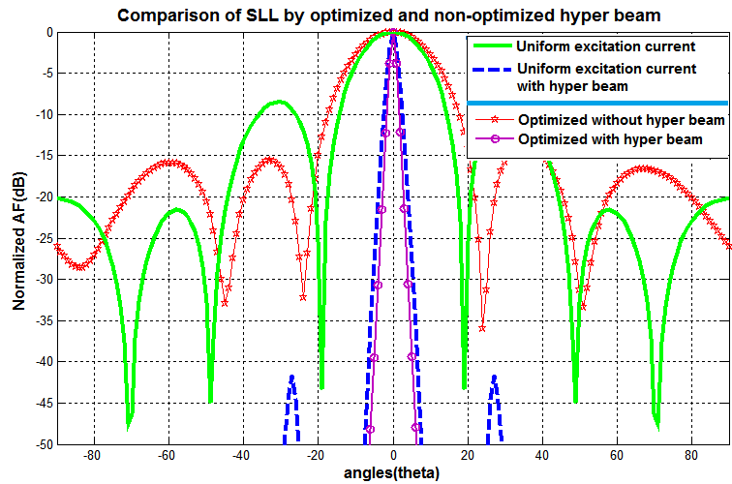

Figure 6: Comparison of optimized versus uniform array elements; and with hyper beam versus without hyper beam

In fact, the proposed optimized hyper beam results simultaneous reduction of the SLL, the FNBW and the required power consumption***.*** This underlines the quality of optimized hyper beamforming over the usual beamforming that are performed over non-optimized array elements.

## **Quantitative Comparison**

Similar study was done for reducing the SLL and power consumption minimization in Rajesh Bera *et.al* using PSO as an optimization algorithm. The Comparison of this work is done with the results of Rajesh Bera *et.al* [16] that are done for SLL reduction on the same antenna array and is summarized in Table 4. Note that, the Experiment Number (Exp. No) 1 is accomplished by Particle Swarm Optimization (PSO) [16]while Exp. No 2 through 7 are completed in this study using SaDE optimized hyper beam technique.

Table 4: Comparison of SLL, beamwidth and power saved of SaDE optimized hyper beam and PSO

|  |  |  |  |  |  |
| --- | --- | --- | --- | --- | --- |
| **Exp.**  **No.** | **EcAA synthesis technique** | **Number of ON elements** | **Power saved (%)** | **SLL**  **(dB)** | **FNBW(deg)** |
| 1 | Rajesh Bera *et.al*  by PSO | 17 | 52.78 | -31.72 | 74.12 |
| 2 | Optimized Hyper Beam, k = 0.3 | 17 | 52.78 | **-54.43** | **39** |
| 3 | Optimized Hyper Beam, k = 0.2 | 17 | 52.78 | **-93.97** | **39** |
| 4 | Optimized Hyper Beam, k = 0.1 | 17 | 52.78 | **-237.6** | **39** |
| 5 | Optimized Hyper Beam, k = 0.3 | 15 | 58.33 | -31.71 | 42 |
| 6 | Optimized Hyper Beam, k = 0.2 | 15 | **58.33** | **-42.63** | **42** |
| 7 | Optimized Hyper Beam, k = 0.1 | 15 | **58.33** | **-75.85** | **40** |

From the above results; the following inferences can be made: (i) in Exp. No 2, 3 and 4, the same percent of power conservation is verified as Exp. No 1, but a -54.43, -93.97 and -237.6 dB SLL reduction are resulted in Exp. No 2, 3 and 4 respectively. This demonstrates that the proposed work has contributed much better SLL reduction than the work done in [16]. (ii) Furthermore, the FNBW is decreased from 74.12o to 39o in this study. (3) Comparing Exp. No. 5, 6 and 7 with Exp. No. 1, a 5.5% of power conservation is observed together with simultaneous SLL reduction and sharpening of the main bean over the same antenna, designed by Rajesh Bera*et.al*. For example, comparing Exp. No. 1 and Exp. No. 7, a 5.5% more power conservation, a 44.13 dB(75.85 dB – 31.72 dB) SLL reduction and a 34.12o (74.12o –40o) FNBW reduction is recorded in Exp. No. 7 (i.e. in this study). Therefore, the proposed technique of SLL reduction brings much better interference avoidance and improved antenna array radiation pattern directivity. These achievements are the corner stone in critical applications such as tracking of enemy targets having small cross-sectional area in military applications.

1. **Comparison of Different Optimization Techniques**

In the recent years, many optimization techniques have come in to effect. They are increasingly occupying dominating place over the analytical techniques of antenna array design. Though they have contributed attractive solutions, it is often obvious to select one that meets the particular design need at hand. In this study, the need of sharper beam width and good SLL reduction is basically found important. To see the better performance of the proposed algorithm, it is compared with GA for the same parameters. The GA is a known iterative optimizing technique that has three control parameters namely the number of population, the crossover probability and the mutation probability.

The optimization implemented for the number of elements in each ellipse, with N=12 and the number of ellipses in the antenna array, M =1 with an eccentricity of zero is used. A 150 population size and 500 numbers of generations are used. A crossover probability = 1, a mutation probability = 0.01 are used. The minimum and maximum allowable values for the variables (i.e., the weights) are set to 0.1 and 1, respectively, along with uniform λ/2 element-spacing are investigated. The current amplitudes for the array elements are normalized to unity.

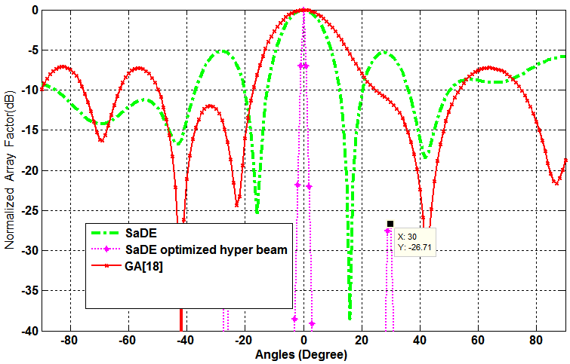

**Figure 6:** Comparison of GA, SaDE and SaDE optimized hyper beam

Table 5: Comparison of SLL and beamwidth of different optimization techniques

|  |  |  |  |
| --- | --- | --- | --- |
| Exp no. | Algorithms | FNBW(degree) | SLL (dB) |
| 1 | SaDE | 32 | -5.33 |
| 2 | GA | 48.8 | -7.22 |
| 3 | SaDE optimized hyper beam (proposed) | 32 | -26.71 |

As it can be seen from Figure 6, the SaDE optimized hyper beam technique has superior FNBW over the GA and SaDE SLL with the values recorded in Table 5. The SaDE optimized hyper beam with hyper beam exponent of k = 0.1(k = 0.1 is the minimum acceptable SLL) has resulted even better FNBW than GA and much superior in SLL reduction than SaDE optimization technique. This ensures reduction of interference and wastage of power.

1. **Conclusion**

An optimization technique that has limited number of control parameters together with hyper beam is integrated to evaluate the performance of elliptical-cylindrical antenna array. The optimized EcAA has resulted in much better SLL reduction than the uniform excitation amplitudes. In addition to the SLL reduction, the proposed technique of pattern synthesis has contributed to increased directivity and reduction of the power wastage due to the actively participating array elements reduction and the reduction of unwanted side lobes that will reduce the interference and maximizes signal to noise ratio. Finally, the proposed algorithm has resulted in better directivity and substantial SLL reduction than SaDE and GA.

References

1. C. A. Balanis, Antenna Theory and Design, 3rd Edition, John Wiley & Sons, 2005.
2. A. A. Lotfi, M. Ghiamy, M. N. Moghaddasi, and R. A. Sadeghzadeh, "An investigation of hybrid elliptical antenna arrays," IET Microw. Antennas Proag., vol. 2, no. 1, pp. 28-34, Jan. 2008.
3. K. R. Mahmoud, M. El-Adway, S. M. M. Ibrahem, R. Basnel, R. Mahmoud, and S. H. Zainud-Deen, "A comparition between circular and hexagonal array geometries for smart antenna systems using particle swarm algorithm," Progress in Electromagnetics Research, PIER, vol. 72, pp. 75-90, 2007.
4. K. L. Du, "Pattern analysis of uniform circular array," IEEE Trans. Antennas Propagat., vol. 52, no. 4, pp. 1125-1129, Apr. 2004.
5. A. D. Munger, G. Vaughn, J. H. Provencher, and B. R. Gladman, "Conical array studies," IEEE Trans. on Antennas and Propagation, vol. 22, no. 1, pp. 35-43, Jan. 1974.
6. T. E. Morton and K. M. Pasala, "Pattern synthesis and performance of conical arrays," in Proc. of the 36th Southeastern Symposium on System Theory, .pp. 145-149, Sep. 2004.
7. E. Yaacoub, M. Al-Husseini, A. Chehab, A. El-Hajj, and K. Y. Kabalan, "Hybrid linear and circular antenna arrays," Iranian J. of Electrical and Computer Eng., vol. 6, no. 1, pp. 48-54, Winter/Spring 2006.
8. R. J. Mailloux, “Phased array architecture for millimeter wave active arrays,” IEEE Antennas and Propagation Society Newsletter, vol. 28, no. 1, pp. 4–7, 1986.
9. H. E. Schrank, “Low sidelobe phased array antennas,” IEEE Antennas and Propagation Society Newsletter, vol. 25, no. 2, pp. 4–9, 1983.
10. S. P. ApplebaumandD. J. Chapman, “Adaptive arrays withmain beam constraints,” IEEE Transactions on Antennas and Propagation, vol. 24, no. 5, pp. 650–662, 1976.
11. Z.Cui, Z. Shi, and J. Zeng, “Using social emotional optimization algorithm to direct orbits of chaotic systems,” in Proceedings of the 3rd International Conference on Swarm, Evolutionary, and MemeticComputing (SEMCCO’10), vol. 6466of LectureNotes in Computer Science, pp. 389–395, Springer, Chennai, India, 2010.
12. D. Mandal, N. T. Yallaparagada, S. P. Ghoshal, and A. K. Bhattacharjee, “Wide null control of linear antenna arrays using particle swarmoptimization,” in Proceedings of the Annual IEEE IndiaConference:Green Energy,Computing andCommunication (INDICON ’10), pp. 1–4, Kolkata, India, December 2010.
13. Z. F. Hao, G. H. Guo, and H. Huang, “A particle swarm optimization algorithm with differential evolution,” in Proceedings of the 6th International Conference on Machine Learning and Cybernetics (ICMLC ’07), vol. 2, pp. 1031–1035,August 2007.
14. B. Luitel and G. K. Venayagamoorthy, “Differential evolution particle swarmoptimization for digital filter design,” in Proceedings of IEEE Congress on Evolutionary Computation (CEC ’08), pp. 3954–3961, June 2008.
15. J. J. Liang, A. K. Qin, P. N. Suganthan, and S. Baskar, “Comprehensive learning particle swarm optimizer for global optimization of multimodal functions,” IEEE Transactions on Evolutionary Computation, vol. 10, no. 3, pp. 281–295, 2006.
16. Rajesh Bera, Durbadal Mandal, Rajib Kar, Sakti P. Ghoshal” Thinned Elliptical Cylindrical Antenna Array Synthesis Using Particle Swarm Optimization” World Academy of Science, Engineering and Technology International Journal of Electrical, Robotics, Electronics and Communications Engineering Vol:8 No:1, 2014
17. K V Price, R M Storn and J A Lampinen “[Differential Evolution: A Practical Approach to Global Optimization](http://citeseerx.ist.psu.edu/showciting?cid=248145) “ 2005.
18. M. Panduro, A. Mendez, R. Dominguez, and G. Romero, “Design of non-uniform circular antenna arrays for side lobe reduction using the method of genetic algorithms,” Int. J. Electron. Commun. (AEU), Vol. 60, pp. 713-717, 2006.

**Authors Biography**

**Gebrehiwet Gebrekrstos** is born in October 06, 1987, in Gulomekada, Tigray, Ethiopia. He has obtained his BSc in Electronics and Communication Engineering from Mekelle Institute of Technology (MIT), Mekelle University, in 2010 and his MSc in Communication Engineering from Ethiopian Institute of Technology-Mekelle (EiT-M) in 2015. Presently, he is working as a lecturer in EiT-M, Mekelle University. His research interest focuses in Antenna design, Communication Systems, optimization technique, beam forming, Signal Processing, Data and Computer Networking. Two research articles accepted for publication, one on IEEE Transaction on Antenna Propagation and the second on International Journal of Engineering Science and Technology (IJEST)

**GebremichaelT.Tesfamariam** (**Dr. –Ing.**) has got his BSc in Electrical Engineering and MSc in Control Engineering from Addis Ababa University in 2001 and 2005 respectively. He studied his PhD in Signal Processing at Technische Universitȁt Darmstadt, Germany in 2013. Currently, he is head of School of Electrical and Computer Engineering, EiT-M, Mekelle University, Ethiopia. His research interests are Signal Processing, Radar Systems, Antenna design and Adaptive control systems.

**Mohammed Ismail (Dr.)** is currently working as an Associate Professor of Electrical and Computer Engineering in Ethiopian Institute of Technology-Mekelle (EiT-M), Mekelle University, Ethiopia. He has received his BE in Electronics and Communication Engineering and M.Tech in Communication systems from Visvesvaraya Technological University in 1999 and 2006 respectively, in India. He received his PhD in Electronics and Communication Engineering in 2010, in India. His area of interest includes electromagnetic, antenna design, fractal antenna, radar systems and evolutionary optimizations.