Induction Motors Stator Fault Analysis based on Artificial Intelligence

Hussein Taha Hussein¹, Mohamed Ammar, Mohamed Moustafa Hassan

Dept. of Electrical Power and Machines, Faculty of Engineering, Cairo University.
Giza, Egypt.
Email:h.adel2011@hotmail.com

Abstract
This article presents a method for fault detection and diagnosis of stator inter-turn short circuit in three phase induction machines. The technique is based on the stator current and modelling in the dq frame using an Adaptive Neuro-Fuzzy artificial intelligence approach. The developed fault analysis method is illustrated using MATLAB simulations. The obtained results are promising based on the new fault detection approach.

Keywords: Fault diagnosis, induction motor, turn-to-turn stator fault, dq modelling, Neuro-Fuzzy, ANFIS

Nomenclature
P | Machine pair poles | L^{sh}_{q} | Self-inductance of phase A faulty area in dq frame
I_{o.l} | Motor over load current setting | V ^{s}_{abc} | Stator Voltage in Three Phase ABC
I_{rated} | Motor rated current | w_{m} | Motor rotational velocity rad/sec2
p | Differential operator =d/dt | X | Fault percentage %
L_{a1a2)f} | Mutual inductance between faulty area and healthy area of phase A | L^{ssh}_{q} | Mutual inductance between faulty area and healthy area of phase A in dq frame
L_{asr} | Mutual inductance between phase A and any rotor phases | L^{shr}_{q} | Mutual inductance between phase A faulty area and any rotor phases in dq frame
L^{s}_{q} | Self-Inductance for healthy area of phase A in dq frame | L^{sr}_{q} | Mutual inductance between phase A healthy area and any rotor phases in dq frame
i^{r}_{abc} | Rotor Current in three phase ABC | L^{sh}_{q} | Self-inductance of phase A faulty area in dq frame
λ^{r}_{abc} | Rotor flux linkage in three phase ABC | L^{ssh}_{q} | Mutual inductance between faulty area and healthy area of phase A in dq frame
r^{r}_{abc} | Rotor resistance in three phase ABC | L^{shr}_{q} | Mutual inductance between phase A faulty area and any rotor phases in dq frame
L_{a2a2)f} | Self-inductance for faulty area of phase A | L^{sr}_{q} | Mutual inductance between phase A healthy area and any rotor phases in dq frame
i^{s}_{abc} | Stator Current in three phase ABC | λ^{sh}_{q} | Stator flux linkage of faulty area in q phase as represent phase A fault
λ^{s}_{dq0} | Stator flux linkage in dq frame | r^{s}_{abc} | Stator resistance in three phase ABC
λ^{s}_{abc} | Stator flux linkage in three phase ABC

- Introduction
The induction machine is commonly used in all the industries. It is utilized in 90% of electrical motor applications [1]. The merits of the induction machine are its low price, ease of control and reliability. Investigating induction machines faults is crucial to minimize downtime and the cost of damages [1, 2].
The induction machine faults are classified as winding faults, unbalanced stator and rotor, broken rotor bars,

Eccentricity and bearing faults. The failure due to stator winding breakdown is about 30~40% of total induction Faults [3]. The predictions of stator faults will save the high maintenance cost [3, 4].There are a lot of approaches to diagnose the stator turns fault. Some methods are based on the stator currents and fast Fourier transforms (FFT) while other methods use the torque profile analysis and vibration study [4, 5]. Recent research work investigated the use of intelligent control, Fuzzy logic (FL), Neural Network (NN), combination of FL and NN and adaptive control in fault analysis [6-8]. This article is organized as follows: Modelling of the three phase induction motor for both the healthy and faulty cases is presented in section II. An overview of the Adaptive Neuro-Fuzzy Inference System (ANFIS) is discussed in section III. The proposed fault analysis technique is investigated in section IV through MATLAB simulations of induction machines with inter-turn stator faults. The results and conclusion are discussed in section V.

- Modelling Of A Three Phase Induction Motor
A dq frame is used to reduce the complexity of differential equations. The original stator and rotor frames of reference are transformed to a common frame that rotates with arbitrary angular velocity [9].

- Healthy case
The three phases of a healthy motor are symmetrical. Thus, all the phases have the same number of turns [8-12]. The rotor is balanced star connection cage rotor
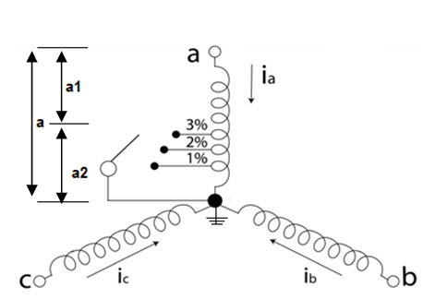

Figure1. 3ph Stator Winding

The voltage equations of the motor can be written as below:

V ^{s}_{abc} = r^{s}_{abc}i^{s}_{abc} + pλ^{s}_{abc},

0 = r^{r}_{abc}i^{r}_{abc} + pλ^{r}_{abc} (1)

λ^{s}_{abc} = [ λ^{s}_{a}λ^{s}_{b}λ^{s}_{c}] = L[i_{a}i_{b}i_{c}]

Where P = d/dt

Converting to dq stationary frame
X_{dq0} = K X_{abc} = [ X_{abc}] (2)
The voltage equations of stator and rotor are derived as:

v^{s}_{dq0} = r^{s}_{dq0}i^{s}_{dq0} + pλ^{s}_{dq0},

0 = r^{r}_{dq0}i^{r}dq0 − ω_{r}λ^{r}_{dq0} + p λ^{r}_{dq0} (3)
The stator resistances in the dq frame depend on the stator resistance values for each phase.
R^{s}_{dq0} = (4)
The Rotor resistance R^{r}_{dq0} = r^{r} I_{3x3} (5)

The Motor flux equation
= (6)
Based on a balanced Y 3ph induction motor, the neutral current has zero value I^{s}₀=I^{r}₀=0. According to balanced stator condition, the turns of each phase are equal (Na=Nb=Nc=Ns). The supply voltage in the dq frame is:

V_{q}^{s} = 2/3[V_{a}^{s}-0.5(V_{b}^{s}+V_{c}^{s})],

V_{d}^{s} = 1/ (-V_{b}^{s}+V_{c}^{s})

V₀^{s} = 1/3 (V_{a}^{s} + V_{b}^{s}+ V_{c}^{s}) (7)

The flux equations are:

pλ^{s}_{q} = V_{q}^{s}- r^{s}₁₁i^{s}_{q}- r^{s}₁₂ i^{s}_{d},

pλ^{s}_{d} = V_{d}^{s}- r^{s}₂₁i^{s}_{q}- r^{s}₂₂ i^{s}_{d},

pλ^{r}_{q} = - r^{r}_{r}i^{r}_{q}+ w λ^{r}_{d},

pλ^{r}_{d} = - r^{r}_{r}i^{r}_{d}- w λ^{r}_{q} (8)

The developed torque and speed are given by:

T_{d} = (3/2)(P)(λ^{s}_{d}i^{s}_{q}- λ^{s}_{q}i^{s}_{d}) (9)

Where P is number of pair poles

Pw_{m} = P / (2J) (T_{d} -T_{L}-Td_{amp}) (10)

  - Inter-turn fault case
Under “a” phase inter-turn fault, the motor parameters (stator resistance, inductance and the mutual inductance between all phases and the faulty phase) change as shown in Figure (1).

X (fault %) = N_{a2} (fault turns) / N_{a} (healthy phase turns) (11)

r_{sh} = X r_{a) healthy} = r_{a)f} ,

L_{a1a1)f} = (1-X) ² L_{asas)healthy} = L'_{asas} ,

L_{a2a2)f} = X² L_{m)healthy} = L_{shsh} ,

L_{a1a2)f} = (1-X)X L_{m)healthy} =L_{assh} ,

L_{asr} = (1-X)L_{m)healthy}, L_{m)healthy} = L'_{asr}+L_{shar} (12)

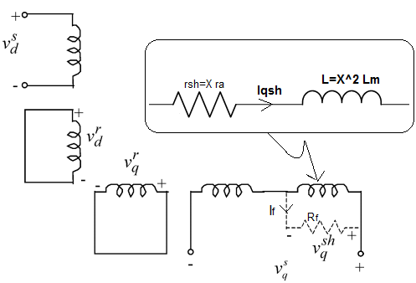

Figure2. 3ph Induction Motor In dq Frame with Turn Fault In q Phase Represent Phase a Fault

The flux equation in the dq frame after taking the shorted turns in consideration is:

= (13)
The stator resistance is given by:

= (14)
The flux linkage derived from equation (3) is:

pλ^{sh}_{q} = V_{q}^{sh} – r^{sh}i^{sh}_{q} ,
pλ^{s}_{q} = V_{q}^{s} - V_{q}^{sh} - r^{s}₁₁i^{s}_{q} - r^{s}₁₂ i^{s}_{d} ,

pλ^{s}_{d} = V_{d}^{s}- r^{s}₂₁i^{s}_{q} - r^{s}₂₂ i^{s}_{d},

pλ^{r}_{q} = - r^{r}_{r}i^{r}_{q}+ w_{r}λ^{r}_{d}, pλ^{r}_{d} = - r^{r}_{r}i^{r}_{d} - w_{r}λ^{r}_{q} (15)

The equations (10-14) show the induction motor dq modeling with fault conditions and the effect of fault severity on the motor parameters.

- Adaptive Neuro-Fuzzy Inference System
The Adaptive Neuro-Fuzzy inference system (ANFIS) depends on two main systems fuzzy logic (FL) and artificial neural networks (ANN).The Fuzzy logic acts as the human logic thinking and the neural network acts as human brain [13].Both the FL and ANN increase the system efficiency and decrease the mathematical equations compared to other detection methods [14]. The system is widely used for many applications of systems modelling, control systems and forecasting predictions [15]. The ANFIS consists of IF-then rules, training and learning algorithms [13].
For the Fuzzy inference system, consider a system with two inputs (X,Y) and one output (Z).The fuzzy rules based on 1st order Sugeno type [16] are:

Rule1: IF X is A1 and Y is B1 Then f1=p₁X+q₁Y+r₁,

Rule2: IF X is A2 and Y is B2 Then f2=p₂X+q₂Y+r₂,

A_{i},B_{i} are the Fuzzy set , f_{i} is the system outputs within the specified fuzzy rules and the p_{i},q_{i} and r_{i} are the design parameters based on the ANFIS training [7],[17-20]

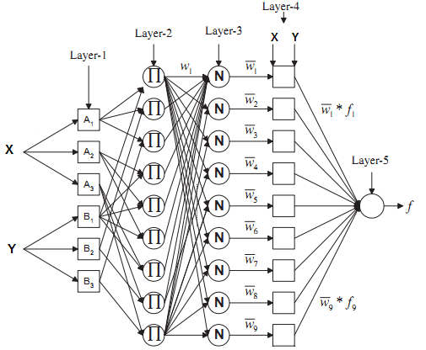

Figure.3: ANFIS Structure For Two I/P with Three MMF And One O/P

The adaptive neuro-fuzzy inference (ANFIS) network consists of five layers. A normalization layer more than the neuro-fuzzy network [21-34].
Layer 1 is the fuzzification layer adaptive nodes with bell membership function with equation of:
µA_{i}(X) = ,
µB_{i}(Y) = (16)
Where the m_{A}, mB, бA, бB, bA and b_{B} are the bell function parameters=1, 2, 3 [20]

MF1,i= µA_{i}(X) & MF1,i= µB_{i}(Y), for i=1,2,3 (17)

The A_{i} and B_{i} are the linguistic variable of X and Y
Layer 2 is the rules layer where its output is considered as fire strength of each node

W_{i} = µA_{i}(X)*µB_{i}(Y), i =1, 2, 3 (18)

Layer 3 is the normalization layer and its output is the normalized fire strength

_{i} = (19)
Layer 4 is the consequent layer where each node is an adaptive node and its output is the product of the consequent polynomial of fuzzy rules and normalized firing strength

f_{i} = (p_{i}X+q_{i}Y+r_{i}), i =1, 2, 3…9 (20)

Layer 5 is the deffuzification layer which has only one node (output node) and its output is the overall ANFIS output, summation of the layer 4 output

ƒ = (21)

- Simulation And Results
The developed fault analysis technique is investigated through MATLAB simulations. An induction motor with inter-turn stator faults is modelled in SIMULINK based on the equations presented in section II. Figure (4) illustrates the fault analysis system procedure.

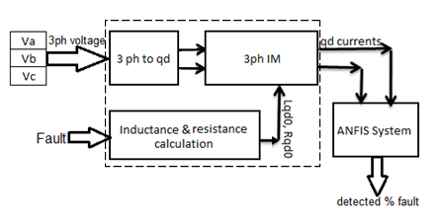

Figure.4: The Fault Analysis System For Induction Motor With Dq Modeling

The qd current indicate better resolution for fault detection. It increase as the fault percentage increases as per Figure (5)

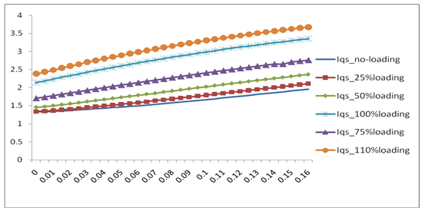

Figure.5: The d Current VS Fault Percentages (X %) At Different Loading

The fault detection technique uses an ANFIS network to estimate the inter turn fault percentage. Training and testing data are generated from the SIMULINK induction motor model. The motor loading condition was varied to simulate no-load, 25%, 50%, 75%, full-load and 110% loading. The inter turn fault percentage was varied to span the range of 0~16% with steps of 0.005. The total points are 199.
The ANFIS network was trained with 66% of the total data and checked/tested with the remaining 34%. The design is based on three input fuzzy membership functions. It was noticed that the learning phase was completed in the first 120 Epochs out of 300 iterations.
Figure (6) views the ANFIS error for the different loading cases and fault percentages estimating.

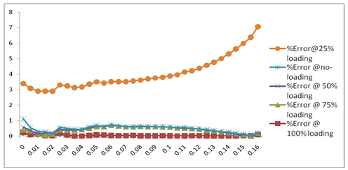

Figure.6: % Error VS Fault Percentages At Different Loading

The fault percentage at the 25% loading case gives the highest error as the ANFIS network was not trained with this fault data. The maximum % error is 6.83% at 25% loading and 16 % fault. The results illustrate the ANFIS accuracy for fault detection even for cases that were not included in the training data.
The network initial configure ration has an effect on the performance and accuracy of the fault diagnosis system. Table (1) shows the errors for a two input and three input membership functions. The three input membership function has lower error for testing and checking data.

Table 1: The Error Comparison for the Two and Three Membership

Error | Two MMF | Three MMF
Training data | 9*10-4 | 6*10-4
Testing (75%) | 6*10-3 | 4*10-3
Checking (25%) | 9*10-3 | 3*10-2

The fault severity was varied from 0% till 16%. However, an actual fault will be limited to 10% fault only at 110% loading based on the induction motor over load protection setting I_{o.l} = 1.5*I_{rated}

- Conclusion
This paper shows the fault diagnosis of inter turn fault of induction motor based on an artificial network system using of the stator dq currents. The dq stator currents give better resolution for inter-turn fault diagnosis. The ANFIS network detects the inter turn stator faults with high accuracy even for low fault percentages. The average ANFIS error is 1% among all the data training, testing and checking. The ANFIS initial structure has an effect on the fault detection system accuracy.

APPENDIX
The motor parameters are given in Table (2).

Table 2: Motor Parameters
parameter | Value
power | 2hp~1.5kw
no. poles | 4
R_{s} | 4.05 ohm
L_{ls} | 0.014H
R_{r} | 2.6 ohm
L_{lr} | 0.014H
L_{m} | 0.5387H
I_{rated} | 2.81A

REFERENCES
- Kripakaran, P., A. Naraina, and S. N. Deepa. Condition monitoring in induction motor by parameter estimation technique. In: Springer 2014 third International Conference on Soft Computing for Problem Solving; India: pp. 87-98
- Drif, M’hamed, and A. J. Cardoso. Stator fault diagnostics in squirrel cage three-phase induction motor drives using the instantaneous active and reactive power signature analyses. IEEE transactions on industrial informatics may 2014; 10: 1384-1360.
- Bindu, S., and Vinod V. Thomas. Diagnoses of internal faults of three phase squirrel cage induction motor—A review. In: IEEE 2014 International Conference on Advances in Energy Conversion Technologies (ICAECT): pp.48-54.
- Siddiqui, KhadimMoin, KuldeepSahay, and V. K. Giri. Health monitoring and fault diagnosis in induction motor-a review. IJAREEIE International Journal of Advanced Research in Electrical, Electronics and Instrumentation Engineering 2014; 3: 6549-6565.
- Karmakar. S, Chattopadhyay. S, Mitra. M & Sengupta. Turn-to-turn fault diagnosis of an induction motor by the analysis of transient and steady state stator current. Innovative Systems Design and Engineering 2014; 5: 65-74.
- A. Medoued, A.Lebaroud, A.Laifa & D.Sayad. Classification of induction machine faults using time frequency representation and particle swarm optimization. Journal of Electrical Engineering Technology 2014; 15: 742-749.
- W. Li, H. Zhao, X. Yang& W. Deng. Modularized fault diagnosis model of induction motor based on radial basis function neural network. Journal of Process Mechanical Engineering 2014; 0: 1-8.
- M. F. D’Angelo, R. M. Palhares, L. B. Cosme, L. A. Aguiar, F. S. Fonseca& W. M. Caminhas. Fault detection in dynamic systems by a Fuzzy/Bayesian network formulation. ELSEVIER 2014; 21: 647-653.
- P. C. Krause, O. Wasynczuk& S. D. Sudhoff. Analysis of electric machinery and drive systems. 2nd ed: John Wiley & Sons, 2013.
- Anna Philo Antony and R. Sankaran. Simulation of performance of a cage induction motor driven spooler drive with speed and current feedback using field-oriented control. IJAREEIE march 2014; 3: 7797-7806.
- Toshiji Kato, Kaoru Inoue, and Keisuke Yoshida. Diagnosis of stator‐winding‐turn faults of induction motor by direct detection of negative sequence currents. Electrical Engineering in Japan 2014; 186: 75-84.‏
- M. K. Ebrahimi and M. Ehsani. A general approach for current-based condition monitoring of induction motors. Journal of Dynamic Systems, Measurement, and Control 2014; 136: 1-26.
- Siddique, Nazmul and Hojjat Adeli. Computational intelligence: synergies of fuzzy logic, neural networks and evolutionary computing: John Wiley & Sons, 2013.
- A. A. Bohari, W. M. Utomo, Z. A. Haron, N.M. Zin, S. Y. Sim and R. M. Ariff. Vector control of induction motor using neural network. In: the 8th International Conference on Robotic, Vision, Signal Processing & Power Applications; 2014; Singapore: Springer. pp. 501-506.
- Chen, Cheng-Hung and Sheng-Yen Yang. Neural fuzzy inference systems with knowledge-based cultural differential evolution for nonlinear system control. ELSEVIER 2014; 270: 154-171.
- Siddique, Nazmul. Neuro-Fuzzy Control. Intelligent Control: Springer International Publishing, 2014.
- Chen, Seng-Chi, Dinh-Kha Le and Van-Sum Nguyen. Adaptive network-based fuzzy inference system (ANFIS) controller for an active magnetic bearing system with unbalance mass. In: Springer, AETA 2013 Recent Advances in Electrical Engineering and Related Sciences, Berlin Heidelberg, 2014. pp. 433-443.
- P. Subbaraj and B. Kannapiran. Fault detection and diagnosis of pneumatic valve using Adaptive Neuro-Fuzzy Inference System approach. ELSEVIER Applied Soft Computing 2014; 19: 362-371.
- Siddique, Nazmul. Fuzzy Control. In: Springer International Publishing, Intelligent Control, 2014. pp. 95-135.
- Boyacioglu, MelekAcar and DeryaAvci. An adaptive network-based fuzzy inference system (ANFIS) for the prediction of stock market return: the case of the Istanbul stock exchange. ELSEVIER expert systems with applications 2010; 37: pp. 7908-7912.‏
- P. M. Menghal and A. Jaya Laxmi. Neural Network based dynamic performance of induction motor drives. In: Springer, Proceedings of the Third International Conference on Soft Computing for Problem Solving; 2014; India.
- A. A. Hassan, M. R. Sayed and M A Moustafa Hassan. Power system quality improvement using flexible ac transmission systems based on adaptive neuro-fuzzy inference system. WSEAS Transactions on Power Systems 2013; 8: 1-13.
- J. Guan, D. Shi, J. M. Zurada& Levitan. Analyzing massive data sets: an adaptive fuzzy neural approach for prediction, with a real estate illustration. Journal of Organizational Computing and Electronic Commerce 2014; 24: 94-112.
- F. Faghani, M. Abzari, S. Fathi& S. A. H. Monajemi. Designing a stock trading system using Artificial Nero Fuzzy inference systems and technical analysis approach. International Journal of Academic Research in Accounting, Finance and Management Sciences 2014; 4: 76-84.
- Sharma Anurag , Jha Manoj and M. F. Qureshi. Governing Control and Excitation Control for Stability of Power System Based on ANFIS. IJIRSET 2014; 3: 13847-13855.
- Tamer S. Kamel, M A Moustafa Hassan. Adaptive Neuro Fuzzy inference system (ANFIS) for fault classification in the transmission lines. OJEEE 2010; 2: 2551-2555.‏
- G. Banu and S. Suja. Fault location technique using GA-ANFIS for UHV line. Archives of Electrical Engineering Journal 2014; 63: 247-262.
- Ali, Mohamed M. Ismail and Mohamed A. Moustafa Hassan. Speed sensorless field–oriented control of a six–phase saturated model of induction motors drive with online stator resistance estimation using ANFIS. International Journal of Modelling, Identification and Control 2012; 17: 334-347.
- Tamer S. Kamel, Mohamed A. Moustafa Hassan and Ahdab El–Morshedy. Advanced distance protection technique based on multiple classified ANFIS considering different loading conditions for long transmission lines in EPS. International Journal of Modelling, Identification and Control 2012; 16: 108-121.
- EM Abd El-Gawad, M. M. Hassan, M. A. M. Hallouda and O. Abul-Haggag. Stochastic modeling compared with artificial intelligence based approach for short term wind speed forecasting. Journal of American Science 2011; 7.
- Aziz, Abdel, Moustafa Hassan, and E. A. Zahab. Applications of ANFIS in high impedance faults detection and classification in distribution networks. In: IEEE International Symposium Diagnostics for Electric Machines, Power Electronics & Drives (SDEMPED); 2011.
- Ali, Mohamed M. Ismail, and M. A. Hassan. Parameter identification using ANFIS for magnetically saturated induction motor. International Journal of System Dynamics Applications (IJSDA) 2012; 1: 28-43.
- Abdel Aziz, M. A. Hassan, and E. A. El-Zahab. An artificial intelligence based approach for high impedance faults analysis in distribution networks. International Journal of System Dynamics Applications (IJSDA) 2012; 1: 44-59.
- H. A. T. Hussein, M. E. Ammar, M. A. M. Hassan, ANFIS based three phase induction motors stator turns fault analysis. In: WCIS 2014, Tashkent Uzbekistan; 1: 43-51.

