Salam Waley Shneen
Advanced Optimal For PV system coupled with PMSM

School of Electrical & Electronic Engineering, Huazhong University of Science and Technology /Wuhan, China
Electromechanical Engineering Department, University of Technology/Baghdad, Iraq

salam_waley73@yahoo.com

Abstract
The main advantages of PMSM are high torque density, high efficiency and small size. Photovoltaic power generation system PV generation technology is treated as the most promising technology among renewable energies. Photovoltaic (PV) power generation system is a promising source of energy with great interest in clean and renewable energy sources. To use different control systems, like Classical PI Controller, Expert System Fuzzy Logic Controller and Optimization PSO Controller. It used to control for power electronic (inverter) &PMSM which worked in the integration system to PV energy. There are two parts in this paper, first part advanced Optimal PSO, Fuzzy &PI Controller power electronic (inverter) with PV for using different control systems this part on the generator side at constant torque. Second part in the load side of variable torque, by using different control systems with PMSM to analyze all results after using the simulation model of proposed based PV system. The PV system is coupled with PMSM. A closed loop control system with a PI control, Fuzzy, PSO in the speed loop with current controllers. The main objective of the present work is to design a PV system by using Matlab Simulink program and apply this system to advance Optimal for PV system coupled with PMSM.

Keywords: PV, Inverter, PSO, FLC, PI Controller &PMSM

1. Introduction
Increasing orientation for the use of PV in industry and electrical appliances because PV energy is predictable to play a big role in future smart grids as distribution renewable source [1]. PV system with PMSM drive is investigated. The PV system application is prospected, in order to highlight the irradiation effect on the PV panel feeding the PMSM [2]. PV source to an AC voltage source by inverter has the ability for controlling a PMSM [3]. A way controller (PI) in addition to the controller integral relative formulated and implemented, using speed control magnet synchronous motor drive system and a permanent pilot phase. While the new strategy promotes traditional PI control performance to a large extent, and proves to be a model-free approach completely, it also keeps the structure and features of a simple PI controller [8].The use consoles mode instead of Fuzzy-PI control to improve the performance of engines of PMSM. To control the speed of PMSM motor using fuzzy logic (FL) approach leads to a speed control to improve the dynamic behavior of the motor drive system and immune disorders to download and parameter variations [9]. In the drive systems, and gains from the traditional can’t usually be set in proportion-integral (PI) controller speed large enough because of mechanical resonance. As a result, performance degradation and speed control. In our work described in this paper, have been adopted and fuzzy logic controller (FLC) for use in drive systems in order to improve the performance of the speed control. The proposed FLC has been compared with traditional PI control with respect to the speed of response and dynamic load torque. Simulation and experimental results have proved that FLC was proposed is superior to the traditional PI. This FLC can be a good solution for the high-performance engine lifts systems. A modern approach to control the speed of PMSM using particle swarm optimization (PSO) to improve the algorithm parameters observer PI-. Simulate the system under different operating year conditions is prepared and the experimental setup. Use PSO algorithm and optimization make a powerful engine, with faster response and higher resolution dynamic and sensitive to load variation [10-11].

2. Model for a PMSM Drive
In Figure1. Block diagram of a PMSM & Figure 2. Block diagram of a PMSM Drive.
The complete nonlinear model of a PMSM without damper windings is as follows:
$v_{q}{\text{ = Ri}}_{q}{\text{ + pL}}_{q}i_{q}\text{ + }ω_{s}(L_{d}i_{d}\text{ +}λ_{\text{af}})$ (1)
$v_{d}{\text{ = Ri}}_{d}\text{ + p}λ_{d}\text{ -}ω_{s}{\text{ L}}_{q}i_{q}$ (2)
v_{d} and v_{q} are the d,q axis voltages, id and iq are the d,q axis stater currents, Ld and Lq are the d,q axis inductance, R and $ω_{s}$ are the stater resistance and inverter frequency respectively. $λ_{\text{af}}$is the flux linkage due to the rotor magnets linking the stator.
The electric torque:
$T_{e}=\text{ 3P}(λ_{\text{af}}i_{q}+(L_{d}{\text{ - L}}_{q})i_{d}i_{q})\text{/2}$ (3)
The motor dynamics:
$T_{e}{\text{ - T}}_{L}+{Bω}_{r}+\text{Jp}ω_{r}$ (4)
P is the number of pole pairs , TL is the load torque , B is the damping coefficient, $ω_{r}$is the rotor speed and J the moment of inertia . The inverter frequency is related to the rotor speed as follows:
$ω_{s}={pω}_{r}$ (5)
The machine model is nonlinear as it contains product terms such as speed with id and iq. Note that$ω_{r}$, i_{d} and i_{q} are state variables. During vector control, i_{d} is normally forced to be zero
$T_{e}=\text{ 3P}λ_{\text{af}}i_{q}\text{ /2 }={\text{ K}}_{t}i_{q}$ (6)
k_{t}
Speed Control
Current Control

T_{L}
k_{t}
- - $ω_{r}$
T_{L}
- - i_{q}
i_{q} $ω_{r}$

$ω_{\text{ref}}$
+

v_{q}
Figure 1. Block diagram of a PMSM Figure 2. Block diagram of a PMSM Drive

3. Speed Control of PMSM Motor

(Figure3. Block Diagram of Speed Control of PMSM)The PMSM is using control to suppress harmonic noise to a level. then, noise to a level below and vibration translates into a more comfortable ride for passengers.IGBT SPWM inverters make the ride more smoother with precisely adjusting speed control with frequency and voltage regulation.It has the latest low-noise power units to make the ride even quieter.Elevator has directed high-speed used (1500 rpm) PMSM. Energy reform in the elevator geared for small rise because travel extremely small and fast.
PMSM

Load
Inverter
DC

Current
measurement
Current
Speed controller
Current controller
command

Speed measurement
Speed command

Figure 3. Block Diagram of Speed Control of PMSM
3.1. PI Controller Modeling

In the PI speed controller the machine speed is compared with the reference speed and the speed error is the nth sampling interval as
ωe[n] = ωr*[n] – ωr[n] (7)
The output of the speed controller gives the reference torque. Hence the output of the speed controller at the nth sampling interval is
T[n] = T[n-1] + Kp(ωe[n] – ωe[n-1]) + Ki.ωe[n] (8)
For constant air gap flux operation reference quadrature axis current is given as
iq* = T[n]/Kt (9)
The limiter is used to limit the maximum value of output of speed controller. The maximum machine rated current and device current of the converter dictate the limit.
Where,
ωe[n] is speed error at nth instant,ωr*[n] is the reference speed at nth instant
ωr[n] is the actual machine speed at nth instant,ωe[n-1] is the speed error at (n-1)th instant
T[n] is the reference torque at nth instant,T[n-1] is the reference torque at (n-1)th instant
Kp is proportional gain of the speed controller
Ki is integral gain of the speed controller is reference quadrature axis current
Kt is torque constant

3.2. Fuzzy Logic Controller
Fuzzy logic controllers have the following advantages over the conventional controllers that they are cheaper to develop, they cover a wide range of operating conditions, and they are more readily customizable in natural language terms. In Mamdani type FIS the crisp result is obtained by defuzzification, in the Mamdani FIS can be used for both multiple input and single output and multiple inputs multiple outputs system as shown in figure 4.

Post
processing
Rule
base
preprocessing
fuzzification
Defuzzification

Inferenc
engine

Figure 4: Arrangement of fuzzy logic controller
The usefulness of fuzzy logic controller is adopted especially in a complex and nonlinear system. The rules of conventional FLC are produced depend on the operator's experience or general knowledge of the system in a heuristic way. The thresholds of the fuzzy linguistic variables are usually chosen arbitrarily in the design process. An improper controller value leads to an adverse consequence, unstable mode, collapse and separation. This work propose BBO to design an Optimal Fuzzy Logic Controller OFLC, the optimized criteria is how to minimizing the transient state.
3.3. Particle Swarm Optimization
The biggest characteristic of PSO is in its simple structure, fast convergence, and its ability to prevent falling into a local optimum solution. At the same time, PSO is a random algorithm with a parallel structure. A uniform distribution is used to randomly create a particle swarm. Each particle represents a feasible solution to the problem, the particle swarm refers to the individual’s best experience, and the group’s best experience, and logically chooses the method it will move itself. After continuous iterations, the particle swarm will gravitate towards the optimum solution . For the i^{th} particle and n-dimensional space can be represented as an equation (12), the best previous position of its particle is recorded as equation (13):
The velocity is an essential part of how PSO work so as modified velocity and position of each particle can be calculated using the current velocity and distance from () to ():
Where n is the number of particles in a group; m is number of Dimension m=1, 2,…,. ; It is a pointer of iterations (generations); W is an inertia weight factor; c1, c2 are acceleration constants were often set to be 1.2 according to past experiences; r is random value in the range between [0,1]; : Velocity of particle no. i at iteration It., : Current position of particle i at iteration It. : Global best particle among all the particles in the population. In the above procedures, the parameter determined the resolution, or fitness, with which regions are to be searched between the present position and the target position, the inertia weight is set according to the equation (14).
(14)
Where: Itermax is the maximum number of iterations and Iter is the current number of iterations.
4. PMSM Connected PV System
PMSM–connected PV system has PV(Source), DC-AC Inverter and PMSM(Load) as show in figure 5. below.
PV
DC-AC
Inverter
PMSM

Figure 5. PMSM Connected PV System
The PV system based on the single-diode PV, the Photovoltaic equivalent circuit implement all the parameters represented in Equation (15)
Figure 6. Photovoltaic equivalent circuit

Iph: is the photocurrent, Io: is the diode saturation current, (NskT)/q is a thermal voltage of the array, Vt, Ns: number of cells in series, q=1.6 x10-19 C stands for the electron charge, k: meanwhile is the Boltzmann’s constant, 1.38 x 10-23 J/K, a: represents the diode ideal factor.
Rs : series resistance, Rp : parallel resistance, The photocurrent influenced by solar irradiance and temperature can be calculated as in Equation (16):
Iscr: is the short–circuit current at STC (25°C and 1000 W/m2), Isc is the short–circuit current temperature coefficient, λ: is the solar irradiance at 1000 W/m 2
I_{rs}: is the reverse saturation current, T_{r}: the 298K reference temperature, T: the operating temperature in K, Eg = 1.13 eV is the band energy gap of the semiconductor used in the cell, Reverse saturation current I_{rs} can be calculated as in Equation (18):
Voc: the PV cell open–circuit voltage
(18)

5-Simulation Analysis and Results

The PV connect with DC Load (Direct-coupled system) or AC Load (System with inverter) as show in figures (7&8):
INCLUDEPICTURE "http://www.simplecircuitsandprojects.com/images/solar/clip_image001.gif" \* MERGEFORMATINET INCLUDEPICTURE "http://www.simplecircuitsandprojects.com/images/solar/clip_image001.gif" \* MERGEFORMATINET INCLUDEPICTURE "http://www.simplecircuitsandprojects.com/images/solar/clip_image001.gif" \* MERGEFORMATINET INCLUDEPICTURE "http://www.simplecircuitsandprojects.com/images/solar/clip_image001.gif" \* MERGEFORMATINET INCLUDEPICTURE "http://www.simplecircuitsandprojects.com/images/solar/clip_image001.gif" \* MERGEFORMATINET INCLUDEPICTURE "http://www.simplecircuitsandprojects.com/images/solar/clip_image001.gif" \* MERGEFORMATINET 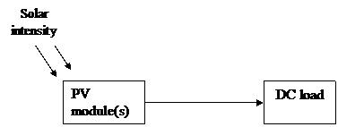 INCLUDEPICTURE "http://www.simplecircuitsandprojects.com/images/solar/clip_image002.gif" \* MERGEFORMATINET INCLUDEPICTURE "http://www.simplecircuitsandprojects.com/images/solar/clip_image002.gif" \* MERGEFORMATINET INCLUDEPICTURE "http://www.simplecircuitsandprojects.com/images/solar/clip_image002.gif" \* MERGEFORMATINET INCLUDEPICTURE "http://www.simplecircuitsandprojects.com/images/solar/clip_image002.gif" \* MERGEFORMATINET INCLUDEPICTURE "http://www.simplecircuitsandprojects.com/images/solar/clip_image002.gif" \* MERGEFORMATINET INCLUDEPICTURE "http://www.simplecircuitsandprojects.com/images/solar/clip_image002.gif" \* MERGEFORMATINET 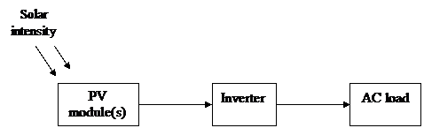
Figure 7.Direct-coupled system Figure 8.System with inverter
5-1 Simulation Result of PV connect with PMPM:
By using Simulation model of Generator Side by PV Source with Inverter, Inverter (DC-AC) is a fixed power converter PV system (DC output voltage) into AC output voltage.
The simulation model of PV system coupled with PMSM & Inverter as show in figure 9. The Simulation result as in figures (10, 13):
Figure 9. Simulation model of PV system coupled with PMSM & Inverter
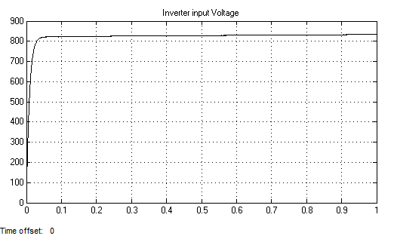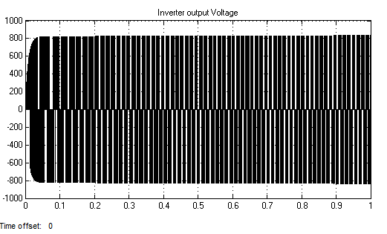

a. Simulation response of inverter input voltage b. Simulation response of inverter output voltage
Figure 10. Simulation response of inverter at constant torque a. inverter input voltage b. inverter output voltage
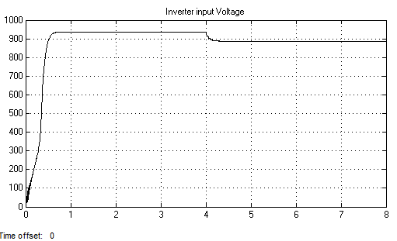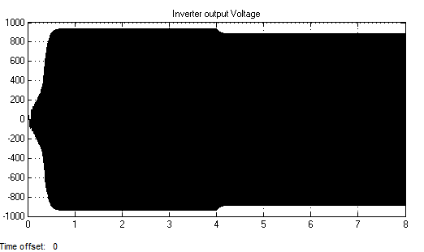
a. Simulation response of inverter input voltage b. Simulation response of inverter output voltage
Figure 11. Simulation response of inverter at variable torque
a. inverter input voltage b. inverter output voltage
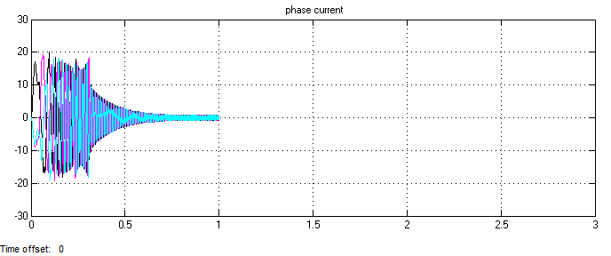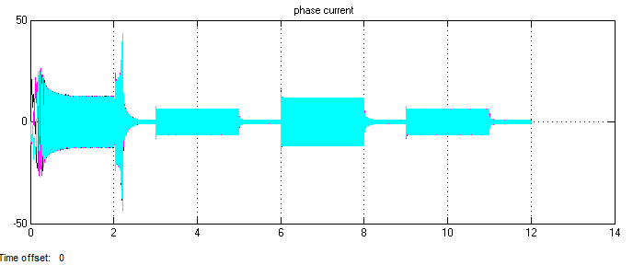
Figure 12. Simulation response of PMSM (AC Load) Figure 13. Simulation response of PMSM (AC Load) at
at constant torque variable torque {Torque= [20 0 10 0 20 0 10 0]N.m
5-2 Simulation Result of PV connect with PMDC:

To analyses the 1st step result as shown in the table 1. and show in figure 14.
At time between (t0-t1) has overshot, but at time between (t1-t2) has undershot and at time between (t2-t3) has small overshot, the steady state after that in( t3-tn).
Where, t0=0, t1=0.075, t2=0.015,t3=0.2, tn=2sec

Table 1. Simulation Response of PV direct connect with PMDC, constant torque ,T=50 N.m
Time(sec) | Speed(rpm) | Power(W) | Voltage(V) | Current(A)
to-t1 | 375 | 1900 | 60 | 32
t1-t2 | 335 | 1550 | 58 | 26
t2-t3 | 340 | 1610 | 58.5 | 27.5
t3-t4&t4-tn | 339.1 | 1600 | 58.44 | 27.33
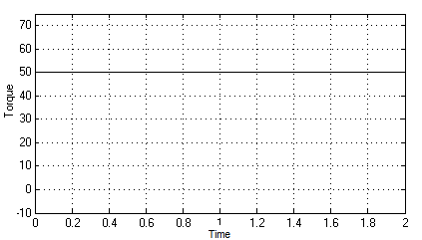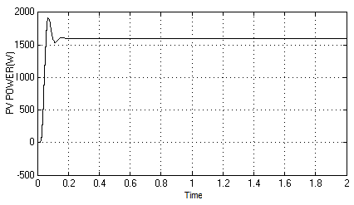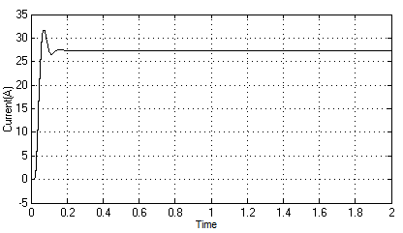
a-Torque b-Power c-Current
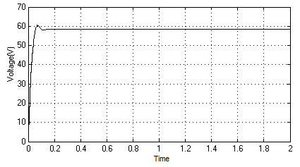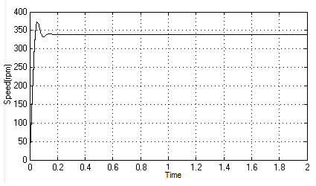
d-Voltage e-Speed
Figure 14. Simulation Response of PV direct connect with PMDC, constant torque ,T=50 N.m(a-Torque b-Power c-Current d-Voltage e-Speed)
To analyses the 2nd step result as shown in the table 2. and show in figure 15.
When, T=25 N.m: At time between (t0-t1) has overshot, but at time between (t1-t2) has undershot and at time between (t2-t3) has small overshot, the steady state after that in( t3-tn1).
When, T=50N.m: At time between (tn1-tn2) has overshot, but at time between (tn2-tn3) has undershot and at time between (tn3-tn4) has small overshot, the steady state after that in( t4-tm).
Where, t0=0, t1=0.075, t2=0. 15,t3=0.2, tn1=1sec and tn2=1.075, tn3=1.15, tn4=1.2, tm=2

Table 2. Simulation Response of PV direct connect with PMDC, constant torque ,T=25&50 N.m
Time(sec) | Speed(rpm) | Power(W) | Voltage(V) | Current(A) | Torque(N.m)
to-t1 | 300 | 750 | 51.5 | 14.5 | 25
t1-t2 | 290 | 660 | 50.8 | 13.5 | 25
t2-t3 | 293 | 710 | 51.3 | 14 | 25
t3-tn1 | 292 | 700 | 51 | 13.8 | 25
tn1-tn2 | 375 | 1900 | 60 | 32 | 50
tn2-tn3 | 335 | 1550 | 58 | 26 | 50
tn3-tn4 | 340 | 1610 | 58.5 | 27.5 | 50
t4-tm | 339.1 | 1600 | 58.44 | 27.33 | 50
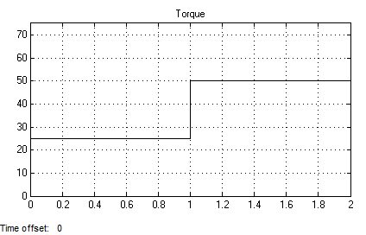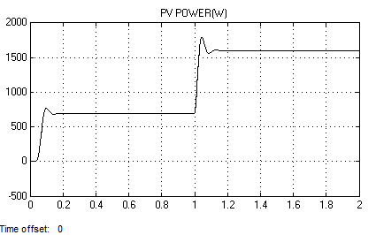 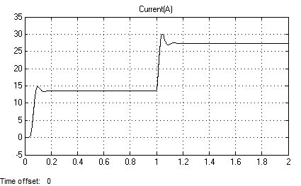 a-Torque b-Power c-Current
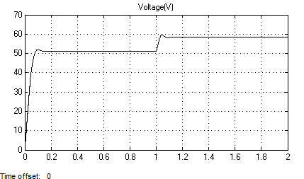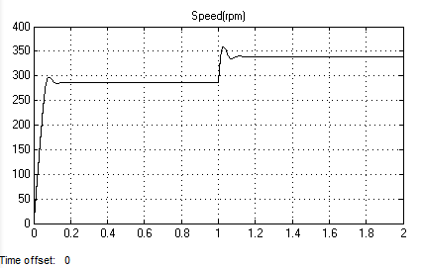
d-Voltage e-Speed

Figure 19 Simulation Response of PV direct connect with PMDC, variable torque,
T=(25 and 50 )N.m(a-Torque b-Power c-Current d-Voltage e-Speed)

5-3 Simulation Analysis and Results Use Different Control Systems

Final step, use different control systems, Like Classical PI Controller, Expert System Fuzzy Logic Controller and Optimization PSO Controller With PMSM to analysis all result. Simulation models(Classical PI Controller, Expert System Fuzzy Logic Controller and Optimization PSO Controller With PMSM)of this step as shown in figures (20-22) &The transfer function of the PMSM can be obtained from its state model by using the following formula:
T(S) = C [SI-A] B + D (19)

The simulation model as shown in figures(20-22)and simulation results as shown in figure (23).

a)PI Control b)Fuzzy_PI Control
c)PSO _PI Control d) PI Control, Fuzzy_PI
Control &PSO_PI Control
Figure 23.Simulation Response (pu) Of PI Control, Fuzzy_ PI Control &PSO_PI Control

CONCLUSIONS

To use different control systems as a case studies. To achieve this objective which characterizes each part of a system such as a PV module, controller and PMSM. After that to investigate the design connection topologies for all components of a PV system in order to study the operation of the system for different environmental conditions.
The simulation circuits for PMSM, inverter, speed and current controllers include all realistic components of the drive system. These results also confirmed that the transient torque and current never exceed the maximum permissible value. Modeling, analysis, testing and simulation a PV array under different conditions using MATLAB. Solar radiation is a material source of renewable energy and is likely for model a main source of future energy.
The performance of the PV system is obtained under wide change in PMSM speed with change in solar irradiation. PV system supplied PMSM drive for water pumping system. Three phase Inverter is controlled to supply PMSM under variation in solar irradiation to regulate discharge of water. PMSM is selected to be the motor for a drive EV owing to its different inherent advantages. The speed and torque tracking by the EV in various driving modes are presented.

REFERENCES

- Kumar L S C, Padma K. Matlab/Simulink Based Modelling and Simulation of Residential Grid Connected Solar Photovoltaic System[C]//International Journal of Engineering Research and Technology. ESRSA Publications, 2014, 3(3 (March-2014)).
- Mayssa F, Aymen F, Lassaâd S. Influence of photovoltaic DC bus voltage on the high speed PMSM drive[C]//IECON 2012-38th Annual Conference on IEEE Industrial Electronics Society. IEEE, 2012: 4489-4494.
- Moussa H, Fadel M, Kanaan H. A single-stage DC-AC boost topology and control for solar PV systems supplying a PMSM[C]//Renewable Energies for Developing Countries (REDEC), 2012 International Conference on. IEEE, 2012: 1-7.
- Kiran Boby-, Prof.Acy M Kottalil-, N.P.Ananthamoorthy, Simulation of PMSM Vector Control System with Fuzzy Self-Adjusting PID Controller Using MATLAB, International Journal of Scientific and Research Publications, Volume 3, Issue 3, March 2013, Page(s): 1 - 4
- Davendra Yadav, Sunil Bansal, Munendra Kumar,Design, Development & Simulation of Fuzzy Logic Controller to Control the Speed of Permanent Magnet Synchronous Motor Drive System, Journal of Electrical and Electronics Engineering Research Vol. 3(3),March 2011, Page(s):52-61,
- M.T. Benchouia , S.E. Zouzou, A. Golea, and A. Ghamri, Modeling and Simulation of Variable Speed Drive System with Adaptive Fuzzy Controller Application to PMSM, 2004 IEEE International Conference on Industrial Technology (ICIT), Page(s): 683 - 687.
- Xiao Xi; Li Yongdong ; Li Min,Performance control of PMSM drives using a self-tuning PID,2005 IEEE International Conference, Page(s): 1053 - 1057 .
- Francesco Parasiliti, and Daqing Zhang, Real-Time Gain Tuning of PI Controllers for High-Performance PMSM Drives, IEEE Transaction on Industry Applications, Vol. 38, No. 4, July/August 2002, Page(s): 1018 - 1026.
- Madhumita Chakraborty , Comparative Analysis of Speed Control of PMSM using PI-Controller and Fuzzy Controller, International Journal of Scientific & Engineering Research, Volume 4, Issue 7, July-2013, Page(s):103-108
- Weihua Li , Ziying Chen , Wenping Cao ’ptimization of Permanent Magnet Synchronous Motor Vector Control System Based on Particle Swarm Optimization,Journal of Information & Computational Science,September 1, 2014,pages 4687–4696.
- B.Jaganathan, R.Brindha, Pallavi Murthy, Nagulapati Kiran,Swetha.S’An Online Tuning of a PMSM for Improved Transient Response Using Ziegler-Nichol’s Method’Proc. of Int. Conf. on Advances in Electrical & Electronics 2010,pages189-192.
- Shneen S W, Mao C. Artificial Optimal Fuzzy Control Strategy for Elevator Drive System by Using Permanent Magnet Synchronous Motor[J]. TELKOMNIKA Indonesian Journal of Electrical Engineering, 2015, 14(3).
- Attiya A J. Compared with PI, Fuzzy_PI & PSO_PI Controllers of Robotic Grinding Force Servo System[J]. TELKOMNIKA Indonesian Journal of Electrical Engineering, 2015, 16(1).

