Olive Trees Cases Classification Based on deep CNN from UAV imagery
NOOR A. SEHREE* 1, ABDULSTTAR M. KHIDHER 2 (ASSISTAT PROFESSOR)
1 Technical Engineering College, Northern Technical University, Mosul, IRAQ
2 Computer Systems Technology, Mosul Technical Institute, Mosul, IRAQ
Abstract:
Unmanned Aerial Vehicles (UAVs) are one of the various aerial remote sensing platforms, ease-of-use, and cost-effectiveness can deliver high-resolution imaging obtained using a variety of sensors. Photogrammetric data is derived by the use of Unmanned Aerial Systems (UAS, which consists of a UAV, sensor(s), and base station). As a result of these types, vegetation monitoring is conceivable. Deep neural networks have had a lot of success with image classification problems from platforms Remote sensing. In this paper, we demonstrate how deep neural networks can be used to classify olive trees from aerial images. We have addressed a multi-class classification problem. As the backbones for our work, we compared five different architectures: VGG16, ResNet50, MobileNet, Xception, and VGG19, which employ skip connections via a residual layer, yielded the best results on the test set. We used metrics such as accuracy, precision, recall, and confusion metric to evaluate the results. With accuracy, our model achieves the best results using ResNet50.
- Introduction:
Now a day computer-aided techniques are used for fast processing Unmanned Aerial Vehicles (UAVs) are one of the various aerial remote sensing platforms that are available. combined this technique with a Convolutional neural network (CNN) is used in the Deep Learning model to automatically extract features and classify images using a fully connected network or more. One most important use for the classification of plant diseases. Olives are one of the most cultivated plants in the world, and they are susceptible to a variety of diseases that reduce crop productivity.
Diseases primarily influence the state and color of olive tree leaves, Because diseases have similar patterns, making them visible is a major challenge[1]. As per the Food and Agriculture Organization, pests cause a 20 to 40% loss in global crop production each year (FAO). As a result, smart agriculture is the best option for farmers to use artificial intelligence techniques combined with modern information[2].
In 2019 (Aravind, KR et al) presented transfer network to VGG16 and other transfer network model AlexNet using dataset capture from six smartphones the best accuracy of VGG16 is 93.33%, and then modified VGG16 by adding a fully connected layer with 4096 neurons to the last fully connected layer the accuracy 96.70%[3] (Madallah Al. et al), employed two pre-trained DL models, AlexNet and GoogLeNet for plant disease classification. An accuracy of 99.35 percent was attained using the Plant Village dataset of damaged and healthy plant leaves.[4].( Xin Zhao et al) A new method for assessing rice lodging was proposed, which is based on a deep learning UNet (U-shaped Network) architecture. image (dataset)taken by the UAV fitted with a multispectral camera and a high-resolution digital camera according to the results the dice coefficients on the RGB and multispectral datasets reach 0.9442 and 0.9284, respectively[5]. (Madallah A. et al ) their improved Convolutional Neural Networks (CNNs) AlexNet, for olive disease detection and classification, was proposed. Its key contribution is to increase the accuracy of diagnosing olive illnesses[1]. ) Harvey Wu et al) presented For imaging plants in the field, small unmanned aerial vehicles (UAVs) are used with a Sony Alpha 6000 The camera was mounted to a DJI Matrice. The first two stages of DeChant et althree-stage.'s CNN pipeline were used to create the image analysis method. (DeChant et al.) used (Jayme Garcia Arnal Barbedo) created in 2017[6] ( classified plant diseases using images taken with a variety of sensors (smartphones, compact cameras, and DSLR cameras) and deep learning techniques (GoogleLeNet). [7]
In 2020 the( Sinan Uğuz1) Used a Single Shot Detector, researchers developed a technique to identify olive peacock spot disease (SSD) The average accuracy (AP) value achieved was 96% percent[8]. (Mireguli A. et al) used a fixed-wing UAV for red–green–blue (RGB) imaging and (CNN)-based VGG16 and VGG19 models. The classification accuracy was 95.6%.to classify plant communities[9]
(Shanmugasudaram. M) worked to develop a classification system for plant diseases like (Early and late blight of potato and tomato, Tomato target spot) on Lenet-5 Architecture Images of crop plant leaf disease were obtained from the Plant Village repository, the validation accuracy 99%.[10].)Utpal B.( presented a citrus leaf disease classification system using the MobileNet CNN and CNN architecture. More helpful and accurate for smartphone image-based citrus leaf disease classification [11]. (Zhao. Z et al ) were using (UAS) for aerial imagery with three different convolutional neural networks (simple convolutional neural network, VGG-16, and GoogLeNet) for wheat lodging detection[12]. (Everton. C el at) introduced five deep learning architectures to classify soybean pests (inception-v3, Resnet-50, VGG-16, VGG-19, and Xception). The highest classification accuracy it obtained was up to 93.82% of the dataset captured in real field using UAV[13]
In 2021 (Emilio . G and al at)presented mask RCNN to detected olives tree using UAV remote sensing the use of RGB Or NDVID or GNDVI not important is not important, and the increase in the number of data did not affect the accuracy result of the accuracy of Mask RCNN[14]. Also previously, several studies were conducted to discover plant diseases based on deep learning and CNN networks, which adopted a database whose data is available on the Internet a (plant village) [15] [7] website. another study was done to discover some diseases that affect trees, from the Ultra Spectrum Linear Scanner Thermal images RGB and hyperspectral images are useful, but the cameras for drones were large and bulky. Which was used to collect data [16]. )Vijaypal S et al) introduce a survey of previous studies that used pre-trained deep learning networks to predict various plant diseases such as (tomatoes, maize, rice ... etc.) was presented During this survey, the accuracy of each type of neural network used in the classification and prediction of diseases on different crops was shown.[17]. (Yunyun S. et al) the proposed approach achieves based on a deep Transfer learning neural network (ResNet, and DenseNet) database from plant village to Identification Plant Diseases[18]. (Venkat M et al) using the convolutional neural networks (ResNet-100 VGG-16, and VGG-19)to classification Seed Phenotyping UAV imagery the better accuracy ResNet-101[19].
These reviews demonstrated the ability of commonly used deep learning models to cope with a variety of objectives, as well as the usage of artificial intelligence in agriculture by implementing various neural network models.
In this study, a database of aerial images spotted by the drone was adopted, which is the most prominent modern technology for remote sensing. These pictures were taken from different heights, and they are real field pictures that were taken of the olive groves of a village in the city of Mosul, northern Iraq. The purpose of the study is to classification four cases from olives trees (healthy, dead, healthy high density, and disease olive trees) due it is an important crop and affects the agricultural economy and is included in industrial agriculture
  - Artificial intelligence: Over the last two decades, artificial neural networks (ANNs) have been employed in a variety of applications
including classification, pattern recognition, regression, and forecasting. Between the input and output layers of an ANN are hidden layers[20]. All global patterns in the input space are learned in an ANN, while CNN's are useful. In contrast to ANNs, which learn global patterns, CNNs learn key local patterns detected in the input.[21].

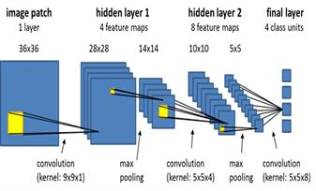
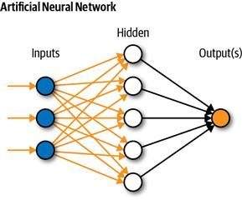

Fig (1): Artificial neural network Fig (2): Main architecture of CNN

1.2 Machine learning (Ml): Many fields employ machine learning (ML) techniques. Machine learning (ML) is a term that describes the processes that allow computers to think using various learning approaches. It's also known as a domain, and it's a subset of Artificial Intelligence (AI)In recent years, deep learning (DL) has emerged as a promising, novel, and cutting-edge technology for data processing. It's a better form of Artificial Neural Networks (ANN), which is one of today's most prominent AI technologies.[22].
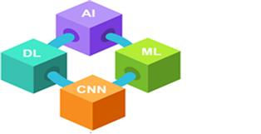

Fig (3): Artificial intelligence progression diagram (AI, artificial intelligence; CNN, convolutional neural network)

1.2.1. Machine learning(ML) and DL Learning (DL)in agriculture
With the rise of big data technologies and high-performance computers, machine learning and DL algorithms have opened up new possibilities for data-intensive science in multidisciplinary agri-technologies. in agricultural Crop management, which included applications such as yield prediction, disease detection, weed detection, crop quality, and species recognition machine learning to sensor data, is evolving into real-time artificial intelligence-enabled algorithms that provide insights for farmer decision support.[23] Remote sensing aircraft are used, which are unmanned aircraft, with digital image processing techniques. In the detection and identification of the most important problems related to agriculture In this research paper, the focus is on the classification of olive trees cases through images of unmanned aircraft vehicles (UAV).
1.3 Application of UAV in agriculture:
Unmanned Aerial Vehicles (UAVs) can revolutionize agriculture, and this platform has grown in importance as the digital farming era unfolds. Where traditional satellite sensing is still unsatisfactory, UAV imaging could improve or even replace routine data assessments. Data science has advanced significantly in recent years [24]. This technology is used in agriculture to help monitor crops from afar, making it easier to make decisions about the state of the field. There are various types of UAVs for different agricultural operation purposes to monitor and detect different plant diseases based on deep learning networks and convolutional neural networks such as DJI s1000, DJI s800, and phantom 4 pro And other types of drones used to discover plant disease[25].
2. Materials and information
2.1 Research topic and data:
In this study, a field study area was chosen to capture aerial photographs of olive groves trees using DJI (Mavic ari2) unmanned aerial vehicles (UAVs) in Al-Fadiliyah, one of the largest villages in Nineveh Governorate, northern Iraq, with a geographical location of (N 36°29' 31.9308" E43°15'.4608") to form the researcher's dataset, which was used in this study, and the application of deep learning networks The total number of photos is 1700, with each image having a resolution of 296 by 296 pixels. Figure 4 shows a map of the research area.
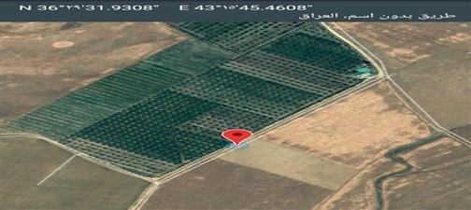
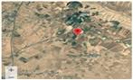

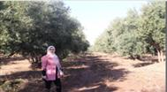

Fig (4) study area
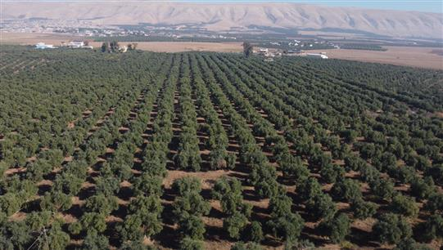

Fig (5) aerial image of trees olives for the study area
2.2 Data pre-processing: After the aerial photographs are collected by the DJI (Mavic ari2) drone in this study, the aerial images are preprocessed by performing numerous procedures aimed at obtaining a huge amount of data. Image processing improves the image's information so that it's easier to understand. The photographs are improved or cropped to acquire the images to be dealt with, and the color intensity is increased to highlight the images of the damaged plant. The application is applied after this processing step is finished. Artificial neural network data that has been preprocessed

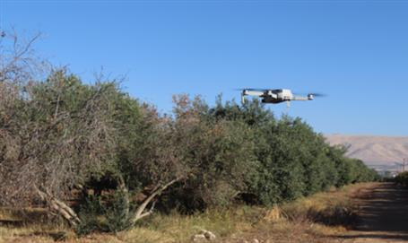

Fig (6)Dji Mavic ari2(UAVs)

3. work methodology and Result
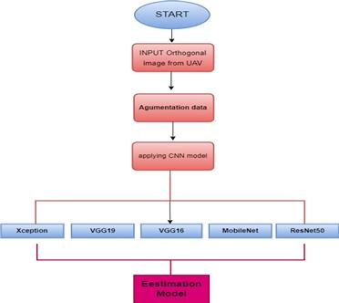
3.1 Researcher methodology: The work methodology used in this study takes place in obtaining data through aerial photography from drones pre-processing the data, designing the artificial network algorithm, The deep learning model was fed with the collected data sets, which are the data set for healthy trees, high and low density, the data set for trees affected by Verticillium wilt disease, as well as the data set for dead trees. and then practical application of the data on it. After that, the performance of the network is evaluated through the results obtained. Figure (7) shows the work methodology
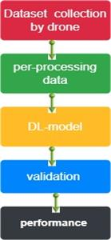

- ( b)
Fig (7):a: Researcher steps b: Researcher work methodology
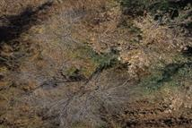
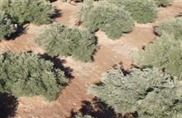

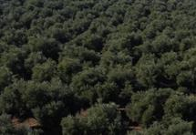
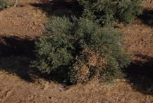

Fig (8): sampling of data from (UAVs)for four classes of olive trees

3.2 Data Augmentation(DA):
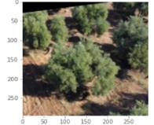
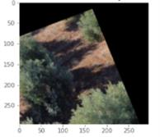
DA techniques improve classification accuracy the process of increasing data is closely related to the improvement of the accuracy and stability of deep learning network models. This increase includes the generation of new data to expand the available dataset [26], and this method has proven its effectiveness in the fields of image processing and object recognition, giving the network high accuracy as a result of the increased number of data and extraction of more information from the original data. DA will help the field produce high-quality, reproducible results by training DL algorithms on datasets
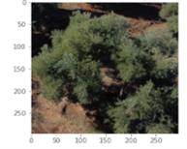
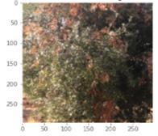

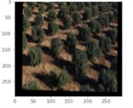
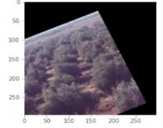

Fig (9): a sampling of data argumentation
3.3 Deep learning transfer Modeling:
Several algorithms have been used to detect crop diseases [27 ], the most well-known of which are the Visual Geometry Group algorithms ( VGG19 [28]VGG16 [28][29]). Other networks for learning transfer include the Residual Neural Network ( ResNet50 [28] [29][30]previously trained these networks on a large dataset (ImageNet). This type of deep learning transfer network is useful in the field of image classification because it transfers learning and training to the image classification state, resulting in more effective results than if the training was started from the beginning [31]in addition to ResNet50 VGG16 and VGG19, the trained and tested under the same conditions other, well-known, deep learning models: MobileNet[32] and Xception[33] al network, In this work, the field data obtained from the unmanned aerial vehicle for olive orchard trees will be applied to the mentioned learning transmission networks, and the accuracy of the results for each network will be compared.
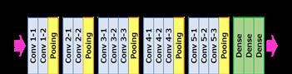
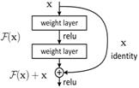

Fig (10). Schematic diagrams of vgg16 Fig (11) Schematic diagrams architecture of ResNet
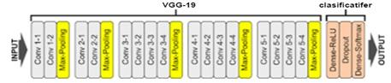

Fig (12). Schematic diagrams architecture of vgg19
3.4 Researchers work
The data was obtained in the field, which in this case was a sequence of aerial images shot by the DJI Mavic ari2 drone. Olive groves were depicted in the aerial shots, which totaled(1705). The goal of this research work is to find and distinguish between infected and healthy olive trees (the disease in question). The goal of this study is to determine whether healthy olive trees have a high density or not, as the photos were divided into four groups to conduct the study and apply deep learning networks, which are a sort of transfer on deep learning networks. Layer Completely Connected.
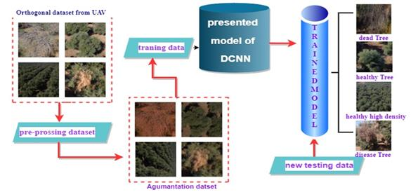

Fig (13): Researchers work

In this work, two fully connected (FC) layers were added to each transfer learning network which was used to classification olive trees case to obtain better accuracy. A new fully connected layer is simply a feed-forward neural network. Fully connected layers are found at the very bottom of the network. A fully connected layer receives input from the output layer of the final pooling or convolutional layer. which is flattened before it is used as input Flattening the output entails unrolling all values obtained from the output after the last pooling or convolutional layer. as a vector (3D matrix) [34]].
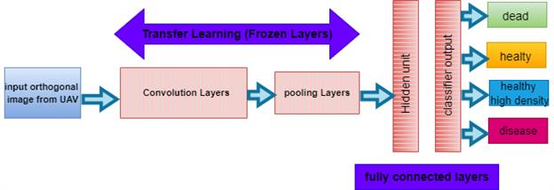
Fig (14): proposed Deep CNN
4. Result
After choosing the deep learning check model, applying our data to these networks, and implementing each type of network at a rate of 100 epochs, where the size of the images used in this study was (296 x 296) pixel, as the results obtained were as follows for each type of network used in this study. Table (1) the model of deep learning ResNet50 given the high accuracy than other models. The accuracy for each model was calculated from equation (1), Table (2) shows the result of the confusion matrix and Training and validation accuracy for each model of DCNN as well as the calculation of Recall (2) precision (3)and selectivity(4)where (TP)is the true positive (FP)is the false positive (FN) is the false negative is the true negative(TN) as shown in Table (3)

Accuracy( % ) =$\frac{TP+TN}{TP+FP+FN+TN}$100% (1)
Table (1): Accuracy results for deep learning networks
Model DCNN | Accuracy%
Xception | 86.7
MobileNet | 92.5
VGG19 | 94.1
VGG16 | 95.7
ResNet50 | 97.2

Table (2): (a)confusion matrix(b): Training and validation accuracy
DCNN | (a)confusion matrix | (b)Training and validation accuracy
xception | 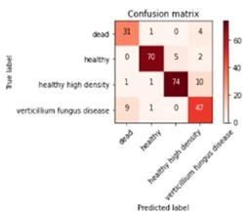 | 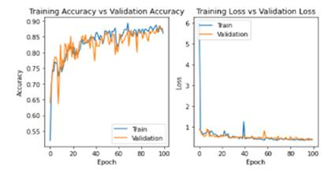
MobileNet | 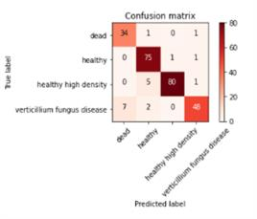 | 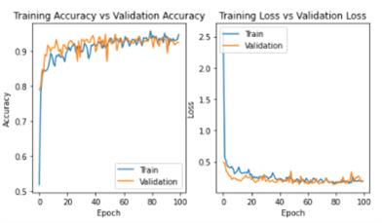
Vgg19 | 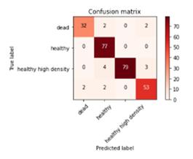 | 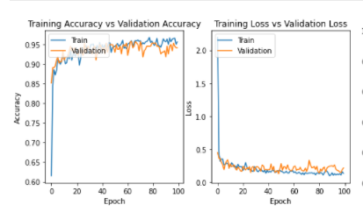
Vgg16 | 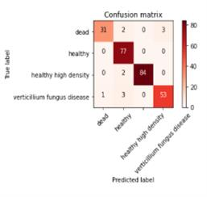 | 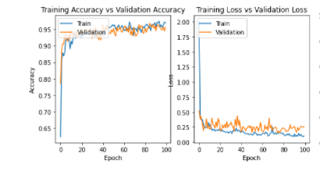
ResNet50 | 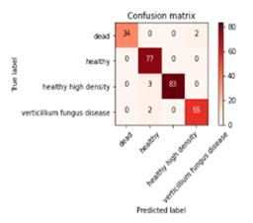 | 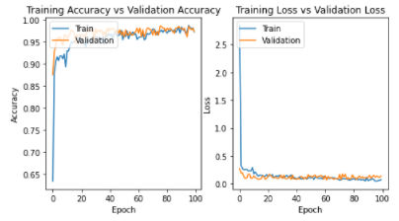

Recall= $\frac{TP}{TP+FN} (2)$
Precision$= \frac{TP}{TP+FP}$ (3)
specivity=$\frac{TN}{TN+FP}$ (4)

Olive tree classification | Dead |  |  | Healthy |  |  | Healthy high density |  |  | Verticillium fungus disease
Model of DCNN | Precision | recall | specivity | Precision | recall | specivity | Precision | recall | specivity | Precision | recall | specivity
Xception | 75.4 | 86.11 | 95.45 | 95.8 | 95.8 | 98.3 | 93.6 | 86.09 | 97 | 74.6 | 82.4 | 91.9
MobileNet | 82 | 0.94 | 96.8 | 90 | 97.4 | 96.2 | 98 | 93 | 99.4 | 94 | 84.4 | 98.5
VGG16 | 96.8 | 86.11 | 99.5 | 91.6 | 1 00 | 96.0 | 100 | 97.6 | 100 | 94.6 | 92.9 | 98.4
VGG19 | 99 | 88.8 | 94.14 | 96 | 100 | 90.5 | 100 | 91 | 100 | 97 | 92.9 | 91.3
ResNet50 | 100 | 94.4 | 100 | 93.9 | 100 | 97.99 | 100 | 96.5 | 100 | 96.4 | 96.4 | 98.8
Table (3): Result of DCNN models

5. Conclusion:
The data that was adopted in this study were aerial photographs of olive orchard trees that were obtained in the field by the drone camera. The purpose of the study is to distinguish the condition of the trees if they are healthy or healthy with a high density or if they are infected with verticillium wilt disease or if the trees are dead as a result of infection with wilt disease. Five models of the deep learning network were applied modified Xcepion, MobileNet, VGG19, VGG16, and ResNet50 in this study, and it was found from the results obtained that the network of ResNet50 is the best. It obtains a higher accuracy than the other models, and the classification accuracy reached (97.2%). The objective is to apply this model to classify the types of diseases affecting olive trees

Reference:
[1] M. Alruwaili, S. Alanazi, S. A. El-Ghany, and A. Shehab, “An efficient deep learning model for olive diseases detection,” Int. J. Adv. Comput. Sci. Appl., vol. 10, no. 8, pp. 486–492, 2019, doi : 10.14569/ijacsa.2019.0100863.
[2] M. E. Karar, F. Alsunaydi, S. Albusaymi, and S. Alotaibi, “A new mobile application of agricultural pests recognition using deep learning in a cloud computing system,” Alexandria Eng. J., vol. 60, no. 5, pp. 4423–4432, 2021, doi: 10.1016/j.aej.2021.03.009.
[3] K. R. Aravind, P. Raja, R. Ashiwin, and K. V. Mukesh, “Disease classification in Solanum melongena using deep learning,” Spanish J. Agric. Res., vol. 17, no. 3, 2019, doi: 10.5424/sjar/2019173-14762.
[4] M. Alruwaili, S. A. El-Ghany, and A. Shehab, “An enhanced plant disease classifier model based on deep learning techniques,” Int. J. Eng. Adv. Technol., vol. 9, no. 1, pp. 7159–7164, 2019, doi: 10.35940/ijeat.A1907.109119.
[5] X. Zhao, Y. Yuan, M. Song, Y. Ding, F. Lin, and D. Liang, “Use of Unmanned Aerial Vehicle Imagery and Deep Learning UNet to Extract Rice Lodging,” pp. 1–13, 2019.
[6] H. Wu et al., “Autonomous Detection of Plant Disease Symptoms Directly from Aerial Imagery,” Plant Phenome J., vol. 2, no. 1, pp. 1–9, 2019, doi: 10.2135/tppj2019.03.0006.
[7] J. G. Arnal Barbedo, “Plant disease identification from individual lesions and spots using deep learning,” Biosyst. Eng., vol. 180, no. 2016, pp. 96–107, 2019, doi: 10.1016/j.biosystemseng.2019.02.002.
[8] S. UĞUZ, “Automatic Olive Peacock Spot Disease Recognition System Development by Using Single Shot Detector,” Sak. Univ. J. Comput. Inf. Sci., vol. 3, no. 3, pp. 158–168, 2020, doi: 10.35377/saucis.03.03.755269.
[9] M. Ainiwaer, J. Ding, and N. Kasim, “Deep learning-based rapid recognition of oasis-desert ecotone plant communities using UAV low-altitude remote-sensing data,” Environ. Earth Sci., vol. 79, no. 10, pp. 1–11, 2020, doi: 10.1007/s12665-020-08965-w.
[10] A. Dubey and M. Shanmugasudaram, “Agricultural plant disease detection and identification,” Int. J. Electr. Eng. Technol., vol. 11, no. 3, pp. 354–363, 2020, doi: 10.34218/IJEET.11.3.2020.038.
[11] U. Barman, R. D. Choudhury, D. Sahu, and G. G. Barman, “Comparison of convolution neural networks for smartphone image-based real time classification of citrus leaf disease,” Comput. Electron. Agric., vol. 177, no. January, p. 105661, 2020, doi: 10.1016/j.compag.2020.105661.
[12] Z. Zhang, P. Flores, C. Igathinathane, D. L. Naik, R. Kiran, and J. K. Ransom, “Wheat lodging detection from UAS imagery using machine learning algorithms,” Remote Sens., vol. 12, no. 11, 2020, doi: 10.3390/rs12111838.
[13] E. C. Tetila et al., “Detection and classification of soybean pests using deep learning with UAV images,” Comput. Electron. Agric., vol. 179, no. May, 2020, doi: 10.1016/j.compag.2020.105836.
[14] A. Safonova, E. Guirado, Y. Maglinets, D. Alcaraz-Segura, and S. Tabik, “Olive tree biovolume from UAV multi-resolution image segmentation with mask r-CNN,” Sensors, vol. 21, no. 5, pp. 1–17, 2021, doi: 10.3390/s21051617.
[15] K. Manjula, S. Spoorthi, R. Yashaswini, and D. Sharma, “Plant Disease Detection Using Deep Learning,” in Lecture Notes in Electrical Engineering, vol. 783, no. May 2022, pp. 1389–1396.
[16] F. Sabrina, S. Sohail, S. Thakur, S. Azad, and S. Wasimi, “Use of Deep Learning Approach on UAV imagery to Detect Mistletoe Infestation,” 2020 IEEE Reg. 10 Symp. TENSYMP 2020, no. January, pp. 556–559, 2020, doi: 10.1109/TENSYMP50017.2020.9230971.
[17] V. S. Dhaka et al., “A survey of deep convolutional neural networks applied for prediction of plant leaf diseases,” Sensors, vol. 21, no. 14, 2021, doi: 10.3390/s21144749.
[18] Y. Sun, Y. Liu, H. Zhou, and H. Hu, “Plant diseases identification through a discount momentum optimizer in deep learning,” Appl. Sci., vol. 11, no. 20, 2021, doi: 10.3390/app11209468.
[19] V. Margapuri, N. Penumajji, and M. Neilsen, “Seed Classification using Synthetic Image Datasets Generated from Low-Altitude UAV Imagery,” pp. 116–121, 2022, doi: 10.1109/icmla52953.2021.00026.
[20] M. A. Alamir, “An artificial neural network model for predicting the performance of thermoacoustic refrigerators,” Int. J. Heat Mass Transf., vol. 164, p. 120551, 2021, doi: 10.1016/j.ijheatmasstransfer.2020.120551.
[21] H. Quang and N. Vo, “Realization and Verification of Deep Learning Models for Fault Detection and Diagnosis of Photovoltaic Modules,” 2020.
[22] F. BAL and F. KAYAALP, “Review of machine learning and deep learning models in agriculture,” Int. Adv. Res. Eng. J., vol. 5, no. 2, pp. 309–323, 2021, doi: 10.35860/iarej.848458.
[23] K. G. Liakos, P. Busato, D. Moshou, S. Pearson, and D. Bochtis, “Machine learning in agriculture: A review,” Sensors (Switzerland), vol. 18, no. 8, pp. 1–29, 2018, doi: 10.3390/s18082674.
[24] L. R. do Amaral, C. Zerbato, R. G. de Freitas, M. R. B. Júnior, and I. O. P. da Silva Simões, “UAV applications in Agriculture 4.0,” Rev. Cienc. Agron., vol. 51, no. 5, pp. 1–15, 2020, doi: 10.5935/1806-6690.20200091.
[25] K. Neupane and F. Baysal-Gurel, “Automatic identification and monitoring of plant diseases using unmanned aerial vehicles: A review,” Remote Sens., vol. 13, no. 19, 2021, doi: 10.3390/rs13193841.
[26] E. Lashgari, D. Liang, and U. Maoz, Data Augmentation for Deep-Learning-Based Electroencephalography. pp. 1–55.
[27] P. D. Detection and D. Learning, “Plant Disease Detection and Classification by Deep Learning,” pp. 32–34, 2019.
[28] K. Thenmozhi and U. Srinivasulu Reddy, “Crop pest classification based on deep convolutional neural network and transfer learning,” Comput. Electron. Agric., vol. 164, no. June, p. 104906, 2019, doi: 10.1016/j.compag.2019.104906.
[29] D. T. R. R. Sedamkar, “Detecting Affect States Using VGG16, ResNet50 and SE ‑ ResNet50 Networks,” SN Comput. Sci., pp. 1–7, 2020, doi: 10.1007/s42979-020-0114-9.
[30] E. Rezende, G. Ruppert, T. Carvalho, F. Ramos, and P. De Geus, “Malicious software classification using transfer learning of ResNet-50 deep neural network,” Proc. - 16th IEEE Int. Conf. Mach. Learn. Appl. ICMLA 2017, vol. 2017-Decem, pp. 1011–1014, 2017, doi: 10.1109/ICMLA.2017.00-19.
[31] X. Han and R. Jin, “A Small Sample Image Recognition Method Based on ResNet and Transfer Learning,” Proc. - 2020 5th Int. Conf. Comput. Intell. Appl. ICCIA 2020, pp. 76–81, 2020, doi: 10.1109/ICCIA49625.2020.00022.
[32] U. Kulkarni, S. M. Meena, S. V Gurlahosur, and U. Mudengudi, “Classification of Cultural Heritage Sites Using Transfer Learning Classification of Cultural Heritage Sites Using Transfer Learning,” no. September, 2019, doi: 10.1109/BigMM.2019.00020.
[33] K. Hasan et al., “Cataract Disease Detection by Using Transfer Learning-Based Intelligent Methods,” vol. 2021, 2021.
[34] D. Bhatt, C. Patel, H. Talsania, J. Patel, R. Vaghela, and S. Pandya, “CNN Variants for Computer Vision : History, Architecture , Application, Challenges and Future Scope,” pp. 1–28, 2021.

