LTE- small cell networks

Optimized Mobility Load Balancing Algorithm

Abdullah Mohammed Abdullah Al-Amodi, Prof. Amlan Datta, and Dr. Abdulrahman Mohammed Hussain Obaid
¹School of Electronic Engineering, KIIT University, India
²School of Electronic Engineering, KIIT University, India
³21 September University of medical and applied sciences, Yemen

Article Info |  | ABSTRACT
Article history:  Received month dd, yyyy  Revised month dd, yyyy  Accepted month dd, yyyy |  | With an ever-increasing number of user equipment (UEs) and the growing bandwidth demands of new applications, deployment dense heterogeneous cellular networks has been adopted in many network scenarios. The cells experience unloaded due to the random UEs mobility and cells deployment, which degrades the network performance such as handover success, throughput, and load distribution. To address such a problem, we propose an optimized algorithm for small cells mobility load-balancing networks. The conventional mobility load balancing (MLB) algorithms that study only the contiguous neighboring cells and do not expand enough performance of the network, while other MLB algorithms consider the neighboring cells of the total network experienced unneeded MLB actions. The proposed load balancing algorithm study overloaded cells and neighbors using the proposed efficiency parameter. To begin with, to identify the overloaded cells; we propose an efficiency parameter B that compares between a pre-define threshold and the network threshold to control the algorithm triggering in both medium loaded and overloaded cells. Then, to control the distribution, we propose a method to shift only a portion of the serving cells load, so the target cell load after handover always be equal or less than Ɓ. The simulation results showed lower standard deviation, higher throughput and better physical resource block utilization(PRBU).
Keywords:
Self-organizing network
Small cell
Mobility load balancing
Throughput
Corresponding Author:
Abdullah Mohammed Abdullah Al-Amodi
Ph.D. scholar in School of Electronic Engineering of KIIT Deemed to be University, India.
Email: eng.aalamodi@gmail.com

- INTRODUCTION
Rising the demands of mobile communication services with an enhancing high data rate and quality of service (QoS) stimulate the researchers to explore alternative solutions. The expected demands for wireless data in 2022 is 77 Exabyte each month which represents 49 times of 2016 demands[1]. Small cells with low power and cost, and cover ten to several hundreds of meters were introduced to support those demands and increasing the capacity to play a main role in the fifth generation (5G) of cellular communication, it is used to cover blind spots of the macro cells to increase the capacity of the mobile wireless network as well as the throughput which make the small cell density is the spine of the 5G networks [2, 3].
The designing of small cell was originally to extend the coverage of macro coverage, the more deployment of small cells in a wireless network, the better throughput and capacity the network gained. Small cells deployment increases rapidly for residential and non-residential areas, the deployment could be planned or unplanned depending on the policy of operators[4]. In small cells, the mobility of user equipment (UE) increases due to the low power of small cells and as a result of that, the imbalance load of small cells has produced a cross the network and the network performance degrades in terms of handover (HO) success rate and capacity. The UEs may move to a small cell with high data rate request which is higher than the cell capacity, the cell gets congested and leads to failures of HO or poor quality of service (QoS)[2, 5].
Diverse solutions have been proposed to decrease the problem of load balancing and enhance the network performance, Mobility parameters for intra-LTE When compared to static/non-optimized cell mobility characteristics, the auto-adjustment depending on the present load of the small cell network can improve system capacity [6]. However, the UE QoS shall not be affected negatively with the forced load balancing. Researchers in [7] were the first to show the efficiency of basic load balancing algorithms in lowering call blockage rate and enhancing cell-edge throughput based on auto-adjustment of handover settings through simulation. Overloaded cells in [8] overloaded cells arrange UEs according to the best nearby eNB based on RSRP measurements and load of neighbouring cells, per each handover offset value, it classifies the surrounding eNBs in decreasing order depending on the number of feasible handovers. If the anticipated load at the neighbouring eNB does not exceed the allowed level, the entire group will be handed over. In the optimization area, The MLB approach introduced in [9] [10] took into account non-adjacent neighborhood cells in the optimization zone. When shifting UEs from source cells, the radio connection state of neighboring cells is considered. MLB enhancing and handover parameter optimization (HPO) algorithms affect UE handover decisions. This interaction minimizes the desirable outcomes of every function. The coordinating among MLB and HPO is examined in [11], The coordinator gives a solution that leverages the capabilities of the separate algorithms to improve performance. In [12], the researchers introduced multi traffic load balance algorithm that restores the load in order to enhance the capacity of network. The algorithm improves the quality of service of the UE (QoS) by adopting a new cell reselection method, two parameters (Handover and Time to trigger (TTT)) are adaptively modified to eliminate the rates of call drop and enhancing the load balancing by handing over the edge-UE of serving cells to the under-load neighbour cells. The process considers two conditions: physical resource blocks (PRB) and signal strength to detect statues of overloaded cells, and a fixed threshold is used which can’t predict adopting the variation of network.
In [13], an adaptive mobility load balancing algorithm in LTE small cells was presented based on the status of network load and load estimation, the algorithm adjusts the parameters of HO depending to load status of the overloaded serving cell and neighbour cells. Overloaded cells are detected by the adaptive threshold, which is changed according to the average load of the network situation. To prevent the HO ping pong, the movable load from overloaded cell to light loaded neighbour cell was considered with restricted conditions. To control the status of the overloaded serving and light loaded neighbour cells. Besides, the algorithm takes in account the estimation load of both overloaded serving and light loaded neighbour cells. However, the algorithm did not consider the overloaded cell load status as well as the load estimation of the edge UE load after handover. In [14], an enhanced adaptive load balancing algorithm for small cells was introduced, the parameters of HO are adjusted over the network by proposing “load balancing efficiency factor”. The algorithm estimates the edge UE loads after handover and the remaining available load of neighbour cells and specifying the operation sequence. However, offloading from an overloaded cell to light loaded cell was restricted with conditions, one of these conditions was the difference load between the overloaded and light loaded cells is less than gap threshold (0.1) which in some cases the offloading can’t be accomplish.
- System model:
The main objective of this paper is to create a balanced cell and take the advantage of the unused physical resource block (PRB) of the neighbor cell for those overloaded serving cells which can be accomplished by shifting the UEs of overloaded cell edge to the light loaded cell and applying some measurements.

Network architecture
For a network of an S small cells S= [1 . . ., s], interconnected via central self-operating network (CSON). The small cells introduced with x2 and operated in open access media interface, where the handover of UEs between the small cells is exchanged via the x2 interface. However, the small cells are connected with CSON through S1 interface and the small cells parameters are updated and optimized periodically by CSON to make the network load balance using the physical resource blocks (PRBs).
In this work, a network is considered, as in [15], comprised of a set of cells, S, and a set of mobile UEs, U The cell group is denoted as S while the UE group is denoted as U [16]. The small cells, on the other hand, are considered to be omnidirectional and mono sectored, and they operated in open access mode. The design of the investigated access network is depicted in Fig. 1. The network's cells are linked together through an X2 interface, allowing them to directly interact with one another and execute functions like as handovers, load management, mobility optimization, and so on [16]. Thus, UE handovers among small cells are feasible. Subsequently, UEs can travel freely across network cells. We exclude the dual connectivity capability of UEs in this research; hence, UEs can only be coupled with one cell at a time. A centralized self-organizing network (SON) subsystem is used for network parameter estimation [17]. The network's cells are linked to the SON unit through the S1 interface [18]. To accomplish load balancing, the SON gathers the relevant load information from the network and optimizes the handover parameters of the cells..

Cell load measurements:
Load balancing will enhance the performance the wireless network by finding a measurement to calculate the cell loads (number of users, processing load, transparent load, and radio load) accurately. To do so, we must have knowledge about the used PRBs of a cell in order to find PRBU or load ratio RB, which can be defined as the ratio of the used PRBs of the cell to the total PRBs in a certain time T. The average resource block utilization ratio of a small cell i at time t, ${\overline{L}}_{i}^{t}$ can be expressed as:
${\overline{L}}_{i}^{t}=\frac{\sum_{t∈(t-T,t)}{{RB}_{i}^{t}}}{T..S_{PRB}}$ (1)
Where ${RB}_{i}^{ȶ}$the number of is allocated blocks and $S_{PRB}$is the total number of resource blocks at duration time t.
For a small cell, when the average ${\overline{p}}_{i}^{t}$ is high it directs to high load and low unused resources. However, if ${\overline{p}}_{i}^{t}$ reaches 1, the cell has no available resources and the moved UEs to the cell will be dropped or experienced low throughput. In this paper we proposed an algorithm to decrease the load of the overloaded cells by shifting UEs to light loaded neighbor cells.
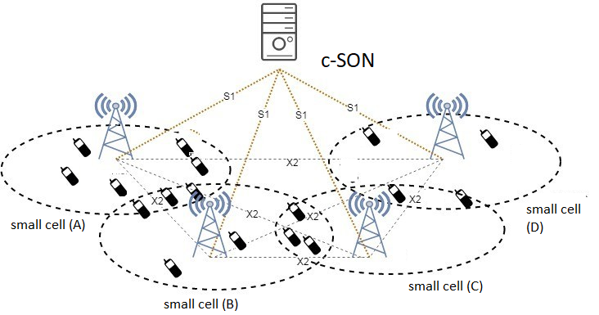
Fiure. 1 : Access network architecture

Problem formulation
The main objective of this work is to make balance and take the advantage of the available PRBs of the neighbor cell for those overloaded serving cells which can be accomplished by shift the edge UEs of the overloaded cells to the light-loaded cells by applying some measurements [19].
For a network of an S small cells at time t during T period of time the average network load [4, 13, 14]
${\overline{L}}_{net}^{t}=\frac{\sum_{i∈s}{{\overline{L}}_{i}^{t}}}{S}$ (2)
The standard deviation of p in the network among all cells is
$σ\left({\overline{p}}^{t}\right)=\frac{\sqrt{{({\overline{L}}_{i}^{t}- {\overline{L}}_{net}^{t})}^{2}}}{S}$ (3)
The expression of the problem indicates to minimizing the average load Ratio (PBRs)
$0≤{RB}_{i}^{t}≤ S_{PRB }, ∀i ∈S, ∀t ∈(t-T,t)$ (4)
To move the load from an overloaded cell to a light-loaded cell and perform a balanced network, the handover parameters are adjusted adaptively and monitor the impact of the shifted load on the neighbor cell.

Load threshold calculation
MLB algorithm aims to reduce the load of overloaded cells bellow the predefined threshold in order to balance the network load. To achieve that we introduce a method to balance the network of small cell loads by categorizing the network into three levels: light load, medium load, and overload cells.
The light load network is considered when the threshold is lower than pre- threshold (P_{pre}), while when the network threshold is equal or higher than pre-threshold, the network is considered as medium loads, and the network reached the threshold,$P_{Thr}$ then it is considered an overloaded determined as:

$P_{Thr}=\frac{1}{N} \sum_{i∈N}{{\overline{L} }_{i} }$ (5)
Where P_{pre} is a selected value represents medium load network

Control parameters

Handover parameters for load balancing
In LTE, eight events were specified to report the measurements, six of them for the measurements of intra-LTE (A1, A2, A3, A4, A5, A6) and two for inter-RAT measurements (B1 and B2). In our paper we will consider load balancing for intra-LTE.
UEs trigger (A1, A2, A4, and A5) events to compare the events with a given thresholds. A1event is triggered when the serving cell signal quality became better than a specified threshold. UE triggers A2 event when serving cell signal quality becomes worse than pre-defined threshold. A4 event is triggered when the neighbor cell signal quality became better than a given threshold. UE triggers A5 event when the neighbor cell signal quality became better than that given threshold. However, (A3 and A6) events are triggered when the real time signal quality is compared among cells. In fact, UE triggers A3 event under carrier aggregation when the offset of neighbor cell is better than the serving cell`s offset. A6 event under carrier aggregation when the offset of neighbor cell better than secondary cells. Based on the UE demands, primary cells add or remove the secondary cells when considering carrier aggregation. A3 is used to find the best neighbor cell and triggers handover if the criteria of A3 triggering satisfies longer than time to trigger (TTT). The condition of A3 event reporting measurement is:
$Mn+Ofn+Ocn-Hys>Mp+Ofp+Ocp+Off$ (5)
Where Mn and Mp are the average values of RSRP; Ofn and Ofp are the frequency specific offsets; Ocn and Ocp are target and serving cells individual offsets respectively, Hyst is hysteresis parameter, and Off is offset of A3 between main and neighbor cells. For inter-frequency, Ofn and Ofp are used so we forego them.
Ocn, Ocp and Off parameters are changed to shift the handover decision area. The load state of source and neighbor cells is playing big role for delaying or hastening the handover. By increasing the neighbor cell Ocn value or decreasing the serving cell Ocp, the range of the cell reduced and UE is handed over to the neighbor cell

Information of serving cells edge -UEs
SON is used to achieve load balance in the network, by shifting the UEs from the overloaded serving cell to under-loaded neighbor cells. the UEs of overloaded serving cells are being nominee to be shifted to under-loaded cells, UEs triggers A4 event when the neighbor cell’s RSRP is better than a given threshold. Each cell of the network collects the information from its UEs in order to share that information with SON including the A4 event.
Triggered A4 event expressed as:
$Mn+Ofn+Ocn-Hys>Threshold$ (6)
When A4 is accomplished, the measurements will be reported by the UEs. The small cell provides the information of edge UEs (when a reasonable threshold value is set and only UEs that report measurements is selected) and the candidate UEs are listed to be shifted from full loaded serving cell to the light loaded neighbor cell as a result of network load balancing.

SNR Estimation
The PRBs of UEs in LTE are allocated for serving cells based on channel quality indicators (CQI) that report the UEs. To achieve load balance, the required PRBs of UEs needed to be found and estimated at the neighbor cell before HO. Unfortunately, in LTE networks the information of CQI of the neighbor cells is unsupported, which force us to predict the required PRBs by Shannon Formula. We use RSRQ measurement reports of the neighbor cell information to estimate the SINR (θ), which is defined as:
$θ=\frac{р}{I+N}$ (7)
Where, P is serving cell signal power, $I$ is the average interference and N is the noise.
Based on [20] by using RSRP, $р$ can be formulated as
$р=x.12.S_{PRB}.RSRP$ (8)
$x$ Is pre antenna subcarrier factor.

RSSI based on [21],
$RSSI=P+I+N$ (9)
And based on [25], RSRQ is formulated as:
$RSRP=S_{PRB} .\frac{RSRP}{RSSI}$ (10)
Therefore, from the above equations, SINR becomes:
$θ_{i}=\frac{1}{\frac{1}{12.RSRQ}+x}$ (11)

Proposed algorithm
In this section, we introduce our proposed algorithm regarding load balancing, which is executed in the subset of SONTable (1) clarifies the algorithm notations.
The load information is collected from all the cells to compute the threshold P_{Thr}, to that end, we propose a method to compare P_{Thr} with a predefined threshold P_{pre} to identify the higher value of them and set as threshold which given a name of efficiency parameter Ɓ.
Ɓ → max(P_{Thr} , P_{pre}) (13)
Ɓ function is to control the algorithm triggering and categorizing the light, medium, and overloaded cells by selecting the values of P_{Thr} and P_{pre .}For instance, if the P_{Thr} is lower than P_{pre} , the network load is underloaded so, the threshold becomes P_{pre} and the algorithm is triggered for the medium-loaded cells wthat reach P_{pre}. When P_{Thr} is higher than P_{pre} then the network cells are considered as overloaded. The load balancing is created for the medium and overloaded cells. The average load of overloaded small cells over the value of Ɓ trigger the algorithm until the network become more balanced.

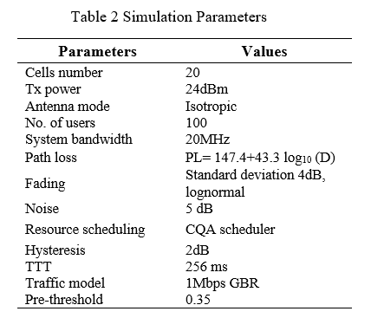
Table 1: Algorithm summery notation
Notations | Description
$$\overline{l_{i}}$$ | average PRBU of a small cell i at time t
$$P_{Thr}$$ | Threshold load of network
P_{pre} | The selected value represents network medium load
Ɓ | Efficiency parameter
$${\overline{L}}_{(i,u)}$$ | Movable load of an edge cell i
$$\tilde{L_{i}}$$ | estimated cell load after handover the UE u,
$${ \tilde{L}}_{(i,u)}$$ | serving cell i Consumed load by UE u
$${ \tilde{L}}_{(j,u)}$$ | UE u load estimated at target cell j
CIO_{(i→j)} | Specific offset parameter of cell i for neighbor cell j

Load balancing
Shifting loads of medium/overloaded serving cells to light/medium neighbor cells is done using the proposed algorithms by adjusting the cell CIO parameters to detect the medium/overloaded cells of the cluster. In that end, any edge UEs of overloaded cells share the coverage with the neighbor cells report RSRPs of neighbor cells and then put in descending order, the edge UEs of the overloaded cells are transferred one after another so that the serving cell load becomes lower than or equal to Ɓ. However, the movable loads are estimated for serving and neighbor cells before the handover decision. In the serving cell, PRBs are used to calculate the accumulative load of the edge UEs. The movable load of an edge UE u in a serving cell i, ${\overline{L}}_{(i,u)}$ determined as:
${\overline{L}}_{(i,u)}=\frac{\sum_{t∈(t-T,t)}{{RB}_{(i,u)}^{t}}}{T.SPRB}$ (12)
Where, ${RB}_{(i,u)}^{t}$ is PRBs that are allocated by over-loaded cell i to UE u.
The estimated cell load of a serving cell after handover the UE u, $\tilde{L_{i}}$ is calculated as

$\tilde{L_{i}}= \overline{L_{i}}{-\overline{L}}_{(i,u)}$ (13)
The neighbor cell signal quality would be different for the shifted UE, therefore, the needed PRB will be different as well.
The estimation load of the moved (shifted) load to a target (neighbor) cell j becomes
$\tilde{L_{j}}= \overline{L_{j}}{+\tilde{L}}_{(j,u)}$ (14)
Where,
${\tilde{L}}_{\left(j,u\right)=\frac{{RB}_{\left(j,u\right)}}{1000.N_{PRB}} }$ (15)

If $\tilde{L_{j}}$ lower than Ɓ, the values of serving and target CIO are updated by the algorithm so the candidate edge UE could be moved to the target neighbor cell as:
CIO(i→j) = Mp -Mn + Hyst +∆ (16)
CIO(j→i) = - CIO(i→j (17)
Where, ∆ is a specified LTE cemented step [17]
If $\tilde{L_{j}}$ higher than Ɓ, we proposed a factor that transfers partition of the load that makes $\tilde{L_{j}}$ lower than or equal to Ɓ which named as rescue factor$R_{f}$.
$R_{f= \frac{β -}{{\overline{L}}_{(i,u)}}}\tilde{L_{j}}$ (18)
$\tilde{L_{j0}}= \overline{L_{j}}{+R_{f}\tilde{ L}}_{(j,u)}$ (19)
Algorithms 1 and 2 represent the load balancing and unload procedure respectively, and can be summarized as:

Algorithm 1 Balancing Process
1: | calculate $\overline{L_{i}}$, for all small cells S
2: | Sort S in descending order of $\overline{L_{i}}$
3: | for $∀ⅈ∈S$
4: |  | while $\overline{L_{i}}$ ≥$Ɓ$ do
5: |  |  | UNLOAD (i, $\overline{L_{i}}$, $Ɓ$)
6: |  | end while
7: | end for

algorithm 2 procedure of unload
1: | UNLOAD (i, $\overline{L_{i }}$,Ɓ)
2: | Get target cell,$τ_{i}$ of cell i  Ɓ→ max(P_{Thr} , P_{pre})
3: | Threshold ← Ɓ
4: | Sort $τ_{i}$based on RSRP by candidate UEs  Calculate
5: | for all j $∈ τ_{i}$ do
6: |  | if $\overline{L_{i}}$ ≥ Ɓ then
7: |  |  | Estimate $\overline{L_{i.u}}$ as (12) and $\tilde{L_{j,u}}$ as in (15) and $\tilde{L_{j0,}}$ as in (19 )
8: |  |  | if $\tilde{L_{j}}$≤ Ɓ
9: |  |  |  | Set CIO_{(i→j)} as (16 ) and CIO_{(j→i)} as (17 )
10: |  |  |  | Update $\overline{L_{i.u}}$ $=\tilde{L_{i}} and$ $L_{j,u}=\tilde{L_{j}}$
11: |  |  | Else
12: |  |  |  | $$\tilde{L_{j}}← \tilde{L_{j0}}$$
13: |  |  |  | UNLOAD (i, $\overline{L_{i }}$,Ɓ)
14: |  |  |  | if UNLOAD succeed then
15: |  |  |  | Set CIO_{(i→j)} as (16 ) and CIO_{(j→i)} as (17)
16: |  |  |  | Update $L_{i.u}$ $=\tilde{L_{i}} and$ $L_{j,u}=\tilde{L_{j0}}$
17: |  |  |  | end if
18: |  |  | end if
19: |  | end if
20: | end for

Performance Evaluation:

Environment of Simulation:
To investigate the proposed algorithm, we introduce the network of ten small cells and 100 UEs as in figure (2), the network has been performed with small cells of a bandwidth of 20 MHz which enables 100 PRBs. The network transmission power was modelled to 24dBm and propagation loss as non-line of sight. Channel and QoS aware (CQA) scheduler was used to allocate resources to UEs. The pre-threshold was set to 0.35 the remaining parameters are illustrated in table (2).
50%, static and non-uniform UEs were spread over the network and 50% in a random circular mechanism (RCM).

Evaluation of the Network performance
We study the performance of two (adaptive and enhanced) MLB algorithms, and No-MLB, the three approachs were compared to our proposed algorithm in terms of network average throughput, PRB utilization and standard deviation to identify and measure load distribution through the network. For each UE, the data traffic was set to 1Mps as a guaranteed data rate (GDR).
Figure (3) illustrates the load standard deviation for the different algorithms and No-MLB, it showed that the proposed algorithm introduced a lower standard deviation than other approaches, the average standard deviation of the proposed algorithm, enhanced and adaptive MLB algorithms, and No-MLB algorithm are 0.358, 0.04279, 0.0458 0.0966 respectively. Accordingly, small cell load variation became lower which makes the network much balanced. The network PRBs utilization varies based on the load balance. Figure (4) shows those variations for the proposed algorithm and the other approaches. However, the algorithms of MLB improved PRB utilization. On one hand, the overloaded cells are unable to assign the UEs required PRBs when No-MLB is used, while unloaded cells have much available PRBS.
On the other hand, MLB algorithms distribute most of UEs on the edges of overloaded small cells to the neighbor under loaded small cells. The proposed algorithm introduced a higher and better PRB utilization ratio than enhanced and adaptive MLB algorithms with 2.065% and 12% respectively due to after handover estimated load UEs for both overloaded cells and neighbor light loaded small cells.
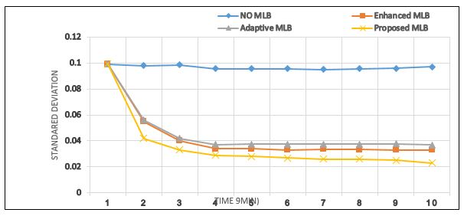
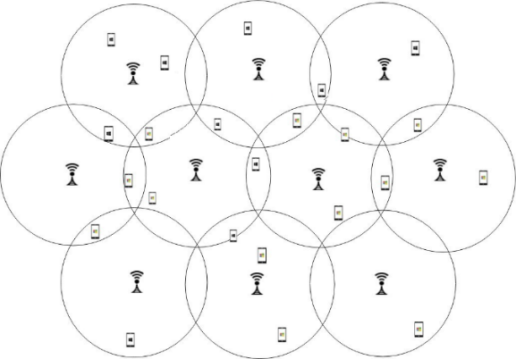
Finally, the performance of throughput was evaluated. Figure (5) illustrates the average throughput with three MLB methods, the average throughput was improved using our proposed algorithm by 7%, compared to the enhanced and adaptive algorithms which accomplished 4.48%, and 3% respectively. The overloaded small cells affect the data rate of UEs due to the leak of PRBs to accomplish required data rates. Therefore, in the No-MLB network, UEs of overloaded small cells experience restricted throughput. However, networks with MLB algorithms experience balanced load distribution and the small cells assign the UEs all required resources to increase the throughput of the network.

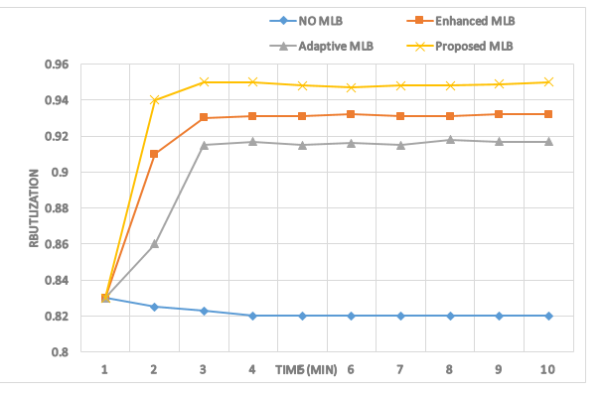
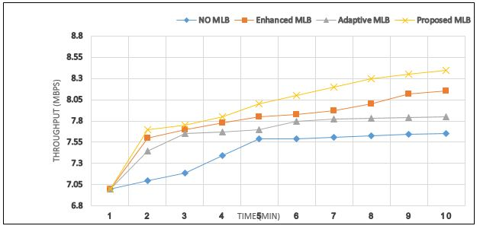
Figure 2: Simulation environment Figure 3: Load standard deviation

Figure 4: Resource Block utilization Figure 5: Average cell throughput.

Conclusion
In this work, we presented an MLB algorithm that first categorizes the load status of a small cell as under-loaded, light-loaded (medium), or overloaded using the proposed efficiency parameter which considers the maximum value between the pre-threshold and adaptive threshold. In the case of shifting loads from overloaded / light-loaded cell to light-loaded/Under-loaded cells, the proposed Rescue factor compares between load statuses of the serving cell and after hand over the neighbor cell to assure its load is less than the adaptive threshold. The System simulation of the proposed algorithm showed a reduction of standard deviation and increased the throughput and PRB utilization compared to surveyed algorithms.

References
[1] "Cisco visual networking index: Global mobile data traffic forecast update 2017–2022," Cisco, San Jose, CA, USA, vol. 1486680503328360, 2019.
[2] A. Al Amodi and A. Datta, "The Impact of Heterogenous Ultra-dense Network Technologies on the Performance of 4G and 5GNetworks," International Journal of Innovative Technology and Exploring Engineering, vol. Volume-10, pp. 35-44, 11/01 2020.
[3] J. G. Andrews, H. Claussen, M. Dohler, S. Rangan, and M. C. Reed, "Femtocells: Past, present, and future," IEEE Journal on Selected Areas in communications, vol. 30, pp. 497-508, 2012.
[4] K. M. Addali, S. Y. B. Melhem, Y. Khamayseh, Z. Zhang, and M. Kadoch, "Dynamic mobility load balancing for 5G small-cell networks based on utility functions," IEEE Access, vol. 7, pp. 126998-127011, 2019.
[5] X. Ge, S. Tu, G. Mao, C.-X. Wang, and T. Han, "5G ultra-dense cellular networks," IEEE Wireless Communications, vol. 23, pp. 72-79, 2016.
[6] S. Feng and E. Seidel, "Self-organizing networks (SON) in 3GPP long term evolution," Nomor Research GmbH, Munich, Germany, vol. 20, 2008.
[7] R. Kwan, R. Arnott, R. Paterson, R. Trivisonno, and M. Kubota, "On mobility load balancing for LTE systems," in 2010 IEEE 72nd Vehicular Technology Conference-Fall, 2010, pp. 1-5.
[8] A. Lobinger, S. Stefanski, T. Jansen, and I. Balan, "Load balancing in downlink LTE self-optimizing networks," in 2010 IEEE 71st vehicular technology conference, 2010, pp. 1-5.
[9] N. Zia and A. Mitschele-Thiel, "Self-organized neighborhood mobility load balancing for LTE networks," in 2013 IFIP Wireless Days (WD), 2013, pp. 1-6.
[10] A. Damnjanovic, J. Montojo, Y. Wei, T. Ji, T. Luo, M. Vajapeyam, et al., "A survey on 3gpp heterogeneous networks. Wireless Comm," ed: IEEE, 2011.
[11] A. Lobinger, S. Stefanski, T. Jansen, and I. Balan, "Coordinating handover parameter optimization and load balancing in LTE self-optimizing networks," in 2011 IEEE 73rd vehicular technology conference (VTC Spring), 2011, pp. 1-5.
[12] Z. Huang, J. Liu, Q. Shen, J. Wu, and X. Gan, "A threshold-based multi-traffic load balance mechanism in LTE-A networks," in 2015 IEEE Wireless Communications and Networking Conference (WCNC), 2015, pp. 1273-1278.
[13] M. M. Hasan, S. Kwon, and J.-H. Na, "Adaptive mobility load balancing algorithm for LTE small-cell networks," IEEE transactions on wireless communications, vol. 17, pp. 2205-2217, 2018.
[14] K. Addali and M. Kadoch, "Enhanced mobility load balancing algorithm for 5G small cell networks," in 2019 IEEE Canadian Conference of Electrical and Computer Engineering (CCECE), 2019, pp. 1-5.
[15] M. M. Hasan, S. Kwon, and S. Oh, "Frequent-handover mitigation in ultra-dense heterogeneous networks," IEEE Transactions on Vehicular Technology, vol. 68, pp. 1035-1040, 2018.
[16] 3GPP, "Evolved universal terrestrial radio access network (E-UTRAN); X2 application protocol (X2AP)," 3rd Generation Partnership Project (3GPP), vol. TS 36.423, 2016.
[17] S. F. a. E. Seidel, "Self-organizing networks (SON) in 3GPP long term evolution,” " Newsletter, Nomor Research GmbH, Munich, Germany, , vol. Tech. Rep, 2008.
[18] 3GPP, "Evolved universal terrestrial radio access network (E-UTRAN); S1 application protocol (S1AP)," 3rd Generation Partnership Project (3GPP), vol. TS 36.413, 2016.
[19] Y. Q. Bian and D. Rao, "Small cells big opportunities," Global Business Consulting. Huawei Technologies Co., Ltd, 2014.
[20] 3GPP, "LTE; Evolved Universal Terrestrial Radio Access (E-UTRA); Physical
Layer; Measurements, document," 3GPP, vol. TS 36.214, 2017.
[21] F. Afroz, R. Subramanian, R. Heidary, K. Sandrasegaran, and S. Ahmed, "SINR, RSRP, RSSI and RSRQ Measurements in Long Term Evolution Networks," International Journal of Wireless & Mobile Networks, vol. 7, pp. 113-123, 08/31 2015.

BIOGRAPHIES OF AUTHORS
 | Abdullah Mohammed Abdullah Al – Amodi is working towards his Ph.D. degree in School of Electronic Engineering of KIIT Deemed to be University, India. His research interests include small cell load balance and handoff decisions, in heterogeneous networks.  He has completed his B. Tech in Electronics and Communication. M. Tech in Electronics and Communication Engineering from Aden University (Yemen) and JNTUH (India) in the year 2011, and 2017, respectively
 | Dr. Amlan Dattais a Professor and Associate Dean, School of Electronics Engineering, KIIT, Deemed to be University, India. He has completed his B. Tech in Electronics and Electrical Communication Engineering, M. Tech in Microwave and Radar Engineering and Ph. D in Electronics Engineering from IIT Kharagpur in the years 1987, 1989, and 1992, respectively. He has worked in MM wave missile seeker head, cellular communication for 20 years. Since, last 10 years, he is working as a professor in KIIT, Deemed to be University, India. His research interest covers wireless communication and microwave.
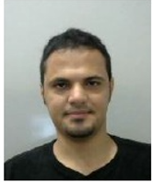 | Dr. Abdulrahman Mohammed Hussain Obaid an assistant professor at 21 September university of medical and applied sciences, and has completed his B. Sc. computer and IT engineering from the Sana'a University, Yemen in 2011, M. tech. degrees in computer science and engineering from the JNTUH University, India in 2016 and Ph.D. in computer science and engineering from the KIIT University India in 2019. His research interest covers Cloud Computer, Cloud of Things, scheduling algorithm, and 5G technology.  E-mail: obaid.eng@gmail.com

