Entropy and POX controller-Based Early DDoS Attack Detection in SDN Environment

Mohammed Ibrahim Kareem ¹, Mahdi Nsaif Jasim ²
¹ Department of Information Networks, University of Babylon, Iraq
² Department of Business Informatics, University of Information Technology and Communications, Iraq

Article Info |  | ABSTRACT
Article history:  Received month dd, yyyy  Revised month dd, yyyy  Accepted month dd, yyyy |  | SDN (Software Defined Networking) is a novel network architecture that allows for centralized network control. The separation of the data plane from the control plane, which establishes a programmable network environment, is the key breakthrough underpinning SDN. The controller facilitates the deployment of services that specify control policies and delivers these rules to the data plane using a common protocol such as OpenFlow at the control plane. Despite the many advantages of this design, SDN security remains a worry because the aforementioned chapter expands the network's attack surface. In fact, Denial of Service (DoS) assaults pose a significant threat to SDN settings in a variety of ways, owing to flaws in the data and control layers. This work shows how DDoS attack detection is based on the entropy variation of the destination IP address. The study takes advantage of the OpenFlow Protocol's (OFP) flexibility and an OpenFlow controller (POX) to apply the proposed method. An entropy computation to determine the distributed features of DDoS traffic is developed and it is capable of detecting a UDP flood attack after 0.445 seconds this type of attack occurred.
Keywords:
SDN security
DDoS
UDP Flooding
Entropy
POX controller.
This is an open access article under the CC BY-SA license.

Corresponding Author:
Mohammed Ibrahim Kareem
Department of Information Networks, University of Babylon, Iraq,
Email: mohamed.ibrahim@uobabylon.edu.iq

- INTRODUCTION
The SDN architecture decouples the data planes and control, so all network control logic is moved to a logically centralized software-based entity known as the controller from the network devices. The network controller / SDN controller is having whole knowledge of the network. It is software residing in the control plane where centralized control and network management functions instruct forwarding behavior to all the nodes distributed across data plane.[1] On data plane side, the nodes are switches that manage packet routing based on a schedule built by the network controller. Before any redirection choice is visualized, this process executes. The network controller is always aware of the state of the network, and all traffic flows are transmitted to the controller at least once during the network's lifetime to determine redirection behaviour, according to the SDN's basic characteristic [2]. SDN like any new technology comes with its own advantages and disadvantages. The modern network / SDN environment has a different approach to network management and configuration. This infrastructure has an effective role in network security. This effect can be divided into two cases. In the first case, it can be called "security via SDN", since in this case the centralized logical visibility and programmability of the SDN makes it easy to implement and enforce network-wide security policies from the central controller's program.
The second aspect of SDN security, which we refer to as “SDN security”, is how to protect or secure the SDN platform itself, as the network architecture is vulnerable to many attacks, so this paper will focus on it, specifically reviewing the works that used entropy and machine learning mechanisms [3].

1.1. Possible Dos/DDoS Attacks
DDoS/DoS attack is not hard to implement that it can be running with limited resources to a big target network called "asymmetric attack". Most of current research focuses on how to effectively send information from source to destination over the lacks of security protocol designed to separate malicious intent [3]. This security gaps can be exploited for DDoS attacks. Today's internet/network architecture and development do not place a high priority on security [4].
Every network model has a finite number of resources. DDoS assaults target resources such as bandwidth, storage, and processing power. The goal of this attack is to disrupt the victim's networks by depleting the victim's resources. DDoS attacks, in general, are directed at the network, server, and application resources.
A. DDoS with Network Resources
This DDoS/DoS attack aims to overload the victim's network resources and increase time delay or response time, such as network bandwidth, by flooding the target machine with a User Datagram Protocol (UDP) or Internet Control Message Protocol (ICMP) flood, preventing it from processing normal requests. (See Figure.1)
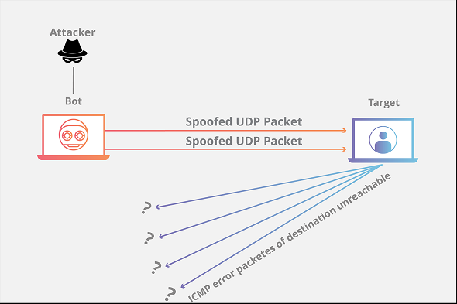
Figure 1: UDP Flood Attack
When UDP Flood [5] is an attack that utilize a large number of UDP packets (random or the same port) to flood the target machine (Figure. 2), ICMP Flood uses the ICMP [6] (ping) echo request packets to disrupt normal traffic to the target machine (see Figure 2) .One of the characteristics of the Amplification-DDoS Attack is traffic amplification. To raise the volume of attack traffic while sending the least amount of traffic to the triggering device, the intruder employed other "launching" devices. Figure 4 shows how the process works. Smurf attacks (Figure 4) and Fragale assaults are two types of UDP-based attacks that can amplify the impact of anomalous traffic [7].
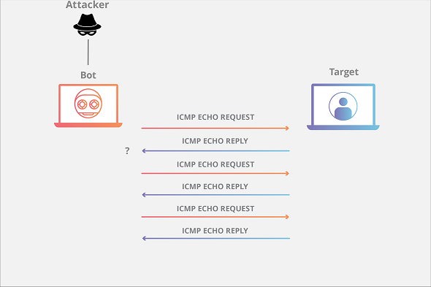
Figure 2: ICMP Flood Attack
- Each server has limited resources, such as CPU capabilities, network bandwidth and amount of memory. This limited resource can be utilized by a DDoS attack to make down the target machine. One common attack that exploits the protocol is called TCP SYN attack, (Figure 1).
- Weak in secure of application protocol such as HTTP, HTTPS, DNS, SMTP, FTP and other security if application protocols can be exploited with abnormal intent such as a DDoS/DoS attack.
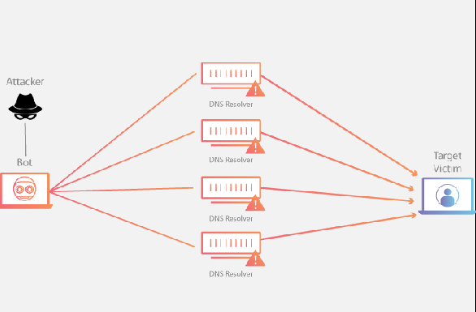
Figure 3: Amplification Attack
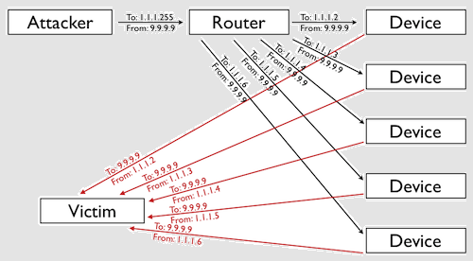
Figure 4: Smurf Attack

1.2. DDoS/DoS Attacks on SDN
SDN has a completely different packet processing procedure compared to the traditional network [8]. Compiling the entire network function into a central entity (SDN controller) appears to be a double-edged sword to the SDN architecture. It obviously improves network management and operation through the network worldview [1], [9]. However, the level of control, i.e., the SDN controller, becomes a critical point of failure risk and a prime target for attackers to exploit. The centralized nature of the control plane of the SDN architecture can reduce the reliability and scalability of the SDN, particularly in data centres.[10].
There are three main threats on SDN controller. The first threat on SDN-controller communications exploiting lack of secure [11] between controller and switches. The attacker can generate DDoS/DoS attacks if the control plane is exposed. The second threat is attacks on lack of secure in controllers. Any intruder can access to controller, can embed malware into an SDN controller, it can potentially harm the entire network because the controller has whole knowledge about network and it can do anything to its own network. The third threat is the week of procedure to ensure the applications of the controllers. This threat is similar to the first but the threat is related to trusted connections between applications on the control plane.

- LITERATURE REVIEW
The characteristics of IP packets and traffic generated by a DDoS attack often makes it possible to distinguish attack traffic from normal traffic. Statistical properties of certain fields in IP packet headers, such as the entropy of the source IP addresses, or statistical properties of normal and attack traffic patterns can be used to detect DDoS traffic.
Researchers can find many studies on DDoS attack detection methodologies. The method proposed by Seyed et al. [12] is works by comparing the entropy of successive packet samples to detect changes in their unpredictability. The entropy is estimated based on the destination IP addresses of a window of 50 packets. An assault is reported if the entropy is less than the threshold.
Surender Singh et al. [13] developed a distributed architecture for analysing the packet flow behaviour. To identify malicious flows from normal flows, the proposed technique employs entropy and a traceback algorithm.
R. Li [14] , the SDN controller periodically finds and collects information from SDN switches and then calculate φ-entropy value based on the IP destination addresses, where if this entropy is less than the threshold means an attack has been discovered.
Jisa David et al. [15] proposed a DDoS attack detection system which is based on fast entropy using flow-based analysis. Their proposed method shows better detection accuracy. They analyse network traffic and compute the fast entropy of request per flow.
Lei et al. [15] proposed a system called FloodGuard. It concentrates on an SDN-specific attack called data-to-control plane saturation attack. It implements two modules proactive flow rule analyser which preserves network policy enforcement and packet migration protects the controller being overloaded.
Qin et al. [15] proposed a method for intrusion detection with a time window of 0.1 seconds and three levels of threshold. This method tries to reduce false positive and false negative values. It is found that the time and resource consumption of the method is high.
Proposed method extends the recent work done by Kia [16] on Early Detection and Mitigation of DDoS Attacks in Software Defined Networks, which is based on an Entropy variation of the destination IP address, Flow Initiation Rate and Study of Flow Specification. T
Kalkan et al. [17], the authors proposed joint entropy based DDoS defence mechanism scheme in SDN. In their proposed defence scheme, entropy value is calculated for all possible k-element subsets of P where P= {IPsrc, IPdst, Psrc, Pdst, Prot, PKTsize, TTL, TCPflag} for 1 ≤ k ≤ P. They use score-based packet marking system for filtering the suspicious packets. The method uses packet-based sliding window with 1000 packets. The method marks the packets as suspicious traffic whenever any current entropy value falls below the threshold value. They use runtime threshold and it is calculated by dividing the sum of current entropy and previous entropy by 2.
Dridi et al. [18] They suggested a method for detecting and mitigating DoS attacks that involved automatically rerouting possible DDoS traffic, changing attack flow Timeout values and aggregating flow rules linked with malicious traffic. During the assault, it decreases controller inbound throughput by 32% and switch ram by 26%, but it also lowers packet loss and average package round trip time.
Jose [19], the authors focuses on the design and implementation of an attack detection system based on machine learning for detecting the flooding DDoS attacks TCP SYN flooding attacks, HTTP request flooding attacks, UDP flooding attacks and ICMP flooding attacks over SDN network traffic.

- PROPOSED UDP FLOODING DETECTION SYSTEM
Basically, is a type of flood attack. Here many packets are sent to a network device for stopping the service or decreasing the performance of such a device. If the source addresses of incoming are spoofed, then the switch would not find a match and the packet needs to be forwarded to the controller. The collection of DDoS spoofed packets and legitimate packets can bind the controller into continuous processing, which exhausts them. Due to this, the controller is unreachable for the new incoming legitimate packets. This will bring the controller down causing loss to the SDN architecture. For a backup controller, the same challenge is to be faced. The suggested approach is based on the fact that a network's destination IP frequency changes when it is under assault. As a result, if we notice a change in this characteristic, we can identify an assault. To identify denial of service attacks, we employ two alternative methodologies, each of which makes different assumptions about the statistical features of the underlying network.

A. System Architecture
The initial packet transferred from one client to another during typical communication between clients in an SDN environment. The switch's flow table will initially have no entry indicating where the incoming packet should be sent. The packet will be sent to the controller by default. The switch will be instructed by the controller to forward the packet to the appropriate destination port. The controller will also give an entry rule for that source and destination in the switch's flow table. Without the intervention of the controller, packets with the same source and destination will be routed automatically in the future.

B. POX Modules
The detecting application will operate as stand-alone modules on POX. The controller will be able to execute a variety of functions, including installing flows, forwarding packets, and verifying DDoS assaults, thanks to the employment of many modules.
  - L3 Learning Module in pox controller: The L3 learning module in the POX controller is the most critical. It's a basic layer 3 learning module that connects the network's nodes. The L3 learning module processes the incoming packet and keeps track of the couplings between the OVS ports and the connected clients' MAC addresses. This information is used to create a rule that substitutes a destination MAC when a packet is sent to the destination port. The module creates ARP requests if no binding is identified. It is combined with a detection algorithm to identify a malicious traffic flow in addition to connection.
  - DDoS Detection Algorithm: The design of the detection algorithm is based on three main inputs which are packetIn flow, packet counts, and Entropy calculations. This design is written in Python and will be implemented within the POX controller as an additional module. It will also feature an alerting mechanism. If an attack is detected, a SMS notification will be sent to an administrator indicating that the SDN has been breach.
  - Flow Recognition: Flows are collections of packets with similar properties. Source IP address, destination IP address, source port number, destination port number, and protocol type are the characteristics. The header of each packet may be used to retrieve the flow categorization information. Each incoming flow based on TCP and UDP protocol usually contain this information. In a SDN architecture, the OVS has a flow table that contains multiple flow entries. Each entry has its own rule, this rule allows the switch to know how to handle each incoming packet. An example would be a client trying to communicate with other clients, and to communicate a packet is sent to the switch. The incoming packets are grouped together to form flows. The incoming flows will navigate through the OVSs to find the rule associated with the entry flow. If there is no match, the switch will generate and send a packet to the controller to acquire a new flow rule. Then, the controller will implement a new flow rule in the flow table so that the OVS can handle any new flows.
With that in mind, attacks or malicious users can exploit the flow rule by sending a large amount flow that are not presented in the OVSs flow table. These new flows will consume the OVS because the controller have to handle and establish new rules for these incoming flows. This will overload the controller and possibly disrupt the entire network. Such attack is known as DDoS. Understanding the flow classification allows us to design an algorithm to identify DDoS attacks from normal traffic through classifying these malicious flows and normal flows. Let’s consider O, an observation sequence of different flows F that injects to an interface i of the OVS. Assume X is a malicious flow if the total number of packets within this flow is lower than a certain threshold. The threshold is predefined through data mining of flow classification. If X is a normal flow, then the total number of packets within this flow is equal to or greater than the threshold. X is defined as follows:

1 # of packets ≥ Threshold
X= (1)
0 # of packets > Threshold

C. DDoS Detection with Entropy-based Algorithm
The main reason for considering entropy is its ability for measuring randomness in a network. The higher the randomness the higher is the entropy and vice versa. So, whenever the entropy is less than a threshold value, we can say that a DDoS attack is occurred. Shannon Entropy [9] is an important concept for understanding the design of entropy-based detection algorithm. Entropy measures uncertainty or randomness associate with a random variable [12]. In our case, the random variable is the destination address. The entropy-based detection is similar to algorithm used [20]. To collect packets for entropy analysis, a fixed window size is defined. For each window, the packets are classified into groups that based on their destination IP address. All of these incoming packets will be coming from different source addresses. The destination IP addresses will be monitored for every new flow. These monitored flows are grouped into windows. Each window contains a hash table or a dictionary of two columns. The first column will state all the IP addresses, and the second column will show the number of times it has occurs. The window equation can be calculated as shown in Eq. 2.
$H(Sj) =$ (2)
Where i denotes each unique element in the window and n is the number of all IP destination addresses for each window. Then, the probability of each unique IP destination address can be calculated with Eq. 3.
(3)
Each window is calculated as shown in equation 3. The entropy will compare to the predefined threshold. If the entropy value is greater than the present threshold, it means there hasn't been an assault. Any number lower than the predetermined threshold indicates that an assault is possible. If no attack is identified, the entropy threshold is changed to the current estimated entropy to avoid future erroneous analysis. This enables the detecting system to adapt to the type of network flow in real time. The entropy-based algorithm is designed to detect an internal attack. The attacker and the victim are located within the internal SDN. The attacker has the options of attacking the controller or clients within the network. In either scenario, the attack is most likely to have a spoofed source IP address. Therefore, the incoming packets will not match the flow table so it will be forward to the controller. With this algorithm implemented, the controller can determine if the network is under attack through the drop in the entropy value due to the large number of packets containing the same destination address. The perfect example of such attack is UDP flooding.
In a normal network, traffic is expected to spread out to every client in the network. During a DDoS attack, the number of packets destined for a targeted host will rise immediately and the entropy value decrease. A decrease in the entropy is an indication that the network may be under attack. It is vital to have a fast and responsive detection because attackers could severely disrupt network service and possibility loss of data. To determine suiting window size, Oshima et al. [20] proposal is used based on entropy computation through calculating entropy in small size windows. Their study proposed a window size ranging from 50 to 5000 and concluded that window width of 50 and 500 successfully detect DoS/DDoS attacks. As proposed by Oshima et al., a window size of 50 is used for this research. The detection algorithm includes a function that collects incoming flow from the OVS. The flows will be stored in a file which will calculate the total number of packets for every destination IP in the current interval.

D. Entropy Based Detection Algorithm
Algorithm 1 shows the Entropy Based Detection Algorithm. The input, new packet in, correspond to a new packet that has arrive with a new source address. The destination IP address is also examined to see if it has an existing instance in the window. If it does exist, the count for that IP address will incremented. If the window gets full, the entropy is computed and then compared with the threshold. If the computed value for an entry is higher than the threshold for five consecutive counts, it will be classified as an attack.
Algorithm 1 Entropy Based Detection DDoS Algorithm

Input: Window_Size, Threshold value
Output: Alert message
Begin
While true Do
Clear hash file
Capture incoming packets from switch
Extract relevant features of current packet and store in Hash_File
// Calculation Entropy
If number of packets = 50 then
Calculate the probability using Eq. 3 after
Else
Calculate entropy of network using Eq. 2
End If
// DDoS Detection
If Entropy>= threshold then
Notify the monitoring server by DDoS detection
End if
End Do

- SIMULATION AND TEST RESULTS
The first department of our experiment is to choose Mininet is used to emulate the network with POX as the controller platform. The detection program will be a standalone module integrated within the L3 Learning module. This will allow the controller to perform additional functionalities such as installing flows and validating DDoS attacks. In this test stage, OF-switch is used to simulate the behaviour of an edge switch in a SDN network. The Mininet network comprises a victim node that is the destination for both normal traffic and attack traffic generated from a client within the SDN network. By using Mininet, we can attack a virtual host and analyse the results of our detection algorithm. The client’s IP addresses are assigned from 10.0.0.1 to 10.0.0.64.
For this research, 64 hosts are implemented, 9 OVS, and single POX controller in the physical test as in figure below.

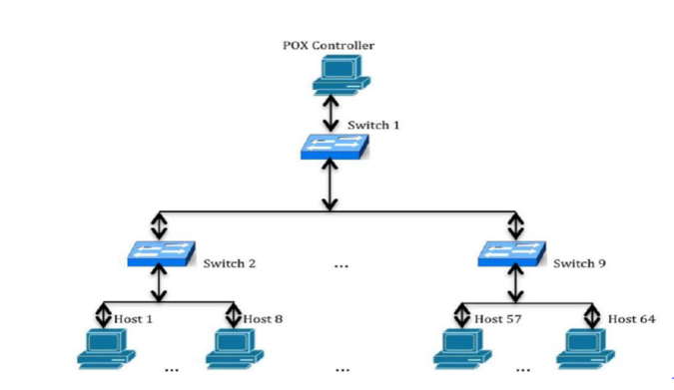
Figure 5: Mininet topology of 9 switches and 64 hosts with single POX Controller
Typical networks consist of thousands of devices; however due to resources limitation the previous test is built to emulate the similar scenarios in large networks. To develop and validate the effectiveness of our solution in a real time environment, we created a virtual network with these exact constraints to better represent our testbed. Scapy module is used to import functions such as sendp, IP, UDP, Ethernet and TCP. In this work, it is used to generate UDP packets with varying payloads and traffic interval (inter=0.025). In constant, a normal traffic, it will have an interval of 0.1 seconds (inter=0.1). Figure 6 shows the traffic generated using Scapy script in virtual host(h1).
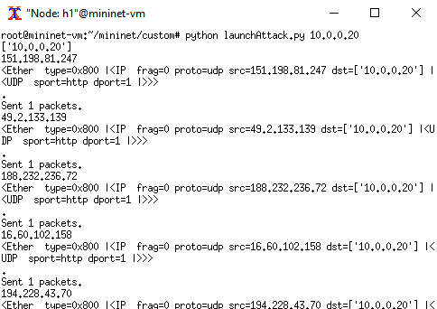
Figure 6: Traffic Generation using Scapy
The simulations and evaluations were performed on multiple platforms. The main platform used to test our detection algorithm is Windows 10 environment set up on a 2.60 GHz Intel Core i7-6600U processor and a memory of 16GB RAM. This environment has two virtual machines (Mininet and POX controller). Before attack launch by Scapy, launch normal traffic also by Scapy tool to specific threshold value that as the separation point between normal traffic and attack traffic (DDoS attack). Normal Traffic Simulation is used to determine the average entropy for a normal traffic, after more than one tests.
Normal traffic is defined as traffic with long duration flows as compared to attack traffic which has short duration’s flows with small numbers of packets. The goal is to determine the average normal entropy value for a network consisting of 64 nodes. A traffic was launched on the network with a traffic interval of 0.5 seconds. The traffic rate is defined by (1/0.5 = 2 packets/sec). In Figure 3, the chart describes how the entropy varies during the traffic. The lowest threshold captured during this traffic flow is 0.828 with the highest point captured at 1 in first traffic. The average entropy value of this small network is 0.577.
For attack traffic simulation with multiple victims, the topology and parameters remain the same as the one use to simulate the normal traffic. The only difference is the traffic interval and rate. For the multiple victim attack, we tested a 25% attack rate. The attack traffic interval is defined by Figure 7: Entropy: Normal Traffic and UDP Flood Attack.

Figure 7: Lunch Normal Traffic and UDP Flood Attack.
In this multiple victim attack scenario, the 2 packets/sec being generate for legitimate traffic. As expected, the attack was detected.
As expected, the algorithm detects the attack under less than one second. With a higher traffic rate of 28 packets/sec, the attack is detected at 0.445 second. The entropy value for both test scenarios are approximately the same which can be noticed on Figure 3. The 25% attack rate has a slightly higher consist entropy levels ranging from 0.511 to 0.00.
The average detection rate of a DDoS attack is determined within 0.445 to 0.501 second. It is safe to say that the algorithm performs very well in distinguishing the difference between a normal and attack traffics. It is important to remember that this simulation is specifically designed for the test used. In a real scenario, the network and its traffic will grow. If so, the threshold must be adjusted accordingly to avoid false positive detection.

- CONCLUSION
Using the Open vSwitch software developed for OFP proved its programming simplicity and integrating Linux-based hardware into an OF switch. Additionally, the POX controller proved to be simple and effective in establishing a test for the Entropy-based UDP flood detection algorithm. During integration, testing, and hardware deployment phase, the accuracy of the proposed algorithm was presented in detecting a generated DDoS attack on single and multiple victims. The attack was detected after 0.445 second of the entropy value reaching 0. Once mitigated traffic continued to flow normally without disturbance from the attacker(s). The flexibility that SDN provides to the overall realm of networking has been proven to aid in programmability and management for network administrators. Even though this new paradigm leaves room for vulnerabilities, the flexibility of SDN provides network administrators with new techniques to protect and expand current and future networks. As a future work, it is recommended to develop this proposal by integrating it with mahine learning algorithm to distinguish the normal intensive use of the targeted machine and the flooded machine.

References
[1] K. Kirkpatrick, “Software-defined networking,” Commun. ACM, vol. 56, no. 9, pp. 16–19, 2013.
[2] U. Rahamathullaha and E. Karthikeyanb, “Distributed denial of service attacks prevention, detection and mitigation–A review,” 2021.
[3] J. Mirkovic and P. Reiher, “A taxonomy of DDoS attack and DDoS defense mechanisms,” ACM SIGCOMM Comput. Commun. Rev., vol. 34, no. 2, pp. 39–53, 2004.
[4] B. Chinnaiah, “Protection of DDoS Attacks at the Application Layer: HyperLogLog (HLL) Cardinality Estimation,” in Cognitive Informatics and Soft Computing, Springer, 2021, pp. 595–604.
[5] S. S. Kolahi, K. Treseangrat, and B. Sarrafpour, “Analysis of UDP DDoS flood cyber attack and defense mechanisms on Web Server with Linux Ubuntu 13,” in 2015 International Conference on Communications, Signal Processing, and their Applications (ICCSPA’15), 2015, pp. 1–5.
[6] H. Harshita, “Detection and prevention of ICMP flood DDOS attack,” Int. J. New Technol. Res., vol. 3, no. 3, p. 263333, 2017.
[7] S. Kumar, “Smurf-based distributed denial of service (ddos) attack amplification in internet,” in Second International Conference on Internet Monitoring and Protection (ICIMP 2007), 2007, p. 25.
[8] Q. Yan, Q. Gong, and F. Deng, “Detection of DDoS Attacks Against Wireless SDN Controllers Based on the Fuzzy Synthetic Evaluation Decision-making Model.,” Adhoc Sens. Wirel. Networks, vol. 33, 2016.
[9] F. Hu, Q. Hao, and K. Bao, “A survey on software-defined network and openflow: From concept to implementation,” IEEE Commun. Surv. Tutorials, vol. 16, no. 4, pp. 2181–2206, 2014.
[10] D. Saini, “Cross-Layer Design in Software Defined Networks (SDNs).”
[11] D. Kreutz, F. M. V Ramos, and P. Verissimo, “Towards secure and dependable software-defined networks,” in Proceedings of the second ACM SIGCOMM workshop on Hot topics in software defined networking, 2013, pp. 55–60.
[12] S. M. Mousavi and M. St-Hilaire, “Early detection of DDoS attacks against SDN controllers,” in 2015 International Conference on Computing, Networking and Communications (ICNC), 2015, pp. 77–81.
[13] S. Singh and S. Jain, “A Review of Detection of DDoS Attack Using Entropy-Based Approach,” IJCST, vol. 4, no. 2, 2013.
[14] R. Li and B. Wu, “Early detection of DDoS based on $\varphi $-entropy in SDN networks,” in 2020 IEEE 4th Information Technology, Networking, Electronic and Automation Control Conference (ITNEC), 2020, vol. 1, pp. 731–735.
[15] J. David and C. Thomas, “DDoS attack detection using fast entropy approach on flow-based network traffic,” Procedia Comput. Sci., vol. 50, pp. 30–36, 2015.
[16] M. Kia, “Early detection and mitigation of DDoS attacks in software defined networks,” M. Sc. Thesis., 2015.
[17] K. Kalkan, L. Altay, G. Gür, and F. Alagöz, “JESS: Joint entropy-based DDoS defense scheme in SDN,” IEEE J. Sel. Areas Commun., vol. 36, no. 10, pp. 2358–2372, 2018.
[18] L. Dridi and M. F. Zhani, “SDN-guard: DoS attacks mitigation in SDN networks,” in 2016 5th IEEE International Conference on Cloud Networking (Cloudnet), 2016, pp. 212–217.
[19] A. S. Jose, L. R. Nair, and V. Paul, “Towards Detecting Flooding DDOS Attacks Over Software Defined Networks Using Machine Learning Techniques,” Rev. GEINTEC-GESTAO Inov. E Tecnol., vol. 11, no. 4, pp. 3837–3865, 2021.
[20] S. Oshima, T. Nakashima, and T. Sueyoshi, “Early DoS/DDoS detection method using short-term statistics,” in 2010 International Conference on Complex, Intelligent and Software Intensive Systems, 2010, pp. 168–173.

