A New Application for Fast Prediction and Protection of Electrical Drive Wheel Speed Using Machine Learning Methodology

Medjdoub Khessam¹, Abdelkader Lousdad ², Abdeldjebar Hazzab ³
¹ Institute of science and technology, University center Salhi Ahmed Naama, Algeria
² Laboratory of Mechanics of Structures and Solids (LMSS), Faculty of Technology
Department of Mechanical Engineering University Djillali Liabes of Sidi Bel Abbes, B.P 89
Cité Ben M’Hidi - Sidi Bel- Abbes 22000 -Algeria, E-mail: a_lousdad@yahoo.com
³ Laboratory of CAOSEE, Tahri Mohamed University, B.P 417 (08000), Bechar, Algeria

Article Info |  | ABSTRACT (10 PT)
Article history:  Receivedmonth dd, yyyy  Revised month dd, yyyy  Accepted month dd, yyyy |  | This paper introduces a non-linear implementation of the speed control technique of permanent magnetic synchronous motors (PMSM) using Electronic Differential (ED) Command. Artificial Neural Network (ANN) coupled with Particles Swarm (ANN-PSO) are implemented to control wheel speed and steering angle. The main purpose of the PMSM system and its application is the command of electric vehicles (EV). In the controller design, three-phase currents and rotor speed shall be measurable and eligible for feedback. Our propulsion platform consists of two PMSM in the back. The study with implemented ANN-PSO is performed after collecting the data from the ED to manage the control of speed EV, Left and right of steering angle and steering ahead. Based on this strategy, a new application can be provided in the GPS application to give the information as input (Curved path angle) to ANN-PSO. Next , the application of ANN-PSO can estimate the parameters of ED to avoid the slip as well as it improves better performance and dynamic stability of electrical vehicle drive systems.
Keywords:
Electric vehicle (EV)
PMSM
Nonlinear Control
ANN-PSO
Lyapunov
Electronic Differential

This is an open access article under the CC BY-SA license.

Corresponding Author:
Medjdoub Khessam
Institute of science and technology, University center Salhi Ahmed Naama, Algeria
Email:khessam.medjdoub@hotmail.fr
khessam@cuniv-naama.dz

- INTRODUCTION
In the last two decades, effective vehicle stability systems have significantly reduced the number of road accidents. These devices allow the driver to maintain the stability of the vehicle in difficult driving situations such as high speeds; abrupt lane changes and rough road conditions, with high stability control systems adoption rates.Serious road accidents still kill people every day. Therefore the vehicle needs to build more sophisticated stability control into roads and wheels in a curved way. Vehicle stability control systems require vehicle states to monitor wheel slips, vehicle yaw rate, and side-slip angle.Longitudinal and lateral velocity contribute significantly to both traction and stability control mechanisms respectively. Based on the previous information, GPS can be used as a tool to extract the way information. The electric wheel vehicle has the advantages of a simple transmission system, independent and precise control of the torque of the driving wheel. It can have a major advantage in the vehicle driving dynamics, driving distribution of torque and driving safety as mentioned in Refs [1]- [2]. Electrical and conventional car wheels have a great difference in structure, where they cannot be used to complete the conventional mechanical differential, and thus electronic differentiation has become a focus of electric vehicle research [3]. Permanent magnetic synchronous motor (PMSM) has been widely used in variable-speed motor drives such as electric vehicles, machine tools, home appliances, Military forces or medical and industrial robots due to its broad range of high power density and conventional service. Set gain PD, PI, PID controllers are commonly used in most industrial drive applications as referred in references [2]-[4]. Command techniques based on recent modern theories are suggested to satisfy the high-performance design criteria of industrial drive applications. Fuzzy logic-based controllers are robust for parameter fluctuations and external disturbances because their architecture is independent of the controlled device. However, professional expertise is important for the real-time use of these controllers as provided in Reference [5]. The method of managing variable structure in a dangerous sliding position has been extensively studied due to its reliability against conventional instability, parameter disturbances, and external disturbances as presented in references [6]-[7]. Among its worst flaws is the gossip phenomenon around a stable state which restricts its application. Control is a modern form of recursive and systematic technique for the feedback regulation of unpredictable nonlinear systems especially for systems with associated uncertainties [7]-[9]. This approach eliminates the difficulties in gaining control of the Lyapunov's function with the aid of many recursive steps that never surpass the order of the procedure. Each step produces a virtual control variable that makes the original high order system simple. Therefore, final control data can be interpreted systematically the appropriate Lyapunov's functions. A robust non-linear adaptive controller derived directly using this PMSM speed control method has been extracted [7]-[10]. The controller is resilient against stator resistance, viscous friction instability and unpredictable load torque disturbance. Nonetheless, this method employs the feedback linearization to cancel all undesirable nonlinearities [11].
In this paper, based on the information about the sliding in a curved path, a new application is developed and implemented to solve this problem using machine learning (ANN-PSO) which adapt the ED parameters where the required information i.e Curved path angle can be extracted by GPS. The remainder of the paper is structured as follows: In the second part, the mathematical model of PMSM is presented. The third part describes the overall design of the control which is given in connection with the Lyapunov's stability theory. In section IV, the electrical traction system elements and the electrical differential system are outlined in section V. Section IV describes the components of the electrical traction system and the electrical differential system in section V. The accomplishments of the proposed controller are described in the last section.

- Modelling of PMSM drive system
The system of the two-drive rear wheels of the electric vehicle driven by a PMSM is considered in this paper.
  - Machine Equations
In the Park transform, the transformation in the reference frame of the rotor (d – q) is defined mathematically. Thus the mechanical and electrical equations of the PMSM model are given by the following expressions :

$\left[\begin{matrix}v_{d} \\ v_{q}\end{matrix}\right]=\left[\begin{matrix}R_{s}+pL_{d} & {-w}_{r}*L_{q} \\ w_{r}*L_{d} & R_{s}+pL_{q}\end{matrix}\right]\left[\begin{matrix}i_{d} \\ i_{q}\end{matrix}\right]+\left[\begin{matrix}0 \\ w_{r}*φ_{f}\end{matrix}\right]$ (1)

Where:
$R_{s}$ : Stator resistance
$L_{d} ,L_{q}:$ d, q Inductances respectively,
$φ_{f}$: Permanent magnetic flux connection,
$i_{d} ,i_{q}$: The current of the stator,
$v_{d} ,v_{q}$: The voltage of the stator,
$w_{r}$: Angle velocity of the rotor.

Transformation (1) from (d-q ) (to α-β ) coordinates, the following voltage equation (2) is given as follows:

$\left\{\begin{aligned}v_{a}=R_{s}i_{a}+pL_{d}i_{a}+w_{r}\left(L_{d}-L_{q}\right)i_{b}+e_{a} \\ v_{b}=R_{s}i_{b}+pL_{d}i_{b}-w_{r}\left(L_{d}-L_{q}\right)i_{a}+e_{b}\end{aligned}\right.$ (2)
Where:${ e}_{α}$ and $e_{β}$ are phase BEMF and
$\left\{\begin{aligned}e_{α}=\left\{\left(L_{d}-L_{q}\right)\left(w_{r}pi_{d}-pi_{q}\right)+w_{r}φ_{f}\right\}\left(-\sin{θ_{r}}\right) \\ e_{β}=\left\{\left(L_{d}-L_{q}\right)\left(w_{r}pi_{d}-pi_{q}\right)+w_{r}φ_{f}\right\}\left(\cos{θ_{r}}\right)\end{aligned}\right.$ (3)

On the basis of (2), the mathematical models of PMSM under the stationary reference frames are as follows:

$\left(\begin{matrix}\frac{di_{a}}{dt} \\ \frac{di_{b}}{dt}\end{matrix}\right)=\left(\begin{matrix}-\frac{R_{s}}{L_{d}} & -w_{r}\left(\frac{L_{d}-L_{q}}{L_{d}}\right) \\ w_{r}\left(\frac{L_{d}-L_{q}}{L_{d}}\right) & -\frac{R_{s}}{L_{d}}\end{matrix}\right)\left({i_{a} \atop i_{b}}\right)+\left(\begin{matrix}-\frac{1}{L_{d}} & 0 \\ 0 & -\frac{1}{L_{d}}\end{matrix}\right)\left({E_{a} \atop E_{b}}\right)+\frac{1}{L_{d}}\left({v_{a} \atop v_{b}}\right)$ (4)

The induced electromagnetic torque $T_{e}$ of PMSM can be expressed in terms of the linkage of the stator flux and the current as:
$T_{e}=\frac{3}{2}p\left(f_{a}i_{b}-f_{b}i_{a}\right)$ (5)
For a uniform air distance, surface-mounted PMSM engine,$L_{d}=L_{q}=L_{s}$, The relation of the state flux in the α-β frame can also be defined by:
$\left\{\begin{aligned}\frac{df_{a}}{dt}=v_{a}-R_{s}i_{a} \\ \frac{df_{b}}{dt}=v_{b}-R_{s}i_{b}\end{aligned}\right.$ (6)
The amplitude of the binding stator flux $\left(φ_{s}\right)$ is:
$φ_{s}=\sqrt{φ_{α}^{2}+φ_{β}^{2}}$ (7)
The mechanical dynamic equation shall be calculated by:
$J\frac{{dw}_{r}}{dt}=p\left(T_{e}-T_{L}\right)-fw_{r}$ (8)
Where $T_{e}$ the electromagnetic torque, p is the pole pairs, J is the inertia of PMSM, $f$$f$is the factor of friction and${ T}_{L }$ the Load torque.
Using (2)-(8), the dynamic model of the PMSM can be described as:
$\left\{\begin{aligned}\left({\frac{{di}_{a}}{dt} \atop \frac{{di}_{b}}{dt}}\right)=\left[\begin{matrix}-\frac{R_{s}}{L_{d}} & 0 \\ 0 & -\frac{R_{s}}{L_{d}}\end{matrix}\right]\left({i_{a} \atop i_{b}}\right)+\left[\begin{matrix}-\frac{1}{L_{d}} & 0 \\ 0 & -\frac{1}{L_{d}}\end{matrix}\right]\left({E_{a} \atop E_{b}}\right)+\frac{1}{L_{d}}\left({v_{a} \atop v_{b}}\right) \\ T_{e}=\frac{3}{2}pf\left(i_{b}\cos{q_{r}}-i_{a}\sin{q_{r}}\right) \\ \frac{dw_{r}}{dt}=\frac{p}{J}\left(T_{e}-T_{L}\right)-\frac{f}{J}w_{r} \end{aligned}\right.$ (9)
- Electrical vehicle traction device modelling elements
The figure 1 presents the general scheme for an electric traction system using PMSM machines supplied by voltage inverter connected to a lithium-ion battery.

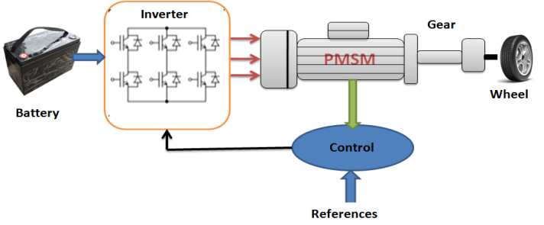

Figure 1. Electromechanical drive chain of the vehicle.

  - Source of Energy
The global energy source focuses on renewable energies as well as good battery power is generally the lithium battery system. Each type of battery has the benefits of specific energy and longevity over certain forms of rechargeable batteries.
    - Model of the inverter
In this electrical traction system (ETS), an inverter is used to generate three balanced phases of alternating current with variable frequency from the current battery expressed as the following:
$\left[\begin{matrix}v_{a} \\ v_{b} \\ v_{c}\end{matrix}\right]=\frac{U_{dc}}{3}\left[\begin{matrix}2 & -1 & -1 \\ -1 & 2 & -1 \\ -1 & -1 & 2\end{matrix}\right]\left[\begin{matrix}S_{a} \\ S_{b} \\ S_{c}\end{matrix}\right]$ (10)

    - Dynamics analysis of the vehicle
Based on the vehicle dynamics and aerodynamics principles [12], the load on the road${ F}_{res}$ is composed by:
$F_{res}={ F}_{roll}+F_{slope}+F_{aero}$ (11)
$F_{roll}=μMg$ (12)
$F_{slope}=Mg\sin\left(α\right)$ (13)
$F_{aero}=\frac{1}{2}ρC_{x}A_{f}{\left(v-v_{0}\right)}^{2}$ (14)
Where:
$F_{roll}$ : is the rolling resistance,
$F_{slope}$ : is the slope resistance,
$F_{aero}$ : is the aerodynamic drag.
The forces acting on the vehicle are shown in figure 2.

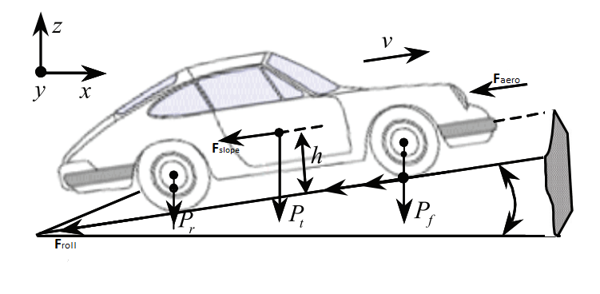

Figure 2. Forces acting on the vehicle
- The electrical differential and the application
The figure 3 shows the device applied to an electric vehicle in the Matlab/Simulink setting. The proposed control system is composed of the following components:
- Electrical driven rear wheels whose speed is controlled by ANN-PSO control technology,
- Two electric motors using speed control technology,
- Four wheels and lithium battery and two inverters,
- Speed sensor.

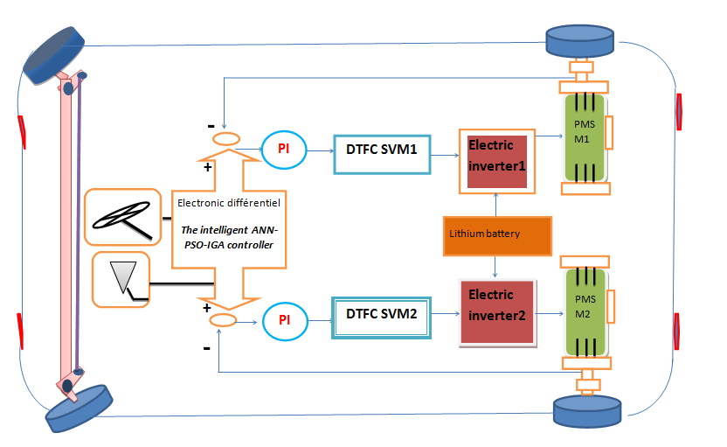

Figure 3. Schematic diagram of EV propulsion and control systems with DTFC
(Direct Torque and Flux Control)

The speed of the car varies depending on the direction of the road in the straight line. The speed of the two rear wheels is equal. However in the non-straight line the two rear wheels are driven directly by two-speed engines and the speed of the outer wheel would be higher than the speed of the inner wheel during the steering manoeuvres.
This process of checking for good results requires several conditions including the speed difference method of the two motors which is called a technique using ANN-PSO-IGA control technique for Electronic Differential (E-D).
The latter provides us with good results using advanced techniques in artificial intelligence which allows an increase in the speed of the external motor of the winding and a decrease in the speed of the internal motor in order to avoid traffic accidents.
Nonetheless, this condition can be easily satisfied if the location encoder is used to detect the angular position of the steering wheel.The standard reference speed Wref is then set by the pedal accelerator order.
The actual reference speed for left drive Wref – left and right drive Wref – right is then achieved by adjusting the common reference speed Wref using the output signal from the position encoder. When the vehicle is turning right, the speed of the left wheel is raised and the speed of the right heel remains equal to the standard reference speed of the Wref. As the vehicle is turning left, the speed of the right wheel is increased and the speed of the left wheel remains equal to the standard reference speed Wref using the ANN-PSO-IGA control technique for the Electronic Differential (E-D) [13]. Modern cars do not use pure Ackermann-Jeantaud steering partially because it lacks essential dynamic and compliant effects however, the concept is sound for low-speed manoeuvres [14, 15] this is illustrated in Figure 4.

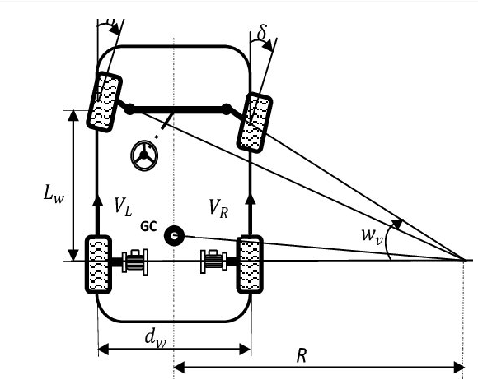
Figure 4. Trajectory driving model
The difference in angular velocity of the wheel engines is expressed as follows:
$∆w=w_{mes1}-w_{mes2}=-\frac{d_{w}\tan{σ}}{L_{w}}w_{v}$ (15)
This angle shows the direction of motion as the following:
$\left\{\begin{aligned}δ>0→turn left \\ δ<0→turn right \\ δ=0 straight ahead\end{aligned}\right.$ (16)
From equation (15) the block diagram of the electronic differential [16] is reconstructed as shown in Figure 5.
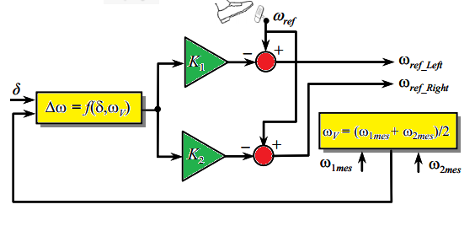
Figure 5. Block diagram shows the use of the electronic differential.

- Electronic differential of Speed Control Using ANN-PSO:
ANN-PSO-IGA control is a technique of control which, in the presence of uncertainties, can effectively linearize a nonlinear system like PMSM. Unlike other linearization feedback techniques, ANN-PSO-IGA control has the flexibility to keep useful nonlinearities intact while stabilizing. ANN-PSO-IGA control is essentially about stabilizing a virtual control state. It, therefore, produces a corresponding error variable that can be balanced by choosing the right control inputs carefully. Those inputs can be determined from the Lyapunov's stability analysis. From Eq. (1), it is evident that PMSM's dynamic model is extremely nonlinear due to the coupling between speed and electric currents. The direct axis current Id is often forced to be zero in order to align all the relation flux in the d-axis and obtain optimal torque per ampere in compliance with the vector control theory.

- Simulation Results:
In this section the electric rear-wheel drive (PMSM) speed regulation is simulated using the DTFC (Direct Torque and Flux Control) command and add the ANN-PSO-IGA technology in the classic electronic differential setting. The simulation is carried out using the model shown in Figure 5 to characterize the behaviour of the steering system as well as to show the engine current and the variable speed of each motor.
  - Straight route case
In this section, Fuzzy Adaptive PI Controller for (DTFC) is used as a reference and applied on an Electric Vehicle [8]. EV velocity is equal to 60Km / h . Figure.6 shows that EV has two phases.
The first phase is between [0 4]s and the second phase is between [4 5]s with a speed equal to 80 Km/h. As it is known, the two back wheels have similar speed .This proves that in this case the electronic differential does not work. When Fpente = 5.81 between [.5]s, the Figure shows that the only change occurs in the direct torques. The slope effect results in a significant improvement of the torque of the electromagnetic motor both on the left and right of each motor.

a-Right wheel speed | b-Left wheel speed
c- Right motor Electromagnetic  Torque. | d-Left motor Electromagnetic  Torque.
e – Vehicle speed | f-Total vehicle torque
g-vehicle resistant torque | h- Flux

Figure 6. Straight route[8]

  - Case of Curved road at a speed of 60km/h on the right
In this section the Fuzzy Adaptive PI Controller for (DTFC) applied for the curved track. The EV speed is equal to 60 km / h. Figure 7 shows that the electric vehicle has two stages: the first stage is between [0 2] seconds and the second stage is between [3 5] seconds at a speed of 80 km / h. At a speed of 80 km / h, the car drives on a curved road to the right. The steering wheels take different tracks in this case, the new electronic differential in the new ANN-PSO-IGA method controls the car and the wheels rotate in the same direction but at different speeds. The steering wheel speed on the right side decreases by a known value and the speed of the left wheel increases. All the required parameters for left and right wheels are plotted in Figure 7. If this speed is stabilized, the torque returns to its initial value corresponding to the total resistance torque applied to the engine wheels.

a – Left Wheel speed. | b – Right Wheel speed.
c – Left motor Electromagnetic  Torque. | d – Right motor Electromagnetic  Torque.
e – Vehicle speed in right turn in  curved way. | f – Resistive Torques in right turn  in curved way.
g - Electromagnetic Torque | h - Flux

Figure7. Curved line to the right

- IMPLEMENTATION OF THE PSO-ANN METHODOLOGY
Artificial Neural Network (ANN) can be applied for a wide range of fields comprising classification, pattern recognition, identification, and image processing and control system. Based on the previous section, Fuzzy Adaptive PI Controller for (DTFC) is used as tool to compute the speed and torque then used as in input and output (Input: speed and curve angle. Output: wheels speed) in ANN. The dominant characteristic of ANN is its capacity to learn through experience to improve performance. In this paper, we employed ANN combined with PSO to predict the speed wheel left and right direction. Basically, a network of ANN has three key components comprising the input layer, the hidden layer and the output layer as shown in figure 8.

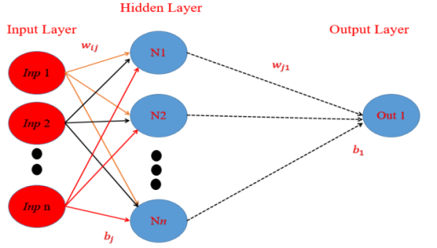
Figure.8 Typical Architecture of Artificial Neural Network (ANN)

Where:
wij : is the weights of neuron relation in hidden layers between the input node and the neuron,
bj : :is the bias, wj is the neuron relation weights in secret and output layers between the neurons,
$b_{1}$ : is a bias in the output layer associated with a single neuron,
i = 1, 2, 3,…, m are the number of collected data and
j = 1, 2,3, …, n are neurons covered on the ground.
The total number of parameters used in the network (weight and biases) is n× (m + 2) + 1.After having built the structure of the ANN model, training with known input and the output sets are performed to find suitable weights and biases using PSO as presented in Ref [17]. The objective is to minimize root-mean-square error (RMSE) function of the network which is described by the following formulation:

$RMSE=\sqrt{\frac{\sum_{l=1}^{n}{{(O_{l}-l_{l})}^{2}}}{nd}}$ (17)
Where:
$O_{l}$ is the output corresponding to lth data point in the training set by the network.
$l_{l}$ is the actual output as consider in the target set.
$nd$is the number of data points considered in training data-set. After collecting the data the regression of ANN technique is presented in figure 9.
Four scenarios are considered to predict the left and right wheel speeds.

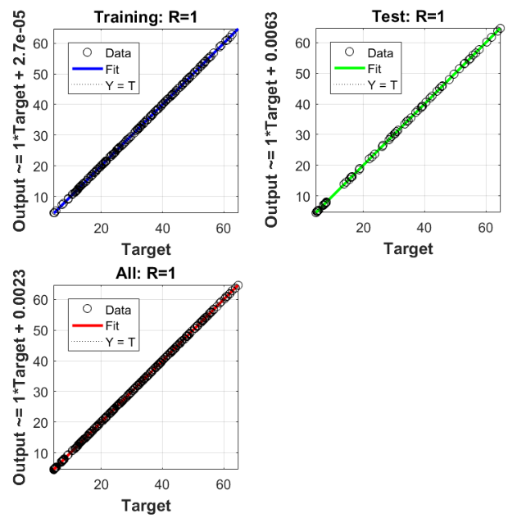

Figure.9 Regression after collecting 44 data
Table 1. Real and predicted results of the left and right wheels based on ANN-PSO
N | Tests |  |  | Speed Real |  | Speed Estimated
N | speed$V_{h}$ | $$α$$ |  | Left (L) | Right (R) | Left (L) | Right (R)
1 | 7.5 |  | 5π/180 | 08.09 | 06.86 | 08.01 |  | 06.93
2 | 17.5 |  | 5π/180 | 18.90 | 16.00 | 18.76 |  | 16.11
3 | 57.5 |  | π/180 | 58.25 | 56.35 | 58.31 |  | 56.32
4 | 52.5 |  | π/180 | 53.20 | 51.45 | 53.12 |  | 51.39
Based on the provided results in Table 1 and Figure 10, ANN-PSO can predict with more accurate the suitable wheels speed in curved way with less CPU time.

Figure 10. Real and predicted results of the left and right wheels based on ANN-PSO
- Conclusion

In this paper the non-linear control of the PMSM placed in the rear drive wheels of the electric vehicle is designed and presented taking into consideration the vehicle dynamics. Based on the linear method of input and output, the proposed non-linear control is evaluated on the EV model.
- Control technology allows for linearity and separation of the system. In Speed Electronic Differential Control, the nonlinear control of a permanent synchronous magnetic drive, based on the linear traction control algorithm, for traction control provides fast response and simple configuration and can be a good candidate for the electric vehicle propulsion system.
- Next, a new application is proposed to solve this problem using machine learning (ANN-PSO) to adapt the ED parameters. The required information (Curved path angle) can be extracted by GPS. Results of simulation show that this structure allows for electronic differentiation which can guarantee good stable and dynamic performance.
- The electronic differential (ED-ANN-PSO) decreases the speed of the steering wheels with high force on both left and right curved paths as well as the change in vehicle speed depending on the road location and conditions.
- The analysis of the results of the approach shows a better performance and dynamic stability of electrical vehicle drive systems.

REFERENCES
[1] A,Lyckegaard, T. Hels, and I.M. Bernhoft, Effectiveness of electronic stability control on single-vehicle accidents. Traffic injury prevention, 2015. 16(4): p. 380-386..
[2] A,Bouscayrol,et al., Physics of Energy Transformation-Multi-converter multi-machine systems: Application for electromechanical drives. European Physical Journal-Applied Physics, 2000. 10(2): p. 131-148..
[3] M,Starnes, Estimating lives saved by electronic stability control, 2008–2012. 2014.
[4] A,Bouscayrol, et al., Control structures for multi-machine multi-converter systems with upstream coupling. Mathematics and Computers in Simulation, 2003. 63(3-5): p. 261-270.
[5] Y,Hori, Y. Toyoda, and Y. Tsuruoka, Traction control of electric vehicle: basic experimental results using the test EV" UOT electric march". IEEE transactions on Industry Applications, 1998. 34(5): p. 1131-1138.
[6] J,Ryu. and J.C. Gerdes, Integrating inertial sensors with global positioning system (GPS) for vehicle dynamics control. J. Dyn. Sys., Meas., Control, 2004. 126(2): p. 243-254.
[7] F, Khoucha, et al. Experimental performance analysis of adaptive flux and speed observers for direct torque control of sensorless induction motor drives. in 2004 IEEE 35th Annual Power Electronics Specialists Conference (IEEE Cat. No. 04CH37551). 2004. IEEE.
[8] M, Khessam, et al., Fuzzy Adaptive PI Controller for DTFC in Electric Vehicle. International Journal of Power Electronics and Drive Systems, 2014. 4(4): p. 557.
[9] I,Husain, and M.S. Islam, Design, modeling and simulation of an electric vehicle system. SAE transactions, 1999: p. 2168-2176.
[10] M,Ehsani, K.M. Rahman, and H.A. Toliyat, Propulsion system design of electric and hybrid vehicles. IEEE Transactions on industrial electronics, 1997. 44(1): p. 19-27.
[11] B,Multon. and L. Hirsinger. Problème de la motorisation d'un véhicule électrique. 1994.
[12] A,Haddoun, et al. Sliding mode control of EV electric differential system. 2006.
[13] S,Gair, et al. Electronic differential with sliding mode controller for a direct wheel drive electric vehicle. in Proceedings of the IEEE International Conference on Mechatronics, 2004. ICM'04. 2004. IEEE.
[14] R,Colyer. and J. Economou. Comparison of steering geometries for multi-wheeled vehicles by modelling and simulation. in Proceedings of the 37th IEEE Conference on Decision and Control (Cat. No. 98CH36171). 1998. IEEE.
[15] Rama, R.S. and P. Latha, Fuzzy Adaptive PI Controller for Direct Torque Control Algorithm Based Permanent Magnet Synchronous Motor.
[16] K,Hartani, et al., Electronic differential with direct torque fuzzy control for vehicle propulsion system. Turkish Journal of Electrical Engineering & Computer Sciences, 2009. 17(1): p. 21-38.
[17] S,Rukhaiyar. M, Alam, and N. Samadhiya, A PSO-ANN hybrid model for predicting factor of safety of slope. International Journal of Geotechnical Engineering, 2018. 12(6): p. 556-566.
[18] R.SenthilRama, P.Latha, Fuzzy Adaptive PI Controller for Direct Torque Control Algorithm Based Permanent Magnet Synchronous Motor, ISSN 2250-2459, ISO 9001:2008 Certified Journal, Volume 3, Issue5, May 2013.
[19] M, Yildirim, M. Polat, and H. Kurum, A survey on comparison of electric motor types and drives used for electric vehicles. IEEE 16th International Power Electronics and Motion Control Conference and Exposition (PEMC), pp. 218-223, 2014.
[20] A,Laguidi . Hazzab A., Adaptive Self-tuning Fuzzy Backstepping controller for the Control of Electric Vehicle with two-Motor-Wheel Drive, Acta Electrotechnica et Informatica, Vol. 19, No. 2, 2019, 38–44, DOI: 10.15546/aeei-2019-0013
[21] B,Lenzo .P, Gruber .B Sorniotti (2019), ‘On the enhancement of vehicle handling and energy efficiency of electric vehicles with multiple motors: the iCOMPOSE’, project. In: The IAVSD, international symposium on dynamics of vehicles on roads and tracks. Springer, Berlin, pp 1342–1349
[22] Abianeh, A.J. “Direct torque and flux control of IPM synchronous motor drive using input-output feedback linearization approach,” IECON 2011-37th Annual Conference of the IEEE Industrial Electronics Society. 2011. IEEE.
[23] E. Sheeba Percis.., Electric Vehicle as an Energy Storage for Grid Connected Solar Power System, International Journal of Power Electronics and Drive System (IJPEDS), Vol. 6, No. 3, September 2015, pp. 567~575.
[24] K, Sreekanth Reddy.B Sreenivasappa .., Single phase multifunctional integrated converter for electric
vehicles,Indonesian Journal of Electrical Engineering and Computer Science ,Vol. 24, No. 3, December 2021 , pp. 1342~1353.
[25] M,Khan .., Electric vehicles participation in load frequency control based on mixed H2/H∞, International Journal of Electrical Power & Energy Systems, Volume 125, February 2021, 106420.

 | Medjdoub Khessam was born in 1984 at Naama-Algeria he’s received the electrical engineering diploma from Bechar University, Algeria in 2009, and the Master degree from the University Sidi bel abbes Algeria in 2011. and the Ph.D.degree from the Electrical Engineering University of Bechar, Bechar, Algeria in 2017. He is currently professor of electrical engineering at Institute of science and technology, University center Salhi Ahmed Naama, Algeria . His research interests include power electronics ,electric drives control, and artificial intelligence and their applications.  He can be contacted at email: Khessam@cuniv-naama.dz  Khessam.medjdoub@hotmail.fr
Abdelkader Lousdad, born at Tilmouni Sidi Bel-Abbes, Algeria, graduated from the University of Cincinnati USA in 1979 in mechanical engineering. Holding a Master in industrial management of enterprises since 1989 and a Magister since 1992 in Structure/Robotics from the University of Sidi Bel-Abbes. He obtained his Doctorate degree in material science in 2008 and Habilitation in 2010 from the University Djillali Liabes of Sidi Bel-Abbes where he is an assistant professor and head of a research team at the LMSS. Co worker in: Intelligent Control Electrical Power Systems (ICEPS) and IRECOM Laboratories Laboratory Mechanics of Structures and Solids (LMSS).
He can be contacted at email: a_lousdad@yahoo.com
 | Hazzab Abdeldjebar received the state engineer degree in electrical engineering in 1995 from the University of Sciences and Technology of Oran (USTO), Algeria the M.Sc. degree from the Electrical Engineering Institute of the USTO in 1999, and the Ph.D. degree from the Electrical Engineering Institute of the USTO in 2006. He is currently professor of electrical engineering at University of Bechar, Bechar, Algeria, where he is Director of the Research Laboratory of Control Analysis and Optimization of the Electro-Energetic Systems. His research interests include power electronics, electric drives control, and artificial intelligence and their applications .  He can be contacted at email: a_hazzab@yahoo.fr

