Classification of specialities in textual medical reports based on natural language processing and feature selection

Hasnain Abdul-Jawad Almuhana 1, Hawraa Hassan Abbas 2, Department of electrical engineering College of Engineering, University of Karbala, Iraq 1. Department of electrical engineering College of Engineering, University of Karbala, Iraq 2.
E-mail: hasanen.a@s.uokerbala.edu.iq 1, Hawraa.h@ uokerbala.edu.iq 2

Article Info |  | ABSTRACT
Article history:  Received month dd, yyyy  Revised month dd, yyyy  Accepted month dd, yyyy |  | Nowadays, a great deal of detailed information about patients, including disease status, medication history and side effects, treatment outcomes, and laboratory test results, is collected in an electronic format; this is generally referred to as an electronic medical record (EMR), and the data serves as a valuable resource for further analysis, diagnosis, and treatment. The huge quantity of detailed patient information in these medical texts produces a huge challenge in terms of processing this data efficiently, however.  Machine learning algorithms, artificial intelligence techniques, and natural language processing tools can have the potential effect of simplifying unstructured data, which could positively affect medical report analysis. Natural Language Processing (NLP) has recently made huge advances, outperforming classical statistical and rule-based systems on a variety of tasks. In this paper, an automatic system was thus produced to classify specialist consultant interactions based on patients’ medical reports. In this system, natural language processing was used as a pre-processing step on a dataset formed of unstructured medical reports. The natural language segment of the classification system includes manual spell checking, tokenization, and data cleaning, as well as removing all English and domain Stop words to help reduce the number of features in the report and to eliminate various noise steps. After pre-processing, feature extraction and feature selection methods were used to convert the textual medical reports to sets of features and to extract the most effective features to increase classification accuracy and reduce execution time. Various classification methods were then applied (ML perceptron, Logistic Regression (RF), and Linear Support Vector Classifier (LSVC)). The highest accuracy (99.39%) was achieved by applying ML-Perceptron classification techniques.
Keywords:
NLP
machine learning
Feature Extraction
feature selection
EHR
EMR

__________________________

Corresponding Author:
Hasnain Abdul-Jawad Almuhana
Department of electrical engineering
College of Engineering
University of Karbala, Iraq

- INTRODUCTION

1.1 Natural language processing.
NLP is a branch of artificial intelligence and machine linguistics that enables computers to access meaning from inputs in the form of natural language or human linguistics. It is used to analyse text or speech, thus allowing machines to access human language [1]. In most well-known languages, such as English, Arabic, Chinese, and Spanish, speech inputs are delivered, whether spoken or written, in human comprehensible forms. The underlying computer language, known as machine language or machine code, is largely incomprehensible to most people, however, as at the lowest levels, machine communication does not utilise words, instead relying on strings of binary data, represented by millions of zeros and ones, which are decoded to produce logical mathematical actions [2].

1.2 Medical records
Medical records include all data collected by medical staff, surgery robots, medical imaging devices, emergency video cameras, and patient monitors in wards, operating theatres, and intensive care units. Healthcare professionals generate many f the important parts of these medical records however, which are recorded in the form of audio files or as text [3].
While the volume and granularity of medical data has grown exponentially over time, most of it remains unused. The main reason for this is that healthcare-related information systems are not equipped to process unstructured data. If the capabilities to interpret, analyse and process unstructured medical data were available, therefore, it is possible that the benefits would be significant both for individual patient treatment and for medical research and public health management purposes [3].
Currently, there is huge interest in applying artificial intelligence in the medical field to improve diagnostics, public health, patient care, and pharmaceutical research, as well as for many other tasks. The success of AI systems in such analysis depends on the availability of datasets and quality of the included data, however, and pre-processing unstructured data is important step towards acquiring efficient information from medical records using AI techniques [3]. Natural language processing, artificial intelligence, and machine learning all have the potential to simplify the use of unstructured data; however, it is unlikely that these systems will ever reach a point at which computers can make decisions in critical cases rather than simply supporting the humans who must make those decisions [4].

1.3 Electronic medical records (EMRs)

A digital copy of the paper charts seen in many clinicians’ offices exists in most cases, and this is known as an electronic medical record or EMR. An EMR includes the patient’s full medical and treatment history in a single file. The main advantage of EMRs is thus that they allow clinicians to track data over time and easily identify where patients need check-ups or preventive screenings, as well as allowing them to check how well their patients are complying with treatment and performing against certain parameters such as blood pressure readings, improving the overall quality of care and service [5].

EMRs as online records include of the standard clinical data and medical data from a single medical source or medical service office. They are thus mostly used by treatment providers for diagnosis or to check a patient’s medical history. Comprehensive and accurate documentation of tests, diagnoses, and treatment in EMRs ensures appropriate care throughout a patient’s experience with a given provider.

1.4 Electronic Health Records (EHRs)
Electronic health records (EHRs) are electronic systems used and maintained by overarching health care systems to collect and store medical information for all patients. Electronic health records are used across health care administration areas and clinical care providers, and thus cover a variety of medical information for each patient over time, which can be used to manage clinical workflow.
At the patient level, EHRs contain multiple variables, such as laboratory data, diagnoses, presenting complaints, medications, vital signs, and demographics, According to the National Academies of Medicine, EHRs thus have multiple primary functions, including obtaining health information, managing outcomes, supporting clinical decision making, facilitating health information exchange, facilitating electronic communications, offering patient support, administrative processes, and population-level health reporting.
EMR records are patient-centred, purpose-driven, and designed to derive information on specific exposures and health outcomes, while in contrast, EHRs are centred around patient transactions. Despite these differences, however, EHRs capture a wealth of data relevant to patient wellbeing. EHRs may also assist with certain functions required by the patient registry, particularly data collection, data cleaning, and data storage, while the registry in turn may increase the value of the information collected in EHRs by performing focused actions such as investigation of comparative safety, efficacy, value, population management, and quality reporting.
Electronic health records thus provide a unique chance for health systems to contribute to external records within the health system and to develop internal records. Such records are often developed by integrating registry functionality with existing EHR platforms: however, these records are limited to existing patients in the health system and may not be able to capture longitudinal data from varying provider settings. Records that capture EHR data from multiple health systems typically interact with EHRs to receive data on at intervals from records associated with or reported by existing EHRs. Despite automation of these efforts and the creation of a two-way exchange of information, making best use of these thus still remains a challenge.
EHRs contain a large amount of unstructured data, such as medical reports and progress notes. The loosely structured nature of typed text and free text is effective in day-to-day clinical workflows but presents a major challenge in terms of automating EHR-based registries. This unstructured data may also contain important information omitted from more structured data, which may be key to determining the patient’s state, or may offer extra information complementing or even contradicting the structured data. The complexities of unstructured data, along with the fact that existing text mining tools and natural language processing applications have limited accuracy in extracting information from free text, often lead to manual chart reviews of individual patients before their final inclusion in the registry in some registries.
Automated computational phenotyping methods for such applications have been limited by the extent of this unstructured data, which has decreased data quality in terms of accuracy and efficiency, particularly with regard to missing data when data are extracted from databases by mining only the structured EHR sections, neglecting any Simi structure and unstructured data. Some EHRs also allow a choice of locations for important data, which results in fragmented storage of treatment information. Treatment information may also be buried in clinical notes, which may not be accessible for research purposes, as such notes often include personally identifiable details such as the patient’s name and other information that may be difficult to identify and redact systematically.

Electronic medical records (EMRs) vs. electronic health records (EHRs)
Table 1:1 shows a comparison of the strengths and weaknesses of electronic medical records (EMRs) and electronic health records (EHRs).
EMR | EHR
- Their evolution began in the 1960s when problem-oriented medical records and patient medical histories were first recorded instead of just the diagnosis and treatment provided by doctors.[6] | - The first EHR systems were known as clinical information systems, and they were developed in the mid-1960s.[7]
- An EMR contains the medical history of a patient and their treatment at a single practice, including medical history, diagnoses, medications, immunisation dates, allergies, lab results and doctors’ notes. | - EHRs focus on a patient’s overall health that beyond standard clinical data collected through treatment services, making them inclusive of a broader view of patient health.
- EMR records are universal: each patient can thus have a single electronic chart that can be accessed by any physician or facility using EMR software, | - EHRs offer access to evidence-based tools that medical staff can use to make decisions about a patient’s health.
- EMRs contain information about an individual or specific patient within a single healthcare organisation. | - EHRs contain a patient’s medical history, diagnoses, medications, treatment plans, immunization dates, allergies, radiology images, and laboratory and test results.
- Static | - Track data over time, automating and streamlining provider workflows
- EMRs are not shared among organisations | - EHRs are shared among organisations
- An EMR does not communicate with other systems | - An EHR communicates with other systems
- From a cybersecurity perspective, an EMR is not an important document or valuable target | - From a cybersecurity perspective, an EHR is a valuable target
- EMRs are essentially digital versions of paper charts. Digitising key data makes it easier to store, retrieve and access while simultaneously limiting the amount of duplication and reducing the risk of inaccurate data capture. | - EHRs offer value for smaller practices that regularly refer patients to specialists or other clinics, as the interoperable nature of EHRs can significantly reduce the amount of time and effort required by administrative staff to ensure transferred records are easily accessible.

Table 1:1 Electronic medical records (EMRs) VS Electronic Health Records (EHRs)

1.5 Data Quality.
Registries must institute data curation to assess and review the quality of data before it is imported into EHRs. This often requires extensive data preparation and cleaning.
EHRs are designed to support clinical workflow and to manage the transactions in healthcare as well as the documentation for billing. The conduction of research is not a formal reason for the creation of an EHR data, and EHRs are not designed to systemically collect research-grade longitudinal data. As a result, data captured by EHRs may be of variable quality. For example, EHRs often house reliable laboratory and medication data for clinical purposes while lacking consistency and sufficiently detailed data on patient risk factors, levels of education, or socioeconomic status.
The quality of origin data can affect both the results generated using such data and the resulting data as represented in a registry. EHR data may thus not be appropriate for some research purposes. Data quality can be defined based on the most impactful aspects for registries as involving
1. Accuracy: the extent to which data extracted to the EHR accurately reflects the real state of patients, which is usually complex to measure because the true value of a given variable may be unknown.
2. Completeness: this is related to the level of missing data in the EHR for a particular data element across the population of interest; generally, this is measured as a data quality indicator for HER integrated registries.
3. Timeliness: the gap between the initial capture of a value and the time the value becomes available in the EHR.

1.6 Feature Selection
Feature selection is the basic process of isolating the most consistent, non-redundant, and relevant features to use in model construction. Methodically reducing the size of datasets is becoming ever more important as the size and variety of datasets continue to grow. The main goals of feature selection are thus to improve the performance of a predictive model and reduce the computational cost of modelling it.
Feature selection in machine learning thus aims to find the best set of features to build useful models of studied phenomena, and the techniques for feature selection in machine learning can be broadly classified into the following categories:
Supervised Techniques: These techniques can be used for labelled data; they are used to identify the relevant features for increasing efficiency in supervised models, such as classification and regression.
Unsupervised Techniques: These techniques can be used for unlabelled data.
Feature selection techniques can be employed to reduce the number of input variables by eliminating redundant or irrelevant features and narrowing down the set of features to those most relevant to the machine learning model in question.
The main benefits of performing feature selection in advance, rather than letting a machine learning model figure out which features are most important as it goes, include
- producing simpler models: simple models are easy to explain, and any model that is too complex and thus unexplainable is not valuable
- creating shorter training times: a more precise subset of features decreases the amount of time needed to train a model
- reducing variance: this increases the precision of the estimates obtained for a given simulation
- avoiding issues of high dimensionality: the dimensionality phenomena is based on the fact that, as dimensionality and the number of features increases, the volume of space used increases so fast that the available data become limited; PCA feature selection is most commonly used to reduce dimensionality
There are a further three key properties to feature representation that make it desirable: it is easy to model, works well with regularisation strategies, and allows disentangling of causal factors.
Feature selection algorithms can be categorised as either supervised, used for labelled data, or unsupervised, used for unlabelled data. Unsupervised techniques can be further classified as filter methods, wrapper methods, embedded methods, or hybrid methods:
    - Filter methods: Filter methods select features based on statistical values rather than by cross-validation of performance. A selected metric is applied to identify irrelevant attributes and perform recursive feature selection. Filter methods may be either univariate, in which an ordered ranking list of features is established to inform the final selection of a feature subset, or multivariate, which evaluate the relevance of features overall, thus identifying redundant and irrelevant features.

    - Wrapper methods: Wrapper feature selection methods consider the selection of a set of features in the form of search problem, whereby their quality is assessed based on the preparation, evaluation, and comparison of a given combination of features with other combinations of features. This method facilitates the detection of possible interactions amongst variables. Wrapper methods also focus on feature subsets that will help improve the quality of the results of clustering algorithms used for such selection. Popular examples include the Boruta feature selection and the Forward feature selection. ‍

    - Embedded methods: Embedded feature selection methods integrate the feature selection machine learning algorithm as part of their learning algorithm, allowing classification and feature selection to be performed simultaneously. The features that will contribute the most to each iteration of the model training process are thus carefully extracted. Random forest feature selection, decision tree feature selection, and LASSO feature selection are common embedded methods.

1.8 Related work
Electronic medical records (EMR) are increasingly being used to document and store large amounts of clinical information, yet efficiently and accurately extracting meaningful data from electronic health records is challenging, as a significant portion of clinical information is stored in unstructured, free text. Manual review of this data is thus often necessary which can be time-consuming, error prone, and costly[8].
In terms of using EHRs, researchers in the genomics, clinical imaging, and mobile domains. authors have reviewed the possibility of automating a number of tasks including disease diagnoses, disease prediction, phenotype modelling, disease classification, and developing training representations of medical concepts, such as diseases and medications. Li et al. [9] focused on a broad scope of tasks, such as classification and prediction, word embedding, extraction, generation, and similar matters such as question answering, phenotyping, generating knowledge graphs, forming medical dialogue, and supporting multilingual communication and interpretability. They reviewed multiple recent studies that showed how such tasks could be supported by electronic health records and health informatics, concluding that Deep learning methods in the general field of NLP have achieved remarkable success, but that applying them to the field of biomedicine remains challenging due to limited data availability and additional difficulties associated with domain-specific text data.
One of the promising trends in this field is the development of better knowledge of mining information from unstructured data [10], which is useful when working with acombination of structured and unstructured data to develop better decision making and facilitate broader interpretation.
Thomas et al.[11] performed a study to assess the validity of an NLP program designed to accurately identify patients with prostate cancer: to achieve this, a retrospective review was performed of a prospectively collected database that featured patients from the Southern California Kaiser Permanente. A consecutive series of 18,453 pathology reports were evaluated, and NLP was found to correctly detect 117 out of 118 patients. This translated to a positive predictive value of 99.1% with 99.1% sensitivity and 99.9% specificity in terms of correctly identify patients with prostatic adenocarcinoma after biopsy. The overall ability of the NLP application to accurately extract variables from the pathology reports was 97.6%.
Classification of health-related texts is a special case of text classification. Clinical notes in a particular patient's record may contain a lot of redundancy, due in large part to the documentation habit of many physicians of copying past notes and pasting them into a new note [12].
Weng et al. [13] showed that a supervised learning-based NLP approach is useful for developing medical subdomain classifiers. The medical subdomain, such as cardiology or neurology, of a clinical note is a useful piece of content-derived metadata for developing machine learning downstream applications. NLP was thus used with respect to clinical text analysis and classifying the medical subdomain of a note accurately. In their research, a Unified Medical Language System (UMLS) Metathesaurus, a Semantic Network, and various learning algorithms were used specifically to extract features from a Massachusetts General Hospital data set, with medical subdomain classifiers with different combinations of data representation methods and supervised learning algorithms thus developed.
This led to the construction of a machine learning-based NLP pipeline and the development of medical subdomain classifiers based on the content of each note using a clinical Text Analysis and Knowledge Extraction System (cTAKES). Two datasets, the iDASH data repository (n = 431) and the Massachusetts General Hospital (MGH) database (n = 91,237), were used.
The convolutional recurrent neural network with a neural word embedding trained-medical subdomain classifier yielded the best F1 scores, with 0.845 for the iDASH dataset and 0.870 for the MGH dataset. This was based on better clinical interpretability from a linear support vector machine-trained medical subdomain classifier using a hybrid bag-of-words and clinically relevant UMLS concepts to develop feature representation.
Frequency-inverse document frequency (Tf-idf) weighting outperformed other shallow learning classifier datasets, with an accuracy of 0.957 and 0.964 and F1 scores of 0.932 and 0.934 for the two datasets, respectively. Classifiers were trained on one dataset and applied to the other dataset, yielding a threshold F1 score of 0.7 with regard to classifiers for half of the medical subdomains.
Electronic medical records (EMR) offer unique possibilities for clinical research; however, some important patient attributes are not readily available due to their unstructured properties. Caccamisi et al. [14]. developed a model using machine-learning algorithms to automatically classify patients’ smoking habits. This applied text mining, using machine learning to enable automatic classification of unstructured information on smoking status drawn from Swedish EMR data. Data on patient smoking status from EMRs was then used to develop 32 different predictive dataset selections across a database of 85,000 classified sentences. The best performing model was based on the Support Vector Machine (SVM) Sequential Minimal Optimization (SMO) classifier. Sentence frequency and attribute selection did not improve model performance, however. SMO achieved 98.14% accuracy and an F-score of 0.981 versus values of 79.32% and 0.756 for the rule-based model.
Hammoud et al.[15] presented a new Arabic medical dataset for text classification. The dataset included 2,000 articles over 10 classes (Blood, Bone, Cardiovascular, Ear, Endocrine, Eye, Gastrointestinal, Immune, Liver, and Nephrological) of disease. These researchers thus suggested that pre-trained models trained on large, related corpora and fine-tuned to specific datasets yield state-of-the-art results. The ABioNER model pre-trained on an Arabic medical corpus before fine-tuning on the relevant dataset with the original BERT model produced results of 97.4331 for F1 Validation. and 95.9124 in F1 Testing, with overall SVMs of 89.1308 and 87.3473, respectively.
Khichdee et al. [16] introduced an instrument for classification of medical records based on language, based on 24,855 text records. The documents were classified into three groups (endoscopy, ultrasonography, and X-ray), with 13 subgroups, using two methods; these were Support Vector Machine (SVM) and 𝐾-Nearest Neighbour (KNN)with feature selection.
The results obtained demonstrated that both machine learning methods performed successfully, with SVM operating slightly more effectively based on feature selection. However, at the second stage of classification into subclasses, 23% of all documents could not be linked to only one definite individual subclass (binary system or liver) due to the common features characterising these subclasses.

2. Proposed System.
The methodology proposed in this research is depicted in Figure 1. As shown, multiple steps are required to achieve the goals of this study:
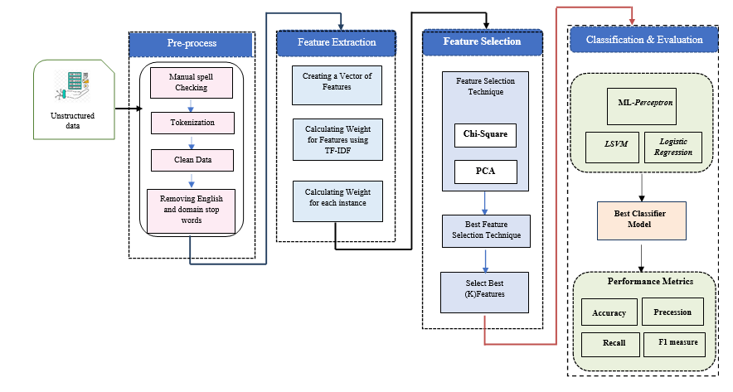
Fig. 1 Illustration of the architecture of the proposed system.
Dataset: The Encounter dataset records interactions between a patient and healthcare provider(s) for the purpose of providing healthcare service(s) or assessing the health status of the patient. A patient encounter is further characterised by the setting in which it takes place, creating subsets of ambulatory, emergency, home health, inpatient, and virtual encounters. The Date Created was taken as 2018-09-20 and the Date Modified as 2019-11-01, with Spatial Coverage being the entire United States
The resulting data set contains 5,448 cases in 26 columns. Most of the data, however, is contained in the Description Column, free text natural language description section. This column is thus used for transcription and the assignation of medical specialty. This column was thus assumed to contain the medical speciality for each case, which was then used as a label.
  - Pre-processing steps
This stage was divided into two separate processes. The first was the pre-processing of structured data, while the second was the pre-processing of the remaining unstructured data to it suitable for text mining algorithms.
For the unstructured data, these pre-processing steps included
- Manual spellchecking: A spellchecker is a software tool that identifies words that may have been misspelled and suggests possible corrections. Every word from a text is compared to an appropriate lexicon, and when a word is not in the dictionary, it is highlighted as an error [17] .This step involves making a sensitive comparison of each word with the closest matched words in dictionary where the result looks different according to the selected word.
The dataset employed in this study includes clinical report-based multi-class classifications written by medical staff; it thus contained multiple misspelled words and transcription errors that np automated spellcheck package could handle. Manual spellchecking was thus used to return a set of possible candidates for each misspelled word, allowing the user to select the best matching word according to the scope of the reports.
- Tokenisation: In this study, tokenisation was performed by dividing the longer strings of medical reports into smaller pieces or tokens (words) based on spaces between them.
- Data cleaning: This was performed in two steps.
- Conversion to Lower Case: This step converted all characters to lowercase to simplify the NLP task.
- Removing punctuation, symbols, and special characters: This step eliminated unnecessary information such as '!', '"', '#', '$', '%', '&', "'", '(', ')', '*', '+', ',', '-', '.', '/', ':', ';', '?', '[', '\\', ']', '_', '`', '{', '|', '}', and '~' to render text in an appropriate form for NLP.
- Removing all English and domain Stop words: This stage filtered out all words that contribute little to the overall meaning of a text such as “the”, “to”, and “this”. For this study, the library NLTK, in addition to a set of prespecified medical words (“mg”, “patient”, “tb”, “lt”,…) was used to clean the data of stop words.

2.2 Feature Extraction (FE)
The task of converting a particular text into a vector-based on space is an important part of text processing that can help extract the most important features from the text. FE methods are necessary to extract features as text data includes formats that are not accepted by machine learning techniques, and the features of such text must thus be extracted in a specific format that is accepted by such algorithms.
In this research, the TF-IDF feature extraction method was used .
TF-IDF is a term derived from the fact that inverted document frequency can be used a numerical statistic that identifies the importance of a word in a set of documents [18]. Mathematically, TF-IDF is the result of the application two scales: TF and IDF. The TF-IDF for each term can thus be calculated using Eq. (1)[18].
𝑇𝐷 - 𝐼𝐷𝐹 (𝑡, 𝑑) = 𝑇𝐹 (𝑡, 𝑑) × 𝐼𝐷𝐹 (𝑡) (1)
where TF is defined as the number of times the term t occurs in document d, which is equivalent to the bags of words (BoW) approach. IDF thus refers to the statistical weight used to measure the significance of a term in a set of documents, which can be calculated using Eq. (2) [18].
𝐼𝐷𝐹 (𝑡) = 𝑙𝑜𝑔 [(𝑛) / (𝑑𝑓 (𝑡))] (2)
where the total number of documents in the document set is denoted by n, and df(t) indicates the document frequency of t. Document frequency is thus the number of documents in the set of documents containing the term t.
Once texts are converted using TF-IDF, and given appropriate weights, machine learning algorithms can then be used.
    - Creating a vector of features
Unstructured text not suitable for use directly by machine learning techniques. As the pre-processing stage removes all punctuation, stop words, and other irrelevant features, the role of FE techniques is to transform a particular text into a matrix appropriate for machine learning algorithms, with rows representing the texts and columns representing the extracted features or words.
    - Calculating weights for features
In this work, Term Frequency-TF-IDF was employed for transforming unstructured text into features based on term frequency and occurrence. This technique takes into account the number of times that a term appears in all documents and in the document set. Once the TF and IDF values are obtained according to Eq. (3), it is possible to calculate the TFIDF:
𝑇𝐹 - 𝐼𝐷𝐹𝑖, = 𝑡𝑓𝑖, × log 𝑑𝑁𝑓𝑖 (3)
where 𝑡𝑓i,j = number of times, the term 𝑖 appears in a document 𝑗, N refers to the total number of documents, and 𝑑𝑓𝑖 =number of documents that contain term 𝑖.
  - Feature Selection (FS)
Feature selection (FS) is a process that automatically selects those features in the data that contribute most to the prediction variable or output of interest. FS can thus be used in data pre-processing to achieve efficient data reduction.
The best feature selection techniques for this work were identified as the Chi-square test and Principal Component Analysis (PCA).
    - Chi-square Test
The Chi-square test is a common statistical technique used for assessing categorical features in a dataset. [19]. The Chi-square value between each feature and the target is calculated, and the desired number of features with the best Chi-square scores thus selected. In order to correctly apply the chi-square test in order to examine the relationship between various features in the dataset and the target variable, the following conditions must be met: the variables must be categorical and sampled independently, and all values should have an expected frequency greater than 5 [20].
    - Principal Component Analysis (PCA):

Principal Component Analysis (PCA) is a dimensionality reduction technique used to extract features from a dataset by reducing the dimensionality of the dataset based on employing matrix factorisation. This projects the dataset completely into a lower dimension while attempting to preserve the variance.

PCA can be used to reduce the umber of features when the dimensionality of a dataset is very high and analysing redundant features is a tedious task. PCA can reduce a dataset with excess features into a dataset with the desired number of features relatively simply, though this does lead to the loss of some variance.
  - Data Mining:
Various AI techniques for text mining are used to automatically process data and generate useful or valuable insights, enabling users to make decisions based on the information extracted from such data.
Text mining identifies facts, assertions, and relationships buried in blocks of textual big data that, without excavation, would never be discovered and which would remain buried indefinitely. Excavation can, however, extract the useful information, and then transform it into a structured model that can be analysed further or even presented directly without analysis
In terms of such data classification, several different techniques, such as random forest and logistic regression methods, have been proposed. Although many other data mining techniques have been utilised in the literature, only the methods most relevant to this research are presented here.
2.4.1 Support Vector Machine (SVM):
Support Vector Machine (SVM) is a supervised machine learning algorithm in which each data element is plotted as a point in an n-dimensional space representing n available features, with the value of each feature being a given coordinate value. The classification process is achieved by finding the hyper-level that most clearly distinguishes between the two categories, as shown in Figure (4) [21].
SVM was invented by Vapnik (1995) based on the theory of statistical learning, and it was originally designed for pattern recognition and multidimensional regression estimation, which can be used to solve linear or nonlinear problems [22].
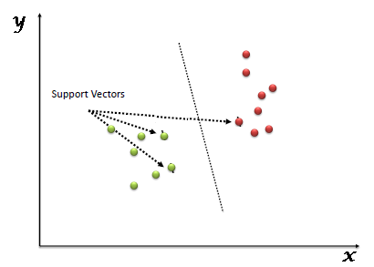

Figure 2: Illustration of a hyperplane

SVM is only effective in high-dimensional spaces, though it remains effective in cases where the number of samples is less than the number of dimensions. It is efficient in terms of memory use because it uses a subset of training points in the decision function (support vectors), and it is versatile in that it is possible to define a custom kernel as well as various kernel functions for the decision function, as shown in figure (5). However, it is ineffective if the number of features is significantly greater than the number of samples, and it cannot provide probabilistic estimates directly [23].
In the context of NLP, there are hundreds or thousands of features in most training data; thus, using a non-linear form to map the data in the input to a large space may offer the best performance in these cases.

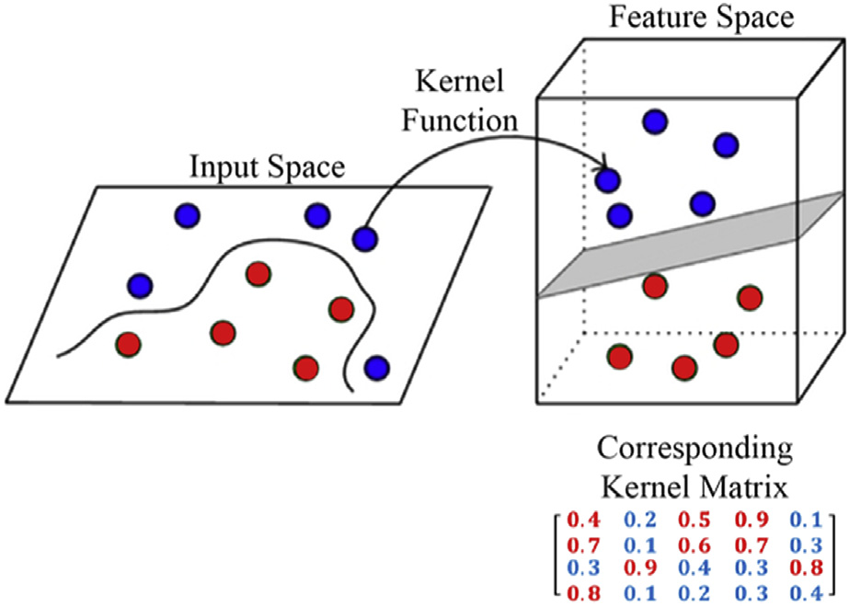
Figure 3: Support Vector Machine
2.4.2. Multiple Layer Perceptron (MLP):
Multiple Layer Perceptron (MLP) is an artificial neural network (ANN) with one or more hidden layers where the nodes in each layer are made up of nonlinearly activated neurons. MLP thus consists of one or more input layers, one or more hidden layers, and output layers where outputs from nodes are interconnected in a feed-forward direction [24].
MLP uses backpropagation (BP) technology for training that consists of redirection and back feed phases. Figure (6) shows that the input is fed in the first stage to the nodes of the first hidden layer to perform activities related to the activation function passing from the input layer to the output layer, while in the second stage, the error between the desired and actual value is used to adjust the learning weights based on spreading the input layer from the output layer [25].
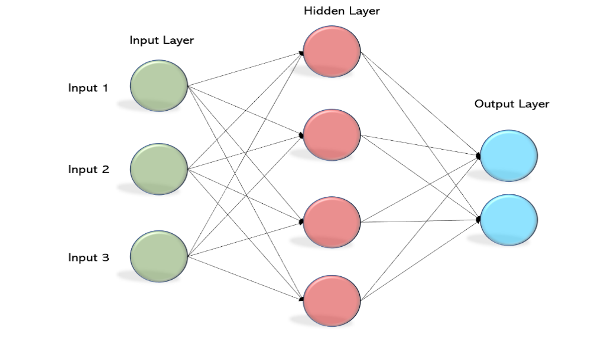

Figure 4: Multiple Layer Perceptron (MLP)

2.4.3. Logistic Regression (LR)
Logistic regression is one of the most important statistical techniques in data mining and one of the most commonly used techniques by which statisticians and scientific analysts analyse and classify proportional and binary response data sets [26]. It is particularly popular for modelling binary data in health sciences and biostatistics, as it excels in determining the effects of most explanatory variables on a dichotomous outcome variable. LR is thus used to describe data and to explain the relationships between one dependent binary variable and one or more nominal, ordinal, interval or ratio-level independent variables [27].
For maximum likelihood estimation, the asymptotic properties of the model parameters are usually used for statistical inference. However, logistic regression models are not suitable where cells with a value equal to zero occur in the contingency table, as this causes serious numerical problems [28]. The most important advantage of LR is its ability to provide probabilities naturally that extend to multi-class classification problems. Another advantage is that most of its optimisation is unrestricted, and, the same principles used in linear regression are followed in the analysis of linear regression models in most of the methods used in LR [29].
Regression methods describe the relationship between a response variable and an explanatory variable, or between a response variable and more than one explanatory variables. LR holds a special place among the various regression models, however, as the basic concept is universal. The linear regression model is thus a valuable tool for estimating the effects that will occur in relation to one continuous variable from various explanatory variables wherever the dependent variable is qualitative [30].
Figure (7) shows a regression line and the value of y between zero and one.
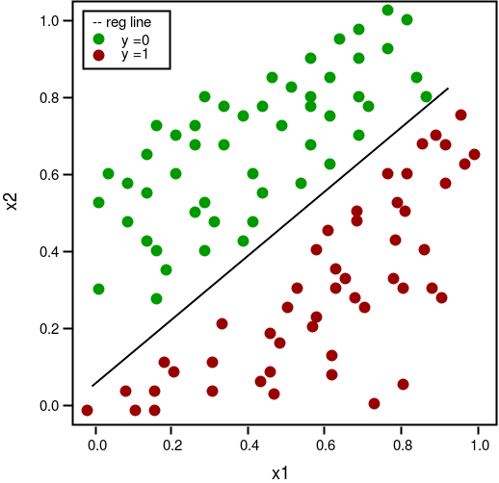
Figure 5: Logistic regression

- Experimental Results
The first table (1:2) shows what happens when the model in figure (1) receives data and applies a pre-processing stage to it, generating mining results by applying the three algorithms LSVM, ML-Perceptron, and Logistic regression to calculate data quality over 10 cross validations.

Text Mining Algorithm | Accuracy Metrics
Text Mining Algorithm | Accuracy | F1-Measure | precession | Recall
LSVM | 98.49 | 96.86 | 98.68 | 95.39
ML-Perceptron | 99.39 | 99.27 | 99.16 | 98.71
Logistic regression | 97.67 | 94.38 | 98.65 | 91.78

Table 1.2: Performance Metric for the Three Algorithms with Chi-Square technique (10 cross validations)

The next table (1:3) shows the data quality of the same data when this is applied on the model in figure (1) without the feature selection stage; a total of 10 cross validations were run.
Text Mining Algorithm | Accuracy Metrics
Text Mining Algorithm | Accuracy | F1-Measure | precession | Recall
LSVM | 97.89 | 96.10 | 98.60 | 94.18
ML-Perceptron | 98.79 | 98.82 | 98.62 | 97.90
Logistic regression | 97.55 | 93.91 | 98.74 | 91.26

Table 1.3: Performance Metric for the Three Algorithms without FS technique (10 cross validations)

Table (1:4) shows the advantages of adding feature selection in terms of decreasing the training time for each algorithm, based on comparing the training times with and without feature selection.
Text Mining Algorithm | Training Time(second)
Text Mining Algorithm | Without FS technique | Without FS technique
LSVM | 3.06 | 3.44
ML-Perceptron | 15.08 | 15.5
Logistic regression | 0.77 | 0.81

Table 1.4: Training time of the Three Algorithms

Figure 6: Performance Metrics of the Three Algorithms with Chi-Square FS technique (10 cross validations)

Figure 7: Performance Metrics of the Three Algorithms without FS technique (10 cross validation)

- Discussion
A consecutive series of 5m000 medical reports from the EMR DATASET was evaluated. NLP with TF-IDF and Chi-Square feature selection techniques was applied on this report to train the algorithm to classify items into ten medical groups. On reviewing the results obtained after applying AI techniques to unstructured data outside of the feature selection reference line, accuracy was found to be acceptable (above 98%) due to the use of pre-processing techniques, represented by the natural language processing steps. However, training and implementation took a long time due to the multiplicity of features, as shown in table (1.3)

A feature selection step was added to reduce the number of features used, retaining only the most effective features. The addition of this step significantly contributed to increasing the accuracy of the implementation of all the algorithms used, as shown in table (1.2). Another important factor in reducing the training and testing time is shown in table (1.4): the training time of the algorithm without a feature selection step was compared with the time taken for training one with such a step. After using the feature selection technique (Chi-Square), the training time of the algorithm was reduced significantly.
The proposed model with WTF-IDF was shown to be effective in identifying the best features and removing inappropriate or bad influences on unstructured data based on NLP techniques. In general, promising results emerged for all applied algorithms. The best accuracy achieved was with the ML-Perceptron at 99.39; this also offered a reduction in the amount of time required for training where feature selection was used. Processing tools should be selected according to the characteristics of the data and the principles of dataset design followed. Even a design method which shows great performance in general contexts may suffer from performance variation in specific biomedical fields.
Table (1:5) shows the results for some of related work in this field where researchers have tried to extract medical information from a database by using several forms of pre-processing and mining. The common approach for most such research is to attempt to extract the most accurate and largest amount of information buried within database with least processing time. Researchers have thus used several types of databases to conduct such research, Li et al.[9] used a dataset closely related to the dataset used in this paper to apply Deep learning methods, attaining an improvement of 0.3464 on AUCROC and 0.4521 on F1; however, they did not address the question of accuracy. Thomas et al. [11] used two datasets to diagnosis prostate cancer; they managed to get good results in terms of data quality and information extraction, but their model classified the data into overarching classes only rather than subclasses.
Only Khichdee et al. [16] tried to classify the medical text reports into classes according to the relevant medical specialty. They classified reports into three types, but during the second stage of classification into subclasses, 23% of all documents could not be linked to a definite individual subclass (binary system or liver) due to common features across subclasses.
The methods for creating a model depend on the structure and the characteristics of the relevant database. This paper used a unique dataset to train the algorithm to classify medical text reports, which enables the resulting model to classify any text report within the medical field. Medical reports can be classified into sex major classes based on results and data quality, as shown in table (1:5)

No. | Research paper | Type of data | Mining method | Result | Country and year
1 | Li et al. [9] | EHR. MIMIC-III dataset | LSTM and CNN-based models | Improves  0.3464 on AUCROC  0.4521 on F1. | United States  2021
2 | Thomas et al. [11]. | 18,453 pathology reports on a prostate cancer | Latent Dirichlet Allocation (LDA) ، Red-LDA | 99.1 % sensitivity  99.9 % specificity  97.6 %. overall ability | Dublin, Ireland  2014
3 | Weng et al. [13] | (iDASH) data repository (n = 431), Massachusetts General Hospital (MGH) (n = 91,237), | (UMLS) Metathesaurus, Semantic Network, and learning algorithms,  frequency-inverse document frequency (Tf-idf) | Accuracy of 0.957  For (iDASH) data.  Accuracy 0.964  For (MGH) data | 2017
4 | Caccamisi et al. [14]. | Data on patients’ smoking status from EMRs. 85,000 classified sentences | the Support Vector Machine (SVM),  Sequential Minimal Optimization (SMO) | 98.14% Accuracy.  0.981 F-score | 2020
5 | Hammoud et al.[15]. | 2000 articles, with 10 classes diseases.in Arabic language | the Support Vector Machine (SVM),  ABioNER model | 97.4331 in F1Validation.  95.9124 in F1 Testing.  whole SVM was 89.1308, 87.3473 | Russia  2021
6 | Khichdee et al. [16] | 24.855 text records from EHRs  In Georgian language | Support Vector Machine (SVM) and 𝐾-Nearest Neighbour (KNN)with feature selection. | the “shrink” case were measure equals 0.914, 0.933, and 0.878 for ultrasonography, X-ray, and endoscopy, respectively, | Georgia  2016
7 |  | 5448 medical reports from EMR DATASET | LSVM  ML-Perceptron  Logistic regression  With feature selection | 99.39 Accuracy  99.27 F1-Measure  99.16 precession  98.71 Recall | Iraq  2021

Table (1:5) Methods and result for related work
- Conclusions
From the results of this research, the following points can be concluded:
- Natural language processing (NLP) is the best way to determine a patient's medical classification and extract relevant data from electronic records, as this offers high reliability and accuracy, helping create better clinical databases. A pre-processing step using NLP helps to make the initial unstructured data amenable to processing and mining and rids it of excess and useless attachments in order to allow greater benefit to be derived from the medical information within the initial records.
- The addition of the selection feature leads to a noticeable increase in the accuracy of the results, especially when using the Chi-Square technique, which offers the best results.
- The addition of the selection feature reduces the training time of the relevant algorithms, should speed up execution.
- ML-Perceptron was found to be the best algorithm in terms of accuracy.
- An algorithm can be trained using the database for the purpose of pre-classifying any medical report, even if the incoming reports were not originally classified based on the previous training values of the model.
- References:
[1] G. Chakraborty, M. Pagolu, and S. Garla, Text mining and analysis: practical methods, examples, and case studies using SAS. SAS Institute, 2014.
[2] M. C. R. Patel, M. V. K. Jadeja, and M. J. N. Solanki, “REVIEW ON NATURAL LANGUAGE PROCESSING WITH ARTIFICIAL INTELLIGENCE,” EPRA Int. J. Multidiscip. Res., p. 143.
[3] A. M. Nancy and R. Maheswari, “A REVIEW ON UNSTRUCTURED DATA IN MEDICAL DATA,” J. Crit. Rev., vol. 7, no. 13, pp. 2202–2208, 2020.
[4] M. Tayefi et al., “Challenges and opportunities beyond structured data in analysis of electronic health records,” Wiley Interdiscip. Rev. Comput. Stat., p. e1549, 2021.
[5] P. Garrett and J. Seidman, “EMR vs EHR–What is the Difference,” Heal. January, 2011.
[6] D. Garets and M. Davis, “Electronic medical records vs. electronic health records: yes, there is a difference,” Policy white Pap. Chicago, HIMSS Anal., pp. 1–14, 2006.
[7] J. Atherton, “Development of the electronic health record,” AMA J. Ethics, vol. 13, no. 3, pp. 186–189, 2011.
[8] A. K. Jha et al., “Use of electronic health records in US hospitals,” N. Engl. J. Med., vol. 360, no. 16, pp. 1628–1638, 2009.
[9] I. Li et al., “Neural Natural Language Processing for Unstructured Data in Electronic Health Records: a Review,” arXiv Prepr. arXiv2107.02975, 2021.
[10] A. Esteva et al., “A guide to deep learning in healthcare,” Nat. Med., vol. 25, no. 1, pp. 24–29, 2019.
[11] A. A. Thomas et al., “Extracting data from electronic medical records: validation of a natural language processing program to assess prostate biopsy results,” World J. Urol., vol. 32, no. 1, pp. 99–103, 2014.
[12] R. Cohen, I. Aviram, M. Elhadad, and N. Elhadad, “Redundancy-aware topic modeling for patient record notes,” PLoS One, vol. 9, no. 2, p. e87555, 2014.
[13] W.-H. Weng, K. B. Wagholikar, A. T. McCray, P. Szolovits, and H. C. Chueh, “Medical subdomain classification of clinical notes using a machine learning-based natural language processing approach,” BMC Med. Inform. Decis. Mak., vol. 17, no. 1, pp. 1–13, 2017.
[14] A. Caccamisi, L. Jørgensen, H. Dalianis, and M. Rosenlund, “Natural language processing and machine learning to enable automatic extraction and classification of patients’ smoking status from electronic medical records,” Ups. J. Med. Sci., vol. 125, no. 4, pp. 316–324, 2020.
[15] J. Hammoud, A. Vatian, N. Dobrenko, N. Vedernikov, A. Shalyto, and N. Gusarova, “New Arabic Medical Dataset for Diseases Classification,” arXiv Prepr. arXiv2106.15236, 2021.
[16] M. Khachidze, M. Tsintsadze, and M. Archuadze, “Natural language processing based instrument for classification of free text medical records,” Biomed Res. Int., vol. 2016, 2016.
[17] G. Neha and P. Mathur, “Spell checking techniques in NLP: a survey,” Int. J. Adv. Res. Comput. Sci. Softw. Eng., vol. 2, no. 12, 2012.
[18] “[Preprocessing techniques for text mining-an overview,” Int.” .
[19] I. S. Thaseen and C. A. Kumar, “Intrusion detection model using fusion of chi-square feature selection and multi class SVM,” J. King Saud Univ. Inf. Sci., vol. 29, no. 4, pp. 462–472, 2017.
[20] A. J. Ferreira and M. A. T. Figueiredo, “Efficient feature selection filters for high-dimensional data,” Pattern Recognit. Lett., vol. 33, no. 13, pp. 1794–1804, 2012.
[21] H. M. Habeeb, “An overview on the use of data mining and linguistics techniques for building microblog-based early detection systems in the healthcare sector,” AIRCC’s Int. J. Comput. Sci. Inf. Technol., vol. 7, no. 5, pp. 143–155, 2015.
[22] M. Awad and R. Khanna, “Support vector machines for classification,” in Efficient Learning Machines, Springer, 2015, pp. 39–66.
[23] T. S. R. Sai, “Comparing The Performance Of Various SVM Classification Techniques: A Survey,” Turkish J. Comput. Math. Educ., vol. 12, no. 13, pp. 1129–1136, 2021.
[24] G. Xiao, J. Xing, and Y. Zhang, “Surface roughness prediction model of GH4169 superalloy abrasive belt grinding based on multilayer perceptron (MLP),” Procedia Manuf., vol. 54, pp. 269–273, 2021.
[25] K.-L. Du and M. N. S. Swamy, “Multilayer perceptrons: Architecture and error backpropagation,” in Neural Networks and Statistical Learning, Springer, 2014, pp. 83–126.
[26] A. Kouhpeima, S. Feyznia, H. Ahmadi, and A. R. Moghadamnia, “Landslide susceptibility mapping using logistic regression analysis in Latyan catchment,” Desert, vol. 22, no. 1, pp. 85–95, 2017.
[27] M. Kirişci, “Comparison of artificial neural network and logistic regression model for factors affecting birth weight,” SN Appl. Sci., vol. 1, no. 4, pp. 1–9, 2019.
[28] A. Diop, A. Diop, and J.-F. Dupuy, “Maximum likelihood estimation in the logistic regression model with a cure fraction,” Electron. J. Stat., vol. 5, pp. 460–483, 2011.
[29] S. Sperandei, “Understanding logistic regression analysis,” Biochem. medica, vol. 24, no. 1, pp. 12–18, 2014.
[30] H. Abdi, “Partial least squares regression and projection on latent structure regression (PLS Regression),” Wiley Interdiscip. Rev. Comput. Stat., vol. 2, no. 1, pp. 97–106, 2010.

