A New Direction Search of Hybrid Quasi-Newton

Evar Lutfalla Sadraddin¹, Ivan Subhi Latif²
¹Mathematics Department, College of Science, Salahaddin University-Erbil, Erbil, Iraq.
²Mathematics Department, College of Education, Salahaddin University-Erbil, Erbil, Iraq.

Article Info |  | ABSTRACT
Article history:  Received month dd, yyyy  Revised month dd, yyyy  Accepted month dd, yyyy |  | A new hybrid quasi-Newton search direction ( ${HQN}^{EI}$ ) is proposed. It uses the update formula of BFGS with a certain conjugate gradient parameter by a nested direction. The global convergence analysis and superlinear rate are proved using exact line search. Finally, the computation comparisons are made with original hybrid parents, through the efficiency in terms of iteration numbers and CPU-running time showing the superior of ${HQN}^{EI}$. Additionally, the results marked preference of ${HQN}^{EI}$ from other acceptable hybridization formula.
Keywords:
Numerical optimization
Unconstrained optimization
Quasi-Newton methods
Hybrid search direction
Exact line search
This is an open access article under the CC BY-SA license.

Corresponding Author:
Evar Lutfalla Sadraddin
Mathematics Department, College of Science, Salahaddin University-Erbil, Erbil, Iraq.
Email: evar.sadraddin@su.edu.krd

- INTRODUCTION (10 PT)
A minimization unconstrained nonlinear optimization problem
 | $$\min{f\left(x\right), x∈R^{n}}$$ | (1)
whenever, $f:R^{n}→R^{m}$ is an objective twice continuously differentiable function. For the problem (1), minimum value can be obtained numerically when the analytical methods are stuck. This is done by iterative procedures with line search $d_{k}$ and step size $α_{k}$ from the formula
 | $$x_{k+1}=x_{k}+α_{k}d_{k}$$ | (2)
where, $k$ is number of iteration with last step $x_{k+1}$ represents minimum of (1) with desirable error in terms of current value $x_{k}$ .
Many scientists developed quasi-Newton methods as Broyden[1], Fletcher[2], Goldfrab[3], Shanno[4] and Powell[5] after Davidon introduced them[6]. These methods are used for minimizing (1) by employing an approximation Hessian matrix $H_{k}$in search direction $d_{k}$. Broyden, Dennis, and Moré [7] proved the iterative methods of quasi-Newton are locally q-linearly convergence when the generated iterative algorithm sequence of $\left\{H_{k}\right\}$ is bounded, but Dennis and Moré[8] showed this sequence is convergent to the true Hessian matrix and for this it is required to be q-superlinear convergence rate.
BFGS stands at Broyden-Fletcher-Goldfrab-Shanno methods. These methods use the direction search having Hessian matrix updated iteratively. It starts from a chosen positive defined matrix $H_{0}$, usually identity matrix, with updating it by formula
 | $$H_{k+1}=H_{k}-\frac{H_{k}s_{k}s_{k}^{'}H_{k}}{s_{k}^{'}H_{k}s_{k}}+\frac{y_{k}y_{k}^{'}}{s_{k}^{'}y_{k}}$$ | (3)
where,
 | $s_{k}=x_{k}-x_{k-1}$ , $y_{k}=g_{k}-g_{k-1}$ | (4)
This belongs to one parameter Broyden family form of rank two (for details see [9] pp:44). Powell in 1976 gave the BFGS methods global convergence analysis on convex objective function which results $\lim_{k→∞}{\inf\left\|g_{k}\right\|}=0$ with any initial point and $H_{0}$ and it converges to the solution with positive Hessian matrix. This is obtained by superlinear convergent rates [5]. However, for non-convex function; the global convergent property was proved by researchers in [10]. The methods belong to Broyden class, the class of updating Hessian matrix approximation. Additionally, Davidon-Fletcher-Powell (DFP) methods are another quasi-Newton with a particular case of Broyden class.
On the other hand, the CG methods are large iterative methods. The first idea began with a quadratic objective function, which the method terminates at most n iterations along with exact line search. There was attempt to gain more efficient algorithms by combining the steepest descent with conjugate properties [9] (pp. 63).
Hybridization is a procedure of combining two algorithms to obtain new algorithm having more efficient properties from the parent algorithms.
In 2008 [11], there was the idea to hybrid the quasi-Newton method with steepest descent after modifying the step size given in [12], which presented a new step-size for the method. Authors, in their research [11], combined each of DFP and BFGS with CG under exact line search satisfying Wolfe condition and they saw that there was an improvement in terms of performance. In 2010, Ibrahim, M. et al. [13] employed the new step size that presented by Yuan in [12], and they used two stages in line search, firstly, they imposed exact line search then in second iteration; inexact line search with Armijo condition was used. Once more, Sofi, A. with others in 2013 proposed bounded Hessian matrix approximation in search direction containing component of BFGS and Fletcher-Reeves (FR) conjugate gradient parameter with exact line search and both Wolfe’s conditions. They showed an enhancement in computations [14]. Another hybridization was found between BFGS and conjugate descent direction and Armijo line search[15]. Furthermore, FR- parameter of CG is combined with DFP and exact line search[16]. The search directions hybridized of BFGS with CG are classified into two types. The first one is poor hybrid that is a linear combination of projection of Hessian matrix into gradient and parameter of different kinds of conjugate gradient, whereas the second one is combining all direction of CG and finding the optimal combining parameter. As a results, they found the optimal value of direction search hybrid parameter [17]. Finally, new hybridization of BFGS with CG was presented [18], that applied to the direction search parameter of Aini, Rivaie, and Mustafa(ARM) [19].

- THE PROPOSED $H{QN}^{EI}$ AND ITS ALGORITHM
In this work, we suggest ${HQN}^{EI}$ which is a hybrid direction starts from the gradient projected by approximation Hessian matrix update of quasi-Newton of type BFGS, else, the next projection is composited with gradient by adding preceding direction multiplied by a parameter. It is given as follows:
 | $$d_{k}=\left\{{-H_{k}g_{k} k=0 \atop -H_{k}g_{k}+η(-g_{k}+β_{k}d_{k-1}) k≥1}\right.$$ | (5)
where, $η∈\left(0,1\right]$ and
 | $$β_{k}=\frac{\frac{\left\|g_{k-1}+g_{k}\right\|}{{\left\|d_{k-1}\right\|}^{2}}{\left\|g_{k}\right\|}^{2}-\left(g_{k}^{T}g_{k-1}\right)}{\frac{\left\|g_{k-1}+g_{k}\right\|}{{\left\|d_{k-1}\right\|}^{2}}{\left\|g_{k-1}\right\|}^{2}}$$ | (6)
This conjugate gradient parameter is designed by Mouiyad, Mustafa, and Rivaie (MMR) [20]. However, in this paper, $β_{k}$ will have different values since it depends on previous direction computed by (5) Moreover, the exact line search is employed in the algorithm with ${HQN}^{EI}$ direction.
The algorithm along with ${HQN}^{EI}$ direction will be compared to its original component as well as the hybrid algorithm suggested by $ARM$ [18], since they showed the ARM hybridization algorithm is more recommended from many designed hybrid methods before.
Now, the following is proposed algorithm to apply using the new hybridization method.
Step 1: Initializations: $H_{0}$ identity matrix, $X_{0}∈R^{n}$, tolerance $ε=1×{10}^{-7}$ , $d_{0}=-H_{0}g_{0}$ , $k=1$
Step 2: Termination criteria, if $\left\|g_{k}\right\|≤ε$ or maximum number of iteration reached stop.
Step 3: Find exact step size $α_{k}$.
Step 4: Compute $s_{k}=x_{k}-x_{k-1}$ and $y_{k}=g_{k}-g_{k-1}$
Step 5: Update $H_{k}$ by (3) and find $β_{k}$ with (6)
Step 6: evaluate search direction by (5)
Step 7: set $k=k+1,$ go to step 2.

- THE CONVERGENCE ANALYSIS OF $H{QN}^{EI}$
In this section, the convergence analysis is showed by presenting assumptions, properties in order to prove the convergence of our algorithm.

3.1. Some assumptions
The required assumptions to obtain desire solutions are assumed as follows:-
(i) The objective function f is twice continuously differentiable.
(ii) The Hessian matrix is Lipschitz continuous at $x^{*}$, that is, there exist a positive constant c satisfying
$$\left\|G\left(x\right)-G(x^{*})\right\|≤c\left\|x-x^{*}\right\|$$
for all $x$ in neighborhood of $x^{*}$
(iii) If $f∈C^{2}$ and the level set $L=\left\{x:f(x)≤f(x_{0})\right\}$ is convex, there exist positive constants $c_{1}and{ c}_{2}$ satisfying
$c_{1}{\left\|z\right\|}^{2}≤z^{'}G\left(x\right) z ≤$ $c_{2}{\left\|z\right\|}^{2}$ $∀z∈R^{n} , x∈L$
and $G(x)$ is Hessian matrix of $f$.

3.2. Sufficient descent property of $H{QN}^{EI}$.
Each iteration must satisfy sufficient descent property, i.e., $g_{k}^{T}d_{k}≤-c{\left\|g_{k}\right\|}^{2} ,∀k≥0$ in addition to hold all above assumptions. It is obvious from equations (5) and (6), we have
$$d_{k}=\left\{{-H_{k}g_{k} k=0 \atop -H_{k}g_{k}+η(-g_{k}+β_{k}d_{k-1}) k≥1}\right.$$
$$g_{0}^{T}d_{0}=-{g_{0}^{T}H}_{0}g_{0}$$
$≤-c{\left\|g_{0}\right\|}^{2}$ by assumption 3.1. (iii)
$$g_{k}^{T}d_{k}=g_{k}^{T}(-H_{k}g_{k}+η(-g_{k}+β_{k}d_{k-1}))$$
$$≤-k{\left\|g_{k}\right\|}^{2}+η(-{g_{k}^{T}g}_{k})+ηg_{k}^{T}β_{k}d_{k-1}$$
Since it is exact line search, $g_{k}^{T}d_{k-1}=0$, then
$g_{k}^{T}d_{k}≤-c{\left\|g_{k}\right\|}^{2}$ where, $c=k+η$
So, it is sufficient descent.
To show the global convergence, the following lemma is needed.
3.2. 1. Lemma: If $α$is generated by exact line search and let part (iii) of assumption 3.1. holds. Then
$$\lim_{k→∞}\left\|g_{k}\right\|=0$$
Proof: refers to [18].
3.2. 2. Theorem : Suppose the assumptions 3.1. and Lemma 3.2.1. fulfilled. Then
$$\lim_{k→∞}{\inf{ \left\|g_{k}\right\|}=0}$$
Proof: suppose $\left\|g_{k}\right\|>δ ∀ k≥0$
$$d_{k}=-H_{k}g_{k}+η(-g_{k}+β_{k}d_{k-1})$$
$$\left\|d_{k}\right\|=\left\|-H_{k}g_{k}+η(-g_{k}+β_{k}d_{k-1})\right\|$$
$$≤\left\|H_{k}\right\|\left\|g_{k}\right\|+η\left\|g_{k}\right\|+η\left|β_{k}\right|\left\|d_{k-1}\right\|$$
$$=(\left\|H_{k}\right\|+η)\left\|g_{k}\right\|+η\left|β_{k}\right|\left\|d_{k-1}\right\|$$
$$\left\|d_{k}\right\|≤\left\|H_{k}+η\right\|\left\|g_{k}\right\|+η\left|β_{k}\right|\left\|d_{k-1}\right\|$$
$$\frac{\left\|d_{k}\right\|}{{\left\|g_{k}\right\|}^{2}}≤\frac{\left\|H_{k}+η\right\|}{\left\|g_{k}\right\|}+\frac{η\left|β_{k}\right|\left\|d_{k-1}\right\|}{{\left\|g_{k}\right\|}^{2}}$$
but, we have$$β_{k}≤\frac{\frac{\left\|g_{k-1}+g_{k}\right\|}{{\left\|d_{k-1}\right\|}^{2}}{\left\|g_{k}\right\|}^{2}}{\frac{\left\|g_{k-1}+g_{k}\right\|}{{\left\|d_{k-1}\right\|}^{2}}{\left\|g_{k-1}\right\|}^{2}}=\frac{{\left\|g_{k}\right\|}^{2}}{{\left\|g_{k-1}\right\|}^{2}}$$
So,
$$\frac{\left\|d_{k}\right\|}{{\left\|g_{k}\right\|}^{2}}≤\frac{\left\|H_{k}+η\right\|}{\left\|g_{k}\right\|}+\frac{η\frac{{\left\|g_{k}\right\|}^{2}}{{\left\|g_{k-1}\right\|}^{2}}\left\|d_{k-1}\right\|}{{\left\|g_{k}\right\|}^{2}}$$
$$=\frac{\left\|H_{k}+η\right\|}{\left\|g_{k}\right\|}+\frac{η\left\|d_{k-1}\right\|}{{\left\|g_{k-1}\right\|}^{2}}$$
$$=\frac{\left\|H_{k}\right\|+η}{\left\|g_{k}\right\|}+\frac{η\left\|d_{k-1}\right\|}{{\left\|g_{k-1}\right\|}^{2}}$$
since $H_{k}$ is bounded, then $H_{k}<u$,
$$\frac{\left\|d_{k}\right\|}{{\left\|g_{k}\right\|}^{2}}≤\frac{u+η}{\left\|g_{k}\right\|}+\frac{η\left\|d_{k-1}\right\|}{{\left\|g_{k-1}\right\|}^{2}}$$
$$≤\frac{u+η}{\left\|g_{k}\right\|}+\frac{1}{\left\|g_{k-1}\right\|}$$
$$≤\sum_{i=1}^{k}{\frac{u+η}{\left\|g_{i}\right\|}+\frac{1}{\left\|g_{0}\right\|}}$$
but $\left\|g_{k}\right\|>δ ∀ k≥0$ by assumption
$$\frac{\left\|d_{k}\right\|}{{\left\|g_{k}\right\|}^{2}}≤\sum_{i=1}^{k}{\frac{u+η}{δ}+\frac{1}{δ}}$$
$$\frac{\left\|d_{k}\right\|}{{\left\|g_{k}\right\|}^{2}}≤\frac{\left(u+η\right)k+1}{δ}$$
$$\frac{{\left\|g_{k}\right\|}^{4}}{{\left\|d_{k}\right\|}^{2}}≥\frac{δ^{2}}{{(\left(u+η\right)k+1)}^{2}}$$
$$\sum_{k=0}^{∞}{\frac{{\left\|g_{k}\right\|}^{4}}{{\left\|d_{k}\right\|}^{2}}≥}\sum_{k=0}^{∞}{\frac{δ^{2}}{{(\left(u+η\right)k+1)}^{2}}}=∞$$
$$\sum_{k=0}^{∞}{\frac{{\left\|g_{k}\right\|}^{4}}{{\left\|d_{k}\right\|}^{2}}≥}∞ , C!$$
Hence, the global convergence is obtained.

3.3. Superlinear Convergence of $H{QN}^{EI}$.
For proving the superlinearity convergence, we need lemma 4.9 and 4.10 in [21], which they state under the hypotheses 3.1; there exists a sequence $\left\{ϵ_{k}\right\}$ of numbers such that
 | $$\frac{\left\|y_{k}-G(x^{*})s_{k}\right\|}{\left\|s_{k}\right\|}≤ϵ_{k}$$ | (7)
and
 | $$\sum_{k=1}^{∞}{ϵ_{k}}<∞$$ | (8)
where, $y_{k}$ and $s_{k}$are defined in (4). These lead to the boundedness of the sequences $\left\{H_{k}\right\} , \left\{H_{k}^{-1}\right\}$ and
 | $$\lim_{k→∞}{\frac{\left\|\left(H_{k}^{-1}-G\left(x^{*}\right)\right)s_{k}\right\|}{\left\|s_{k}\right\|}=0}$$ | (9)
3.3.1. Theorem: Suppose assumptions 3.1 (i) and (iii) are holds, $\left\{x_{k}\right\}→x^{*}$ and the sequence $\left\{H_{k}\right\} , \left\{H_{k}^{-1}\right\}$ are bounded. If $x_{k+1}=x_{k}+d_{k}$ holds for all sufficiently large $k$ with
$\lim_{k→∞}{\frac{\left\|\left(H_{k}^{-1}-G\left(x^{*}\right)\right)d_{k}\right\|}{\left\|d_{k}\right\|}=0}$, then $\lim_{k→∞}{\frac{\left\|x_{k+1}-x^{*}\right\|}{\left\|x_{k+1}-x_{k}\right\|}=0}$
Proof:
$\left[H_{k}^{-1}-G\left(x^{*}\right)\right]d_{k}=H_{k}^{-1}d_{k}-G\left(x^{*}\right)d_{k}$
$${=H}_{k}^{-1}[-H_{k}g_{k}+η\left(-g_{k}+β_{k}d_{k-1}\right)]-G\left(x^{*}\right)d_{k}$$
$=-g_{k}-η{H_{k}^{-1}g}_{k}+{ηβ}_{k}d_{k-1}H_{k}^{-1}-G\left(x^{*}\right)d_{k}$
$=\left(-I-{{ηH}_{k}^{-1})(g}_{k}+G\left(x^{*}\right)d_{k}\right)+{ηβ}_{k}d_{k-1}H_{k}^{-1}{+ηH}_{k}^{-1}G\left(x^{*}\right)d_{k}$
$=(-I-{{ηH}_{k}^{-1})g}_{k+1}+{ηβ}_{k}d_{k-1}H_{k}^{-1}{+ηH}_{k}^{-1}G\left(x^{*}\right)d_{k}+o(\left\|d_{k}\right\|)$
$\left\{\left\|H_{k}\right\|\right\}$, $\left\{\left\|H_{k}^{-1}\right\|\right\}$ are bounded sequence by (7), (8) and this leads to $β_{k}$ be coverage.
Therefore,
$$\left\|\left(H_{k}^{-1}-G\left(x^{*}\right)\right)d_{k}\right\|=\left[1+O\left(1\right)\right]\left\|g_{k+1}\right\|+o(\left\|d_{k}\right\|)$$
since it is given that,
$$\lim_{k→∞}{\frac{\left\|\left(H_{k}^{-1}-G\left(x^{*}\right)\right)d_{k}\right\|}{\left\|d_{k}\right\|}=0}$$
which is implies that,
$$\lim_{k→∞}{\frac{\left\|g_{k+1}\right\|}{\left\|d_{k}\right\|}\underset{k→∞}{=lim}{\frac{\left\|g_{k+1}\right\|}{\left\|x_{k+1}-x_{k}\right\|}=0}}$$
On the other hand,
$g_{k+1}-G\left(x^{*}\right)-G\left(x^{*}\right)\left(x_{k+1}-x^{*}\right)=o\left(\left\|x_{k+1}-x^{*}\right\|\right)$, with $G\left(x^{*}\right)=0,$
Hence, $\lim_{k→∞}{\frac{\left\|x_{k+1}-x^{*}\right\|}{\left\|x_{k+1}-x_{k}\right\|}=0}$.

- NUMERICAL RESULTS
In this part, The performance profile plots suggested in [22] is displayed. It is the cumulative distribution function that presents the performance of a problem solver by computing the probability of its efficiency. Further, it is a good way to highlight the differences among approaches; in case, if there is a significant difference in the area of interests. In other words, the performance profile plot does not show small variant among algorithms.
In this paper, this way is used to reveal the comparison of different algorithms based on CPU time and number of iterations to obtain the solution with desired error. MATLAB 2018a codes is used with an exact line search using secant method to approximate the step size with combination parameter $η=0.01$ and $ε=1×{10}^{-7}$ or maximum number of iterations which is the number of variable times 1000 on a list of 13 test functions collected in each of [23] and [24] showed in Table 1. MATLAB codes for comparison of algorithm performance profiles were written in [25] and they are utilized here. Moreover with initiating the starting point, the notation $1_{n}$ for some integer $n$ is used as a column of ones. Additionally, the operator $⨂$ refers to kronecker product in two matrices to reduce the running time in MATLAB inputs. However, for the second comparison in this research; the 13th test function is not running. The results are appeared in these four figures. In the Figure 1 (a) and (b), the performance profile reveals the winning algorithm with our new direction ${HQN}^{EI}$. As a sequence, the probability of solving all function tests listed in Table 1 with various corresponding initial points is one. This means that, the distribution function curve shows an enhancement in number of iterations and CPU running time for the procedure with using ${HQN}^{EI}$ direction in comparison with its original components. Finally, the Figure 2 (a) and (b), demonstrate how the solver with direction ${HQN}^{EI}$ is superior the designed one by ARM [19]. Therefore, the plots show the ability with 100% of hybrid ${HQN}^{EI}$ to solve all test functions given in Table 1, except the last one, while the other fails approximately 20% to do so again with running time and iteration numbers.

Table 1. List of test functions with some initial points
ID | Functions | $$X_{0}$$
1 | Zettl | (100,100), (-100,-100), (100,200), (-100,100)
2 | Zakharov | (1,1,1,1), (100,100,100,100), $(-200){×1}_{10}$
3 | Dixon & Price | (12,12), (-10,10,-10,10), (100,100,100,100)
4 | Generalized Rosenbrock | (-100,100), (10.5,10.5), $1_{50}⨂\left(100,100\right),$ $1_{100}⨂\left(100,100\right)$
5 | Extended Rosenbrock | $1_{50}⨂\left(100,100\right),$ $1_{10}⨂\left(-1,0,1,0\right), { 1}_{10}⨂\left(-10,10,-1,0\right)$
6 | Raydan 1 | (7,7), (1,1,1,1,1,1)
7 | Fletcher | (-100,100,-100,100), $1_{100}⨂\left(100,100\right), 1_{100}⨂\left(100,-100\right)$
8 | Extended White & Holst | $1_{100}⨂\left(-1.2,1\right)$, $1_{200}⨂\left(-1.2,1\right)$
9 | Extended Beale | $1_{10}⨂\left(1,0.8\right)$, $1_{100}⨂\left(1,0.8\right)$ $1_{500}⨂\left(1,0.8\right)$
10 | Camel & Six Hump | (50,50), (-5,5)
11 | Generalized Quartic | $1_{100}⨂\left(-1,1\right)$,$1_{500}⨂\left(-1,1\right)$ , $1_{100}⨂\left(-10,0\right)$, $1_{100}⨂\left(-1,0\right)$, $1_{100}⨂\left(-1,0,10\right)$, $1_{100}⨂\left(-1,0,-10,0\right)$,
12 | Extended_DENSCHNB | (1,1,1,1,1,1), $1_{100}⨂\left(-100,-100\right)$
13 | Generalized Tridiagonal 1 | $1_{100}⨂\left(-100,100\right)$, $1_{100}⨂\left(1,1\right)$, $1_{50}⨂\left(10,0,-10,1\right)$ $1_{50}⨂\left(-1,1,-1,1\right)$, $1_{50}⨂\left(12,12\right),$ $1_{50}⨂(0,0)$
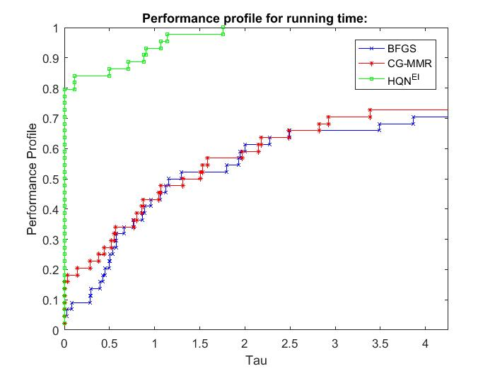
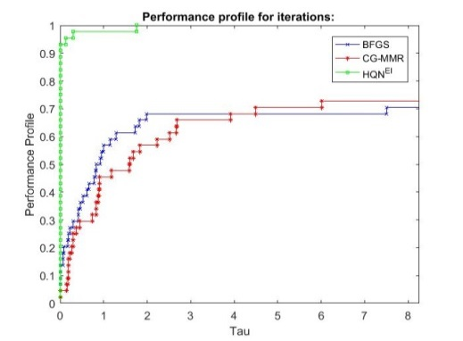

(a) (b)

Figure 1. Performance profile for BFGS, CG-MMR and HQN^{EI} (a) Number of iterations and (b) CPU running time among them.

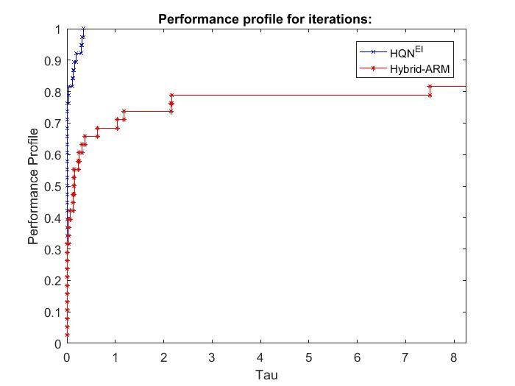
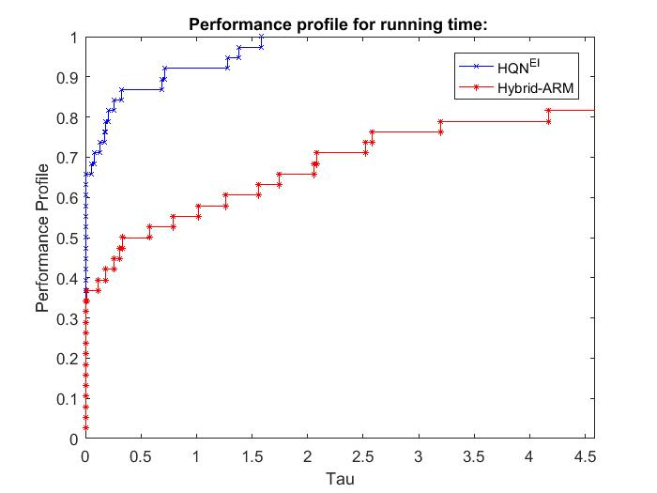

(a) (b)

Figure 2. Performance profile for HQN^{EI} and Hybrid-ARM, (a) Number of iterations and (b) CPU running time between them.

- CONCLUSIONS
In this paper, a new direct search ${HQN}^{EI}$ is introduced. It is a type of line combination of projection of BFGS Hessian matrix update together with the direction parameter $β_{k}$ defined in (6). The ${HQN}^{EI}$ direction improves the performance of algorithms in terms of number of iteration and CPU running time in comparison with its originator components. Additionally, it shows that the imposed hybrid algorithm is superior to the one defined in [18].

ACKNOWLEDGEMENTS
The authors thank their University to open the opertunity for conducting this research.

REFERENCES
[1] C. G. Broyden, “The convergence of a class of double-rank minimization algorithms: 2. The new algorithm,” IMA J. Appl. Math., vol. 6, no. 3, pp. 222–231, 1970.
[2] R. Fletcher, “A new approach to variable metric algorithms,” Comput. J., vol. 13, no. 3, 1970.
[3] D. Goldfarb, “A Family of Variable-Metric Methods Derived by Variational Means,” Math. Comput., vol. 24, no. 109, p. 23, 1970.
[4] D. F. Shanno, “Conditioning of Quasi-Newton Methods for Function Minimization,” Math. Comput., vol. 24, no. 111, p. 647, 1970.
[5] M. J. Powell, “Some global convergence properties of a variable metric algorithm for minimization without exact line searches,” SIAM-AMS Proc., vol. 9, no. 1, pp. 53–72, 1976.
[6] W. C. Davidon, “Variable metric method for minimization,” AEC Res. Dev. Rep. ANL, p. 5990, 1959.
[7] C. G. Broyden, J. E. Dennis, and J. J. Moré, “On the local and superlinear convergence of quasi-newton methods,” IMA J. Appl. Math. (Institute Math. Its Appl., vol. 12, no. 3, pp. 223–245, 1973.
[8] J. E. Dennis and J. J. More, “A Characterization of Superlinear Convergence and Its Application to Quasi-Newton Methods,” Math. Comput., vol. 28, no. 126, p. 549, 1974.
[9] R. Fletcher, Practical Methods of Optimization. USA: John Wiley & Sons, 1980.
[10] D.-H. LI and M. Fukushima, “On the Global Convergence of the BFGS Method Nonconvex Unconstrained Optimization Problems,” SIAM J. OPTIM., vol. 11, no. 4, pp. 1054–1064, 2001.
[11] A. Z. M. Sofi, M. Mamat, I. Mohd, and Y. Dasril, “An alternative hybrid search direction for unconstrained optimization,” J. Interdiscip. Math., vol. 11, no. 5, pp. 731–739, 2008.
[12] Y. X. Yuan, “A new stepsize for the steepest descent method,” J. Comput. Math., vol. 24, no. 2, pp. 149–156, 2006.
[13] M. A. H. Ibrahim, M. Mamat, A. Z. M. Sofi, I. Mohd, and W. M. A. W. Ahmad, “Alternative algorithms of Broyden familyAMI: For unconstrained optimization,” AIP Conf. Proc., vol. 1309, pp. 670–680, 2010.
[14] A. Z. M. Sofi, M. Mamat, and I. Mohd, “An improved BFGS search direction using exact line search for solving unconstrained optimization problems,” Appl. Math. Sci., vol. 7, no. 1–4, pp. 73–85, 2013.
[15] M. A. H. Ibrahim, M. Mamat, and W. J. Leong, “The hybrid BFGS-CG method in solving unconstrained optimization problems,” Abstr. Appl. Anal., vol. 2014, 2014.
[16] W. F. H. W. Osman, M. A. H. Ibrahim, and M. Mamat, “A new search direction of DFP-CG method for solving unconstrained optimization problems,” AIP Conf. Proc., vol. 1974, 2018.
[17] O. Bamigbola, O. Okundalaye, and C. Ejieji, “Optimal Hybrid Bfgs-Cg Method for Unconstrained Optimization,” Asian Res. J. Math., vol. 9, no. 1, pp. 1–18, 2018.
[18] N. Aini, M. Mamat, M. Rivaie, and I. M. Sulaiman, “A Hybrid of Quasi-Newton Method with CG Method for Unconstrained Optimization,” J. Phys. Conf. Ser., vol. 1366, no. 1, 2019.
[19] N. Aini, N. Hajar, M. Rivaie, and M. Mamat, “A modified conjugate gradient coefficient under exact line search for unconstrained optimization,” Int. J. Eng. Technol., vol. 7, no. 3.28 Special Issue 28, pp. 84–88, 2018.
[20] M. Yousef, M. Mamat, and M. Rivaie, “A New Conjugate Gradient Method with Exact Line Search,” AIP Conf. Proc., vol. 1739, pp. 521–525, 2016.
[21] L. Han, “Combining Quasi-Newton and Steepest Descent Directions,” no. January 2003, 2015.
[22] E. Dolan and J. Moré, “Benchmarking optimization software with performance profiles Received:,” Math. Program., vol. 91, no. C, pp. 201–213, 2002.
[23] N. Andrei, “An Unconstrained Optimization Test Functions Collection,” Adv. Model. Optim., vol. 10, no. 1, pp. 147–161, 2008.
[24] M. Jamil and X. S. Yang, “A literature survey of benchmark functions for global optimisation problems,” Int. J. Math. Model. Numer. Optim., vol. 4, no. 2, pp. 150–194, 2013.
[25] M. Sofi, AzfiZaidi Mohammad, Mamat, S. Z. Mohid, M. A. H. Ibrahim, and N. Khalid, “Performance Profile Comparison Using Matlab,” Proceeding IC-ITS 2015, no. June, pp. 253–259, 2015.

BIOGRAPHIES OF AUTHORS

 | Evar Lutfalla Sadraddin born in Erbil, Iraq in 1983. She graduated from mathematics Department / College of Science in Salahaddin University-Erbil in 2004-2005, in Erbil, Iraq. She got Master of Science in mathematical statistics in 2010. She is working as assistant lecturer in mathematics department / college of science / Salahaddin University-Erbil, and now she is Ph.D. student in Numerical Optimization since 2019. Her interested area of reseach is Mathematical statistics and Numerical Optimization. Her contacted email is evar.sadraddin@su.edu.krd.
 | Ivan Subhi Latif born in Erbil, Iraq in 1973. She recived B.Sc. in Salahaddin University- Erbil in mathematical science. She got her M.Sc. in mathematical statistics scine 2000 while her Ph.D. program was on numerical optimization in Salahaddin University-Erbil in 2007. She is assistant professor and teaching staff in education college in Salahaddin University-Erbil, Iraq. She has many publications in mathematical statistics and numerical optimization.

