Comparative analysis and prediction of coronary heart disease

Sashikanta Prusty ¹, Srikanta Patnaik², Sujit Kumar Dash³
^{1,2}Department of Computer Science & Engineering, Siksha ‘O’ Anusandhan (Deemed to be University), Bhubaneswar, India
³ Department of Electrical & Electronics Engineering, Siksha ‘O’ Anusandhan (Deemed to be University), Bhubaneswar, India

Article Info |  | ABSTRACT
Keywords:  Cardiovascular disease (CVD)  Machine Learning  Deep Learning  Keras Library  Performance Metric |  | Cardiovascular disease (CVD) is now one of the leading causes of death worldwide and was also thought to be a serious illness in the Mid and Old Ages. Artificial Intelligence and Machine Learning have a huge impact on the healthcare areas. As a result, getting a familiar individual with data processing techniques suitable for numerical health data. Although, the most often used algorithms for classification tasks will be incredibly advantageous in terms of time management. It is based on blood pressure, cholesterol levels, heart rate, and other typical traits to predict heart disease. Depending on the severity of coronary artery disease, patients are divided into different groups. In particular here, a common procedure has been proposed for predicting cardiovascular disease. Accordingly, we herein consider nine typical classifiers of both ML and DL technology for the comparative analysis and prediction of coronary heart failure. These models are computationally inexpensive and easy to build. Moreover, these classifiers are tested and compared using a confusion matrix in Jupyter notebook, yielding classification measures such as accuracy, f1-score, recall, and precision. As a result, the logistic regression classifier gives the maximum possible accuracy, precision, and f1-score of 90.78%, 90.24%, and 91.35% respectively.  This is an open access article under the CC BY-SA license.  
Corresponding Author:
Sashikanta Prusty¹
Department of Computer Science & Engineering
SOA University, Bhubaneswar, India-751030
sashi.prusty79@gmail.com

- INTRODUCTION
Heart disease is one of the world's most serious diseases nowadays, which shows the difficulty in identifying it, therefore making it a convenient time for both physicians and patients. Early detection of heart disease aids in the improvement of patients' health through preventative measures. Cardiovascular disease (CVD) refers to a group of diseases affecting the heart and blood arteries which cause 13% of CVD deaths, while tobacco is responsible for 9%, diabetes for 6%, lack of exercise for 6%, and obesity for 5% [1]. In human beings, the heart is a muscular organ that pumps blood through the circulatory system's blood arteries. The pumping blood transports oxygen and nutrients to the body, as well as metabolic waste like carbon dioxide, to the lungs. The heart in humans is about the size of a closed fist and is placed in the middle compartment of the chest, between the lungs. Due to cardiac valves that prevent backflow, blood flows in one direction through a healthy heart. Epicardium, myocardium, and endocardium are the three layers that make up the heart's wall. A collection of placemaking cells in the sinoatrial node controls the heart's pumping rhythm, which generates a current that travels through the atrioventricular node, causing the heart to contract.
In humans, other mammals, and birds, the heart is divided into four chambers: upper left and right atria, and bottom left and right ventricles. The right atrium and ventricle are commonly referred to as the right heart, whereas their left counterparts are referred to as the left heart. Figure 1, displays the outer view of the human heart system, where the right atrium is the area that blood returns to the heart from the rest of the body. The blood has been delivering oxygen to the body and now has to be replenished. This blood fills the right atrium, which subsequently goes into the right ventricle. The right ventricle will pump blood into the lungs to replenish oxygen levels. The right ventricle contracts when it is full, propelling blood into the lungs. The blood travels from the lungs to the left atrium, and the right atrium pumps oxygen-depleted blood into the right ventricle, whereas the left atrium pushes oxygenated blood into the left ventricle from the previous cycle. The blood flows back to the right atrium, and the cycle begins again.

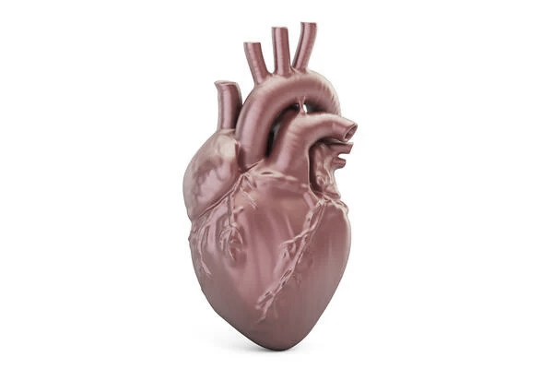
Left
Atrium
Right
Atrium
Left
Ventricle
Right
Ventricle
Superior
Vena cava
Aorta
Pulmonary
Trunk
Figure 1. Outer view of Human Heart

A heart attack is a life-threatening medical condition. When a blood clot stops blood flow to the heart, a heart attack ensues. Tissue lacks oxygen and dies without blood. In general, a heart attack occurs when the heart's blood supply is cut off. The most common cause of blockage is a build-up of fat, cholesterol, and other substances in the arteries that supply the heart, forming plaque. A plaque can break and generate a clot, obstructing blood flow. Parts of the heart muscle can be damaged or destroyed if blood flow is disrupted. Although a heart attack, also known as a myocardial infarction, can be fatal, therapy has vastly improved over the years. CardioHelp is a technology that uses a deep learning algorithm called convolutional neural networks to estimate the probability of a patient having a cardiovascular illness (CNN) [2].

1.1. Risk Factor
The undesired build-up of plaque in the arteries that limits arteries all over the body is caused by a wide variety of factors. Many of these risk factors can be improved or eliminated to lessen the chances of having a heart attack for the first or second time. Some of the factors that raise the probability of getting a heart attack are listed below. As heart attack is more common in middle and old-aged men and women over the age of 45 and 55 respectively than the younger people.

1.1.1. Tobacco
This comprises smoking and long-term indirect exposure to nicotine. Symptoms like high blood pressure may lead to harm the arteries over a period. When high blood pressure is coupled with other health issues like obesity, high cholesterol, or diabetes, the risk is increased even further. High cholesterol or triglyceride levels in the blood. The most prevalent cause of arterial narrowing is a high level of low-density lipoprotein (LDL) cholesterol. An excessive amount of cholesterol, a type of blood fat connected to diet, raises the chance of a heart attack.

1.1.2. Diabetes
The human body's blood sugar levels rise when there haven't produced enough of a hormone generated from the pancreas or don't respond to insulin adequately, raising the risk of a heart attack. Obesity, high blood pressure, and high blood sugar are all symptoms of metabolic syndrome. If the patient has metabolic syndrome, then he/she is twice as likely to get heart disease as someone who doesn't. Adults may be at higher risk if their siblings, parents, or grandparents faced heart attacks at a young age (by age 55 for males and 65 for women). Lack of physical activity is connected to obesity and high blood cholesterol levels.

1.1.3. Stress
Stress may cause us to react in ways that put us at risk of a heart attack. Cocaine, amphetamines, and ecstasy are all steroids that can induce a heart attack.

1.1.4. Preeclampsia's history
While pregnant, this condition raises the risk of heart disease. Heart attack risk increases with autoimmune conditions such as rheumatoid arthritis or lupus.
Therefore, early detection of heart problems like coronary artery disease, arrhythmias, infection or defect in the heart, and disease in the heart muscle are much important both for the physicians as well as patients. Machine Learning (ML) is one of the most effective ways for predicting whether or not a person is suffering from a specific ailment in the field of medical analysis. The greatest algorithm for predicting a person's heart illness is the Random Forest Classification algorithm, which is the most accurate way to perform analysis [3]. ML and DL techniques can help in overcoming the issues caused by the large volume of data. Data-driven approaches based on ML algorithms such as K-Nearest Neighbor (KNN), Decision Tree (DT), Logistic Regression (LR), and many more are viable alternatives [4]. Healthcare firms might use ML technologies to address rising medical demands, improve operations, and cut costs. ML innovation at the bedside can assist healthcare practitioners in detecting and treating disease more quickly, with greater precision, and with more individualized care. A look at ML in healthcare (for example NB and RF model) illustrates how technological advancements can lead to more effective, holistic care practices that can enhance patient outcomes [5]. In the coming section 2, some related works regarding heart disease are taken; section 3, the methodology has been described that to be taken for predicting heart disease in the healthcare field; section 4, provides the performance result of all models; finally, section 6 and 7 concluded with result and conclusion respectively.

- RELATED WORKS
The application of ML and image retrieval for cardiac illness diagnosis are important activities that can benefit both healthcare practitioners and patients [6]. Features gathered from clinical databases could be determined using an ML classification that is good at detecting heart attacks, and the experimental results show that the results are considerably better when compared to heart disease data, then testing and training data [7]. ML is a branch of science concerned with the design and testing of algorithms that enable computers to learn from various sorts of data. ML is a branch of artificial intelligence that allows existing data to be used to predict and model future events [8]. On three separate illness datasets, namely diabetes, coronary heart disease, and cancer, the Random Forest (RF) algorithm outperforms the Naive Bayes (NB) method in terms of prediction accuracy. The RF technique is used to overcome over-fitting in single decision tree problems [9]. The proposed NB algorithm has reached an impressive performance. On the testing data, the accuracy of around 81.5 percent, which is higher than Decision Tree (DT) accuracy [10]. The feature extraction is done with an RF classifier, and the prediction results are generated with a DT classifier. However, the RF classifier will extract the data, and the DT will generate the final classifier output [11]. The Enhanced Decision Tree Algorithm (EDT) with Normalization was employed. Also, the task of categorizing data and determining the chance of heart disease for patients was implemented using NetBeans and Weka software [12]. When diagnosing the heart disease dataset, KNN with a genetic algorithm produces effective classification and optimal solution that improves accuracy [13]. This study employs a variety of ML approaches, including PSO-based Support Vector Machine (SVM), Neural Network (NN), DT, NB, and SVM, to aid in the development, comprehension, and interpretation of various heart disease diagnosis models. In the prediction of heart disease, the PSO-based SVM algorithm outperforms the DT, NB, NN, and SVM by a factor of 100 [14]. Moreover, the hybrid model with SVM and RF, which uses iterative feature elimination to produce accurate cardiac disease prediction at an early stage, beats previous models [15].
In the medical field, coronary artery disease (CAD), often known as atherosclerosis, is the leading cause of death globally. ML approaches such as SVM, ANN, K-NN, DT, LR, and others can be used to detect CAD at an early stage [16]. Among 598 individuals of Korean people, a random forest model was utilized to find characteristics that predicted bleeding occurrences. Interaction of drugs with steroids, as well as overall physical state has a substantial impact on bleeding in the elderly. With an area under the curve of 0.87, the random forest model was sensitive (80.77 percent), specific (87.67 percent), and accurate (85.86 percent), implying fair prediction [17]. CNN has an adaptive intelligent technique for determining a patient's risk of heart attack based on the patient profiles [18]. This classifier can classify the data, to confirm whether the disease is present or not. Although, the heart disease prediction using different ML models such as DT, NB, NNs, the apriori algorithm, and MAFIA algorithm, where DT outperforms with 99.62 percent of accuracy among other models [19]. However, the NN model uses efficient features to intelligently predict the class of heart disease, lowering the error rate and increasing the predictive model's accuracy [20]. ANN has a good decision-making system that helps doctors predict the stages of coronary heart disease. Also, it has built a detection system that can be implemented on wearable devices to continuously monitor cardiac activity [21]. After successfully evaluating medical records of patients, goes for predicting heart disease using various ML algorithms such as DT, LR, K-NN, SVM, and Gradient Boosting (GB) to uncover the greater accuracy model [22].

- METHODOLOGY
The Electronic Health Record (EHR) is one of the strategies for keeping track of a patient's whole medical history and analyzing the data in the future. The EHR contains a considerable amount of big data in the form of X-Rays, crucial physician evaluations on fitness, and vital signs. Because of technological advancements, healthcare facilities now have to keep vast amounts of data in their databases, which makes data interpretation a difficult task. Advanced ML/DL technologies made it possible to diagnose patient records and compare them to a global population to extract the noise from the signal. Also, it helps to better understand heart failure trends, which was previously impossible, and to speed up diagnosis and treatment. AI techniques and algorithms have recently advanced, allowing models to be built and key inferences to be drawn from the dataset. The complete process for comparative analysis and prediction for heart disease undergo some basic steps as shown in figure 2:

Heart Disease
Repository

Apply ML/DL Model
Split the dataset
Data
Collection
Data
Preparation
Data
Cleaning

Neural Network
Naïve
Bayes
Logistic
Regression
Random
Forest
Decision Trees

Support
Vector
Machine
Artificial Neural Network
Light Gradient
Boosting Machine
K-Nearest
Neighbor

DL Classifiers
ML Classifiers

Choose a
Model

Model
Prediction

Evaluate all the Models

Performance
Measure

Predict the
Heart Attack

Figure 2. Methodology for Heart Attack Prediction

Although, there have been analyzing the heart dataset with different ML/DL models, might help both the patient and doctor while predicting the heart disease in advance, so that precaution can take place to overcome this illness.

4.1. Data Collection
Data collection is the process of gathering, measuring, and evaluating correct insights for research using defined distinguished techniques. This method is frequently the first and most important element of the research process, regardless of the subject of investigation. Data collection allows us to keep track of past events that might be utilized in data analysis to uncover repeating patterns. Using ML algorithms may create predictive models that look for trends and predict future changes based on those patterns. This approach could propagate inherent biases on gender, age, and symptoms depending on how the data, individuals, and labels are chosen. In this work, the heart disease dataset has been collected from the UCI machine repository that contains 303 individual patient records and 14 dependent features, as described in below Table 1.

Table 1. Features & Descriptions
No. of features | Features | Description
1 | Chest pain (cp) | 0: Typical angina: A reduction in blood supply to the heart is linked to chest pain.
1 | Chest pain (cp) | 1: Atypical angina: chest pain that isn't caused by the heart
1 | Chest pain (cp) | 2: Non-anginal pain: Esophageal spasms are the most common type of esophageal spasm (not heart-related)
1 | Chest pain (cp) | 3: Asymptomatic: Chest pain that isn't preceded by any symptoms of illness
2 | Resting electrocardiographic results (Restecg) | 0: Nothing to note
2 | Resting electrocardiographic results (Restecg) | 1: ST-T Non-normal heartbeat is detected by wave abnormalities, which can range from mild symptoms to serious difficulties.
2 | Resting electrocardiographic results (Restecg) | 2: Hypertrophy of the left ventricle, which may or may not be present. The primary pumping chamber of an enlarged heart
3 | Thalium stress result (thal) | 1, 3: normal
3 | Thalium stress result (thal) | 6: fixed defect: It used to be a flaw, but now it's OK.
3 | Thalium stress result (thal) | 7: reversible defect: When exercising, there isn't enough blood flow.
4 | trestbps | Anything exceeding 130-140 in the resting blood pressure is usually caused for worry.
5 | fbs | '>126' mg/dL indicates diabetes if fasting blood sugar is greater than 120 mg/dL (1 = true; 0 = false).
6 | age | age in years
7 | Sex | (1 = male; 0 = female)
8 | chol | Serum cholesterol in mg/dl
9 | thalach | Attained maximal heart rate
10 | exang | exercise induced angina (1 = yes; 0 = no)
11 | oldpeak | ST depression generated by exercise compared to rest examines heart stress during activity; a diseased heart will be more stressed.
12 | slope | The slope of the ST portion of the peak exercise  0: Upsloping: Exercise causes a higher heart rate (uncommon)
12 | slope | 1: Flatsloping: a minor modification (typical healthy heart)
12 | slope | 2: Downslopins: symptoms of a damaged heart
13 | ca | The doctor may see the blood flowing via the number of major vessels (0-3) colored with fluoroscopy colored vessels. The greater blood movement, the better (no clots)
14 | output | predicted heart disease or not (1=yes, 0=no) (= the attribute

Among all these above 14 features, the categorical columns are sex, exng, caa, cp, fbs, restecg, slp, and thall; and the numeric columns: age, trtbps, chol, thalachh, and oldpeak. Also, among those 303 patients, 165 are completely affected with heart disease whereas 138 people with no heart disease. Also among 303 people, 207 are male and 96 are female where a female has a 75% of chance of facing heart disease as compared to a male which is 45%.

4.2. Data Pre-processing
Raw data and photos from the real world are frequently incomplete, unreliable, and lacking in specific behaviors or trends. They're also likely to be riddled with errors. As a result, when they've been gathered, they're pre-processed into a format that the ML algorithm can utilize to build the model. The second stage in ML data pre-processing is to import all of the necessary libraries.
4.2.1. Import the libraries
Since python is the most widely used and preferred language for data pre-processing in ML. Specific data pre-treatment activities can be performed using the specified Python libraries.
4.2.2. Data Cleaning
The process of removing duplicate, null or irrelevant values from the dataset. Also, unwanted outliers are filtered, structural errors are fixed, and handles all the missing data
4.2.3. Splitting a dataset
To make the model train, the dataset should be splitted into train set and test set (here 80 percent data is for training and 20 percent of data is for testing).
4.2.4 Feature scaling
A technique for normalizing a set of independent variables or data components. It's also known as data normalization that usually doing the data pre-processing step.

4.3. Apply ML and DL Models

4.3.1. Machine Learning (ML)
One of the most common types of AI is Machine Learning. It analyses and discovers patterns in massive data sets to aid decision-making. Algorithms are the building blocks of ML applications, which are a set of instructions for completing a set of tasks. The algorithms are programmed to learn from data without the need for human involvement. The three key components of algorithms are representation, evaluation, and optimization where "representation" refers to the classification of data in a format and language that a computer can understand. This component prepares the groundwork for the next step, evaluation, which will decide whether the data categories are valuable. Moreover, ML is the process of allowing machines to learn. It accomplishes this by creating problem-solving foundational models. Every time the ML system combs through the data and discovers new patterns, it modifies the model. This method allows for learning and produces progressively accurate results. A comprehensive analysis of several Ml algorithms was used to build a cost-effective model for correctly predicting cardiac disease [23].
Although, in this article, some supervised ML and DL algorithms have been implemented on the heart disease dataset for finding the best predictive model to measure the coronary heart attack in advance. However, in some cases, the best threshold for the classifier can be calculated by using Precision-Recall Curve (PRC) that has been discussed here. Moreover, this PR curve for various Decision Threshold (DT) values helps us to choose the best DT value for High Precision or High Recall, depending on whether our project is precision- or recall-oriented. The best score can be derived from the output of the decision function and used as the DT value. Although, it considers all Decision Score (DS) values less than this DT value to be in the negative class i.e. 0, and more than DT value to be in the positive class i.e. 1.

$Class label= \left\{\begin{aligned}0, &if, p<0.5 \\ 1, &if, p≥0.5\end{aligned}\right.$ (1)

In the above equation (1), p stands for the prediction that compared with a threshold value (set to 0.5 by default), for normalized projected probability in the range of 0 to 1. The threshold determines whether a predicted probability or scores are converted to a class label. Class 1 is assigned to values less than the threshold (i.e. more chances of heart attack), while class 0 is assigned to values greater than or equal to the threshold (i.e. chances of heart attack). The thresholds are represented on a line plot with recall on the x-axis and accuracy on the y-axis in increasing order.

4.3.1.1. Naive Bayes (NB) Classifier
The two terms Naive and Bayes make up the NB algorithm, which can be described as naive since it implies that the existence of one feature has no bearing on the presentation of other features. It is called Bayes as based on the Bayes Theorem concept that solves classification problems. Because of its accuracy, this algorithm is employed to predict cardiovascular disease on a real-time dataset collected from the UCI machine repository. As a result, the heart disease prediction system accurately identifies and predicts heart disease and diabetes based on medical data [24]. This model is easy to use and provides a fast classification strategy to make an accurate prediction. Moreover, this classifier uses a probabilistic technique, that operates by calculating the probability of one event occurring based on the probability of another event occurring. It is calculated as follows in equation (2):

P (A|B) = (P (B|A) P (A)) / P (B) (2)
Where,
P (A|B) is Posterior probability: Probability of hypothesis A on the observed event B.
P (B|A) is Likelihood probability: Probability of the evidence given that the probability of a hypothesis is true.
P (A) is Prior Probability: Probability of hypothesis before observing the evidence.
P (B) is Marginal Probability: Probability of Evidence

Algorithm
- At first, the heart disease dataset would be converted into a frequency table,
- A Likelihood table has been designed by calculating the probabilities ( i.e. probability of heart disease ),
- Now applying the NB equation for calculating the posterior probability for each class,
- Finally, the highest posterior probability will be considered as the predicted outcome.

However, a normal distribution is sometimes known as a Gaussian distribution that produces a bell-shaped curve, which is symmetric around the mean of the feature values when plotted. The Gaussian model assumes that all the characteristics for heart disease are distributed normally. The PRC plot for the NB classifier measures the performance on positive data, as displayed in figure 3 (a) below. The precision values on prediction score >= threshold tend last element ‘1’ and decreasing the recall values with recall prediction score >= threshold tends to last element ‘0’.

Confusion Matrix
Figure 3 (b) gives the result of the confusion matrix for the NB classifier, where the model predicts a total of thirty-six heart disease patients.

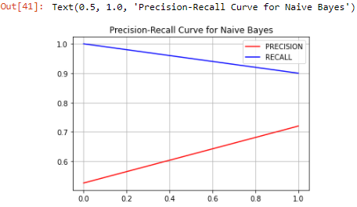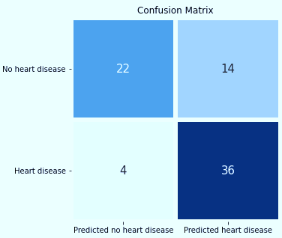
(a) (b)

Figure 3. (a) PRC Plot for NB Model, (b) Confusion matrix representation of NB classifier

The probabilistic approach of Bayesian networks is used to draw the results. To track patterns, the Bayesian network takes into account the time series of electronic health records.

4.3.1.2. Decision Tree (DT) Classifier
A DT model is mostly used to address the classification problems. While performing heart disease prediction DT achieves the highest accuracy, whereas LR achieves the most precision, and KNN achieves the highest recall [25]. However, a DT contains two basic nodes called as Decision Node and the Leaf Node. Internal nodes in DTs represent dataset attributes, branches represent decision rules, and each leaf node provides the conclusion in this tree-structured classifier. These models employ the divide-and-conquer strategy, in which a complicated problem is broken down into smaller sub-problems and the divide-and-conquer strategy is applied recursively to each sub-problem. Moreover, DT provides the mechanism for identifying the class of a given dataset begins at the root node. Based on the comparison, the values of the root parameter are compared to the values of the record (real dataset) attribute in this algorithm, then follows the branch and leaps to the next node. The algorithm compares the attribute value with the other sub-nodes and moves on to the next node. It repeats the process until it reaches the tree's leaf node. The biggest challenge that emerges while developing a DT is to choose the best attribute for the root node and sub-nodes. To overcome such circumstances, a method called Attribute Selection Measure (ASM) might be applied. It can easily determine the best property for the tree's nodes using this measurement.
Although, in this work, the DT Classifier class from the ‘sklearn.tree’ package is used to fit the model for training the data. This class contains parameters called entropy and random-state. Entropy is a metric that measures the degree of impurity in a given property. It denotes the randomness of data. The following formula as shown in below equation (3), can be used to compute entropy:

Entropy = - P(y) log2P(y) – P (n) log2P (n) (3)
Where,
P (y) = probability of yes
P (n) = probability of no

The quality of a split is measured using the criterion, which is determined using the information gain supplied by entropy.

Algorithm
- Starts from the root node and moves forward to its branch node to find the best attribute.
- Calculate the Entropy (H) and Information Gain (IG) of each attribute.
- Select the attribute that has the lowest entropy and highest information gain.
- On each subset, the process repeats itself, taking into account only traits that have never been selected previously.
- Go to step 1 until getting the outcome.

The PRC plot for the NB classifier measures the performance on positive data, as displayed in figure 4 (a). Moreover, both precisions and recall meet at a given point irrespective of the threshold value (default is 0.5), closer to 0.8, which turns into an average model.

Confusion Matrix
Figure 4 (b) gives the result of the confusion matrix for the Decision Tree classifier, where the model predicts a total of thirty heart disease patients.

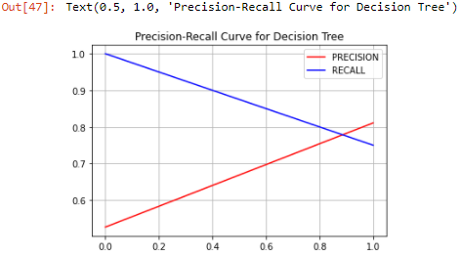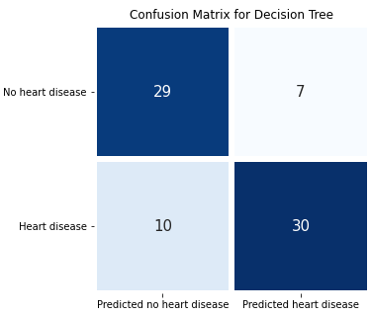

(a) (b)

Figure 4. (a) PRC Plot for DT Model and (b) Confusion matrix representation of DT classifier

4.3.1.3. Random Forest Classifier
One of ML technologies uses a model called Random Forest for the data analysis technique to anticipate and detect Cardio Vascular Disease (CVDs) such as stroke and heart attack. Using this technique, which accurately predicts cardiovascular disorders 90.3 percent of the time [26]. The Random Forest approach creates decision trees from data samples, then gets predictions from each one before choosing the best one. It's an ensemble method that avoids overfitting by averaging the results rather than having a single decision tree. It predicts by averaging or averaging the output of various trees. It generates a forest at random, mixing numerous decision trees. Each tree attempts to estimate a ranking, which is referred to as a "vote," resulting in a more accurate and consistent prediction.

Algorithm
- Randomly select the “k” features (i.e. k = 13) from the heart dataset from a total number of “m” features (i.e. m = 14) where k << m.
- Apply decision tree for every sample.
- Consider the text features and apply rules to predict the outcome and store the predicted result.
- Find the majority for every predicted result.
- The most scored predicted result will be treated as the final prediction.

Although this model predicts the disease by averaging or averaging the output of various trees. As the number of trees increases, the precision of the output improves. It outperforms the DT algorithm in terms of accuracy. The outcome of RF classification is achieved using an ensemble process. The PRC plot for the RF classifier measures the performance as predicted score with a threshold on test data, which has been displayed below figure 5 (a). This curve shows that both precision and recall meet at a given point, closer to ‘0.85’ while predicting the heart attack.

Confusion Matrix
Figure 5 (b) gives the result of the confusion matrix for the Random Forest classifier, where the model predicts a total of thirty-four heart disease patients.

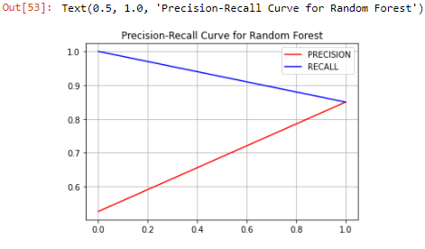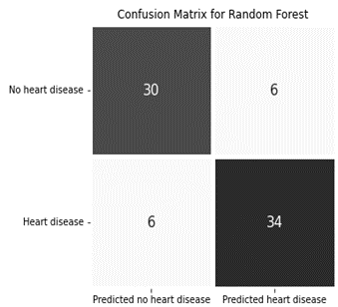

(a) (b)

Figure 5. (a) PRC Plot for RF Model, and (b) Confusion matrix representation of RF classifier

4.3.1.4. K-Nearest Neighbors (K-NN) Classifier
The K-NN classifier assumes that the new case/data and previous cases are the same, and allocates the new case to the extant categories only in the most similar group. This approach saves all existing data and categorizes additional data points based on how similar they are to the current data. This means that utilizing this technique, raw data can be efficiently sorted into a well-defined category. After successfully comparing with 13 parameters, K-NN outperforms best than other data mining techniques such as NB and DTs [27]. However, K-NN performs some major steps as follows:

Algorithm
- Decide on the number of neighbors (here K=5).
- Determine the Euclidean distance between K neighbors.
- Using the obtained Euclidean distance, find the K closest neighbors.
- Count the number of data points in each category among these k-neighbors.
- Allocate the newly acquired data points to the category with the most neighbors.
- The model is now ready for prediction.

As the name suggests, K-NN employs a similarity measure to determine which class the new data belongs to, in this case, 5 nearest neighbors. Taking K=1 or K=2 becomes noisy and causes outlier effects in the model. Since large values for K are desirable, they may cause problems. Although, this classifier will be fitted to the training data. To do so, we have used the Sklearn Neighbors library's KNeighborsClassifier class. After importing the class, a Classifier object for this class has been created. Also, the N_neighbors will be the class's parameter which usually takes 5 minutes. However, the PRC plot for the KNN classifier measures the performance for the predicted score with a threshold on test data, as displayed in above figure 6 (a). When it comes to predicting heart attacks (i.e. maximum possibilities), this plot indicates that both precision and recall meet at a certain point, closer to ‘0.88’ (proving as an average model).

Confusion Matrix
Figure 6 (b) gives the result of the confusion matrix for the KNN classifier, where the model predicts a total of thirty-four heart disease patients.

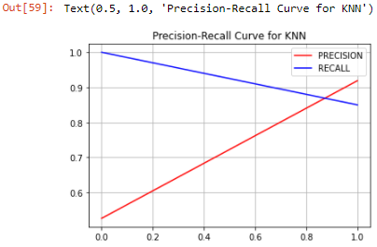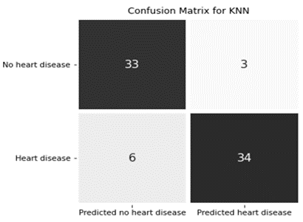
(a) (b)

Figure 6. (a) PRC Plot for KNN Model, and (b) Confusion matrix representation of KNN classifier

4.3.1.5. Logistic Regression (LR) Classifier
LR is a type of machine learning (ML) classification technique for calculating the probability of a categorical dependent variable. The dependent variable, in this case, is a binary variable with data coded as 1 or 0. The primary pathogenic determinants of heart disease were discovered using data mining technologies, and the incidence of heart disease was predicted using an LR model. When the accuracy of this model was compared to that of other algorithms that had been evaluated, it was found that the LR model was suitable in the field of heart disease prediction [28]. When a discrete result is expected, the LR approach is utilized (for example predict whether a patient is affected with heart disease or not). This classifier takes three parameters i.e. solver, max_iter, and random_state where “solver” takes the value as “liblinear” to fit this model. Another parameter called “max_iter” takes the value “250” that specifies the maximum number of iterations that a solver takes to fit the model and “random_state” takes the value as “0” i.e. no pseudo-random number generator has been used.
While implementing this classifier on the heart disease dataset, there is a dependent variable y (here y = output) on the set of independent variables x= (x₁, …, x₁₃), where the total number of inputs is 13. Next is to design an LR function called p(x), where the predicted outcomes p (x_{i}) are much closer to the actual result y_{i} (i.e. ‘i’ stands for the number of observations). Moreover, here the actual outcome is represented to either 0 or 1 where 0 stands for no heart disease and 1 for heart disease. The logistic function p(x) is defined as follows in below equation (4):

p (x) = 1 / (1 + exp (-f (x))) (4)
Where,
f (x) = b₀ + b₁x₁ + ….. + b₁₃x₁₃
p (x) is the probability of heart disease i.e. 1
- p (x) is the probability of no heart disease i.e. 0
f (x) is a sigmoid function
P (x) = $\left\{\begin{aligned} 0, if f \left(x\right)<0 \\ 0.5, if f \left(x\right)=0 \\ 1, if f \left(x\right)>1\end{aligned}\right.$

The above equation calculates the best weights and this process is called model fitting. After that for every observation of x_{i} (where i=1, 2, … , 13), the predicted output will be 1 if p(x_{i}) > 0.5 and 0 if otherwise. The PRC plot for the LR classifier measures the performance for the predicted score in respect to threshold on test data has been displayed in figure 7 (a). When it comes to predicting heart attacks, this plot indicates that both precision and recall would meet at a certain point closer to ‘1’ (representing a good model).
Confusion Matrix
Figure 7 (b) gives the result of the confusion matrix for the LR classifier, where the model predicts a total of thirty-seven heart disease patients.
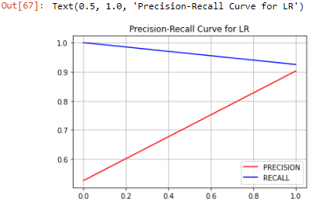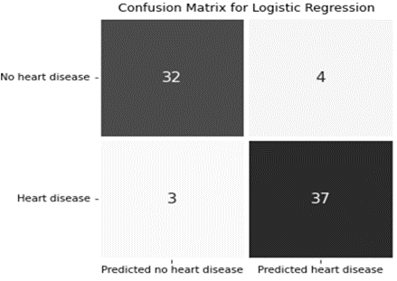
(a) (b)

Figure 7. (a) PRC Plot for LR Model, and (b) Confusion matrix representation of LR classifier

4.3.1.6. Support Vector Machine (SVM)
The SVM algorithm uses a line to separate data points which are called a hyperplane. Hyperplane has been used to classify the most significant of the closest data points into two separate classes. SVM iteratively generates the best hyperplane, which is then utilized to minimize an error. SVM generally considers three important factors while predicting results called support vectors, hyperplane, and margin. The main objective of SVM is to separate the heart disease dataset as efficiently as feasible. SVM employs a kernel trick to convert the input space to a higher-dimensional space. In this work, the Radial Basis Function (RBF) kernel transforms our input data space into the appropriate form that may be in high dimensional or infinite space. Also, the “gamma” parameter has been used that takes the value as “Auto” for fitting the training dataset perfectly. However, SVM follows some basic steps for predicting this heart disease dataset as:

Algorithm
- Create hyperplanes to separate the dataset into two classes
- Identify the right hyperplane among all that best suits this model
- Check if this hyperplane is properly segregate the heart disease dataset
- If not, apply the kernel trick to transform it into higher-dimensional space.
- Now check whether the data points are linearly separable or not
- Next, find the margin on both sides that are closest to the hyperplane and should be at the maximum point.
- If yes, then this model is now ready for prediction.

Similarly, the PRC plot for the SVM model measures the performance with a predicted score in respect to threshold on test data is displayed in figure 8 (a). Both the P-R lines meet at a certain point closer to ‘0.9’, which indicates that the SVM model would predict with good accuracy.

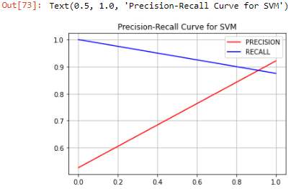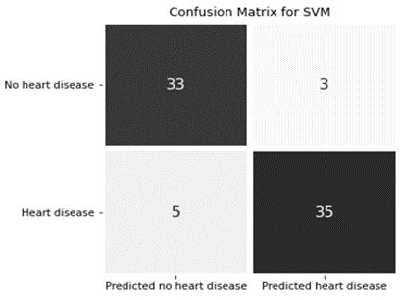
(a) (b)

Figure 8. (a) PRC Plot for SVM Model, and (b) Confusion matrix representation of SVM classifier
Confusion Matrix
Figure 8 (b) gives the result of the confusion matrix for the SVM classifier, where the model predicts a total of thirty-five heart disease patients.

4.3.1.7. LGBM (Light Gradient Boosting Machine)
As the name suggests Light GBM is very fast while dealing with large datasets and follows the best-first search to find the optimal path. This gradient boosting framework algorithm uses decision tree techniques for ranking, classification, and is also used for a variety of other ML problems.
LGBM splits this dataset into sets like a decision tree to find the best accuracy result even on the large size of the dataset. This model grows trees vertically i.e. leaf-wise whereas other decision trees grow horizontally i.e. level-wise. Here, LGBM classifier takes 5 parameters where max_depth = 5, random-state =0, num_leaves = 50, n_estimators = 20 and learning_rate = 0.1. The max_depth defines the maximum depth and is also used to handle any overfitting issues present in the model.

Algorithm
- Create hyperparameters and number of decision tree
- Recall the decision trees to improve prediction.
- Assign the number of trees i.e. here n_estimators is 20
- Measure model’s performance
- Explore the tree depth i.e. here max_depth is 5
- Explore the number of terminal nodes and learning rate whose default value is 0.1
- Ready for model prediction

Similarly, the PRC plot for the LGBM model measures the performance with a predicted score in respect to threshold on test data is displayed in figure 9 (a). Both the lines meet at a certain point closer to ‘0.9’, which indicates that the LGBM model predicts good accuracy than NB and DT models.

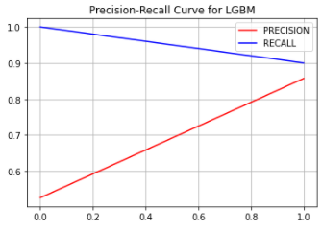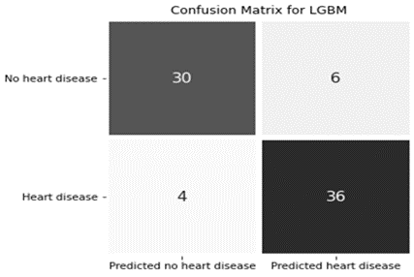
(a) (b)

Figure 9. (a) PRC Plot for LGBM Model, and (b) Confusion matrix representation of LGBM classifier

Confusion Matrix
Above figure 9 (b) gives the result of the confusion matrix for the LGBM classifier, where LGBM predicts a total of thirty-six heart disease patients.

4.3.2. Deep Learning (DL)
One AI mechanism called deep learning mimics the network of neurons in a brain. It is a subclass of ML that combines representation learning and artificial neural networks. An advanced DL model can build a knowledge-rich environment that can assist clinical decision-making by properly predicting the survival of cardiovascular patients [29]. As the name suggests, it employs deep neural networks (DNN) to classify non-linear complex data. The input signal received by the layer above the neuron will be processed and then propagated by the neuron. The weight, bias, and activation function all influence the strength of the signal sent to the neuron in the following layer. A hybrid DL model for heart disease prediction using a recurrent neural network (RNN) with multiple gated recurrent units (GRU) and long short-term memory (LSTM) have been implemented to achieve the best performance [30].

4.3.2.1. Neural Network (NN)
The NN algorithm is based on biological neural networks and aims to mimic the nervous system of humans in the learning process. Although, this network incorporates a series of algorithms that attempt to recognize underlying correlations in a piece of data using a way that mimics how the human brain functions. The results reveal that for the heart attack prediction tasks, a three-layer NN model using a backpropagation algorithm and an Adam optimizer reached a promising accuracy [31]. NN consists of 3 layers (i.e. input layer, hidden layer, and output layer) where each layer is made of nodes. Layers of interconnected nodes make up a neural network. A node is a location where actual computation occurs and fires when it receives sufficient inputs. The sum of the input-weight products is then sent via a node's so-called activation function, which determines whether and how far that signal should continue through the network to affect the outcome. A Deep Neural Network technique is offered for developing an automated system for predicting heart attacks. Although, the advancement of the tiered multivariate technique in NN, has the potential for diagnosis of coronary heart disease with good accuracy [32], [33]. However, NN follows some basic steps, while predicting this disease as:

Algorithm
- Starting from the input layer, each neuron takes weight and bias.
- Create function in combination bias + (weight x inputs)
- Move forward to the hidden layer
- Assign activation function to every output from hidden layer and input to the output layer
- Combine bias, weights with each input with activation function
- The outcome is displayed on a single output layer

Similarly, the PRC plot for the NN model measures the performance with a predicted score in respect to threshold on test data is displayed in figure 10 (a). Both the P-R lines meet at a certain point closer to ‘0.85’, which indicates that the NN model predicts good accuracy than NB and DT models.

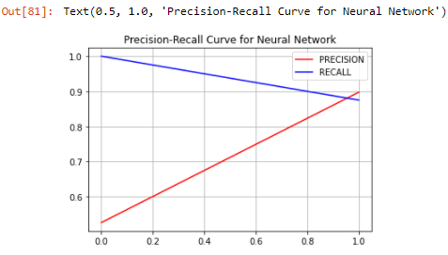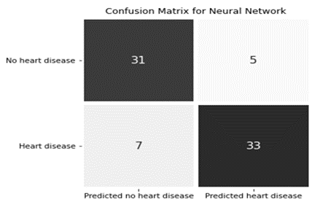
(a) (b)

Figure 10. (a) PRC Plot for NN Model, and (b) Confusion matrix representation of NN classifier

Confusion Matrix
Above figure 10 (b) gives the result of the NN classifier in the form of a confusion matrix, where the model predicts a total of thirty-three heart disease patients.

4.3.2.2. Artificial Neural Network (ANN)
ANNs are a versatile and effective tool that can assist doctors in analyzing, modeling, and making sense of complex clinical data in a variety of medical settings. The benefits of ANN come from its ability to organize the information it receives during training and tackle complicated tasks and difficulties using the data provided for training. The proposed system creates an effective methodology for collecting clinical and electrocardiogram (ECG) data to train an ANN to reliably detect heart problems [34]. It will evaluate ECG and clinical data to train a neural network to predict the occurrence of a heart attack, after which it will generate a report indicating problems in the heart or its function. A smart health care framework called as Swarm-Artificial Neural Network (Swarm-ANN) technique, for identifying cardiovascular disease that generates predefined numbers of Neural Networks (NNs) after training and evaluating the framework [35], [36].

Algorithm
- The input layer receives data and passes it on to the hidden layer.
- Each input is randomly assigned weights by the interconnections between the two layers.
- After weights are multiplied with them individually, a bias is added to each input.
- The activation function receives the weighted sum.
- The activation function defines which nodes should be used to extract features.

The input layer to the ANN model is a sequential layer that specifies the size of the model. In the hidden layer, the model has been implemented with the ReLU activation function which goes forward to the next layer. Finally, a sigmoid function has been implemented at the output layer to find the pattern. When the result is ready, it is compared to the real value, and a backpropagation procedure is used to improve the result by adjusting the weights of the network linkages. Sigmoid function has value ranges between ‘0’ to ‘1’ and has represented as an S-shaped curve. Similarly, the PRC plot for the ANN model measures the performance with a predicted score in respect to threshold on test data is displayed in figure 11 (a). Both the lines meet at a certain point closer to ‘0.85’, which indicates that the NN model predicts greater accuracy than NB, RF, and DT models.

Confusion Matrix
Figure 11 (b) gives the result of the confusion matrix for the ANN classifier, where the model predicts a total of thirty-five heart disease patients.

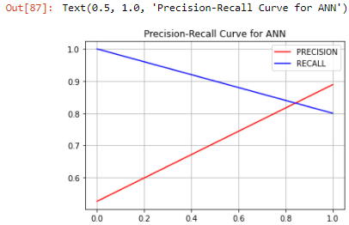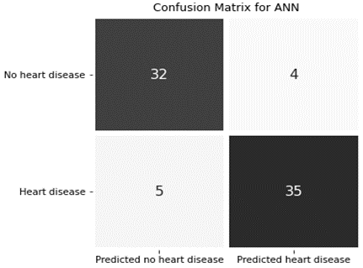
(a) (b)

Figure 11. (a) PRC Plot for ANN Model, and (b) Confusion matrix representation of ANN classifier

- PERFORMANCE METRICS
The performance of a model can be measured using some performance metrics. In ML, various criteria are available to measure the performance of the model such as precision, recall, accuracy, and F1 score that have been discussed as follows:

5.1. Precision
It is the metric of accurateness used to assess a classifier's performance. There are fewer false positives if the precision is high. It mainly specifies the proportion of actually correct identifications.

Precision = TP / (TP+FP) (5)
Where,
TP and FP stand for True Positive and False Positive respectively.

5.2. Recall
It is a metric for determining the classifier's completeness. Higher recall equals fewer false negatives, while lower recall equals more false negatives. When recall improves, precision often suffers as a result.
Recall = TP / (TP+FN) (6)
Where,
TP and FP stand for True Positive and False Negative respectively.

5.3. Accuracy
The accuracy of an ML/DL model is a metric for identifying which model is the best at finding relationships and patterns between variables in this dataset based on the training data.

Accuracy = (TP+TN) / (TP+TN+FP+FN) (7)

5.4. F1 Score
The F-score is a combination of accuracy and recall that may be measured using the equation given:

F1 Score = 2 * ((precision * recall) / (precision + recall)) (8)

Equations from (5) to (8) are the mathematical formulas used for evaluating the model’s performance. The performance of all nine models is displayed in the form of accuracy, recall, precision, and f1-Score in Jupyter notebook as shown in figure 12, after successfully predicting the heart disease dataset.

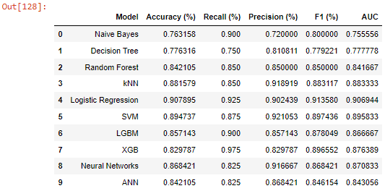

Figure 12. Performance Metrics of 9 models

- RESULT & DISCUSSION
Heart disease prediction at an earlier stage may help to avoid deaths from heart attacks. A good classification system can assist a doctor in predicting the existence of cardiovascular disease before it occurs. Heart patient’s dataset has been collected from the UCI repository that consists of 303 healthcare records with 13 input variables and 1 output variable which undergoes data pre-processing. Also, in this pre-processing step, cleaning and splitting of data have taken place for removing null values. Although, two feature selection strategies named as StandardScaler and OneHotEncoder are employed in this step. Python packages such as pandas, NumPy, and matplotlib are implemented using the Anaconda Jupyter notebook. Furthermore, for the ML side of this project, the sklearn module and, for the deep learning side, Keras layers are used. Moreover, seven ML and two DL classifiers are implemented with train and test sizes of 75 and 25 percent respectively for predicting cardiovascular disease if present, in advance.
After evaluating all models successfully, all models have been moving forward to measure the performance by using a confusion matrix. This can be done by implementing the accuracy, precision, recall, and Fi-Score overall models for finding out the best predictive model, as displayed in above figure 12. Moreover, the overall performance of all nine models is plotted using the ROC curve that describes the information regarding TPR (true positive rate) and FPR (false positive rate) as given in figure 13. This plot demonstrates that LR (indicating orange color) model proves as the best predictive classifier in detecting heart attack.
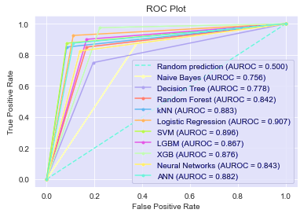

Figure 13. ROC Curve representation

As a result, the LR model predicted coronary heart disease in providing higher accuracy of 90.7 percent as compared to other models.

- CONCLUSION
The leading cause of death in the country is heart disease. Manually calculating the chances of developing heart disease based on risk factors such as age and sex is difficult. To predict the output from data, the relevant technologies of ML and DL are applied that might give a significant result. As described, these methodologies have the potential to improve health care delivery strategies. They can assist professionals in identifying, diagnosing, and treating cardiovascular disease. ML applications in healthcare could also help to streamline tasks and improve operation planning, preparation, and execution. Also, DL algorithms can uncover patterns related to diseases and health conditions. Some cardiac test parameters, as well as normal human habits, are included in this dataset. In this work, a total of nine classifiers are tested and measured using a confusion matrix for predicting heart attack on the heart disease dataset, retrieved from the UCI repository. Moreover, a PRC plot has been carried out on every classifier that entirely focuses on the model's performance on the test set. The results demonstrate that the LR model outperforms the strategies beyond all other models. Although, this model achieves 90.7 percent accuracy, which specifies that this model has a greater extent of identifying heart disease. In conclusion, it might find that the LR model would predict more effectively on the real-time heart disease datasets.
However, both ML and DL advances in healthcare will continue to revolutionize the business in the future. The predictive analytics empowerment of these models could detect heart attack occurrence in advance, based on medical records and photographs. In the future, a larger heart disease dataset will be taken for better prediction.

REFERENCES
[1] Mendis, S., Puska, P., Norrving, B., and World Health Organization., “Global atlas on cardiovascular disease prevention and control,” World Health Organization, 2011.
[2] Mehmood, A., Iqbal, M., Mehmood, Z., Irtaza, A., Nawaz, M., Nazir, T., and Masood, M., “Prediction of Heart Disease Using Deep Convolutional Neural Networks,” Arabian Journal for Science and Engineering, 46(4), 3409-3422, 2021.
[3] Dhankhar, A., and Jain, S., “Prediction of disease using machine learning algorithms. Smart and Sustainable Intelligent Systems,” 115-125, 2021.
[4] Ramesh, G., Madhavi, K., Reddy, P. D. K., Somasekar, J., and Tan, J., “Improving the accuracy of heart attack risk prediction based on information gain feature selection technique,” Materials Today: Proceedings, 2021.
[5] Mary, T. S., and Sebastian, S., “Predicting heart ailment in patients with varying number of features using data mining techniques,” International Journal of Electrical and Computer Engineering, 9(4), 2675, 2019.
[6] Diwakar, M., Tripathi, A., Joshi, K., Memoria, M., and Singh, P., “Latest trends on heart disease prediction using machine learning and image fusion,” Materials Today: Proceedings, 37, 3213-3218, 2021.
[7] Patil, P. B., “Heart Attack Detection Based On Mask Region-Based Convolutional Neural Network Instance Segmentation and Hybrid Classification Using Machine Learning Techniques,” Turkish Journal of Computer and Mathematics Education (TURCOMAT), 12(9), 2228-2244, 2021.
[8] Alpaydin, E., “Introduction to machine learning": MIT press, 2020.
[9] Jackins, V., Vimal, S., Kaliappan, M., and Lee, M. Y., “AI-based smart prediction of clinical disease using random forest classifier and Naive Bayes,” The Journal of Supercomputing, 77(5), 5198-5219, 2021.
[10] Ramadugu, B., “A Novel Approach to Predict Cardio Disease Using Naive Bayes Algorithm,” 2021.
[11] Kapoor, N., and Singh, P., “Heart Disease Prediction Using Decision Tree and Random Forest Classification Techniques,” In Applications of Big Data in Large-and Small-Scale Systems (pp. 234-259). IGI Global, 2021.
[12] Enriko, I. K. A., Suryanegara, M., and Gunawan, D., "Heart disease prediction system using k-Nearest neighbor algorithm with simplified patient's health parameters,” Journal of Telecommunication, Electronic and Computer Engineering (JTEC), 8(12), 59-65, 2016.
[13] Sowmiya, C., and Sumitra, P., “A hybrid approach for mortality prediction for heart patients using ACO-HKNN,” Journal of Ambient Intelligence and Humanized Computing, 12(5), 5405-5412, 2021.
[14] Suresh, T., Assegie, T. A., Rajkumar, S., and Kumar, N. K., A hybrid approach to medical decision-making: diagnosis of heart disease with machine-learning model,” International Journal of Electrical & Computer Engineering (2088-8708), 12(2), 2022.
[15] Verma, E. P., and Singh, E. P., “Human Heart Disease Prediction System using Enhanced Decision Tree Algorithm in Data Mining,” International Journal of Innovative Science, Engineering & Technology, 2020.
[16] Bahtiar, A., Dwilestari, G., Basysyar, F. M., and Suarna, N., “Data mining techniques with machine learning algorithms to predict patients of heart disease,” In IOP Conference Series: Materials Science and Engineering (Vol. 1088, No. 1, p. 012035), IOP Publishing, 2021.
[17] Joshi, A., and Shah, M., “Coronary Artery Disease Prediction Techniques: A Survey,” In Proceedings of Second International Conference on Computing, Communications, and Cyber-Security (pp. 593-604), Springer, Singapore, 2021.
[18] Kim, J., and Jang, I., “Predictors of bleeding event among elderly patients with mechanical valve replacement using random forest model: A retrospective study,” Medicine, 100(19), 2021.
[19] Chitra, R., and Seenivasagam, V., “Heart attack prediction system using cascaded neural network,” In Proceedings of the International Conference on Applied Mathematics and Theoretical Computer Science-2013 (p. 223), 2013.
[20] Methaila, A., Kansal, P., Arya, H., and Kumar, P., “Early heart disease prediction using data mining techniques,” Computer Science & Information Technology Journal, 24, 53-59, 2014.
[21] Jeyaranjani, J., Rajkumar, T. D., and Kumar, T. A., “Coronary heart disease diagnosis using the efficient ANN model,” Materials Today: Proceedings, 2021.
[22] Saranya, G., and Pravin, A., “A comprehensive study on disease risk predictions in machine learning,” International Journal of Electrical and Computer Engineering, 10(4), 4217, 2020.
[23] Kiran, K. S., Azman, M., Nandu, E., and Prakash, S. S., “Real-Time Detection and Prediction of Heart Diseases from ECG Data Using Neural Networks,” In Proceedings of International Conference on Recent Trends in Machine Learning, IoT, Smart Cities and Applications (pp. 93-119), Springer, Singapore, 2021.
[24] Arunachalam, S, “A Comparative Study of Machine Learning Algorithms for the Prediction of Heart Disease,” International Journal for Research in Applied Science & Engineering Technology, 2020.
[25] Sanni, R. R., and Guruprasad, H. S., “Analysis of Performance Metrics of Heart Failured Patients using Python and Machine Learning Algorithms,” Global Transitions Proceedings, 2021.
[26] Marathe, N., Gawade, S., and Kanekar, A., “Prediction of Heart Disease and Diabetes Using Naive Bayes Algorithm,” International Journal of Scientific Research in Computer Science, Engineering and Information Technology, 447-453, 2021.
[27] Zhang, Y., Diao, L., and Ma, L., “Logistic Regression Models in Predicting Heart Disease,” In Journal of Physics: Conference Series (Vol. 1769, No. 1, p. 012024). IOP Publishing, 2021.
[28] Elyassami, S., and Kaddour, A. A., “Implementation of an incremental deep learning model for survival prediction of cardiovascular patients,” IAES International Journal of Artificial Intelligence, 10(1), 101, 2021.
[29] Krishnan, S., Magalingam, P., and Ibrahim, R., “Hybrid deep learning model using recurrent neural network and gated recurrent unit for heart disease prediction,” International Journal of Electrical & Computer Engineering (2088-8708), 11(6), 2021.
[30] Aslam, M., and Jaisharma, K., “Hierarchical Random Forest Formation with Nonlinear Regression Model for Cardiovascular Diseases Prediction,” In 2021 International Conference on Computer Communication and Informatics (ICCCI) (pp. 1-5). IEEE, 2021.
[31] Antar, R. K., ALotaibi, S. T., and AlGhamdi, M., “Heart Attack Prediction using Neural Network and Different Online Learning Methods,” International Journal of Computer Science & Network Security, 21(6), 77-88, 2021.
[32] Wiharto, W., Kusnanto, H., and Herianto, H., “Hybrid system of tiered multivariate analysis and artificial neural network for coronary heart disease diagnosis,” International Journal of Electrical and Computer Engineering, 7(2), 1023, 2017.
[33] Ashraf, M., Rizvi, M. A., and Sharma, H., “Improved heart disease prediction using deep neural network,” Asian Journal of Computer Science and Technology, 8(2), 49-54, 2019.
[34] Bagul, A., Gorde, A., Gargade, A., Amrutkar, S., and Mahajan, M., “Heart Attack Prediction And Prevention Using Artificial Neural Network,” Open Access International Journal of Science and Engineering, 4, 1-5, 2019.
[35] Nandy, S., Adhikari, M., Balasubramanian, V., Menon, V. G., Li, X., and Zakarya, M., “An Intelligent heart disease prediction system based on swarm-artificial neural network,” Neural Computing and Application, 1-15, 2021.
[36] Wiharto, W., Herianto, H., and Kusnanto, H., “The Analysis of Performace Model Tiered Artificial Neural Network for Assessment of Coronary Heart Disease," International Journal of Electrical & Computer Engineering (2088-8708), 7(4), 2017.

BIOGRAPHIES OF AUTHORS

 | Mr. Sashikanta Prusty received an MCA degree in Computer Science & Engineering from Purusottam Institute of Engineering & Technology (PIET), Rourkela, Odisha, India in 2010. MTech degree in Computer Science & Engineering from Raajdhani Engineering College, Bhubaneswar, Odisha, India in 2020. He is currently pursuing his Ph.D. in Computer Science and Engineering at Siksha ‘O’ Anusandhan (Deemed to be University), Bhubaneswar, India and has published 2 Conferences. Moreover, One Transaction paper has been accepted and is under publishing in Elsevier. Although, he has 5+ years of teaching experience and 3 years of industry experience.
 | Dr. Srikanta Patnaik is a Professor in the Department of Computer Science and Engineering, Faculty of Engineering and Technology, SOA University, Bhubaneswar, India. He has received his Ph. D. (Engineering) in Computational Intelligence from Jadavpur University, India in 1999 and supervised 25 Ph. D. Theses and more than 60 Master theses in the area of Computational Intelligence, Soft Computing Applications, and Re-Engineering. Dr. Patnaik has published around 100 research papers in international journals and conference proceedings. He is the author of 2 textbooks and 32 edited volumes and a few invited book chapters, published by leading international publishers like Springer-Verlag, Kluwer Academic, etc.  Dr. Patnaik is the Editors-in-Chief of International Journal of Information and Communication Technology and International Journal of Computational Vision and Robotics published from Inderscience Publishing House, England, and also Editors-in-chief of Book Series on “Modeling and Optimization in Science and Technology” published from Springer, Germany, Book Series on Advances in Computer and Electrical Engineering (ACEE) and Book Series on Advances in Medical Technologies and Clinical Practices (AMTCP), published from IGI-Global, USA. He is the Editor of the Journal of Information and Communication Convergence Engineering, published by the Korean Institute of Information and Communication Convergence Engineering. He is also Associate Editor of International Journal of Granular Computing, Rough Sets and Intelligent Systems (IJGCRSIS) and International Journal of Telemedicine and Clinical Practices, published from Inderscience Publishing House, England.
 | Dr. Sujit Kumar Dash heads the Corporate Engagements, Training & Placement at Siksha O Anusandhan University, Bhubaneswar, Odisha. He pursued Electrical Engineering from VSSUT, Burla, Odisha, followed by post-graduation (MTech) in Industrial Engineering & Management from IIT, Kharagpur. Later he earned his Ph.D. in Electrical Engineering from SOA University, Bhubaneswar. Dr. Dash has 18+ years of teaching experience for undergraduate and postgraduate students in Engineering. His area of expertise in teaching has been Electrical Power Systems, Energy Management, Network Analysis, Electrical Machines, and Computational Techniques. He has keen interests in research areas like Machine Intelligence Techniques for Forecasting and Classification of Non-linear time series (Electricity Price) in deregulated Electricity Markets. (The works are based on Neural Network techniques). Dr. Dash has been published in some international journals and conference articles (06) in the reputed journals with an impact factor of 2+.

