The Coordinated operation of 2DOF-PID-JAYA with UPFC-RFB for LFC Problem of Interlinked Hydro Power System

Article Info |  | ABSTRACT
Article history:  Received month 10, 2021  Revised month dd, yyyy  Accepted month dd, yyyy |  | This paper proposes the initial strategy of designing two degree of freedom proportional integral derivative (2DOF-PID) made load frequency control (LFC) action optimized using JAYA optimization algorithm for a hydro-hydro system. At first, the PID optimized through JAYA is used for hydro dominated system and the comparative analysis of all possible error definitions are carried out to show the benefits of selecting integral time absolute error (ITAE) for LFC. Then, (2DOF-PID) is designed for hydro governing system and its performance is compared with other designs to show the efficacy of the present LFC with regard to computed error values, gain of the various models via graphical LFC. The results obtained through simulations are promising but oscillatory with greater settling time and hence the proposed controller is retuned by considering the unified power flow control (UPFC) in arrangement with the tie-line and redox flow battery (RFB) units in area-2. The in line LFC actions are examined considering the LFC non-linearity, sensitivity analysis, random load disturbance and it is seen that the applications outcomes shows the prevalence of the proposed work.
Keywords:
LFC
2DOF-PID
JAYA optimization
UPFC
RFB
Keywords:  LFC  2DOF-PID  JAYA optimization  UPFC  RFB |  | This is an open access article under the CC BY-SA license.  
Corresponding Author:
Dr. Gulshan Sharma,
Department of Electrical Power Engineering,
Durban University of Technology,
Steve Biko Campus, 70 Steve Biko Road, Durban 4001, South Africa.
Email: gulshanS1@dut.ac.za

- INTRODUCTION
The electrical generation and delivery systems must fulfill its operation in interconnected manner as it makes the operation of system more reliable and it reduces the generation reserve capacity requirements. The power generation areas are interconnected by means of AC tie-line which encounter the frequency and tie-line power alterations from particular standard values. This is due to alteration in energy requirement of the customers over the complete day and thus the load frequency control (LFC) regulators are installed on the generators to minimize the generation-demand mismatch and therefore to maintain frequency to its satisfactory constrain i.e. ± 0.5 Hz [1-3] and also to set the tie-line power to its original value. The straight combination of frequency deviation and tie-line power control alter is named as area control error (ACE). In writing, different LFC procedure have been proposed to supply a straightforward and viable control to meet LFC guidelines. The control procedure based on classical controllers i.e. PID was earlier utilized in the LFC [4].
However, the classical strategy did not perform well due to improper tuning and completely depend on the rich experience of the plant. The wide-ranging investigations have been made to find effective controller methodologies i.e. full state LFC using modern control theory, control design on few states containing most of the system information, model predictive action etc., are accessible for the LFC problem [5-7]. The LFC plans based on full states gives ideal execution response by optimizing the specific performance index. Be that as it may, the plan model requires accessibility and evaluation of all the system states. To delude the disadvantages of full state, the concepts built on few and easily accessible states have been proposed by the analysts. Later, the intelligent LFC actions founded on fuzzy logic, neural networks, multi-agent system, swarm based intelligent optimization and fusion of intelligent techniques have been connected by the analysts and control engineers around the world to unravel the LFC issue [8-12]. The optimization algorithm such as GA is one of the foremost broadly utilized intelligent optimization among some other optimization methods and GA was successfully utilized to handle the complex and large system problem of LFC. In [13], this technique is utilized to discover and unravel the LFC issues. In [14], effective implementation is accomplished through GA utilizing linear matrix inequalities (LMI) for solving LFC problem. Though, in [15] a few limitations were detailed by the analysts in this technique. Further, output of GA mostly hinge on chosen objective function and also depends on the selection of algorithm parameters. The issue seen by GA can be overcome through Particle Swarm Optimization (PSO) method. PSO often fails to trap into local minima/maxima and has lesser convergence time for same degree of execution. Of late, the investigators have tried the application of more viable and formative computation strategy i.e. bacteria foraging optimization (BFO) calculation to unravel LFC issues effectively. It is modelled as per the behavior of E. coli microscopic organisms which are found in human. In a view of its special dispersal as well as elimination technique, for fewer population it is able to find the global optimum. These points of interest overcome the confinement of GA and PSO i.e. avoid trapping in local minima/maxima and demonstrated to be an effective optimization control for LFC. In [16], the creators displayed the efficacy of BFO over other algorithm base LFC for interconnected vitality framework. In [17], the issue of LFC is overseen utilizing BFO optimized PI and its predominance over GA is outlined for a two-area interconnected electrical framework. The joint BFO-PSO was proposed in [18] to find the perfect values of PI for two-area and multi-area electrical system. The predominance of BFO-PSO was seen over PSO, BFOA, GA, craziness built PSO and ANFIS. Thus, it is observed that intelligent optimization procedures are picking up force in LFC examinations and the modern and capable optimization method is continuously welcomed by the examiners in LFC i.e. JAYA optimization [19]. On the other side the researchers are also exploring diverse PID models these days and one of the new and advancement over standard PID is two degree of freedom (2DOF) PID. Furthermore, LFC designs were illustrated on thermal model or hydro-thermal interlinked generation system and lacks in appropriate and straightforward control plan for hydro governing frameworks because hydro turbines need higher time to respond for sudden load alteration in comparison to thermal turbines due to which the LFC abdicate of hydro regulating framework are lazy and have diligent movements. Subsequently, the analysts and electric control engineers are dodging this framework to create reasonable plan for LFC. Recent trend shows that clean and green energy sources are getting worldwide acceptance to produce electric power such as hydro be it bulk hydro or micro-hydro. However, the operation of existing power network in the presence of such sources become more complex. Hence, it is critical to examine a straightforward and compelling controller technique for such crucial hydro-hydro framework.
The modern and quick advancement of power electronic techniques has given rise to the advancement of Flexible Alternating Current Transmission (FACTS) frameworks to form strides the lesson of electrical system and to agreeable control the electrical power flowing in any lines [20]. FACTS has the capability to control active & reactive power and can improve the electrical output for sudden changes in control requirements and moreover guarantee the quality transmission of electrical essentialness to the advanced clients. Redox Flow Battery (RFB) within the framework of FACTS, is fast acting reserve and provide immediate response to active power demand. Therefore, presence of such fast-acting reserves manages to damp out the electromechanical oscillation [21]. If there is a sudden rise in the power demand, the stored energy in RFB is immediately utilized through power conversion system which comprises of inverter/rectifier system. Essentially it assimilates control amid the sudden discharge of loads. Be that as it may, it isn't conceivable to put RFB in each region of interconnected control framework due to financial reasons and hence Unified Power Flow Controller (UPFC) may prove to be effective, very cheaper and can be introduced in arrangement with tie-line in order to advance the execution of electrical vitality framework. In this way, the shared action of RFB and UPFC with 2DOF-PID-JAYA is proposed and investigated for LFC of interlinked hydro system. In line with this, the novel contributions of this article are:
- To suggest a new plan for LFC of an interlinked hydro governing system based on 2DOF-PID. The accurate and precise gains of PID are accomplished through the JAYA optimization algorithm.
- At first, the PID is design though JAYA for the hydro governing interconnected framework and the LFC action is check with regards to various definition of errors such as IAE, ISE, ITAE and ITSE for standard load alteration and the correct error definition is chosen for the next level of study i.e. ITAE for the present LFC studies.
- In next step, 2DOF-PID base LFC action effectively optimized through JAYA is design for LFC of interconnecting hydro governing framework and the outcomes of propose LFC is compare with other LFC actions with regards to parameters of 2DOF-PID, value of ITAE and graphical LFC.
- It is observed that output of 2DOF-PID is respectable in comparison to other LFC actions but still the outcomes of LFC have greater overshoot, continuous wavering and that is why the proposed controller is explored once more with consideration of UPFC in course of action with tie-line and RFB units presented at terminals of another area.
- The framework execution of the planned LFC is assessed beneath different framework examinations considering the LFC non-linearity, sensitivity analysis, random load disturbance and the applications results are uncovered to seem the predominance of the proposed work.
The rest of the article is arranged as follows: In Section 2, the hydro governing framework is shown with GRC and dead-band non-linearity in Section 3 with UPFC and RFB information in Section 3.1. Section 3.2 shows full information of JAYA algorithm with results analysis in Section 4 and at end conclusions in Section 5.

- MODEL INFORMATION
To investigate capacity of 2DOF-PID develop via JAYA for LFC, an interlinked system having hydro generating unit in respective areas is considered. The RFB model is incorporated in zone-2 seeing UPFC linked in course of action with tie-line. The linked hydro electrical framework in view of RFB and UPFC is well revealed in Figure 1 (a).

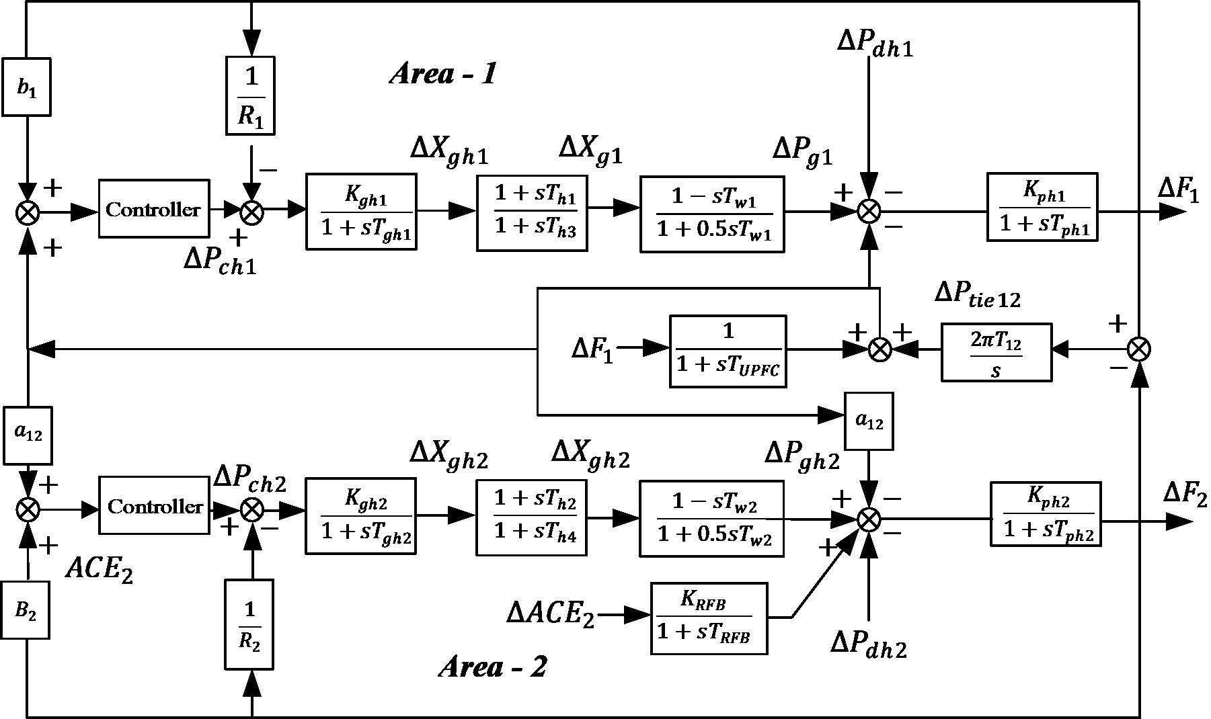

Figure 1 (a). Inter-linked hydro governing model with UPFC and RFB

- GENERATION RATE CONSTRAINTS AND DEAD-BAND DETAILS
In this section, it is explained the results of research and at the same time is given
the comprehensive discussion. Results can be presented in figures, graphs, tables and others that make
the reader understand easily [14], [15]. The discussion can be made in several sub-sections. In an interconnected electrical network, the change in generation as per the control action is restricted to avoid the wear and tear of energy source and modeled as upper and lower bounds. The GRC limit is 270%/min (0.045pu/s) for increasing and 360%/min (0.06pu/s) for bringing down the generation. The schematic exchange work layout is given in Figure 1 (b). Assist a non-linearity dead-band of 0.02% [12] is additionally joined within the hydro-hydro model as this non-linearity impact the output of controllers of LFC and make it more worse but it is important to consider to avoid the damages to the various other equipment’s connected in hydro-hydro plant.
Figure 1 (b). Turbine model with GRC

3.1. UPFC and RFB Details
UPFC is capable enough to arrange the stream of power flow in tie-lines, thus displays up the prevalent execution and set the standard voltage. With sudden electric power requirement variations, the execution of LFC of hydro frameworks is unsuccessful in showing the required LFC performance owing to higher returning nature of hydro turbines and subsequently UPFC is introduced in arrangement association to tie-lines. The shunt converter given for UPFC presents the controlled shunt voltage such that the real/active component of the current in shunt department equalize the genuine control as require by arrangement converter. The complex control at the tolerating conclusion of line is [20]:
(1)
Where, (2)
In Eqn. (2), V_{se} is the magnitude of series voltage:
From Eqn. (1), the real portion is expressed as:
(3)
In over Eqn. in case Vse = 0, the real power is uncompensated whereas the significance of UPFC course of action voltage can be control between zero and Vse max. Subsequently, the phase angle can be coordinate between 0º to 360º at any control point. In LFC considers approximately, the UPFC based control action can be finished through taking exchange work portrayal [20]:
(4)
Where, T_{UPFC} implies the time constant of UPFC. The RFB is modeled as dynamic control source for area-2 with time steady T_{RBF}. RFB may be an inactive gadget and thus its reaction for control is exceptionally quick compared to frequency alteration, the time steady of RFB is respected as seconds for control plan. The modelling and transfer function domain of RFB is created in [21] as shown in Figure 1 (c). The derived transfer function model of UPFC and RFB is considered in the model to improve the performance of hydro dominated LFC.

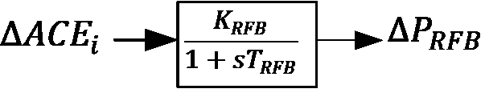
Figure 1 (c). The depiction of RFB

3.2. Optimization Problem
The thought behind optimization is to attain least objective work as characterized by the client for the considered framework demonstrate employing a characterized execution list (PI). The performance index for LFC is defined as the area control error from the interconnected electrical network. The various distinct performance index are available in past LFC studies, however integral time multiplied absolute error (ITAE) diminishes the settling time & peak overshoot which cannot be finished by means of other error definitions. It is detailed and tried by the analysts and control engineers that ITAE ensures many time response specifications as compared to other performance index. Consequently, the ITAE is utilized to assess the execution of 2DOF for hydro framework.

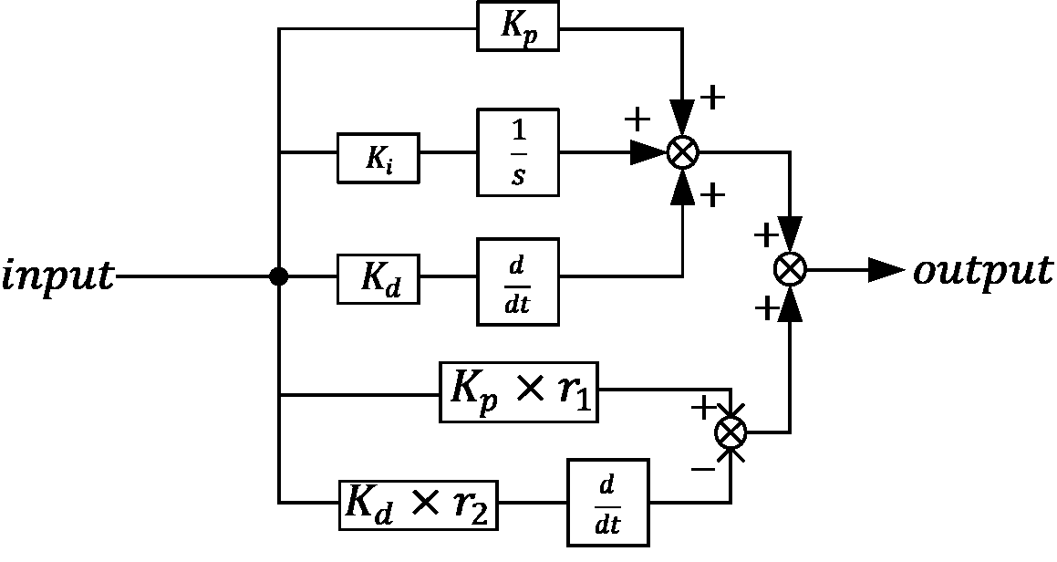

Figure 1 (d). Structure of 2DOF-PID controller

The PI (J_{n}) for the nth control ranges are as takes after:
The application of optimization is to decide the controller picks up for which the ITAE has the least esteem. These gains are calculated after considering following constraints.
The schematic representation of 2DOF-PID is given in Fig. 1 (d). The 2DOF-PID is designed by optimizing the parameters of controller. The JAYA optimization algorithm is simulated to decide the ideal values of controller gains. The JAYA strategy was proposed by R. Venkata Rao in 2016 [19] and effectively tried in present work as its application has not been tried on hydro dominated LFC framework with 2DOF-PID controller.
The parameter less JAYA algorithm has only one phase and simpler to apply for the application like LFC. The solutions for i^{th} iteration is modified as per the following below Eq. (5)
(5)
Where, = best value of variable in all population in iteration. worst value of variable in all population in iteration. updated position of variable for population in iteration. two random number for the variable during the iteration in the range [0,1]. As per Eqn. (5), causes solution to move closer to best solution and causes solution to move away from the worst solution. The is accepted only if it gives better function value. These accepted function values in the current iteration become input to the next iteration. The steps for finding optimized solutions through JAYA algorithm is given in Figure 1 (e). The calculation was run 30 epochs and the driving course of action obtained via 30 epoch is considered as final parameters for diverse structures of PID. Table 1 shows various structures of PID and calculated values. Table 2 shows up the effect on objective work by joining UPFC & RFB with optimized controller which is outlined with framework non linearity.

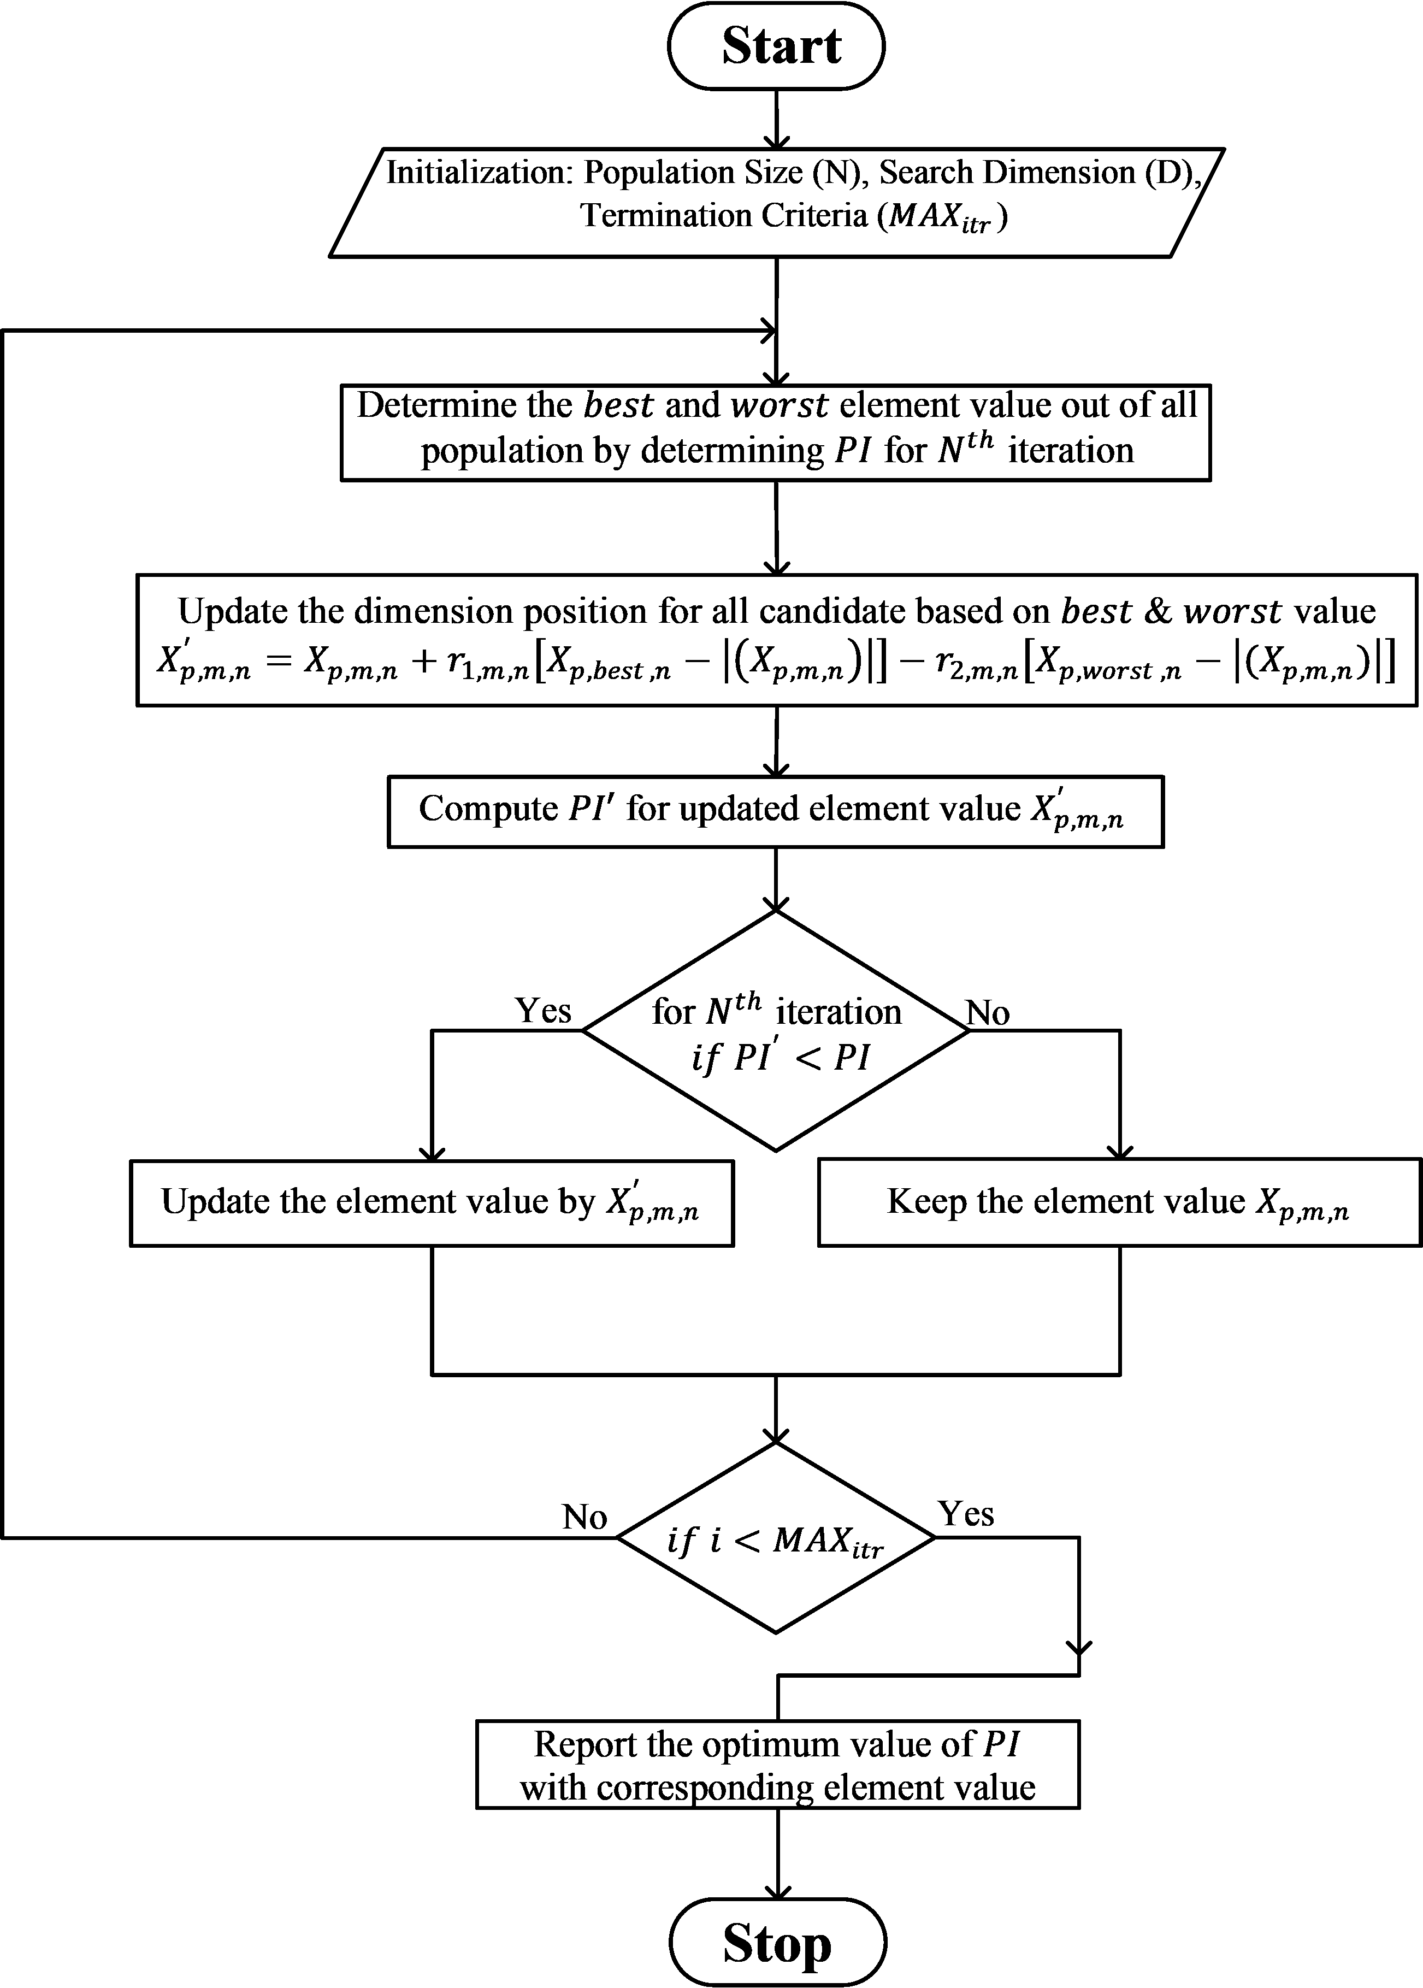

Figure 1 (e). The execution steps of JAYA built PID controller

- RESULT ANALYSIS
A linked hydro framework having hydro turbines in both of the control regions with same capacity is utilized for the investigation. The thought behind the inquire about work is to explore the execution of such kind of hydro governing framework to demonstrate and to propose a compelling plan of 2DOF built PID and its parameters are evaluated through JAYA algorithm and to assess the execution of control for LFC beneath differing working framework conditions.

TABLE 1: Comparative analysis of gains of various PID obtain via JAYA
Controllers | K_{p} | K_{i} | K_{d} | r₁ | r₂ | ITAE
PI | 0.0529 | -0.045 | - | - | - | 10.858
ID |  | -0.037 | 0.619 | - | - | 7.1952
PID | -0.3351 | -0.048 | 0.447 | - | - | 4.9620
2DOF-PID | -0.3351 | -0.048 | 0.447 | -0.264 | -0.054 | 4.7958

TABLE 2: Computed gains of 2DOF-PID for LFC with UPFC & RFB with respect to GRC and dead-band
Controllers | K_{p} | K_{i} | K_{d} | r₁ | r₂ | ITAE
2DOF-PID | -0.3351 | -0.048 | 0.4478 | -0.2648 | -0.0548 | 4.7958
2DOF-PID+UPFC+RFB | -0.3351 | -0.048 | 0.4478 | -0.2648 | -0.0548 | 12.497
2DOF-PID+UPFC+RFB+Retune | -2 | -2 | 2 | -2 | 0.6517 | 0.9478

TABLE 3: Sensitivity analysis of 2DOF-PID for LFC with UPFC & RFB with respect to GRC and dead-band
Sensitivity Variation | K_{p} | K_{i} | K_{d} | r₁ | r₂ | ITAE
+20 | -2 | -2 | 2 | -2 | 0.651773 | 0.944902
-20 | -2 | -2 | 2 | -2 | 0.651773 | 0.980002
+40 | -2 | -2 | 2 | -2 | 0.651773 | 0.937871
-40 | -2 | -2 | 2 | -2 | 0.651773 | 1.09217

TABLE 4: Computed gains of 2DOF-PID for random load pattern
Load Disturbance | K_{p} | K_{i} | K_{d} | r₁ | r₂ | ITAE
Random Load | -2 | -2 | 2 | -2 | 0.651773 | 56.08275

Especially few examinations were performed and nitty gritty by the investigators on this appear for LFC as the hydro overseeing models are insecure due to colossal reacting time of hydro turbines in orchestrate to meet the sudden modify of control request. The 2DOF-PID regulator is presented in each of the control zones and the yield (u) gotten from the JAYA optimized 2DOF-PID are associated in each region of linked hydro framework. The governor in interlinked hydro system has dead-bands.
Advance, the generation output is limited by imposing the GRC limitation in each region of linked hydro system. It in addition acknowledged that control ranges may have the particular kind of parametric vulnerabilities due to unfeeling environment and developing of framework components. In this way, due thought has been paid to all perspectives of LFC whereas arranging 2DOF-PID. Advance the execution of 2DOF-PID in addition checked for random load pattern. To start with, the PID control is planned for LFC of hydro control framework and measured for 1% load variation in area-1 of the framework. The frequency as well as tie-power deviations are obtained and compared with different error values and these results are shown in Figure 2 (a-c).
It is observed that frequency and tie-power deviations manage to reach consistent original value quite quickly in comparison to other LFC actions. Additionally, it is also seen that oscillations damp out from LFC results after 25 seconds which is only possible through ITAE in comparison to other error values and hence ITAE is the precise and accurate error for LFC and chosen for rest of the LFC studies.
Now, the 2DOF-PID is designed for hydro governing system and its outcomes are matched with PI, ID and PID. The execution of 2DOF-PID founded on JAYA over other LFC actions are assessed on the premise of ITAE and the comparative investigation of all LFC in terms of various parameters of controller and ITAE is appeared in Table 1.

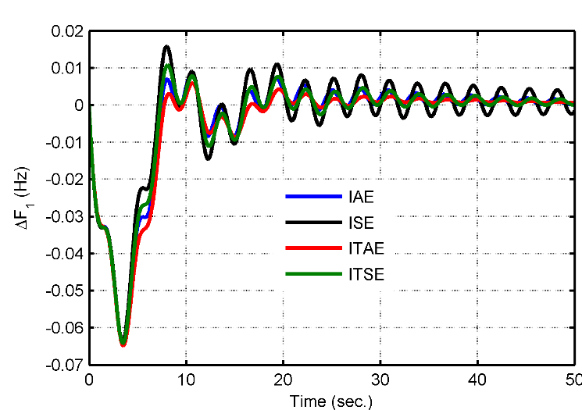
(a)
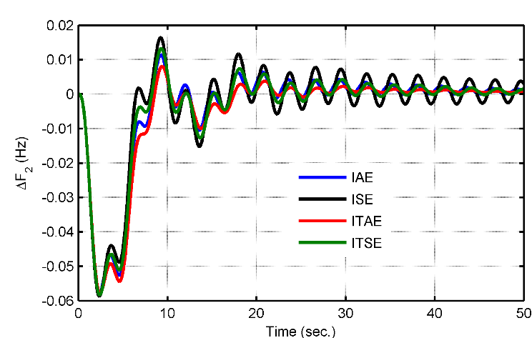
(b)
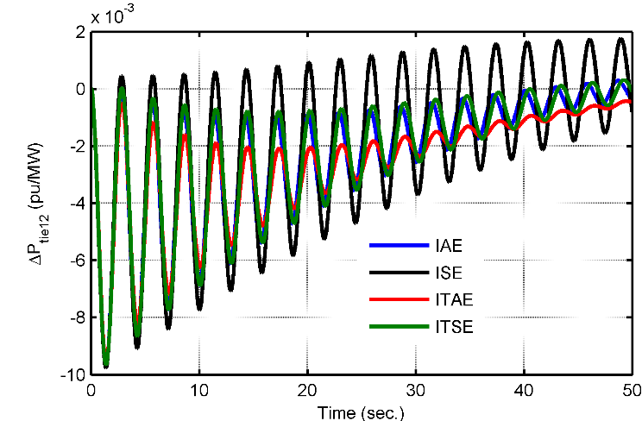
(c)
Figure 2 (a-c). LFC outcomes for 1% load alteration in area-1 obtain via PID

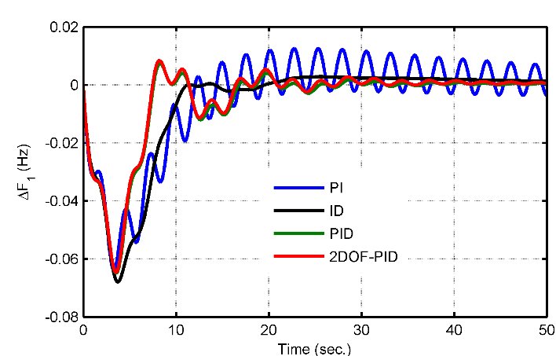
(a)
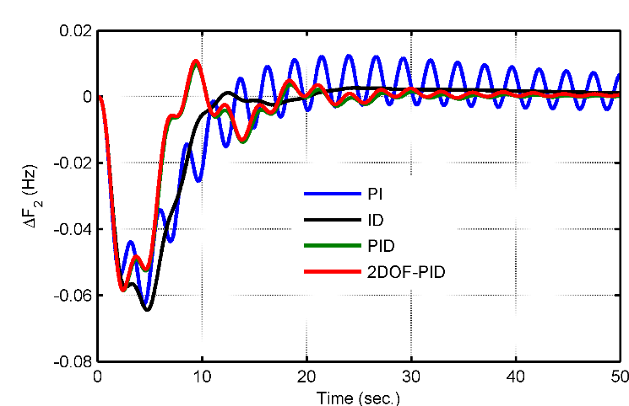
(b)
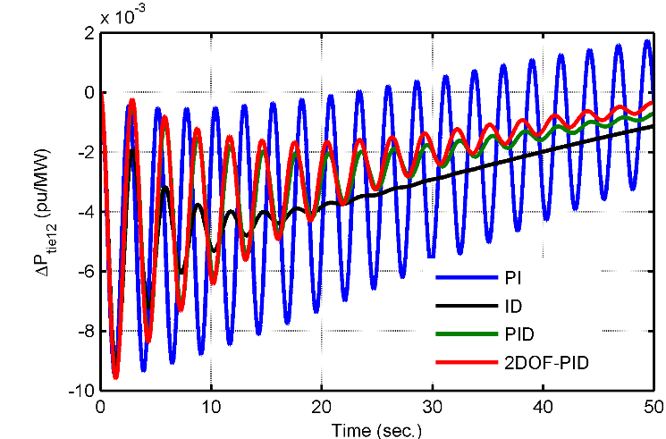
(c)
Figure 3 (a-c). LFC outcomes for 1% load alteration in area-1

The look of outcomes shows that ITAE value obtained via 2DOF-PID (4.795867) is very less in comparison to PID (4.962033), ID (7.195234) & PI (10.85805) and it further shows the financial aspects of implementation of LFC. The graphical outcomes appeared in Figure 3 (a-c).
It is observed that performance of 2DOF-PID and PID is almost comparable in terms of overshoot, settling time and getting back to reference value when optimized through BFO-PSO.
Though, the obtained ITAE is lesser for 2DOF-PID in comparison to PID when both are calculated through BFO-PSO. On the other side, the LFC outcomes obtained via ID for frequency and tie-power are free from oscillations yet the overshoot is of higher magnitude.
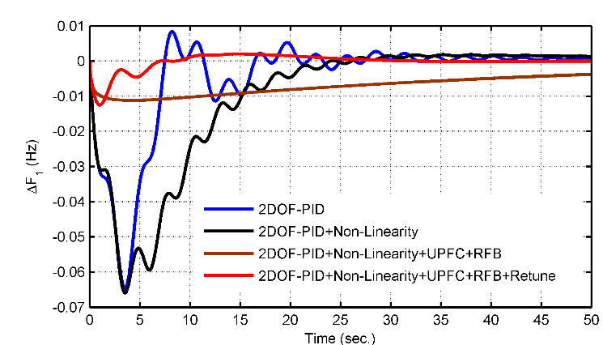
(a)
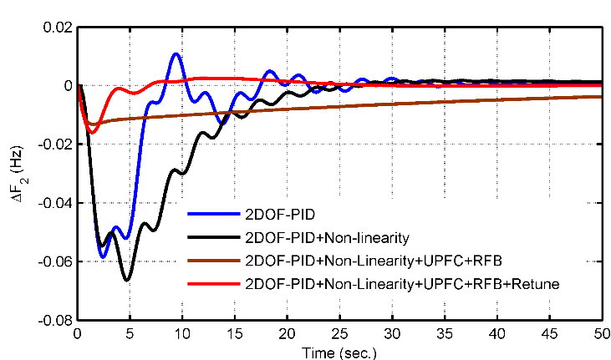
(b)
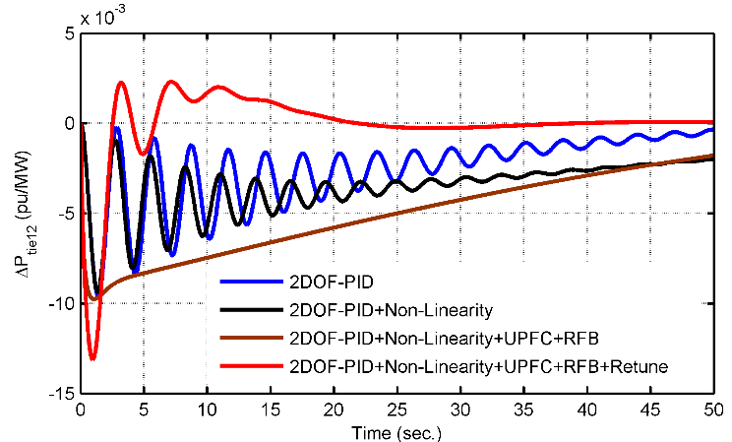
(c)
Figure 4 (a-c). LFC outcomes for 1% load alteration in zone-1 i.e. in view of dead-band and GRC

The LFC outcomes offered by PI is worst considering all aspects of LFC under similar operating conditions. Though, the LFC actions need further enhancement and therefore the RFB is added to the model at terminal-2 and UPFC align with tie-line and 2DOF-PID is design again through BFO-PSO for hydro governing system. The outcome of 2DOF-PID is assessed with regards to ITAE and matched with 2DOF-PID+UPFC+RFB and with parameters reevaluated i.e. 2DOF-PID+UPFC+RFB+Retune.
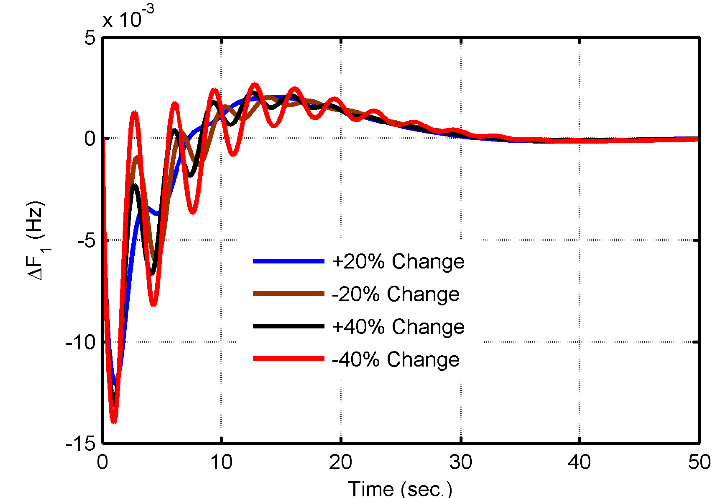
(a)
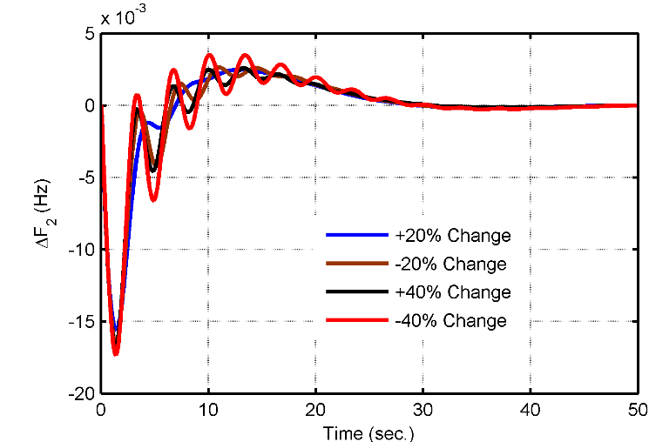
(b)
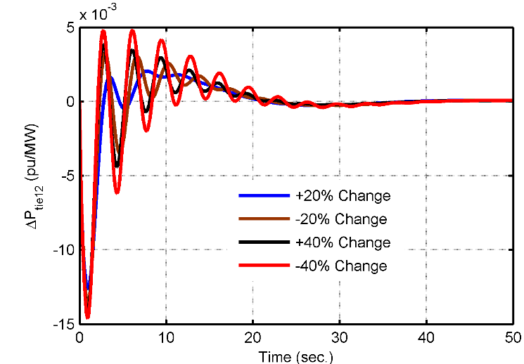
(c)
Figure 5 (a-c). LFC outcomes for parametric alteration from original values JAYA-2DOF-PID with UPFC-RFB including dead-band and GRC

The outcomes are listed in Table 2 and it is observed that there is an increase in value of ITAE (12.49768) with incorporation of UPFC and RFB with regard to no UPFC and RFB with 2DOF-PID (ITAE: 4.795867) for hydro governing framework. It is also observed that there is a further reduction in ITAE (0.947843) when all parameters are recalculated via JAYA for 2DOF-PID+UPFC+RFB even when LFC non-linearity are included in hydro governing framework.
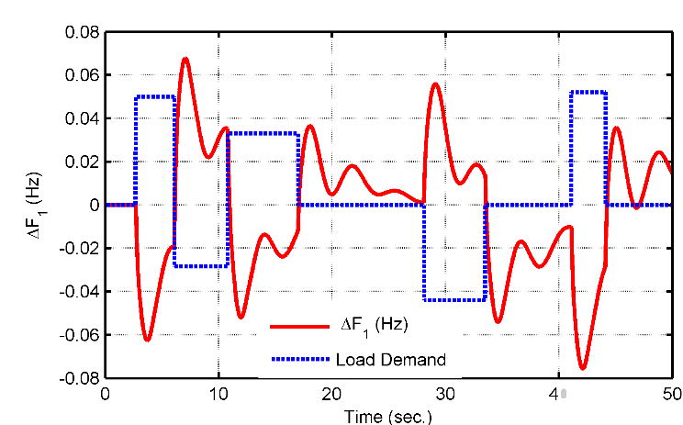
(a)
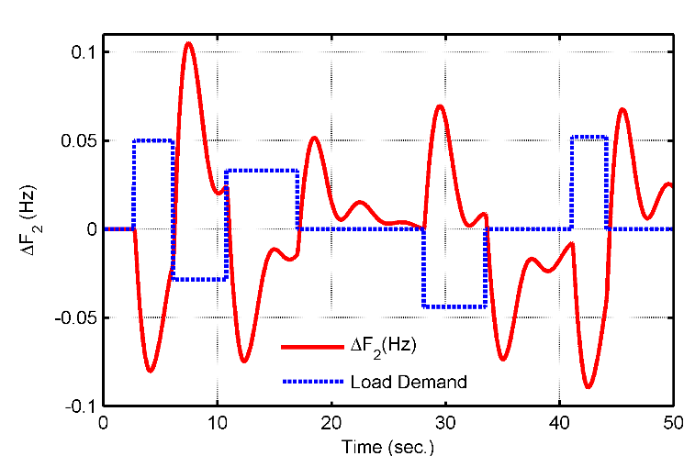
(b)
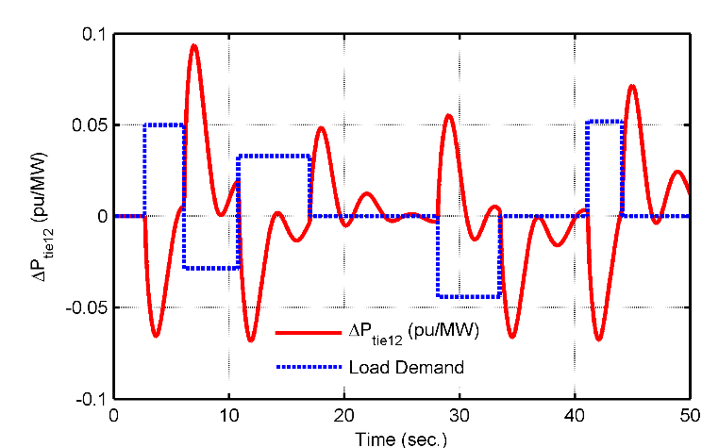
(c)
Figure 6 (a-c). LFC outcomes for random load pattern in zone-1 with JAYA-2DOF-PID through UPFC-RFB including dead-band and GRC

The same effect is also observed in LFC outcomes of Figures 4 (a-c) and it is clearly watched that there is a significant difference in LFC outcomes of 2DOF-PID with and without LFC non-linearity’s. The incorporation of UPFC and RFB has improved the LFC outcomes to a great extent even when non-linearity is present. Finally, there is a further improvement including lowest first peak, enhanced settling to reference value and oscillation free LFC outcomes in case all parameters of 2DOF-PID are recalculated via JAYA with UPFC and RFB.
Besides, the affectability examination of the JAYA optimized 2DOF-PID control in extension is evaluated by changing some model parameters i.e. T₁₂ (tie-line synchronizing coefficient), and Tg (governor-time-constant) ± 20% and ± 40% from typical values. The graphical results are shown up in Figure 5 (a-c).
The picks up and error values are specified in Table 3. From the outcomes generally wrapped up, it is observed that the JAYA optimized 2DOF-PID with UPFC-RFB offers intellect blowing execution in case of parametric combinations and scarcely any alter is taken note insides the eager reactions of the considered control system.
It in expansion taken note that the hydro-hydro plant parameters wrapped up through -20% and -40% from standard values comes around in higher ITAE respect. Still, the framework comes about are well inside considered limits and can be recognized for such kind of hydro control framework.
The considered show up in expansion is assessed for unpredictable load plan over a period of 50 seconds and the calculated parameters as well as ITAE is recorded in Table 4 with graphical LFC comes about in Figures 6 (a-c). It is appreciated that 2DOF-PID effectively calculated via JAYA with UPFC and RFB is perfect in following the random load demand and quenching the frequency and tie-power deviations effectively to zero value. Hence, after complete investigations it is comprehended that JAYA optimized 2DOF-PID action with UPFC and RFB is direct and effective to meet the diverse operating conditions of hydro governing framework.

- CONCLUSION
The present efforts are to propose 2DOF-PID successfully optimized through the JAYA optimization calculation for LFC having interlinked hydro directing system. The 2DOF-PID orchestrate is endeavored for 1% load adjustment in area-1 and appears up the dominance of JAYA enhanced 2DOF-PID over other LFC exercises. The conclusions is:
- The proper selection of error value is quite important while designing the LFC actions for hydro governing framework. It is observed that ITAE is one of the precise and accurate error definition to consider while designing LFC action in comparison to ITSE, IAE and ISE.
- The 2DOF-PID effectively optimized through JAYA is good enough to meet the LFC standards of hydro governing framework even in presence of LFC non-linearity’s. Still, it needs further improvement in order to have better LFC action for such systems.
- The UPFC linking in course of activity with tie-line seeing RFB in region-2 with JAYA augmented 2DOF-PID has well secured the deviations in a hydro governing system in reality in closeness of dead-band and GRC and moves forward the LFC results to an incredible degree. The reduction in ITAE gotten through JAYA optimized 2DOF-PID with UPFC and RFB appears up the taken a toll with reasonable arrange.
- The changing system parametric values and variable load plan in expansion surveyed for JAYA improved 2DOF-PID through UPFC-RFB in view of dead-band and GRC. The examinations uncover that the JAYA optimized 2DOF-PID with joint efforts from UPFC and RFB is effective, clear and able to minimize the large system frequency and tie-power deviations in interlinked hydro governing system.

REFERENCES
- Sharma, G., Nasiruddin, I., Niazi, K. R., and Bansal, R. C., “Adaptive fuzzy critic based control design for AGC of power system connected via AC/DC tie-lines”, IET-Generation Transmission and Distribution, vol. 11, no. 2, pp. 560-569, 2017.
- Sharma, G., Nasiruddin, I., Niazi, K. R., and Bansal, R. C., “Robust automatic generation control regulators for a two-area power system interconnected via AC/DC tie-lines considering new structures of matrix Q”, IET-Generation Transmission and Distribution, vol. 10, no. 14, pp. 3570-3579, 2016.
- Sharma, G., Krishnan, N., Arya, Y., and Panwar, A., “Impact of ultracapacitor and redox flow battery with JAYA optimization for frequency stabilization in linked photovoltaic‐thermal system”, Int. Trans. On Electrical Energy Systems, vol. 31, no. 5, e12883, 2021.
- Arya, Y., Dahiya, P., Celik, E., Sharma, G., Gozde, H., and Nasiruddin, I., “AGC performance amelioration in multi-area interconnected thermal and thermal-hydro-gas power systems using a novel controller”, Engineering Science and Technology, an International Journal, vol. 24, no. 2, pp. 384-396, 2021.
- Ibraheem, Niazi, K. R., and Sharma, G., “Study on dynamic participation of wind turbines in AGC of power system,” Electric Power Comp. and Syst., vol. 43, no. 1, pp. 44-55, 2014.
- Sharma, G., Ibraheem, and Niazi, K. R., “Optimal AGC of asynchronous power systems using output feedback control strategy with dynamic participation of wind turbines”, Electric Power Component and Systems, vol. 43, no. 4, pp. 384-398, 2015.
- Mohamed, T. H., Bevrani, H., Hassan, A. A., and Hiyama, T, “Decentralized model predictive based load frequency control in an interconnected power system”, Energy Conv. and Manag., vol. 52, pp.1208-1214, 2011.
- Arya, Y., “Effect of energy storage systems on automatic generation control of interconnected traditional and restructured energy systems”, Int. Journal of Energy Res., vol. 43, no. 12, pp. 6475-6493, 2019.
- Bevrani, H., and Hiyama, T., “Intelligent automatic generation control”, CRC Press; 2011.
- Safari, A., Babaei, F., and Farrokhifar, M., “A load frequency control using a PSO-based ANN for micro-grids in the presence of electric vehicles”, Int. Journal of Ambient Energy, pp. 1-13, 2019.
- Arya, Y., “Impact of hydrogen aqua electrolyzer-fuel cell units on automatic generation control of power systems with a new optimal fuzzy TIDF-II controller”, Renewable Energy, vol. 139, pp. 468-482, 2019.
- Demiroren, A., Sengor, N. S., and Zeynelgil, H., “Automatic generation control by using ANN technique”, Electric Power Components and Systs., vol. 29, no. 10, pp. 883-896, 2001.
- Abdel Magid, Y. L., and Dawoud, M. M., “Optimal AGC tuning with genetic algorithms”, Elect. Power Syst. Res., vol. 38, no. 3, pp. 231-238, 1996.
- Rerkpreedapong, D., Hasanovic, A., and Feliachi, A., “Robust load frequency control using genetic algorithms and linear matrix inequalities”, IEEE Trans. Power Syst., vol. 18, no. 2, pp. 855-861, 2003.
- Passino, K. M., “Biomimicry of bacterial foraging for distributed optimization and control”, IEEE Control Syst. Mag., vol. 22, no. 3, pp. 52-67, 2002.
- Nanda, J., Mishra, S., and Saikia, L. C., “Maiden application of bacterial foraging based optimization technique in multi-area automatic generation control”, IEEE Trans. Power Syst., vol. 24, pp. 602-609, 2009.
- Ali, E. S., and Abd-Elazim, S. M., “Bacteria foraging optimization algorithm based load frequency controller for interconnected power system”, Int. Journal of Elect. Power & Energy Syst., vol. 33, pp. 633-638, 2011.
- Panda, S., Mohanty, B., and Hota, P. K., “Hybrid BFOA-PSO algorithm for automatic generation control of linear and non-linear interconnected power systems”, Appl. Soft Comput., vol. 13, no. 12, pp. 4718-4730, 2013.
- Venkata Rao R., “Jaya: A simple and new optimization algorithm for solving constrained and unconstrained optimization problems”, Int. Journal of Industrial Engg. Computation, vol. 7, pp. 19-34, 2016.
- Sahu, R. K., Gorripotu, T. S., and Panda, S., “A hybrid DE-PS algorithm for load frequency control under deregulated power system with UPFC and RFB”, Ain Shams Engg., Journal, vol. 6, pp. 893-911, 2015.
- Francis, R., and Chidambaram, I. A., “Optimized PI+ load frequency controller using BWNN approach for an interconnected reheat power system with RFB and hydrogen electrolyser units”, Int. Journal of Elect. Power & Energy Syst., vol. 67, pp. 381-392, 2015.

BIOGRAPHIES OF AUTHORS
 | Mr. Avinash Panwar is presently working towards his Ph.D. at Department of Electrical Engineering, School of Engineering and Technology, SANGAM University, India. He has more than 11 years of teaching and research experience. He has the qualifications of B.E., M. Tech from Institute of Technology & Management (Bhilwara), Shri BalaJi college of Engineering and Technology, (Jaipur), India respectively. He has published a number of research papers in international conferences of high repute. His area of interest includes power system operation and control, renewable energy technology and applied soft computing.
 | Prof. Vinesh Agarwal is presently working as Associate Professor in Department of Electrical Engineering, School of Engineering and Technology, SANGAM University, India. He has more than 18 years of teaching and industrial experience. He has the qualifications of B.E., M. Tech and Ph.D. from recognised institution of India. He has published a number of research papers in international journals and conferences of high repute and has been continuously engaged in guiding research activities at graduate/post-graduate and Ph.D. levels. His area of interest includes Renewable Energy and Conventional Power Systems which includes Wind, PV, Hybrid Power Systems, Distributed Generation, Grid Integration of Renewable Energy, FACTS, Power System, and Power Electronics and Smart Grid.
 | Dr. Gulshan Sharma is presently working as Senior Lecturer, DRC Chair and Deputy Director of RTPS center in Department of Electrical Power Engineering, Durban University of Technology, Durban, South Africa. He has more than 12 years of teaching and research experience. He has the qualifications of B. Tech, M. Tech and Ph.D. from Punjab Technical University (Punjab), Jamia Millia Islamia University (New Delhi) and Malaviya National Institute of Technology (Jaipur), India. He was a Post Doctoral research fellow at Faculty of EBIT, University of Pretoria, South Africa from 2015 to 2016. He is also working as Associate Editor of International Transactions on Electrical Energy System Wiley & Regional Editor of Recent Advances in E & EE, Bentham Science. He is a rated researcher from NRF South Africa. He has published a number of research papers in international journals and conferences of high repute and has been continuously engaged in guiding research activities at graduate/post-graduate and Ph.D. levels. His area of interest includes power system operation and control, renewable power generation and integration, smartgrid, electric vehicles, FACTS and application of AI techniques to the power systems.
 | NARAYANAN. K received his B.E. in Electrical and Electronics engineering from Anna University, Chennai in 2008 and M. Tech in Power Systems in 2010 and Ph.D. degree in Electrical Engineering in 2016 from Malaviya National Institute of Technology, Jaipur (Rajasthan), India. Presently he is working as Assistant Professor in SASTRA Deemed University, Thanjavur, India. He is a Senior Member of IEEE Power and Energy Society, life member of Indian Society of Systems for Science & Engineering (ISSE). He is currently acting as a reviewer for various journals of international repute. His areas of research interests are power system planning and operation.

