Variable Speed Induction Motor Drive Based on Modular Multilevel Converter with Ripple Power Decoupling Channels

Enaam Abdul-Khaliq Ali¹, Turki K. Hassan²
¹ Department of Electrical Engineering, College of Engineering. Baghdad University, Baghdad, Iraq.
² Department of Electrical Engineering, College of Engineering. Mustansiriyah University, Baghdad, Iraq.

Article Info |  | ABSTRACT
Article history:  Received month dd, yyyy  Revised month dd, yyyy  Accepted month dd, yyyy |  | A driving system for a three-phase variable-speed induction machine-based modular multilevel converter (MMC) with high-frequency magnetic canals connecting neighbouring-arm submodules is displayed in this paper. High voltage ripple generated by submodule capacitors at low speeds with constant torque is the primary disadvantage of using MMC in variable-speed motors. The DHB modules are utilized as energy canals in this study, enabling energy to be exchanged between the SM capacitors to correct the power imbalance. The ripple power of adjacent-arm SMs may be fully decoupled, outcomes a virtually fluctuation-free SM capacitor voltage profile. Thus, regardless of operating frequency, the typical MMC issue of large voltage fluctuation between SM capacitors has been completely addressed. The design and analysis of Field Oriented Control (FOC) of induction motors is based on an algorithm that ensures the motor's efficiency across a broad speed range. In this paper, we achieved a very small ripple in the capacitive voltage for some frequencies (50Hz, 25Hz, 10Hz, 5Hz) by (±0.25%) compared with the previous papers that achieved a reduction in ripple within (±5%), and also this system was compared with the traditional system. The operating principle was presented analytically and verified using Matlab Simulink.
Keywords:
Modular multilevel converter
Field-Oriented Control (FOC)
Dual Half-Bridge (DHB)
Induction Motor drive system

This is an open access article under the CC BY-SA license.

Corresponding Author:
Enaam Abdul-Khaliq Ali
Department of Electrical Engineering, College of Engineering. Baghdad University, Baghdad, Iraq
Email: enaamalimsc2009@yahoo.com

- INTRODUCTION
MMCs, are attracting significant interest in a large number of fields of high power applications due to their scalability, flexibility, and controllability. Examples include high voltage direct current transmission (HVDC), high voltage dc/dc transformers, grid-connected inverters, and medium voltage motor drives (MVMD) [1-11].
The major issue with traditional MMC for variable speed drives is the high sub-module fluctuation in capacitor voltage, particularly at lower speeds. The peak-to-peak capacitor voltage ripple is proportional to the load current amplitude and inversely proportional to the supply frequency. The high voltage ripple raises the switches' voltage rating [12-15]. Several solutions for dealing with capacitive voltage ripple of SM in variable speed drive systems have been presented in various researches. At present, the commonly used method of suppressing capacitor voltage fluctuation is to insert high-frequency common-mode voltage and bridge arm circulating current into the MMC [16], but the insertion of common-mode voltage will cause damage to the motor. The damage to the edge and the bearing, and the injected high-frequency circulating current will increase the capacity and loss of the converter. SM condenser voltage-ripple suppression from many viewpoints was studied. The control methods in [17], were adopted to develop the SM capacitor voltage-ripple profile, a hybrid MMC architecture that integrates a conventional MMC with a dc-link sequence switch. As a consequence, the ripple in capacitor voltage is reduced, especially at low motor speeds. To solve the power imbalance issue between the MMC arms, several changes to the fundamental MMC structure have been proposed. A back-to-back MMC to reduce voltage ripple in the capacitor, instead of a dc voltage source, the grid-side MMC produces a current source at its output. A three-phase induction motor is driven using this current source as an input to the motor-side MMC. Due to the current source, the voltage-ripple of the SM capacitor is seen to remain constant until extremely low frequency [18 -20]. Also, other researchers suggested a back-back hybrid MMC that is applied to four-quadrant motor drive applications, retaining the benefits of hybrid MMC in terms of decreased capacitor voltage ripple at zero motor speeds while avoiding the use of massive filters at the DC connection [21].
This paper uses a modular multilevel converter (MMC) with high-frequency magnetic canals to link neighboring-arm submodules (SMs). The design uses DHB chains to connect neighboring SMs of three-phase identical arms. The DHB modules act as energy conduits, allowing power interchange between SM capacitors. The bidirectional energy transmission between neighboring-arm SMs decouples the arms' ripple power, outcome near-linear SM voltage profile of a capacitor. Thus, regardless of operation frequency, the MMC's frequent issue of large voltage fluctuation between SM capacitors is fully addressed. [22], and the induction motor can be operated at low speed and full load.
The suggested Modular Multilevel Converter with Dual Half Bridge (MMC-DHB), for ripple power decoupling drive system arrangement, is outlined in section 2. Algorithms for drive systems are discussed in section 3. System simulation is illustrated in part 4, and the results are obtained and discussed in part 5.

- MMC-DHB Drive System Configuration:
The proposed system configuration is shown in Figure (1). of the MMC-DHB motor drive for a three-phase induction motor, MMC has two arms, upper and lower, linked by buffering inductors. Every arm is made up of N half-bridge SMs, every with a dc capacitor and two insulated gate bipolar transistors (IGBTs). [23].

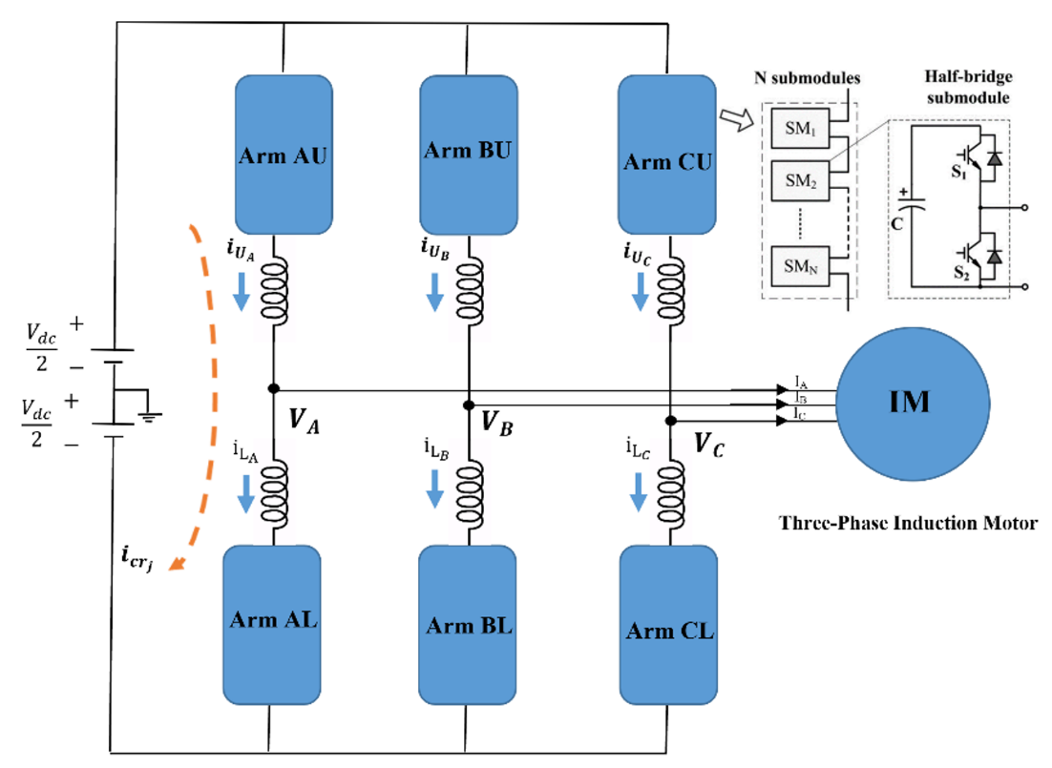

Figure 1. Drive system configuration.

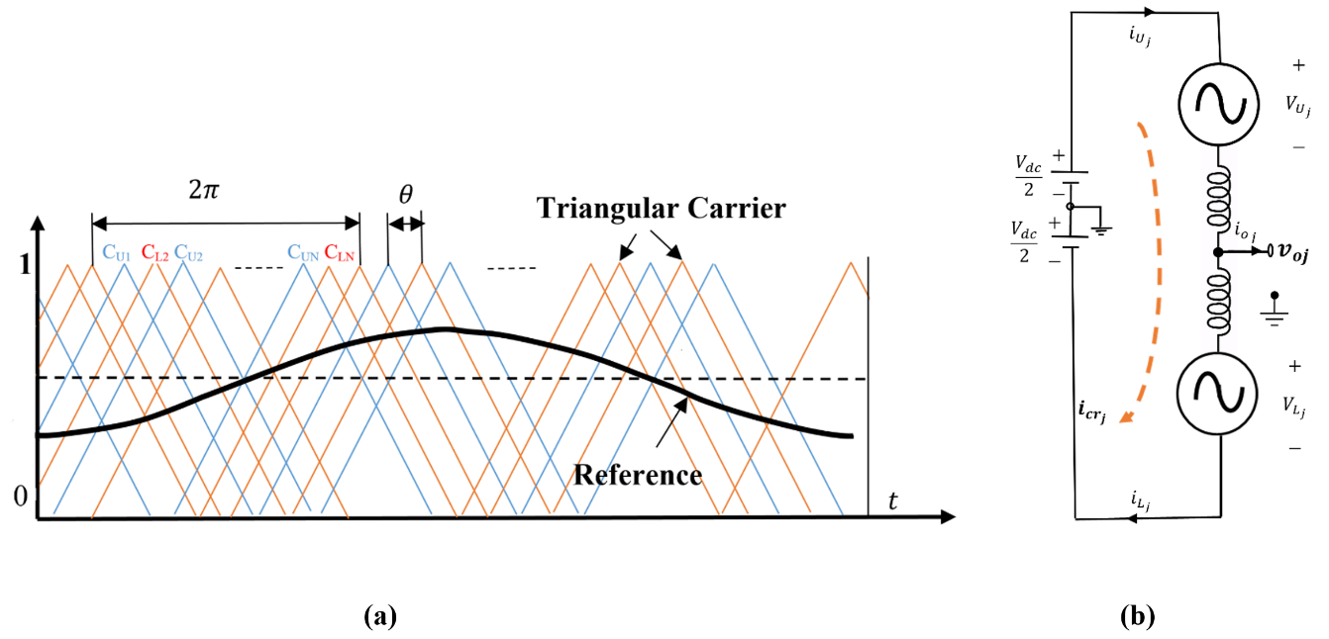

Figure 2. (a) phase-shifted carrier (PSC) modulation, (b) One phase equivalent circuit of MMC.

To provide the best harmonic cancellation properties, the N triangular carriers of each arm are gradually shifted by 2π /N. As a result, the phase angles θ_{L} (i) and θ_{U} (i) of the i^{th} carrier C_{Li} and C_{Ui} in the lower and upper arms may be calculated using the following formula:

$θ_{L}(i)=\frac{2π}{N}×\left(i-1\right)$ (1)

$θ_{U}(i)=θ+\frac{2π}{N}×(i-1)$ (2)

The angle of displacement between the upper and lower carriers is denoted as θ. It's important to note that has a considerable influence on MMC's harmonic characteristics [23].
From the equivalent circuit diagram of one phase of MMC, as illustrated in figure (2-b), is utilized for analysis, the output voltage and current are denoted by symbols 𝑣_{𝑜j} and $i_{oj}$describes as in equations below:

$v_{o_{j}}$ = 𝑉_{𝑜} cos (𝜔𝑡 + $θ_{j}$) (3)

$i_{o_{j}}$ = 𝐼_{𝑜} cos (𝜔𝑡 + $θ_{j}$ − 𝜑) (4)

Where j {A, B, C}, V_{o} and I_{o} are the amount of voltage and current, respectively, 𝜔 is the angular frequency of the output, 𝜃_{𝑗} is the stator voltage's phase angle (𝜃_{A}=0⁰, 𝜃_{B}=120⁰, and 𝜃_{C}=240⁰), and φ, where is the power factor of the load.
The amount of the ac output voltage is as follows:

$V_{o}=\frac{1}{2}MV_{dc}$ (5)

$M=\frac{ω_{o}}{ω_{rated}}$ (6)

Where M denoted the modulation index, while V_{dc} input voltage source.
The arming voltage and current of the MMC and the j-phase current (dc component current or circulating current) are described in the following equations [22]:

${V_{U}}_{j}$ = $\frac{1}{2}$ $V_{dc}$ – $v_{j_{o}}$ (7)

$V_{L_{j}}$ = $\frac{1}{2}$ 𝑉_{𝑑𝑐} + $v_{j_{o}}$ (8)

$i_{U_{j}}$= $i_{{cr}_{j}}$ + $\frac{1}{2}$ $i_{o_{j}}$ (9)

$i_{L_{j}}$ = $i_{{cr}_{j}}$− $\frac{1}{2}$ $i_{o_{j}}$ (10)

$i_{{cr}_{j}}=\frac{i_{U_{j}}+i_{L_{j}}}{2}$ (11)

The circulating current ( $i_{{cr}_{j}}$) can be considered as a dc For even-order harmonic elimination control, which is:

$i_{{cr}_{j}}=\frac{1}{3} I_{dc}=\frac{MI_{o \cos{φ}}}{4}$ (12)

The capacitor voltage fluctuation contains each of the CM and DM items alternating at $ω_{t} and 2ω_{t}$ because of the dual-frequency variation of the typical MMC arm energy as seen in equations (13) and (14) [22]:

$∆v_{C_{Uj}}=-\frac{∆V_{C_{cm}}}{2} \sin\left[2\left(ω_{t}+θ_{j})-φ\right)\right]+\frac{∆V_{C_{dm}}}{2} \sin\left(ω_{t}+θ_{j}-φ\right)$ (13)

$∆V_{C_{Lj}}=-\frac{∆v_{C_{cm}}}{2} \sin\left[2\left(ω_{t}+θ_{j})-φ\right)\right]-\frac{∆v_{C_{dm}}}{2} \sin\left(ω_{t}+θ_{j}-φ\right)$ (14)

Where ∆$v_{C}$ defines the capacitor voltage variation and $∆V_{C}$ defines the SM ripple's in capacitor voltage absolute peak-to-peak fluctuation, respectively. The magnitudes of the peak-to-peak capacitor voltage-ripple due to CM and DM components are shown below [24] [25]:

$∆V_{C_{cm}}=\frac{I_{o}M}{8ωC}$ (15)

$∆V_{C_{dm}}=\frac{I_{o}}{4ωC}\sqrt{4+\cos^{2}\left(φ\right)\left(M^{4}-4M^{2}\right)}$ (16)

The fluctuation of capacitor voltage produces by two components CM and DM. The fluctuation in capacitor voltage was very little affected by the CM component that appears only when the load current increase regardless of operating frequency, but the DM item has a significant effect on ripple which increased dramatically with reducing the frequency of operation and increasing the current output.
A proposed MMC-DHB configuration, shown in Figure (3), Allows the transfer of the ripple force from one SM with extra capacitive power stored to another SMs in a closed magnetic ring, to insufficient power supply over there, redistributes the capacitive energy that has been stored across all three SMs of the adjacent arm.
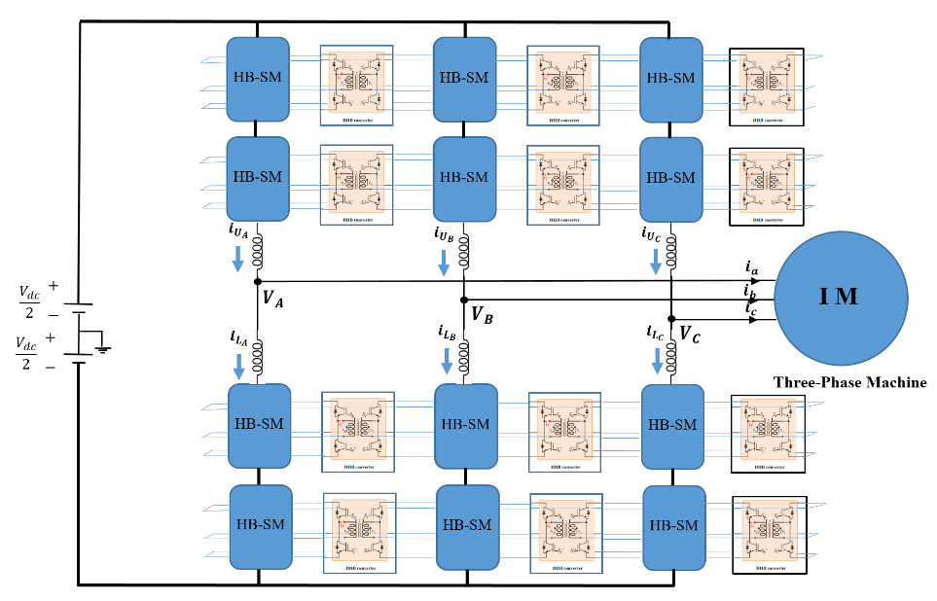

Figure 3. MMC-DHB drive system configuration [22].

- Control System for MMC-DHB Drive in Various Speed
  - MMC Control
    - Averaging Capacitor Voltage Control
The schematic diagram of a complete leg (phase) averaging shown in figure (4) capacitor voltage control, consists of two loops, in the first loop the upper and lower arm's estimated capacitor voltages as illustrated in equation (17):

$V_{C_{jav}}=\frac{1}{2N} \sum_{k=1}^{N}{\left[V_{C_{U_{jk}}}+V_{C_{L_{jk}}}\right]}$ (17)

Subtracting from the reference capacitor voltage and the error handling via the proportional-integral (PI) controller to result in a reference current $i_{{cr}_{j}}^{*}$the circulating current calculated in equation (11) is forced to follow the reference current $i_{{cr}_{j}}^{*}$and fed to another PI controller in the second loop to generate an average voltage $V_{{dc}_{s}}$ as shown in equations below [25][26]:

$i_{cr}^{*}=k_{1}\left(V_{C}^{*}-V_{C_{jav}}\right)+k_{2}\int{\left(V_{C}^{*}-V_{C_{jav}}\right)}dt$ (18)

$V_{{dc}_{s}}=k_{3}\left(i_{{cr}_{j}}-i_{{cr}_{j}}^{*}\right)+k_{4}\int{\left(i_{{cr}_{j}}-i_{{cr}_{j}}^{*}\right)}dt$ (19)

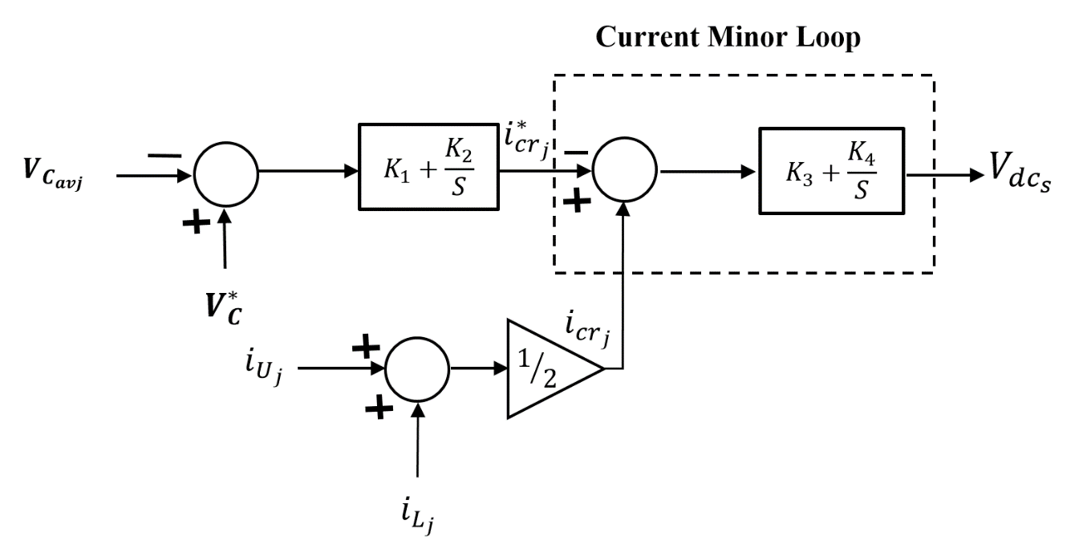

Figure 4. Schematic diagram of SM capacitor voltage averaging controller.

3.1.2. Balancing Controller of Capacitor Voltages
Arm and individual balancing capacitor control are characteristics of this kind of control The proportional controller of gain $k_{5}$ balances the average capacitor voltages of the upper and lower arms of MMC ($V_{{CU}_{j}}^{av}and V_{{CL}_{j}}^{av}$ ) respectively as shown in figure (5-a). A voltage reference is produced for each SM by the arm balancing controller as illustrated in the equation below [25] [26]:

$V_{j_{arm}}=k_{5}\left(V_{{CU}_{j}}^{av}-V_{{CL}_{j}}^{av}\right)$ (20)

The difference between each arm's average capacitor voltage ($V_{{CU}_{j}}^{av}or V_{{CL}_{j}}^{av}$ ) and its SM capacitor voltage ($V_{C_{U_{jk}}} or V_{C_{L_{jk}}}$ ) is used to organized the capacitor voltage of every SM of each arm. The reference signals for each upper or lower SM is obtained as shown in figure (5-b). Proportional gains ( $K_{6} and k_{7 })$, are used to generate extra dc voltage references for every SM, as shown in equations (21) and (22) [27].

$V_{{dc}_{jUk}}=K_{6}(V_{{CU}_{j}}^{av}-V_{C_{U_{jk}}})$ (21)

$V_{{dc}_{jLk}}=k_{7}(V_{{CL}_{j}}^{av}-V_{C_{L_{jk}}})$ (22)

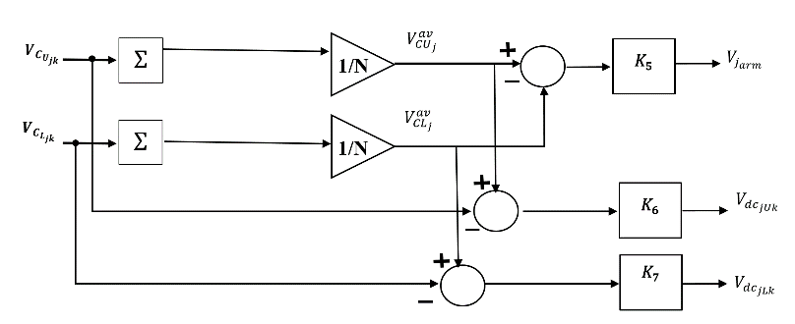
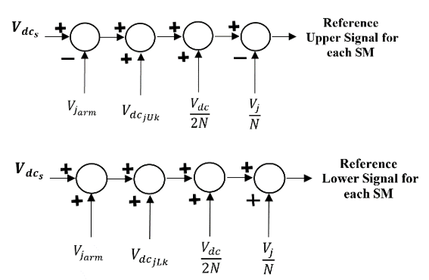

- (b)

Figure 5. MMC capacitor voltage balancing controllers, (a) Arm & Individual SM balancing controller, (b) Reference signal for each SM arm (upper& lower).

  - The DHB Modules' Control
The DHB converter is utilized as a dc-dc energy-exchange unit that achieves energy rebalancing for MMC SMs. The DHB converter is composed of a pair of voltage-fed HB inverters connected through an HF transformer. The transformer turns ratio is unity since the dc-dc conversion is only used for energy balancing between bridge sides at the same voltage level. DHB components are employed to achieve some operational characteristics, where the leakage inductance of the HF transformer is used as an energy transfer element between the dc capacitors, while the output capacitance of switching devices is used to achieve soft-switching operation. the circuit diagram for one of the magnetic chains linking adjacent-arm SMs, shown in figure (6).

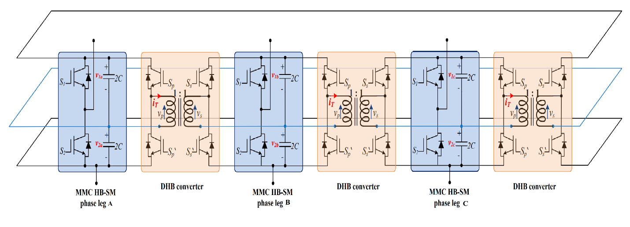
Figure 6. The circuit diagram for one of the magnetic chains linking adjacent-arm SMs [21].

Finally, the DHBs are regulated by rebalancing the stored capacitive energy between the SMs. Every DHB module contains a loop of control with a PI regulator to ensure ripple-free SM capacitor voltage. A potential difference between each pair of primary and secondary DHB capacitors is set to zero by the PI controller, which results in the desired phase angle $δ^{*}$ where used as an input to the DHB modulator. as shown in figure (7).
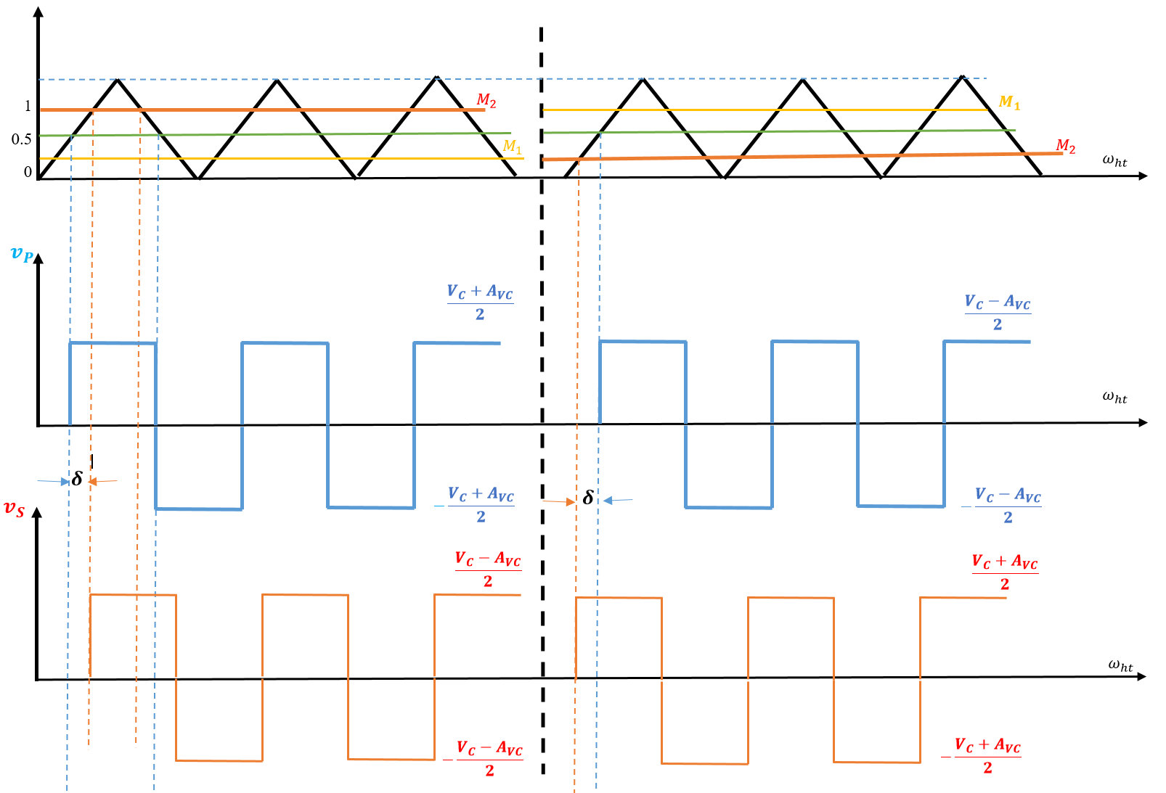

- (b)
Figure 7. Bi-directional power can be transmitted between both sides of the DHB transformers: (a) Positive Angle δ and (b) Negative Angle δ [22].

A carrier signal is compared to the DHB control modulator created signals M₁, M₂ to generate a DHB switching signal (S_{P} and S_{S}), produces square wave voltages on every side of the DHB module, displaced by the necessary angle δ as stated in equations below:

$M_{1}=D-\frac{δ}{π}$ (23)

$M_{2}=\left|1-M_{1}\right|$ (24)

The upper of two adjacent sub-model capacitors at two phases, such as SM capacitor voltages of phase A ($\sum{V_{C_{AU}}}$), subtracted from phase B ($\sum{V_{C_{BU}}}$), is the algorithm used to regulate the DHB converter. To eliminate any harmonic wave distortion, a low-pass filter (LPF) is used. For every pair of DHBs connecting the SMs of two neighboring arms, the same control loop is repeated, with six PI controllers controlling all DHB modules, as shown in figure (8) [22].

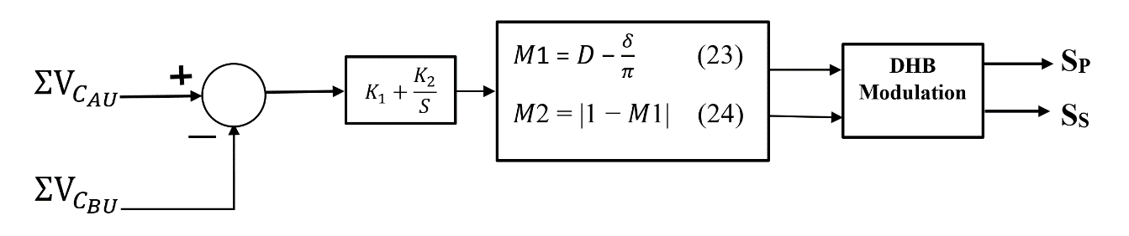

Figure 8. DHB control block diagram.

  - The (FOC) of Induction Motor
The induction motor's operating parameters are controlled using the field-oriented control (FOC) method. Figure (9) shows the schematic of the suggested MMC-DHB motor-driven system.
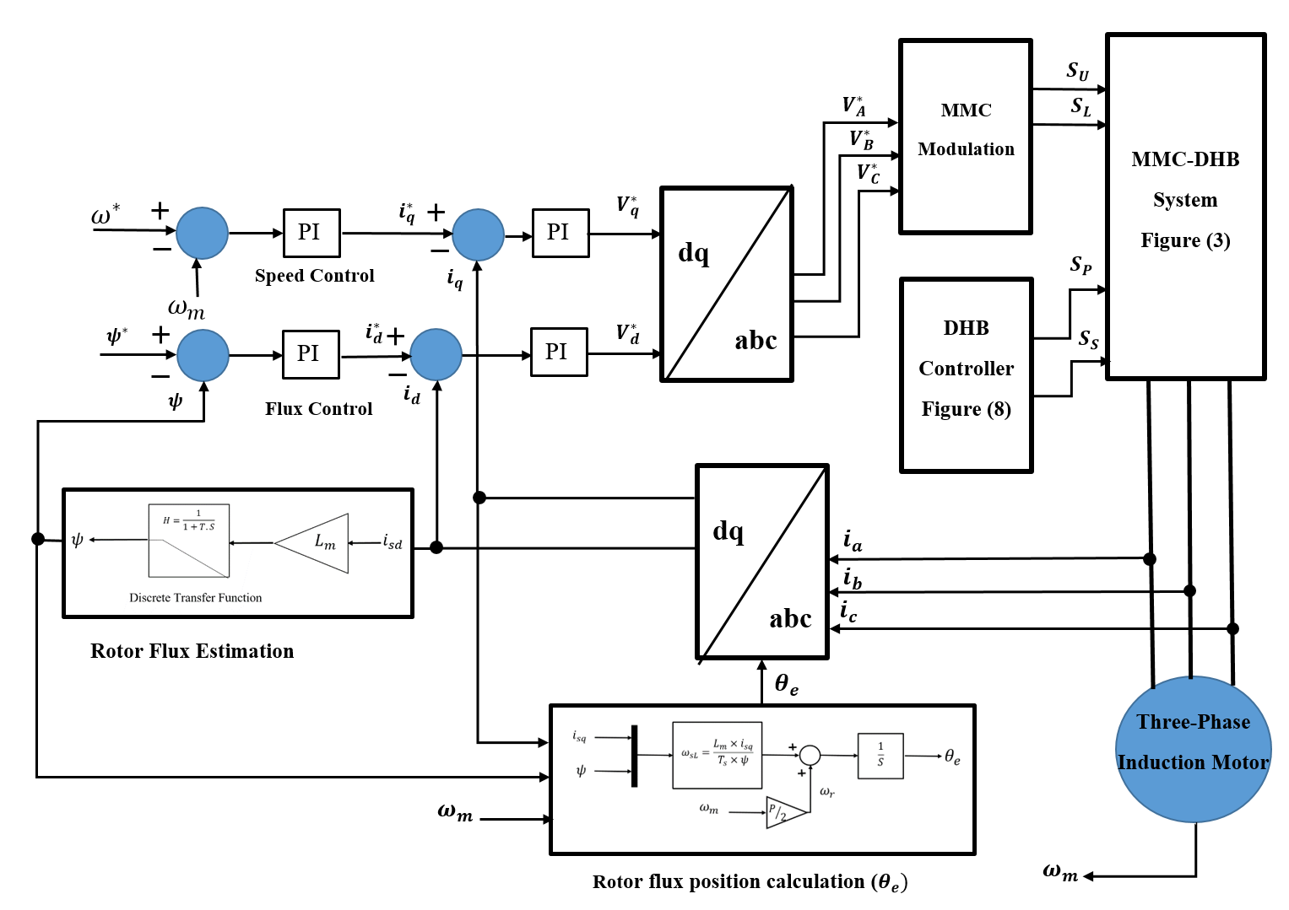
The Field Oriented Control (FOC) employs two machine loop torque and flux, which are performed in the (dq) rotating frame, the FOC method uses two motor speed and flux reference values to result in the commanded torque and flux-generating elements of the stator current ($i_{q}^{*}$ and $i_{d}^{*}$). Two separate pairs of proportional-integral (PI) controllers have been utilized to process reference current components and create two groups of reference voltage vectors ($V_{q}^{*}$ and $V_{d}^{*}$), were then utilized to construct a group of three-phase reference voltages. (${V_{A}}^{*}, {V_{B}}^{*}, and {V_{C}}^{*}$), that are applied in the MMC modulation. The control system of operation behavior of FOC is summarized in a block diagram given in figure (9), and each step is discussed in the following parts [22]:
Figure 9. Schematic diagram of MMC-DHB control system.

3.3.1 The Rotor Flux Block Estimation

According to equation (25), the rotor flux estimation block is implemented as shown in figure (10) [28-30]:

$ψ=\frac{L_{m}*i_{sd}}{1+ T_{S}}$ (25)

where $T=\frac{R_{r}}{L_{r}}$ , $L_{r}={\overline{L}}_{l_{r}}+L_{m}$.
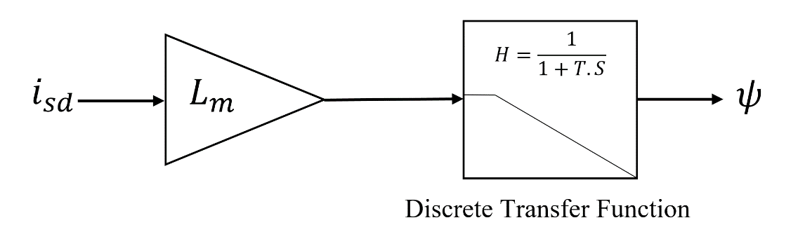

Figure (10). The Rotor flux estimation block.
3.3.2. The Rotor Flux Position
According to equation (26), the rotor block estimation is shown in figure (11) [28-30]:

$\left\{\begin{aligned}θ_{e}=\int{\left(ω_{r}+ω_{sL}\right)dt} \\ ω_{r}=\frac{p}{2}ω_{m} \\ ω_{sL}=\frac{L_{m}i_{sq}}{T_{s}ψ}\end{aligned}\right.$ (26)

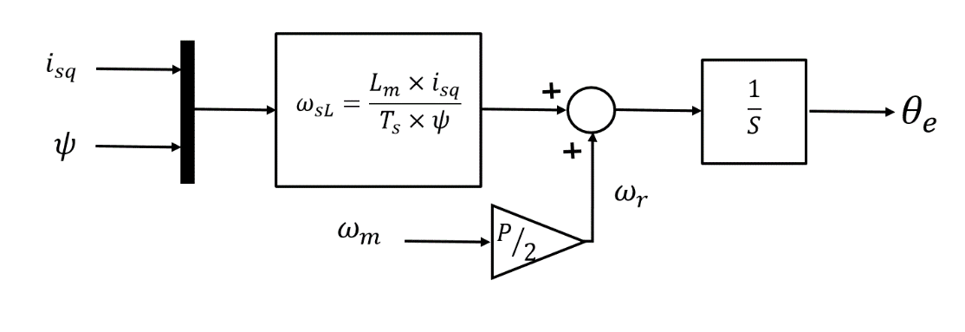

Figure 11. The rotor flux position calculation ($θ_{e})$.

- System simulation
The MATLAB / SIMULINK is used for simulation of the traditional MMC-Drive system, and the MMM-DHB drive system. Table (1) shows the parameters of the system as illustrated below:

Table 1. System Parameters for Simulation
Input dc voltage | 800V
No. of SMs in each arm | 2
SM capacitor voltage (𝑉𝑐 ) | 400V
Rated frequency (𝑓_{𝑜} ) | 50 Hz
PWM Carrier frequency (𝑓_{𝑐} ) | 5kHz
Arm inductance (𝐿_{𝑎𝑟𝑚}) | 2.4 m H
SM capacitance (C) | 2mF
DHB Parameters
Transformer turns ratio leakage inductance | 35µH
Switching frequency (𝑓ℎ) | 10kHz
Induction Motor Parameters
Induction Motor output Power | 5.4 HP
Induction Motor Line-line Voltage | 400V
No. of Poles | 4
Fundamental Frequency | 50 Hz
Rated Speed (nr) | 1430 rpm
Magnetizing Inductance (L_{m}) | 0.1722 H
Stator Resistance (R_{s}) | 1.405 Ω
Rotor Resistance (R_{r} ) | 1.395 Ω
Stator Leakage Inductance (L_{ls}) | 0.005839 H
Rotor Leakage Inductance (L_{lr}) | 0.005839 mH

- Results and Discussion
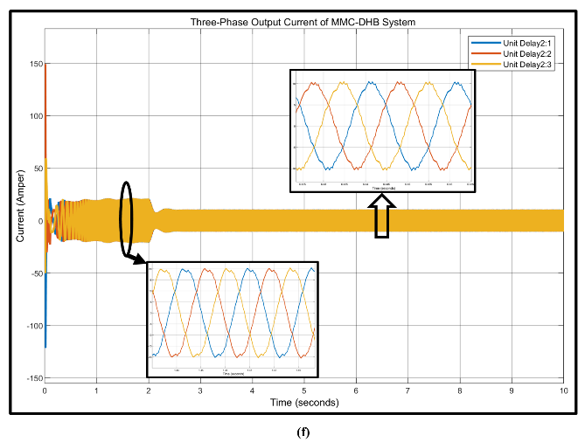
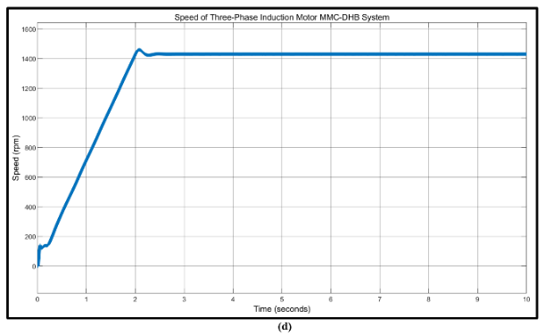
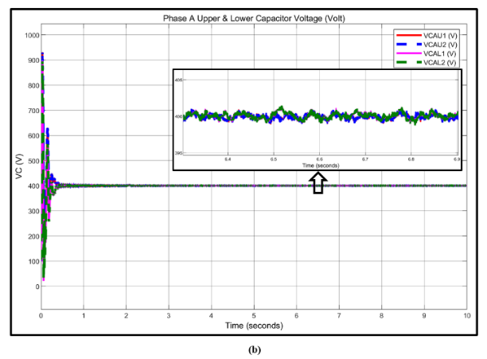
To verify the proposed conventional-MMC and MMC-DHB drive systems the Matlab Simulink has been used to implement a 5.4 hp ($≅$ 4 kW), 400V line voltage induction motor. Two separate pairs of proportional-integral (PI) controllers were used to process the reference current components and create two sets of voltage reference vectors ($V_{sq}^{*}$ and $V_{sd}^{*}$). To create a set of three-phase reference voltages, these vectors were used. Figure (12) shows the speed of (ω_{m} =1430 rpm) with load torque 100% (T_{L} = 25 N ⋅m). Phase A was chosen current ( $i_{A}$ ) is sinusoidal with a fundamental frequency, 50Hz. The cell capacitor voltages are also well regulated within around 7V for traditional MMC drive, while for DHB-MMC drive equal to 1V, at the same rated speed and current as illustrated in (a, c, e, b, d, f) respectively.
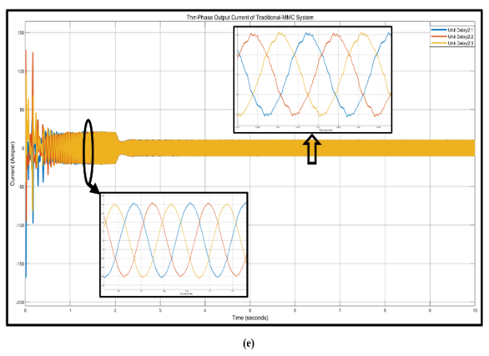
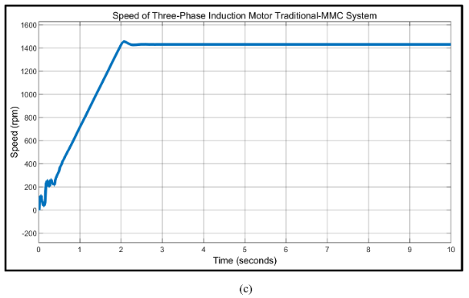
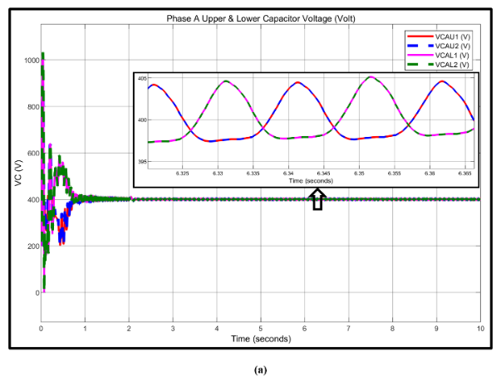
Figure 12. MMC representation at 1430 rpm where (a, c, e) represent the capacitor voltage, speed, output current for traditional MMC drive system respectively, and (d, e, f) represent the capacitor voltage, speed, output current of MMC-DHB drive system.
In figure (13) the machine operates at (ω_{m} =715 rpm) with 100% load torque (TL= 25 N.m). There is a clear reduction of ripple with the DHB energy balanced system, and the fluctuation of capacitor voltage decreases from (15 V_{P-P} to 1 V_{P-P}), and approximately sinusoidal output current are shown.

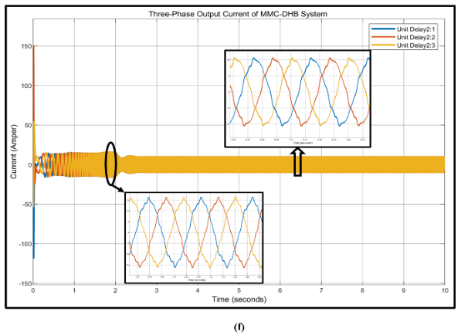
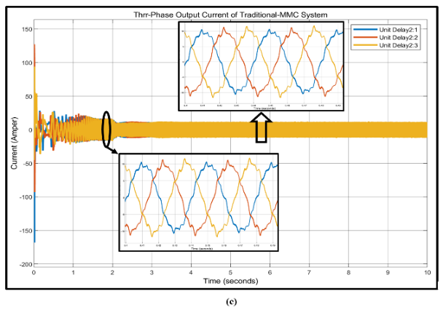
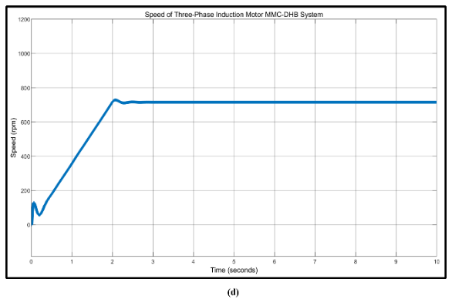
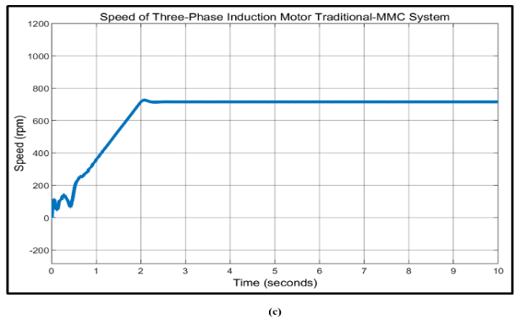
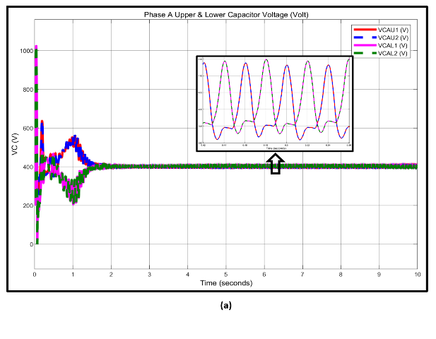
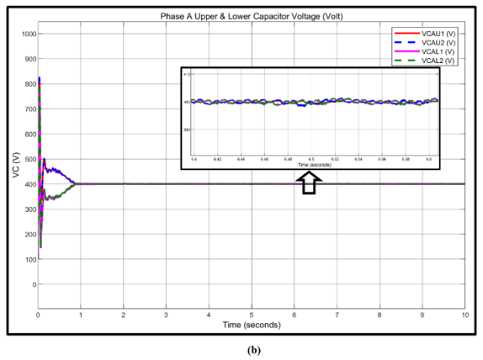
Figure 13. MMC performance at 715 rpm where (a, c, e) represent the capacitor voltage, speed, output current for traditional MMC drive system respectively, and (b, d, f) represents the capacitor voltage, speed, output current of MMC-DHB drive system.

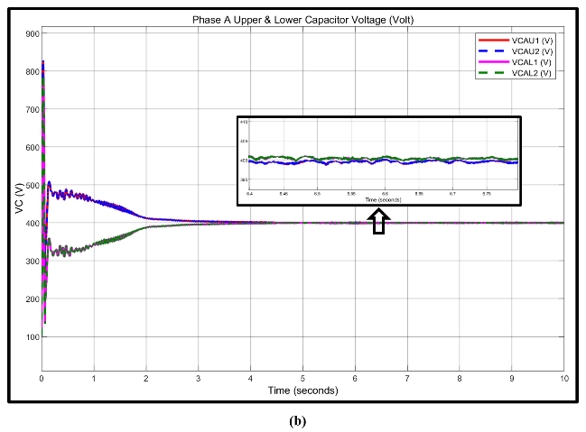
In figure (14), the machine operate at (ωm =286 rpm ) at 100% load torque (TL= 25 N.m), it offers a good indication for the capacitor voltage ripple is reduced from (40VP-P to 1 VP-P).when the DHB is employed.also the output currents are shown with better shape in MMC-DHB system
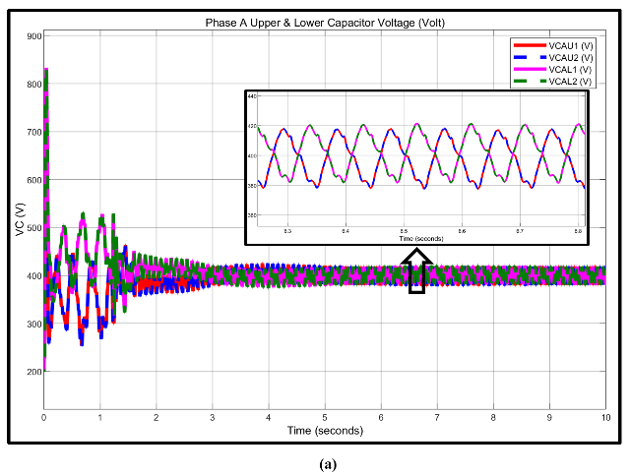
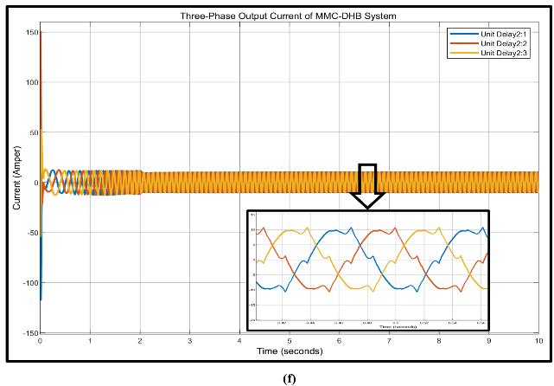
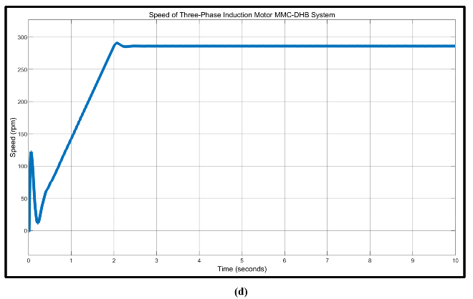
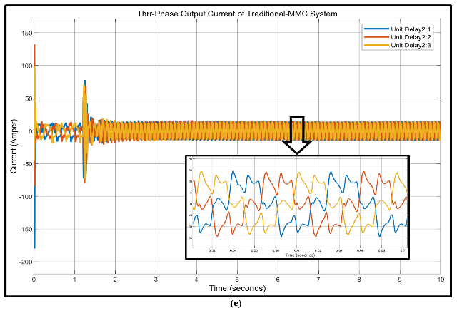
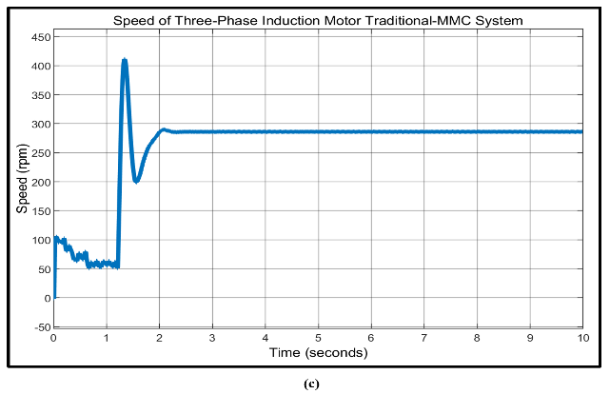
Figure 14. MMC performance at 286 rpm where (a, c, e) represent the capacitor voltage, speed, output current for traditional MMC drive system respectively, and (b, d, f) represents the capacitor voltage, speed, output current of MMC-DHB drive system.

Figure (15) shows the machine speed of 143 rpm at 100% load torque (TL= 25 N.m), there is a high reduction of ripple for the DHB power balancing system, the fluctuation of capacitor voltage decreases from (50VP-P to 1VP-P). The sinusoidal three-phase output currents are shown for the MMC-DHB system compared with a traditional system.
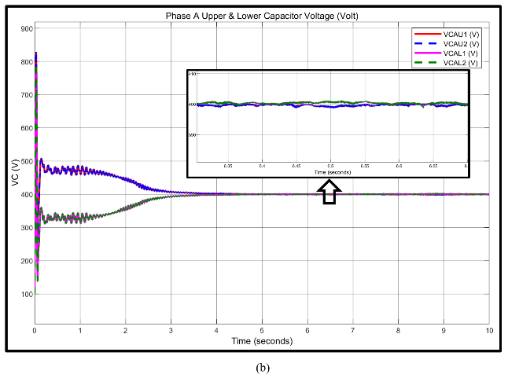
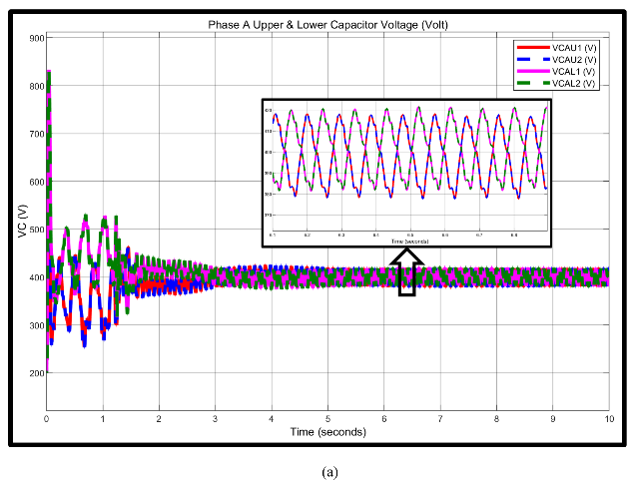

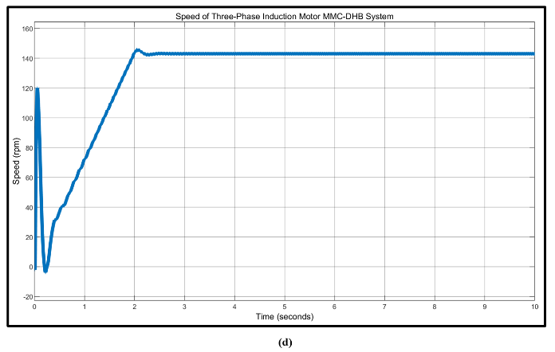
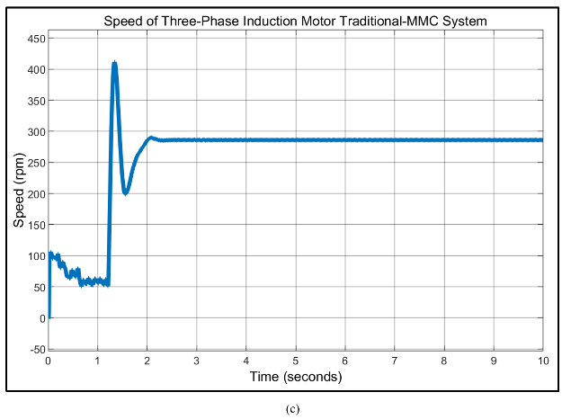

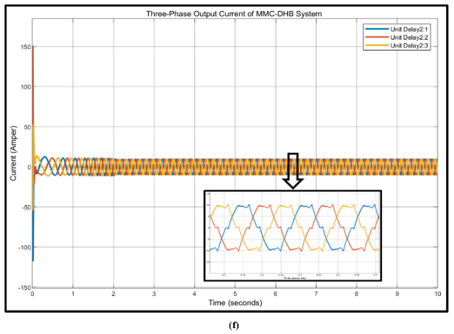
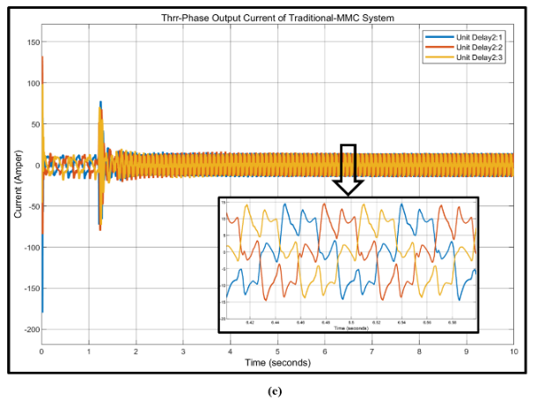
Figure 15. MMC performance at 143 rpm where (a, c, e) represent the capacitor voltage, speed, output current for traditional MMC drive system respectively, and (d, e, f) represents the capacitor voltage, speed, output current of MMC-DHB drive system.

- conclusion
The modelling, control, and design consideration were taken in this paper for the MMC-DHB drive system with the primary emphasis on comparing with the conventional MMC drive system. The main contributions are presented in the following way:

- While the voltage ripple, regardless of the operating frequency, stays almost constant, a substantial decrease in SM capacitance is feasible. At low operating speeds, multiple megawatt machines may be driven.
- the results showing the effective decoupling of the ripple power technique on the ripple of SM capacitor voltage reduction, at a variable frequency of operation have been obtained compared with that of the traditional MMC drive system. At 1430 rpm the capacitor voltage ripple has been reduced. from $±1.75\%$ to $±$0.25 %, the voltage ripple of the capacitor at 715 rpm decreases from$±3.75\%$ to $±$0.25 %, At lower operating frequencies, the DHB power decoupling has significant effects, as shown, the voltage ripple of a capacitor at 286 rpm decreases from $±$10 % to $±$0.25 %, whereas the voltage ripple of the capacitor at 143 rpm decreases from $±12.5\%$ to $±$0.25%.
- Instead of using a traditional-MMC drive system, a DHB-MMC-based drive system produces a high-quality sinusoidal waveform of output currents in a wide range of operating speeds.

REFERENCES
[1] Josep Pou, Salvador Ceballos, Georgios Konstantinou, Vassilios G. Agelidis, Ricard Picas, and Jordi Zaragoza, “Circulating Current Injection Methods Based on Instantaneous Information for the Modular Multilevel Converter”, IEEE Transactions on Power Electronics, vol. 62, no. 2, 2015, doi. 10.1109/TIE.2014.2336608.
[2] Wanxun Liu, Kai Zhang, Xiaosen Chen, Jian Xiong, “Simplified model and submodule capacitor voltage balancing of single-phase AC/AC modular multilevel converter for railway traction purpose”, IET (The Institution of Engineering and Technology) Power Electronics, vol. 9, no. 5, pp. 951–959, 2016, doi. 10.1049/iet-pel.2015.0120.
[3] Rongfeng Yang, Binbin Li, Gaolin Wang, Carlo Cecati, Life Fellow, Shaoze Zhou, Dianguo Xu, and Wanneng Yu, “Asymmetric mode control of MMC to suppress capacitor voltage ripples in low frequency low voltage condition”, IEEE Transactions on Power Electronics, vol. 32, no. 6, 2017, doi. 10.1109/TPEL.2016.2600762.
[4] Yerraguntla Shasi Kumar and Gautam Poddar, “Medium-Voltage Vector Control Induction Motor Drive at Zero Frequency Using Modular Multilevel Converter”, IEEE Transactions on Power Electronics, vol. 65, no. 1, 2018, doi. 10.1109/TIE.2017.2721927.
[5] Harin. M. Mohan, Vanitha. V, M. Jayakumar, “Comparison of PWM Techniques for a Three Level Modular Multilevel Inverter”, 1st International Conference on Power Engineering, Computing and Control, Energy Procedia, vol. 117, 4 March 2017, pages 666–673, doi. 10.1016/j.egypro.2017.05.180.
[6] Sze Sing Lee, Yeh En Heng,” A voltage Level Based Predictive Direct Power Control for Modular Multilevel Converter”, Electric Power Systems Research, vol. 148, July 2017, Pages 97-107, doi.10.1016/J.EPSR.2017.03.023.
[7] Cathrine E. S. Feloups, Essam E. M. Mohamed, “Design and Implementation of a New Multilevel Inverter Employing Reduced Components”, Open Access Library Journal, vol. 6, 20 September, 2019, doi. 10.4236/oalib.1105689.
[8] Ziwen Liu, Shihong Miao, Zhihua Fan, Kaiyun Chao, Yuliang Liu, “Characteristics Analysis and Improved Arm Control of Modular Multilevel Converter Under Asymmetric Operation Conditions”, International Journal of Electrical Power & Energy Systems, vol. 105, February 2019, Pages 272-282, doi. 10.1016/j.ijepes.2018.08.037.
[9] Luca Bessegato, Kalle Ilves, Lennart Harnefors, Staffan Norrga, Stefan Ostlund, “Control and Admittance Modeling of an AC/AC Modular Multilevel Converter for Railway Supplies”, IEEE Transactions on Power Electronics, vol. 35, no. 3, March 2020, pages 2411-2423, doi. 10.1109/TPEL.2019.2930321.

[10] Songda Wang, Danyang Bao, Gustavo Gontijo Sanjay Chaudhary and Remus Teodorescu, “Modeling and Mitigation Control of The Submodule-Capacitor Voltage Ripple of a Modular Multilevel Converter under Unbalanced Grid Conditions”, Energies, vol.14, no. 3, 28 January 2021, doi.10.3390/en14030651.
[11] Hamed Pourgharibshahi, Hassan Zargarzadeh, Seyyedmahdi Jafarishiadeh, Hamid Mahmoudi, Reza Ahmadi,” Novel Single-Armed Modular Multilevel Converter for Reducing Total Converter Capacitance”, IET (the Institution of Engineering and Technology) Power Electronics, vol. 14, pages 760-774, 2021, doi. 10.1049/pel2.12061.
[12] Yerraguntla Shasi Kumar and Gautam Poddar, “Balanced Sub-Module Operation of Modular Multilevel Converter Based Induction Motor Drive for Wide-Speed Range”, IEEE Transactions on Power Electronics, vol. 35, no. 4, April 2020, pages 3918-3927, doi. 10.1109/TPEL.2019.2938096.
[13] Masoud Noushak, Alireza Hadizadeh, Hossein ImanEini, Shahrokh Farhangi, David Frey,” Reduction of Capacitor Voltage Ripple in a Modular Multilevel Converter Employed in Adjustable Speed Drive Application”, 8th Power Electronics, Drive Systems & Technologies Conference (PEDSTC), 14-16 Feb. 2017, Ferdowsi University of Mashhad, Mashhad, Iran, doi. 10.1109/PEDSTC.2017.7910345.
[14] Harsh Rajesh Parikh, Ruben Sanchez Martin Loeches, Georgios Tsolaridis, Remus Teodorescu,” Capacitor voltage ripple reduction and arm energy balancing in MMC-HVDC”, IEEE 16th International Conference on Environment and Electrical Engineering (EEEIC), 7-10 June 2016, doi. 10.1109/EEEIC.2016.7555778.
[15] Johannes Kolb, Felix Kammerer, Mario Gommeringer, and Michael Braun,” Cascaded Control System of the Modular Multilevel Converter for Feeding Variable-Speed Drives”, IEEE Transactions on Power Electronics , vol. 30, no. 1, January 2015, doi. 10.1109/TPEL.2014.2299894.
[16] Shambhu Sau, B. G. Fernandes,” Modular Multilevel Converter based Variable Speed Drives with Constant Capacitor Ripple Voltage for Wide Speed Range”, IECON 2017 - 43rd Annual Conference of the IEEE Industrial Electronics Society, doi.10.1109/IECON.2017.8216348.
[17] Binbin Li, Shaoze Zhou, and Dianguo Xu, Stephen J. Finney, and Barry W. Williams,” A Hybrid Modular Multilevel Converter for Medium-Voltage Variable-Speed Motor Drives”, IEEE Transactions on Power Electronics, vol. 32, no. 6, June 2017, pages 4619-4630, doi. 10.1109/TPEL.2016.2598286.
[18] Maryam Saeedifard, Reza Iravani, “Dynamic Performance of a Modular Multilevel Back-to-Back HVDC System”, IEEE Transactions on Power Delivery, vol. 25, no. 4, October 2010, doi.10.1109/TPEL.2016.2598286.
[19] Mauricio Espinoza B., Andr´es Mora, Mat´ıas Diaz and Roberto C´ardenas, “Balancing Energy and Low Frequency Operation of the Modular Multilevel Converter in Back to Back Configuration”, Tenth International Conference on Ecological Vehicles and Renewable Energies (EVER), 31 March-2 April 2015, Monte Carlo, Monaco, doi. 10.1109/EVER.2015.7113005.
[20] Yerraguntla Shasi Kumar and Gautam Poddar, “Balanced Sub-Module Operation of Modular Multilevel Converter Based Induction Motor Drive for Wide-Speed Range”, IEEE Transactions on Power Electronics, vol. 35, no. 4, April 2020, pages 3918-3927, doi. 10.1109/TPEL.2019.2938096.
[21] Binbin Li, Shaoze Zhou, Linjie Han, Jingkun Wang, and Dianguo Xu, “Back-to-Back Modular Multilevel Converter Topology with DC-Link Switches for High-Power Four-Quadrant Variable Speed Motor Drives”, 21st European Conference on Power Electronics and Applications (EPE '19 ECCE Europe), Genova, Italy, September 2019, doi. 10.23919/EPE.2019.8914791.
[22] Mohamed S. Diab, Ahmed M. Massoud, Shehab Ahmed, and Barry W. Williams, “A Modular Multilevel Converter with Ripple-Power Decoupling Channels for Three-Phase MV Adjustable-Speed Drives”, IEEE Transactions on Power Electronics, vol. 34, no. 5, May 2019, pages 4048 – 4063, doi.10.1109/TPEL.2018.2858003.
[23] Binbin Li, Rongfeng Yang, Dandan Xu, Gaolin Wang, Wei Wang,” A Dual Multilevel Converter with High-Frequency Magnetic Links Between Submodules for MV Open-End Stator Winding Machine Drives," IEEE Transactions on Power Electronics, vol. 33, no. 6, pp. 5142-5159, June 2018, doi. 10.1109/TPEL.2017.2735195.
[24] M. S. Diab, B. W. Williams, D. Holliday, A. M. Massoud and S. Ahmed, "A modular multilevel converter with isolated energy-balancing modules for MV drive incorporating symmetrical six-phase machines", 2017 IEEE Energy Conversion Congress and Exposition (ECCE), 1-5 Oct. 2017, Cincinnati OH USA, pp. 715-2722, doi. 10.1109/ECCE.2017.8096509.
[25] Mahmoud Abdelsalam, Mostafa Marei, Sarath Tennakoon, and Alison Griffiths, “Capacitor Voltage Balancing Strategy Based on Sub-Module Capacitor Voltage Estimation for Modular Multilevel Converters”, CSEE Journal of Power and Energy Systems, vol. 2, no. 1, March 2016, Pages 65 – 73, doi. 10.17775/CSEEJPES.2016.00010.
[26] Makoto Hagiwara and Hirofumi Akagi, “Control and Experiment of Pulse Width-Modulated Modular Multilevel Converters”, IEEE Transactions on Power Electronics, vol. 24, no. 7, July 2009, pages 1737 – 1746, doi. 10.1109/TPEL.2009.2014236.
[27] Yerraguntla Shasi Kumar and Gautam Poddar, “Balanced Sub-Module Operation of Modular Multilevel Converter Based Induction Motor Drive for Wide-Speed Range”, IEEE Transactions on Power Electronics, vol. 35, no. 4, April 2020, Pages 3918 – 3927, doi. 10.1109/TPEL.2019.2938096.
[28] Yin Li, Lingling Fan,” Modular Multilevel Converter Based Induction Machine Drive”, North American Power Symposium (NAPS), 4-6 Oct. 2015, Charlotte, NC, USA, doi. 10.1109/NAPS.2015.7335129.
[29] Sandeep Goyat, Rajesh Kr. Ahuja,” Speed Control of Induction Motor Using Vector or Filed Oriented Control”, International Journal of Advances in Engineering & Technology, 2012, vol. 4, no. 1, pp. 475-482.
[30] Hafeezul Haq, Mehedi Hasan Imran, H. Ibrahim Okumus, Mohammad Habibullah,” Speed Control of Induction Motor using FOC Method”, Hafeezul Haq et al. Int. Journal of Engineering Research and Applications, vol. 5, no. 3, (Part -1) March 2015, pp.154-158.

