Improving the design of super-lift Luo converter using hybrid switching capacitor-inductor cell for PV system

Article Info |  | ABSTRACT
Article history:  Received mm dd, yyyy  Revised mm dd, yyyy  Accepted mm dd, yyyy |  | In this article, an improvement to the DC-DC positive output super-lift Luo converter (POSLC) has been proposed to get high gain at low duty cycle. also reduce the stress on the switch and diodes, reduce the current through the inductors to reduce loss and increase efficiency. Using a hybrid switch unit composed of four inductors and two capacitors it is replaced by the main inductor in the elementary circuit. it is charged in parallel with the same input voltage and discharged in series. the output voltage is increased according to the number of components. the gain equation is modeled. the boundary condition between CCM and DCM has been derived. Passive components are designed to get high output voltage (8 times at D=0.5) and low ripple about (0.004). the circuit is simulated and analyzed using MATLAB/Simulink. Maximum power point tracker (MPPT) controls the converter to provides the most interest from solar energy.
Keywords:
DC-DC converter
Positive output converter
High gain converter
PV system
Maximum power point tracker
This is an open access article under the CC BY-SA license.

Corresponding Author:
Hussein Abdul-Khader Hussein
Departement of Electrical Engineering,
babylon University,
city of hilla, Babil Province, Iraq,
Email: hussein.radi@student.uobabylon.edu.iq

- INTRODUCTION
DC-DC converters are essential to meet residential, commercial, agricultural and industrial needs in our daily lives. Modern power systems require compact, robust, powerful, and inexpensive equipment. The linear controller is best replaced by a DC-DC converter. Many modern DC-DC converter systems have been patented through extensive research [1,2]. These DC-DC converters can be used in a variety of applications, including hybrid vehicles, solar cell applications and more. Applications of traction, machine motors and fuel cells [3,4,5]. Use the super lift (SL) method and voltage lift (VL) to improve the converter to increase the voltage without ripple [6]. These techniques are used to design converters, gradually improving (VL) technology or (SL) technology to increase the output voltage geometrically [7].
The primary Luo converter cannot provide such a high conversion gain (at least 10 times the gain is required in the above application), and the solution is to use a switched capacitor-inductor unit [8]. In order to obtain non-isolated control, they are integrated into a simple converter. An electronic circuit that can increase the voltage ten times or more and operate with high efficiency. This concept has been explored in various journals and there are several solutions [9] [10]. a lot of high gain dc-dc converter has been proposed in general structure [10] We focused on the Luo converter because it has proven its efficiency and practicality and for its extensive and comprehensive analysis.
Many modifications to (POSLC) are to use a switching cell to boost the voltage [11]. The modification to obtain four times the gain (0.5) at half-duty cycle is to add an inductor and diode in series and connect with the primary The second diode in parallel (POSLC)[11]; to reach higher voltage gain another modification by adding four capacitors and four diodes, this can raise the output voltage about five times at one-half duty cycle[12], recently a modification on (POSLC) has been proposed [13] using hybrid switching cell combine from two inductors, one capacitor and two diodes, the voltage gain produced from this modification is the same as [14].
MPPT was used with the converter to meet full power delivery to the load and high output boost voltage to satisfy maximum interested from the PV system, a PV generation system is becoming important as it offers many advantages including no fuel costs, almost no pollution, little maintenance, and no noise emission [15].
To implement an off-grid PV system for use in remote areas, so we propose in this paper the positive output super lift Luo converter with hybrid capacitor-inductor switching cell, which has high efficiency, very low equivalent resistance, high output voltage, decrease the inductors current and low output voltage ripple. can operate with gain more than four times of input voltage at a very low duty cycle when control with MPPT.

In this paper a new modification on super-lift Luo converter has been proposed, capacitor-inductor switching cell composed of four inductors and two capacitors has been used to achieve higher voltage gain than elementary converter since the output voltage is 8 times the input voltage at D=0.5 and 20 times the input voltage at D=0.8

2 Topology of PV model
A photovoltaic device converts solar energy into electrical energy using one or more solar panels, Photovoltaic panels are made up mostly of solar cells. The solar cells are connected in parallel or series, depending on the voltage and current needs, respectively. The voltage of the panel is improved by connecting the solar cells in series, while the current value of the panel is improved by arranged the cells in parallel [16], fig (1) show a circuit diagram of the PV model
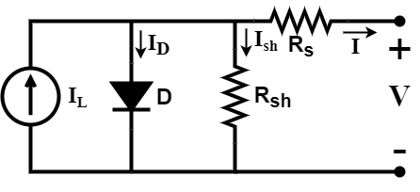

Fig (1) PV model circuit [17]
The PV system's P-V and I-V properties are not linear. Temperature and irradiation intensity are the two major factors that influence the performance of a PV device. The voltage and current provided by the PV device change as the temperature and irradiation level change. The solar module's nominal working conditions are 25°C temperature, 1000 W/m2 (G=1) irradiation; Figure 2 depicts the P-V and I-V properties of a PV cell [18]. The open-circuit voltage (VOC) is the highest voltage a cell will produce when I=O and the short-circuit current (ISC) is the current that belong to a short circuit when V=O. The PV cell produces maximum power at just one point during service, which is known as the Maximum Power Point (MPP). The maximum current, maximum voltage, and maximum power of the solar cell are represented in the graph by Im, Vm, and Pm, respectively. is the mathematical expression for the output current of an ideal cell. [19-20] is:
$I= I_{PV}-I_{d}$ (1)
I_{d} is the Shockley equation, R_{sh} is the shunt resistance of the model, and I_{pv} is the current generated by light, which is proportional to solar irradiation. The solar cell's light produced current is primarily determined by solar irradiation and its work temperature, which is measured in Celsius.
$$I_{PV }=\left[I_{SC}+K_{I }\left(T_{c}-T_{R}\right)\right].G (2)$$
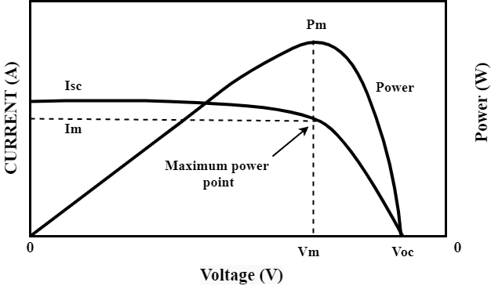

Fig (2): I-V and P-V characteristics of solar cell [21]

(Isc) is the cells short-circuit current at (25°C) and (G=1), KI is the cell's short-circuit current temperature co-
efficient, Tr and Tc are the cell's reference and working temperatures respectively. The Shockley equation is as follows:
$I_{d}=I_{S }\left\{exp\left(\frac{q}{AKTc}\right)-1\right\}$ (3)
$$I=I_{PV}-I_{d}-I_{P } (4)$$
$I=I_{PV}- I_{S }\left\{exp\left(\frac{q}{AKTc}\right)-1\right\}-\frac{V+IR_{se}}{R_{P}} (5)$
To achieve the required output power, the solar cells must be connected in a series-parallel configuration. The generalized PV array mathematical equation with (Ns) number of modules connected in sequence and (Np) number of modules connected in parallel, q is the electron charge [1.60 x 10-19 oC], k is the Boltzmann constant [1.38x10-23J/K], is as follows:
$$I= I_{PV}N_{P}- I_{S}N_{P}\left\{exp\left(\frac{qV}{AKTcNs}+\frac{IR_{se}}{N_{P}}\right)-1\right\} (6)$$
$$I_{s}=I_{rs} {\left(\frac{T_{c}}{T_{r}}\right)}^{3 }exp\left[\frac{qE_{g}}{A_{k}} \left(\frac{1}{T_{c}}-\frac{1}{T_{r}}\right)\right] (7)$$
Where (Eg) is the bandgap energy of the semiconductor and (Irs) is the reverse saturation current of a cell at a reference temperature and sun irradiation. For polycrystalline Si, (Eg) is around 1.12 eV at 25oC [20-22]. The equation can be used to calculate a cell's reverse saturation current (Irs) (8).
$$I_{RS}=\frac{I_{SC}}{exp\left(\frac{q}{AKT_{C \left(n\right)}N_{S}} Vo\right)-1} (8)$$

PV systems employ DC-DC step-up converters to control the voltage generated by PV modules and to raise the module voltage. One switch (S), one inductor (L), capacitors (C1&C2), and two diodes make up the (POSLC). Figure 3 depicts the (POSLC) circuit architecture [23], as well as its modeling equations (9) (on-state) and (10) (off-state) for displaying the output voltage gain [24]:
$$Vin= VL = Vc1=L Δi/dt (9)$$
$$Δi= VL (1-D)T/L = Vo-2Vin (1-D)T/L (10)$$
$G= \frac{Vo}{Vin}= \frac{2-D}{1-D} (11)$
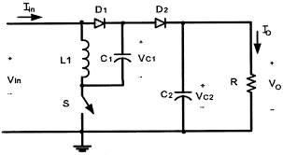

Fig (3) elementary circuit (POSLC) [25]

3. Modify (POSLC)
The elementary circuit of (POSLC) is high output voltage gain [26], we can get many times the input voltage without need to raise duty cycle at a level that makes the MOSFET switch cause more losses, we proposed a hybrid switching capacitor-inductor(S-C-L) cell as shown in fig (4.a) composed of four inductors and two capacitors to raise the voltage about eight times at duty cycle 0.5 the inductors and the capacitors charge in parallel the same input voltage and discharge in series to increase the output voltage, the modify circuit shown in fig (4.a) and its on-off state fig(4.b and 4.c) consist of four inductors (L1&L2&L3&L4) and three capacitors C1&C2&C3 and output capacitor Co to reduce the output voltage ripple and two diodes Dm1, Dm2 the diode Dm2 protects the circuit from reverse currents.: the equation of the converter at switch-on is:
$$Vin=V_{L1}=V_{L2}=V_{L3}=V_{L4}=V_{C1}=V_{c2}=V_{C3 } (12)$$
And the voltage of the inductor at switch-off is:
$$V_{L1}=\frac{4V_{in}-V_{o}}{4} (13)$$
From the Volt-Second balance equation:
$$VL DT+VL \left(1-D\right)T=0 (14)$$
Sub equation (12) and (13) in (14) we get the voltage gain equation:
$$G=\frac{Vo}{Vin}=\frac{4}{1-D} (15)$$
Equation (15) is the output voltage gain equation that means when the duty is 0.5 the output voltage increases eight times, figure (4.d) shows the relationship between duty cycle and gain for both elementary and modified circuits.
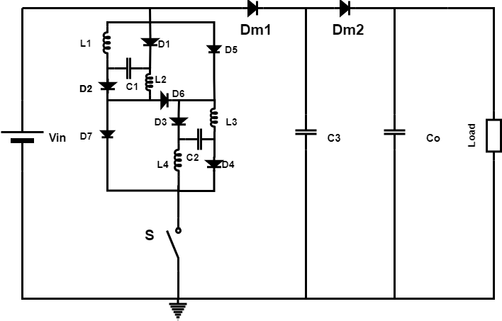

a) b)
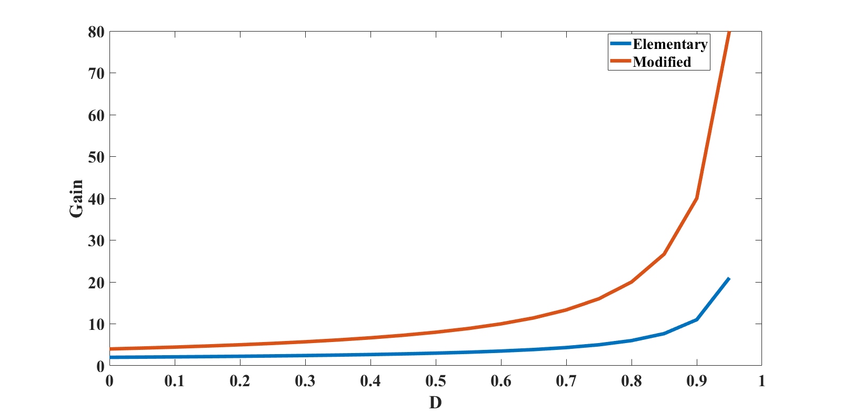
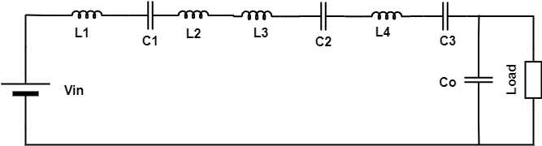

C) D)
Fig (4) a) circuit of modify (POSLC) b) circuit at switch-on c) circuit at switch-off d) relationship between gain and duty cycle for both POSLC and MPOSLC

4. Design of passive elements:
from equation (9)
$$L_{min}= \frac{V_{in }D}{f ΔI} (16)$$
$ΔI$ : ripple of inductor current recommended (0.2 to 0.4)
𝐿𝑚𝑖𝑛 = 3 𝑒 − 4 H is the minimum value of the inductor to work in CCM

The output capacitor can be selected from the following equation:
$C_{o}= \frac{D V_{O}}{f R Δ{vc}_{0}}$ (17)
Therefore, the voltage ripple in the capacitors:
$$Δ{VC}_{1,2,3}=\frac{ΔQ}{C_{1,2,3}}= \frac{Io\left(1-D\right)T}{C_{1,2,3}}= \frac{1-D }{f C_{1,2,3}} \frac{Vo}{R} (18)$$
$$Δ{VC}_{1,2,3}=\frac{Δv_{0}∕2}{v_{0}}=\frac{1-D}{2fRC_{1,2,3}} (19)$$
${C_{1,2,3}}_{min}=\frac{1-D}{2fR Δ{VC}_{1,2,3}} (20$)
$Δ{VC}_{o}$ recommended to set less than 5% [27]
$C_{min}=1.5 e-6 farad$ in the minimum value of the output capacitor for working in CCM

5. Boundary conditions between CCM and DCM
When switch (s) on at T= 0~D equation (9) satisfied
when switch (s) off at T= 1-D
$VL=\frac{4Vin-Vo}{4}=L\frac{ Δ_{i}}{\left(1-D\right)T} (21)$
$$Δ_{i}= \frac{\left(4Vin-V0\right)\left(1-D\right)T}{4L} (22)$$
Sub equation (9) in equation (22) we get
$$\left(1-D\right)=\frac{4 VinD}{(4Vin-Vo)} (23)$$
Equation (23) showing the duration of time at the switch-off.
$$I_{L}=\frac{1}{2} \left(1-D\right)Δi_{L} (24)$$
I_{L} equation from the signal in current waveform, At steady state $I_{co}=0$so:
$$\frac{1}{2} \left(1-D\right)Δi_{L}= I_{o} (25)$$
$$\frac{1}{2} \frac{4 VinD}{(4Vin-Vo)}* \frac{Vin DT}{L}= \frac{Vo}{R} (26)$$
$$\frac{1}{2}*\frac{4 {V_{in}}^{2}D^{2}}{\left(4Vin-Vo\right)}= \frac{Vo fL }{R} (27)$$
$$\frac{1}{2}* \frac{4 V_{in}^{2}D^{2}}{\left(4Vin-Vo\right)}=Vo τ (28)$$
$$V_{o}^{2} τ-4 V_{o} V_{in} τ+2 V_{in}^{2} D^{2 }=0 (29)$$
The above equation solved by law
$$V_{o}=2 Vin ∓ \sqrt{4 V_{in}^{2}-\frac{2 V_{in}^{2} D^{2 }}{τ}} (30) \\ τ=\frac{2D^{2}}{({\frac{2+2D}{1-D})}^{2}-4} (31)$$
The equation (31) draws the boundary condition between CCM and DCM we can draw the curve between duty cycle and τ= (f L)/R as shown in fig (5); notice if we increase the load resistance over its limits the circuits work at DCM that mean the inductor current during the off-state will be zero for a while.
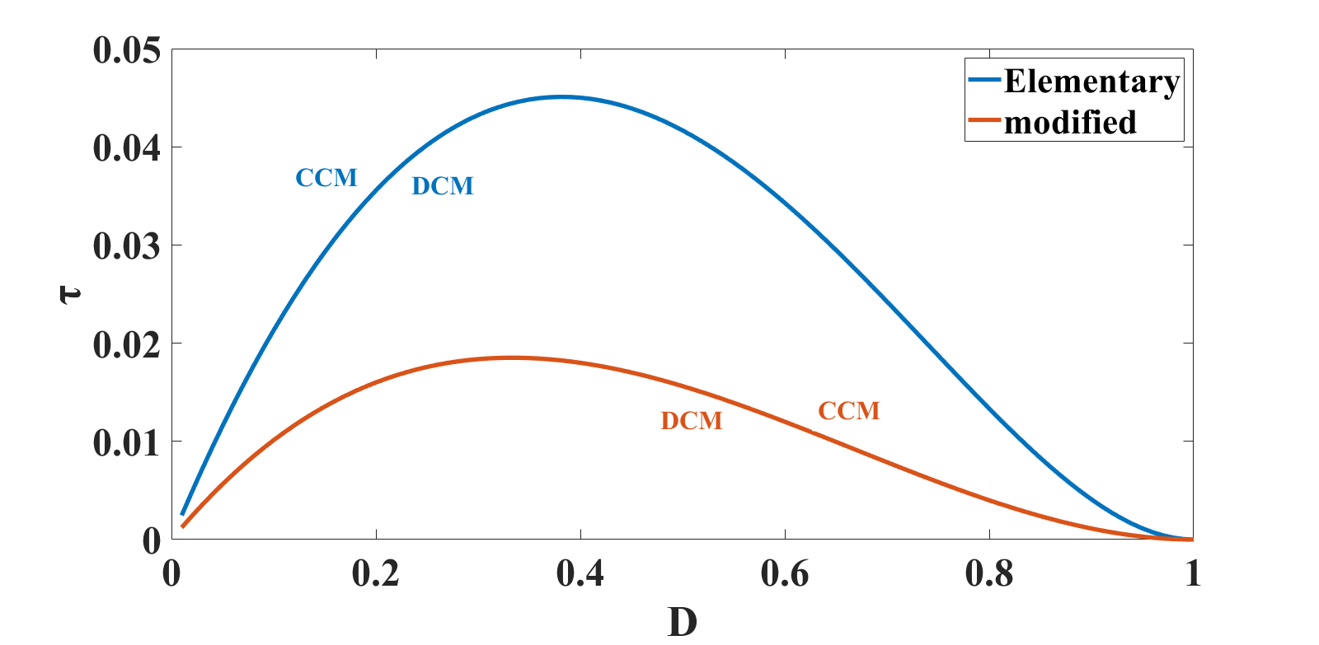

6. Simulation result and discussion:

Fig (5) boundary condition between CCM and DCM for POSLC and MPOSLC

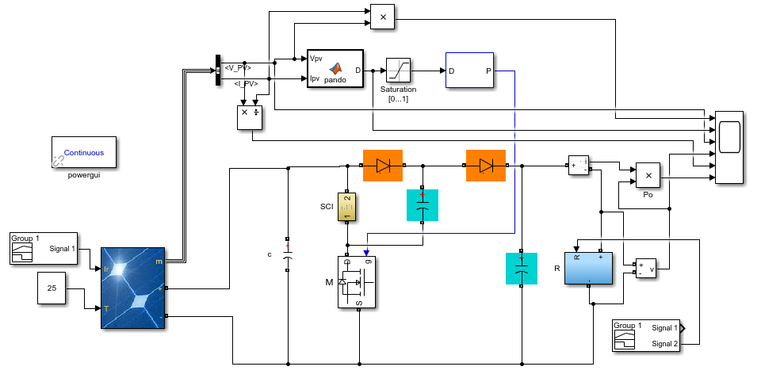

Fig (6) modified (POSLC) with switching C-L cell and MPPT controller
6. Simulation results and discussion:
Modified (POSLC) that shown in fig (4.a) has been simulated and analyzed with the parameters shown in Table (I) the simulation results satisfy the theoretical calculation, we choose all inductors with value 0.8 mH and the capacitors with 220 µF and the load with 50Ω and switching frequency 60000 HZ, fig (7.a) shows that the input current of PV panel divided equally between all inductors, that reduce the current pass through one inductor that saves size and protect inductors from high current, fig (7.b) shows the low level of input pulsating current in modified circuit can reduced its effect and protect the source.
Table I parameters of the proposed converter
I | parameters | symbol | value | unit
1 | Input voltage | V | 12 | volt
2 | Output voltage | V | 96 | volt
3 | inductors | L1, L2, L3, L4 | 8e-4 | henry
4 | Capacitors | C1, C2, C3, Co | 220u | f
5 | Switching frequency | f | 60000 | HZ
6 | Duty cycle | D | 0.5 | -
7 | Load resistant | $$Ω$$ | 50 | Ohm
8 | Maximum power of PV array | Pm | 213 | W
Table I shows all the parameters of the modified converter which simulated in MATLAB and shown in fig (6) with its control and PV cell
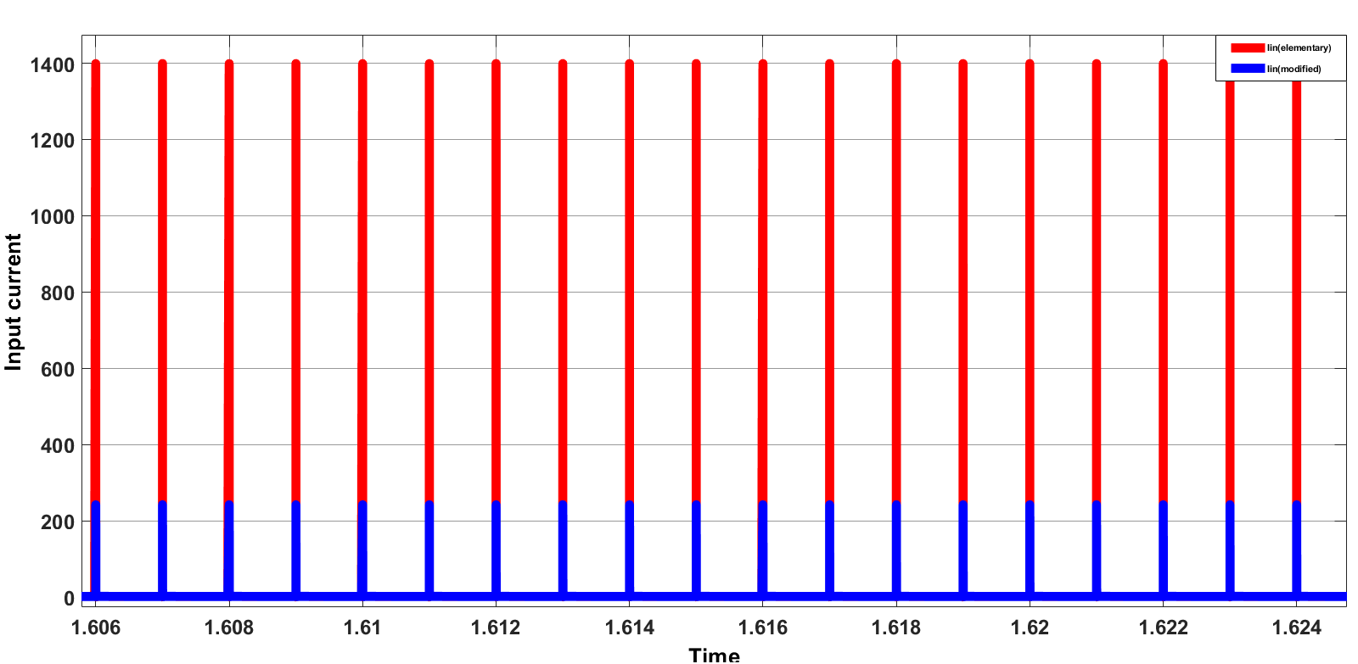
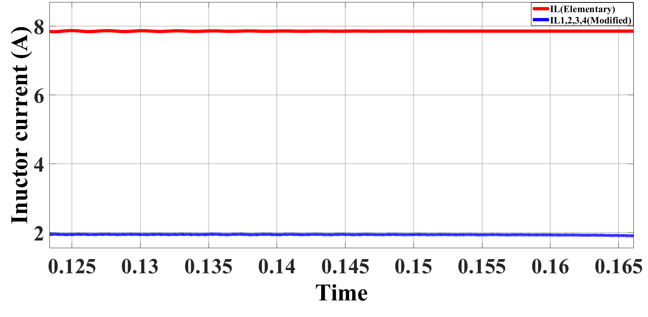

a) b)
Fig (7) Modified converter current a) inductors currents b) input pulsating current
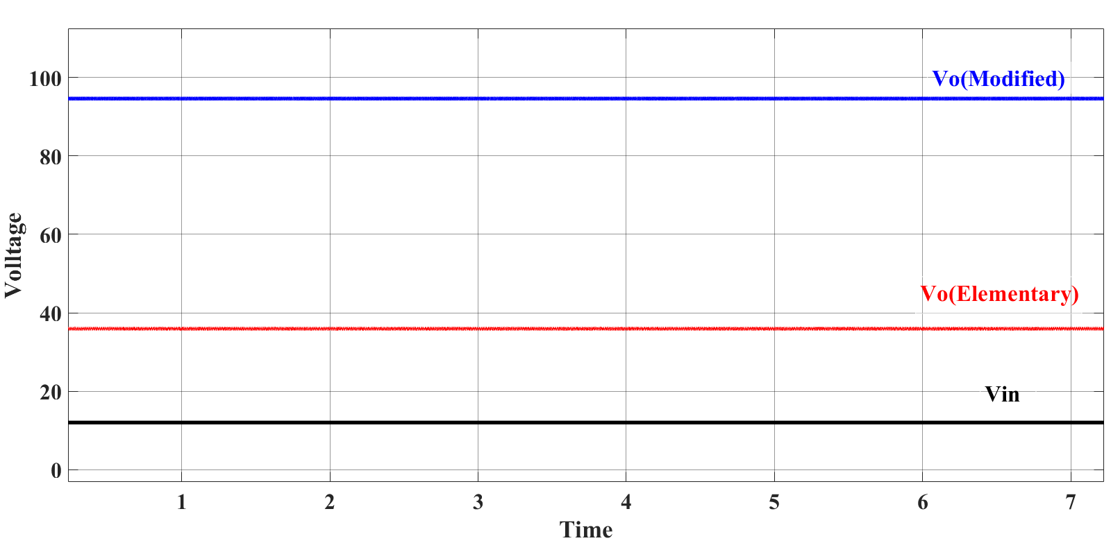

a)
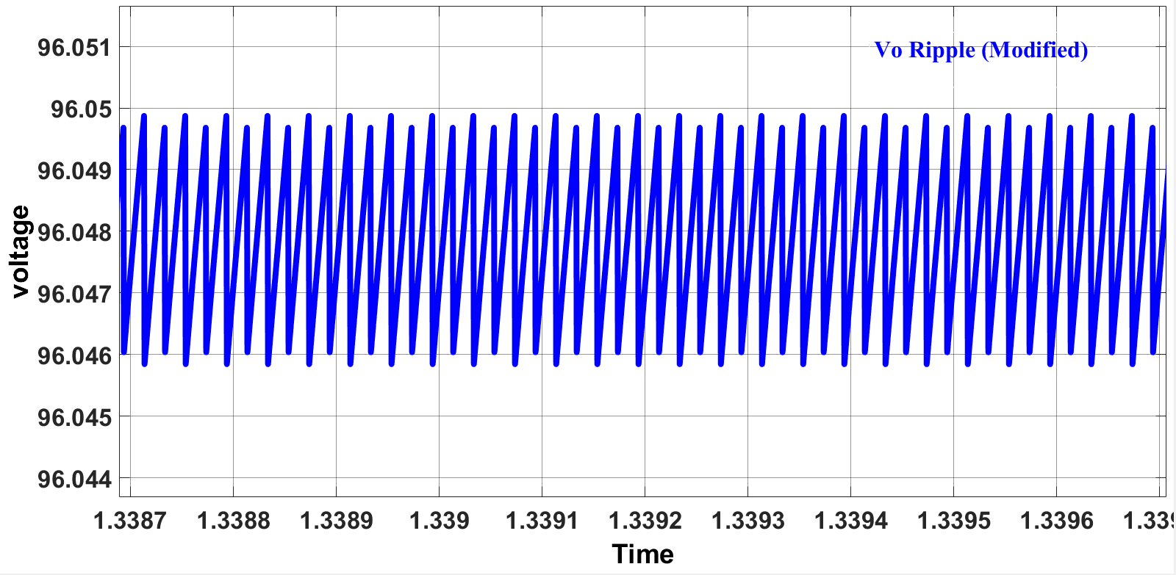

b)
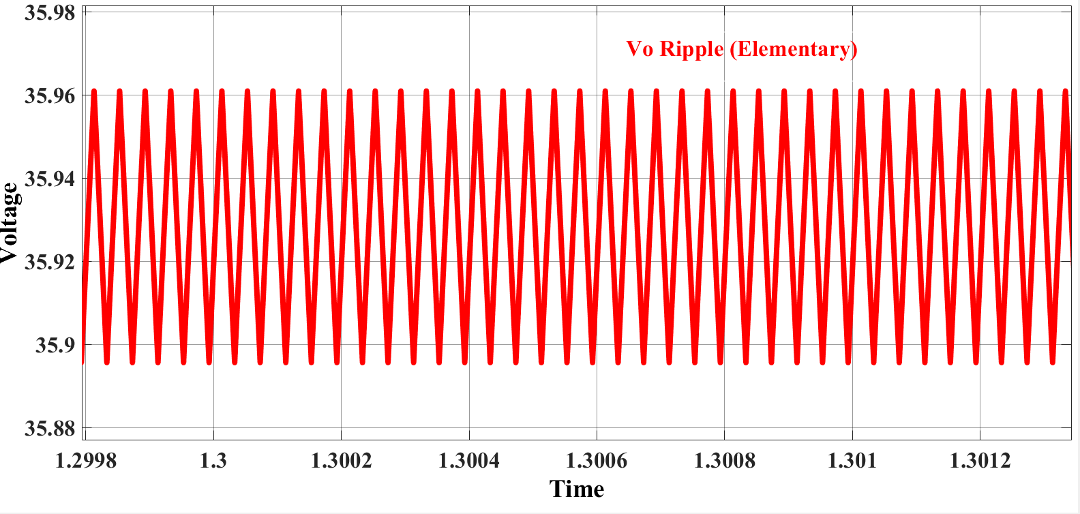

C)
Fig (8) Output voltage a) for both elementary and modified converter b) ripple for elementary POSLC c) ripple for modified POSLC
From fig (8.a) shows the difference between output voltage for elementary and modified circuits, fig (8. b and c) ripple of modified and elementary converters respectively, the low level of ripple for the modified converter makes the operation more efficient, this is very good for highly sensitive such as medical applications.

Table II the gain formula and the gain factor for D= 0.2, 0.5, 0.7
Topology | Gain formula | Gain at D=0.2 | Gain at D=0.5 | Gain at  D=0.7
(POSLC) | $$G=\frac{2-D}{1-D}$$ | 2.25 | 3 | 4.333
Modification in [11] | $$G=\frac{2}{1-D}$$ | 2.5 | 4 | 6.666
Modification in [12] | $$G=\frac{3-D}{1-D}$$ | 3.5 | 5 | 7.666
Modification in [13] | $$G=\frac{3-D}{1-D}$$ | 3.5 | 5 | 7.666
Proposed modification in fig (4) | $$G=\frac{4}{1-D}$$ | 5 | 8 | 13.333

Table II shown the comparison between proposed converter and other modification on (POSLC)
Topology | Gain formula | No. of capacitors | No. of  inductor | No. of diodes | No. of switches | Equivalent resistance
(POSLC) | $$G=\frac{2-D}{1-D}$$ | 2 | 1 | 2 | 1 | 5.6 ohm
Modification in [11] | $$G=\frac{2}{1-D}$$ | 2 | 2 | 3 | 1 | -
Modification in [12] | $$G=\frac{3-D}{1-D}$$ | 6 | 1 | 6 | 1 | -
Modification in [13] | $$G=\frac{3-D}{1-D}$$ | 3 | 2 | 4 | 1 | -
Proposed modification in fig (4) | $$G=\frac{4}{1-D}$$ | 4 | 4 | 9 | 1 | 1.3 ohm

Tables II and III show a comparison between the modified circuit and the rest of the circuits in the aforementioned research. Table II shows the comparison in terms of gain, while Table III shows the comprehensive comparison.

7. Simulation with MPPT:
To interesting with all of the power generated from the PV panel we should control the converter with maximum power point tracker, the P-V characteristic shown in fig (2).
Fig (6) shows the circuit diagram of the converter proposed in fig (4) in MATLAB/Simulink with MPPT algorithm to control the converter and extract maximum power point, fig (9) show the output power of the proposed converter with MPPT and the eefeciency is about 94%. we notice that when MPPT controls the circuit the raise in the power extracted is too obvious in simulation.
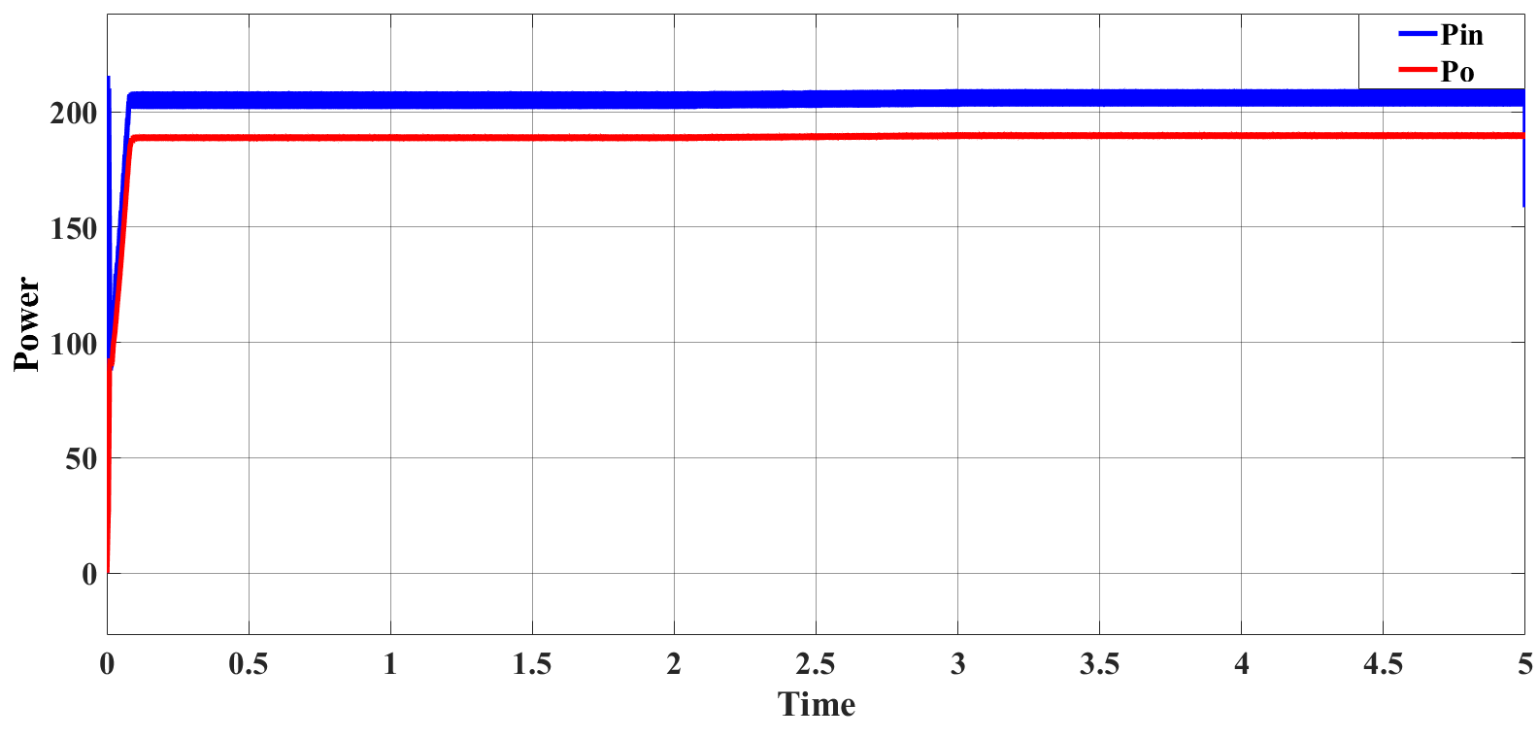

Fig (9) P_{PV} and P_{O} with MPPT controller

8. Conclusion
The design and model of improved positive output super-lift luo converter (MPOSLC)is simulated successfully with MATLAB/simulink and verified the theoretical results. many switching units can be applied to the DC-DC converter we chose Luo because it was originally a high gain converter. replacing the inductor with a hybrid unit (SCL). The equivalent resistance is reduced and the efficiency is improved, the current intensity in each inductor is reduced to protect them and the use of small-sized inductors and capacitors, because the improved converter is reduced capacitor voltage level that makes the size smaller and reduces the cost, and the low level of input pulsating current protects the power supply especially in the non-isolated converter.
From the boundary conditions we see that the small area of ​​work in DCM and the freer work are not reached the inductor current is zero.
This topology can be based on the MPPT of an independent photovoltaic system used in agricultural projects to run pumps used to irrigate crops. From figure (9) we notice that when the converter is controlled by the P&O algorithm the extracting power from PV increases

REFERENCES
[1] E. V. Beulin, J. Pradeep, “Design of Ultra-Lift Luo Converter for Pumping Applications”, in International Conference on Power, Energy, Control and Transmission Systems (ICPECTS), Chennai, India, 2018.
[2] N. Mohan, T. M. Undeland, W. P. Robbins, “Power Electronics Converters, Applications and Design”, Hoboken New Jersey: John Wiley & Sons, 2003.
[3] X. Haiping, K. Li, X. Wen, “Fuel cell power system and high-power DC to DC con-verter, IEEE Transactions on Power Electronics”, vol. 19, no. 5, ppp.1250-1255, 2004.
[4] L. Zhang, D. Xu, G. Shen, M. Chen, A. Ioinovici, X. Wu, “A high step-up DC to DC con-verter under alternating phase shift control for fuel cell power system”, IEEE Transac-tions on Power Electronics, vol. 30, no. 3, pp. 1694-1703, 2014.
[5] T. K. Brekken, H. M. Hapke, C. Stillinger, J. Prudell, “Machines and drives comparison for low power renewable energy and oscillating applications”, IEEE Transactions on Energy Conversion, vol. 25, no. 4, p. 1162–1170, 2010.
[6] N. Silpa, J. Chitra, “An Improved Luo Converter for High Voltage Applications, International Journal of Emerging Technology and Advanced Engineering”, vol. 4, no. 5, pp. 262-267, 2014.
[7] Luo F. L., Ye H., "Super-lift Boost Converter," IET Power Electron, vol. 7, no. 7, pp. 1655-1664, 2014.
[8] B. Axelrod, Y. Berkovich, A. Ioinovici, Switchedcapacitor/switched-inductor structures for getting transformerless hybrid DC–DC PWM converters, Transactions on Circuits and Systems I: Regular Papers, vol. 55, no. 2, p. 687–696, 2008.
[9] B. Axelrod, Y. Berkovich, A. Ioinovici, “Transformerless DC-DC converters with a very high DC line-to-load voltage ratio”, w IEEE International Symposium on Circuits and Systems, Bangkok, 2003.
[10] K. Li, Y. Hu, A. Ioinovici, "Generation of the large DC gain step-up non-isolated converters in conjunction with renewable energy sources starting from a pro-posed geometric structure", IEEE transactions on power electronics, vol. 32, no. 7, pp. 5323-5340, 2016.
[11] S. A. Nath, J. Pradeep, "PV Based Design of Improved Positive Output Super-Lift Luo Converter", in Second International Conference on Science Technology Engineering and Management (ICONSTEM), Chennai, India, 2016
[12] M. P. Chand, G. Ramesh, “design of new positive output super-lift Luo converter for solar input in comparison with different DC-DC converter”, International Research Journal of Engineering and Technology (IRJET), vol. 3, no. 9, pp. 1589-1594, 2016.
[13] A. T. Mohammed, N.K. Alshamaa, “Design and Implementation of a Modified Luo Converter with Higher-Voltage Ratio Gain”, w 3rd International Conference on Sustainable Engineering Techniques (ICSET), Munich, Germany, 2020.
[14] S. Mohammed, “Modeling and Simulation of Photovoltaic Module using MATLAB/Simulink”, International Journal of Chemical and Environmental Engineering, vol. 2, no. 5, pp. 81-90, 2011.
[15] R. Kumar, B. Sahu, C. Shiva, B. Rajender “A control topology for frequency regulation capability in a grid integrated PV system”. Archives of Electrical Engineering. vol 69 issue 2. 2020, pp. 389–401
[16] G. R. Krishnal, Y. Y. Pundlik, “analysis of stand-alone photo-voltaic system with boost converter”, international journal of advanced technology in engineering and science, vol. 4, no. 9, pp. 573-583, 2016.
[17] H. Sharma, N. Pal, P.K. Sadhu, “Modeling and Simulation of Off-Grid Power Generation System Using Photovoltaic”, TELKOMNIKA Indonesian Journal of Electrical Engineering, vol. 13, no. 3, pp. 418-424, 2015,
[18] S. S. Mohammed, D. Devaraj, “Simulation and analysis of stand-alone photovoltaic system with boost converter using MATLAB/Simulink”, w International Conference on Circuits, Power and Computing Technologies (ICCPCT), Nagercoil, India, 2014.
[19] R. A. Messenger, A. Abtahi, “Photovoltaic Systems Engineering, Boca Raton”, Florida: CRC Press, 2000.
[20] De Soto W., Klein S. A., Beckman W. A., Improvement and validation of a model for photovoltaic array performance, Solar Energy, vol. 80, no. 1, pp. 78-88, 2006.
[21] Y. Jiang, J. A. A. Qahouq, I. Batarseh, “Improved solar PV cell Matlab simulation model and comparison” In 2010 IEEE International Symposium on Circuits and Systems (ISCAS) (pp. 2770-2773).
[22] G. Walker, “Evaluating MPPT converter topologies using a Matlab PV model”, Journal of Electrical & Electronics Engineering, Australia, vol. 21, no. 1, pp. 49-55, 2001.
[23] S. Muthukaruppasamy, A. Abudhahir, A. G. Saravanan, J. Gnanavadivel, P. Duraipandy, “Design and implementation of PIC/FLC plus SMC for positive output elementary super lift luo converter working in discontinuous conduction mode”, Journal of Electrical Engineering and Technology, vol. 13, no. 5, pp. 1886-1900, 2018.
[24] Luo F. L., Ye H., Essential DC/DC Converters, Boca Raton, Florida: CRC Press, 2018.
[25] H. K. Khalil, S. S. Hreshee, H. J. Motlak, “Design and Implementation of Photovoltaic System Based on Super-Lift LUO Converter”. In Journal of Physics: Conference Series, Vol. 1530, No. 1, p. 012013.
[26] R. Femi, T. Sree Renga Raja, R. Shenbagalakshmi, “A positive output‐super lift Luo converter fed brushless DC motor drive using alternative energy sources”, International Transactions on Electrical Energy Systems, vol. 31, no.2, pe.12740, 2021.
[27] H. J. Motlak, A. S. Rahi, “Performance comparison of different control strategies for the regulation of DC-DC negative output super-lift luo-converter”, International Journal of Electrical & Computer Engineering (2088-8708), vol. 10, no. 6, pp. 5785 – 5792, 2020.

