Compact Dual-Band RF Rectifier for Wireless Energy Harvesting Using CRLH Technique
Marwa Jasim Alhily¹, Dr. Nasr Al-Khafaji² and, Dr. Salim Wadi³
^{1,2,3}Engineering Technical Collage-Najaf, Al-Furat Al-Awsat Technical University, Communications Department, Iraq

Article Info |  | ABSTRACT
Article history:  Received  Revised  Accepted |  | In this paper, a new dual-band RF rectifier was designed. The proposed design is a low profile structure with dimensions of 5 X 5.5 mm² owing to the use of lumped elements rather than the conventional transmission lines which occupy large footprints. This property can be potentially exploited to use the proposed rectifier in high dense rectenna arrays to generate high output DC voltages. Furthermore, the proposed design adopts the composite right/left-handed CRLH technique to realize the dual-band structure at frequencies of 1.8GHz and 2.4GHz. Afterward, the matching circuit was optimized to make sure that it offers good matching. The frequency response shows good matching at both bands which are about -22dB and -25dB respectively. Eventually, the simulated circuit has a conversion efficiency of 52% and output voltages of 0.5V at -5dBm for the two bands.
Keywords:
Dual-Band Rechifier
CRLH Matching Network
RF energy harvesting

 |  | This is an open access article under the CC BY-SA license.
Corresponding Author:
Marwa Jasim Alhily,
Engineering Technical Collage-Najaf,
Al-Furat Al-Awsat Technical University,
Najaf, Iraq.
Email: marwah@atu.edu.iq

- INTRODUCTION
Energy harvesting is a promising technology since the environment of the IOT network depends highly on sensors, which in turn, they need continuously power sources [1]. This is by itself is a big challenge because batteries should be replaced from time to another, resulting in a task that is a heavy burden. Thus, looking for an alternative source which constantly provides the required power becomes in high demand [2]. One of the solutions is to scavenge the radio frequency RF power which is always available in space [3]. Also, there are other types of energy sources which are thermal energy [4], solar energy [5], and vibrations energy [6], and each type has advantages over others. The RF power density in space is 0.2nW/cm2-1µW/cm2 [7]. This power is very low if it is compared to other sources. However, this does not prevent researchers from using the RF because of its continuous availability as mentioned before [8]. The RF power is categorized as indoor (e.g., Wifi) and outdoor (e.g., broadcasting, GSM, digital TV, and so on) [9].
A lot of research has been done in this field of power transmission and energy harvesting, but it is rare to see a rectifier design working simultaneously at more than one frequency band with a small footprint [10]. Both these difficulties will be addressed in this paper to come up with a very compact design, capable to harvest the RF power at 1.8GHz and 2.4GHz (i.e., a dual-band structure). As a consequence, the proposed design will be potentially a good candidate to work within an array of rectennas to harvest more power from the atmosphere as much as we can.
Various research on single-band matching networks is reported. In [11], a full-wave bridge rectifier is adopted in their design. It is matched only at one single frequency band which is 2.45GHz and the power is about 15dBm. The conversion efficiency obtained from the rectifier was about 61% at the same frequency. The design is suitable for power more than 10dBm owing to four diodes. For powerless than 0dBm, it is preferred to use a single diode to reduce turn-on power consumption. Furthermore, the circuit is bulky size and costly. Researchers in [12], also, were working to realize high output DC voltage. Thus, they have used a two-stage Dickson charge pump configuration. As in [11], it has high losses due to a large number of used components. Another work designed at 2.45GHz and input power 10dBm is reported in [13]. The achieved efficiency was almost 70%. All works, in [11]-[13], have attained conversion efficiencies more than 60% at high levels of input powers. However, high power is not available for ambient RF energy because it has low power levels and spreads over a wide range of frequencies. To compensate for this deficit, picking up energies from multiple bands in one design was another direction of research and had attracted attention. This aids to collect more power from space.
A dual-band matching network is used in [14], where the amount of scavenged power is raised. The proposed design can work at any arbitrary two frequency bands, where the T-type microstrip matching network is adopted. The conversion efficiency obtained was 50% and 20.1% at frequencies of 2.45GHz and 5.85GHz, respectively, at a low input power of -10dBm and a footprint size of (32.8×24)mm². The one problem which was raised here is a relatively big size design. In [15], a rectifier has two branches and each branch consists of an open redial stub for matching purposes with a size of (60×80×1.6)mm³ which is a very large size as well. Authors, in [16], have designed a rectifier, capable of harvesting six bands simultaneously. It has three branches and each branch is matched to operate at two different frequencies. The design was bulky and complicated. In [17] the lowest conversion efficiency attained in this structure was 50% and 40% at a frequencies 1.9GHz and 2.45GHz respectively at an input RF power of 0dB. Although the lumped elements were employed in the matching circuit design, the proposed design in [17] has a large footprint of 19×21mm2. We can deduce here that, most works mentioned above, have big footprints and the high-frequency band has lower conversion efficiency compared with a lower band because of the priority of matching to low frequencies. This paper will address these two problems (i.e., size and mismatch at higher frequency). In this paper, the proposed rectifier has a compact size of (5×5.5)mm² relying on the CRLH technique to design a dual-band matching network to obtain a compact size structure compared to [14]-[17], with RF-to-DC conversion efficiencies more than 50% for the two bands.
The paper is organized as: section 2. discusses the theoretical part, design methodology, and procedure. The best topology of a rectifier and diode selection is investigated to fit our design requirements. Then, theoretical calculations of lumped elements to achieve a dual-band CRLH matching circuit are introduced. The proposed matching network can be adjusted to work at any two arbitrary frequencies. In section 3. results and discussion is presented. Finally, section IV concludes the current research in this paper.

- General Form of the Conventional Energy Harvesting System and the Proposed Design
The rectifier is an important part of the energy harvesting systems due to its ability to convert RF input signals into DC signals, and then save it in the power storage (i.e., capacitors). If the rectifier performs well, more power can be added to the power storages at the same level of the input power [18]. As a consequence, a good rectifier design requires careful attention with low power consumption and high sensitivity to input power. A block diagram of the conventional rectenna (rectifier and antenna) is shown in Figure 1.a. The receiving antenna captures RF energy from the ambient environment and converts it to AC electrical signal. Typically, antennas have 50ohm input impedances. Thus, matching circuits becomes necessary, inserted between the antenna with 50ohm input impedances and the rectifier because most rectifiers have complex impedances, varying with power and frequency. Matching circuits ensure the maximum transfer of power. Moreover, the matching circuits act to reject any high harmonic, propagated back from the conversion procedure that occurred in diodes into the antenna. The third part which is the rectifier topology (i.e., either a single diode or a combination of diodes) is the core of the rectifier that converts AC to DC power. A complex impedance of the rectifier due to the non-linearity behavior of the diode makes it sensitive to change in frequency, input power, and load. DC, RF, and all higher harmonics are injected into the low pass filter (LPF), which in turn, attenuates all components except the DC one. The load placed at the end-stage represents an equivalent impedance for any real application that will be supplied by power from the rectifier. All these parts operate as one system, but they should be optimized to reach the optimal design [19].
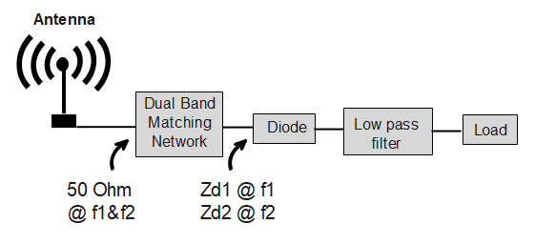
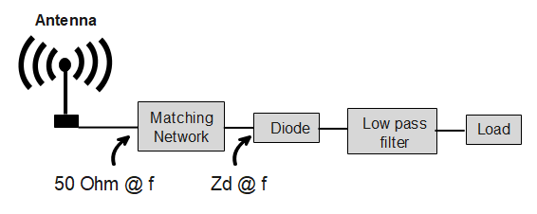
In this work, we have made a noticeable modification on the matching part in the conventional rectifier, see Figure.1. b. A dual-band matching network is utilized. Making a circuit operating at any two arbitrary frequencies is not a simple task. The reason behind that, the rectifier has two different complex input impedances, so that rectifier input impedance is a function with frequency. Moreover, powers and loads can influence the rectifier input impedance.
- (b)
Figure 1. Block diagram of rectenna (a) Conventional rectenna with single-band matching network. (b) Proposed rectenna with dual-band matching network

  - Rectifier Topology
There is a bunch of rectifier typologies and each topology has its benefits over others relying on application and the power density available in space. The most common typologies are the single series diode for low power applications [20] and the voltage doubler for moderate and high power applications [21]. Her a single series diode is utlize owing to operate at low power range of (-5dBm). A large-signal S-parameter (LSSP) and Harmonic Balanced (HB) tools in ADS software are used to analyze and compare the rectifier’ efficiencie. Diodes employed in the analysis is HSMS2850 Schottky diodes. This diode type has low forward bias voltage 0.15v characteristics and fast switching. A vendor model from the ADS library is used with a low pass filter of the series inductor L=14nH and shunt capacitor C=47pF, used to eliminate the high order harmonics and to smooth the output voltages.

  - CRLH Dual-Band Matching Network
Impedance matching network is a key part in most microwave and RF circuits because it ensures the maximum power transfer among parts of the one circuit. Furthermore, it rejects the harmonics propagating backward from one part to another because it acts like a band pass filter BPF, but with unequal port impedance, unlike the conventional filters. When the microwave circuit operates at fixed frequency, input power, and fixed
load, this leads to the circuit, operating under fixed circumstances. However, as we mentioned earlier, in rectifiers, impedance are variable. Unless the matching circuit is designed carefully, the overall performance will be deteriorated with any a slight change in the diode impedance. Typically, the matching circuits are designed to operate at only one frequency and this is normal in the RF circuits because they work at that frequency. On the contrary, it is desirable to harvest the ambient power from a wide range of frequencies to collect power as much as we can. As a number of frequency bands is increased, the circuit complexity increases. Both circuit parts and sizes are matter. If lumped elements used, sizes will be smaller than circuit consisting of transmission circuit, but extra losses introduced by lumped elements will be added. Mostly, the compromise have been made to achieve in between goal. Herein, the goal is to build very small footprint circuits with lumped elements in order to use it in our future works with dense-rectenna array. Also, the circuit will be designed at two arbitrary frequencies using the CRLH technique. The mathematical analysis of the adopted CRLH technique to design the proposed dual-band matching circuit is introduced in the following discussion. To calculate the complex input impedance of any two port network, the transmission ABCD parameters are used as:
$Z_{in}=\frac{{AZ}_{L}+B}{D+CZ_{L}}$ (7)

Where Z_{L} is the load impedance where it consists of real and imaginary parts as in $Z_{L}=R_{L}+jX_{L}$ Values of A, B, C, and D rely on the type of the circuit utilized in the matching network and values of lumped elements. This equation is employed to design a dual-band matching network. Besides, it is used to calculate the scattering S-parameters. Various types can be found in [22] regarding dual-band matching networks using lumped elements, but only one type is adopted here to achieve research task. This circuit is the series-shunt type.
In this paper, the proposed circuit operates at 1.8GHz and 2.4GHz. These two frequencies are chosen since they are always available in space indoor and outdoor. To demonstrate how the dual-band matching occurs, let us follow this procedure. First, the circuit is designed at the lower frequency, where the shunt inductance L_{L} and series capacitance C_{R} lumped elements are responsible for doing. Then, the series inductance L_{R} and shunt capacitance C_{R} are optimized to match the circuit at the higher frequency of 2.4GHz. The subscript $L$ stands for the left or lower frequency band, while the subscript $R$ stands for the right or high frequency band. Due to a rule. of thumb, that when selecting a matching component, the component should have more impact in the target band and less effect in the other band. For example, the series inductance L_{R} is one of the components used to match the circuit at the second frequency, and it should have a zero or close to zero impedance at the first frequency. In other words, this lumped element does not have any impact on matching of the other frequency [23].
The ABCD matrix of series-shunt connection can be obtained as [24].
$\begin{matrix}1-X_{m}X_{n} & jX_{m} \\ jX_{n} & 1\end{matrix}$ (8)
Where $jX_{m}=Z$ and $jX_{n}=y$.
To compote the input impedance of series-shunt connection, Equation (7), (8) can use as

$Z_{in}=\frac{R_{L}+j\left\{X_{L}-X_{L}^{2}X_{n}-R_{L}^{2}X_{n}+\left(1-2X_{L}X_{n}+R_{L}^{2}X_{n}^{2}+X_{L}^{2}X_{n}^{2}\right)X_{m}\right\}}{{\left(1-X_{L}X_{n}\right)}^{2}+{\left(R_{L}X_{n}\right)}^{2}}$ (9)

Equation (9) consists of both real and imaginary parts. Hence, the real part, which is R_{in}, is rearranged to obtain X_{n} as following:
$X_{n}=\frac{(R_{in}X_{L}±\sqrt{R_{in}R_{L}({R_{L}}^{2}+{X_{L}}^{2}-R_{in}R_{L}} )}{R_{in}({R_{L}}^{2}+{X_{L}}^{2})}$ (10)

X_{n} should always be real, and to satisfy this situation the expression $R_{L}-R_{in}+{X_{L}^{2}}/{R_{L}>0}$. After obtaining the X_{n} term, the X_{m} term can be calculated by rearranging the imaginary part of the input impedance which is given as following:
$X_{m}= \frac{\left({R_{L}}^{2}+{X_{L}}^{2}\right)X_{n}-X_{L}+\frac{X_{in}}{R_{in}}R_{L}}{\left({R_{L}}^{2}+{X_{L}}^{2}\right){X_{n}}^{2}-2X_{L}X_{n}+1}$ (11)
In Equation (11), only the term X_{m} is unknown.
The one deficit of this approach is that the radicands of X_{n} and X_{m} must be always a positive value. To overcome this problem, a combination between series-shunt and shunt-series circuit types are used as in [22]. The adopted modification aids to increase a degree of design freedom, and ensures that the radicands of X_{n} and X_{m} can be either positive or negative values. One of these combinations is the composite right left-handed (CRLH), being widely used last two decades to synthesize dual-band transmission lines. The synthesized transmission lines can be implemented using only lumped elements. The new transmission lines offer compact footprints. However, extra losses added by lumped elements represent the main source of losses, so making a CRLH transmission line, being a combination of lumped elements and conventional transmission lines, is preferred over other combinations. Here in this research, a CRLH transmission line with only lumped elements will be used as mentioned earlier because the proposed energy harvester will be used in a rectenna array in our future work., seeking for ones with very small footprints. Figure 7. shows a dual-band CRLH transmission line, acting as a dual-band matching network, connected to a load impedance Z_{L} varying with the frequency. As known, the CRLH has dual-band pass characteristics, where the resonance coming from the series resonant tank is called series resonance W_{ES} and the resonance coming from the shunt resonant tank is called the shunt resonance W_{SH}. The series and shunt resonant tanks have impedance Z and admittance Y, respectively, given as

$Z=jX_{m}=j\left(WL_{R}-\frac{1}{WC_{L}}\right)$, $Y=jX_{n}=j\left(WC_{R}-\frac{1}{WL_{L}}\right)$ (12)

where $W$ is the design angular frequency. X_{m} and X_{n} can calculate from Equation (10) and (11) of series shunt connection. Then the component value of $C_{R}, C_{L}, L_{R}, L_{L}$ can obtain as
$C_{L}=\frac{K^{2}-1}{w k (X_{m2}-kX_{m1})}$ (13) $L_{R}=\frac{1}{w}(X_{m1}+\frac{1}{wC_{L}} )$ (14)
$L_{L}=\frac{k^{2}-1}{w k (X_{n2}-kX_{n1}}$(15) $C_{R}=\frac{1}{w}\left(X_{n1}+\frac{1}{w L_{L}}\right)$ (16)
where K is frequency ratio, $K={f_{2}}/{f_{1}={W_{2}}/W}$ and $K>1. f_{1}$and $f_{2}$ are a first and second frequency respectively.
Having discussed and analyzed all the important information regarding the rectifier and the proposed dual-band impedance transformer, in this work, we will design the proposed dual-band energy rectifier, operating
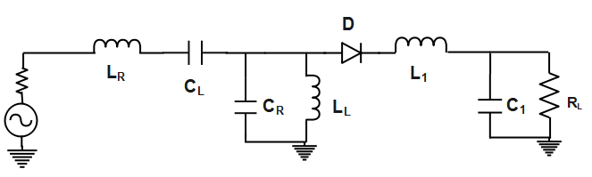
Figure 2. Schematic of rectifier with CRLH dual band matching network transformin. R_{L=}1.5Kohm, C₁=47pF, L₁=14nH, L_{L}=4.6nH, C_{R}=0.2pF, C_{L}=0.4nH, L_{R}=6.9nH

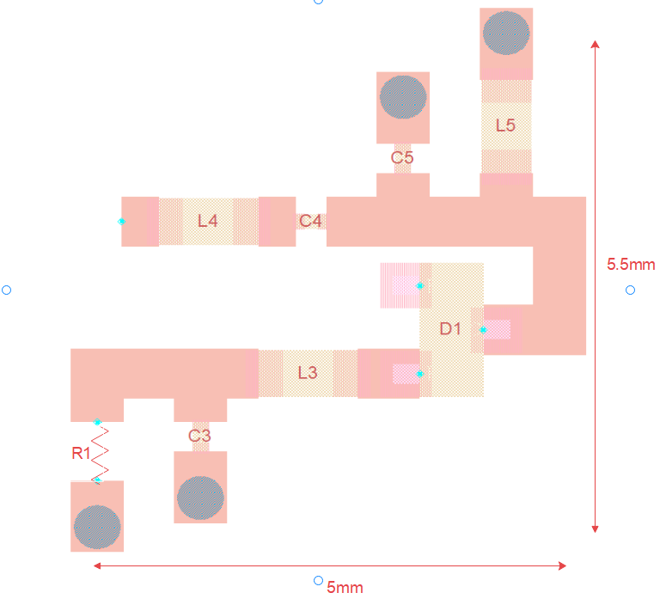
at frequencies 1.8GHz and 2.4GHz, but any two arbitrary frequencies can be considered. To evaluate its performance, the reflection coefficient, output voltage, and efficiency are optimized to obtain the best results as much as possible. The input power, load, and frequency are the most three parameters that effectively impact rectifier performance. Thus, trading-off among them is imperative. In all simulations, real-world lumped components from Murata are utilized in order to make the results closer to the practical ones because each element in Murata has its associated parasitic effects. The circuit schematic is depicted in Figure 2. R_{L} and C₁ represent the load and the low pass filter, respectively. The larger the R_{L} is, the larger the output voltage, but is the smaller the efficiency. C₁ can be considered the main storage of the DC power, and it can also work to shorten out the AC signals. The latter function can be carried out with a help of the series inductor L₁. This inductor tends to have bigger impedance as the frequency increases, so fundamental and higher harmonics are attenuated to some acceptable extent. In the schematic, D₁ is the diode which is the main component, responsible for the rectification process, while all other remaining elements L_{L}, C_{L}, L_{R}, and C_{R} form the dual-band matching circuit. Furthermore, the traces connecting among all the circuit components are electromagnetically simulated and then are exported into the main schematic to take into account their losses. This procedure is called co-simulation and is achieved by the ADS software. The final real circuit with the true footprint layout for each lumped element is shown in Figure 3. The Roger Duroid 3010 laminate is used with a relative permittivity of 10.2 and a thickness of 0.5 mm.

Figure 3. Final topology of the proposed dual-band rectifier where the final size on the PCB is 5.5X5mm2 taken from the ADS software

- Results and Discussion (Rectifier Performance)
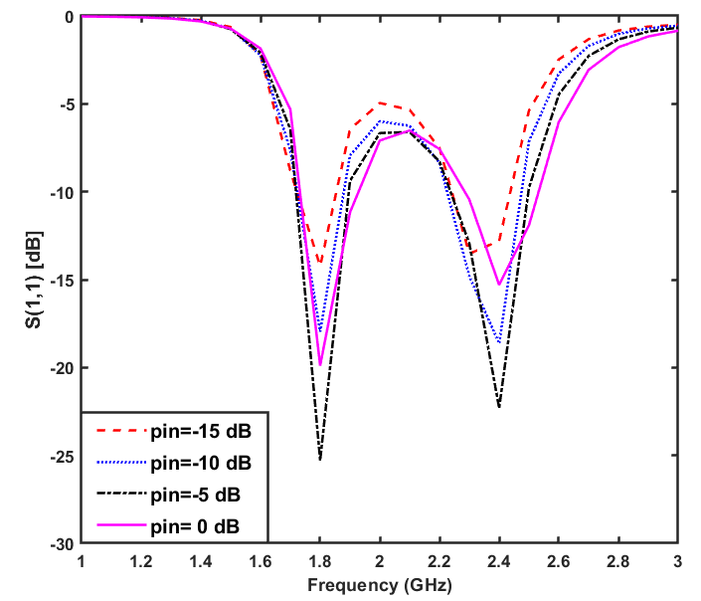
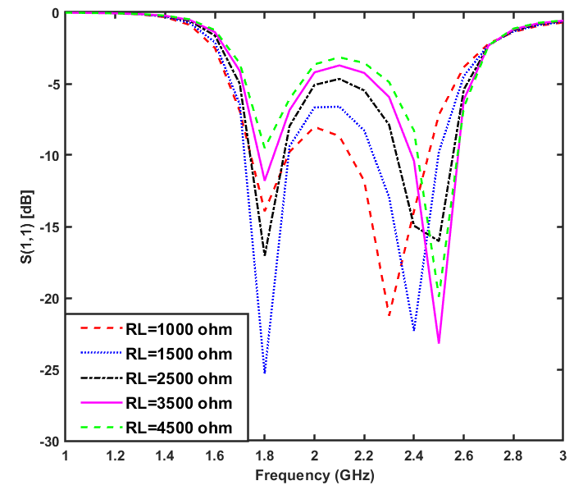
The simulated reflection coefficient S11 of the rectifier circuit with different input power levels is depicted in Figure 4.a with a fixed load resistance of 1.5kohm. As can be seen, the proposed rectifier is matched very well at frequencies of 1.8GHz and 2.4GHz even with varying input power. For both bands, the matching frequency tends to slightly shift to a lower frequency. This means that the matching operates well with the new resonant frequencies. However, matching of all bands is still satisfactory. Moreover, the frequency range between the two bands has S11 about -6dB when the input power is equal to -5dBm, and this could result in a wide-band rectifier which is very useful to harvest more power from space. The rectifier has good matching at -5dBm where this value is close to the power available from typical sources such as WiFi, cellular, digital TV broadcasting, etc. In Figure 4.b, the input power is fixed at -5dBm, and the load resistance varies from 1kohm to 4.5kohm. Load resistance of 1.5kohm provides the best results of matching at frequencies of 1.8GHz and 2.4GHz because the circuit is optimized at this value. As the input power increases the matching is improved, but the response begins to deteriorate after -5dBm. This occurs because the diode utilized in the proposed design is dedicated to operating at the low power levels.
- (b)
Figure 4. Reflection coefficient S11 of the rectifier with (a) different input power levels and fixed load resistance value of 1.5kohm (b) different load resistance values and fixed input power of -5dBm

The conversion efficiency and the output voltage can be calculated using the formulas given below as [25].
$Effeciency=\frac{P_{Dc}}{P_{in}}×100$ (17)
And output voltage
$V_{o}=\sqrt{P_{Dc}×R_{L}}$ (18)

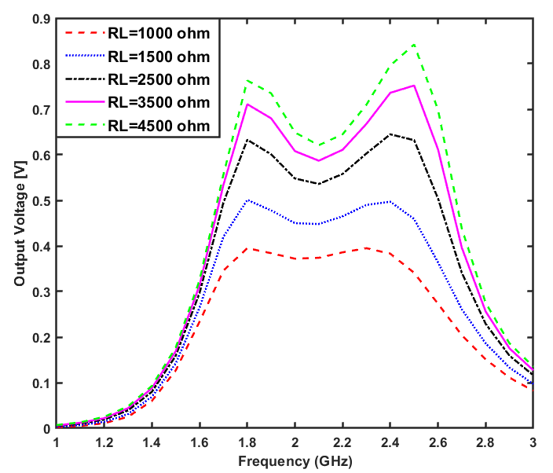
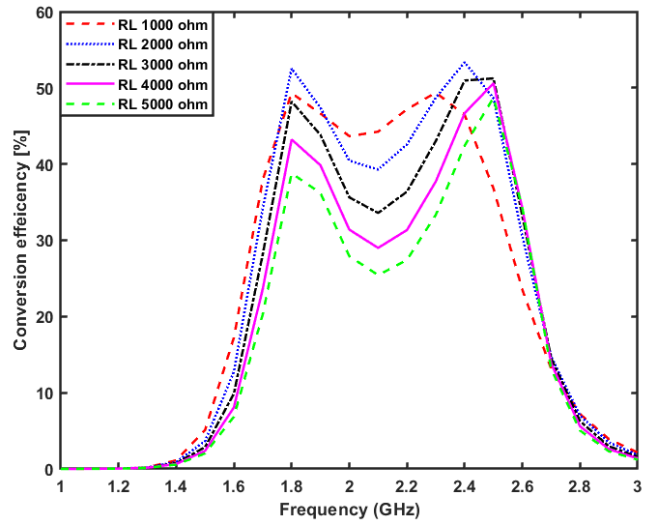
Here, V₀ and P_{Dc} represent the DC output voltage and DC output power, respectively. P_{in} denotes the input power from the RF source. They are depicted in Figures 5 and 6. When R_{L} is equal to 1.5kohm, it gives rise to the highest efficiency, approximately about 53% for both bands, thanks to the benefit of CRLH dual-band matching network. As the matching increases, the more power will be transferred into the load. in other words, the efficiency increases, where the best matching occurs at a load value of 1.5kohm. Apart from the Figure 5. (a) Conversion efficiency vs. frequency for different loads and fixed input power of -5dBm (b) output DC voltage vs. frequency for different loads and fixed input power of -5dBm
optimum load value, especially when it increases, the efficiency is noticeably decreased. This is reasonable as we stated before. On the contrary, the DC output voltage increases, as the load resistance increases. Even if the output voltage increases, the output DC power decreases, leading to the decrement inefficiency , see Figure 11. for more details. Figure 5. shows the output DC voltage versus frequency for different input power. Also, it increases when increasing the input power, and the output voltage reaches about 0.95v at frequencies of
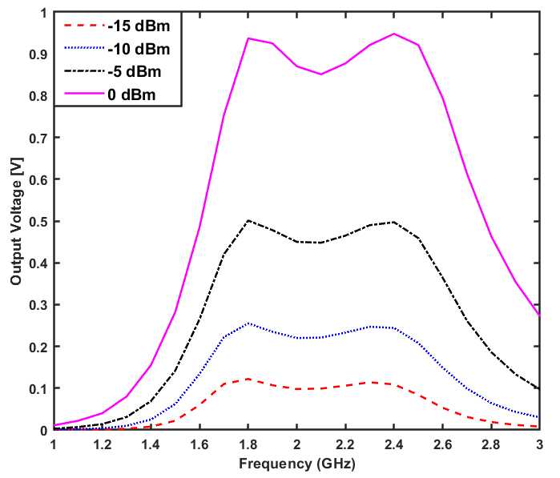
1.8GHz and 2.4GHz. This voltage decreases to almost half when the input power becomes -5dBm. The dip between the two bands tends to diminish with decreasing in the input power and the two bands are emerged to be as a single wideband.

Figure 6. Output DC voltage vs. frequency for different input power and a fixed load of 1.5kohm

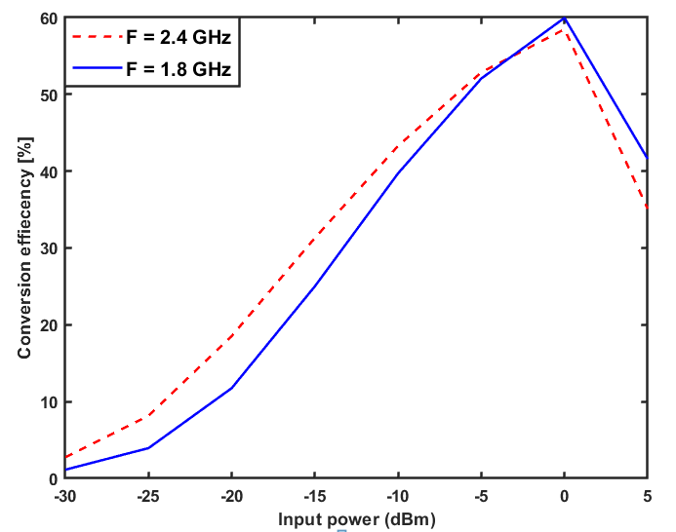
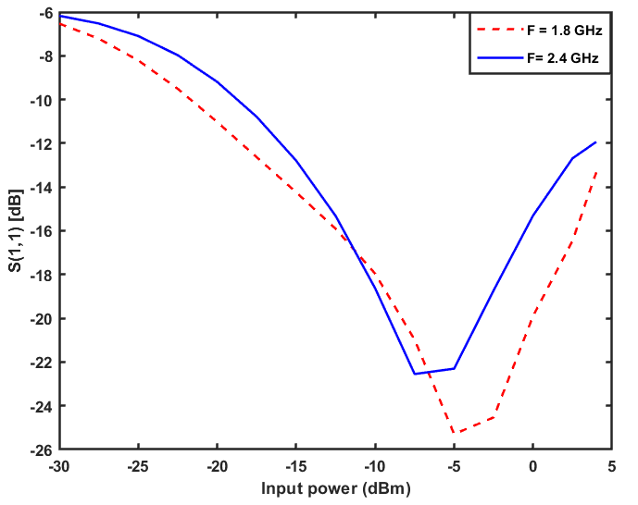
The S11 versus the input power is depicted in Figure 7.a for 1.8GHz and 2.4GHz frequencies. The proposed circuit is well matched at about -5dBm for both bands with large bandwidths. The simulated S11 is less than -20dB which means that 99% of the input power is transferred into the load if we ignore the losses in lumped elements and transmission lines. Practically, some power will be absorbed and converted into heat. Furthermore, the conversion efficiency at both bands versus the input power is illustrated in Figure 7.b. As can be seen, the efficiencies are almost equal at 0dBm. After that, the diode fails to convert the power since the input voltage is larger than the diode’s breakdown voltage. The efficiencies are almost 53%. At very low input power.
- (b)
Figure 7. a. Simulation of S11. b. Simulation of conversion efficiency. concerning input power at the two frequency band 1.8 and 2.4 GHz and a resistive load of 1.5Khom
- Conclusion
In this work, a compact dual-band rectifier for a low input power range from -30 to -5dBm with the single series diode topology using HSMS2850 Schottky diode is implemented, operating at frequencies of 1.8GHz and 2.4GHz. The composite right\left-handed (CRLH) transmssion line technique is used to design the dual-band matching network using only lumped elements. The closed-equations formulas based dual-band matching network design is derived in this paper, with full explination, to provide values of the lumped elements. The effeceincies obtained at both prescribed frequency bands are almost the same, being 52%. Moreover, more than 0.5v is appeared at the load when the input power is -5dBm. The reflection coefficient is -22dBm and -25dBm for 1.8GHz and 2.4GHz, respectively. The overall size of the rectifier is very small 5.5$×$5mm² when compared to other related works.

REFERENCES
[1] S. Shen, Y. Zhang, C.-Y. Chiu, and R. Murch, \A triple-band high-gain multibeam ambient rf energy harvesting system utilizing hybrid combining," IEEE Transactions on Industrial Electronics, vol. 67, no. 11, pp. 9215{9226, 2019.
[2] C. Song, P. Lu, and S. Shen, \Highly e_cient omnidirectional integrated multi-band wireless energy harvesters for compact sensor nodes of internet-of-things," IEEE Transactions on Industrial Electronics, 2020.
[3] R. A. Mo_att, \Wireless power transfer by means of electromagnetic radiation within an enclosed space," arXiv preprint arXiv:1611.07076, 2016.
[4] N. Kumari and M. Rokotondrabe, \Thermal network modelling of hybrid piezo-pyro transducer for application in energy harvesting," in 2019 IEEE 5th International Conference for Convergence in Technology (I2CT). IEEE, 2019, pp. 1{4.
[5] S. M. Antony, S. Indu, and R. Pandey, \An e_cient solar energy harvesting system for wireless sensor network nodes," Journal of Information and Optimization Sciences, vol. 41, no. 1, pp. 39{50, 2020.
[6] S. Balguvhar and S. Bhalla, \Green energy harvesting using piezoelectric materials from bridge vibrations," in 2018 2nd International Conference on Green Energy and Applications (ICGEA). IEEE, 2018, pp. 134{137.
[7] W. Zahra and T. Djera_, \Ambient rf energy harvesting for dual-band frequencies below 6 ghz," in 2018 IEEE Wireless Power Transfer Conference (WPTC). IEEE, 2018, pp. 1{2.
[8] B. Munir and V. Dyo, \On the impact of mobility on battery-less rfenergy harvesting system performance," Sensors, vol. 18, no. 11, p. 3597, 2018.6
[9] R. K. Sidhu, J. S. Ubhi, and A. Aggarwal, \A survey study of di_erent rf energy sources for rf energy harvesting," in 2019 International Conference on Automation, Computational and Technology Management (ICACTM). IEEE, 2019, pp. 530{533.
[10] U. Muncuk, K. Alemdar, J. D. Sarode, and K. R. Chowdhury, \Multi- band ambient rf energy harvesting circuit design for enabling batteryless sensors and iot," IEEE Internet of Things Journal, vol. 5, no. 4, pp. 2700{2714, 2018.
[11] F. Erkmen, T. S. Almoneef, and O. M. Ramahi, \Scalable electromagnetic energy harvesting using frequency-selective surfaces," IEEE Transactions on Microwave Theory and Techniques, vol. 66, no. 5, pp. 2433{2441, 2018.
[12] S. Chandravanshi and M. J. Akhtar, \Design of e_cient recti_er circuit in the gsm band for energy harvesting applications," in 2017 IEEE MTT-S International Microwave and RF Conference (IMaRC). IEEE, 2017, pp. 1{5.
[13] A. Sedeek, E. Tammam, and E.-S. Hasaneen, \High e_ciency 2.45 ghz low power hybrid junction recti_er for rf energy harvesting," in 2018 International Japan-Africa Conference on Electronics, Communications and Computations (JAC-ECC). IEEE, 2018, pp. 147{150.
[14] M. ur Rehman, W. Ahmad, and W. T. Khan, \Highly e_cient dual band 2.45/5.85 ghz recti_er for rf energy harvesting applications in ism band," in 2017 IEEE Asia Paci_c Microwave Conference (APMC). IEEE, 2017, pp. 150{153.
[15] S. Chandravanshi and M. J. Akhtar, \A dual band di_erential rectifying circuit for rf energy harvester," in 2017 IEEE Asia Paci_c Microwave Conference (APMC). IEEE, 2017, pp. 491{494.
[16] C. Song, Y. Huang, P. Carter, J. Zhou, S. Yuan, Q. Xu, and M. Kod, \A novel six-band dual cp rectenna using improved impedance matching technique for ambient rf energy harvesting," IEEE Transactions on Antennas and Propagation, vol. 64, no. 7, pp. 3160{3171, 2016.
[17] K. Niotaki, S. Kim, S. Jeong, A. Collado, A. Georgiadis, and M. M. Tentzeris, \A compact dual-band rectenna using slot-loaded dual band folded dipole antenna," IEEE Antennas and Wireless Propagation Let- ters, vol. 12, pp. 1634{1637, 2013.7
[18] H. Tafekirt, J. Pelegri-Sebastia, A. Bouajaj, and B. M. Reda, \A sensitive triple-band recti_er for energy harvesting applications," IEEE Access, vol. 8, pp. 73 659{73 664, 2020.
[19] D. Colaiuda, I. Ulisse, and G. Ferri, \Recti_ers' design and optimization for a dual-channel rf energy harvester," Journal of Low Power Electronics and Applications, vol. 10, no. 2, p. 11, 2020.
[20] S.-P. Gao and H. Zhang, \Topology comparison of single-diode recti_ers: Shunt diode vs. series diode," in 2019 12th International Workshop on the Electromagnetic Compatibility of Integrated Circuits (EMC Compo).IEEE, 2019, pp. 177{179.
[21] J. Tissier, M. Koohestani, and M. Latrach, \A comparative study of conventional recti_er topologies for low power rf energy harvesting," in 2019 IEEE Wireless Power Transfer Conference (WPTC). IEEE, 2019, pp. 569{572.
[22] B.-T. Moon and N.-H. Myung, \A dual-band impedance transforming technique with lumped elements for frequency-dependent complex loads," Progress In Electromagnetics Research, vol. 136, pp. 123{139, 2013.
[23] Z. Zhang, Antenna design for mobile devices. John Wiley & Sons, 2017.
[24] D. M. Pozar, Microwave engineering. John wiley & sons, 2011.
[25] A. Sample, D. Yeager, M. Buettner, and J. Smith, \Development of sensing and computing enhanced passive r_d tags using the wireless identication and seinsing platform," D

