Additional information on the distribution and correlation of collected data

- Analysis of the distribution of collected data

Next, the collected data distribution test will be carried out, using the Shapiro Wilk test, which is used for samples smaller than 50. It should be noted that the sample in this investigation is equal to 30, because a daily measurement was carried out. Likewise, when finding normality of the data, this will incline us to determine the indicators that are related to each other; This analysis will be carried out for the data collected in the automatic system, since they are the values that show an improvement in its indicators. En la siguiente tabla se muestra lo obtenido por medio del software SPSS V25.
Table 1: Normality test of the data
 | Shapiro -Wilk
 | Statistical | gl | Sig.
Actual production (m³/hr) | 0.942 | 30 | 0.100
Estimated production (m³/hr) | 0.842 | 30 | 0.405
Production time (hr) | 0.785 | 30 | 0.120
Efficiency | 0.942 | 30 | 0.101
Loss capacity (m³/hr) | 0.942 | 30 | 0.100

In table 1, it can be observed that the bilateral significance of the data (Sig.), In all indicators is greater than α = 0.05, and according to statistical theory, if this statement is fulfilled, it indicates that there is normality in the data, therefore, the correlation test can be applied. Likewise, Figure 1 shows us the normality curve of the data, which corroborates the normal distribution of the results obtained.
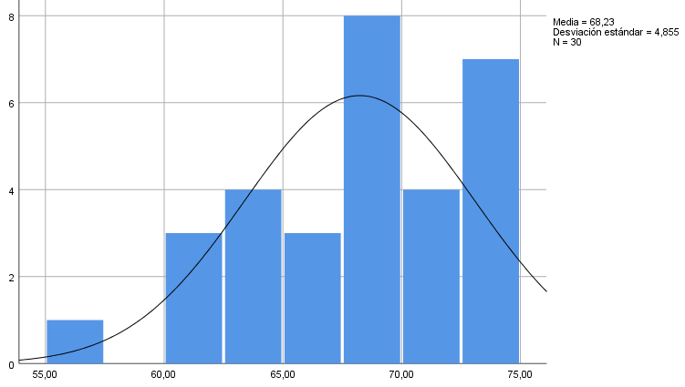

Figure 1. Histogram with normal distribution curve of the collected data

- Correlation of collected data
When finding normality of the data in the previous point, and once the comparative analysis of the results has been carried out, it will be statistically validated, by means of the Pearson coefficient, if there is a correlation between the indicators of the productivity variable; As indicated, this analysis will be carried out for the data collected in the automatic system, since, as observed in point 3.2, these are the values that show an improvement in its indicators.
Table 2: Pearson's Correlation Test
 | Actual production (m³/hr) | Estimated production (m³/hr) | Production time (hr) | Efficiency | Loss capacity (m³/hr)
Actual production (m³/hr) | 1,000 | 0,049 | -0,675 | 0,948 | -0,949
Estimated production (m³/hr) | 0,049 | 1,000 | 0,891 | 0,916 | -0,989
Production time (hr) | -0,675 | 0,891 | 1,000 | -0,827 | -0,091
Efficiency | 0,948 | 0,916 | -0,827 | 1,000 | -0,916
Loss capacity (m³/hr) | -0,949 | -0,989 | -0,091 | -0,916 | 1,000

As can be seen in the previous table and focusing on the efficiency indicator, we can establish the following:
• There is a highly significant correlation of 0.948, positive and directly proportional between the efficiency indicator and the real production (m³/hr) of the stone materials dosing process. The positive constant means that the higher the efficiency, the greater the amount of production.
• There is a highly significant correlation of 0.916, positive and directly proportional between the efficiency indicator and the estimated production (m³/hr) of the stone materials dosing process.
• There is a highly significant correlation of -0.827, negative and inversely proportional between the efficiency indicator and the production time (hr) of the stone materials dosing process. The negative constant means that the higher the efficiency, the shorter the time used for production.
• Finally, the results indicate that there is a highly significant correlation of -0.916, negative and inversely proportional between the efficiency indicator and the production loss capacity. The negative constant means that, the higher the efficiency, the lower the production loss capacity will be generated in the stone materials dosing process.

