Design and Implementation of a Broad-band High Gain
Low Noise Amplifier for 3G/4G Applications

Ahmed M. Abdelmonem ¹, Ahmed S. I. Amar ², Amir Almslmany ³, Ibrahim L. Abdalla¹ and Fathi A. Farag¹
¹Electronics and Communications Engineering Department, Faculty of Engineering, Zagazig University, Zagazig, Egypt
²Department of Electronics and Communications Engineering, Ain Shams University, Cairo, Egypt
³Electrical Engineering Department, Alexandria University, Alexandria, Egypt

Article Info |  | ABSTRACT (10 PT)
Article history:  Received  Revised  Accepted |  | The main objective of this paper is to design and implement a broadband low noise amplifier (LNA) based on compensated matching network technique in order to get high stable gain, low noise figure, low cost and smaller size for 3G/4G communication system applications at 2 GHz with bandwidth 600 MHZ. The proposed circuit is simulated by the Advanced Design System (ADS). The implementation has been done by using Low noise transistor BFU 730F with the usage of minimum noise figure of 0.62 dB with class A bias circuit. Collector current is measured to be 5.8mA and base current is 19.1µA with a supply voltage of 2.25V. The new design proposed a minimum noise figure of 0.62 dB with a 17.8 dB high stable amplifier gain. The microstrip lines (MSL) and compensated matching network techniques was used To improve the LNA’s stability and to achieve a good result. The LNA printed circuit board is designed and assembled on FR4 substrate material. Wellbeing concession is settled between the simulated and measured results.
Keywords:
Low Noise Amplifier
3G/4G
High Stable Gain
Low Cost
Communication System
Compensated Matching Network
This is an open access article under the CC BY-SA license.

Corresponding Author:
Ahmed Mohammed Abdelmonem,
Department of Electrical and communication engineering,
zagazig University,
zagazig meetghamr street,
Email: bakhom.ahmed@gmail.com.

- INTRODUCTION
As well known, needing for 3G/4G portable wireless devices has motivated the development of a Low Noise Amplifier (LNA). In a wireless system, LNA is the first stage of most RF receiver design. The performance of the RF receiver mainly depends on the effectiveness of the LNA block . Cell phones are the perfect way to stay connected with others and have become a necessity for many people throughout the world. Today’s technically advanced cell phones (3G/4G) are capable of not only receiving and placing phone calls but storing data, taking a picture, mobile internet access, video calls, mobile TV gaming services and 3D television. Broadband LNA is essential in the multi-band mobile receiver [1]. Briefly, the definition of LNA is a reception system able to receive very weak signals to be strengthened in order to satisfy the level acceptable to proceed to the main device transceiver compared to traditional narrow-band LNA. The design of wide-band LNA is quite distinctive and afford much more challenges such as broad-band input matching to minimize the return loss, sufficient and flat gain, low noise figure (NF), low power consumption and high linearity [2].
There are many techniques to design broadband LNA such as: compensated matching network [3], balanced amplifier [4], distribution amplifier [5] and negative feedback [6]. Some references about these LNAs design have been published. The utilization of dual wide band with (2-4 GHz and 5- 6 GHz) has been proposed in [7]. Also, 2.3 GHz LNA for WiMAX is published in [8], the noise figure for the optimized LNA is 1.102dB and the voltage gain is 15.11 dB at 2.3 GHz. Broadband low-noise amplifier (LNA) 2- 6 GHz with prevailing reuse and noise-shaping technique [9].
Over the band of interest, noise figure differ from 3-3.7 dB, this situation does not support the specification that will be built, LNA design for 3G/4G applications. For this band, the designed LNA with a NF of 0.588 dB, unconditional stability along and the gain of 12.85 dB has been published in [10].
In this paper, a broadband LNA based on compensated matching network technique has been designed and implemented at 2 GHz in order to get high stable gain, low noise figure, and smaller size for a 3G/4G communication system.
This work is organized as: The second section illustrates the LNA circuit design methods. The analysis, design steps and simulations by using ADS have been discussed in the third section. The implementation and simulation results have been introduced in the fourth section. Finally, the conclusion has been explained.
- BROADBAND LNA CIRCUITS APPROACHES.
The key and challenge to realize broadband LNA design is to achieve high gain and ensure stability in the whole band. The common structures of broadband LNA are as follows [12]:
- Compensated matching network,
- Balanced amplifier,
- Distribution amplifier,
- Negative feedback amplifier.
The compensated matching network design is essential to obtain gain flatness results and low noise figure by using stepped impedance matching and single short stub. The stepped impedance matching circuit (quarter-wave transmission line) helps the design to reduce the load and source reflection coefficient (Γ) by making multiple steps ʎ/4 length of the TL. In this case, the input impedance at the load or the source efficient can be obtain as Zin = Z₀²/Z_{L}, Zin = Z₀²/Z_{S} where Z_{o} is TL characteristic impedance. Also, single short stub also be considered matching circuit at source and load to improve the reflection coefficient and voltage standing wave ratio (VSWR).
A balanced amplifier is a practical method of implementing a broadband amplifier that has flat gain and good input and outputs matching. using two (3-dB) hybrid couplers of a balanced amplifier consider the most popular arrangement.
A distribution amplifier is a circuit, which designs that incorporate transmission line theory into conventional amplifier design to get a high gain-bandwidth product than is realizable by traditional circuits.
Negative feedback can be used in broadband amplifiers to provide a flat gain response and to reduce input and output VSWR, It also controls the amplifier performance due to variations in the S-parameters from transistor to transistor. Negative feedback has two forms, shunt, and series. When accordingly designed, negative feedback can be:
- Preserve gain flatness and impedance match;
- Reduce component temperature tolerance effects
- Enhance dc and RF stability;
- Reduce distortion (depending on where the distortion is generated) [13].
In general, shunt feedback can simply maintain stability at lower RF frequencies but weakens it at the higher frequencies [14].
Series feedback is not favored for RF applications because it can decrease stability with respect to parallel feedback.
Even though the compensated matching network amplifier enhances the other indicators by sacrificing the noise figure marginally, but by comparison, this structure nonetheless is the excellent method with the best effect. So, compensated matching network amplifier is adopted and used in this work.

- CIRCUIT ANALYSIS AND DESIGN STEPS
In this section, the design analysis of LNA for 3G/4G applications is presented. Table 1 shows the proposed low noise amplifier specifications.
Table 1. LNA design parameters
Parameter | Value
Center Frequency ($f_{c}$) | 2 GHz
Sweep Bandwidth ($BW$) | 600 MHz
Gain | > 16.5 dB
Noise Figure | < 0.7 dB
Stability | Unconditional Stable
Supply Voltage | 2.25 V

The proposed broadband Class-A LNA circuit [6] with compensated matching network with a NPN SIGE RF transistor BFU-730F device as shown in Figure 1.
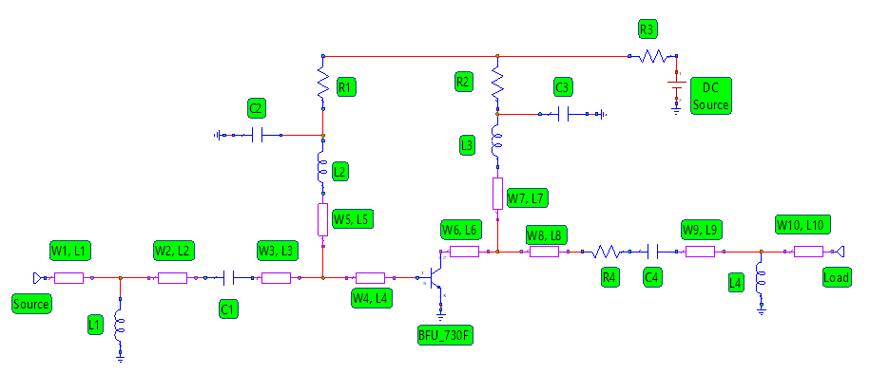
Figure 1: Proposed circuit schematic of broadband LNA
In this case, stable broadband gain and good impedance match simultaneously in the RF range, the compensated matching network amplifier was used. The computer base method [15] has been used for the amplifier designing.

3.1. Bias Configuration
Most microwave Bipolar junction transistors (BJTs) are made via silicon in the NPN mode. Below 4 GHz, silicon BJTs provide a reliable and low-cost solution to many electronic designs.
The transistor dimensions are tiny to allow operations at microwave frequencies. The NPN SIGE RF transistor BFU-730F was used. These transistor has a small noise figure over the whole band along with enough gain at high frequency. From data sheet, the BFU-730F amplifier provides less than 0.7 dB noise figure with a typical gain of 17.8 dB at V_{CE} = 2.025V and Ic = 5.8mA operating point. The high DC current is necessary for high gain. Of course, the higher current generates higher noise. In order to obtain the greatest possible high-frequency gain, the noise figure is sacrificed to a certain extent.

3.2. Stability Analysis

The stability of the amplifier is a very important consideration since, it measure the resistivity of the system against the oscillation. For unconditional stability, the scattering parameters of the device determines the stability as provides in equation (1) to (4):
|Γ_{S}| < 1 | (1)
|Γ_{L}| < 1 | (2)
|Γ_{IN}| =| S₁₁ + $\frac{S12×S21×ΓL}{1-S22×ΓL}$ | < 1 | (3)
|Γ_{OUT}| =| S₂₂ + $\frac{S12×S21×ΓS}{1-S11×ΓS}$ | < 1 | (4)

Where, Γ_{S} and Γ_{L} are the source and load reflection coefficients respectively.
Moreover, the stability of the amplifier circuit was recognized by the stability factor (k) as mentioned in equation (5). The state of unconditional stability can be realized from:
K= $\frac{1-{\left|S11\right|}^{2}-{\left|S22\right|}^{2}+{\left|Δ\right|}^{2}}{2|S12×S21|}$ > 1 | (5)
Δ= S₁₁×S₂₂ - S₁₂×S₂₁< 1 | (6)
So, |S₁₁| and |S₂₂| must be less than 1 to achieve unconditional stability, in order to reach the entire frequency range we have to use stabilizing branches since potential instabilities exist in the whole frequency band.
In table 2, shows the scattering parameters and stability factor (K) to the Low noise transistor BFU 730F. The simulation has been done at the same biasing in our design V_{CE} = 2.025V, I_{BB}=19.1µA without any matching technique where shows the circuit to obtain the scattering parameter of the RF BJT amplifier as shown in figure 2.
Table2. Scattering parameters and stability factor.
Freq. | S₁₁ | S₁₂ | S₂₁ | S₂₂ | K
_{2(GHZ)} | _{-4.2└ -106.16} | _{-27.4└ 41.6} | _{14.5└ 106.7} | _{0.59└ -51.09} | _{0.425}

At the outset, the circuit will achieve lower stability by accommodating the bias circuit to make the stability factor as high as possible, determine the stability factor of BFU-730F in the static bias as shown in table 2. Therefore the high stability factor and low noise characteristic amplifier the circuit shown in Figure 1 is proposed. After simulation and optimization, a compensated matching network circuit is introduced in parallel to strengthen the stability.

3.3. Broadband Matching Network Design
As shown in Figure 1, biasing network is consisting of two bypass capacitors (power supply ripple eliminations). The two RF choke coils (L₂ and L₃) prevent the interaction between DC source voltage and RF signals. Also, the quarter wavelength transmission line (λ\4 T.L) keep the design matching at needed bandwidth, make the impedance high at RF signal and preserve the impedance low at DC source voltage. There are three varieties of transmission lines (the two-wire, the coaxial and the micro strip transmission line).
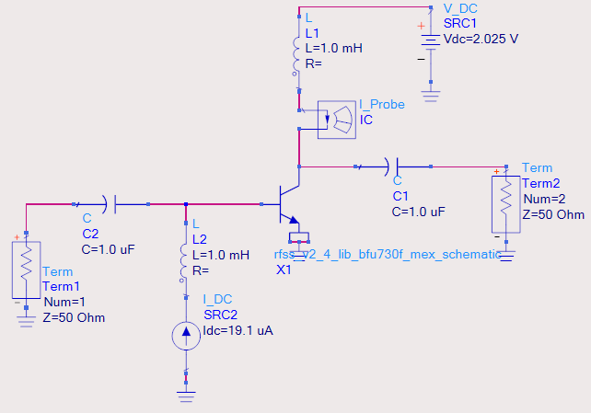
Figure 2: The circuit for S-parameters calculations of RF amplifier

The micro strip transmission line (MSTL) is the most proper for the construction of microwave amplifiers. The input network represents a compromise between best noise figure and reasonable input return loss and consists of capacitor C1 as (DC block), microstrip line matched (Stepped impedance matching Technique)-T, shunt inductor L1 (equivalent for shunt single short stub to make so small size). The output matching network consists of a shunt resister R4 (equivalent for transmission line matching) and shunt inductor L4 (equivalent for shunt single short stub) and capacitor C4 (DC blocking). The methodology mentioned in [16] has been used for matched element realization. The designed elements are shown in table 3.

3.4. LNA Nosie Analysis
Generally, in LNA noise circuit analysis, the input source is modeled as the parallel connection of an equivalent source admittance Y_{S} and noise current $\overline{i_{s}}$. The total noise contributed by the two-port network is modeled as a noise voltage source $\overline{e_{n}}$ and a noise current source $\overline{i_{n}}$ as shown in Figure 3, and the network is noiseless and linear.
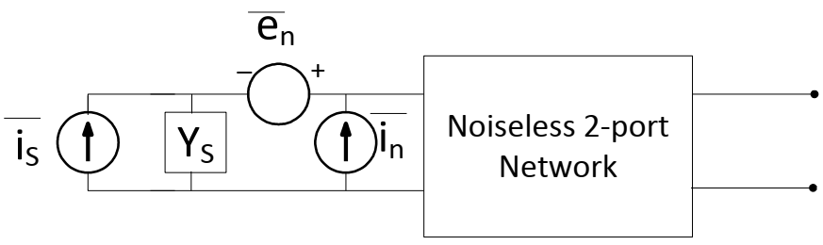
Figure 3: Equivalent Noise Model.
The definition of noise figure is expressed as in equation (7):
$$NF=\frac{total output noise power}{output noise due to input source}$$ | (7)
There are many types of noise sources in electronic circuit such as, thermal noise, Shot noise, and Flicker noise. But Thermal noise and Shot noise are the most effective in LNA circuits. Thermal noise increases with increasing Temperature and Resistance as in equation (8).
$$v_{rms}^{2}=4kTR∆f$$ | (8)
Where K is Boltzmann constant, R is equivalent resistance and T is the temperature in kelvin.
Moreover, shot noise in microelectronic devices results from unavoidable random statistical fluctuations of the electric current when the charge carriers (such as electrons) traverse a junction. If electrons flow across a barrier, then they have discrete arrival times. Those discrete arrivals exhibit shot noise as mentioned in (9)
$$i_{rms}^{2}=2qI∆f$$ | (9)
Where ($i_{rms}^{2}$) is current shot noise generator , q is the elementary charge of an electron, Δf is the single sided bandwidth in hertz over which the noise is considered, and $I$is the DC current flowing.

4. SIMULATION RESULTS
The proposed LNA is designed according to a computer-based method. The scattering parameters are obtained by using the ADS [17] software for NPN SIGE RF transistor BFU-730F device as shown in figure 1and The designed elements values are given in Table 3.
Table 3. Transmission lines, and lumped components Values
Symbols | W₁, l₁  (mm) | W₂, l₂  (mm) | W₃, l₃  (mm) | W₄, l₄  (mm) | W₅, l₅  (mm) | W₆, l₆  (mm)
Values | 0.962, 3.14 | 0.83,  3.35 | 0.55  ,2.16 | 0.55,  3.67 | 0.83,  2.52 | 0.55,  1.72
Symbols | W₇, l₇  (mm) | W₈, l₈  (mm) | W_{9,} l₉  (mm) | W₁₀, l₁₀ (mm) | DC source | R₁
Values | 0.83,  2.52 | 0.55,  1.11 | 0.55,  3.35 | 0.55,  3.14 | 2.2V | 70 KΩ
Symbols | R₂ | R₃ | R₄ | L₁ | L₂ | L₃
Values | 10 Ω | 20 Ω | 20 Ω | 7 nH | 3.3 nH | 8 nH
Symbols | L₄ | C₁ | C₂ | C₃ | C₄ | R₂
Values | 7 nH | 1 pF | 68 pF | 0.5 pF | 2.4 Pf | 10 Ω
Where W is the transmission line width and L is the transmission line length.

Figure 4 shows the Layout for the proposed LNA. Considering the package parasitic inductance, resistance and capacitance of the peripheral. Murata's chip inductors, capacitors and other companies’ resistances with package are appropriate in the schematic simulation.
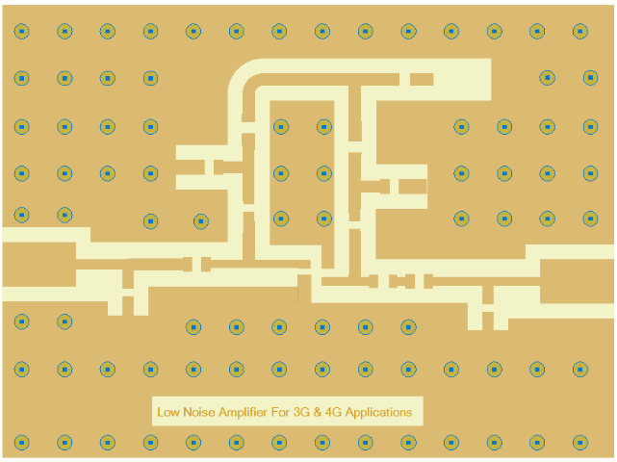
Figure 4: Layout of the proposed LNA.
It should be recognized that each manufacturer’s passive elements demonstrate slightly different parasitical attribute with the help of ADS optimization tool.Both the input matching circuit and load network are composed of ideal micro strip transmission lines.
For 3G/4G applications, the designed LNA proposed circuit has been simulated by using stepped impedance matching network technique and shunt short single stub technique to achieve high flatness gain (17.8dB). Figure 5 demonstrates the variation of the gain (S₂₁) and the input return loss (S₁₁) over the proposed bandwidth (1.7 GHZ to 2.3 GHz).
As observed that the input return loss S₁₁ varied between (-7) dB and (-11) dB and achieved a gain S₂₁ varied between 16.5 dB and 17.8 dB. Thus, these values indicate a good matching and high gain over the interesting bandwidth.
Figure 5: The gain (S₂₁) and the input return loss (S₁₁)
Also, figure 6 shows the NF (Noise Figure) achieved a good result (0.62dB-0.69dB) over the LNA operating band 1.7GHz-2.3GHz. This value indicates that the amount of noise added to the overall system is very low.
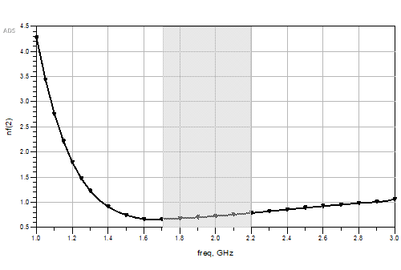
Figure 6: The noise figure.

From Figure 7 it can be observed that stability factor (K) is greater than 1 over the operating band. Thus, the conditions for unconditional stability are validated on the pass frequency band. Therefore, there is no risk to get oscillations.
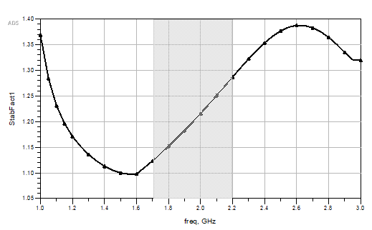
Figure 7: The stability factor (K).

5. EXPERIMENTAL RESULTS

The proposed broadband LNA is implemented using FR4 substrate material with a dielectric constant $ε_{r}= 4.5$, thickness (h) of 1.6 mm, and loss tangent (tanδ = 0.025). The printed circuit board is a one-layer configuration, it has an overall size of about 3 x 3 cm² as shown in Figure 8 .
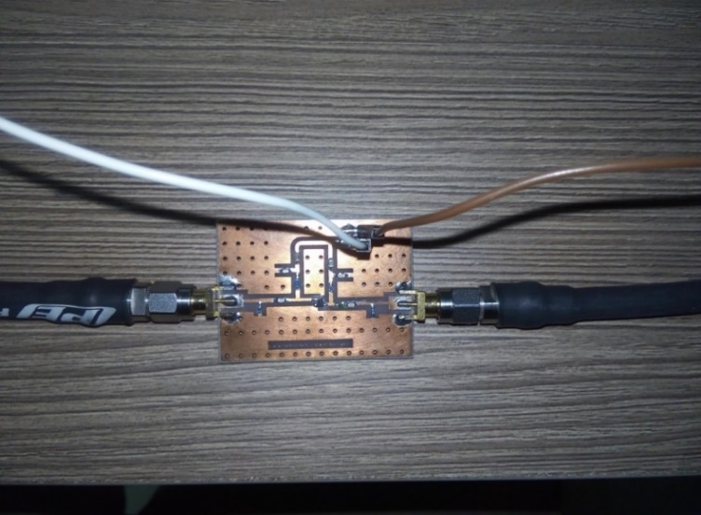
3 cm
3 cm
Figure 8: The PCB of the broadband LNA.
The LNA measurements starts with the quiescent current testing, then the S-parameters measurements using Vector Network Analyzer (VNA). The connections for printed circuit board to the power supply and the network analyzer shown in Figure 9. Figure 10 illustrates the values of the simulated gain (S₂₁) which varied between 16.5 dB to 17.8 dB. The values of the measured gain (S₂₁) which varied between 15.5 dB to 17.1 dB over the proposed band 1.7 GHz to 2.3 GHz. The measurement shows that the difference between the values of simulated gain and measured gain is the same value at center frequency (2 GHz), but over the broad band, it almost less than 1dB. Any slight inequality between simulated and measured outcome due the standard manufacture defects and the copper surface unevenness [18].

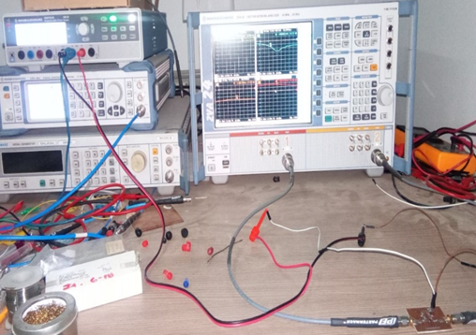
Figure 9: The measurements setup for the LNA circuit.
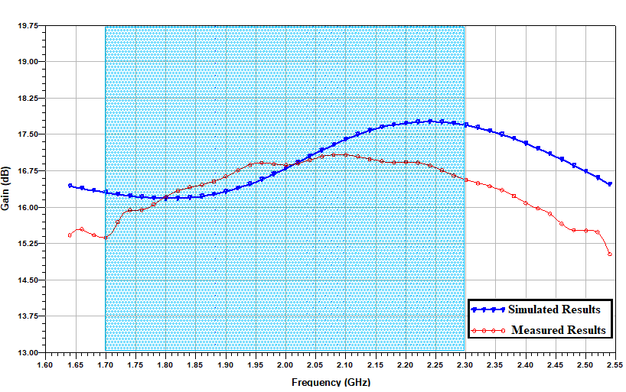
Figure 10: Measured and simulated results of the proposed LNA.
Table 4 Shows comparability between the suggested broadband LNA and other previously developed LNA circuits. The comparison shows that the suggested broadband LNA circuit was achieved the lowest noise figure in addition to the leverage of the gain, small size, with relatively better return loss.

6. CONCLUSION

With the assist of the Advanced Design System (ADS) and the compensated matching network and broadband matching theory, the LNA has been designed by steadily optimization and correcting the circuit parameters. The design was sufficed the electromagnetic (EM) simulation and the design result proved that the proposed broadband LNA has succeeded in a gain of more than 16.5dB, gain-flatness of less than ±0.7dB, noise-figure of less than 0.69 dB. The circuit is designed and assembled on FR4 substrate material to reduce LNA price where it can be extensively used in (3G/4G) communication systems. The proposed circuit was implemented by using a microstrip and the measured parameters are matched with the simulation results.

Table 4. Previous Work Comparison
Ref. | Technology | Frequency | NF (dB) | Gain(dB) | Cost
This Work | BFU-730F SIGE | 1.7-2.3 GHz | 0.69 | 16.5 -17.8 | Low
[19] | SIGE Bipolar | 1.8 GHz | 1.3 | 17 | High
[20] | AT-41410 Si-BJT | 1.75 - 2.15GHz | N/A | 10 - 11.8 | Moderated
[21] | ATF-54143 | 2.3 GHz | 0.46 | 13.8 dB | Moderated
[22] | PHEMT ATF-54143 | 0.5 to 6 GHz | 3.5 | 18 dB | Moderated
[23] | BFP720 | 2.3 | 1.15 | 34 | Moderated
[24] | SIGE HBT | 1.6 – 2.4 | 1.5 | 18 | Moderated
[25] | SIGE HBT | 1 – 2 | 1 | 13 | Moderated

REFERENCES

- A. Youssef, A. Ismail and J. Haslett, “A Sub - 2 dB Noise Figure Wideband LNA in 65 nm CMOS for Mobile TV Applications”, IEEE Radio and Wireless Symposium (RWS formerly RAWCON), pp. 372-375, 2010.
- D. Barras, F. Ellinger and H. Jackel, “A Comparison between Ultra-Wideband and Narrow-Band Transceivers”, TRLabs/IEEE Wireless, pp. 211–214, Jul. 2002.
- Y. Lo and J. Kiang, “Design of Wideband LNAs using Parallel–to-Series Resonant Matching Network between Common Gate and Common Source Stages”, IEEE Transaction on Microwave Theory and Technique, Vol. 59, No. 9, PP. 2285-2294, Sept 2011.
- V. Doki, S. Nandanwar and J. Thakkar, “Balanced Amplifier Technique for LNA in UHF Band”, Fifth International Conference on Communication Systems and Network Technologies, pp. 24-27, 2015.
- M M. Radmanesh, “Advanced RF & Microwave Circuit Design the Ultimate Guide to Superior Design”, June 2018.
- G. Gonzales, “Microwave Transistor Amplifiers Analysis and Design”, second edition, Prentice Hall Upper, Saddle River New Jersey 07458, 1997, 1984.
- M. Ben Amor, M. Loulou, S. Quintanel and D. Pasquet, “A Dual Wideband CMOS LNA Design for the 4G of Wireless Applications”, International Conference on Design & Technology of Integrated Systems in Nanoscale Era, 2008.
- I. Biswas, A. Jyoti Deka and SC Bose, “Design of a 2.3 GHz Low Noise Amplifier for WIMAX Applications”, Devices Circuits and Systems (ICDCS), International Conference on, 2012.
- W-H. Hung, K-T. Lin, J-Y. Hsieh, and S-S. Lu, “A 2-6GHz Broadband CMOS Low-Noise Amplifier with Current Reuse Topology Utilizing a Noise-Shaping Technique”, Circuits and Systems (ISCAS), IEEE International Symposium on, 2011.
- M. Arsalan, D F. Amir, T. Khan, “Phemt LNA Design and Characterization for 4G Applications”, IEEE 17th International Multi-Topic Conference (INMIC), 2014.
- Agilent Technologies Keysight, “Practical Noise-Figure Measurement and Analysis for Low-Noise Amplifier Designs”, Application Note 1354, 2000.
- R. Gilmore and L. Besser, “Practical RF Circuit Design For Modern Wireless Systems”, vol. II: Active Circuits And Systems, pp. 123- 141, 2003.
- Kenington, P. B, “High-Linearity RF Amplifier Design”, Norwood, MA: Artech House, 2000.
- C-W. Kim, M-S. Kang, P T. Anh, H-T. Kim and S-G. Lee, “An Ultra Wide-Band CMOS Low-Noise Amplifier for 3–5-GHz UWB System”, IEEE J. Solid-State Circuits, vol. 40, pp. 544–547, Feb 2005.
- S M. Salah Eldeen, F A. Farag, and A M. Moselhy, “CAD Tools Broadband Amplifier Design”, World Academy of Science Engineering and Technology, Vol. 5, pp. 923-028, Jan 2011.
- J. Wang, S. He, F. You, W. Shi, J. Peng and C. Li, “Codesign of High-Efficiency Power Amplifier and Ring-Resonator Filter Based on a Series of Continuous Modes and Even–Odd-Mode Analysis”, IEEE Transactions on Microwave Theory and Techniques, vol. 66, no. 6, pp. 2867-2878, June 2018.
- Available online https://www.keysight.com/en/pd-2979469/ADS-2019-update-10?CC=EG&IC=eng.
- X. Chen, “EM Modeling of Microstrip Conductor Losses Including Surface Roughness Effect”, IEEE Microwave and Wireless Components Letters, 17(2), 94–96, 2007, doi:10.1109/LMWC.2006.890326.
- O. Shana’a, I. Linscott and L. Tyler, “Frequency-Scalable SiGe Bipolar RF Front- End Design”, IEEE J. Solid-State Circuits, vol. 36, pp. 888-895, June 2001.
- Rachakh, E A. Larbi, Z. Jamal, A. Errkik, A. Tajmouati and L. Mohamed, “A Novel Configuration of a Microstrip Microwave Wideband Power Amplifier for Wireless Application”, TELKOMNIKA (Telecommunication Computing Electronics and Control), vol. 16, no. 1, p. 224, 2018.
- Sidik, M Y. Fathany and B R. Alam, “Design of Broadband Low Noise Amplifier (LNA) 4G LTE TDD 2.3 GHz for modem application”, International Symposium on Intelligent Signal Processing and Communication Systems (ISPACS), Nusa Dua, pp. 488-492, 2015.
- T. Lianjuan and B. Jingfu, “An 0.5–6GHz ultra-wideband low noise amplifier design”, International Conference on Electronics, Communications and Control (ICECC), Ningbo, pp. 2516-2519, 2011.
- Tafriyana and B R. Alam, “2.4 GHz Low Noise Amplifier Design for Broadband IoT Runway Application”, International Symposium on Electronics and Smart Devices (ISESD), pp. 1-4, 2019.
- J L B N. Gao, “Design of 1.6-2.4 GHz Low Noise Amplifier Based on SiGe HBT”, IEEE Conference on Electron Devices and Solid-State Circuits, pp. 1-3, 2019.
- N. Deo, J. Wernehag and J. Thelberg, “Low Power Highly Stable and Wideband LNA for GNSS Applications in SIGE technology”, Nordic Circuits and Systems Conference (NORCAS): NORCHIP & International Symposium on System-on-Chip (SoC), pp. 1-4, 2015.

BIOGRAPHIES OF AUTHORS

First author’s  Photo (3x4cm) | Mr. Ahmed M. ABDELMONEM was born in zagazig, Egypt on August 23, 1986. He received his M.Sc. from Alexandria university, Alexandria, Egypt in 2009. He has worked as a teacher in Air Defense College since july, 2017 up to January, 2018 Also, from 2020 till now.
Second author’s  photo(3x4cm) | Mr. Ahmed S. I. AMAR was born in Cairo, Egypt. He received the B.S. degree in electrical engineering from the University of Alexandria, Alexandria, EGYPT, in 2008, and the M.Sc. degree in electrical engineering from the Ain Shams University, CAIRO, EGYPT, in 2016. He is currently an Assistant Researcher at Electromagnetic Fields Department, Air Defense Research and Development Center, Egypt and aiming for getting a Ph.D. degree from Ain Shams University. His current research interests include Antennas, RF and Microwave Circuit Design, Power Amplifiers, RF system engineer, and Millimeter-wave passive and active circuits Design.
Thirth author’s photo(3x4cm) | Amir ALMSLMANY was borne in Alexandria Egypt, in 1982. He received the B.S. degree in Electronic Engineering and the M.Sc. degree in Communications and Electronics from the Faculty of Engineering, Alexandria University, Alexandria, Egypt, in 2003, 2011 respectively. He received his Ph.D. degree from Nanjing University of Aeronautics and Astronautics, College of Electronic and Information Engineering, Nanjing, China. In 2015. He worked as a researcher in the Egyptian air defense research center and currently he works as an Assistant Lecturer in Air Defense College, Alexandria, Egypt. His research interests are in microwave and RF technologies and radar signal processing. He became a Member (M) of IACSIT, IEICE organization, and IEEE student member. He is a reviewer for IEEE Transaction on Signal Processing, and many other SCI journals, He had published more than 15 papers on different journals and international conferences.
fourth author’s | Dr. Ibrahim ABDALLA received the B.S.E.E. and M.Sc. degrees from Zagazig University, Zagazig, in 2003 and 2009, respectively, and his Ph.D. degree in Electrical Engineering from the Egypt-Japan University of Science and Technology, Alexandria, in 2015. He studied as a research assistant in Graduate School/Faculty of Information Science and Electrical Engineering (ISEE), Kyushu University, Japan from Sept. 2014 to June 2015. He is currently an assistant professor in the ECE department at Zagazig University. His research interests lie within the area of wireless and broadband communications and biomedical sensors. His research focus areas include analog, RF, and mm-wave circuits
fifth author’s | Prof. Fathi A. FARAG was born in Egypt, on October 21, 1963.He received the B.Sc ,the M.S degrees from Assuit university .Assuit ,Egypt ,in 1986, and 1990 respectively. He got the Ph. D. degrees from the Federal University of Santa Catarina (UFSC), SC, Brazil, in 1999, all in Electrical Engineering. He has worked as administrator and lecture since 1978 up to 2000. Also, from 2000-2014, he worked as Assistant and associate professor of the electronics and communications engineering department, in Zagazig

