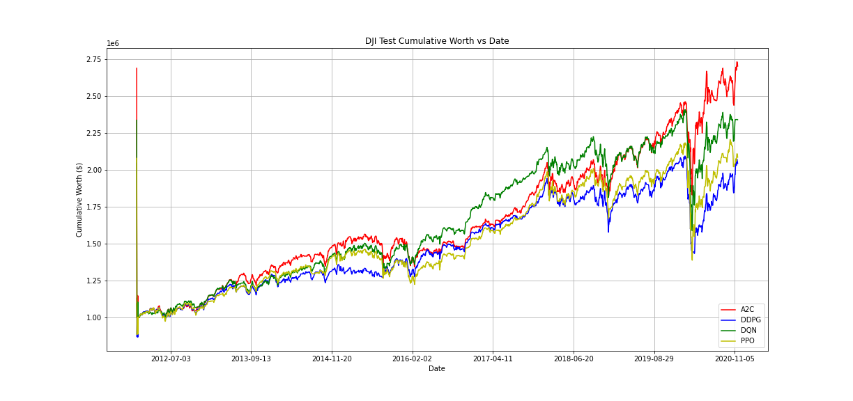

Figure 4: DJIA cumulative worth based on test data

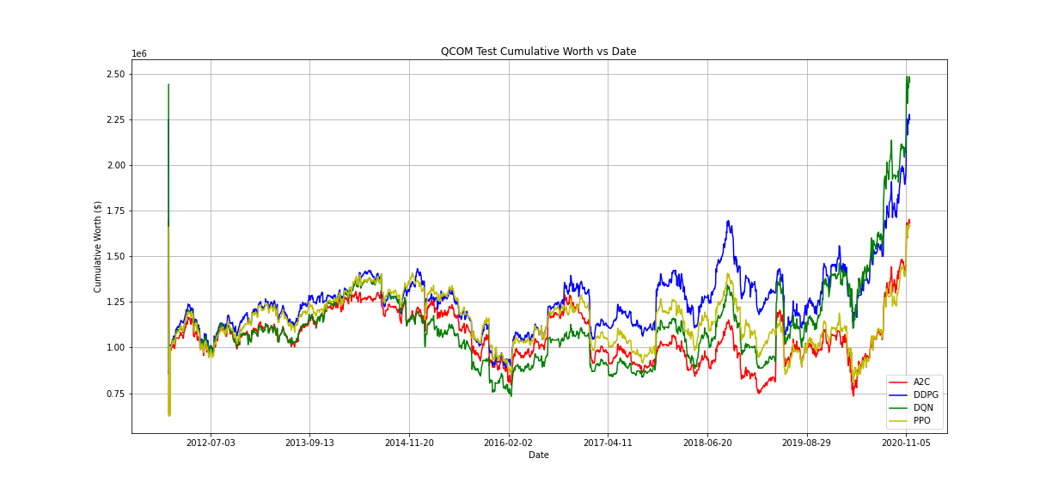

Figure 5: Qualcomm cumulative worth based on test data

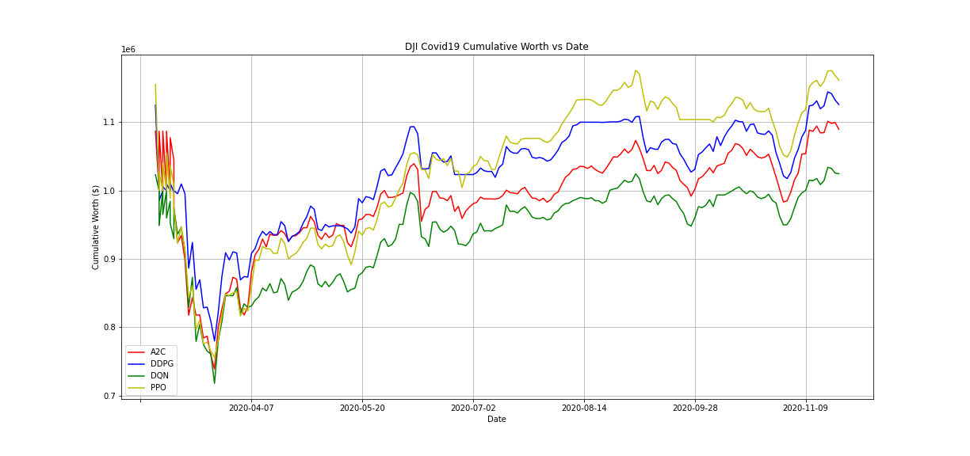
Figure 6: DJIA simulation (COVID-19 dataset)

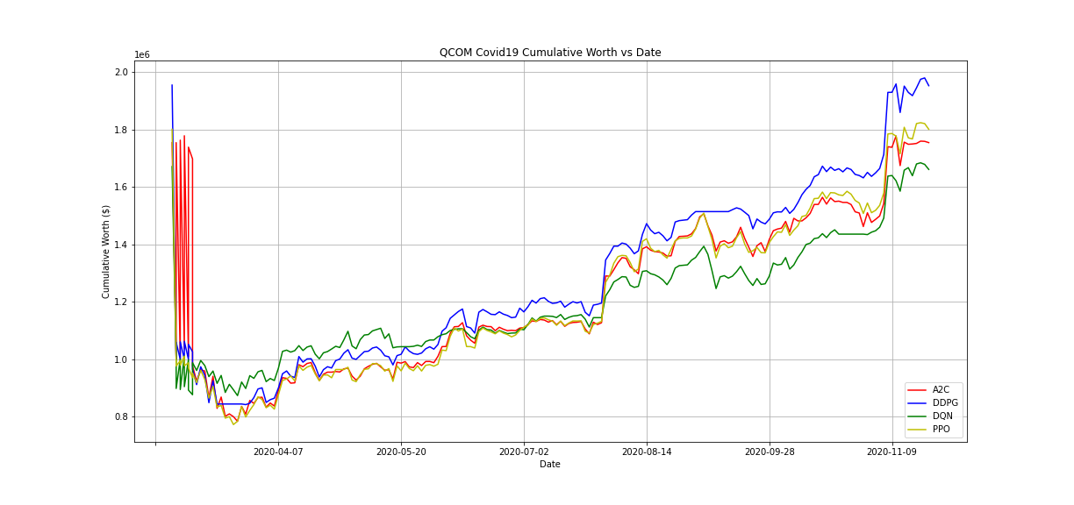

Figure 7: Qualcomm simulation (COVID-19 dataset)

