**Development of mobile and desktop applications for a fingerprint-based attendance management system**

**Olubunmi Adewale Akinola1, Sikiru Olatunde Olopade2, Akindele Segun Afolabi3**

1,2Department of Electrical and Electronic Engineering, Faculty of Engineering and Technology, Federal University of Agriculture, Abeokuta, Nigeria.

3Department of Electrical and Electronics Engineering, Faculty of Engineering and Technology, University of Ilorin, Ilorin, Nigeria.

|  |  |  |
| --- | --- | --- |
| **Article Info** |  | **ABSTRACT** |
| ***Article history:***  ReceivedOct 1, 2018  Revised Dec 10, 2018  Accepted Jan 25, 2019 |  | Mobile application technology has been at the forefront of technological advancement in recent years. This has made life easier, and tasks that were considered herculean have been made easier and executable in a much shorter time than ever. One of such tasks is the process of taking attendance during events (such as lectures, conferences, etc.) by scribbling one’s signature and other personal details on a central register. This manual process is cumbersome and inconvenient, especially when a large number of participants are involved. To address this problem, this paper presents an automated solution in which a Java-based mobile application was developed and connected wirelessly to a central database that was created using MySQL application whose task, among others, was to record attendance information. The database was connected to the backend of the web-based software program which was coded in PHP programming language. Authentication was achieved through username, password, and fingerprint information. The system was deployed in a University to log Students’ details, Time absent, Time Present, Cumulative attendances per month, etc. and it was realised that the system was highly effective, efficient and provides a fast and easy access to attendance statistics from anywhere via the Internet. |
| ***Keywords:***  Database  Attendance register  Fingerprint Biometrics  Mobile Application  Server |
| *This is an open access article under the* [*CC BY-SA*](https://creativecommons.org/licenses/by-sa/4.0/) *license.* |
| ***Corresponding Author:***  Akindele Segun Afolabi,  Department of Electrical and Electronics Engineering,  University of Ilorin,  P.M.B. 1515 Ilorin, Ilorin, Kwara State, Nigeria.  Email: [afolabisegun@unilorin.edu.ng](mailto:afolabisegun@unilorin.edu.ng) | | |

1. **INTRODUCTION**

A mobile application (apps) is a software application designed to run on mobile devices such as a phones, tablets and watches, just to mention a few. Mobile apps were originally intended for productivity assistance and was therefore designed for email, calendar, and contact information; but the public demand for apps caused rapid expansion into other areas such as mobile games, factory automation, GPS and location-based services, order-tracking, and ticket purchases, so that there are now millions of apps available. Apps are generally downloaded from application distribution platforms which are operated by the owners of mobile operating system, such as the App Store (iOS) or Google Play Store. Some apps are free while others are pricy, with the profit being split between the application's creator and the distribution platform. Mobile applications contrasts desktop applications through their target devices, as they run on devices such as mobile phones, tablets, watches, etc., whereas desktop applications are designed to run on desktop computers [1].

The development of Mobile application requires the use of specialized integrated development environments. Mobile apps are first tested within the development environment using emulators and later subjected to field testing. Emulators provide an inexpensive way to test applications on mobile phones to which developers may not have physical access [2]. Mobile user interface (UI) design is also essential in the development of mobile application. Mobile UI considers constraints and contexts, screen, input and mobility as outlines for design. The device of the user is often the focus of interaction and it entails components that span both hardware and software modules. User input allows for the users to manipulate a system, and device's output allows the system to indicate the effects of the users' manipulation. Mobile UI design constraints include limited attention and form factors, such as a mobile device's screen size for a user's hand. Mobile UI contexts signal cues from user activity, such as location and scheduling that can be shown from user interactions within a mobile application [3]. Overall, mobile UI design's goal is primarily to realise an understandable, user-friendly interface.

Mobile application UIs or frontends rely on mobile backends to support access to enterprise systems. The mobile backend facilitates data routing, security, authentication, authorization, working off-line, and service orchestration. This functionality is supported by a mix of middleware components including mobile app servers, Mobile Backend as a Service (MBaaS), and SOA infrastructure [4]. The backend is made up of scripts and programs that execute in the background. Its major function is to ensure that requests for data and services from clients are adequately catered for. To achieve this feat, it makes use of database, data integration and application, API and other backend processes [5].

These days, mobile applications and attendance taking are gradually finding a common ground. The need to provide a technology that makes the system of attendance taking and viewing seamless and automated lead to the introduction of student attendance management system designed using mobile application-based technologies. In various educational institutions, managing and maintaining student information is a rigorous task for any one [6]. The whole academic record of the student information consists of monitoring their performances and progress periodically, which is a very huge workload on lecturers to handle. In some cases, these lecturers have to continuously monitor the promptness of each and every student during lectures and this could have devastating consequences on the schedule of such lecturers. The traditional way of taking attendance by an instructor is through the use of a register book. Such a system takes so much time to generate a record and it is highly prone to errors. In addition to its susceptibility to errors, it is also susceptible to fraud and even, the entire register book could get missing. For this reason, there is a recent interest in the automation of attendance taking. The authors in [7 - 17] used Haar cascade classifier to automatically detect faces of subjects in captured images, after which the captured face images are compared with face images in a database. Once a match is found, the attendance record of the subject is automatically updated. Byalpi [18] integrated Alexa voice assistants developed by Amazon to facilitate the procccess of automatic attendance record taking. The assistant receives a voice command from the teacher, which intitiates the start of the process of attendance taking. After this, inputs from the students are accepted by the system which is used in updating of the attendance database present on a server.

Many research works on mobile application-based attendance management system exist in the literature. For example, the authors in [19] developed a mobile application-based attendance logging system using Visual Basic.Net (VB.NET) and SQL server. The system was used to store, organize, find and manage the information of the students, and it also helps to generate the reports of the student’s information [20].

Saparkhojayev *et al.* [21] also addressed the problems associated with the manual method of taking attendance by proposing an android-based mobile application. The mobile application allows users to store and edit lecture schedule, obtain information about students, which include students’ attendance and performance. Mshelia *et al.* [22] presented a new approach to attendance management system by proposing a mobile application and automated system for monitoring student attendance through both RFID (radio frequency identifier) and fingerprint biometric technology. This system made provisions for each student’s RFID card as well as their respective fingerprint as the valid means of verification and authentication. Singh *et al.* [23] developed a cloud-based attendance management system, deplorable by academic institutions, for taking the record of attendance of faculty members. The application allows teachers to mark and edit student’s attendance and also to add marks in the system database for future retrieval. Cryptography is also sometimes employed in attendance taking, and it has the advantage of being a user friendly design, does data encryption, and requires small size but limited battery life [24].

Mohammad *et al*. [25] developed an automated time and attendance logging system that used location data as a proof of attendance. The authors showed that the coordinates of the location of an organization and an employee can be determined by the help of GPS device; and if both coordinates are same indicated an employee was present in the organization. Srinidhi et al. [26] developed a secured, web-based attendance monitoring system that used Biometrics and RFID Technologies. Their design had the capability of notifying both parents as well as the student via e-mail, if the student is lagging behind in attendance. An Android-based student activity register system was presented in [27]. The system marked the attendance and stored the details of the students so that professors or other officials can view it and caution them (the students) if they are not regular in classes.

In order to address problems associated with paper-based attendance system, this paper presents a smart mobile-based attendance recording system that wirelessly connects to a remote backend server for updating attendance information. Compared to paper-based attendance system, it helps to increase efficiency as well as security, since all information captured from subjects through the application at the frontend are automatically forwarded to the server at the backend, which ensures that the database is updated with minimum intervention from the concerned subject. The frontend of the proposed system is an android-based application, which is used by the instructor/administrator to access information on the subjects, who, in this case, are students. Some of the information that pertains to the student include student’s name, student’s ID, course ID, just to mention a few. In addition to the administrator’s and/or instructor’s frontend access, which is granted a privileged access level, the subjects can also access the system at the frontend but with much lower privileges. The subjects can access the system during data enrolment and subsequently, during routine attendance logging. The backend server at the other end is accessible only by the system administrator.

The mobile application was developed using Java programming language because it is a general-purpose programming language that is simple to use and supports object-oriented programming. A number of stages are involved in this research work, which includes:

(i) **Conceptualization and Planning:** This is the first stage in mobile application development where hardware and functionality vary from device to device; an application that depends on certain features may not work properly on some devices. For instance, not all mobile phones are equipped with cameras; so if a video messaging application is to be created, some devices will be able to play videos but will be incapable of capturing new videos by themselves.

(ii) **Design:** It is the second stage that needs to be considered in mobile application development. When designing the mobile application, there is need to pay attention to the different supports and screen sizes of the target devices. In addition, when designing the application’s user interface (UI), different screen resolutions must be considered and different software operating system (OS) of the mobile devices must be put into consideration as well.

(iii) **Development:** It is the third stage in mobile application development. When using a code function, the presence of this functionality should always be tested first. For example, before using a device function, such as a camera, it is necessary to query the operating system first for the presence of this function. Then, when the device(s) is initialized, confirming the support of the current operating system for the device is often considered a good programming practice, before applying the associated settings.

(iv) **Testing:** This is the last stage in mobile application development, it is very important to test the application very early and frequently on real devices. Even the mobile devices with the same hardware specifications can vary considerably in their behavior.

Considering the efficiency and data security that the proposed automated system promises, adopting it in institutions and parastatals comes with enormous benefits. Among such benefit is that its invasion-resistant characteristics leaves the subjects with no choice other than to embrace a good attendance behavior, which is healthy not only for the institution concerned, but also for the society at large. The design was deployed at Federal University of Agriculture, Abeokuta and it worked efficiently.

1. **MATERIALS AND METHODS**

The proposed attendance management system was implemented using programming languages such as embedded C++, Hypertext Pre-processor (PHP), HTML (Hyper Text Markup Language) and Java. Figure 1 illustrates the block diagram of the design. A database is used to store all the information pertaining to the participants and it is powered by MySQL database application. During attendance logging process, the information of the individuals is forwarded from the mobile application to a central server and the MySQL database is updated. After the web address of the server has been inserted on the mobile phone, the mobile application launches the attendance page and displays the login page where either admin/instructor or the student can input their login details.

Hardware

Mobile Application

Desktop Software and Database (MySQL)

Captured Data

Upload

Display

Download

Attendance

Information

Figure 1: Block diagram of the attendance Management System.

If the login details are valid, the page proceeds to the attendance status where the instructor can review and edit information; the student can also review his or her attendance history but can not edit it.

**2.1 Analysis of software structure**

In the development cycle of the system, decisions were made on the parts of the system to be realized in hardware, the parts to be implemented in the desktop software, and finally the part to be implemented in mobile application. The software was decomposed into modules so that each module can be individually tested as a unit and debugged before the modules are integrated and tested as a software-hardware system in order to ensure that the system design meets its specification.

As can be seen in the block diagram of Figure 1, the system is composed of 3 main blocks, which include the hardware, the mobile application and the desktop software and database. Programs were developed for each of these blocks and these programs were written in different programming languages as shown in Table 1:

Table 1. Programming languages used

|  |  |
| --- | --- |
| **System block** | **Programming Language** |
| Hardware | Embedded C++ |
| Mobile App | Java and XML |
| Desktop Software (Server) | PHP, SQL, and HTML |

**2.1.1 Hardware block**:

The hardware contains an arduino microntroller, whose function is to coordinate the operation of all the peripheral components attached to it, including the fingerprint scanner, etc. In order to achieve this coordination function, specific instructions are developed into a program code using embedded C++ programming language. The program code is compiled on a computer and downloaded to the microcontroller unit with the aid of a programmer.

**2.1.2 Mobile application block**:

The mobile application developed resides on a mobile device. In our case, the operating system on the mobile device is the Android Operating System. The application was developed using Java programming language while the user-interface was implemented using XML. The mobile device is assigned an IP address with which it communicates with the desktop software. In addition to the IP address, the mobile application has been designed to create a socket which is assigned a port number of 8888. Data leaving the mobile application, which is bound for the desktop application, is sent through this socket. In the same vein, data arriving from the server IP address of the server are received by the mobile application through the socket that has the aforementioned port number.

**2.1.3 Desktop software (server) block:**

The software that resides on the desktop computer which performs the function of a server was written in PHP programming language. In order to provide access to the MySQL database where the fingerprint, personal details, etc. of subjects are stored. SQL queries are included in PHP instructions in form of strings and are acted upon by the MySQL server. The user interface of the server was developed in HTML and CSS (cascaded styles sheet). The communication between the mobile application and the desktop software follows a client-server pattern. In this case, the mobile application is the client application while the desktop software is the server application. In order to facilitate this client-server relationship between the mobile application and desktop software, the apache and SQL servers are employed.

**2.1.3.1 Apache server**:

An Apache Server is a web server application whose function is to deliver contents such as web pages, multimedia, etc. to a client application. In order to access the functionality of the apache server, WAMP software was installed which provides access to the desired apache services.

**2.1.3.2 MySQL server**:

It is a relational database management system (RDBMS). It organises data into one or more tables that are related to each other. SQL is the programming language used to create as well as extract data from the database. Again, the installed WAMP is relevant in providing MySQL database services. The attendance management system database consists of tables that stores records, each of which corresponds to an authorized person that has access to the system. Each record contains the minutiae templates of the person’s fingerprint, username, password, just to mention a few.

**2.2 System architecture**

A detailed discussion on the hardware block of Figure 1 is beyond the scope of this paper; hence in what follows, we discuss the mobile application block as well as the desktop software (the server) block.

**2.2.1 The mobile application**

The mobile application was designed to help the lecturers take attendance easily, securely and in an error-free manner. After taking the attendance on the mobile phone, the mobile application forwards it automatically to the desktop application which invokes the database server to update the database with the logged information. Instructors access and edit the attendance by logging into the system through their respective accounts. The attendance management system can be used by three categories of people namely:

(i) The admin

(ii) The instructor

(iii) The student.

The admin accesses the system in the admin mode, the instructors access it in the instructor mode, while the students access it in the student mode. The admin is responsible for the creation of accounts for new users. All users gaining access to the attendance platform must first of all get authenticated through their username and password. An algorithm was developed for authenticating users’ access to the application through their username and password that must have been pre-registered on the system by the admin user. The authentication process is illustrated in Figure 2. The user accesses the webpage of the attendance management system through the mobile application and supplies the required login information. As can be observed in Figure 2, the record of the user is searched in the database; assuming either the username or password is incorrectly supplied to the software while trying to gain access to it, the record of the user will not be found in the record and this results in a failed login attempt such that access to the system is denied.

Figure 2: Illustration of a failed login attempt by administrator/instructor and student



Login request

(user name + password)

Search record

Not found

Login failed

Mobile Application

**Desktop**

**Software**

**Database**

Website login attempt

Wrong username or password



Student

Admin or instructor

**2.2.2 Access procedure for an administrator and instructor**

Figure 3 illustrates another scenario where an attempt is made by an administrator and instructor to log into the system. Again in this case, the login information including the username and password are supplied. This information is searched in the database. If the username supplied by the user matches a username in the record and also if the password supplied matches the password stored against the record in the database, the mobile application displays the status of the user as an administrator or instructor and the functions available in the attendance management system are made available to this user. The user in this case is categorised as a privileged user.

Figure 3: Illustration of a successful login attempt by administrator/instructor

Login request

(user name + password)

Search record

Found in admin record

Login success.

Privileged user

Mobile Application

**Desktop**

**Software**

**Database**

Website login attempt

Logged in with privilege functions activated (can view and edit record)



Admin or instructor



Figure 4: Illustration of a successful login attempt by student

Login request

(user name + password)

Search record

Found in student record

Login success.

Limited user

Mobile Application

**Desktop**

**Software**

**Database**

Website login attempt

Logged in with only

a few functions activated



Student



**2.2.3 Access procedure for student user**

Figure 4 illustrates a scenario where an attempt is made by a student to login into the system. The student supplies the required login information, which are, the username and password. This information is searched in the database. If the username supplied by the user matches the username of a record in the database, and also if the password supplied matches the password stored against that record in the database, the mobile application displays the status of the user as a student and only a few functions in the attendance management system are made available to the user. The user is categorised as a limited user.

**2.2.4 Users’ roles**

As was seen in the preceding section, the attendance management system consists of three login modes, namely admin, instructor and student login modes. The admin and instructor login mode enables the admin and instructor users such as faculty members and principal officers of an educational institution to access, edit, update, and view the student attendance records. The admin is the only user that can add a new user’s record and also delete an existing user’s record. The student login mode, on the other hand, enables the student users to view the log history of class attendance available in the database. Students can not edit the content of the attendance system but can only view it. This is an important feature that distinguishes student users from instructor users of the platform. The restricted function that is accorded to student mode is intended at reducing the chances of falsification of attendance record by students. Both the instructors and students can view a summary of the logged attendance data; for instance, for a duration of say, one month.

**2.2.5 Software realisation of users’ roles**

In order to accomplish the specific roles of each class of user described in the preceding section, the desktop software selectively enables and disables specific functions in the user interface of the logged in user. Figure 5 is a flowchart illustrating the selective activation and deactivation of functions in the mobile application of admin, instructor, and student users. It can be observed in the flowchart that no function is disabled in the mobile application of the admin user, whereas some functions are deactivated in that of the instructor and student users; for example, the instructor interface does not have the capability of enrolling new users. In the case of the students, only personal features are enabled. Hence, a student can not gain access to attendance information that pertains to other students or even other categories of users such as the admin and instructor users. It should be noted that the functions contained in the mobile application extends beyond the ones shown in Figure 5 but are not shown in the figure for brevity. Hence, only the important ones are illustrated.

Figure 5: Flowchart illustrating selective activation and deactivation of some functions in the mobile application of the admin, instructor, and student users

Start

Admin

Supply account log in information

Can enroll new users = enabled

Admin?

Instructor?

Can view all users = enabled

Can delete or update all users = enabled

Can search record of all users = enabled

Can enroll new users = disabled

Can view student user = enabled

Can delete or update all users = disabled

Can search record of all students = enabled

Stop

Instructor

Can enroll new users = disabled

Can view personal attendance record = enabled

Can upload new attendance data = enabled

Can search personal attendance record = enabled

Student?

Student

**3. MAKING THE ATTENDANCE MANAGEMENT SYSTEM FOOLPROOF**

The focus of discussion of the preceding sections was mainly on the roles that could be performed by the users of the attendance management system and how the underlying software is able to support them. So far, in the discussion, username and password have been the elements used for authentication. However, username and password can be learned or stolen which could jeopardise the success of the developed system. For this reason, an additional layer of security is necessary. Hence, in this section, we will introduce how the added layer is accomplished biometrically.

**3.1 Biometric data enrolment**

A biometric data enrolment module is incorporated in the system, whose task is to enrol users and their fingerprints into the system database. During enrolment, the fingerprint and other bio-data of the user are captured and the unique features are extracted from the fingerprint image and stored in a database as a template for the subject. The instructor’s bio-data to be stored in the database include: employee number, surname, other names, gender, position, phone number, email, department, and passport photograph. For the students, the relevant bio-data include: matriculation number, surname, other-names, gender, department, phone number and passport photograph. In order to increase the probability of storing a good quality fingerprint image in the database during enrolment stage, the system is programmed to mandate the capturing of two image samples per fingerprint.

When the fingerprint images and the user name of a person to be enrolled are fed to the enrolment module, a minutiae extraction algorithm is applied to the fingerprint images and the minutiae patterns (features) are extracted. These features form a template that is used in the future to determine the identity of the user, hence, making the system less prone to access by unauthorised persons. The enrolment process can be carried out by only the admin user.

**3.2 Verification and authentication process**

An authentication module is used to validate the identity of participants that attempt to log their attendance record on the system. The person to be authenticated has to login through the mobile application platform with a valid username and password. This is the first layer of security provided by the system which is targeted at preventing impersonation. The second layer of security is accomplished by the biometric verification and authentication module. The sole aim of this module is to ensure that the logging of attendance data into the system is not done by proxy. The fingerprint biometric of the intending user of the attendance platform is matched with the fingerprint data that was previously enrolled. If an attempt is made to update the attendance record by proxy, it is immediately detected and flagged by the system. If however the fingerprint of the user matches the fingerprint template in the database, the user is granted access to update his attendance data on the platform.

**4. RESULTS AND DISCUSSIONS**

The attendance management system was deployed at the Department of Electrical and Electronics Engineering, Federal University of Agriculture, Abeokuta. It was used to capture the attendance information of the final year students of the department. In what follows, we describe some of the user interfaces available in the developed system.

**4.1 The welcome screen and enrolment user-interface**

In order to enrol a new user into the platform, the administrator has to log into the attendance management platform. The IP address of the server needs to be entered in an appropriate textbox of the mobile application. Once this is done, the welcome screen shown in Figure 6 is loaded. Figure 6 is the user interface of the mobile application that provides the opportunity to log into the attendance management platform. In the welcome screen, the intending user of the attendance platform is prompted to supply his username and password in order for the user to get logged in. After logging in, if the logged in user is an administrator, the page shown in Figure 7 can be used to enrol new users into the platform.

**4.2 The student user page**

The profile page of the student category of user is illustrated in Figure 8. As a student, the content of the attendance register can only be viewed but not edited. This helps to reduce the chances of falsification of attendance record by students. Once the student is logged into the platform, the opportunity to update the attendance record is presented. In order to update the attendance record, the student is prompted to supply fingerprint data which is realised by placing a registered finger on the fingerprint scanner.

**4.3 The instructor user page**

The user interface of the instructor is illustrated in Figure 9. Once logged in, the instructor has the opportunity to view the list of registered students. He can also view daily or monthly report of the attendance record. In addition, he can edit the record based on his initiative. Through the attendance management platform, statistical analysis of each student’s attendance record can be done. For example, it is possible to extract the percentage attendance achieved by individual student from the platform. This is extremely important, and is even the major result obtained from the platform since it provides the opportunity to identify students that are less prompt to classes, and if there is a penalty for such behaviour, it will serve as deterrence against future recurrence. As can be observed in Figure 9, the particular student under consideration has an average attendance of 11.67% out of 15% in all the lectures attended up till the day this data was obtained from the attendance database by an instructor.

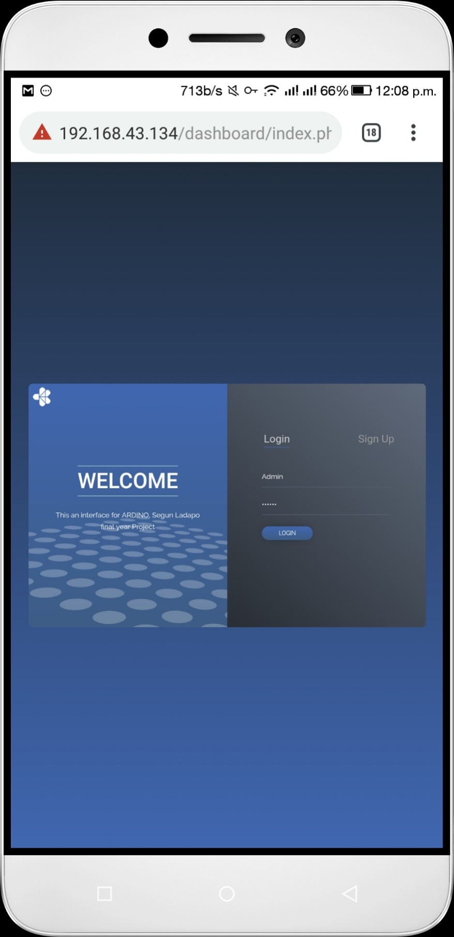

Figure 6: The welcome screen of the mobile application

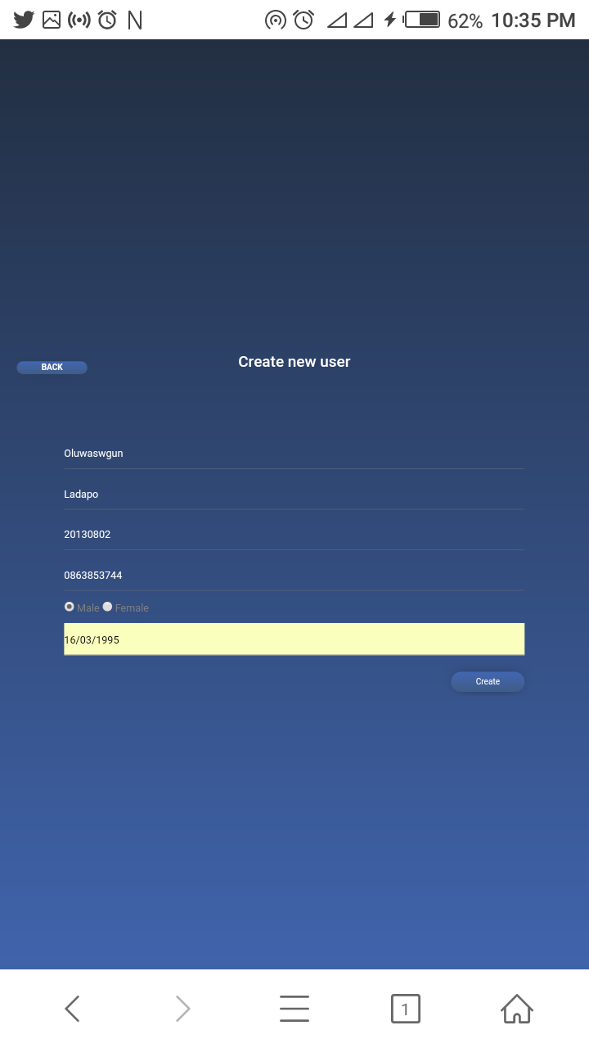

Figure 7: Enrollment page for creating a new user in the attendance database

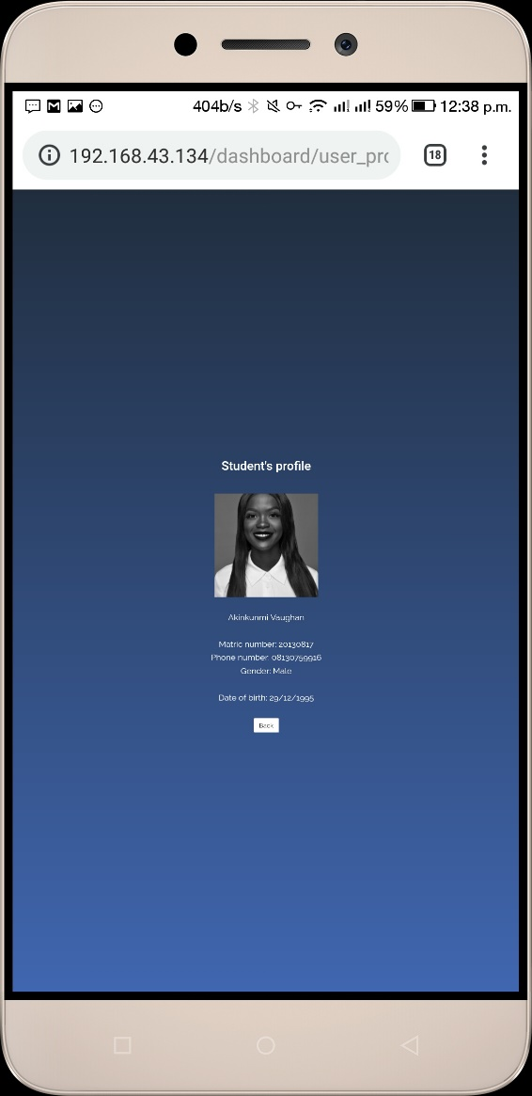

Figure 8: The user interface of the student category of user on the mobile application

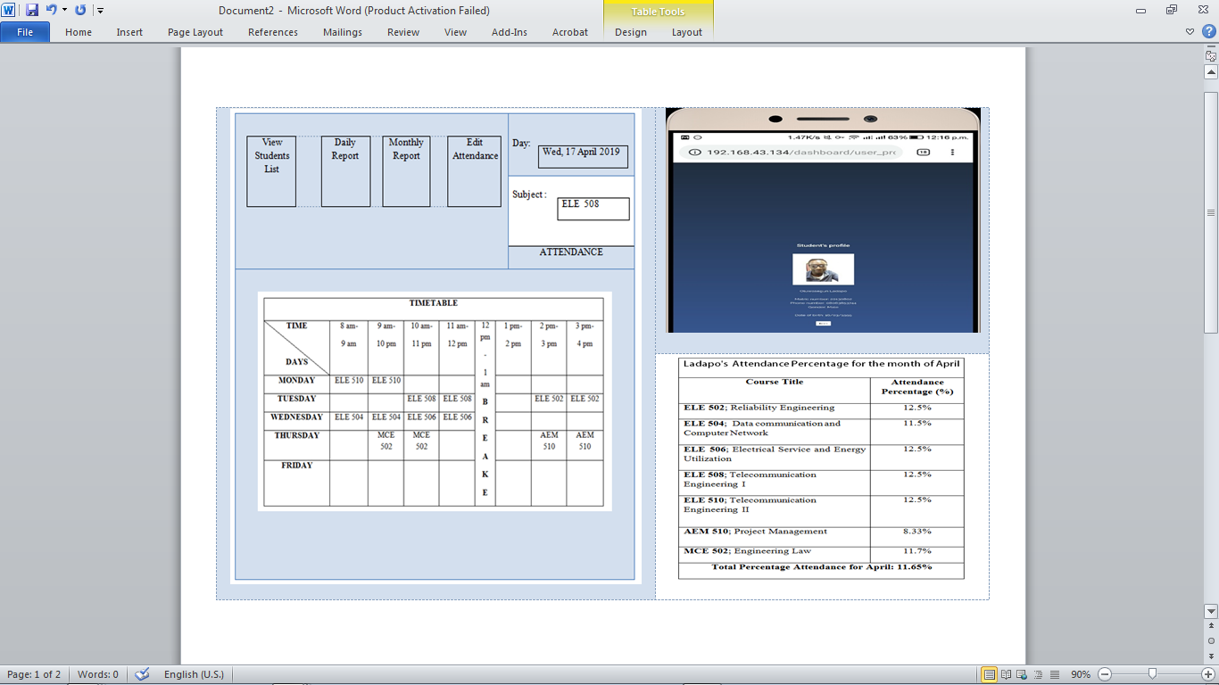

Figure 9: The user interface of the instructor category of user on the mobile application

**5. CONCLUSION**

In this paper, a mobile application was designed and implemented. The programs of the developed system were written in PHP, Java, embedded C++, HTML, XML, CSS, and SQL programming languages. As a first layer of security, a username and password is generated by the Admin for each new user enrolled into the platform. In addition to the first layer, a second layer of security, which is based on biometric data (fingerprint) is employed. The second layer is necessary because the first layer alone provides insufficient security since username and password can be learnt or even stolen and afterwards used to perpetrate impersonation. In order to update attendance record, each participant is prompted for fingerprint scanning. Once the fingerprint has been scanned, it is matched with the fingerprint pre-registered on the platform. If there is a match, the attendance record is updated, otherwise, the record update request is denied. Since the attendance capturing tasks by the platform is automated, it relieves the staff or instructor from the herculean task of manually obtaining the attendance information for record keeping. In addition, it eliminates attendance taking by proxy due to the fingerprint requirement which necessitates the physical presence of the subject during the attendance updating process. It also addresses other shortcomings of manual attendance taking, including total loss of the attendance book.

**REFERENCES**

[1] B. Kishore, “Mobile Application Development,” *International Journal of Computer Science and Mobile Computing,* vol. 6, no. 9, pp.15-20, 2017.

[2] H. C. Afaq et al., “A methodology to develop a Mobile Application Model to Appraisal Housing Design Quality,” *Ajman University*, 2017, (online) [https://doi.org/10.3991/ijim.v11i6.6379 full.htm](https://doi.org/10.3991/ijim.v11i6.6379%20full.htm)

[3] N. I. Venkata et al., “Role of Mobile App Development Life Cycle,” *International Journal of Software Engineering and Applications,* vol. 5, pp. 5-12, 2014.

[4] H. Suhas and K. M. Mahima, “Android Based Mobile Application Development and its Security,” *International Journal of Computer Trends and Technology* vol. 3, no. 3, pp. 2231-2235, 2012.

[5] B. M. Adam et al. “Backend Server System Design Based on REST API for Cashless Payment System on Retail Community,” *International Electronics Symposium (IES), Surabaya, Indonesia,* pp. 208-213, 2019.

[6] S. Monika et al., “Mobile based Student Attendance Management System,” *International Journal of Computer Applications* 1vol. 65, no. 3, pp. 875-887, 2017.

[7] V. Ruhitha et al., "Implementation of IOT based Attendance Management System on Raspberry Pi," 2019 International Conference on Intelligent Sustainable Systems (ICISS), Palladam, Tamilnadu, India, 2019, pp. 584-587, doi: 10.1109/ISS1.2019.8908092.

[8] Rusia, M. K et al., “Human Face Identification using LBP and Haar-like Features for Real Time Attendance Monitoring,” 2019 *Fifth International Conference on Image Information Processing (ICIIP), 2019.* doi:10.1109/iciip47207.2019.8985867

[9] B. T. Chinimilli et al., "Face Recognition based Attendance System using Haar Cascade and Local Binary Pattern Histogram Algorithm," 2020 4th International Conference on Trends in Electronics and Informatics (ICOEI)(48184), Tirunelveli, India, 2020, pp. 701-704, doi: 10.1109/ICOEI48184.2020.9143046.

[10] E. Indra et al., "Design and Implementation of Student Attendance System Based on Face Recognition by Haar-Like Features Methods," 2020 3rd International Conference on Mechanical, Electronics, Computer, and Industrial Technology (MECnIT), Medan, Indonesia, 2020, pp. 336-342, doi: 10.1109/MECnIT48290.2020.9166595.

[11] S. Matilda and K. Shahin, "Student Attendance Monitoring System Using Image Processing," 2019 IEEE International Conference on System, Computation, Automation and Networking (ICSCAN), Pondicherry, India, 2019, pp. 1-4, doi: 10.1109/ICSCAN.2019.8878806.

[12] R. Hartanto and M. N. Adji, "Face Recognition for Attendance System Detection," 2018 10th International Conference on Information Technology and Electrical Engineering (ICITEE), Kuta, 2018, pp. 376-381, doi: 10.1109/ICITEED.2018.8534942.

[13] S. Dev and T. Patnaik, "Student Attendance System using Face Recognition," 2020 International Conference on Smart Electronics and Communication (ICOSEC), Trichy, India, 2020, pp. 90-96, doi: 10.1109/ICOSEC49089.2020.9215441.

[14] C. James and D. Nettikadan, "Student Monitoring System for School Bus Using Facial Recognition," 2019 3rd International Conference on Trends in Electronics and Informatics (ICOEI), Tirunelveli, India, 2019, pp. 659-663, doi: 10.1109/ICOEI.2019.8862534.

[15] M. Srivastava et al., "Real Time Attendance System Using Face Recognition Technique," 2020 International Conference on Power Electronics & IoT Applications in Renewable Energy and its Control (PARC), Mathura, Uttar Pradesh, India, 2020, pp. 370-373, doi: 10.1109/PARC49193.2020.236628.

[16] C. B. Yuvaraj et al., "An approach to maintain attendance using image processing techniques," 2017 Tenth International Conference on Contemporary Computing (IC3), Noida, 2017, pp. 1-3, doi: 10.1109/IC3.2017.8284353.

[17] J. W. S. D'Souza et al., “Automated Attendance Marking and Management System by Facial Recognition Using Histogram,” 2019 5th International Conference on Advanced Computing & Communication Systems (ICACCS), Coimbatore, India, 2019, pp. 66-69, doi: 10.1109/ICACCS.2019.8728399.

[18] A. S. Byalpi and Anush, "Alexa based Real-Time Attendance System," 2018 3rd International Conference on Communication and Electronics Systems (ICCES), Coimbatore, India, 2018, pp. 121-124, doi: 10.1109/CESYS.2018.8724006.

[19] V. Somasundaram et al., “Mobile based Attendance Management System,” *Indian Journal of Science and Technology* vol. 9, no. 35, pp. 1-4, 2016.

[20] S. D. Asir et al., “Mobile Application for Student Attendance and Mark Management System,” *International Journal of Computational Intelligence Research*, vol. 13, no. 3, pp. 425-432, 2017.

[21] N. Saparkhojayev, “Mobile Attendance Checking System on Android Platform for Kazakhstani University,” *Journal of Physics* vol. 5, no. 9, pp. 45-48, 2016.

[22] D. E. Mshelia et al., “An RFID and Fingerprint Automated Attendance System,” *Journal of Computer Engineering,* vol. 19, no. 4, pp. 75-84, 2017.

[23] M. Singh, M. et al. “Attendance management system,” In 2015 *2nd IEEE International Conference on Electronics and Communication Systems (ICECS),* pp. 418-422, 2015.

[24] N. Kale and H. P. Prakash, “A Review on Fingerprint based Biometric Attendance Systems,” *International Journal for Scientific Research & Development*, vol. 5, no. 4, pp. 2321-2329, 2017.

[25] A. U. Mohammad et al., “A location-based time and Attendance system, *International Journal of Computer Theory and Engineering*, vol.6, no. 3, pp. 1-4, 2017.

[26] M. Srinidhi and R. A. Roy, “Web enabled secured system for attendance monitoring and real time location tracking using Biometric and Radio Frequency Identification (RFID) technology,” *International Journal of Engineering and Technology,* vol*.* 20, no. 15, pp. 1-5, 2018.

[27] J. Sunil et al., “Android Based Smart Attendance System using QR Code,” *International Journal of Innovative Research in Computer Engineering*, vol.6, no. 3, pp. 2320-2326, 2018.

**BIOGRAPHIES OF AUTHORS**

|  |  |
| --- | --- |
| Description: C:\Users\hp\Desktop\IMG_20200502_124055_2~2.jpg | Olubunmi A. Akinola received the Bachelor, Masters, and Ph.D. Degrees in Electrical Engineering in 1991, 2001, and 2016 respectively. He is currently with the Federal University of Agriculture, Abeokuta, Nigeria. He was the recipient of a plethora of research-based awards issued by OMICS group - USA, NUC – Nigeria, just to mention a few. He is a member of the Nigerian Society of Engineers and a registered engineer with the Council for the Regulation of Engineering in Nigeria (COREN). He is the author of several journal and conference articles. His research interest includes internet of things, D2D communications, MANETS, Automation and Electronic System Design & Applications. |
|  |  |
| IMG-20190929-WA0022 | Sikiru O. Olopade studied at the Department of Electrical and Electronic Engineering, College of Engineering, Federal University of Agriculture, Abeokuta, Nigeria and obtained a B.Eng degree in Electrical and Electronics Engineering. |
|  |  |
| Description: C:\Dr Afolabi Picture\Afo.JPG | Akindele S. Afolabi received the Bachelor and Masters Degrees in Electrical Engineering from the University of Ilorin, Nigeria in 2004 and 2009 respectively. He received the Ph.D. Degree in Computer Science and Systems Engineering from Kobe University, Japan in 2012. He was the recipient of the prestigious Japanese Government MEXT Scholarship Award from 2009 to 2012. He is currently with the University of Ilorin. He has published numerous journal and conference papers. He is fully registered with the Council for the Regulation of Engineering in Nigeria (COREN). His research interests include wireless sensor networks, internet of things, VANET, D2D communications, and artificial intelligence. |