Evaluation VOIP Services over WiMAX Network

Noor Nateq ALfaisaly¹, Azhar Hussein Neama², Suhad qasim naeem³
^{1,2,3} Department of Information Engineering, College of Information Engineering, Al Nahrain University, Iraq

Article Info |  | ABSTRACT
Article history:  Received Oct 1, 2018  Revised Dec 10, 2018  Accepted Jan 25, 2019 |  | Worldwide Interoperability Microwave Access (WiMAX) is an 802.16 wireless standard that delivers high speed, throughput and covers more space. Besides QoS, IEEE 802.16 provides a data rate of 100Mbps and a coverage area of ​​50km. Voice over Internet Protocol (VoIP) is flexible and offers low-cost telephony for clients over IP. However, there are still many challenges that must be addressed to provide a stable and good quality voice connection over the Internet. In this paper, the performance of various parameters such as Multipath channel Model and Bandwidth over the Star trajectory WiMAX network were evaluated under a scenario consisting of four cells. Each cell contains one mobile and one base station. Network performance metrics such as throughput and MOS were used to evaluate the best performance of VoIP codecs. Performance was analyzed via OPNET program14.5. According to the results, the higher the BW, the better the results. In addition, the use of multipath channel model (Disable) was better than using the model (ITU Pedestrian A).
Keywords:
Worldwide Interoperability for Microwave Access (WiMAX) Voice over Internet Protocol (VoIP)
Internet Protocol (IP)
OPNET 14.5
MOS

 |  | This is an open access article under the CC BY-SA license.
Corresponding Author:
Noor Nateq Fadhil,
Department of Communication Engineering,
Information Engineering College,
Al Nahrain University,
Email: noor.nateq@coie-nahrain.edu.iq

- INTRODUCTION
Recently, the way people communicate was changed via VoIP applications like FaceTime, Google Talk, and Skype. Because it is inexpensive, VoIP is a vital alternate to costly conventional Public Switched Telephone Network (PSTN). VoIP parameters are defining its QoS like throughput, jitter, end to end delay, and Mean Opinion Score (MOS)[1]. The current WiMAX and WiFi wireless networks offer flexibility for supporting real-time applications like VoIP[2]. Also, the technology of IEEE 802.11 (WiFi) is beneficial as low-cost wireless Internet access, whereas IEEE802.16 (Wi-MAX) is providing high data rates (up to 75 Mbps) and a large coverage area (about 50 km) utilizing radio links [3]. In this paper, the performance of various parameters such as Multipath channel Model and Bandwidth over the Star trajectory WiMAX network will be evaluated under a scenario consisting of four cells

1.1 VOIP
VoIP is specified as one of the internet technologies used to transmit multimedia and voice-over IP-based networks, particularly the Internet [4], [5]. VoIP is majorly utilized as one of the communication protocols for replacing conventional telephone technologies, PSTN. Recently, the popularity of VoIP was increased because it is inexpensive compared to traditional long-distance telephone calls. In addition, the telephone calls might be made over computer networks, like the Internet, with VoIP-to-VoIP at no additional cost other than the monthly fee the user is paying for Internet access.
VoIP is converting the analog voice signals into digital data packets from an end-user. The restored data packets will be transmitted to another end-user via a computer network. The digital data packets will undergo conversion again and will end up being the original analog voice signal. This technology provides service for real-time transmission of conversations with cost-effectiveness and flexibility. VoIP-to-PSTN services are also available at a fixed monthly payment; however, this type of service's performance is beyond the scope of this project and will not be discussed or analyzed. There are also some downsides to VoIP technology. It has an average drop of calls at 3%, and it could go up to 5%, while regular phone services have a moderate decrease in calls at less than 0.1%. In case of a power outage or lost access to the Internet, VoIP calls would not be able to make. Furthermore, there are no available VoIP-to-VoIP calls for emergency services.

1.2 VOIP over WI-MAX
One alternative solution to wired networks is Wi-MAX as a broadband wireless technology; it provides a data rate of 75 Mbps with 50 km as coverage area [3]. In addition, it is supporting the requirements of QoS via many applications, particularly real-time applications like VoIP. There are four different traffic classes used by Wi-MAX for supporting its applications:
• Best Effort (BE) was developed for web browsing applications [6] that don't need QoS.
• Non-Real Time Polling Service (nrtPS) supports non-real-time applications like FTP [7] requiring variable data sizes.
• Unsolicited Grant services (UGSs) are supporting the applications of Constant Bit Rate (CBR) like VoIP with no silence suppression [7], [8], in which users are assigned a fixed bandwidth via Base Station (BS).
• Real-Time Polling Service (rtPS) is supporting the real-time applications with data of variable sizes like MPEG [8], in which Bandwidth is allocated via BS based on the request regarding Subscriber Station (SS).

Even though that Wi-MAX was developed for providing broadband Internet service, the applications of VoIP have an increased effect on the performance related to Wi-MAX networks [9].

1.3 VOIP Application QoS
Currently, users benefit from present networks of data via video calls, voice calls, and text messages. Conventional phone networks cannot compete with such service types because of their reduced operating and equipment costs and the capability of integrating data and voice applications [10]. Also, QoS for VoIP was evaluated via performance metrics like jitter, end to end delay, and Mean Opinion Score MOS.
- The scale of MOS is varying between 1 and 5, also measuring the voice quality. Furthermore, the value related to the most inferior quality was 1, while the optimal quality was 5 [11], as can be seen from Table1
Table 1. MOS [12]
Scale of Quality | Score | The scale of Listening Effort
Excellent | 5 | No efforts needed
Good | 4 | No considerable efforts needed
Fair | 3 | Moderate efforts needed
Poor | 2 | Substantial efforts needed
Bad | 1 | No meaning understood with efforts

- Jitter can be defined as the arrival time variation related to consecutive packets [13]. Before the decoding, the packages arrived at limited size buffers and a few packages might come out of order or be lost. Jitter was calculated by evaluating the differences in packets delay overtime period [11].
- Packet's end-to-end delays were evaluated via the speakers' calculation of delays from the speakers to the receivers. Also, it involves decoding and encoding delay, network delay, decompression, and compression delays [13].
The telecommunication Standardization Sector of the International is providing the guidelines for voice quality measurements for jitter and end-to-end delay, as can be seen in Table 2.
Tele-communications Union (ITU-T) [13]. A voice call of better quality might be having a delay in the range of (0ms-150ms), while the jitter in range of (0-20) ms. Yet, when a call is experiencing a delay over 300 ms or jitter over 50 ms, it will be specified as poor quality, or else, calls specified to be of suitable quality.

Table2: Guidelines for the quality of voice [13].
Network parameters | Good | Acceptable
Delays (ms) | 0_150 | 150–300
Jitters (ms) | 0_20 | 20–50

1.4 Codecs of VOIP
VoIP depends on many codecs utilized to compress and decompress the audio samples; each of the codecs is applying a unique algorithm. Table 3 is providing a list of significant codecs [12]. This study is evaluating 3 VoIP codecs: G711, G723, and G729.

Table3: Major codecs of VoIP [12].
Codec | Data rates (kb/s) | MOS scores
G. 711 | 64 | 4.30
G. 723 | 5.30 | 3.60
G. 726 | 32 | 4.00
G. 728 | 16 | 3.90
G. 729 | 8 | 4.00

1.4.1 G. 711
This is one of the public domain codecs majorly utilized in the applications of VoIP. In 1972, it was developed via ITU. In addition, it applies a logarithmic compression, which is compressing each one of the 16-bit samples to 8bits. Therefore, its bit rate was 64kbps, specified as the maximum bit rate between codecs. Furthermore, G. 711 offers an excellent quality of audio, and the value of MOS was 4.3 [14].

1.4.2 G. 723
This is considered one of the licensed codecs; it was developed for calls across modem links with (28.8kbps and 33kbps) data rates. Thus, it has two types with different bit rates: 6.4 and 5.3kbps [14]. This work considers 5.3 kbps, which is based on Algebraic Code Excited Linear Prediction (ACELP), while the value of MOS was 3.60 [15].

1.4.3 G729
This has been considered one of the licensed codecs developed to deliver excellent quality of calls without high-bandwidth consumption [14]. It has been developed based on the Conjugate Structure ACELP (CS-ACELP) algorithm with an (8kbps) bit rate, while the values of MOS value were 4.0 [14], [15].

- RELATED WORKs
Recently, there was a rapid development in many wireless technologies. Thus, there was an increase in the requirements for wireless data services and multimedia applications like video streaming and VoIP [16]. Also, VoIP and video streaming were increasingly significant, particularly following the use of Wi-MAX networks in various nations [17]. Furthermore, studies tackled many features of VoIP over Wi-MAX. Besides, the researchers in [12] examined the performance related to VoIP as well as video streaming over Wi-MAX network (IEEE 802.16d for a fixed, nomadic user and IEEE 802.16e for mobile user)., and utilizing Bandwidth (10 and 20 MHz). The results showed excellent performance in the case when using more channel bandwidth, while the packet loss was perfect in the case when utilizing IEEE 802.16e. There have been 8-users served when operating 10 MHz as channel bandwidth and 16-users when using 20 MHz as channel bandwidth. A study conducted by [18] examined the data and voice support in the Wi-MAX Network. Their study's goal has been to read QoS's deployment over Wi-MAX network, also comparing the performance acquired utilizing two distinctive Wi-MAX service classes, for instance, ertPS and UGS. A study conducted by [19] examined a fixed Wi-MAX network for evaluating the VoIP performance
The presented work is evaluating the performance of VOIP related to Wi-MAX network with using various bandwidths and indicating the impact of differences in the multipath channel model on results, along with using Wi-MAX service class UGS. The service class of UGS has the best performance parameters serving VoIP.

- RESEARCH METHOD
This paper has a Scenario consists of four cells, and each cell contains one mobile and one base station. Work through it to evaluate the performance of VOIP over the WiMax network by using OPNET MODELER 14.5.With change some parameters to get the best results.

In Figures 1-4 clarify the parameters for each of them .in Figure (1) WiMAX configureuration including the numbers of Rows and efficiency mode (mobility and Ranging Enabled) the reason for choosing this type is because the project includes a mobile node. Wimax configure. Contents scheduling type (UGS) chose this type because it is used with VOIP. There are other types, for example (steps it is used with the active voice detection technology, rtps with video, nrtps with FTP and HTTP, best effort but this type does not have any guarantees. Moreover, OFDM PHYprofiles (wireless OFDM 20MHz), in Figure (2) also application configureurations (node-0) includes the description (voice PCM Quality speech) this type it has a high quality of voice, in Figure (3) application configure. (node-1) includes many rows and profile name (voice_app) because I reported about VOIP. Figure (4) WiMAX Base station (BS) the WiMAX parameter antenna gain 15 dB and in Figure (5, 6) Mobiles (4-1) (1-1) have these mobiles the same Path loss parameter (free space). However, different int the Multipath channel Model in Mobile (4-1) (Disabled) and the Mobiles [(1-1), (2-1), (3-1)] the multipath channel model (ITU Pedestrian A).

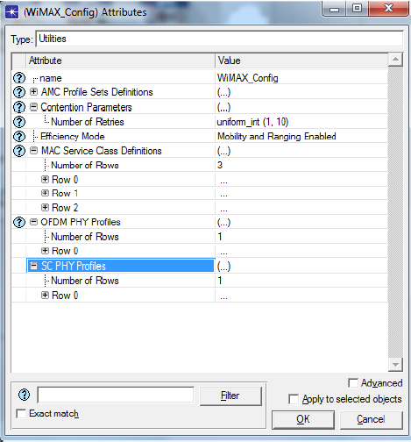 | 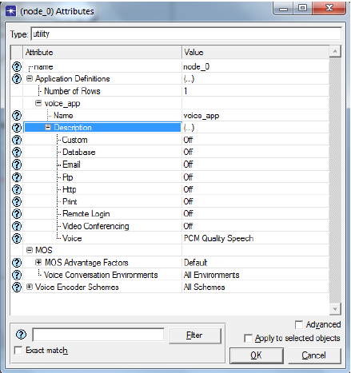
Figure 1. Wimax configureuration | Figure 2. Application Configureuration
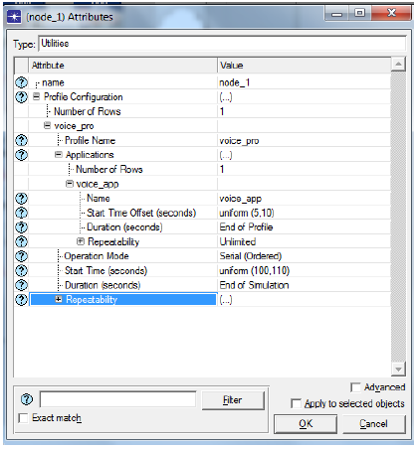 | 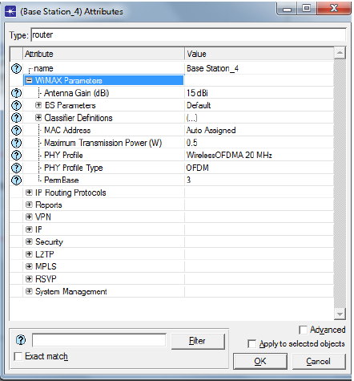
Figure 3. Profile configureuration | Figure 4. WiMAX BS
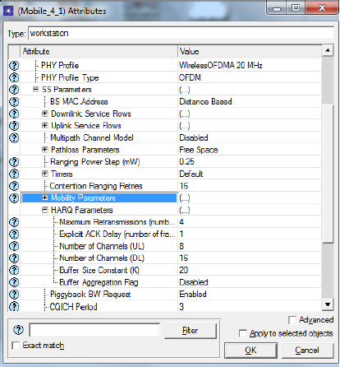 | 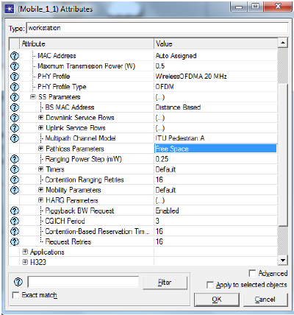
Figure 5. Mobile (4-1) | Figure 6. Mobile (1-1)

- RESULTS AND DISCUSSION
The outputs of the different simulation runs, which have been obtained, were statistically analyzed. The simulation results are Average MOS for all networks, MOS for Mobile (4-1), MOS for Mobile (1-1), and throughput. Moreover, the quality of the VoIP call is measured through the result,

4.1. OPNET simulation Modeler
OPNET can be defined as one of the research-oriented network simulation tools. It is also supplying a comprehensive development environment for simulation and modeling of the used wireless and wired networks. Users are enabled via OPNET Modeler to develop customized models and simulating many network situations, like Wi-MAX and WiFi [20]. OPNET is supplying high fidelity modeling, simulation, and analysis related to wireless networks such as throughput, delay variation, delay, packet loss, and load. This study provides several scenarios concerning Wi-MAX network involving VoIP, video conferencing, along with Handover. In addition, this work discusses individual results for all scenarios.
OPNET Company has been developed at MIT in the year 1986. However, in the year 1987, the first simulation software related to commercial network performances has been provided via OPNET Company, which offers one of the optimization tools of powerful network performances making developed network simulations [21]. Creating the management related to analytical network performance was significant with simulation and therefore it becomes likely. Other products' development at OPNET besides Modeler was achieved; also, it includes Kit of OPNET Development, WDM Guru Etc [22], [23].
The simulation model was specified as an increasingly effective method to study the functionalities and performance of the proposed models in many scenarios. Besides, the simulation was one of the testing procedures related to the developed prototype on platform duplicating real environment and offering the possibility to study, create and modify the performances related to design proposing to strengthen and weaken the expectations before model implementation a real environment [24], [25].

4.2. Simulation Result
The results are obtained after implementing the IEEE802.16e network simulation by using OPNET Modeler. The simulation includes Throughput (packet/sec), Mean Opinion Score (MOS), SNR (dB) and Pathloss (dB). In Figure (9) shows the average MOS value. The MOS value describes the perceived quality of receiving voice after being transmitted and compressed using codecs. In our results in Figure (1), the MOS value in our results when the Network using star Trajectory and the BW =15 is recorded for mobile is higher than 3.5. Figure (10) shows the MOS for mobile (1-1),(1-4) with used different parameters, With a note, in the case of using the multipath channel model (Disable) for mobile (1-1), the MOS is better and higher if use the multipath channel model (ITU Pedestrian A) for mobile (4-1). Moreover, in Figure (11), the throughput of mobile has a maximum rate of throughput of 1600 packets /sec when the Network has star trajectory and the Bandwidth (15 dB). However, when using the same scenario but with different bandwidths (-1 dB), we get different results, noting that throughput in the case of higher Bandwidth is better

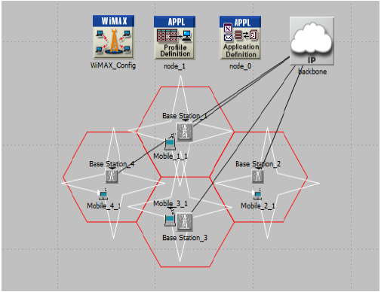

Figure 7. Scenario (1) WiMax network
(Star trajectory)

According to result, it can observed that the MOS for Mobile (4-1) higher than 2.5. However, for mobile (1-1) equal to 1.5. Here shows the effect of the difference in the multipath channel model
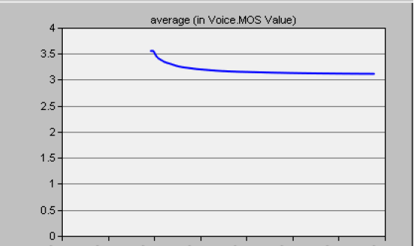
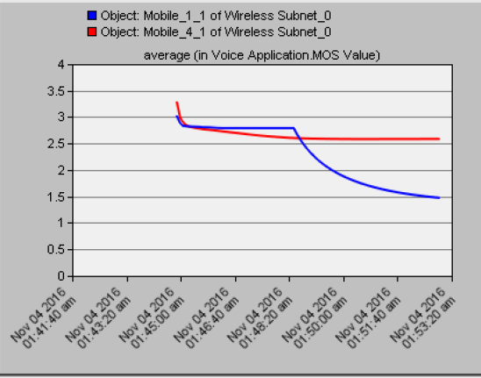

Figure 9. Average MOS for all Network Figure 10. MOS
Figure 10 shows that:
- For Mobile (4-1)
B.W=15, path loss parameter = free space
Multipath channel Model = Disable
- For Mobile (1-1)
B.W=15, pathloss parameter = free space
Multipath channel Model = ITU Pedestrian A

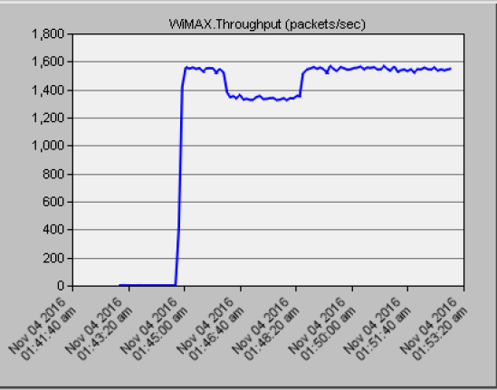

Figure 11. Throughout

In the same scenari, only the difference in Bandwidth $=-1db$
In this result, we can see the MOS for Mobile (4-1) higher than 2.9. However, for mobile (1-1), less than 2. Here shows the effect of the difference in the multipath channel model

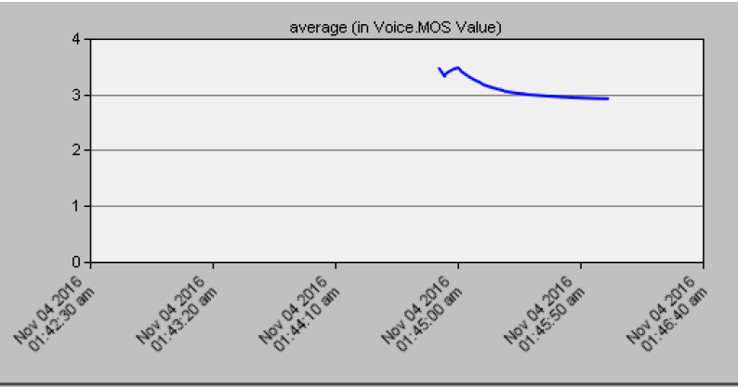 | 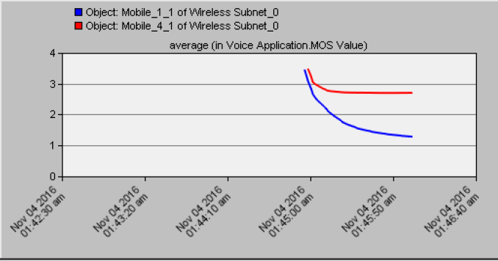
Figure 12. Average MOS for all Network | Figure 13. MOS
Figure 13 shows that:
- For Mobile (4-1)
B.W= -1dB, pathloss parameter = free space
Multipath channel Model = Disable
- For Mobile (1-1)
B.W= -1dB, pathloss parameter = free space
Multipath channel Model = ITU Pedestrian A.

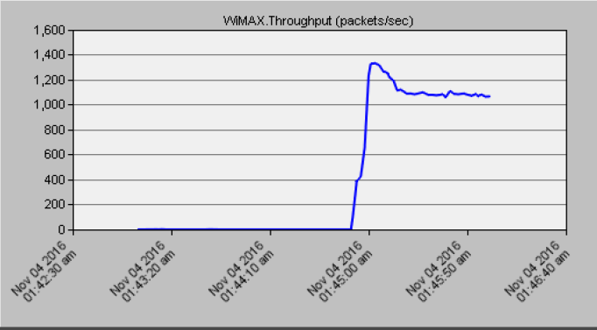

Figure 13.Throughput

- CONCLUSION
In this paper, extensive simulation study had conducted to evaluate the performance of WiMAX for supporting VoIP traffic. Important critical parameters such as Multipath channel Model and Bandwidth over the Star trajectory WiMAX network were analyzed. Simulation results show that when increase the Bandwidth, the average MOS and the throughput was increased. Noting that the increase in bandwidth has a clearer effect on a throughput compared to MOS. The value of the throughput at 15dB was approximately 1600 packet/sec, and at -1dB was its value 1300 packet/sec. On the other hand, the bandwidth was fixed at (15dB, -1dB) with a change in the Multipath channel Model in two mobiles (1-1), (4-1). According to data, the Multipath channel Model of the Disable type the value of the MOS was better than the ITU Pedestrian A type .Future work includes adding other results, such as Traffic sent and received for mobiles, Jitter and End to end delay with the possibility of using other types of Multipath channel Model and clarifying the extent of their impact on the results.

REFERENCES
[1] D. R. Mukaddim Pathan, Ramesh K. Sitaraman, Advanced Content Delivery, Streaming, and Cloud Services, vol. 66. John Wiley & Sons, Inc., Hoboken, New Jersey, 2014.
[2] Saeed Abdulmonem Saeed, “Performance Analysis of VoIP over Mobile WiMAX Networks,” vol. 4, no. 6, pp. 2514–2518, 2016.
[3] S. Islam, M. Rashid, and M. Tarique, “Performance Analysis of WiMax WiFi System under Different Codecs,” Int. J. Comput. Appl., vol. 18, no. 6, pp. 13–19, 2011, doi: 10.5120/2290-2973.
[4] M. H. Miraz, S. A. Molvi, M. A. Ganie, M. Ali, and A. R. H. Hussein, “Simulation and analysis of quality of service (QoS) parameters of voice over IP (VoIP) traffic through heterogeneous networks,” arXiv, vol. 8, no. 7. 2017, doi: 10.14569/ijacsa.2017.080732.
[5] A. I. Alghannam and A. K. Alhafid, “Performance analysis of Unsolicited Grant Service (UGS) service class in WiMAX voip application,” J. Eng. Sci. Technol., vol. 15, no. 3, pp. 1481–1491, 2020, Accessed: Nov. 21, 2020. [Online]. Available: http://jestec.taylors.edu.my/Vol 15 issue 3 June 2020/15_3_2.pdf.
[6] A. A. Ali, S. Vassilaras, and K. Ntagkounakis, “A comparative study of bandwidth requirements of VoIP codecs over WiMAX access networks,” in NGMAST 2009 - 3rd International Conference on Next Generation Mobile Applications, Services and Technologies, 2009, pp. 197–203, doi: 10.1109/NGMAST.2009.47.
[7] L. Nuaymi, WiMAX: Technology for Broadband Wireless Access. 2007.
[8] I. Koffman, V. R.-I. communications magazine, and undefined 2002, “Broadband Wireless Access Solutions Based on OFDM Access in IEEE 802.16,” 2002. Accessed: Nov. 23, 2020. [Online]. Available: https://ieeexplore.ieee.org/abstract/document/995857/.
[9] A. Pérez et al., Switching to VoIP, vol. 5, no. 1. 2017.
[10] R. M. Jeffrey G. Andrews, Arunabha Ghosh, Fundamentals of WiMAX: Understanding Broadband Wireless Networking, First. 2007.
[11] T. C. Kwok, “Residential broadband internet services and applications requirements,” IEEE Commun. Mag., vol. 35, no. 6, pp. 76–83, 1997, doi: 10.1109/35.587710.
[12] G. F. Ahmad Jubair, M. I. Hasan, and O. Ullah, “Performance Evaluation of IEEE 802 . 16e ( Mobile WiMAX ) in OFDM Physical Layer,” 2009.
[13] M. Edwards, “IP telephony ready to explode into the corporate world,” Communications News, pp. 96–97, 2001.
[14] P. P. Francis-Cobley and A. D. Coward, “Voice over IP versus voice over frame relay,” International Journal of Network Management, vol. 14, no. 4. pp. 223–230, Jul. 2004, doi: 10.1002/nem.518.
[15] P. Chandrasekhar, M. Kumar, and M. Nathan, “Bandwidth-efficient voice activity detector,” 2007, Accessed: Nov. 23, 2020. [Online]. Available: https://digital-library.theiet.org/content/conferences/10.1049/ic_20070669.
[16] S. Sengupta, M. Chatterjee, and S. Ganguly, “Improving quality of VoIP streams over WiMax,” IEEE Trans. Comput., vol. 57, no. 2, pp. 145–156, 2008, doi: 10.1109/TC.2007.70804.
[17] E. Halepovic, M. Ghaderi, and C. Williamson, “Multimedia application performance on a WiMAX network,” in Multimedia Computing and Networking 2009, 2009, vol. 7253, p. 725309, doi: 10.1117/12.815557.
[18] I. Adhicandra, “Measuring Data and VoIP Traffic in WiMAX Networks,” J. Telecommun., vol. 2, no. 1, pp. 1–6, Apr. 2010, Accessed: Nov. 21, 2020. [Online]. Available: http://arxiv.org/abs/1004.4583.
[19] K. Pentikousis, E. Piri, J. Pinola, F. Fitzek, T. Nissilä, and I. Harjula, “Empirical evaluation of VoIP aggregation over a fixed WiMAX testbed,” 2008, doi: 10.4108/tridentcom.2008.3140.
[20] R. Prasad and F. J. Velez, “WiMAX Networks: Techno-Economic Vision and Challenges,” 2010. Accessed: Nov. 21, 2020. [Online]. Available: https://books.google.com/books?hl=en&lr=&id=hYZKAAAAQBAJ&oi=fnd&pg=PR3&dq=WiMAX+networks:+techno-economic+vision+and+challenges&ots=Pjgff8lkmr&sig=-GlGDkofuockLeDh6q0YNOUlLFM.
[21] S. A. S. Lafta, A. H. Ali, M. M. Kareem, Y. A. Hussein, and A. H. Ali, “Performance simulation of broadband multimedia wireless networks simulation based on OPNET,” Indones. J. Electr. Eng. Comput. Sci., vol. 17, no. 1, pp. 1–9, 2020, doi: 10.11591/IJEECS.V17.I1.PP1-9.
[22] M. M. Kareem, M. Ismail, M. A. Altahrawi, N. Arsad, M. F. Mansor, and A. H. Ali, “Grid Based Clustering Technique in Wireless Sensor Network using Hierarchical Routing Protocol,” ISTT 2018 - 2018 IEEE 4th Int. Symp. Telecommun. Technol., pp. 1–5, 2018, doi: 10.1109/ISTT.2018.8701720.
[23] M. I. Youssef, A. E. Emam, and M. Abd Elghany, “Image multiplexing using residue number system coding over MIMO-OFDM communication system,” Int. J. Electr. Comput. Eng., vol. 9, no. 6, pp. 4815–4825, 2019, doi: 10.11591/ijece.v9i6.pp4815-4825.
[24] D. A. Hussein Ali, “Analysis of Self-Homodyne and Delayed Self-Heterodyne Detections for Tunable Laser Source Linewidth Measurements,” IOSR J. Eng., vol. 02, no. 10, pp. 01–06, 2012, doi: 10.9790/3021-021040106.
[25] A. J. Abid, F. M. Al-naima, and A. H. Ali, “Comprehensive Modeling of Photovoltaic Array based on Proteus Software,” Int. J. Appl. Eng. Res., vol. 13, no. 6, pp. 4440–4447, 2018, Accessed: Nov. 21, 2020. [Online]. Available: http://www.ripublication.com.

BIOGRAPHIES OF AUTHORS (10 PT)

Noor Nateq Fadhil
Assistance Lecturer at information engineering college
Al Nahrain University
noor.nateq@coie-nahrain.edu.iq

Azhar Hussein Neama
Assistance Lecturer at information engineering college
Al Nahrain University
azhar.hussein@coie-nahrain.edu.iq

Suhad qasim naeem
Assistance Lecturer at information engineering college
Al Nahrain University
suhadkn@yahoo.com

