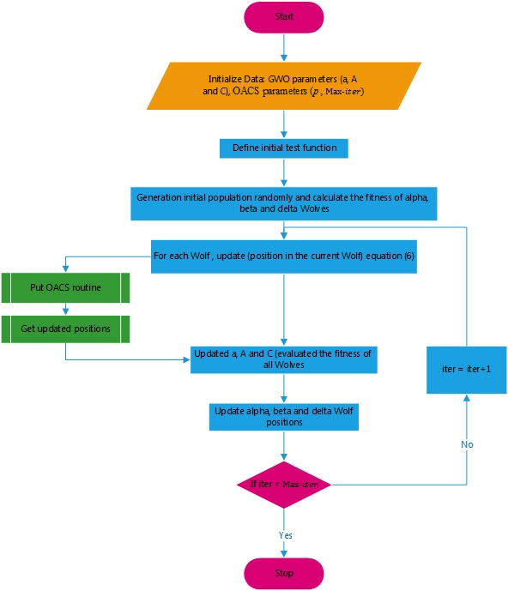
Figure1. Flowchart of the optimal Cuckoo algorithm interfering with the Gray Wolf algorithm

