Table 1: ASHRAE thermal sensation scale of PMV
PMV | Sensation | PMV | Sensation
-1 | Slightly Cool | +1 | Slightly Warm
-2 | Cool | +2 | Warm
-3 | Cold | +3 | Hot
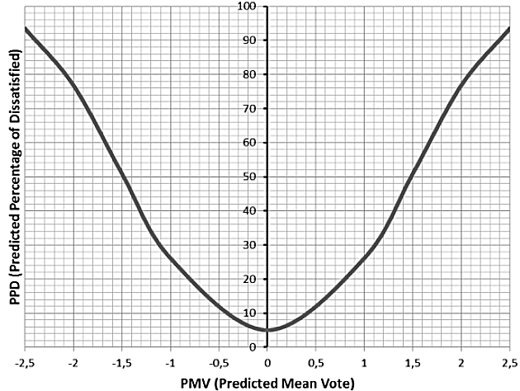
Figure 1: Relationship between PMV and PPD [15]

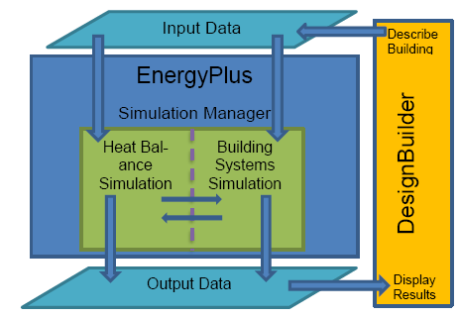
Figure 2: Relationship between “EnergyPlus” and “DesignBuilder”

Interface System
(Fuzzy)
(Fuzzy)
Outputs
Inputs
De-Fuzzifier

Fuzzifier
Interface system

Base Rule

Figure 3: Configuration of the Fuzzy system
Table 2: Energy consumption for Terminal-1 of Sharm-Elsheikh airport
Load | Consumption %
HVAC | 70.5%
Lighting | 6.5%
Hot water | 1.4%
Motors and miscellaneous | 21.6%

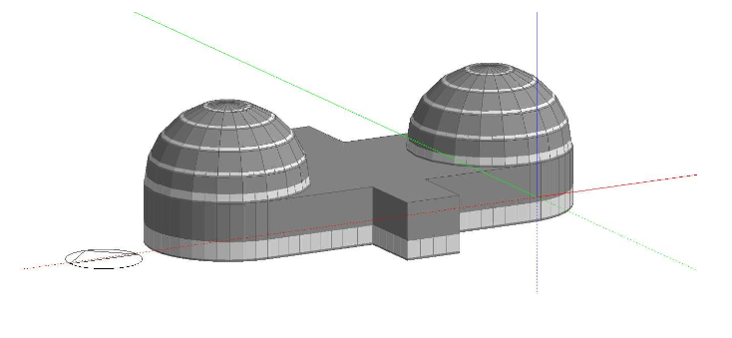
Figure 4: 3D Modeling of Sharm-Elsheikh Terminal-1 building

Figure 5: Comparing BMS & FLC in saving lighting consumption for Terminal-1 of Sharm-Elsheikh airport

Figure 6: Comparing BMS & FLC in saving HVAC consumption for Terminal-1 of Sharm-Elsheikh airport

Figure 7: Comparing BMS & FLC in saving total energy consumption for Terminal-1 of Sharm-Elsheikh airport

Figure 8: PMV comparison between BMS & FLC for Terminal-1 of Sharm-Elshiekh airport
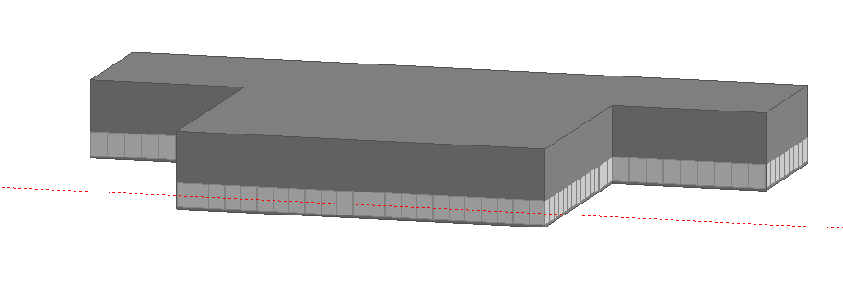
Figure 9: 3D Modeling of Luxor Terminal building

Figure 10: Comparing BMS and FLC in saving lighting consumption for Luxor airport

Figure 11: Comparing BMS and FLC in saving HVAC consumption for Luxor airport

Figure 12: Comparing BMS and FLC in saving total energy for Luxor airport

Figure 13: PMV comparison between BMS & FLC for Luxor airport
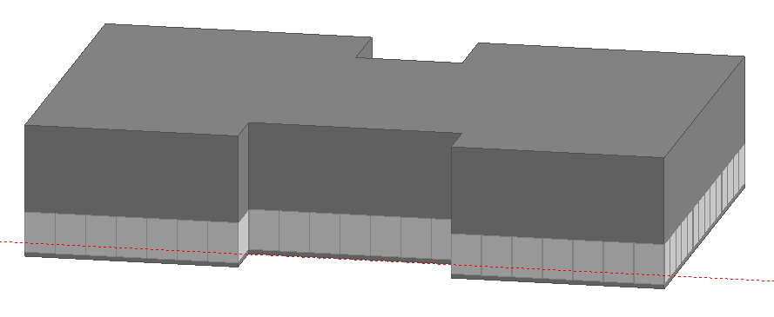
Figure 14: 3D modeling of Taba airport

Figure 15: Comparing ON/OFF controller and FLC in saving lighting consumption for Taba airport

Figure 16: Comparing ON/OFF controller and FLC in saving HVAC consumption for Taba airport

Figure 17: Comparing ON/OFF controller and FLC in saving total energy consumption for Taba airport

Figure 18: PMV comparison between ON/OFF controller & FLC for Taba airport

Table 3: Achieved results for the three studied airports
 | Sharm-Elshiekh  Airport | Luxor  Airport | Taba  Airport
Occupancy Level | High | MED | Low
Total Annual Energy Saving | 20% | 17% | 13.5%
Total Annual Emissions Avoided | 18.75% | 14.9% | 13%
PMV Achieved | -0.12 : 0.8 | -0.21: 0.59 | -0.12:1.4

