The MRAC Based - Adaptive Control System for Controlling the Speed of Direct Current Motor

**Trong-Thang Nguyen**

Faculty of Electrical and Electronic Engineering, Thuyloi University, Vietnam

|  |  |  |
| --- | --- | --- |
| **Article Info** |  | **ABSTRACT** |
| ***Article history:***  Received Jun 1, 2018  Revised Jul 10, 2018  Accepted Jul 25, 2018 |  | This research aims to propose an adaptive control system for controlling the speed of the Direct Current (DC) motor. The system consists of two control loops: the first control loop is a traditional PID controller and the second control loop is an adaptive controller. The role of the adaptive controller is adjusting the output of the control object follows with the output of the reference model. The adjustment mechanism is very simple, but the quality of the whole system is very high: the conversion time is short and there isn't overshoot. The quality of the proposed adaptive control system is also compared to the traditional PID control system to show the advantages of the new system. |
| ***Keywords:***  MARC  DC Motor  PID control  Speed Control |
| *Copyright © 2019 Institute of Advanced Engineering and Science.  All rights reserved.* |
| ***Corresponding Author:***  Trong-Thang Nguyen,  Faculty of Electrical and Electronic Engineering, Thuyloi University,  175 Tay Son, Dong Da, Hanoi, Vietnam  Email: nguyentrongthang@tlu.edu.vn | | |

1. **INTRODUCTION**

The Direct Current (DC) motor is a traditional electric motor. In comparison to the other electric motor such as brushless DC motors [1], [2], [3], induction motor [4], [5], [6], the intrinsic structure of the DC motor [7] has advantages such as the ease of maintenance, the simple control structure, the large electromagnetic torque, and the wide range of speed control. Therefore, DC motors are increasingly widely used in areas that require high-quality control, such as crane, elevator, conveyor, steel rolling, transportation, mining, etc [8], [9], [10], [11], [12], [13]. There is some research for controlling the DC motor such as [14], [15], [16], [17], [18]. Most of these researchers use a simple controller such as Proportional–Integral–Derivative (PID) controllers [19], [20]. The advantage of the PID control is a simple structure, but the drawback is that the quality of the control system is not high. In the research [21], the author has proposed a method for controlling the DC motor that has achieved high-quality, that is the control method based on the flatness principle, but the limitation of this method is that the control algorithm is complex. In the other research [22], the author has proposed a solution to build a control system based on the linear quadratic regulator controller. This control algorithm is simple, but for the system to achieve good quality, it is necessary to know the exact parameters of the control object.

From the above overview, we see that if the structure of control system is simple, the quality of control system is low. In order for the system to achieve high-quality control, the control structure must be complex and at the same time know exactly the parameters of the control object. Therefore, to overcome the above limitations, in this article, the author will propose a new control system for DC motors with simple structure but high quality. That [is the model reference adaptive control (MRAC)](https://www.sciencedirect.com/science/article/pii/S2351978916301664) system. Moreover, the proposed control system can adapt to the transformation of the object. This control system is suitable for the object in the case of unknown exactly the parameters of the control object or the parameters are changed.

The remnant of this research is structured as follows. The sate separately excited DC motor is presented in Section 2. The design of the control system is presented in Section 3. The results and analysis are presented in Section 4, and lastly, in Section 5, some conclusions are presented.

1. **THE SEPARATELY EXCITED DC MOTOR**

The diagram of a [separately excited DC Motor](https://www.google.com.vn/url?sa=i&rct=j&q=&esrc=s&source=images&cd=&cad=rja&uact=8&ved=0ahUKEwi-sfSo45LWAhXGsY8KHQTsDL4QjhwIBQ&url=http%3A%2F%2Fwww.electronics-tutorial.net%2Felectronic-systems%2Fseparately-excited-dc-motor%2Findex.html&psig=AFQjCNHmaSyCcIBSltk_iutMExIfE-EU6g&ust=1504863409181770) is presented as Figure 1 [22], [23], it includes:

* The field windings are in the stator, they are used to excite the field flux.
* The armature coils are on the rotor, they are supplied current via brush and the commutator.

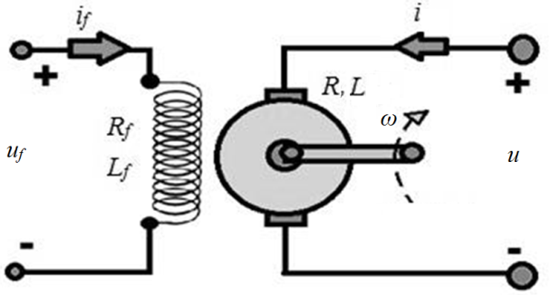

Figure 1. The diagram of a [separately excited DC Motor](https://www.google.com.vn/url?sa=i&rct=j&q=&esrc=s&source=images&cd=&cad=rja&uact=8&ved=0ahUKEwi-sfSo45LWAhXGsY8KHQTsDL4QjhwIBQ&url=http%3A%2F%2Fwww.electronics-tutorial.net%2Felectronic-systems%2Fseparately-excited-dc-motor%2Findex.html&psig=AFQjCNHmaSyCcIBSltk_iutMExIfE-EU6g&ust=1504863409181770)

The mathematical equations of the DC Motor include:

* The voltage equation:

 (V) (1)

Where is the armature voltage, which is fed into the armature coil;  is the armature current; is the armature resistance and inductance; *E* is the electromotive.

* The electromotive equation:

 (V) (2)

Where *ω* is the speed of the rotor, *Kb* is the coefficient of voltage, is the winding field current, is the field armature mutual inductance.

* The motion equation:

(N.m) (3)

Where is the inertia,  is the electromechanical torque,  is the torque which impact to the shaft,  is the coefficient of the viscous friction,  is the coulomb friction torque.

* The electromechanical torque equation:

 (N.m) (4)

Where is the torque coefficient.

1. **BUILDING THE CONTROL SYSTEM**

**3.1. The structure of the control system in the case of non-adaptation**

The traditional control system structure is a feedback control system with a PID controller. It has the diagram as shown in Figure 2.

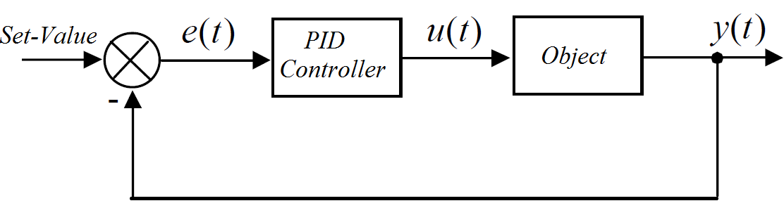

Figure 2. The diagram of control system with PID controller

PID controller is a common controller, it is applied in automatic control systems of production processes such as rolling steel, paper production, cement furnaces, and in the electrical control system, steam control system, diesel motor, etc. The structure of a PID controller consists of three components:

* The proportion component (P)
* The integral component (I)
* The derivative component (D)

The block diagram of the PID controller is shown in Figure 3.

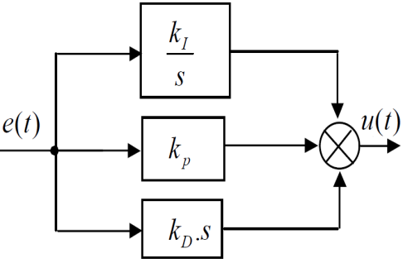

Figure 3. The PID controller

The relationship of input and output of the PID controller is as follows:

 (5)

The function of each component is as follows:

* The proportion component performs the main role of the controller. If there is an output deviation, this deviation will be amplified through the proportion component to affect the object and reduce the deviation.
* The integral component is a supporting component to the role is increasing the accuracy of the system. If the static deviation is not equal to zero, then through the integral component, there is a signal fed into the input of the object to reduce the static error.
* The derivative component also is a supporting component to the role is increasing the sensitivity of the system. Just a small change of external factors that affect the system will create a big change and impact on the object, so the object will react quickly to changes in the environment.

The control system built in Matlab is shown in Figure 4.

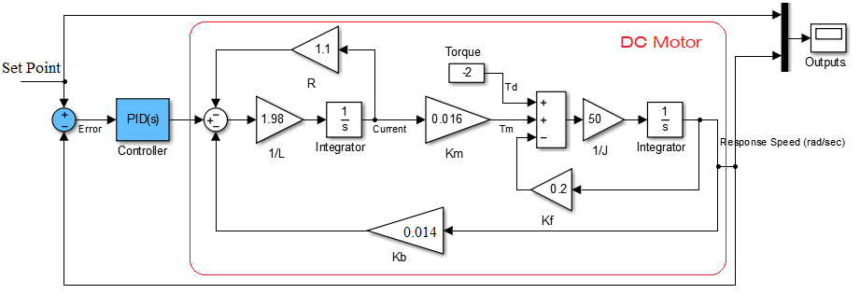

Figure 4. The control system with PID controller

**3.2. The MRAC Based - Control System**

The traditional PID controllers are only suitable for systems with unchanged or known parameters. The parameters of the controller are determined experimentally by the Ziegler-Nichols [24], [25] method or optimizing module. After defining the parameters *kP, kI, kD,* these parameters will be stable during control processes.

To control the systems that are continually changing or unknown parameters, the parameters *kP, kI, kD* must be continuously adjusted during control processes. The author proposes a simple self-tuning algorithm based on the adaptive control method according to the reference model MARC. The purpose of the control system is that the output response of the control object (the speed of the DC motor) must follow the output of the reference model even if the parameters or the state of the DC motor change.

The diagram of the adaptive control system according to the reference model is shown in Figure 5.

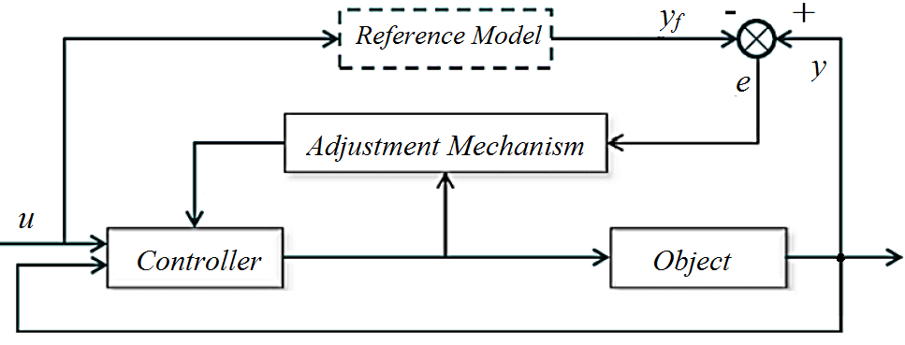

Figure 5. The diagram of the [model reference adaptive control (MRAC)](https://www.sciencedirect.com/science/article/pii/S2351978916301664) system

The control object is a DC motor, with the input is the armature voltage, the output response is the speed of the motor. The reference model is a first-order inertia component with a time constant *T = 0.1* so that the output of The Reference Model adheres to the set signal quickly. The adjustment mechanism is a gamma multiplier.

The MARC control system built in Matlab is shown in Figure 6.

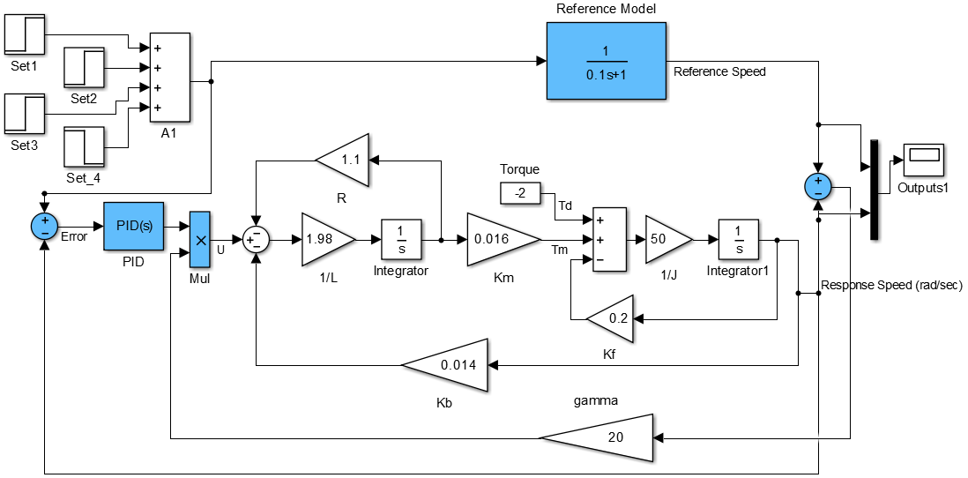

Figure 6. The [MRAC](https://www.sciencedirect.com/science/article/pii/S2351978916301664) control system

1. **THE RESULTS AND ANALYSIS**

Before running the system simulation, we set the motor parameters as shown in Table 1.

Table 1. The parameters of the DC Motor

|  |  |  |  |  |  |
| --- | --- | --- | --- | --- | --- |
| R(Ω) | L(H) | Km | Kb | J(kg.m^2) | Td+Tm(N.m) |
| 1.1 | 0.505 | 0.016 | 0.014 | 0.02 | Var |

To demonstrate the superiority of the proposed system, the author simulates two systems: the MARC adaptive control system and the traditional PID control system.

The simulation results are shown in Figure 7: Figure 7.a shows the response of the adaptive control system and Figure 7.b shows the response of the PID control system.

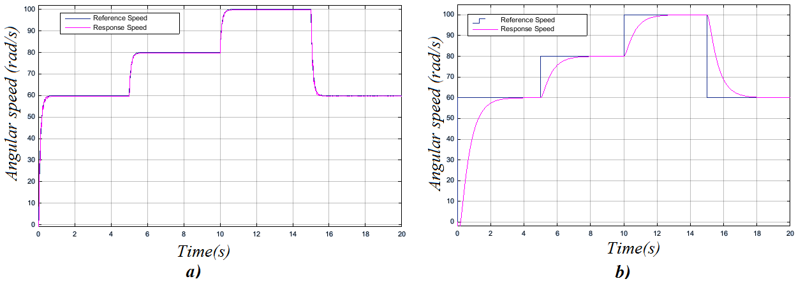

Figure 7. The response of the control system: a) MARC control system; b) PID control system

The simulation results show that the quality of the adaptive control system is much better than the PID control system. In PID control system, the conversion time is about 2-3s. In the adaptive control system, the conversion time is very small, about 0.05s, the response speed almost always adheres to the reference speed immediately.

To show more clearly the advantages of the adaptive control system, the author runs two systems in case of changing in motor parameters: *R=0.12; Kb=0.016*. The results are shown in Figure 8.

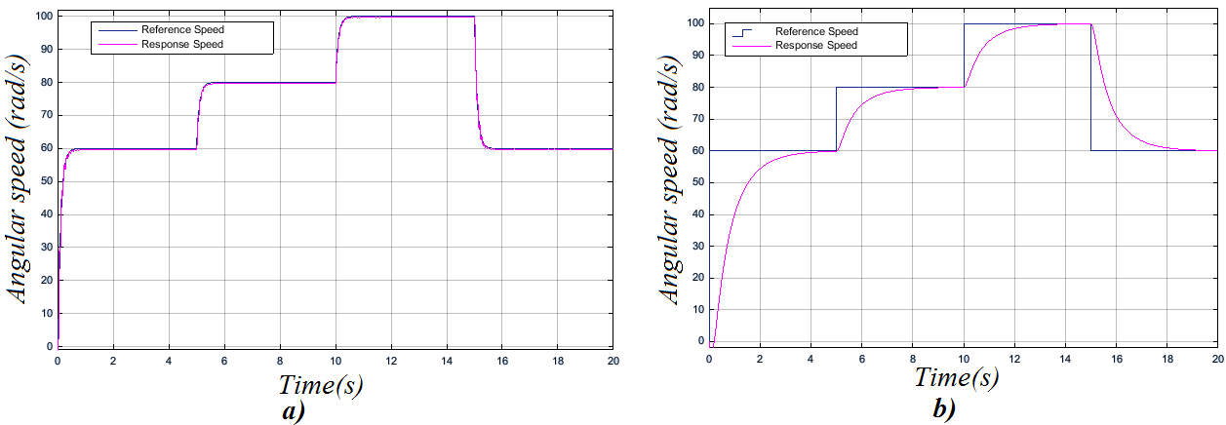

Figure 8. The response of the control system in case of changing in motor parameters: a) MARC control system; b) PID control system

The results in Figure 8 show that when the parameters of the control object change, the quality of the PID control system is significant decline, but the adaptive control system is still as good as the original. Therefore, it can be affirmed that the adaptive control system can apply to the DC motor control with good quality in the condition of unknown exactly the DC motor parameters or the DC motor parameters are changed.

1. **CONCLUSION**

The author successfully proposed the MARC adaptive control system for controlling the DC motor. This control system is simple but highly effective. The structure of the calibration system is very simple, just a multiplier, so the cost of the control system is low. The quality of the proposed control system is superior to that of a traditional PID system: The conversion time is very small and there is no static deviation during the control. The success of this study is a good basis for the author to apply it to practice in further studies.

**REFERENCES**

1. Sekhar, G. R., & Banakara, B. (2018). An Internal Current Controlled BLDC Motor Drive Supplied with PV Fed High Voltage Gain DC-DC Converter. *International Journal of Electrical and Computer Engineering (IJECE), 8(2),* 1262.
2. Park, J. S., & Lee, K. D. Design and Implementation of BLDC Motor with Integrated Drive Circuit. *International Journal of Power Electronics and Drive Systems (IJPEDS)*, *8*(3), 1109-1116, 2017.
3. Trong, T. N., & Duc, M. N. (2015). The speed control system of BLDC using PID controller with PWM modulation technique. *International Journal of Advanced and Appied Sciences, (2(12), 47-51.*
4. Gunabalan, R., & Subbiah, V. Speed Sensorless Vector Control of Induction Motor Drive with PI and Fuzzy Controller. *International Journal of Power Electronics and Drive Systems (IJPEDS)*, *5*(3), 315, 2015.
5. Abdelhak, B., & Bachir, B. A High gain observer based sensorless nonlinear control of induction machine. *International Journal of Power Electronics and Drive Systems (IJPEDS)*, *5*(3), 305, 2015.
6. A. Ramesh, O. Chandra Sekhar, M. Siva Kumar (2018). A Novel Three Phase Multilevel Inverter with Single Dc Link For Induction Motor Drive Applications. [*International Journal of Electrical and Computer Engineering (IJECE)*](http://www.iaescore.com/journals/index.php/IJECE)*, 8(2)*, pp. 763-770.
7. Nayak, B., & Sahu, S. (2019). Parameter estimation of DC motor through whale optimization algorithm. *International Journal of Power Electronics and Drive Systems*, *10*(1), 83.
8. Solihin, M. I., Wahyudi, & Legowo, A. (2010). Fuzzy-tuned PID anti-swing control of automatic gantry crane. *Journal of Vibration and Control*, *16*(1), pp.127-145.
9. Sakawa, Y., & Nakazumi, A. (1985). Modeling and control of a rotary crane. *Journal of Dynamic Systems, Measurement, and Control*, *107*(3), pp.200-206.
10. Colby, R. S. (2000). *U.S. Patent No. 6,163,472*. Washington, DC: U.S. Patent and Trademark Office.
11. Petru, L., & Mazen, G. (2015). PWM control of a DC motor used to drive a conveyor belt. *Procedia Engineering*, *100*, pp. 299-304.
12. Shen, Y., & Xia, X. (2014). Adaptive parameter estimation for an energy model of belt conveyor with DC motor. *Asian Journal of Control*, *16*(4), pp.1122-1132.
13. BETZ, Robert Eric; MIRZAEVA, Galina; SUMMERS, Terrence J. A Dynamic dynamometer for testing of mining DC motors. In: *2010 IEEE Industry Applications Society Annual Meeting*. IEEE, 2010. p.1-8.
14. Thomas, Neenu, and Dr P. Poongodi, "Position control of DC Motor using genetic algorithm based PID controller", *Proceedings of the World Congress on Engineering,* 2009, vol. 2, pp. 1-3.
15. Xue, Dingyu, Chunna Zhao, and YangQuan Chen, "Fractional order PID control of a DC-Motor with elastic shaft: a case study", *American Control Conference,* IEEE, 2006, pp.1-6.
16. Yao, Jianyong, Zongxia Jiao, and Dawei Ma,"Adaptive robust control of DC Motors with extended state observer", *IEEE Transactions on Industrial Electronics Vol 61.7 ,2014*, pp. 3630-3637.
17. Bosco, Maycon Chimini, et al,"Estimation of parameters and tuning of a speed PI of permanent magnet DC Motor using differential evolution", *Electric Machines and Drives Conference (IEMDC)*, *IEEE International,2017,*pp.1-6.
18. Trong-Thang Nguyen (2019). The neural network-based control system of direct current motor driver. [*International Journal of Electrical and Computer Engineering (IJECE)*](http://www.iaescore.com/journals/index.php/IJECE)*, 9(2),* pp. 1445-1452.
19. Xue, D., Zhao, C., & Chen, Y. (2006, June). Fractional order PID control of a DC-motor with elastic shaft: a case study. In IEEE *2006 American control conference.* pp.1-6.
20. Obaid, B. A., Saleh, A. L., & Kadhim, A. K. (2019). Resolving of optimal fractional PID controller for DC motor drive based on anti-windup by invasive weed optimization technique. *Indonesian Journal of Electrical Engineering and Computer Science*, *15*(1), pp. 95-103.
21. Trong, T. N. (2017). The Control Structure for DC Motor based on the Flatness Control. *International Journal of Power Electronics and Drive Systems (IJPEDS)*, *8*(4), pp.1814-1821.
22. Trong-Thang Nguyen (2019). The linear quadratic regular algorithm-based control system of the direct current motor. *International Journal of Power Electronics and Drive Systems (IJPEDS), 10(2),* pp. 768-776.
23. Khac-Khiem Nguyen, Trong-Thang Nguyen (2019). The sensorless control system for controlling the speed of direct current motor. *Indonesian Journal of Electrical Engineering and Computer Science, 16(3)*, pp. 1171-1178.
24. Åström, K. J., & Hägglund, T. (2004). Revisiting the Ziegler–Nichols step response method for PID control. *Journal of process control*, *14*(6), pp.635-650.
25. Mantz, R. J., & Tacconi, E. J. (1989). Complementary rules to Ziegler and Nichols' rules for a regulating and tracking controller. *International journal of control*, *49*(5), pp.1465-1471.