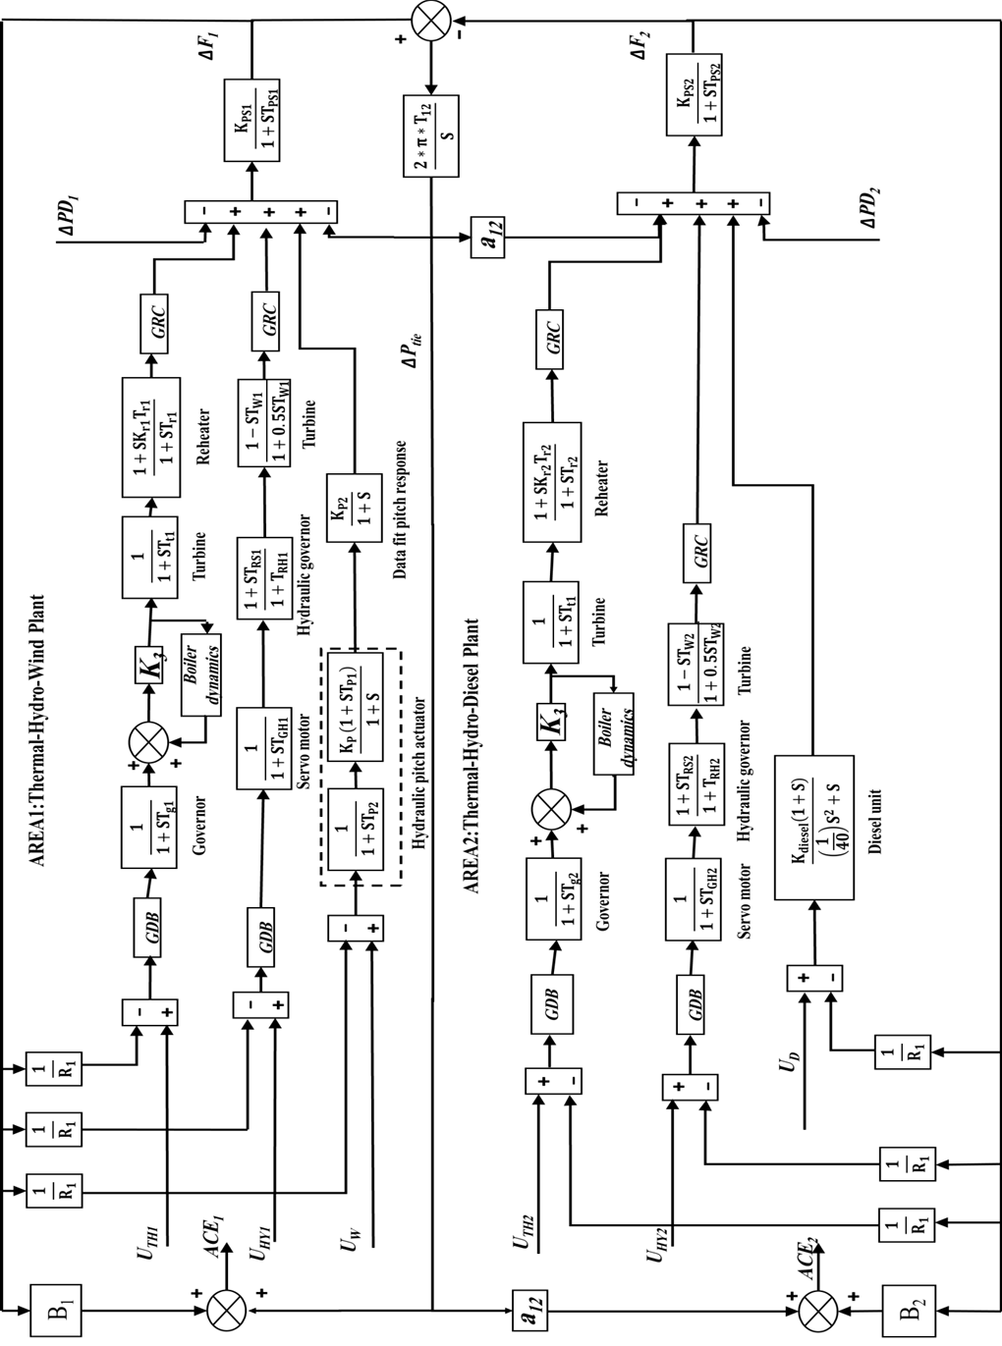

**Wind Turbine**

**Figure 1:** Transfer function model of multi-area multi-source power system with nonlinearities

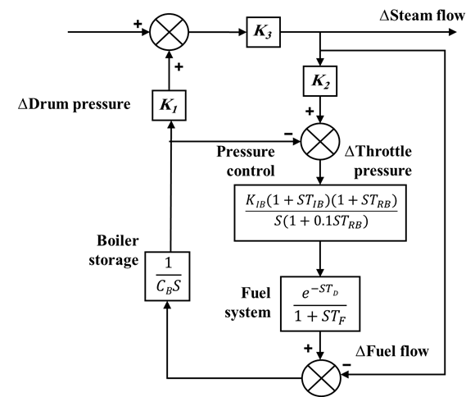

**Figure 2:** Transfer function model of boiler dynamics

|  |
| --- |
|  |
| 1. Change in frequency of area-1 |
|  |
| 1. Change in frequency of area-2 |
|  |
| 1. Change in tie line power |
| **Figure 3:** Test system performance for 1% step load increase in area-1 |

Table 1: Optimized parameters of PID-P controllers

|  |  |  |  |  |  |  |  |  |  |
| --- | --- | --- | --- | --- | --- | --- | --- | --- | --- |
| **Controller Parameters of Optimized PID-P for Area-1** | | | | | | | | | |
|  | **Thermal unit** | | | **Hydro unit** | | | **Wind unit** | | |
|  | **GA** | **BBO** | **LBBO** | **GA** | **BBO** | **LBBO** | **GA** | **BBO** | **LBBO** |
| $$K_{P1}$$ | 6.6055 | 0.0393 | 8.7836 | 1.7881 | 3.6204 | 6.5792 | 4.8085 | 25.2475 | 7.9714 |
| $$K_{i}$$ | 2.2142 | 4.7151 | 2.7111 | 1.7206 | 21.1854 | 0.5958 | 8.9051 | 7.3818 | 14.5213 |
| $$K_{d}$$ | 3.7526 | 19.7084 | 0.452 | 2.9945 | 17.7429 | 2.1061 | 2.457 | 8.0561 | 3.1253 |
| $$K_{P2}$$ | 1.4203 | 0.632 | 9.5214 | 2.2657 | 25.7295 | 6.3599 | 0.4899 | 9.8763 | 1.8951 |
| **Controller Parameters of Optimized PID-P for Area-2** | | | | | | | | | |
|  | **Thermal unit** | | | **Hydro unit** | | | **Diesel unit** | | |
|  | **GA** | **BBO** | **LBBO** | **GA** | **BBO** | **LBBO** | **GA** | **BBO** | **LBBO** |
| $$K_{P1}$$ | 1.4828 | 1.242 | 6.7454 | 1.8259 | 0.2568 | 13.254 | 6.1326 | 16.585 | 1.8852 |
| $$K_{i}$$ | 2.2934 | 0.3294 | 13.9548 | 4.1141 | 7.5174 | 1.4632 | 1.885 | 19.6848 | 0 |
| $$K_{d}$$ | 4.9281 | 14.3159 | 4.5611 | 1.9045 | 23.55 | 1.3941 | 0.27098 | 22.5798 | 0.17 |
| $$K_{P2}$$ | 1.6191 | 27.9625 | 4.5 | 1.1218 | 0.4567 | 0.669 | 2.9666 | 12.1444 | 2.0851 |

Table 2: Comparative study for applying 1% step load increase in area-1

|  |  |  |  |  |  |  |
| --- | --- | --- | --- | --- | --- | --- |
| **Peak overshoot (p.u)** | | | **Settling time (2% band)(sec)** | | | Controllers |
| $$∆P_{tie}$$ | $$∆F_{2 }$$ | $$∆F_{1 }$$ | $$∆P_{tie}$$ | $$∆F_{2 }$$ | $$∆F_{1 }$$ |
| - | - | - | 25.89 | 21.93 | 19.68 | DE tuned PID [7] |
| - | - | - | 16.28 | 18.88 | 18.22 | TLBO tuned PID [6] |
| - | - | - | 13.01 | 18.72 | 17.95 | TLBO tuned IDD [6] |
| - | - | - | 12.77 | 16.79 | 16.14 | TLBO tuned PIDD [6] |
| **0.0008** | **0.0031** | **0.0065** | **9.84** | **8.09** | **5.58** | GA tuned PID-P |
| **0.0001** | **0.0006** | **0.0022** | **9.08** | **7.04** | **5.04** | BBO tuned PID-P |
| **0.0006** | **0.003** | **0.0055** | **9.7** | **5.17** | **4.54** | LBBO tuned PID-P |

|  |
| --- |
|  |
| 1. Change in frequency of area-1 |
|  |
| 1. Change in frequency of area-2 |
|  |
| 1. Change in tie line power |
| **Figure 4:** Test system performance for 30% step load increase in both areas |

Table 3: Comparative performance for applying 30% step load increase in both areas

|  |  |  |  |  |  |  |
| --- | --- | --- | --- | --- | --- | --- |
| **Peak overshoot (p.u)** | | | **Settling time (sec)** | | | **Controllers** |
|  | |  |  |  |  |  |  |
| 0.0191 | | 0.111 | 0.2 | 20.97 | 14 | 8.34 | GA tuned proposed PID-P |
| 0.0056 | | 0.0273 | 0.0673 | 20.84 | 16.18 | 9.7 | BBO tuned proposed PID-P |
| 0.0239 | | 0.2295 | 0.1722 | 13.88 | 8.45 | 9.74 | LBBO tuned proposed PID-P |

|  |
| --- |
|  |
| 1. Change in frequency of area-1 |
|  |
| 1. Change in frequency of area-2 |
|  |
| 1. Change in tie line power |
| **Figure 5:** Testsystem performance for updated participation factors | | |

|  |
| --- |
|  |
| 1. Change in frequency of area-1 |
|  |
| 1. Change in frequency of area-2 |
|  |
| 1. Change in tie line power |
| **Figure 6:** Testsystem performance for 0.5 sec delay time |

Table 4: Updated optimized parameters of PID-P controller for 0.5 sec delay time

|  |  |  |  |  |  |  |
| --- | --- | --- | --- | --- | --- | --- |
|  | **Controller Parameters of Optimized PID-P for Area-1** | | | | | |
|  | **Thermal unit** | | **Hydro unit** | | **Diesel unit** | |
|  | **GA** | **LBBO** | **GA** | **LBBO** | **GA** | **LBBO** |
| $$K_{P1}$$ | 1.008 | 0.102 | 1.5072 | 0.1 | 8.6736 | 0.101 |
| $$K_{i}$$ | 1.0316 | 0.111 | 23.3141 | 0.246 | 16.5147 | 0.1001 |
| $$K_{d}$$ | 12.0384 | 0.1005 | 1.2203 | 0.2995 | 4.441 | 0.1007 |
| $$K_{P2}$$ | 7.9254 | 0.5085 | 2.9489 | 0.2959 | 10.9337 | 0.112 |
|  | **Controller Parameters of Optimized PID-P for Area-2** | | | | | |
|  | **Thermal unit** | | **Hydro unit** | | **Diesel unit** | |
|  | **GA** | **LBBO** | **GA** | **LBBO** | **GA** | **LBBO** |
| $$K_{P1}$$ | 8.2759 | 0.1002 | 2.9499 | 1.942 | 1.2942 | 0.592 |
| $$K_{i}$$ | 1.4325 | 0.7604 | 23.1751 | 0.2565 | 6.3013 | 0.138 |
| $$K_{d}$$ | 19.7879 | 1.0293 | 20.0251 | 0.2681 | 13.0733 | 0.104 |
| $$K_{P2}$$ | 15.0634 | 1.1497 | 1.5023 | 0.2989 | 10.7218 | 0.1288 |

Table 5: Proposed PID-P performance for applying 0.5 sec delay time

|  |  |  |  |  |  |  |
| --- | --- | --- | --- | --- | --- | --- |
| **Peak overshoot (p.u)** | | | **Settling time (sec)** | | | **Controllers** |
| $$∆P_{tie}$$ | $$∆F_{2 }$$ | $$∆F_{1 }$$ | $$∆P_{tie}$$ | $$∆F_{2 }$$ | $$∆F_{1 }$$ |
| 0.0077 | 0.012 | 0.0258 | 21.38 | 24.85 | 21.43 | GA tuned proposed PID-P |
| 0.0045 | 0.0192 | 0.0259 | 9.86 | 14.45 | 13.91 | LBBO tuned proposed PID-P |