Risk Assessment Optimization for Decision Support using Intelligent Model based on Fuzzy Inference Renewable Rules

Abdulkareem Merhej Radhi
College of Information Engineering-Al-Nahrain University-Baghdad-Iraq
abdulkareemradhi@gmail.com

Article Info |  | ABSTRACT
Article history:  Received  Revised  Accepted |  | Due to unreliability of wired communications and the risks of controlling the process of transmitsing data besides the complications that affecting data protection and the high costs of systems infrastructure, led to use wireless communications instead of wires media, but these networks are valunerable towards illegal attacks. The side effects of these attacks are modifying data or penetrate the security system and discover its weaknesses, which leads to great material losses. These risks and difficulties led to reluctance of wires communications and propose intelligent techniques and robust encryption algorithms for preventing data transmitted over wireless networks to keeps it safe from cyber security attacks. So, there is a persistent need for providing intelligent techniques and robust algorithms to preserve conveyed information using wireless network. This paper introduces asenario for proposing intelligent technique to increase data reliability and provides a new way to improve high level of protection besides reduces infrastructre cost. The proposed system relies on two models, where the first model based on producing a knowledge base of risk rules while the the aim of the second module is a risk assessment outcomes and encryption process according to attacks type. In this system, reducing risks levels based on renewable rules while a novel security system based on non-periodic keys with unsystematic operations using fuzzy system. We conclude that the proposed system has the ability to protect the transmitted data, increases its reliability and reduce the potential risks. MATLAB Toolkit 2014 then Weka open sources package were used in encryption and data mining for the proposed system.
Keyword:
Encryption
Fuzzy
Cipher key
WLAN
Risk assessment
Copyright © 2020 Institute of Advanced Engineering and Science.
All rights reserved.
Corresponding Author:
Abdulkareem Merhej Radhi,
Department of Information and Communication Engineering, College of Information Engineering
Al-Nahrain University, Iraq-Baghdad
Email: abdulkareemradhi@gmail.com

1. INTRODUCTION
Wireless networks has a most advantages when it is compared with wires networks, “especially after the growth of demand to utilize information resources to support decision making”, such as its ability in transmitting a huge data in the real-time applications and its economic characteristics in improving transmission speed for massive data “However, wireless technology also creates a new threats via alters the existing transmitted information. “Unlike wired networks, wireless networks” transmit data "through the air using radio frequency transmission or infrared. Current wireless technology in use enables an attacker to monitor a wireless network and in the worst case may affect the integrity of the data”. “The above vulnerabilities and threats which are arise in adapting wireless communication is very important to make sure that the wireless network is secure whether for a home or an enterprise network [Choil, 1].” Also, this networks transfer a sensitive data which may be vulnerable when it is intercepted by malicious users and illegal threats. “This would maximize the risks to the user’s data that use these communications. To overcome these risks, this paper presents a framework of utilization a novel and intelligent encryption methodology with a reliable classification methodology to maximize authenticity. “Encryption is the key to keep information more secure in a Wi-Fi network”. However, “commonly utilized known encryption techniques have big weaknesses and are susceptible by attackers via compromising confidentiality and risks [Bhatia, 2]”.
“WEP transfer data "as 64 bit or 128 bit but the actual transmission keys are 40 bits and 104 bits long where the other 24 bits is an Initialization Vector (IV) to send in the packet along with the data [Waliullah, 3, 4]."
"The organization should implement continuous attack and vulnerability monitoring and perform periodic technical security assessment to measure overall security of the WLAN [Kahai 5]." "The use of strong encryption standards protects WLANs from the worst threats [Liu, 6].” This research paper depicts a new technical method for protecting data from illegal threats. Moreover, this method provides a novel methodology in creating an intelligent and “self-adaptive system” based on creation a renewable rule and encrypts data when it is in a high level of risks. This technique is easiest if we taking in consideration both the simplicity of management of the encryption key distribution and reducing the infrastructure cost for protecting transmitted data and achievement of the maximum degree for encryption parameters (i.e. safety, reliability, and authenticity). Its designs capable to reduce risks in various situations, such as “a noise that affect the accuracy of data sent” via investment of fuzzy scheme concepts to reduce all possible likelihoods of risk levels.
The objectives of various related techniques are to safe data transferred via wireless networks, therefore “Sedghi and Kaghazgaran [7], introduces “a public key cryptography” to secure wireless network security”.
2. Methodology
Minimizing risks and optimizing management of the control for the transmitted packets is the main aim of this research. Due to security and system reliability characteristics, this research covers all risks of expected security disasters in several circumstances. Surveillance the network and identifies the behaviour of malicious intruders via unsupervised learning was used. Features are extracted and evaluated after data collection to test the conveyed packets.

2.1 Fuzzy Renewable Rules
First of all, the main core of this step is a creation of fuzzy rules to produce a knowledge base of risk rules which was satisfied via two specific models as follows:
The first module is a construction of a risk knowledge base. This module aims to creat a repository of risk levels and a subject oriented experts from the “inference part for many risks and focus on cause-and-effect relationships based on their knowledge [Lyne, 8]”. "The aim of the second module is a risk assessment outcomes model, (i.e. Flow into the risk decision-making process and the outcome of the decision are fed back into the system to refine the fuzzy sets, rules”. "Fuzzy logic models used with other risk models such as decision trees to model complicated risk issue.)” . In the proposed system and according to “analysis for the types of attacks, the packets encryption should be tackled according to its type [Kahai,5]". "A key feature of fuzzy sets is that there are no hard rules about how their membership functions are defined [Malik, 9]". “In order to establish inference rules from fuzzy data in WLAN security system, independent and dependent variables selected and then fuzzy sets with numeric values adopted. In this research, robust and unbreakable data is dependent variables while true packets are the independent variable”.

  - Proposed Algorithm
Radhi (the author), 2017, 10], “was previously adopted algorithm to achieve two important features which are data security and satisfying its reliability, while the second is the creation of recordable security automated system”. In this paper, a different technique adopted to have higher security for “the transmitted data, which are formed as packets”. We can specify this algorithm as follows:

- An initial key (Basic Key) stated and represented by a “shift register as 16-bits (Two Bytes)”.
- A message key (64 bits) long represented by (4 “shift registers”).
- “Every single bit of the message key integrates with “shift register” output for the basic key, according to” the following sequence of nonlinear function”:
$Output= B_{k}⊕$ $M_{k}⊕⋀{ I}_{k}$ …… (1)
- Specifying a random permutation for the output.
- Final output will be organized using the mathematical form: $O_{f}={output}_{n}⊕\sim (P_{k})$ , “Where P_{k} is packet bit”.

The recipient decrypts encrypted packets via reversing cycle of the proposed algorithm which is shown in figures (1) and (2) respectively.

Figure (1) presents the general block diagram of the proposed system architecture, where naïve Bayesian classifier was used to classify packets and renewable rule generator with risk level base for risk assessment optimization.

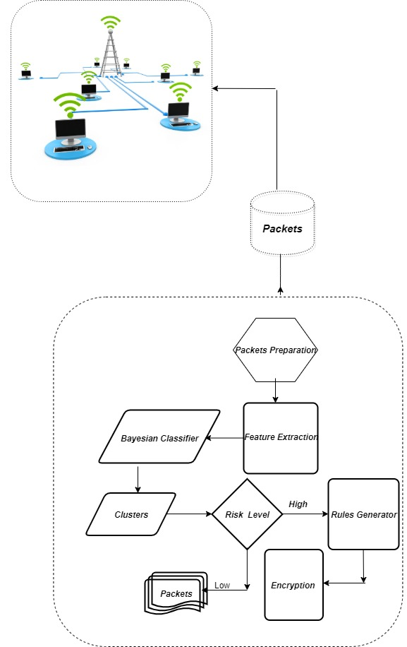

Figure.1: Block Diagram of the proposed system

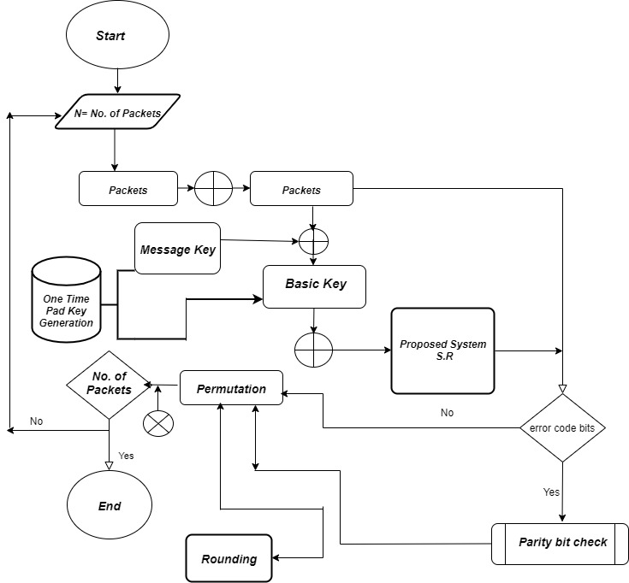

Figure [2] Proposed System for Security Control
  - Rule knowledgebase
This paper adopts a novel methodology for creating knowledgebase of rules. Proposed rules and mathematical hypothesis used to improve and induct facts and rules with logical and discrete theory. The inductive rules are: “modus ponens, modus tollens, addition, simplification, hypothetical syllogism, Disjunctive syllogism, and resolution.” The reasoning models of inference rules are seeds for the rules of the proposed system. It depends on the condition and consequence of the following form:

(“if risk then packets) is accepted, but the antecedent risk holds, then the consequent encryption cannot be activated.”

Analyzing the data, “there are four variables from QoS parameters. They are delay, jitter, packet loss, and throughput. Technique for analyzing the data of IP network quality in this paper implemented via calculating the value of each Quality of Service parameters such as delay rata which is the number of delays divided by the number of received packets, and the Percentage Packet Loss” [11], as shown in equation (2):

$$percentage Packet Loss= \frac{(Number of sent packets-Number of received packets) }{Number of sent packets} ×100…..(2)$$

$$Throughput=\frac{Number of Packets ×8}{Simulation time}……(3)$$

The proposed system achieves these parameters concerning Qos for the transmitted packets after risk optimization as shown later implicitly in the tables (II) and (III).

2.4 Naïve Bayes Classifier
It is a probabilistic classifier based on Bayes' statistics theorem with (naive) or independence attributes and hypothesis. It is a descriptive technique and “independent feature model”. Naive Bayes classifiers can be trained very efficiently in a supervised learning setting. Parameter estimation uses the method of maximum likelihood. Figure [3] presents cascading steps of this method, where the probability of a classification can be determined using equation [4].

$P(H|X) =\frac{P\left(X | H\right)P(H)}{P(X)}$ …… (4)
Where “P (H|X) is the a posteriori probability of H conditioned on X. In contrast, P (H) is the a priori probability of H. Similarly, P (X|H) is the a posteriori probability of X conditioned on H. P(X) is the a priori probability of X.”

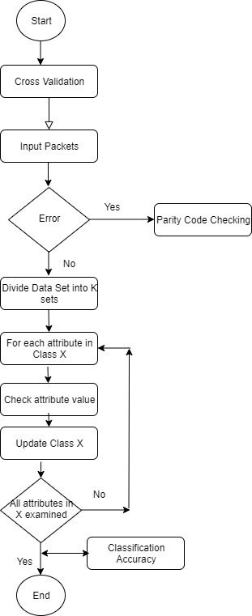
Figure [3] Naive Bayesian Classifier
“It is a method for estimating parameter values θ = (K,(n)^{k} ,h^{k} ) which is based on the information from the data y_{n} (expressed in the probability distribution f(y| θ) ) and information from the parameter θ (expressed in the prior distribution π(θ) )”[12] .

3. Optimization of Risk Assessment
Risk assessment is the aim of this research such that the objectives of the proposed technique are maximizing the reliability and confidentiality of data and network via reducing and minimizing risk level. Table [I] depicts risks and rules assessment, where there are three parameters for assigning encryption using the proposed model directed and controlled via threshold. Threshold specified, modified and updated according to data sensitivity and packet size. “So the risk management is the identification, assessment and prioritization of risks (by risk measurements) followed by coordinated and economical application of resources to minimize, monitor and control the probability and/or impact of unfortunate events (by risk treatments)” [13].

TABLE I: Risks and rules assessment

Packets Size | Risk | Encryption
Low | Low | Negative
High | Low | Positive
Low | Med | Negative
High | Med | Positive
Low | High | Negative
High | High | Positive
Low | Very Low | Negative
High | Very Low | Negative
Low | Very High | Negative
High | Very High | Positive

Table [II], presents a support mean in decision making for data transmitted via WLAN vs a probable risks. There are various types for cipher attack as shown in table [II], where the risk level depends on the attack type. So, comprehensive studying for the attacking techniques is an essential topic to identify risks using the proposed model. This table depicts a related attacking type according to its methods and a risk level when applying a security technique to safe data in a suitable and confidential mode.

TABLE II. Decision making and attack type
Attack type | Packets size | Risk Threshold | Risk Level | Encryption  (Decision)
Masquerade | Low | 0.213 | Low | Negative
Rogue Point | High | 0.681 | Low | Positive
MITM | Low | 0.114 | Med | Negative
DOS | High | 0.752 | Med | Positive

Table [III] in the later section presents packets classification precision using Naïve Bayesian classifier. “Entropy measurement used as a tool to check the performance of the obtained classifier that detects set of packets in a specific cluster”. So, if a set of packets (M) belonging to a cluster then:

"Entropy (S) = -p₊ log₂ (p₊) – p₋ log₂ (p₋) - - (5)"

“Performance measured in terms of recall and precision.”

4. Results and Discussion
Due to a processing of huge data with several instances in wireless communication as a problem introduced in this paper as a case study to test the proposed system accuracy, Weka open source package have been used to classify and clustering data based on a Naïve Bayesian classifier with the following properties:

- Number of instances = 1500
- Multifactor for all attributes based on region-centroied.
- Test operations: Cross validation.
- Output prediction format: CSV.
- Hieratical clustering using training set.
Output results

- Minimum = 1
- Maximum = 254
- Mean = 125.197
- Standard Deviation = 73.228
Table [III] Clustering Accuracy of the Proposed System

 | TP Rate | FP Rate | Precision | Recall | F-Measure | MCC | ROC Area | PRC Area | Risk Level
 | 0.973 | 0.007 | 0.955 | 0.937 | 0.946 | 0.937 | 0.997 | 0.986 | Low
 | 1.000 | 0.000 | 1.000 | 1.0000 | 1.0000 | 1.000 | 1.0000 | 1.000 | Low
 | 0.793 | 0.024 | 0.842 | 0.793 | 0.817 | 0.789 | 0.974 | 0.889 | Med
 | 0.845 | 0.040 | 0.785 | 0.845 | 0.814 | 0.781 | 0.976 | 0.875 | Med
 | 0.770 | 0.030 | 0.801 | 0.770 | 0.785 | 0.752 | 0.974 | 0.840 | High
 | 0.970 | 0.010 | 0.946 | 0.970 | 0.958 | 0.950 | 0.998 | 0.991 | High
 | 1.000 | 0.001 | 0.995 | 1.000 | 0.998 | 0.997 | 1.000 | 1.000 | Very Low
Weighted Avg. | 0.904 | 0.016 | 0.904 | 0.904 | 0.904 | 0.888 | 0.989 | 0.941

So, we conclude that (1356) correctly classified instances which is (90.4%) precision rate for weighted average for all possible risk levels, and (144) incorrect classified instances (i.e. 9.6%) precision rate. Recall and precision rate of the implemented proposed technique value 95% with very low minimum risk.

Figure [4] presents WEKA GUI for the processed training data.

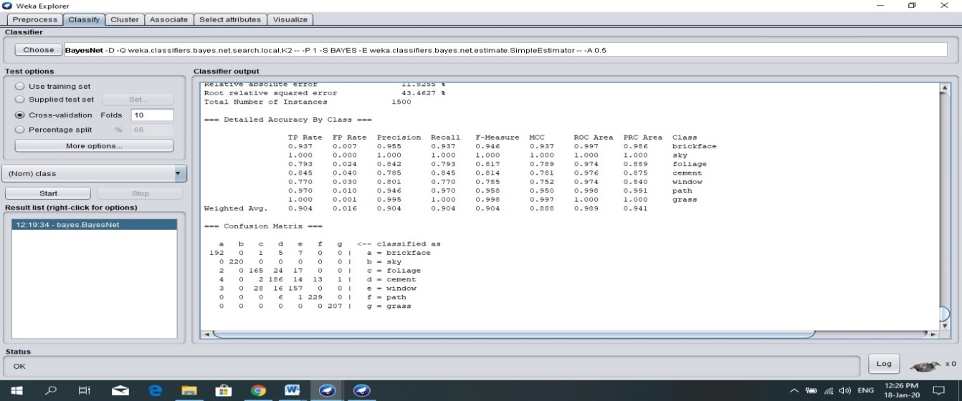
Figure [4] WEKA GUI for the processed training data

5. CONCLUSIONS

The proposed work in this paper presents a new method to have a reliable and safe conveyed data against the attacker and illegitimate interceptors. Optimization assessment of risks level is the main key to minimizing risks via data encryption which is based on the proposed encryption system. The proposed model based on the training and learning phase in order to be “adaptable and immune against different attacks”. WEKA open source package was used based on naïve Bayesian classifiers with specific features. Average accuracy rate was (90.4%). Recall and precision reflects a precision rate value was 95% with very low minimum risk.

REFERENCES
[1]. Choil, Robles, and Kim, "Wireless Network Security: Vulnerabilities, Threats and Countermeasures", International Journal of Multimedia and Ubiquitous Engineering Vol. 3, No. 3, July 2008.
[2]. Bhatia and Sumbaly, "Framework for Wireless Network Security Using Quantum Cryptography", department of Computer Science in Dubai, UAE, 2013.
[3]. Waliullah and Gan, "Wireless Network Security: Vulnerabilities, A Literature Review", International Journal of Advanced Computer Science and Applications, Vol. 5, No. 1, 2014.
[4]. Md Waliullah, and et. al, "An Experimental Study Analysis of Security Attacks at IEEE 802.11 Wireless Local Area Network", International Journal of Future Generation Communication and Networking Vol. 8, No. 1 (2015), pp.9-18
[5]. P. Kahai, S. Kahai, “Deployment Issues and Security Concerns with Wireless Local Area Networks:” The Deployment Experience at A University” Journal of Applied Business Research, 2004, vol. 20, no. 4.
[6]. Liu.Tao, and et. al., "An Evaluation of Feature Selection for Text Clustering", Nankai University, 2002.
[7]. Sedghi and Kaghazgaran, "Data Security via Public-Key Cryptography in Wireless Sensor Network", International Journal on Cybernetics & Informatics (IJCI) Vol.2, No.3, June2013.
[8]. J.Lynne, “Hot Tips for Securing Your Wi-Fi Network”, 2012.
[9]. Malik, Kapoor, Naryan, and Singh, "Rule Based Technique detecting Security attack for Wireless Sensor Network Using Fuzzy Logic" , International Journal of Advanced Research in Computer Engineering & Technology Volume 1, Issue 4, June 2012.
[10]. Radhi, A., “Risk Surveillance Control of Wireless Security Attack with Fuzzy Rules”, International Journal of Science and Research (IJSR), 2017.
[11]. A., Nabeela, J., Najumnissa, R., L. Arun,” Comparative analysis of energy based optimized dynamic source multipath routing protocol in WSNs”, Indonesian Journal of Electrical Engineering and computer Science”, Vol. 16, No. 1, October 2019, pp. 441-455.
[12]. D. Michel,” Bayesian Segmentation in Signal with Multiplicative Noise Using Reversible Jump MCMC ”, TELKOMNIKA, Vol.16, No.2, April 2018, pp. 673~680.
[13] H., Omer, B., Smajo, “Risk assessment for ancillary services”, International Journal of Electrical and Computer Engineering (IJECE) Vol. 9, No. 3, June 2019, pp. 1561~1568


Dr.Abdulkareem Merhej Radhi is Assistant Professor and has Doctorial of Philosophy in computer science. He is supervisor of many graduate students in Information Engineering College rather than Science Colleges. Lecturer in AL-Nahrain University. Director of Computer Center and Avincina for E-Learning. Interested in Data Security, Soft Computing, Distributed Database, Engineering Analysis, Wireless Networks, Data Mining and Social Network Analysis. The author is a reviewer in one of the famous international journals in computer science applications. He was published many novel researches in text classification and summarization, image processing, and cyber forensic. He is author of a book in artificial intelligence concepts and its applications in 2017.

