Mathematical Modelling of Solar PV Module with

MPPT Algorithm using MATLAB/Simulink

Hayder Moayad Abd Alhussain¹, Dr. Naseer Yasin²
Electrical Power Engineering Techniques, Department of Electrical Engineering Technical College
Middle Technical University Baghdad, Iraq

Article Info |  | ABSTRACT
Article history:  Received Jun 1, 2018  Revised Jul 10, 2018  Accepted Jul 25, 2018 |  | This paper introduces a procedure for the modelling of a PhotoــVoltaic (PV) cell and the application of“maximum power point tracking (MPPT)”in step-by-step with MATLAB/Simulink. The model of one diode is used to explore the characteristics of IــV and PــV curves of 60W PV module. Due to the non-linear and time varying of PV characteristics, the generated power of the PV is continually varying with atmospheric conditions like temperature and irradiation, the MPPT technology is very important to chase“maximum power point (MPP)”on the PــV curve to obtain maximum output power from PV array. This study focuses on two common types algorithms of MPPT,“namely perturb and observe (P&O) and incremental conductance (INC)”. A DC--DC boost converter is implemented to regulate the voltage output from the PV array's and for the application of MPPT algorithm.
Keywords:
PhotoــVoltaic (PV),
Maximum Power Point Tracking (MPPT),
DC--DC boost converter,
Perturb and Observe (P&O),
Incremental Conductance(INC).
Copyright © 2019 Institute of Advanced Engineering and Science.
All rights reserved.
Corresponding Author:
Hayder Moayad Abd Alhussain,
Electrical Power Engineering Techniques, Department of Electrical Engineering Technical College
Middle Technical University Baghdad, Iraq
Email: hayder_moayad@yahoo.com

- INTRODUCTION
The Photovoltaic power could be considered among the renewable energy resources as the most essential resource, this is because it is ubiquitous, and there is plenty of solar radiant free energy. Researchers have a best understanding of PV working principles because of continuous updating of the mathematical modelling of solar PV cell [1]-[6]. The solar cells insolation, and the cells temperature of the PV are the most important factors, the output characteristic of PV cells system, is dependent upon.
As the characteristics of PــV and IــV curves are non-linear and time varying, it is necessary to implement a“maximum power point tracking MPPT”system to chase the MPP on the PــV curve, so that maximum power output can be gained from the PV Array system [7].
The incremental conductance method INC, and perturbation and observation method P&O,are the most commonly used methods. The erroneous judgment and continuous oscillations around the“maximum power point MPP”is immanent with P&O method. More detection devices are required in INC method, and the decision of the step can be very stressful [8].
For the representation of the MPPT, the PV system needs to have a DC--DC converter. The DC--DC converter can be either boost converter or buck--boost converter, they are usually used because of their efficiency high. [9]-[10]. The boost converter is used in this paper to track the MPP.

- Nmenclature
[$I_{PV}$] PV output current in (A), [$V_{PV}$] PV output voltage in (V), [$T_{n}$] reference temperature = 298K,
[$T$] operating temperature in Kelvins, [$I_{o}$] PV saturation current in (A), [$n$] PV ideality--factor, which = 1.6,
[$I_{ph}$] PV light generated current in (A), [$K$] Boltzman-constant, which= (1.3805×10⁻²³ J/K), [$q$] Charge of electron, which = (1.6×10⁻¹⁹ C), [$R_{s}$] series resistance of a PV, which =0.0111Ω, [$R_{sh}$] parallel resistance of a PV which =1000 Ω, [$E_{go}$] the band gap of the silicon, which =1.1 eV, [$K_{i}$] short circuit current temperature cــefficient, which =0.0032A/ºC, [$G$] the illumination of PV in (W/m²) which =1000W/m², [$I_{scr}$] short ـcircuit current with irradiation (1000W/m²) and temperature 25ºC= 2.55A, [$N_{s}$] Cells number in series, [$N_{p}$]Cells number in parallel.

- PHOTOVOLTAIC MODELING
3.1. MODEL REFERENCE
PV module of MXS 60W is taken as a reference for the simulation as given in Table 1 [11].

Table 1 60W PV module specifications
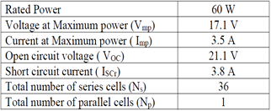

3.2. SOLAR CELL MODULE
A solar panel can be built by connecting series cells and parallel cells to form the PV. In this paper 60W PV model is used with NS = 36 and NP = 1. The solar cells can be represented as a diode circuit as shown in Fig.1. This circuit includes photo current I_{ph} , R_{s} and R_{sh} are the series and parallel resistance of the PV cell respectively.
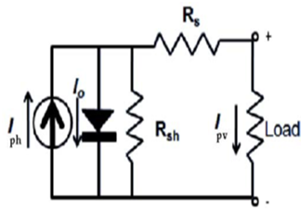
Fig.1. Solar cell circuit

The PV panel can be formed mathematically as shown below [3]-[5]:

Shunt current I_{sh} module:
$I_{sh}=(V+IR_{s})/R_{sh}$
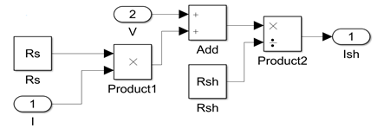
Fig.2. Matlab Simulation of shunt current I_{sh}

Temperature module from degrees to Kelvin:
T _{kelvin} =273+T_{degree}
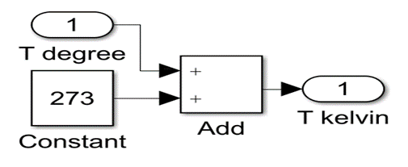
Fig.3. Matlab simulation of temperature conversion from degrees Celsius to Kelvin

    - Photo Current I_{ph} Module:
$I_{ph}={[I}_{sc}+K_{i}(T-298)]G/1000$
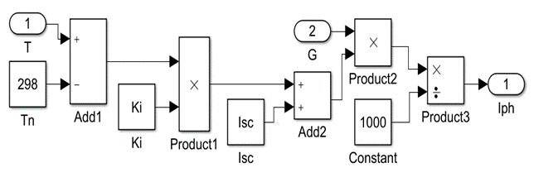
Fig.4. Matlab simulation of photo current $I_{ph}$

Reverse saturation current module I_{rs} :
$I_{rs}=I_{sc}/[\exp\left(\frac{qV_{oc}}{N_{s}knT}\right)-1]$
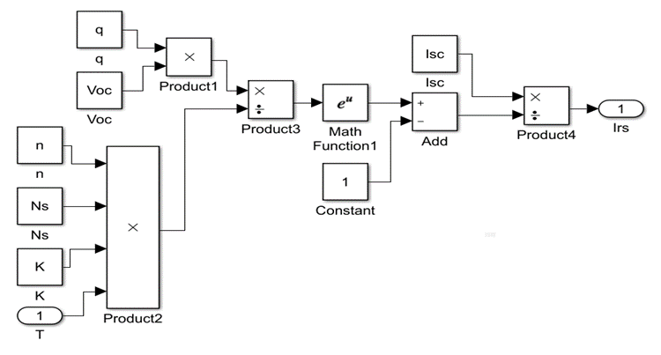
Fig.5.Simulation of the reverse saturation current $I_{rs}$

Saturation current I_{o} module:
$I_{o}=I_{rs}{(T/T_{n})}^{3}exp⁡[qE_{go}(\frac{1}{T_{n}}-\frac{1}{T})/nK]$
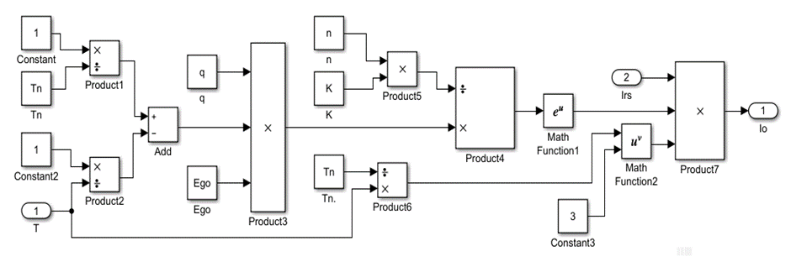
Fig.6. Matlab simulation of saturation current $I_{o}$

The current output of PV module I_{PV} :
$I_{pv}=I_{ph}-I_{o}\left\{\exp\left[\frac{q\left(V+{IR}_{s}\right)}{ KnT}\right]-1\right\}-I_{sh}$
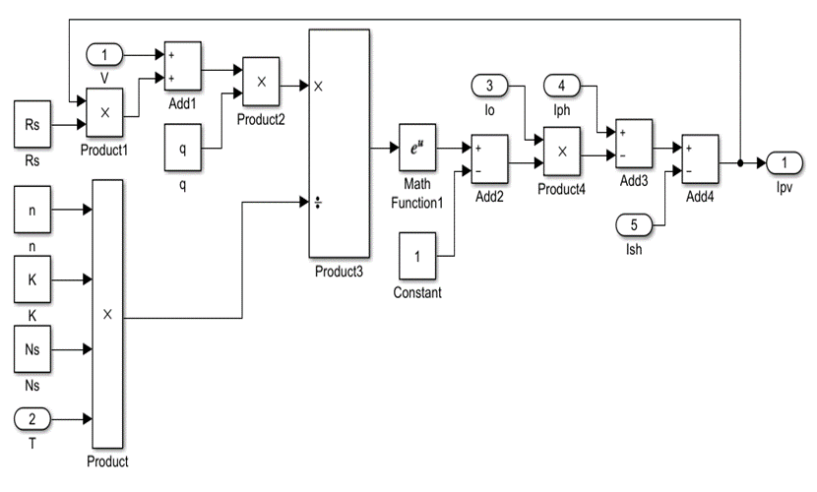
Fig.7. Simulation of output current of PV module $I_{pv}$
All six models above are connected as shown in Fig.8, and a ramp function is used to simulate the whole axis of voltage for the characteristics of IــV and PــV curves, and the slope of the ramp function is set to 10.
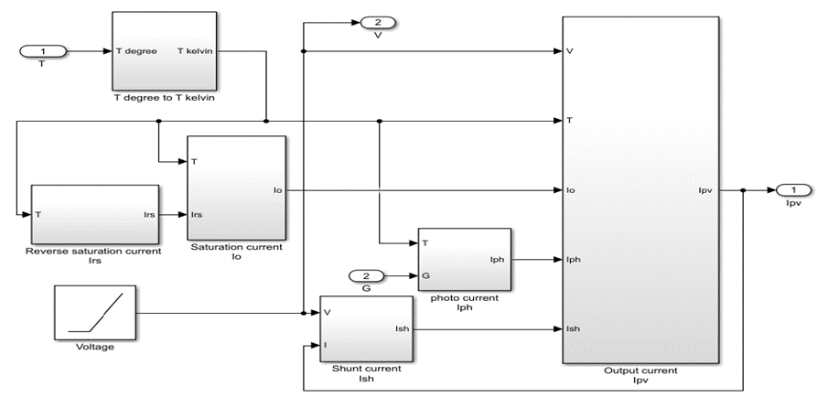
Fig.8. Simulation of all six models

Algorithm of MPPT Control
PV system curves are influenced by temperature and solar irradiation. Furthermore, daily irradiation behaviour has abrupt variations during day time. The MPP of the PV array's under these conditions keeps changing continuously, and the operating point of the PV cell should also change consequently to maximize the extracted energy. The MPPT technique is useful to maintain the operation point of a PV array at its maximum [12].

4.1. DC--DC BOOST CONVERTER
The DC-DC boost converter circuit shown in Fig.9, the circuit consists of DC input source voltage Vin to represent the PV output voltage, L is boost inductor, boost controlled switch IGBT, C is boost filter capacitor, boost diode D and R is load resistance.[10]
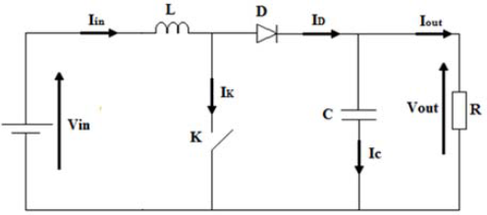
Fig.9. DC-DC converter

The boost controller switch IGBT is controlled by a duty-cycle (d) and the gain DC voltage of the DC-DC boost converter is:

$\frac{V_{out}}{V_{in}}=\frac{1}{1-d}$

Vout is the voltage output from the boost convrter,Vin is the voltage input to the boost converter from the PV array and (d) is the duty-cycle generated from MPPT controller either by P&O or INC to boost the input voltage using pulse width modulation (PWM) technique as shown in Fig.10.
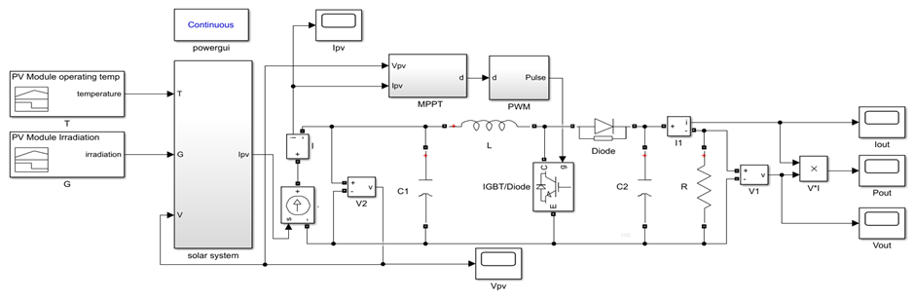Fig.10. Configuration of PV system to control the boost converter with MPPT
Details of the boost converter is given in Table2.
Component | Rating
L | 150[μH]
C1 | 100[μF]
C2 | 470[μF]
R | 30[Ω]
Table 2 dc-ـdc boost converter component values

Two methods of MPPT are taken in this paper

4.2. Perturb and Observe Method (P&O)
The algorithm based on the process of perturbation (increase or decrease) of power based on increases or decrease the voltage of the PV array's, based on the observation of the power output of the PV. The algorithm of P&O is continuously increasing or decreasing the voltage reference through depending on the previous value of power sample. The P&O method is the simpler as it requires sensors for the voltage and current only, and it is easier to be implemented [13]. In this algorithm the time taken to reach the MPP is longer than that in INC. When MPP point is reached, P&O keeps alternating around the point and would never stops on it.
According to the algorithm of P&O, when a small increase on the operating voltage of the PV array is perturbed, and if the power change ΔP is (positive), it is going in a direction towards MPP and it should keep on the perturbing along the same direction. If the changes in power ΔP is (negative), then the operating point is moving away from the MPP point and the sign has to be changed of the delivered perturbation.
The algorithm of P&O is shown in Fig.11; it is based on perturbing the operating voltage periodically and comparing the previous one with it. If the difference in voltage ΔV and the difference in power ΔP are positive then the PV array voltage is increased. If both ΔP and ΔV are negative then there is also an incraese in the PV array voltage, otherwise the voltage is decreased. Similarly the next period is reiterated until the point of maximum power is reached [14]-[15].

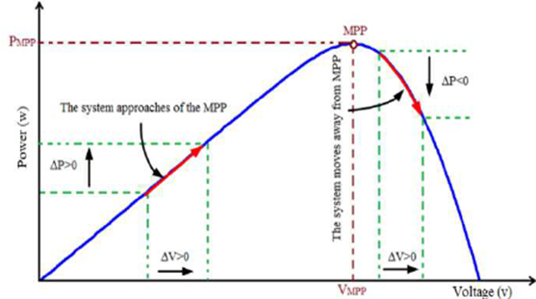
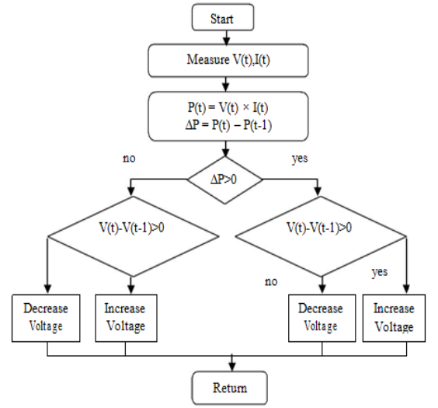
(a) Flowchart of P&O (b) P-V graph
Fig.11.P&O control technique

Fig.12. shows the configuration of MPPT algorithm in MATLAB/Simulink according to the flowchart of P&O method expounded in Fig.11.
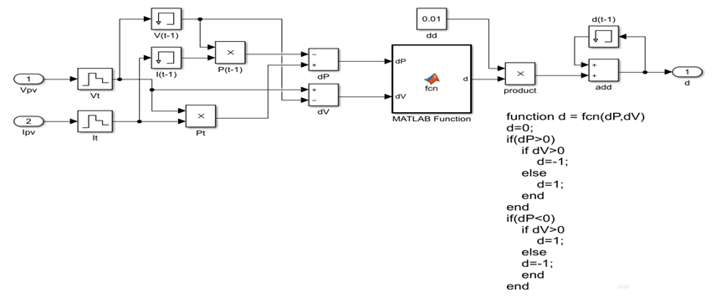
Fig.12. Configurations of (P&O) MPPT algorithm in Simulink

Fig.13.shows the configuration of PWM to increase or decrease the duty-cycle used to control the boost switching IGBT.
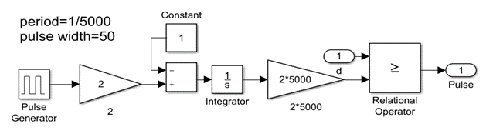
Fig.13.Configuration of PWM

4.3. Incremental Conductance ( INC )
INC is another method for tracking the MPP. This method is used to counter the weakness of the P&O method [16]. The P&O method is not capable to compare the actual operating voltage at a maximum power point with the terminal voltage of the (PV) array. The INC method is easier to implement, it has a higher tracking speed, and better efficiency, this makes INC algorithm better than P&O [17]. The algorithm of INC is derived by differentiating the power of the PV with respect to its voltage, then the result is set equal to zero [18], as in equations (1 and 2).

At point of MPP
$\frac{dP}{dV}=\frac{d(VI)}{dV}=V\frac{dI}{dV}+I=0 ..(1)$
Rearranging equation (1)
$$\frac{dI}{dV}=-\frac{I}{V} .. (2)$$
From equation (2),“the (left hand side) is the incremental conductance, while the (right hand side) is the opposite instantaneous conductance”. When the operating point reaches the MPP, both sides of equation (2) are opposite in the sign but equal in magnitude.
When operating point is away from the MPP, two possibilities exist, either the operating point is at the (left hand side) of MPP when incremental conductance is greater than instantaneous conductance, or at the (right hand side) of MPP when incremental conductance is less than instantaneous conductance as shown in equation (3,4,5).
$$\frac{dI}{dV} = - \frac{I}{V} ,and \frac{dP}{dV} = 0 at MPP \left(3\right)$$
$$\frac{dI}{dV} > - \frac{I}{V} ,and \frac{dP}{dV} > 0 left side of MPP \left(4\right)$$
$$\frac{dI}{dV} < - \frac{I}{V} ,and \frac{dP}{dV} < 0 right side of MPP (5)$$
The operation of incremental conductance idea is shown in Fig.14.
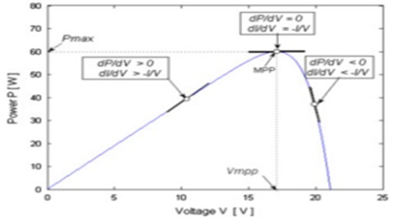
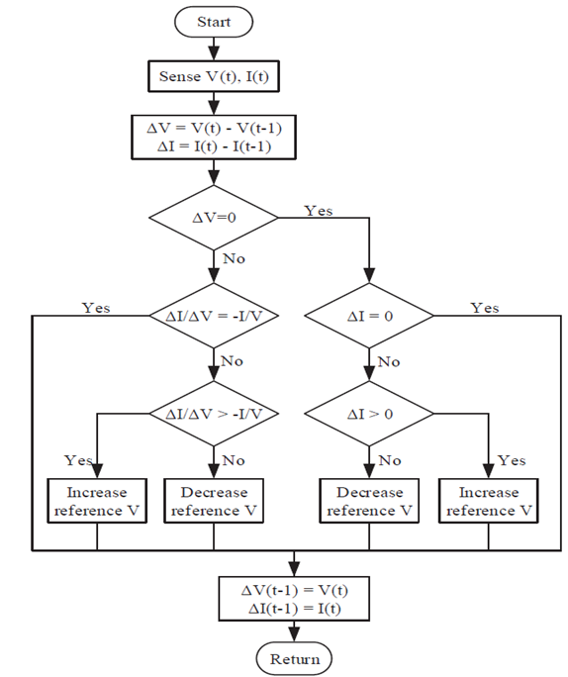(a) Flow chart of INC (b) P-V graph Fig.14.Incremental conductance control technique
5. SIMULATION RESULTS
5.1 Simulation results of the PV array without DC--DC converter.
In Fig 15(a), the input irradiation until time 1 sec, is set to 1000W/m², 1 & 2sec is set to 800W/m², 2 & 3sec it is set to 600W/m², 3 & 4 sec the setting is 400W/m², and between 4 & 5 sec, it is set to is 200W/m². With input temperature set at 25⁰C during the whole simulation.
In Fig.15(b), the input temperature from 0 to 1sec is 25⁰C, between 1 & 2sec it is 50⁰C, 2 & 3s it is set to 75⁰C. With input irradiation set at 1000W/m² during the whole simulation.
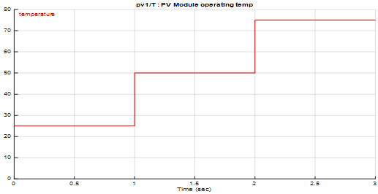
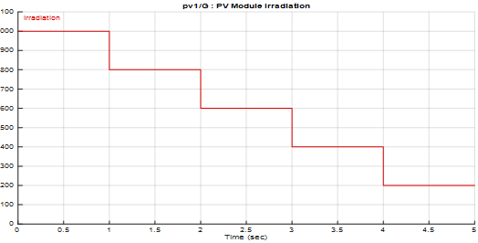
(a) InputـــTime varying irradiation. (b) Input – time varying temperature.
Fig.15.InputـــTime varying irradiation and temperature.

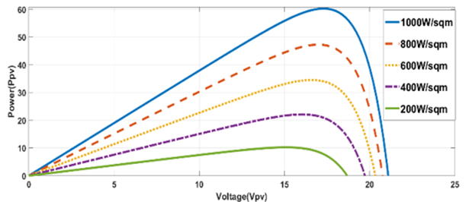
Fig.16 shows that the current output from the PV is decreasing, and the voltage output is also decreasing when the irradiation decreases. This would result in a net decrease in output power with decrease in irradiation when the temperatures are constant.
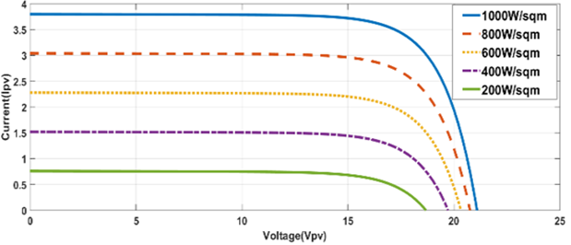
(a) Output IــV. (b) Output PــV
Fig.16.Output characteristic of the PV while varying irradiation.

In Fig.17 when the operating temperature increases, the voltage output from the PV decreases drastically, but the current output increases marginally. This results in a net reduction in the power output with a rise in temperatures.
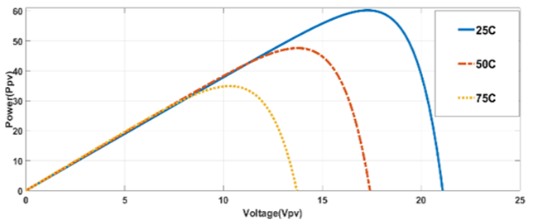
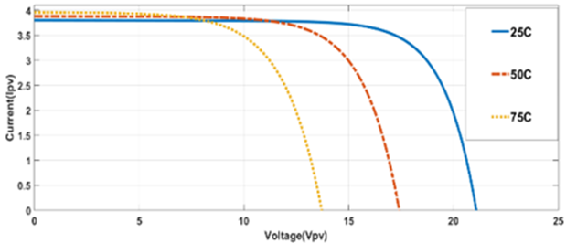
(a) Output IــV (b) Output PــV
Fig.17.Output characteristic of the PV with temperature varying.
5.2. Simulation results of the PV array with resistive load.
The irradiation is set to1000W/m² and the temperature is set to 25⁰C, it is seen in Fig.18 that the output DC power is about 14W which is equal to: $P=VI$ … (6)
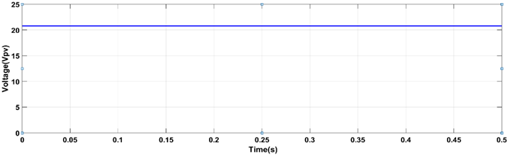
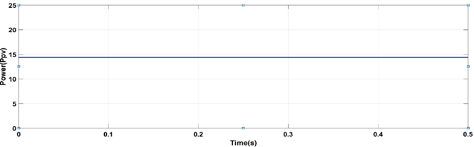
(a)Power (Ppv). (b)Voltage (Vpv). Fig.18.Output of the PV array with resistive load.
5.3. Simulation results with dc-dc boost converter using MPPT (P&O, INC).
As seen in Fig.19, the output power from the P&O method is 57W and output voltage is 42V which represents the maximum power (Pmax) and (Vmax) that can be drawn from the PV module. This maximum power was achieved in about 0.08 sec. the final value of output power has a ripple of about 1.5 as seen in Fig.19(a).
While in the INC method the maximum power output (Pmax) of value 58W is achieved with a rise time of about 0.05 sec, with a ripple of about 1.5 as seen in Fig.20.
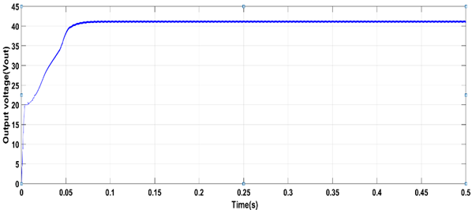
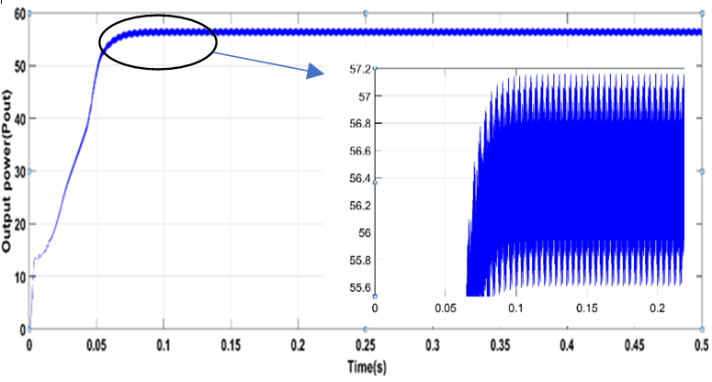
(a) Output power (b) Output voltage
Fig.19.The output power and voltage of the DC--DC boost converter with P&O method.
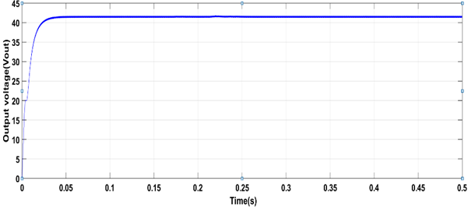
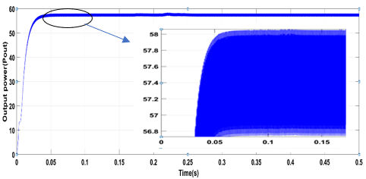
(a).Output power. (b).Output voltage.
Fig.20.The output voltage of the dc--dc boost converter with INC method.

It can be noted that after applying the MPPT algorithm the point of operation at maximum power is reached a lesser rise time with INC. The result of simulation show that the energy production from solar panels being independent and maximized of weather conditions.
- CONCLUSIONS
In this paper a procedure for the mathematical modelling of the PV module is demonstrated to earn more understanding the characteristics of PــV and IــV curves of PV module. The MPPT algorithms of P&O and INC are discussed and simulated by MATLAB/Simulink. The simulated MPPT controller achieved and maintained the MPP efficiently in different temperatures and irradiation levels. The simulation proved that the INC method has a higher speed, better performance with more accuracy in tracking the MPP than )P&O( method. These two methods improve the steady state and dynamics performances of a photovoltaic system, and improve the efficiency of the dc--dc boost converter system.

References
- M.Veerachary,“Power Tracking for Nonlinear PV Sources with Coupled Inductor SEPIC Converter,” IEEE Transactions on Aerospace and Electronic Systems, vol. 41, No. 3, July 2005.
- I. H. Altas and A.M. Sharaf, “A Photovoltaic Array Simulation Model for Matlab-Simulink GUI Environment,” IEEE, Clean Electrical Power, International Conference on Clean Electrical Power (ICCEP '07), June 14-16, 2007, Ischia, Italy.
- S.Chowdhury, S.P.Chowdhury, G.A.Taylor, and Y.H.Song, “Mathematical Modelling and Performance Evaluation of a Stand-Alone Polycrystalline PV Plant with MPPT Facility,” IEEE Power and Energy Society General Meeting - Conversion and Delivery of Electrical Energy in the 21st Century, July 20-24, 2008, Pittsburg, USA.
- Jee-Hoon Jung, and S. Ahmed, “Model Construction of Single Crystalline Photovoltaic Panels for Real-time Simulation,” IEEE Energy Conversion Congress & Expo, September 12-16, 2010, Atlanta, USA.
- S. Nema, R.K.Nema, and G.Agnihotri, “Matlab / simulink based study of photovoltaic cells / modules / array and their experimental verification,” International Journal of Energy and Environment, pp.487- 500, Volume 1, Issue 3, 2010.
- Pandiarajan N, Muthu R. Mathematical modeling of photovoltaic module with Simulink. In2011 1st International Conference on Electrical Energy Systems 2011 Jan 3 (pp. 258-263). IEEE.
- M. A. Eltawil and Z. Zhao, "MPPT techniques for photovoltaic applications," Renewable and Sustainable Energy Reviews, vol. 25, pp. 793-813, 9// 2013.
- Liu F, et al. 2008. "A variable step size INC MPPT method for PV systems. IEEE Transactions on Industrial Electronics". 55: 2622-2628, Jul.
- Walker G. 2001."Evaluating MPPT converter topologies using a MATLAB PV model". Journal of Electrical and Electronics Engineering, Australia, IE Aust. 21(1): 49-56.
- Muhammad H. Rashid, "Power Electronics: Circuits, Devices Applications" Text Book.
- www.solarelectricsupply.com/media/custom/upload/Solarex-MSX64.pdf.
- I.H. ALTAS and A.M SHARAF, “Novel On-line Mpp Search Algorithm for PV Arrays”, IEEE Transactions on Energy Conversion, Vol.11.No 4,December 1996
- Peng Lei, Yaoyu Li, John E. Seem” Sequential ESC-Based Global MPPT Control for Photovoltaic Array With Variable Shading” IEEE TRANSACTIONS ON SUSTAINABLE ENERGY, VOL. 2, NO. 3, JULY 2011.
- Dr. Anil S. Hiwale, Mugdha V. Patil, Hemangi Vinchurkar, ”An Efficient MPPT Solar Charge Controller”, International Journal of Advanced Research in Electrical, Electronics and Instrumentation Engineering Vol. 3, Issue 07, July 2004.
- Azad, M.L., Das, S., Sadhu, P.K., Satpati, B., Gupta, A. and Arvind, P., 2017, April. P&O algorithm based MPPT technique for solar PV system under different weather conditions. In 2017 International Conference on Circuit, Power and Computing Technologies (ICCPCT) (pp. 1-5). IEEE.
- Hussein, K.H., Muta, I., Hoshino, T. and Osakada, M., 1995. Maximum photovoltaic power tracking: an algorithm for rapidly changing atmospheric conditions. IEE Proceedings-Generation, Transmission and Distribution, 142(1), pp.59-64.
- Zainudin, H.N. and Mekhilef, S., 2010. Comparison study of maximum power point tracker techniques for PV systems.
- Kobayashi, K., Takano, I. and Sawada, Y., 2005. A study of a two‐stage maximum power point tracking control of a photovoltaic system under partially shaded insolation conditions. Electrical Engineering in Japan, 153(4), pp.39-49.

