THE INFLUENCE OF SOLAR POWER AND SOLAR FLUX ON THE EFFICIENCY OF POLYCRYSTALLINE PHOTOVOLTAICS INSTALLED CLOSE TO A RIVER
Armstrong O. Njok^{1*} Ferdinand A. Kamgba¹ Panjwani M. Kumar^{2, 3}
¹Department of Physics, Faculty of Sciences, Cross River University of Technology (CRUTECH) Calabar, Calabar, 540252, Nigeria.
² Department of Energy Systems Engineering, Sukkur IBA Unviersity, Sukkur 65200 Pakistan
³ Renewable Energy School, North China Electric Power University Beijing 102206 China
*Corresponding author: Armstrong O. Njok; (+2348132283875), 540242, Njokarmstrong@crutech.edu.ng

ABSTRACT
There is an increasing focus on utilizing the renewable energy resources, especially solar energy as the fossils are expected to deplete in near future. Solar Photovoltaics have remained of particular interest because of their relative lower overall efficiencies .Most researchers are trying to enhance the overall performance of Solar Photovoltaic and trying to study factor that may possible lead to an increase in the overall performance of a Solar Photovoltaic Panels. A thorough investigation was carried out to study the influence of solar power and solar flux on the performance parameters of Photovoltaics (Polycrystalline). The data used in the research was obtained by in-situ measurement approach using an SM206 precision digital solar power meter, a digital solar flux meter, and an M890C⁺ digital Multimeter. The result obtained shows an interesting correlation for current, efficiency and solar power as well as for solar flux which indicates that high solar power and solar flux positively enhances the performance of the photovoltaic. The results also reveal that once the solar power or solar flux reaching the photovoltaic exceeds 200W/m² or 20Klux, the voltage from the photovoltaic approaches maximum and remains fairly stable irrespective of the amount of solar power or solar flux reaching the photovoltaic. The data collected for three months, July, August and September shows prediction efficiency of 87 %, 63% and 71% at 11:30am, 12:30 pm and 10:30 am respectively.

Keywords: Solar power, solar flux, efficiency, photovoltaic.

- INTRODUCTION
The basis for the migration from our traditional fossil fuel to other alternative energies is not far-fetched. The increasing demand for energy and the ever depleting sources of fossil fuel amidst exploration and exploitation that are no longer environmentally friendly has created a paradigm shift to alternative energy of which solar energy plays a significant role. This energy is primarily produced by the sun.
For over 4-billion years now the sun which is not so particularly different from other stars in the universe has been producing enormous amount of energy through nuclear activity in its core and this activity may continue for at least another 4-billion years before it transforms into a giant star (red giant) while swallowing the earth and other planet in the process. For all the different forms of energies available to man on earth, the sun is almost the main source for it. 95% of the sun output energy is been released as light (some of the light cannot be picked up by the human eye) in the process of producing energy [1].
Roughly 99% of solar radiation reaching the earth surface ranges between 0.3 to 3.0 µm. While the vast majority of radiation reaching the earth (long wave radiation) ranges between 3.5 to 50 µm. The intensity of solar radiation which is approximately 1370 watts/metre² outside the earth’s atmosphere is the power of solar radiation obtained at mean distance between the earth and sun, while the direct beam radiation will be approximately 1000 watts/metre² for a good number of locations at sea level on a clear day at noon [2]. Energy accessibility is mainly influenced by location (latitude and height), time and season. All of this can be promptly decided. However, the greatest parameters influencing the accessibility of energy are conditions (meteorological conditions) which regularly vary with time, season and location as well.
Solar radiation striking a target or passing through a transmitting medium is mostly reflected and assimilated, while the rest is transmitted. The solar spectrum coupled with the optical properties of the transparent medium determines the relative values of the transmitted radiation [3]. Solar radiation is reduced and weakened as it navigates the layers of the atmosphere, keeping a large segment of it from arriving at the surface of the earth.

Solar radiation (flux) is obviously a deciding component with regards to analyzing the potential of solar energy as renewable power source. The solar flux transmitted from the sun is described by infrared and visible radiation. Their distinctive spectrums are depicted by their different wavelengths ranging between 0.20 to 4.0µm.
Photovoltaic electricity is generated through a process known as the photovoltaic effect which is achieved by converting sunlight into free particles capable of carrying charges within a semiconducting material. Thus it is important it’s very important to note that the performance of photovoltaic panels in real time outdoor conditions is different than the conventional laboratory conditions [4].
Nigeria stands at the threshold of rapid depletion of conventional energy resources [5], as such; renewable energy source (such as solar) should be identified as an attractive area for research and should receive substantial attention for investment purposes. In many rural locations of Nigeria, solar energy could provide a unique and cost effective way of supplying both metropolitan and rural areas with energy. Economic and agricultural activities take place in these areas with little or no access to energy and clean water supply.
Chegaar et al. [6] researched on how illumination intensity affects photovoltaic cells parameters using the one diode model. The study results indicated those parameters such as ideality factor, photocurrent, and output power as well as the short circuit current increases linearly as the intensity of irradiation is increased at room temperature within the range of intensity (160-1000 W/m²).
El-Shaer et al. [7] investigated how light intensity and temperature influences the parameters of crystalline silicon solar modules by using xenon lamp (150W) as a solar simulator. The results of their investigation from the two crystalline modules reveal that current parameters are dominantly controlled by light intensity. Short circuit current and maximum current increases linearly with increasing light intensity. The investigation further reveals that with an increase in light intensity from 0.2 to 1.0 Sun the maximum output power increased by 80%.
Tobnaghi & Naderi [8] researched on how the performances of solar cells are influenced by temperature and solar radiation. Their research shows that current parameters are directly proportional to the intensity of light reaching the cells, while open circuit voltage changes logarithmically with light intensity.
Omubo-pepple et al. [9] carried out a research on how temperature, relative humidity and solar flux affect the production of electricity using PV modules in Port Harcourt. Their result starkly established that direct relationships between solar flux and current and also with efficiency exist.
Ettah et al. [10] using solar photovoltaic panels installed in Port Harcourt, Nigeria established that a positive linear relationship exist between solar radiation and efficiency.
Omubo-pepple et al. [11] carried out a study on photovoltaic panel situated in the Niger Delta region of Nigeria to unravel how meteorological parameters influence the efficiency of photovoltaics. Their study reveals that solar panel efficiency is strongly influenced by metrological parameters including temperature, solar flux and relative humidity.
Hamrouni et al. [12] employed the Simulink tool to unravel how the performances of PV pumping systems are influenced by air temperature and solar radiation. Their simulated results show that large solar radiation increases both the global efficiency and the pump flow.
Touati et al. [13] carried out a research in Qatar to investigate how the efficiency of photovoltaics (monocrystalline and amorphous technologies) in Qatar are affected by environmental and climatic conditions. From their result it was obvious that for both technologies, as the amount of radiation increase the output power increases linearly.
Rani et al. [14] worked on the effect of temperature and irradiance on solar module performance. Their result shows that with increasing solar irradiance the voltage and power output of the cell increases.
Syafiqah Z. et al. [15] reported that as the operating cell temperature increases it triggers a reduction in the output power of the photovoltaic panel.
Leow W. et al. [16] investigated the performance difference in the PV panel subjected to difference in the wind velocity. The results encouraged exposure of the photovoltaic panels to operate in the open atmosphere with considerable wind velocity for achieving better output power.
The novelty and aim of this research lies with the thorough investigation on the influence of solar power and solar flux on the performance efficiency of photovoltaics installed for residential household use in atmosphere close to river which is not yet investigated especially in the Nigeria prospects.
- MATERIALS AND METHOD
  - Materials
A 130 watt polycrystalline solar panel with dimension of 1480*670*35 mm and capacities of 7.18A and 18.10V at maximum current and voltage respectively. Charge controller was utilized to assure smooth charging of the lead acid battery with specification of (12V-75AH). A digital multimeter (M890C+) was utilized to monitor voltage and current values, accompanied by a K type thermocouple for measuring temperature in Celsius. A digital solar power meter (SM206) was also used which is capable of measuring solar power in Watt per square metre (W/m²) and also in British thermal unit (Btu). A mastech digital solar flux meter (MS6616) was utilized to carefully monitor the solar flux.
2.2 Methods
The solar panel was placed horizontally flat facing the sun on a platform one metre high above the ground as can be referred from Figure 1(a). Connecting cables were connected to the output terminals of the photovoltaic panel which ran into the input of the charge controller. The output of the charge controller was then connected to the battery for charging the battery which powered the load through an inverter followed by a Grid connection as can be seen from Figure 1(b)
Measurements were taken at an interval of 30 minutes from 6.00am to 6.00pm for a period of 90 days (30 days each in the month of July, August and September). During measurements, the voltage and current from the panel were measured using the digital multimeter. The time of day was recorded and the amount of solar flux and solar power reaching the PV panel were also measured using a digital lux (light) meter and a digital solar power meter respectively.
Using the recorded data, the output power produced by the photovoltaic panel was obtained using equation (1), the maximum power that the solar panel can give out can be calculated using equation (2), while the normalized power output efficiency was calculated using equation (3) as shown by [17]. It has been shown by [10] that the efficiency of a photovoltaic module can be determined using equation (4). [17] Also show that the short circuit current and the open circuit voltage are been influenced by parameters like solar power and temperature as indicated in equations (5) and (6).
2.3 Equations

Measured Power:
Pmea = Vmea x Imea (1)

Maximum power:
Pmax = Vmax x Imax (2)

Normalized power output efficiency:
𝜂_{p} = $\frac{P_{mea}}{P_{max}}$ × 100 (3)

Module efficiency:
𝜂_{mod} = $\frac{Power of solar panel ×100\% }{Area of solar panel ×1000W/m^{2}}$ (4)

Short circuit current:
𝐼𝑠𝑐 = bH (5)

Open circuit voltage:
V_{oc} = $\frac{KT}{Q}ln\frac{Isc}{Io}$ (6)
Where P_{mea}, V_{mea} and I_{mea} are the measured power, voltage and current respectively. P_{max}, V_{max} and I_{max} are the maximum power, voltage and current respectively that the module can give out. Q is the electronic charge, I_{o} is the saturation current, T is the absolute temperature of the photovoltaic module, b is a constant depending on the properties of the semiconductor junction, K is the Boltzmann constant and H is the incident solar power (light intensity) on the photovoltaic module. Fig. 1 shows how the experimental setup of the photovoltaic system was done.
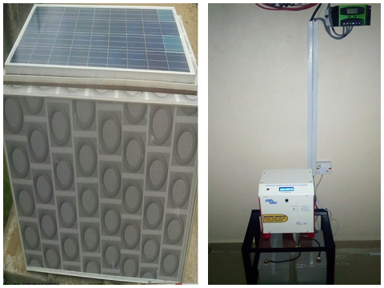
a). Solar panel on a platform 1m high b). Grid connection

Fig. 1: The experimental layout
  - Study Area
Calabar which is the capital of Cross River State is located in the southern part of Nigeria, located on Latitude 4⁰57’06’’N and longitude 8⁰19’19’’E at an elevation of 32m above sea level. But the location selected for this study is on Latitude 4⁰57‘38.6161” N and Longitude 8⁰18’58.482” E, it is about 400metre away from the Calabar River as shown in Fig. 2.

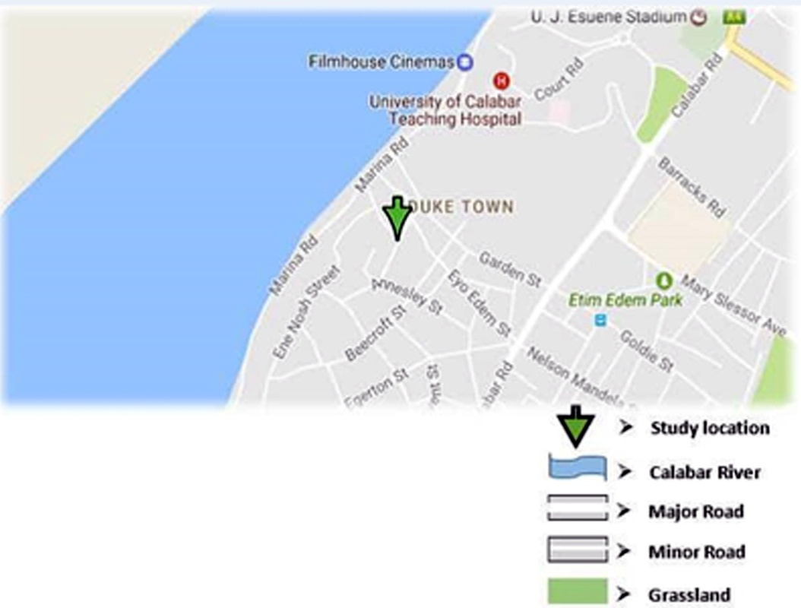

Fig. 2. Map showing study location
- RESULTS AND DISCUSSION

Fig. 3 shows how the photovoltaic module responds in terms of voltage production to an increasing amount of solar power received from the sun. It reveals that above a solar power of 200W/m² the voltage output remains fairly constant irrespective of the amount of solar power received. This shows that maximum voltage can be expected from photovoltaic modules as early as 9am.

FIG. 3: Voltage (V) against solar power (W/m²)
Fig. 4 reveals the effects of solar power on the current of the photovoltaic module. It clearly shows a very high positive correlation between current and solar power. This very high positive correlation tell us that increasing solar power favors an increase in current; this conforms to our statistical correlation, showing that linear relationship exist between solar power and current. Which is in agreement with studies by Ettah et al. [10].

FIG. 4: Current (A) against solar power (W/m²)

Fig. 5 also clearly shows a very high positive correlation between the efficiency of the module and solar power. This very high positive correlation reveals that the efficiency of the photovoltaic module is enhanced as the amount of solar power reaching it increases, which is also in agreement with studies by Ettah et al. [10].

FIG. 5: Efficiency (%) against solar power (W/m²)

Fig. 6 shows how the photovoltaic module responds to increasing amount of solar flux in terms of voltage production. It reveals that above a solar flux of 20klux the voltage output remains fairly constant irrespective of the amount of solar flux reaching the panel. This further reveals that the photovoltaic module is expected to produce its maximum voltage once the brightness of the sun reaches or exceed 20Klux.

FIG. 6: Voltage (V) against solar flux (Klux)

Fig. 7 and Fig. 8 show how the current and efficiency respectively of the photovoltaic module is influenced by solar flux. These figures clearly show very high positive correlations which indicate that as solar flux increase, a rise in current and efficiency is enabled. This conforms to our statistical correlations showing that linear relationships exist between solar flux and current and also solar flux and efficiency. Both figures are in agreement with studies by Omubo-pepple et al. [9].

FIG. 7: Current (A) against solar flux (Klux)

FIG. 8: Efficiency (%) against solar flux (Klux)
Fig. 9 depicts the way that a photovoltaic module responds in terms of voltage and current production with increasing efficiency. It reveals that from 0% to 20% efficiency, an increase in voltage is observed, from 20% and above, the voltage remains fairly stable, while current continues to increase linearly as efficiency from the photovoltaic module increases.

FIG. 9: Voltage (V) and current (A) against efficiency (%)
Fig. 10 shows the efficiency of the photovoltaic module for the three months in which data was recorded. It shows that in the month of July, a peak efficiency of 87% at 11:30am should be expected from the photovoltaic module. In the month of August, the highest efficiency to be expected from the photovoltaic module is 63% at 12:30pm. While in the month of September, double peaks in efficiency at 10:30am (71%) and 2:00pm (70%) should be expected.

FIG. 10: Efficiency (%) against time of day (mins) for the month of July, August and September

Fig. 11 shows the average efficiency of the photovoltaic module before noon, after noon and for full daytime, for the months of July, August and September. It shows that the photovoltaic module was more efficient before noon in the month of September and less efficient in August, with the efficiency of July lying in between. This was because the average solar power received by the photovoltaic module before noon in the month of September was higher, followed by July and the less in August as shown in Fig. 12. The photovoltaic module was least efficient after noon in the month of September, while reaching the same efficiency in the months of July and August. This was due to the fact that the average solar power received by the photovoltaic module after noon in the month of September was the lowest, while July and August almost had the same level of solar power as shown in Fig. 12. For the average efficiency produced by the photovoltaic module during the day, the photovoltaic module was more efficient (33%) in the month of September due to the high average solar power received.

Before Noon After Noon Full daytime

FIG. 11: Average efficiency produced by the module before noon, after noon and during the day for the month of July, August and September

Before Noon After Noon Full daytime

FIG. 12: Average solar power across the module before noon, after noon and during the day for the month of July, August and September

- CONCLUSION
The output voltage from the photovoltaic approaches maximum and remains fairly stable once the solar power or solar flux reaching the photovoltaic exceeds 200W/m² or 20Klux respectively. The result also shows a very high positive correlation for current, efficiency and solar power as well as for solar flux which indicates that high solar power and solar flux positively enhance the performance of the photovoltaic. The current produced increases linearly with efficiency but the voltage remains fairly stable above 20% efficiency. For the months in which data was acquired, the photovoltaic module was more efficient in the month of July followed by September and less efficient in the month of August. Applying photovoltaic technology to produce electricity from solar energy conversion in the months of July, August and September within the study location can be said to be favorable.
- CHALLENGES AND RECOMMENDATIONS
It is recommended that this same research be carried out on monocrystalline and thin film solar photovoltaics installed for street lighting and household use close to the river for the location under study.
COMPETING INTERESTS
Authors have declared that no competing interests exist.
REFERENCES
- Baghzouz, Y. “Photovoltaic Devices III”. Retrieved March 6, 2017, from http://www.egr.unlv.edu/~eebag/Photovoltaic%20Devices%20III.pdf.
- Rackat, A. (2005). The relative flux density of photosynthetically active radiation. New York, Academic press, 355.
- Dietz, A. G. (2002). Diathermanous Materials and properties of surface, in zaren: Introduction to the utilization of solar energy. New York, McGraw Hill, 359.
- Y. H. Sabri, W. Z. W. Hasan, S. Shafie, M. A. M. Radzi, A. H. Sabry. “Daily Harvested Energy of Cadmium Telluride Thin Film Photovoltaic”. Indonesian Journal of Electrical Engineering and Computer Science (IJEECS). 2018, 11(1): 18-26.
- Kamgba, F. A., Edet, C. O. & Njok, A. O. (2017). Effects of some meteorological parameters on wind energy potential in Calabar, Nigeria. Asian journal of physical and chemical sciences, 4(1), 1-7.
- Chegaar, M., Hamzaoui, A., Namoda, A., Petit, P., Aillerie, M., & Herguth, A. (2013). Effect of illumination intensity on solar cells parameters. Energy Procedia, 36(2013), 722-729.
- El-Shaer, A., Tadros, M. T. & Khalifa, M. A. (2014). Effect of light intensity and temperature on crystalline silicon solar modules parameters. International Journal of Emerging Technology and Advanced Engineering, 4(8), 311-318.
- Tobnaghi, D. M. & Naderi, D. (2015). The effect of solar radiation and temperature on solar cells performance. Extensive journal of applied sciences, 3(2), 39-43.
- Omubo-Pepple, V. B., Isreal-cookey, C. & Alaminokuma, G. I. (2009). Effects of Temperature, Solar Flux and Relative Humidity on the Efficient Conversion of Solar Energy to Electricity. European Journal of Scientific Research, 35(2), 173- 180.
- Ettah, E. B., Obiefuna, J. N. & Njar, G. N. (2011). The relationship between solar radiation and the efficiency of solar panels in Port Harcourt, Nigeria. International Journal of Applied Science and Technology, 1(4), 124-126.
- Omubo-Pepple, V. B., Tamunobereton-ari, I. & Briggs-Kamara, M. A. (2013). Influence of meteorological parameters on the efficiency of photovoltaic module in cities in the Niger Delta of Nigeria. Journal of Asian scientific research, 3(1), 107-113.
- Hamrouni, N., Jraidi, M. & Cherif, A. (2008). Solar radiation and ambient temperature effects on the performances of a PV pumping system. Revue des Energies Renouvelables, 11(1), 95-106.
- Touati, F., Massoud, A., Hamad, A. & Saeed, S. A. (2013). Effects of environmental and climatic conditions on PV efficiency in Qatar. Renewable Energy and Power Quality Journal, X(11), ISSN 2172-038.
- Rani, S. P., Giridhar, S. M. & Prasad, S. R. (2018). Effect of temperature and irradiance on solar module performance. IOSR Journal of Electrical and Electronics Engineering, 13(2), 36-40.
- Syafiqah, Z., Y. M. Irwan, N. A. M. Amin, M. Irwanto, W. Z. Leow, and A. R. Amelia. "Thermal and Electrical Study for PV Panel with Cooling System." Indonesian Journal of Electrical Engineering and Computer Science 7, no. 2 (2017): 492-499.
- Leow, W. Z., Y. M. Irwan, M. Asri, M. Irwanto, A. R. Amelia, Z. Syafiqah, and I. Safwati. "Investigation of solar panel performance based on different wind velocity using ANSYS." Indonesian Journal of Electrical Engineering and Computer Science 1, no. 3 (2016): 456-463.
- Njok, A. O. & Ogbulezie, J. C. (2018). The effects of relative humidity and temperature on polycrystalline solar panels installed closed to a river. Physical Science International journal, 20(4), 1-11.

