**Investigation of Indoor Propagation of WLAN Signals**

Mohammed S. Salim, Khalil H. Sayidmarie, and Abdullah H. Aboud

College of Electronic Engineering, Ninevah University, Mosul, IRAQ

**Abstract**

***The propagation of radio waves inside a typical university building is investigated by simulation and measurements. The Line of sight (LOS) and Obstructed Line of sight (OLOS) propagation scenarios were considered. The received power from a WLAN access point operating at 2.45GHz was determined from the simulations and measurements at various positions, orientations, and heights of the Tx and Rx antennas. The path loss exponents were estimated from the obtained simulation and measurement results of the received power variation with distance. The obtained path loss exponent values were found between 1.15-1.63 for LOS propagation and 2.14-2.55 for OLOS.***

**Kew word:** Indoor propagation, Path Loss Exponents, WLAN.

1. **INTRODUCTION**

The need for using wireless communication systems has been an increasing focus of the attention of researchers and engineers [1]. Following an extensive series of measurements in Tokyo at frequencies up to 1290 MHz, Okumura et al., presented an empirical prediction model in 1968. This has been used for signal strength prediction in outdoor environments. For an easier application of Okumura model, Hata (in 1980) established empirical formulae to describe the graphical information published by Okumura [2]. After that, several indoor propagation models were proposed [3-7].

With the ever-increasing applications for wireless services, the attention is to provide a better prediction of wave propagation inside the buildings. This is because most of the mobile services are used indoors for most of the time. The successful design of wireless services requires sound knowledge about wave propagation in various indoor and outdoor environments. For a better location of the transmitter, it is vital to estimate the path loss inside the building, and how various objects influence the wave propagation. Thus the modern wireless services demand indoor propagation prediction. The propagation inside buildings is highly influenced by many factors like the building layout, the construction materials, the

by many factors like type the of the building, the furniture and occupying persons [1].

A review of the path-loss prediction models for the indoor environment was presented in [8]. An approach to optimize the positions and numbers of access points to ensure good radio coverage in an indoor environment was presented in [9]. H. A. Obiedat, et al proposed an indoor path-loss prediction model using factors for wall correction for WLAN and 5G indoor network [10]. The obtained results from the proposed model were compared with other indoor models like one slope model, dual slope model, partitioned model, ITU model, COST231 and direct path model. The results were also compared with measurements and simulations (by Insite software) results.

This paper investigates the propagation within buildings by simulation and measurements. In the first part, theoretical analysis is presented, which includes simulations using the Insite™ software package (Remcom Company/ USA). The second part of the paper is the experimental measurements to assess the level of the signal received from an access point working at 2.45 GHz. From the simulation and measurement results, path loss exponent and RMSE values were calculated for various placements of Tx and Rx positions at LOS and OLOS environments.

1. **THE LOG-DISTANCE PATH LOSS MODEL**

In the log-distance path-loss model the loss is assumed to vary exponentially with the distance between the transmitting and receiving antennas. The received power in dB is given by [7]:

 .. (1)

Where *n* is the path-loss exponent, *d* is the separation in meters between Tx-Rx, and *d0*is a reference distance in meters. *Pr* (d0) is the received power at the reference distance *d0*. The value of *d0* is selected such that it is larger than the far-field distance of the transmitting and receiving antennas, but still small relative to any practical distance between them (typically *d0 =1m* for indoor propagation).

1. **THE SIMULATION AND MEASUREMENTS SCENARIO**

For studying radio wave propagation in an indoor environment, the building of the Department of Communication Engineering/ Ninevah University was selected as the study region. The building consists of three similar floors. Each floor contains laboratories, classrooms, corridors, administrative rooms and W.C. as shown in Fig. (1). Table (1) lists the specifications of the building used in the study. Three cases for three different Tx positions were investigated, where the received signal level across the floor was determined.

**3.1** **Transmitter and Receiver Data**

WLAN access point was chosen to be as the transmitter, which operates at 2.45 GHz. The antennas used for the transmitter and receiver were λ/4 monopoles with a gain of 2dBi. The transmitted power was kept constant at 4.5 dBm. The receiver antenna was placed at a height of 1.2m above the ground (desktop height).

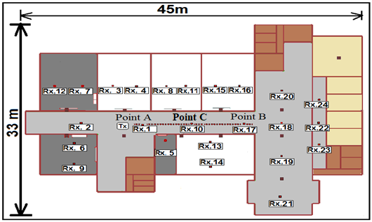

Fig. 1: Geometry of the 1st floor of the Comm. Eng. Dept. building showing Tx and Rx positions.

Table (1). Specifications of the building of the communication Eng. Dept./ Ninevah University.

|  |  |
| --- | --- |
| Height of the floor | 4m |
| Thickness of walls | 27cm |
| Materials of ceiling | 1cm false ceiling panels+50cm Air gap+15cm concrete +10cm  mosaic tiles |
| Material of floors | Concrete+ mosaic tiles (30cm*30cm) |
| Material of walls | Concrete blocks covered by plaster  (εr = 4.44, σ=0.001) |
| Material of doors | PlyWood, Doors of Labs.; two parallel sheets of iron separated by 3cm |
| Material of windows | 4mm thick Glass, with iron bar grid of 30cm*30cm |

**3.1 Computer Simulations**

The simulations of the radio wave propagation have been performed using the Wireless Insite™ software package (Remcom Company/ USA). The building has been reconstructed in the Insite Software according to its dimensions and types of materials. The Tx and Rx data specified in section 4 were used. The ray tracing model was used as the propagation model to predict the received power at various locations on the floor.

1. **EXPERIMENTAL MEASUREMENTS**

The measurements of the received power inside the building of the Dept. of Comm. Eng. was performed and compared with the results obtained from simulations. The surrounding environment was kept stationary during the data acquisition by preventing movements close to the transmitter and receiver. The transmitter used in the indoor propagation is an Access Point (D-link DWL 2100AP) as shown in Fig. (2), which has the same specification mentioned above. A 3GHz spectrum analyzer (Agilent N9320B) was used as the receiver as shown in Fig. (2). The antenna used for the receiver was a λ/4 vertical monopole. The received power was measured by the spectrum analyzer and the results were recorded at sampling intervals of 30 cm along the propagation path under the study.

1. **ANALYSIS OF THE RESULTS**

This section presents the results (of simulation and measurements) for several studied scenarios.

* 1. **Received Power along the Corridor (LOS Cases)**

The received power along the 3 m wide corridor in the 1st floor of the building was measured and compared with the simulation results for the three positions of the Tx (see Fig. (1)). The three cases are:

**Case one**: The Tx was placed at point A and the Rx was moved towards point B.

**Case two**: The Tx was placed at point C and the Rx was moved towards point B.

**Case three**: The Tx was placed at point B and the Rx was moved towards point A.

Figure 3 shows comparisons between the results of the received power along the Tx-Rx path. Tables (2) and (3) show the calculated parameters of the received power results for the three cases. It is clear from Fig. (3) and Tables (2), (3) that there is a substantial convergence in the mean values of the received power for the first and third cases that have almost the same number of data points and Tx-Rx separation (15m). As regards the second case, the measurement and simulation were performed for a small range of (7m), the mean values of the simulated and measured results are smaller than those for case 1 and case 2. This is because case2 has a shorter path and thus a larger portion of the data is near the Tx that lead to higher average value. It can also be noticed that, in spite of the fluctuations in the simulation and measurement data the two fitted lines agree very well indicating similar trends.

**Effect of Height and Orientation of the Antenna on the Received Power:**

To show the effect of changing the height and orientation of the Tx antenna on the received power, simulation and measurements were performed for two Tx antenna heights, 1.2m, and 2.5m for both vertical and horizontal orientation. In these cases, the Tx and Rx antennas were kept parallel to each other thus always measuring the co-polarized component of the received field.

**Effect of Tx Antenna Height:**

1. **Vertical antenna orientation:**

Figure (4-a,b) shows plots of the received power obtained from the simulation and measurement results for Tx heights of 1.2m and 2.5m for vertical orientation of the antennas. The receiving antenna was kept at a height of 1.2m. The calculated parameters of the received power are listed in Table (4). The figure shows that the fit lines are approximately parallel to each other indicating that the path loss exponent is the same at the two heights for both simulation and measurement as shown in Table (4). It is also seen that the fit line for the case of Tx antenna height 1.2m is higher by 4dB than the fit line for the 2.5m Tx antenna height for both simulation and measurement results. This difference is also indicated in the mean values of the received power as shown in Table (4).

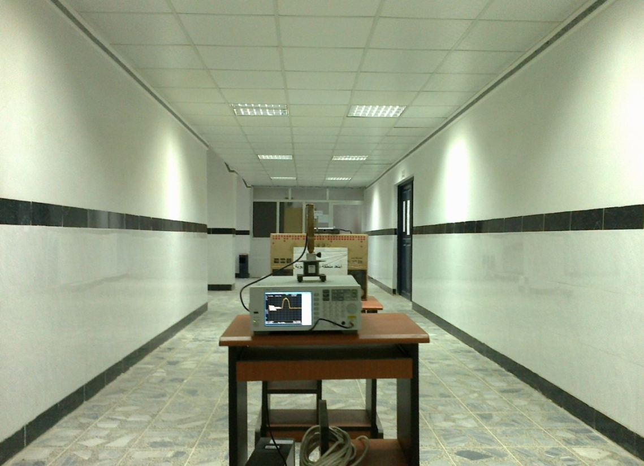

Rx

Tx

Figure (2): The spectrum analyzer used as the receiver, and the antenna on a trolley, which was moved along the corridor.

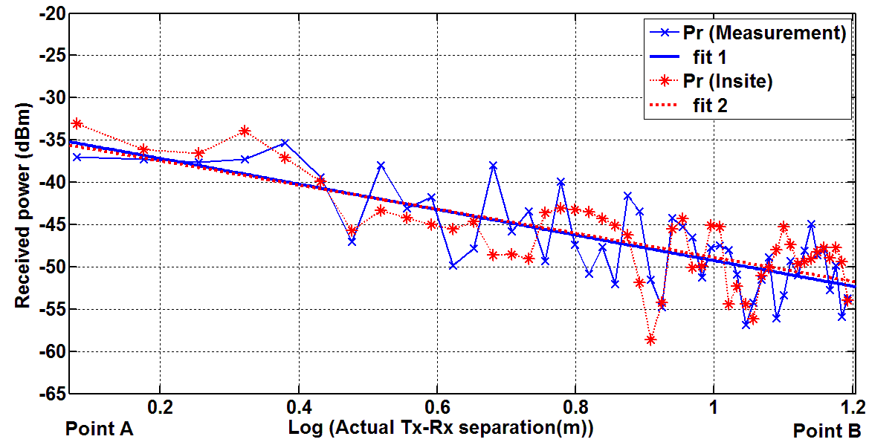

-a-

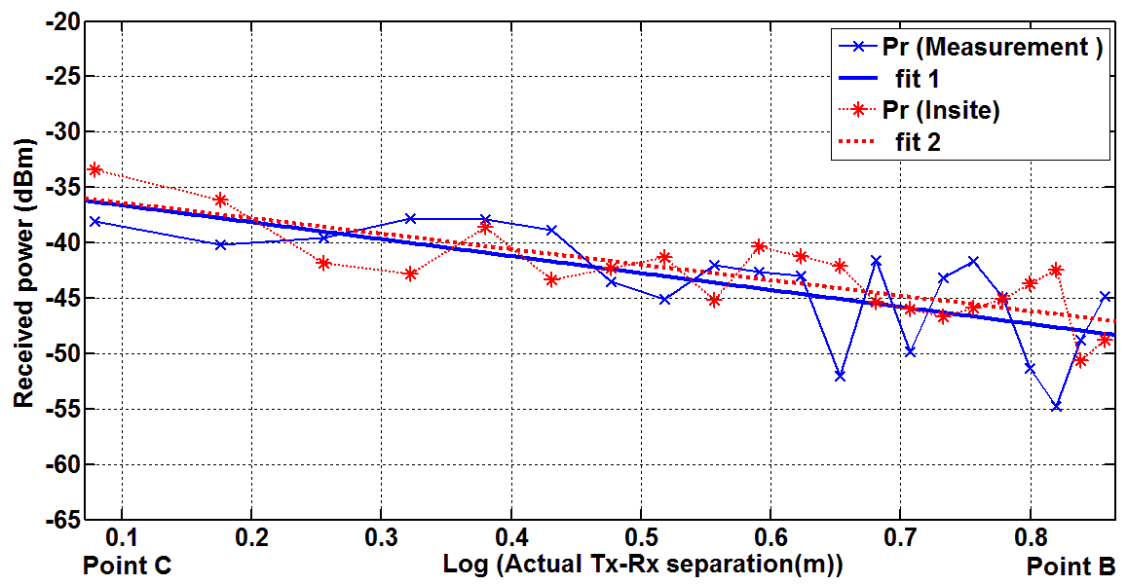

-b-

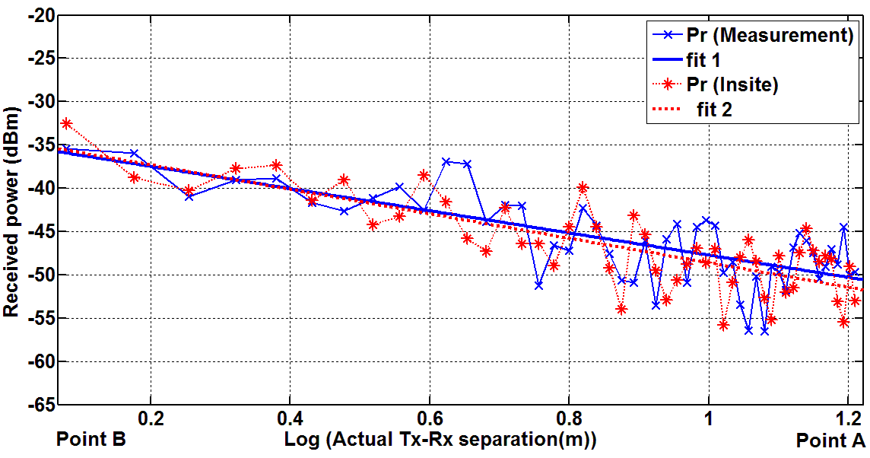

-c-

Figure (3): Comparison between the simulated and measured received power along the Tx-Rx path for; (a)1st case (Tx at point A), (b) 2nd case (Tx at point C), (c) 3rd case (Tx at point B).

Table (2): Mean values of the received power for the three cases

of the Tx positions.

|  |  |  |  |  |
| --- | --- | --- | --- | --- |
| Case  No. | Measurement | Simulation  (Insite) | Number  of data  points |  |
| Mean  (dBm) | Mean  (dBm) |
| Case One | -46.96 | -46.7 | 49 |
| Case Two | -43.86 | -43.34 | 21 |
| Case Three | -45.96 | -46.65 | 51 |

Table (3): Calculated parameters of the received power results for the three cases of the Tx positions.

|  |  |  |  |  |  |
| --- | --- | --- | --- | --- | --- |
| Case No. | Measurements | | Simulation  (Insite) | | Number  of data  points |
| n | RMSE  (dB) | N | RMSE  (dB) |
| Case One | 1.51 | 3.67 | 1.43 | 3.56 | 49 |
| Case two | 1.53 | 3.57 | 1.4 | 2.96 | 21 |
| Case three | 1.28 | 3.39 | 1.41 | 1.8 | 51 |

Table (4): Calculated parameters of the received power results for different cases of Tx antenna

height and orientations.

|  |  |  |  |  |  |
| --- | --- | --- | --- | --- | --- |
| Simulation | | | Measurements | | |
| Mean (dBm) | RMSE (dBm) | n | Mean (dBm) | RMSE (dBm) | n | Antenna Orientation | Rx Height(m) | Tx Height(m) |
| -46.96 | 3.67 | 1.51 | -46.7 | 3.56 | 1.43 | V | 1.2 | 1.2 |
| -43.75 | 3.9 | 1.15 | -44.45 | 4.5 | 1.23 | H | 1.2 | 1.2 |
| -50.47 | 2.79 | 1.51 | -49.27 | 2.24 | 1.33 | V | 1.2 | 2.5 |
| -44.42 | 3.3 | 1.63 | -45.32 | 3.7 | 1.54 | H | 1.2 | 2.5 |

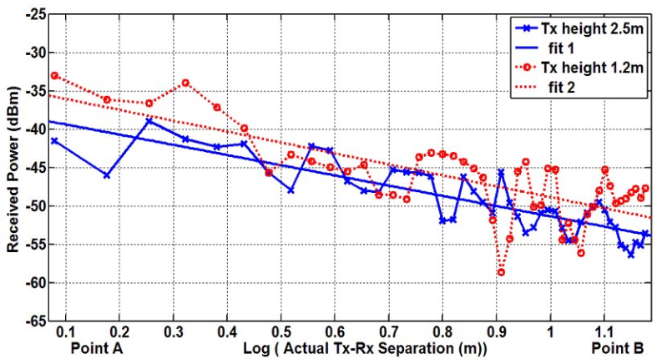

-a-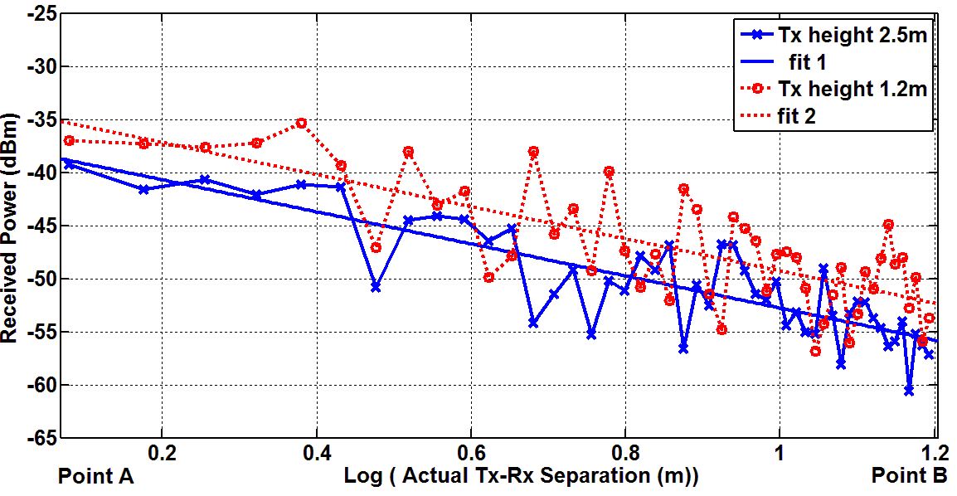

-b-

Figure (4): Variation of the received power along the Tx-Rx path, for vertically oriented antennas at the height of 1.2m and 2.5m; (a) Simulation, (b) Measurements.

These differences are due to two factors. The first is the effect of the radiation patterns of the Tx and Rx antennas which becomes more effective when the antenna heights are far from equal. The pattern of each antenna may be given by the normalized function *F(θ)=sin(θ)*, where *θ* is measured from the vertical axis of the antenna as shown in Fig.(5-a). The second factor is that the direct-path ray travels a longer distance when increasing the Tx height (i.e. is longer than *d*). This factor has a higher effect in regions near to the Tx ( while  in far regions) see Fig. (5-a).

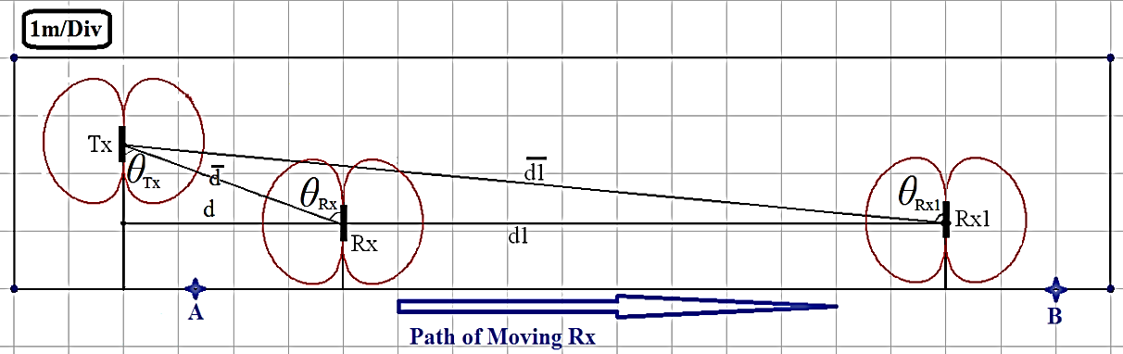

-a-

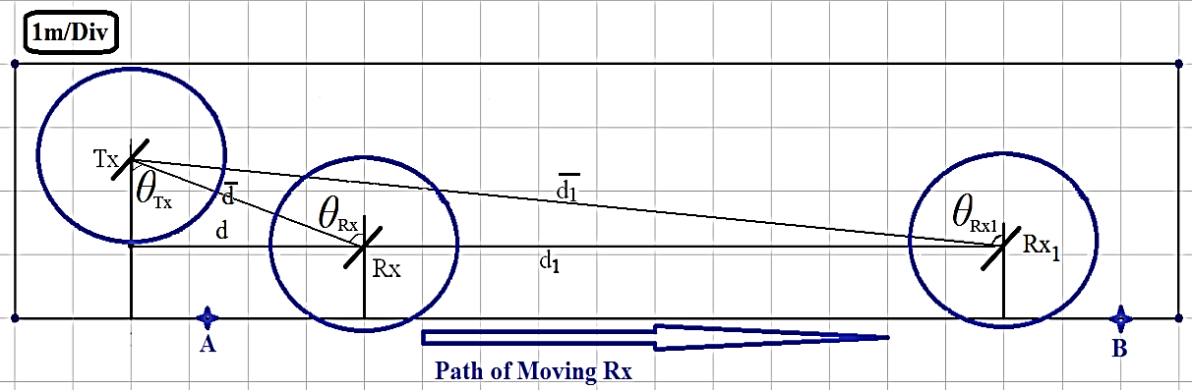

-b-

Figure (5): Orientations of Tx and Rx antennas; (a) vertically oriented, (b) horizontally oriented.

**B. Horizontal antenna orientation:**

Figure (6-a,b) shows plots of the received power obtained from the simulation and measurements respectively for the heights of Tx 1.2m and 2.5m and horizontal orientation of the antennas. The calculated parameters of the received power are listed in Table (4). Figure (6) shows that there is a difference in the slope of the fit lines. Only the second factor (mentioned above) has an effect on the received power see Fig. (5-b). This gives an indication about the small differences in the mean received power and RMSE values.

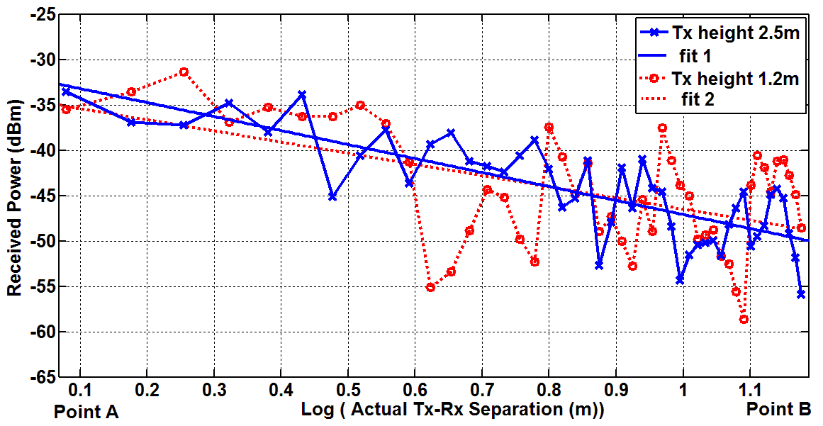

-a-

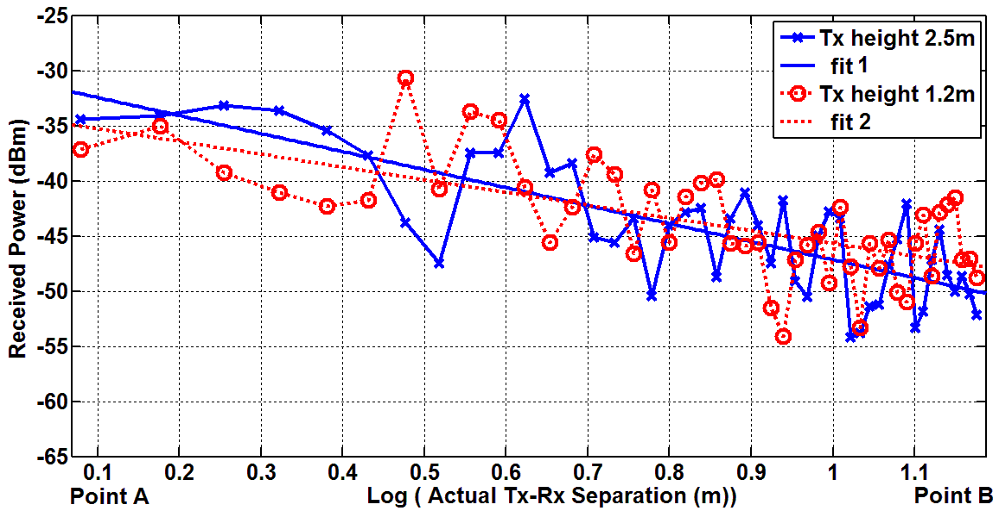

-b-

Figure (6): Variations of the received power along the Tx-Rx path, the antennas were horizontally oriented at heights of

1.2m and 2.5m; (a) Simulation, (b) Measurement.

**5.2 Received Power for (OLOS) cases:**

The Obstructed Line of Sight (OLOS) path scenario was also investigated. The variation of the received power and path loss exponent at 24 test locations inside the building were determined. Six of these points have LOS rays while the remaining 18 points have OLOS rays. This situation is with respect to Tx position at point A see Fig. (1). The test points were chosen to assess coverage at various rooms placed on the 1st floor of the building. The Tx was located in the corridor at 1.2m height.

The received power at any test point depends on the separation between Tx and Rx, and the number and type of walls between them. The variation of the received power is plotted in Fig. (7). The results of test points were arranged according to their distances from the Tx in an ascending manner. The test points were classified (according to the number of walls that separate between the Tx and Rx) into 4 sets. These sets are unobstructed sets as well as sets obstructed by 1, 2 and 3 walls respectively as shown in Fig. (7). The path loss exponent and RMSE values for each set of data are listed in Table (5). Figure (7) and Table (5) show that the path loss exponent has increased when the number of obstructing walls increased. The last set of data (for the case of three obstructing walls) comprised 5 test points. Thus, the estimated values of the path loss exponent may not be as accurate as that for the larger number of test points. However, the estimated values of the path loss exponent were between 2.17 and 2.37 for the simulations and between 2.26 and 2.55 for the measurements for the cases of one to three obstructing walls. This indicates that the obstructing wall effect is exhibited as a slight increase in the path loss exponent as well as an added amount of loss. In a former paper, it was shown that the added path loss due to the obstructing walls is about 3.5dB/ wall [11].

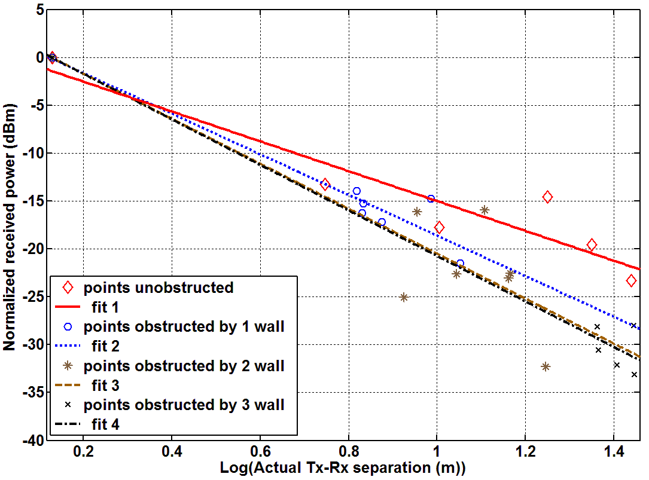

-a-

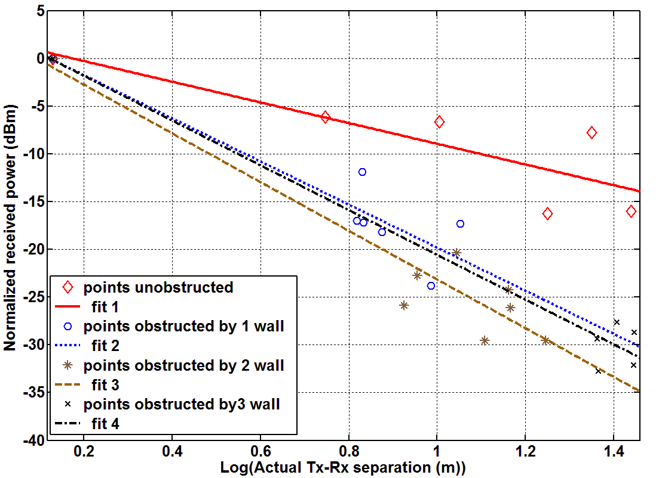

-b-

Figure (7): Variation of the received power with distance for; actual data and fitted lines for the;

(a) Simulation, and (b) Measurement.

Table (5): Calculated parameters of the received power for each set of data, for simulation and measurements.

|  |  |  |  |  |  |
| --- | --- | --- | --- | --- | --- |
| Number  of  walls | Number  of test  points | Simulation | | Measurement | |
| n | RMSE  (dB) | n | RMSE  (dB) |
| 0 | 6 | 1.5 | 3.3 | 1.1 | 3.7 |
| 1 | 6 | 2.17 | 1.97 | 2.26 | 3.2 |
| 2 | 7 | 2.35 | 4.8 | 2.55 | 3.2 |
| 3 | 5 | 2.37 | 2.2 | 2.34 | 2.5 |

**6- COMPARISONS WITH OTHER WORKS**

Table (6) shows a comparison of the obtained path loss exponents in this work with those that have been reported in recent works. The cases that have similar environments to those investigated in this work are considered in the comparison. The obtained results in this work are comparable to those found for the LOS scenarios. However, the estimated path loss exponents for the OLOS cases in [12,15,16,19] are slightly higher. This can be related to the type and number of walls that sperate between Tx and Rx. Also, this can be related to the existence of metallic obstacles as in [12,15,16]. Whereas in [19] the rooms are busy by humans this leads to more consumption of electromagnetic field and higher path loss exponent.

Table (6): Comparison of path loss exponent with recent works.

|  |  |  |  |
| --- | --- | --- | --- |
| Environment / Ref. | Ferq.  GHz | n | Case |
| This work (corridor) | 2.45 | 1.15-1.63 | LOS |
| This work (corridor+rooms) | 2.45 | 2.14-2.55 | OLOS |
| Rooms [12] | 2.5 | 1.56 | LOS |
| Corridor [13] | 2.4 | 1.57-1.68 | LOS |
| Hallway [14] | 2.45 | 1.3 | LOS |
| Corridor [15] | 2.6 | 1.27 | LOS |
| Labrotaory [16] | 2.35 | 1.95 | LOS |
| Corridor [17] | 2..48 | 1.19-1.48 | LOS |
| Conference room [18] | 2.45 | 1.2-1.7 | LOS |
| Corridor+ Open space [19] | 2.45 | 1.73-1.92 | LOS |
| Obstructed Rooms [12] | 2.5 | 2.9-3.08 | OLOS |
| Rooms+ Hallway [14] | 2.45 | 2.5 | OLOS |
| Obstructed Rooms[15] | 2.6 | 3.34 | OLOS |
| Obstructed Labrotaory [16] | 2.35 | 2.8 | OLOS |
| Busy Rooms[19] | 2.45 | 2.67-3.29 | OLOS |

**7- CONCLUSIONS**

It can be concluded from the performed simulations and measurements that the path loss exponent (n) in WLAN systems depends on the nature of the path between Tx and Rx (either LOS path or OLOS path). Moreover, it depends on the environment (corridor, rooms, type of walls, ….). It was found that the value of the path loss exponent is less than 2 (1.15-1.63) for LOS path in the corridor and larger than 2 for OLOS path. Therefore, the in-building environment slightly enhances the LOS propagation compared to the free-space propagation that is characterized by an exponent of 2. This can be attributed to enhancements due to reflections from walls, ceilings, and floors. However, OLOS scenarios are worse than free space ones. Orientations, heights, and positions of the Tx and Rx antennas must be taken into consideration when installing a WLAN system.

**References:**

1. Rappaport, T. S., “**Wireless Communications Principles and Practice**”, 2nd Edition, Prentice Hall PTR. 2002.
2. Parsons, J. D., “**The Mobile Radio Propagation Channel**”, 2nd Edition, John Wiley and Sons, 2000.
3. Schaubach, K. R., Davis N. J., and Rappaport, T. S., “**A Ray Tracing Method for Predicting Path Loss And Delay Spread in Microcellular Environments**”, IEEE Transactions on Vehicular Technology, Vol. 2, pp. 932-935,1992.
4. Salaheddin H., Hadi L., Krystyna C., Andrew W., Amin A.," Empirical propagation performance evaluation of LoRa for indoor environment", 15th IEEE conference on industrial informatics, pp:26-31, July. 2017.
5. Sayidmarie, K. H., and Ali, Y. E. M**., "Characterization of indoor radiowave propagation at university buildings"**, *Asia-Pacific Radio Science Conference AP-RSC04*, 24-27 Aug. 2004, Qing Dao, China.
6. Dres, D., Vouyioukas, D., Triantafilidis, D., and, Constantinou, P., “**Building penetration measurements for 2.4 GHz broadcasting CDMA system**”, *IEEE Vehicular Technology Conference,* pp. 1982–1987, 1999.
7. Seidel, S.Y., and Rappaport, T. S., “**914 MHz Path Loss Prediction Models for Indoor Wireless Communications in Multifloored Buildings**”, IEEE Transaction on Antennas and Propagation, Vol. 40, No. 2, pp. 207-217, Feb. 1992.
8. Oni, O., and Idachaba, F**.,** “**Review of Selected Wireless System Path Loss Prediction Models and Its Adaption to Indoor Propagation Environments**”,International conference of Engineers and Computers Scientists, Vol. 2, Hong Kong, 15-17 March 2017.
9. Youmni, Z., **“Optimization of Indoor Radio Coverage”** IEEE Middle East and North Africa Communications Conference, 18-20 April 2018.
10. Obiedat, H. A., et al, **“ An Indoor Path Loss Prediction Model Using Wall Correction Factor for Wireless Local Area Network and 5G Indoor Networks”,** Journal of Radio Science, Vol. 53, Issue 4 , pp. 544-564, April 2018.
11. Khalil Sayidmarie, Abdullah H. Aboud, And Mohammed S. Salim, **“Estimation of Wall Penetration Loss for Indoor WLAN Systems”**, International Conference on Sciences of Electronics Technologies of Informations and Telecommunications, SETIT12, 21-24 March 2012, Tunisia.
12. Nobles, P., and Halsall, F., “**Delay Spread and Received Power Measurements within a Building at 2 GHz, 5 GHz and 17 GHz**”, 10th international IEEE Conference on Antennas and Propagation, pp. 2319-2324, 14-17 April 1997.
13. Tummala, D., “**Indoor Propagation Modeling at 2.4 GHz for IEEE 802.11 Networks**”, MSc. dissertation, Department of Engineering Technology, North Texas University, USA, 2005.
14. Lu, D., and Rutledge, D., “**Investigation of Indoor Radio Channels from 2.4GHz to 24GHz**” , IEEE International Symposium on Antennas and Propagation, Vol. 2, PP. 134-137, USA, 22-27 June 2003.
15. Zyoud A., Habaebi H. M. and Islam R**.,** “**Parameterized Indoor Propagation Model for Mobile Communication Links**”, Microwave and Optical Technology Letters, Vol. 58, Issue 2, pp. 823-826, Apr. 2016.
16. Yi-Liu G., et al, “Path Loss Measurements of Indoor LTE System for the Internet of Things”, Journal of Applied Science, Vol. 7, Issue 6, pp. 1-8, May 2017.
17. Ganev Z., “**Indoor Propagation of Signals Between Wireless Sensor Nodes**”, 15th International Conference on Electrical Machines, Drivers and Power Systems, Bulgaria, pp. 467-470, June 2017.
18. Heereman F., et al, “**Path loss model and prediction of range, power and throughput for 802.11n in large conference rooms**”, International Journal of Electronics and Communications, Vol. 66, Issue 7, pp. 561-568, July 2012.
19. Rath K. H., Timmadasari S., Panigrahi B., Simha A. “**Realistic Indoor Path Loss Modeling for Regular WiFi Operations in India**”, 23rd international IEEE conference on Communication, India, pp 1-6, Vol. 1, Mar. 2017.