A Modified of Cascaded H-Bridge Multilevel Inverter (CHB-MLI) for Thirteen Level Based on Particle
Swarm Optimisation (PSO) Technique

Mohammed Rasheed¹, Rosli Omar², Marizan Sulaiman³, Wahidah Abd Halim⁴
^{1,2,3,4}Universiti Teknikal Malaysia Melaka, Faculty of Electrical Engineering, Industrial Power, 76100
Hang Tuah Jaya, Durian Tunggal, Melaka, Malaysia.
rasheed@utem.edu.my ¹, rosliomar@utem.edu.my ², marizan@utem.edu.my³ wahidahhalim@utem.edu.my⁴

Abstract
In this paper, modified multilevel inverters based on Newton Raphson (NR) and Particle Swarm Optimization (PSO) techniques were presented. A NR and PSO techniques were presented for selective harmonics elimination (SHE) solution in a modified Cascaded H Bridge Multilevel inverter (CHB-MLI). The Selective Harmonic Elimination Pulse-Width Modulation (SHE-PWM) is a powerful technique for harmonic minimization in multilevel inverter. NR and PSO techniques were used to determine the switching angles by solving the non-linear equation's analysis of the output voltage waveform of the modified CHB-MLI in order to control the fundamental component. The proposed techniques based on NR and PSO techniques are capable to minimize the Total Harmonic Distortion (THD) of output voltage of the modified CHB-MLI within allowable limits. The main aims of this paper cover design, modeling, construction and testing of a laboratory the modified topology of the CHB-MLI for a single-phase prototype for 13-levels. The experimental results of the prototype were also illustrated. The controllers based on NR and PSO were applied to the modified multilevel inverter. The Digital Signal Processing (DSP) TMS320F2812 is used to implement these modified inverters control schemes using NR and PSO method. The inverter offers much less THD and efficiency using PSO scheme compared with the NR scheme. The performance of the proposed controllers based on NR and PSO techniques are verified through simulation and is implemented in a prototype, and the experimental results are compared.

Key words: Harmonics, PSO, modified multilevel inverters, digital signal processor DSP, 13-level.

- Introduction
Multilevel power conversion was first introduced 25 years ago [1-5]. The general concept involves utilising a higher number of active semiconductor switches to perform the power conversion in small voltage steps. There are several advantages to this approach when compared with traditional two-level power conversion. The smaller voltage steps lead to the production of higher power quality waveforms and also reduce the dv/dt stresses on the load and the electromagnetic compatibility concerns. Another important feature of multilevel converters is that the semiconductors are wired in a series-type connection, which allows operation at higher voltages. However, the series connection is typically made with clamping diodes, which eliminate over voltage concerns. Furthermore, since the switches are not truly series connected, their switching can be staggered, which reduces the switching frequency and thus the switching losses. In order to lower harmonic content to improve the output waveform for voltage inverter, reduce the size of the filter utilized and the level of electromagnetic interference (EMI). Numerous topologies to realize this connectivity which can be generally divided into three major categories, namely, diode clamped MLI, flying capacitor MLI and separated dc sources cascaded H-bridge CHB-MLI. Type of MLI which using a single DC source rather than multiple sources is the diode-clamped MLI. While, FC type is designed by series connection of capacitor clamped switching cells. CHB switches are connected in parallel and series in order to provide high power demand and high-power quality [5]–[11]. For improving the quality of the output voltage inverter for two types of MLI, as symmetrical and asymmetrical, both types are very effective and efficient for multilevel inverter utilize reduced number of switching devices with Hybrid topologies for the conventional and non-conventional multilevel inverter topologies to create a specified number of output voltage levels in operating in higher voltage levels based on DC voltage supply [12][13]. Reduced number of switches with installation area and cost and has simplicity of control system, with a high number of steps associated using a new topology of cascaded multilevel inverter (CHB-MLI) has been presented in [14]. A current source inverter (CSI) apply a new topology for multilevel with reduced number of switches to generate desired output current for multilevel based on sinusoidal pulse width modulation (SPWM) method. This topology employs (n+7)/2 switches and (n−1)/2 current-sharing inductors for an n-level CSI has been developed in [15]. For 5-level single-phase inverter has been developed by field-programmable gate array (FPGA). The digital control technique is generated based on multi carrier PWM in Altera DE2 board, which has many features that allow design based on DC supply application of the system device have been implementation Simulation and experiment results in [16]. A seven-level inverter has been simulated via implementation of PWM techniques to reduce total harmonic distortion (THD). Therefore, with decrees number of gate driver in the circuit, there will be an increase for high voltage inverter. The circuitry consists DC supply and smaller (CHB-MLI) blocks connected in series to implementation its characteristic output waveform [17].
The Important coding in order to control the modified CHB-MLIs using NR and PSO techniques for optimisation of the output of the modified CHB-MLIs for 13-levels is also created and then embedded into DSP TMS320F2812. Most of the researchers applied PSO technique in a single phase of a conventional CHB-MLIs. The NR and PSO techniques are used to calculate switching angles with the capability to eliminate harmonics of the output CHB-MLIs. Finally, in this paper method is evaluated and validated through simulation and experimental results.

- Switching Operation Modes of Modified CHB-MLIS for 13-Levels
The switching mode operation of the proposed of a single-phase modified CHB-MLIs for 13-levels can be illustrated Fig ‎1. As previously mentioned the proposed topology adopts a full-bridge configuration with an auxiliary circuit comprising four diodes and a switch, and generates half-level DC bus voltage. To depict each switch's switching pattern, Fig ‎2 shows the timing diagram or switching pattern of modified CHB-MLIs. The Output voltages of modified CHBMLIs for 13 levels can be summarized as described in Table 1. As a solution, this work presents a 13-level PWM inverter with output voltages Vdc, Vdc/2, Vdc/3, Vdc/4, zero, -Vdc/4, -Vdc/3, -Vdc/2 and -Vdc. Increased number of output levels reduces harmonic content.

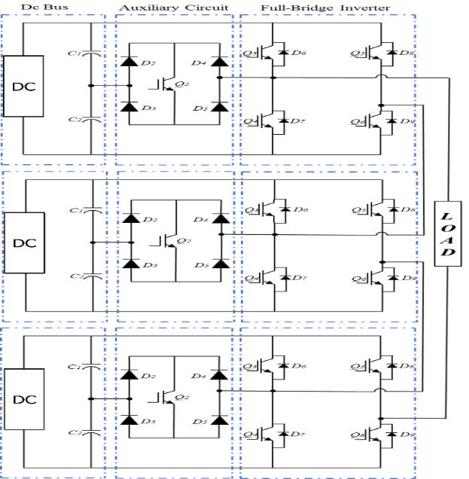
Fig 1. Proposal Modified of a CHB-MLI, Single-Phase 13-level Topology.
Table I. Output Voltage for 13-Level to The Switches’ On=1-Off=0 Condition.
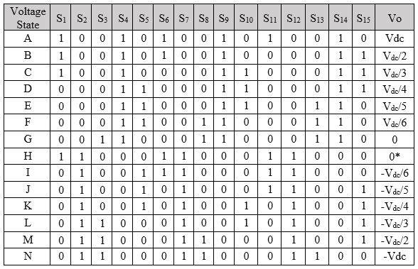
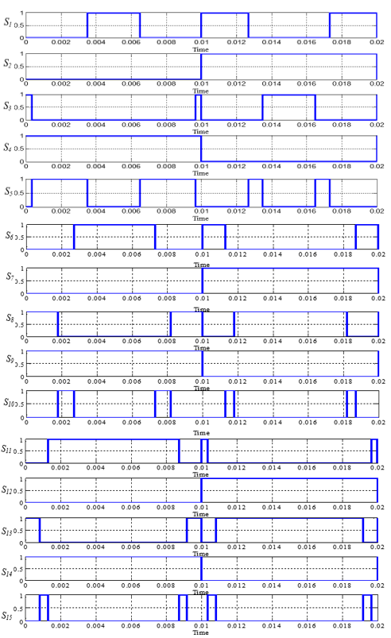
Fig 2. Switching pattern of modified CHB-MLIs for 13-Levels.
The switching operation modes of modified CHB-MLIs for thirteen levels are explained in this partition. As mentioned State A of Figure ‎3.29 the equivalent power circuit of the proposed modified CHBMLIs for thirteen level can produce the output voltage level of V_{dc} if power switches S₁, S_{4,} S₆, S₉, S₁₁, and S₁₄ are in the state 1. In Figure 3.35, State B shows the equivalent power circuit of the proposed CHBMLIs to generate output voltage level of V_{dc}/2, in this case power switches S₁, S_{4,} S₆, S₉, S₁₄, and S₁₅ are in the state 1. In Figure 3.35, State C shows the equivalent power circuit of the proposed inverter to generate the output voltage level V_{dc}/3. Power switches S₁, S₄, S₉, S₁₀, S₁₄, and S₁₅ are in the state 1 to achieve V_{dc}/3 voltage level. In Figure 3.35, State D shows the equivalent power circuit of the proposed inverter to generate the output voltage level V_{dc}/4. Power switches S₄, S₅, S₉, S₁₀, S₁₄, and S₁₅ are in the state 1 to produce V_{dc}/4 voltage level. In Figure 3.35, State E shows the equivalent power circuit of the proposed inverter to generate the output voltage level V_{dc}/5. Power switches S₄, S₅, S₉, S₁₀, S₁₃, and S₁₄ are in the state 1 to achieve V_{dc}/5 voltage level., State F as illustrated in Figure 3.35 mentioned the equivalent power circuit of the proposed modified CHBMLIS in order to generate the output voltage level of V_{dc}/6. Power switches of the proposed CHB-MLs S₄, S₅, S₈, S₉, S₁₃, and S₁₄ are in the state 1. In Figure 3.35, State G shows the equivalent power circuit of the proposed CHBMLIs in order to generate the output voltage level to be zero. To achieve zero level of output voltage, power switches S₃, S_{4,} S₈, S_{9,} S_{13,} and S₁₄ are in the state1. State H in Figure 3.35, shows another possibility to obtain zero voltage level. In order to achieve this value of voltage level all [ower switches S₁, S_{2,} S₆, S_{7,} S_{11,} and S₁₂ are in the state 1 Figure 3.35, State I shows the equivalent power circuit of the proposed inverter to generate the output voltage level -V_{dc}/6. Power switches S₂, S₅, S₆, S₇, S₁₁, and S₁₂ are in the state 1 to achieve -V_{dc}/6 voltage level. In Figure 3.35, State J shows the equivalent power circuit of the proposed inverter to generate the output voltage level -V_{dc}/5. Power switches S₂, S_{5,} S₇, S₁₀, S₁₁, and S₁₂ are in the state 1 to achieve -V_{dc}/5 voltage level. In Figure 3.35, State K shows the equivalent power circuit of the proposed inverter to generate the output voltage level -V_{dc}/4. Power switches S₂, S₅, S₇, S₁₀, S₁₂, and S₁₅ are in the state 1 to achieve -V_{dc}/4 voltage level. In Figure 3.35, State L shows the equivalent power circuit of the proposed inverter to generate the output voltage level -V_{dc}/3. Power switches S₂, S_{3,} S₇, S_{10,} S_{12,} and S₁₅ are in the state 1 to achieve -V_{dc}/3 voltage level. Switching operation modes of State M of the modified CHB-MLIs explained how to produce the output voltage level -V_{dc}/2. In this situation all power switches S₂, S₃, S₇, S₈, S₁₂, and S₁₅ are in the state 1. In Figure 3.35, State N illustrates the equivalent power circuit of the proposed inverter to generate the output voltage level -V_{dc}. In order to produce this output voltage level. power switches S₂, S₃, S₇, S₈, S₁₂, and S₁₃ of the modified CHB-MLIs must be in state 1.

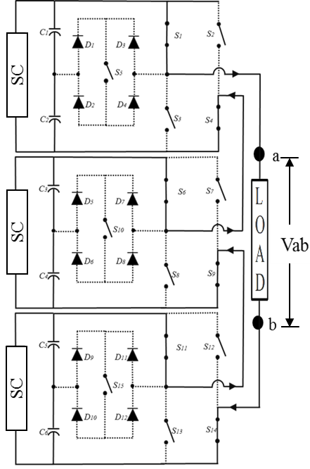  State A, Vab = Vdc. | 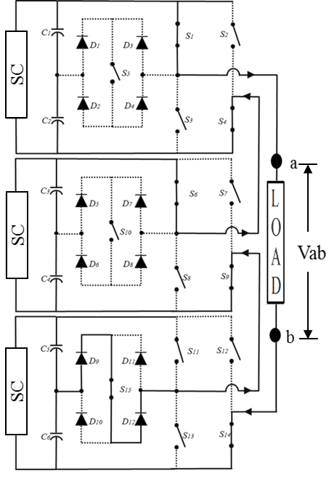  State B, Vab = Vdc/2. | 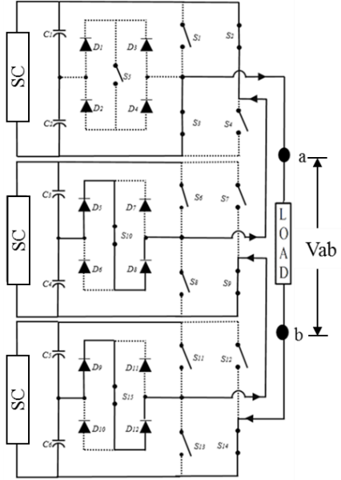  State C, Vab = Vdc/3.
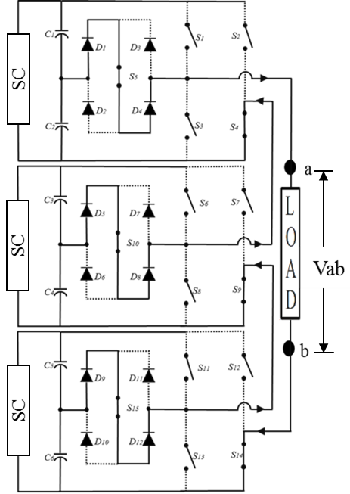  State D, Vab = Vdc/4. | 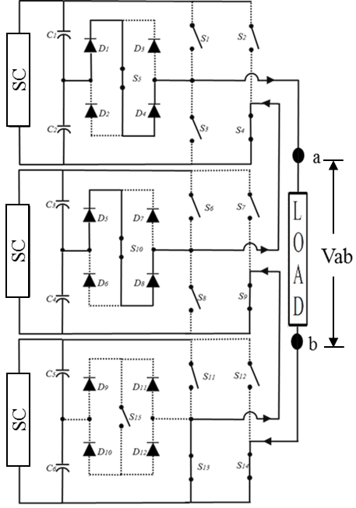  State E, Vab = Vdc/5. | 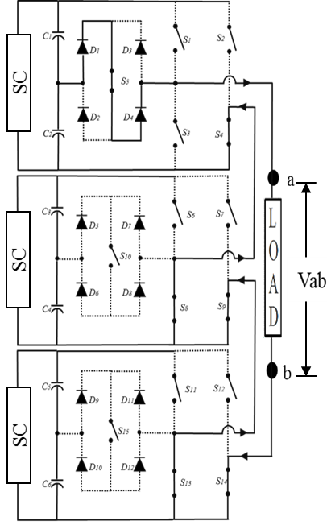  State F, Vab = Vdc/6.
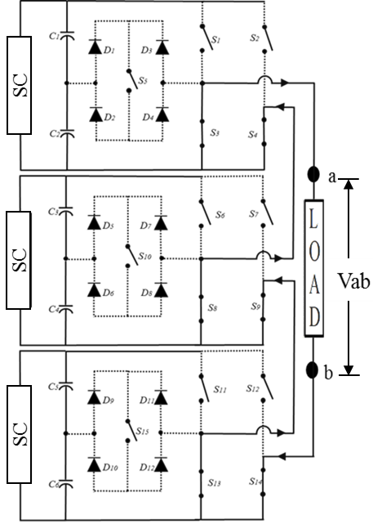  State G, Vab = Zero. | 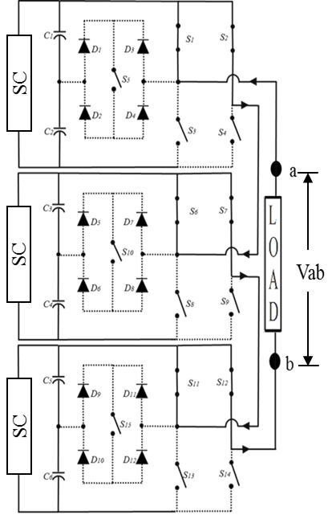  State H, Vab = Zero*. | 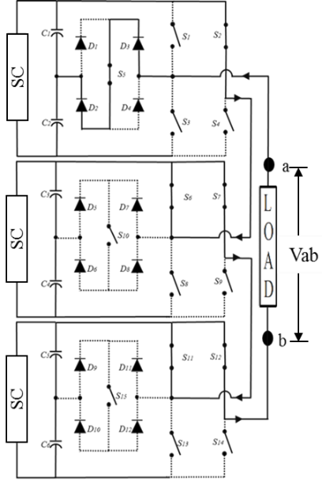  State I, Vab = -Vdc/6.
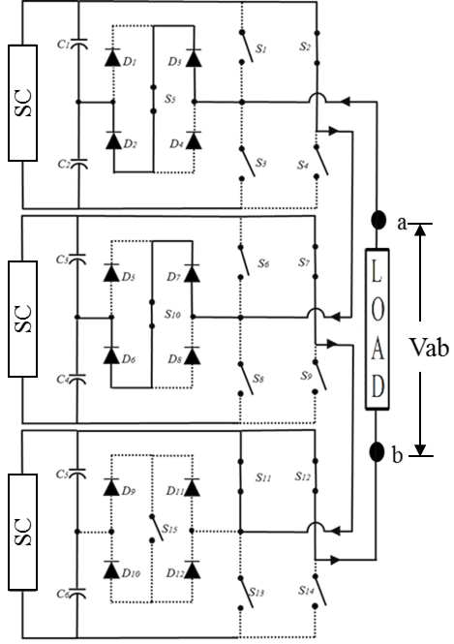  State J, Vab = -Vdc/5. | 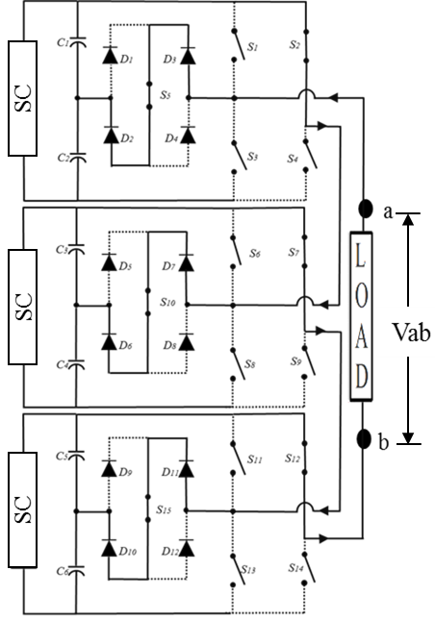  State K, Vab = -Vdc/4. | 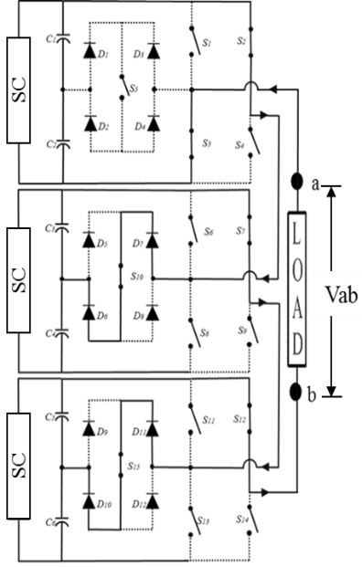  State L, Vab = -Vdc/3.
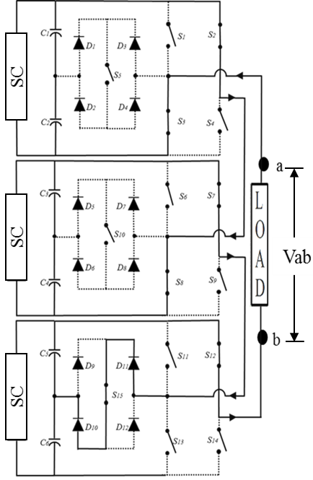 | 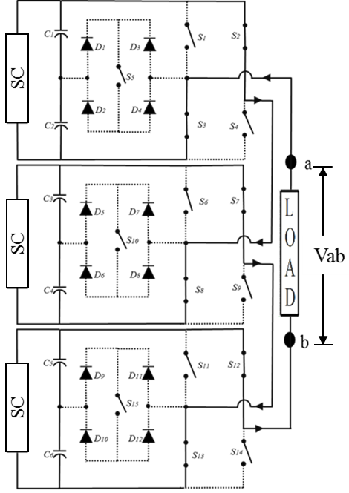
State M, Vab = -Vdc/2. | State N, Vab = -Vdc.
Fig 3. Switching operating modes access of the modified CHB-MLIs for 13-levels.

- Analyses of The Proposed Topologies of a Modified CHB-MLIS for 13-Levels
- Fourier Series for Output Voltage of Proposed of a Modified CHB-MLIs for 13-Level
The equations for 13-levels based on the Fourier series are described below (Vijayakumar, 2015):
$$f\left(t\right)= f_{θ1}\left(t\right)+ f_{θ2}\left(t\right)+ f_{θ3}\left(t\right)+f_{θ4}\left(t\right)+f_{θ5}\left(t\right)+f_{θ6}\left(t\right)$$
$$=\sum_{n=1, 2, 5}^{∞}{\frac{2Vdc}{nπ}(V_{dc1}\cos\left(nα_{1}\right)}$$
$+V_{dc2}cos\left(nα_{2}\right)+V_{dc3}cos\left(nα_{3}\right)+V_{dc4}cos\left(nα_{4}\right)+V_{dc5}cos\left(nα_{5}\right)+V_{dc6}cos\left(nα_{6}\right))sin(nwt)$ (1)
where:
: Voltage of each voltage source that was in unity
: The switching angles
From (1), four equations were resulted in eliminating the 1st, 3th, 5th, 7th, 9th and 11th harmonic.
$$V_{AN}= V_{dc1}+V_{dc2}+V_{dc3}$$
(2)
Eq. (2) has s variables ($θ_{1}, θ_{2}, θ_{3}, . . . , θ_{s}$), where 0 <$θ_{1}$< $θ_{2}$< $θ_{3}$…<$θ_{s}$< $π/2,$ and a solution set is obtained by assigning a specific value to the fundamental component, V_{f}, and equating s-1 harmonics to zero as given below:
$V_{1}cos\left(θ_{1}\right)+V_{2}cos\left(θ_{2}\right)+V_{3}cos\left(θ_{3}\right)+V_{4}cos\left(θ_{4}\right)+V_{5}cos\left(θ_{5}\right)+V_{6}cos\left(θ_{6}\right)=6m$
$V_{1}cos\left(3θ_{1}\right)+V_{2}cos\left({3θ}_{2}\right)+V_{3}cos\left({3θ}_{3}\right)+V_{4}cos\left({3θ}_{4}\right)+V_{5}cos\left({3θ}_{5}\right)+V_{6}cos\left({3θ}_{6}\right)=0$ $V_{1}cos\left(5θ_{1}\right)+V_{2}cos\left({5θ}_{2}\right)+V_{3}cos\left({5θ}_{3}\right)+V_{4}cos\left({5θ}_{4}\right)+V_{4}cos\left({5θ}_{4}\right)+V_{4}cos\left({5θ}_{4}\right)=0$
$V_{1}cos\left(7θ_{1}\right)+V_{2}cos\left({7θ}_{2}\right)+V_{3}cos\left({7θ}_{3}\right)+V_{4}cos\left({7θ}_{4}\right)+V_{5}cos\left({7θ}_{5}\right)+V_{6}cos\left({7θ}_{6}\right)=0$ $V_{1}cos\left(9θ_{1}\right)+V_{2}cos\left({9θ}_{2}\right)+V_{3}cos\left({9θ}_{3}\right)+V_{4}cos\left({9θ}_{4}\right)+V_{5}cos\left({9θ}_{5}\right)+V_{6}cos\left({9θ}_{6}\right)=0$
$V_{1}cos\left(11θ_{1}\right)+V_{2}cos\left({11θ}_{2}\right)+V_{3}cos\left({11θ}_{3}\right)+V_{4}cos\left({11θ}_{4}\right)+V_{5}cos\left({11θ}_{5}\right)+V_{6}cos\left({11θ}_{6}\right)=0$(3)
where m = V_{f} /(2Vdc/$π$), and it is related to the modulation index mi by mi = m/s, where 0 < mi <1. An objective function is then needed for the optimisation procedure selected as a measure of effectiveness of eliminating selected order of harmonics while maintaining the fundamental component at a pre-specified value. Therefore, this objective function is defined as:
F($θ_{1}, θ_{2}, . . . , θ_{s}$) = ${\left[\sum_{\text{n=1}}^{\begin{aligned} \\ \text{s }\end{aligned}}{{\text{V}}_{\text{1}}\text{cos}\left({\text{θ}}_{\text{n}}\right)\text{-m}}\right]}^{2}$ +${\left[\sum_{\text{n=1}}^{\begin{aligned} \\ \text{s }\end{aligned}}{{\text{V}}_{\text{2}}\text{cos}\left(3{\text{θ}}_{\text{n}}\right)}\right]}^{2}+ . …{\left[\sum_{\text{n=1}}^{\begin{aligned} \\ \text{s }\end{aligned}}{{\text{V}}_{\text{s}}\text{cos}\left(2s-1\right){\text{θ}}_{\text{s}}}\right]}^{2}$ (4)
The optimal switching angles are obtained by minimising Eq. (4) subject to the constraint 0 < ${\text{θ}}_{\text{1}}$ < ${\text{θ}}_{\text{2}}$ < ${\text{θ}}_{\text{3}}$ < ${\text{θ}}_{\text{4}}$ _ < ${\text{θ}}_{\text{s}}$ < $π$ /2, and consequently the required harmonic profile is achieved. The main challenge is the non-linearity of the transcendental set of Eq. (4), as most iterative techniques can be used with five and 13-levels of the modified CHB-MLIs as shown in Figure 5 and each step is explained below:

Fig 5. General flow-chart of NR of the modified CHB-MLIs.

- NR Technique
The values of the conducting angles $θ_{1,}$ $θ_{2,}$ $θ_{3},$ $θ_{4,}$ $θ_{5,}$ and $θ_{6}$ can be chosen by solving the transcendental equations using a modulation index formula Eq. (5) to obtain the suitable.
$M=\frac{πVf}{2V_{dc}} (0≤M≤1)$ (5)
Where, modulation index values,${ m}_{i}$. Other angles which are $θ_{7 }$until $θ_{24 }$can be obtained by referring the output waveform of 13-levels of a modified CHB-MLIs theory in Fig 7. The procedure of detecting attributes and configuration of a system is called optimisation. For 13-level inverter single phase, only five harmonics can be eliminated here which are the 3rd, 5th, 7th, 9th, and 11th harmonics, chosen to be removed. Thus, the switching angle can be found by solving transcendental equations by using NR technique. Which is the output voltage for 13-level of a modified CHB-MLIs. These switching angles are then examined for their corresponding THD given by:

${THD}_{V}=\frac{\sqrt{ \sum_{n=1}^{∞}{V_{n}^{2}}}}{V_{1}}$ (6)

The effect of optimised angles for 13-levels are $α_{1}$, $α_{2}$, $α_{3}$, $α_{4}$, $α_{5}$, $α_{6,}$ on the THD and the modulation index is shown in Fig 7. By using MATLAB coding for number of iterations it can be easily concluded that the modulation index equal 0.949. However, the THD value of 13-levels equal to 6.18 %.
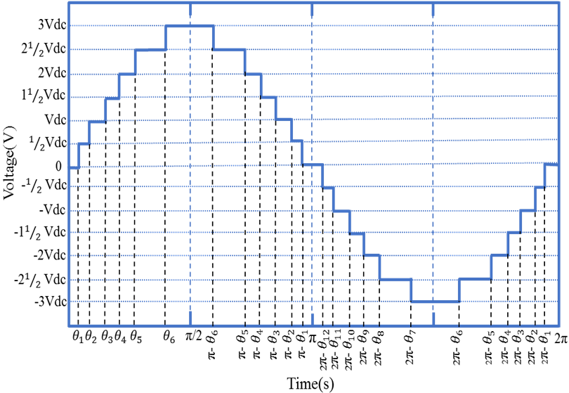
Fig 7. Vab at low switching frequency of modified CHB-MLIs, for 13-levels.

- Particle Swarm Optimization PSO Technique
PSO has become a very popular technique in solving non-linear optimization problems. Many types of evolutionary algorithms; particle swarm is preferred primarily because of its computational efficiency, simplicity and ability to avoid local optima. PSO has the following key advantages over other evolutionary optimization techniques [21]–[24]. The PSO algorithm are required to solve nonlinear equations based on SHE algorithm for solving the transcendental equations in order to optimise best switching angles. The number of iteration algorithm is solved using MATLAB coding to get better angles and harmonic. From number of iteration PSO algorithm.
Step 1 Initialise the system parameters such as velocity vector Vi, location vector Xi, personal best particle vector Pi, particle inertia weight C0, and global best vector Pg. Assign the values of generations as 100, population size as 40, cognitive parameter C1 as 0.5 and social parameter C2 as 1.25.
Step 2 Check for the case 0 < (C1 + C2) < 2 and (C1 + C2)/ 2 < C0 < 1, if the two cases are satisfied then the system will be guaranteed to converge to a stable equilibrium point. If false, go to Step 1.
Step 3 Update the Velocity, Vi (t + 1).
Vij (t+1) =Vi(t) + $γ_{1i}$($P_{i}-x_{i}(t)$) + $γ_{2i}$ ($G_{i}-x_{i}(t)$) (7)
Step 4 Update the Position, Xi (t + 1).
Xij (t+1) = Xij (t) + Vij (t+1) (8)
where i is the particle index, j is the index of parameter of concern to be optimised, x is the position of the ith particle and jth parameter, k is the discrete time index, v is the velocity of the ith particle and jth parameter, P is the best position found by the ith particle and jth parameter (personal best), G is the best position found by swarm (global best), c is a random uniform number between [0,1] applied to the ith particle, u is the inertia function, a is the acceleration constants.
Step 5 Now, utilize the Fitness Function in order to evaluate the particle,
${THD}_{V}=\frac{\sqrt{ \sum_{n=1}^{∞}{V_{n}^{2}}}}{V_{1}}$ (9)
For harmonic elimination. Here the switching angles $α_{1},$ $α_{2}$, $α_{3,}$ $α_{4},$ $α_{5},$ and $α_{6}$ are chosen in such a way that the selective harmonics 3th, 5th, 7th, 9th, and 11th is eliminated.
F(1)=(cos($α_{1}$) + cos($α_{2}$)+ cos($α_{4}$)+ cos($α_{4}$)+ cos($α_{5}$)+ cos($α_{6}$))-ma;
F(2)=(cos(${3*α}_{1}$)+cos(${3*α}_{2}$)+cos(${3*α}_{3}$)+cos(${3*α}_{4}$)+cos(${3*α}_{5}$)+cos(${3*α}_{6}$));
F(3)=(cos(${5*α}_{1}$)+cos(${5*α}_{2}$)+cos(${5*α}_{3}$)+cos(${5*α}_{4}$)+cos(${5*α}_{5}$)+cos(${5*α}_{6}$));
F(4)=(cos(${7*α}_{1}$)+cos(${7*α}_{2}$)+cos(${7*α}_{3}$)+cos(${7*α}_{4}$)+cos(${7*α}_{5}$)+cos(${7*α}_{6}$));
F(5)=(cos(${9*α}_{1}$)+cos(${9*α}_{2}$)+cos(${9*α}_{3}$)+cos(${9*α}_{4}$)+cos(${9*α}_{5}$)+cos(${9*α}_{6}$));
F(6)=(cos(${11*α}_{1}$)+cos(${11*α}_{2}$)+cos(${11*α}_{3}$)+cos(${11*α}_{4}$)+cos(${11*α}_{5}$)+cos(${11*α}_{6}$)); (10)
Step 6 Check the constraints 0 $≤α_{1}≤α_{2}$ $≤α_{3} ≤α_{4 }≤α_{5 }≤α_{6 }≤π$/2.
Step 7 Check for the case P(xi) < P(Pi), if i = i + 1 not satisfied then execute to Step 3.
Step 8 If the produced location of the particle is the best then update by change with the previous location as Pi = Xi.
Step 9 Update the global best location as Pg = min (P neighbour).
Step 10 Switching angles are optimised the best. Accomplish the solution of the problem.
The general flow chart of PSO of a modified CHB-MLIs is shown in Fig 8 and each step is explained below:

Fig 8. General flow chart of PSO of a modified CHB-MLIs.

- Modelling of The Proposed Modified CHB-MLIS
MATLAB/SIMULINK software was used to model the proposed topologies of a modified CHB-MLIs for 13, levels. This was because the analysis and mathematical and engineering issues can be performed via MATLAB/SIMULINK. MATLAB has the feature of superior graphics and programming ability. Meanwhile, utilized SIMULINK for analyses model, and catalyze effective block diagram system, which is fully integrated with MATLAB, simple and smart to be learnt as well as flexible. Besides, it has an overall library of blocks that can be utilized to simulate systems of linear, non-linear or discrete elements. Fig 9 shows the circuit diagram of the proposed of a single-phase modified CHB-MLIs for 13-levels. The configuration of this model consists of 12 switches of the conventional inverter in addition to a 3-bi-directional switch. In this paper purpose to develop a PSO based on SHE algorithms for getting the best firing angles for harmonics elimination and compare it with the conventional NR based SHE algorithms. The system operation was simulated at low switching frequency. In this simulation model, has dc supply is equals to 300V. Generator pulse block is used to procedure the switching pattern and results of generating pulse will control the MLIs based on NR and PSO algorithms. A resistor, 100kΩ will be used as a load to the proposed modified CHB-MLIs model. The output phase voltage of modified CHB-MLIs is 300 volts with frequency 50Hz. The series connected DC bus capacitors C1, C2 and C3 were 2500e-6 mF, which split the DC bus voltage for each cell: VDC/2, 0, -VDC/2. The middle point n of the capacitors is defined as the neutral point.

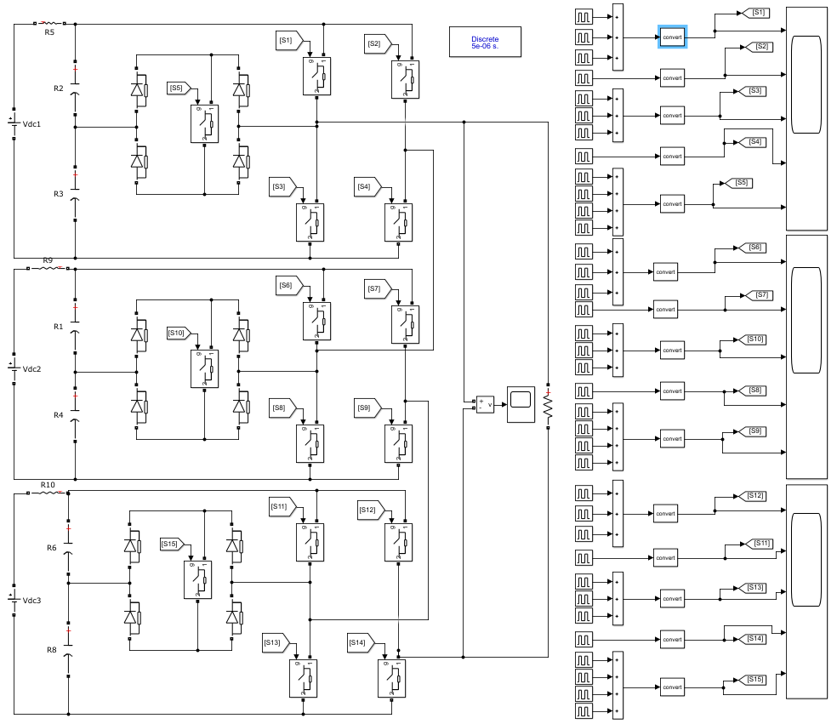
Fig ‎9. Simulations of modified CHB-MLIs 13-levels model.

Simulation Results of Modified CHB-MLIS for 13-Levels Mi=0.81 Using NR And PSO Techniques

In order to obtain the optimisation of the output of a single-phase modified CHB-MLIs of 13-levels, the switching angles based on the NR and PSO techniques were calculated. Based on the simulation model, Fig 10, Fig 11and Fig 12 show the timing diagram of a single-phase modified CHB-MLIs of 13-levels. There are 3 cells available in the configuration of a single-phase modified CHB-MLIs of 13-levels as shown in the methodology. Each cell comprises five switches, including bi-directional switch, namely S1, S2, S3, and S4 and bi-directional switch S5. From these figures, it is noted that the ten switches have equal switching periods using a switching frequency of 2500 Hz. The switching angles of a single-phase modified CHB-MLIs of 13-levels were calculated using the NR technique and the obtained switching angles are equal to θ₁=6.2542⁰, θ₂=14.3224⁰, θ₃=22.9152⁰, θ₄=32.044⁰, θ₅=48.0239⁰, and θ₆=62.6458⁰.calculate by using MATLAB cod${43.53}^{°} at upper and lower switches$e. These switching angles have used SHE based on the NR technique. NR technique is then embedded into SHE in order to generate the output of the inverter waveform. In SHE, the duration of time of one cycle is equal to 0.02s, while MI is equal to 0.81.
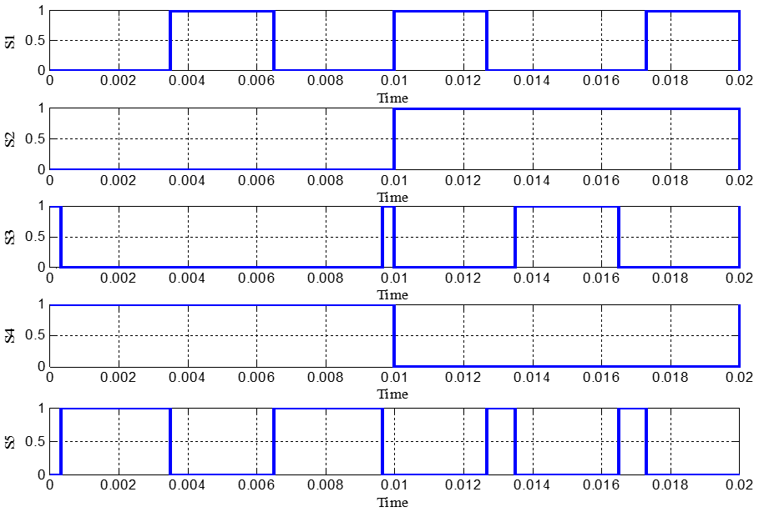
Fig 10. Timing diagram of 13 levels for cell 1 comprising S₁, S₂, S₃, S₄, and S₅ switches with MI=0.81 using NR technique.

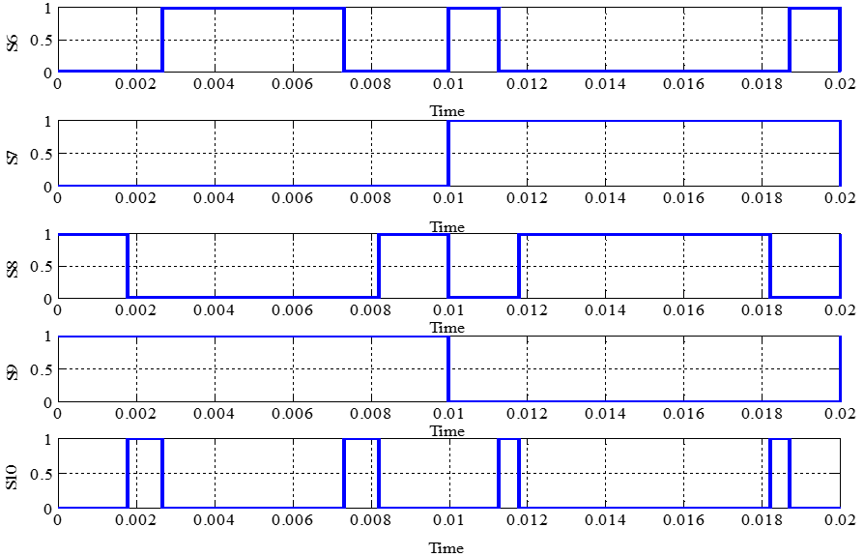
Fig 11. Timing diagram of 13-levels for cell 2 comprising S₁, S₂, S₃, S₄, and S₅ switches with MI=0.81 using NR technique.

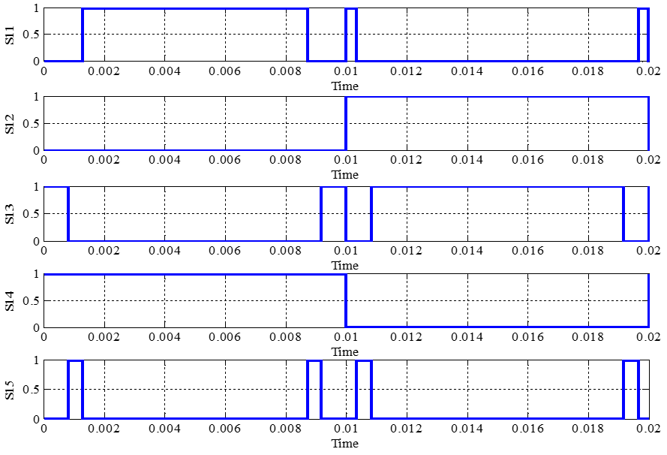
Fig 12. Timing diagram of 13 levels for cell 3 comprising S₁, S₂, S₃, S₄, and S₅ switches with MI=0.81 using NR technique.

The obtained timing diagram for the optimisation of output voltage waveform of a single-phase 13-level modified CHB-MLIs using the NR technique has been produced as shown in Fig 13. In order to eliminate the specific order harmonics of the inverter output, the SHE technique of the fundamental switching frequency scheme is used. In this research, a single-phase modified CHB-MLIs with equal DC sources based on the super capacitor is utilised. The modulation strategy used here is Selective Harmonic Elimination Pulse Width Modulation (SHE-PWM); in which the nonlinear equations in order to get the optimised switching angles for the low order harmonics can be solved using NR and PSO. The output voltage harmonics of a single-phase modified CHB-MLIs using NR were obtained through simulation as shown in Fig13. Meanwhile Fig 14 shows the THD values of a single-phase modified CHB-MLIs of 13-levels and its values are equivalent to 6.59%.
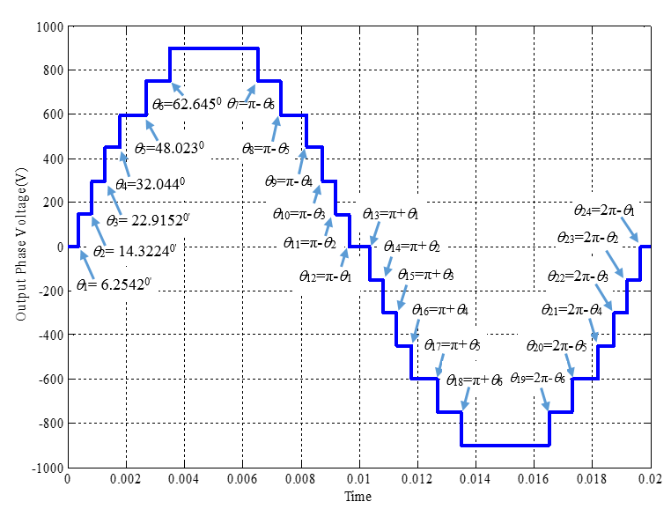
Fig 13. The optimisation of output voltage waveform
of 13-level with mi=0. 81 using NR technique.

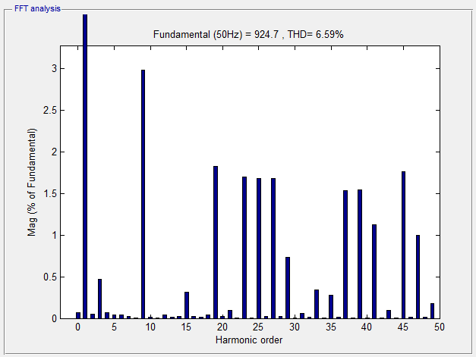
Fig 14. harmonic spectrum of output voltage waveform of a modified CHB-MLIs with MI=0.81 using NR technique.

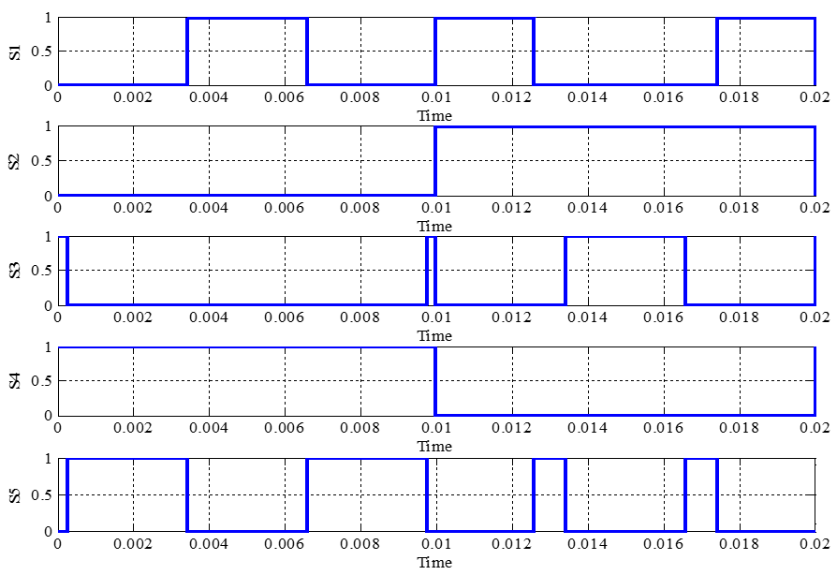

Fig 15. Timing diagram of 13-level for cell 1 comprising S₁, S₂, S₃, S₄, and S₅ switches with MI=0.81 using PSO technique.
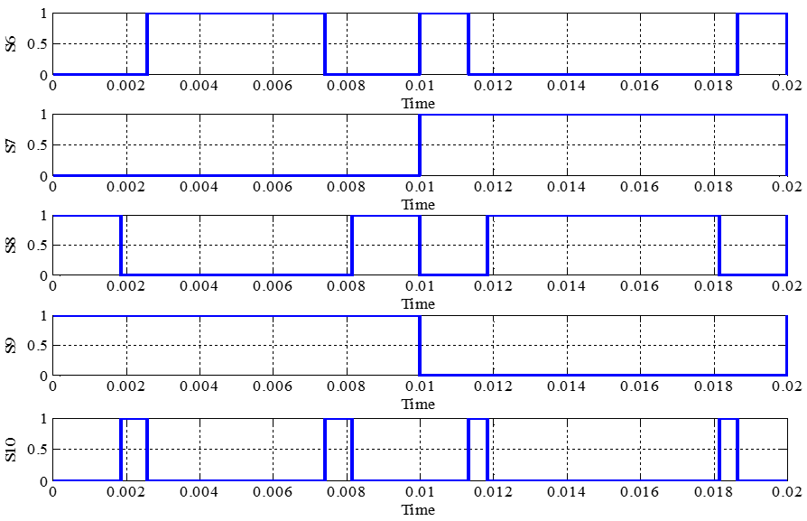
Fig 16. Timing diagram of 13-level for cell 2 comprising S₆, S₇, S₈, S₉, and S₁₀ switches with MI=0.81 using PSO technique.
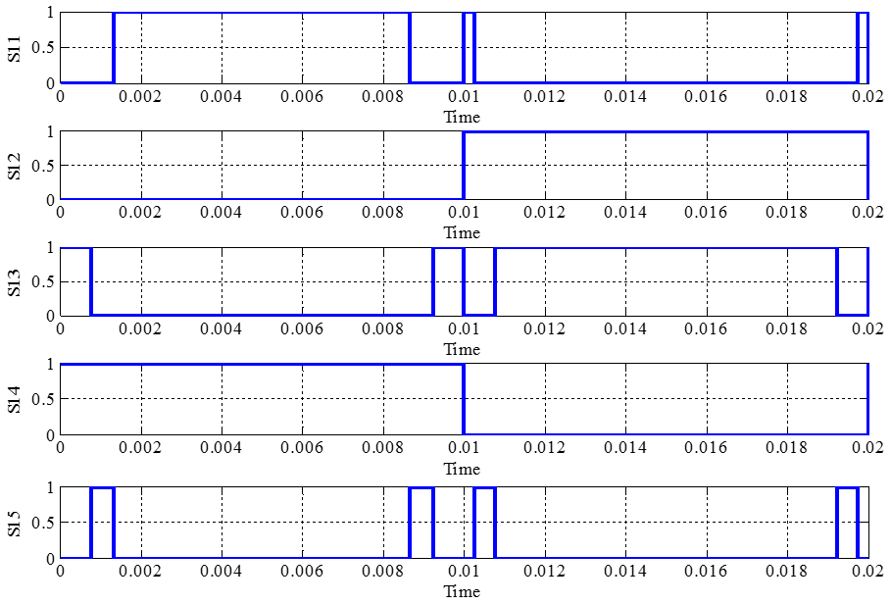
Fig 17. Timing diagram of 13-level for cell 3 comprising S₆, S₇, S₈, S₉, and S₁₀ switches with MI=0.81 using PSO technique.
The simulation results of timing diagram of a single-phase 13-level modified CHB-MLIs based on the PSO technique can be observed as shown in Fig 15, Fig 16 and Fig 17. The optimised switching angles obtained are equal to θ ₁=4.4873⁰, θ ₂=14.5441⁰, θ ₃=24.5761⁰,θ ₄=33.1991⁰, θ ₅=45.82⁰, and θ ₆=62.672⁰ calculate by using MATLAB.
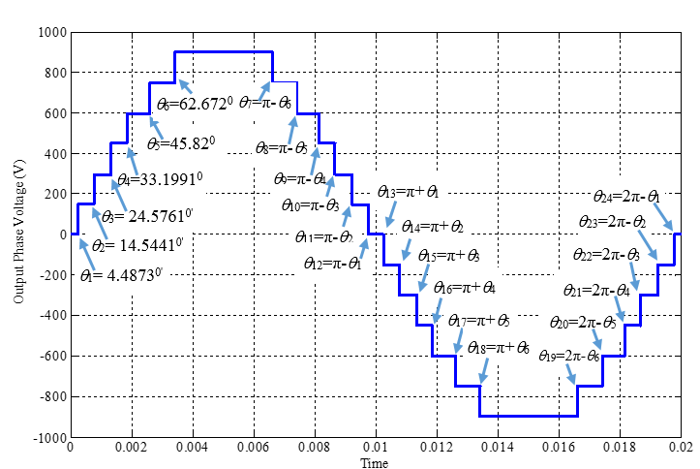
Fig 18. Optimisation of output voltage waveform of
13-level with MI=0. 81 using PSO technique.

Fig 18 shows the simulation results for the optimisation of the output voltage waveform of a modified CHB-MLIs using the PSO technique. The optimisation of the output voltage waveforms of a single-phase modified CHB-MLIs was smoother than the optimisation with the NR technique due to the inaccurate calculation of the switching angles. Fig 19 shows the optimization harmonic spectrum of the output voltage waveform of a single-phase modified CHB-MLIs using PSO with its THD values equivalent to 5.16%.

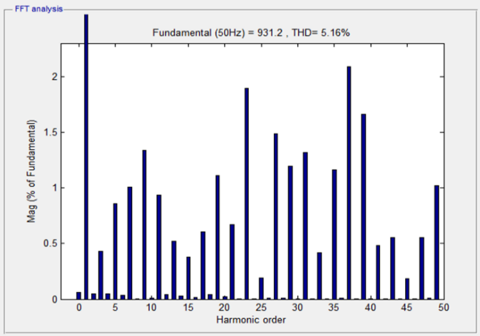
Fig 19. harmonic spectrum of output voltage waveform of a 13-level with MI=0.81 using PSO technique.

Table II. Overall values of MI, switching angles and THD for voltage of modified CHB-MLI for 13-levels based on NR and PSO techniques.

13-level | MI | θ1 | θ2 | θ3 | θ4 | θ5 | θ6 | THD  PhaseV
NR | 0.81 | 4.48 | 14.5 | 24.5 | 33.1 | 45.8 | 62.6 | 6.3
PSO | 0.81 | 14.3 | 22.9 | 32.0 | 48.0 | 62.6 | 6.2 | 5.16

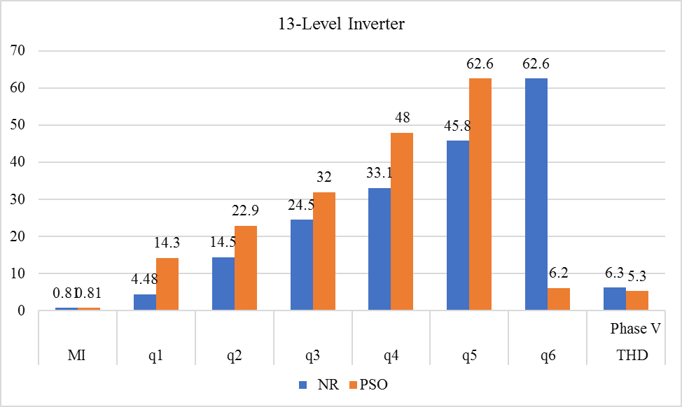
Fig 20. Overall values of MI, versus the switching angles and the values of THD for voltage of modified CHB-MLI of 13-levels based on NR and PSO.

Efficiency of Modified CHB-MLI
Actually, the efficiency of the inverter simply can be defined as DC power is converted to AC power during the conversion of the powers in the system, there are losses available, the losses would change as a heat as making the inverter hot, then would affect its less long life. When the output power has dropped it will be heading to effect of efficiency, so the efficiencies of the both controllers have dropped as shown in Fig 21 it can be noted that the obvious observation is that the controller of PSO shows the efficiency performance is much better than NR due to its optimization is being more efficient his means that in terms of efficiency PSO controller is higher than the NR controller case of inverter efficiency based on the formula above mentioned that the quantity of DC power is converted to AC power, however not all DC power totally changes to AC Power may be a part of them will be converted as a heat which is known as a loss. Normally, losses produced in the inverters totally depend on its material and efficiency.
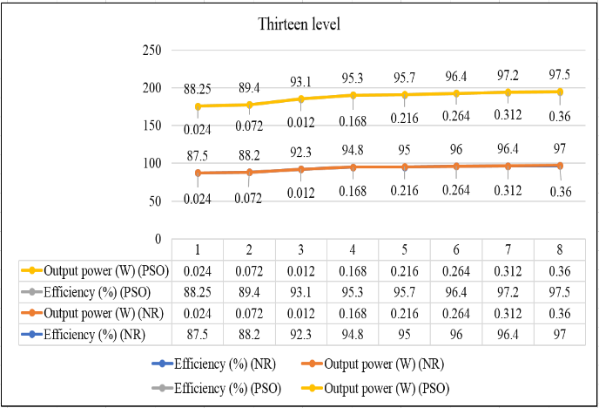
Fig. 21. Efficiency of the 13-level modified CHB-MLI for versus technique PSO and NR.

Conclusions
The simulation results and experimental showed that the higher level of inverter it will produce lower harmonics contents of the modified CHB-MLIs using the both techniques. However, PSO technique produce lower content of THD of the modified CHB-MLIs output voltage waveform compared to NR technique due to switching angles of the PSO technique is simple and efficient. The coding based on NR and PSO techniques were then stored into DSPTMS320F2812. The simulation results for the optimisation of single-phase modified CHB-MLIs of 13, levels are in good agreement with the experimental results, which further exhibit the effectiveness of the proposed developed prototype and the effectiveness of the proposed techniques in reducing harmonics. However, PSO technique produce lower content of THD of the modified CHB-MLIs output voltage waveform compared NR technique due to switching angles of the PSO technique is simple and efficient.

ACKNOWLEDGEMENTS
This research is sponsored by the Fundamental Research Grant Scheme (FRGS) which the number is FRGS/1/2016/ TK04/FKE-CERIA/F00306. The authors wish to thanks to the Ministry of Education Malaysia for the funding to support this project and also to thanks to UTeM in providing the facilities and research environment. The authors would also to thank the Centre for Research and Innovation Management Universiti Teknikal Malaysia Melaka (CRIM-UTeM).

REFERENCES
[1] E. Babaei, M. F. Kangarlu, M. Sabahi, and M. R. A. Pahlavani, “Cascaded multilevel inverter using sub-multilevel cells,” Electr. Power Syst. Res., vol. 96, pp. 101–110, Mar. 2013.
[2] H. Rashid, Power electronics: circuits, devices, and applications. Pearson/Prentice Hall, 2004.
[3] J. P. Baharu, “Harmonic Reduction of Cascaded H-Bridge Multilevel Inverter Based on Newton-Raphson,” vol. 10, no. 3, pp. 6569–6580, 2015.
[4] M. Rasheed, R. Omar, A. Sabari, and M. Sulaiman, “Validation of a Three-Phase Cascaded Multilevel Inverter based on Newton Raphson ( N . R .),” vol. 9, no. May 2016, pp. 1–13.
[5] M. Jones and I. N. W. Satiawan, “A simple multi-level space vector modulation algorithm for five-phase open-end winding drives,” Math. Comput. Simul., vol. 90, pp. 74–85, Apr. 2013.
[6] S. K. Mondal, B. K. Bose, L. Fellow, and V. Oleschuk, “Space Vector Pulse Width Modulation of Three-Level Inverter Extending Operation Into Overmodulation Region,” vol. 18, no. 2, pp. 604–611, 2003.
[7] R. N. A. Krismadinata, H. W. Ping, and J. Selvaraj, “Elimination of Harmonics in Photovoltaic Seven-level Inverter with Newton-raphson Optimization,” Procedia Environ. Sci., vol. 17, pp. 519–528, 2013.
[8] A. Pradesh, “H ARMONIC O RIENTATION OF P ULSE W IDTH M ODULATION,” POWER Eng. Electr. Eng., vol. 9, no. 1, pp. 29–34, 2011.
[9] A. Fri, R. El Bachtiri, and A. El Ghzizal, “A Comparative Study of Three Topologies of Three-phase (5L) Inverter for a PV System,” Energy Procedia, vol. 42, pp. 436–445, 2013.
[10] O. Abdel-Rahim, H. Abu-Rub, and A. Kouzou, “Nine-to-Three Phase Direct Matrix Converter with Model Predictive Control for Wind Generation System,” Energy Procedia, vol. 42, pp. 173–182, 2013.
[11] B. Boost, V. Current, S. Inverter, Q. Lei, S. Member, and F. Z. Peng, “Space Vector Pulsewidth Amplitude Modulation for a,” vol. 29, no. 1, pp. 266–274, 2014.
[12] E. Babaei, M. F. Kangarlu, and F. N. Mazgar, “Symmetric and asymmetric multilevel inverter topologies with reduced switching devices,” Electr. Power Syst. Res., vol. 86, pp. 122–130, May 2012.
[13] R. a Ahmed and S. Mekhilef, “New multilevel inverter topology with minimum number of switches,” TENCON 2010 - 2010 IEEE Reg. 10 Conf., pp. 1862–1867, Nov. 2010.
[14] S. H. H. Ebrahim Babaei, “New multilevel inverter topology with minimum number of switches,” IEEE Reg. 10 Annu. Int. Conf. Proceedings/TENCON, vol. 50, no. 11, pp. 1862–1867, 2010.
[15] S. H. Hosseini, M. F. Kangarlu, and A. K. Sadigh, “A New Topology for Multilevel Current Source Inverter with Reduced Number of Switches,” Electr. Electron. Eng. 2009. ELECO 2009. Int. Conf. on. IEEE, pp. 273–277, 2009.
[16] W. A. Halim and N. A. Rahim, “FPGA-based pulse-width modulation control for single-phase multilevel inverter,” 2011 IEEE 1st Conf. Clean Energy Technol. CET 2011, pp. 57–62, 2011.
[17] J. J. Nedumgatt, D. V. Kumar, A. Kirubakaran, and S. Umashankar, “A multilevel inverter with reduced number of switches,” 2012 IEEE Students’ Conf. Electr. Electron. Comput. Sci. Innov. Humanit. SCEECS 2012, vol. 1, 2012.
[18] “Data sheet for super capacitor from EPCOS with Part No.: B48621-S0203-Q288,” 2011.
[19] A. Al-janad, R. Omar, M. Rasheed, Z. Ibrahim, and M. H. A. Mustapha, “ANALYSING PERFORMANCE OF SUPER-CAPACITOR AND BATTERY IN LOW VOLTAGE ELECTRICAL,” vol. 61, no. 1, pp. 99–106, 2014.
[20] R. Vijayakumar, “Selective Harmonic Elimination PWM Method using Seven Level Inverters by Genetic Algorithm Optimization Technique,” Int. J. Eng. Res. Technol., vol. 4, no. 2, pp. 812–818, 2015.
[21] A. K. Al-Othman and T. H. Abdelhamid, “Elimination of harmonics in multilevel inverters with non-equal dc sources using PSO,” Energy Convers. Manag., vol. 50, no. 3, pp. 756–764, 2009.
[22] S. Sudha Letha, T. Thakur, and J. Kumar, “Harmonic elimination of a photo-voltaic based cascaded H-bridge multilevel inverter using PSO (particle swarm optimization) for induction motor drive,” Energy, vol. 107, pp. 335–346, 2016.
[23] V. K. Gupta and R. Mahanty, “Optimized switching scheme of cascaded H-bridge multilevel inverter using PSO,” Int. J. Electr. Power Energy Syst., vol. 64, pp. 699–707, 2015.
[24] B. Alamri, A. Sallama, and M. Darwish, “Optimum SHE for Cascaded H-Bridge Multilevel Inverters Using : NR-GA-PSO , Comparative Study,” pp. 1–10, 2015.

