An Open Source Tool for Reliability Evaluation Using Monte Carlo Simulation
Dr. Chitumodhu Bhargava¹, Renuka Loka²
¹Associate Professor, Department of Electrical and Electronics Engineering
Sreenidhi Institute of Science and Technology, India
²P. G Student, Department of Electrical and Electronics Engineering
Sreenidhi Institute of Science and Technology, India

SUPPORTING MATERIAL

LIST OF ABBREVATIONS AND ACRONYMS

CAIDI Customer Average Interruption Duration Index
CDF Customer Dmage Function
ECOST Expected Customer Interruption Cost
EENS Expected Energy Not Supplied
FMEA Failure Mode Effect Analysis
HTTP Hypertext Transfer Protocol
IEAR Interrupted Energy Assessment Rate
MCS Monte Carlo Simulation
SAIDI System Average Duration Index
SAIFI System Average Frequency Index
SOAP Simple Object Access Protocol
UI User Interface
XML Extensible Mark-up Language
WSDL Web Service Description Language

SUPPORTING IMAGES

Web application for reliability evaluation of distribution system using Monte Carlo Simulation technique was deployed on the Glass-fish web server using NetBeans IDE. After deployment, service was tested using SOAP-UI software [1]. Test results for primary indices, secondary indices, Customer Damage Function and Cost/ Worth Indices are listed below:

Sampling years for feeder-3 were provided as input for the SOAP project in XML format as shown in figure 1.

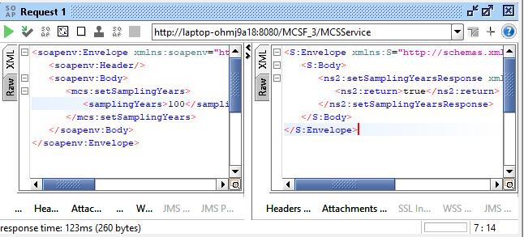
Figure 1: SOAP_UI request for providing inputs

There are three primary indices that give information about reliability of a distribution system namely failure rate, repair time and unavailability. Failure rate gives the number of failures that are going to occur per year. Repair time specifies the time needed for the failed element to come back to UP state which thus inclues switching time. Unavailability specifies the duration for which the supply was inavailable to the customers. [2]-[5]

SOAP-UI response for primary indices using MCS service for feeder-3 of Bus2 of RBTS is as shown in figure-2, figure-3 and figure-4.

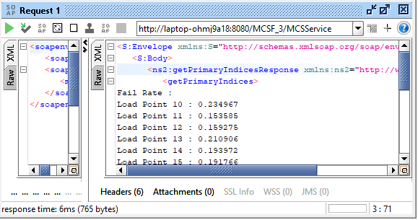
Figure 2: SOAP_UI test response for failure rate of Feeder-3

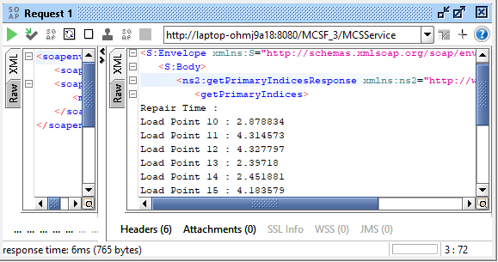
Figure 3: SOAP_UI test response for Repair time of Feeder-3

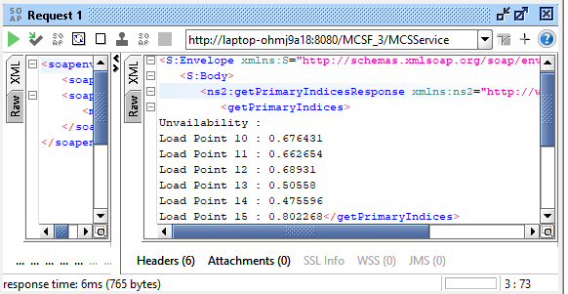
Figure 4: SOAP_UI test response for Unavailability of Feeder-3
Secondary Indices were computed using Web service and MCS service was tested in SOAP-UI. The following results were obtained for SAIFI, SAIDI and CAIDI for feeder-3.

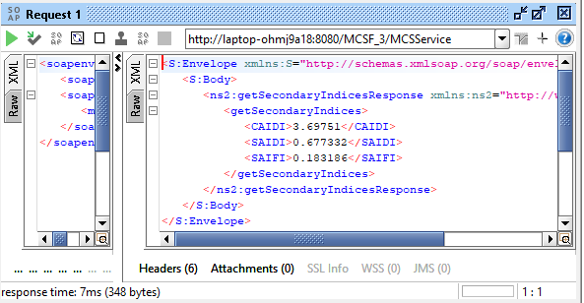
Figure 5: SOAP_UI test response for Secondary Indices of Feeder-3

Customer damage function was calculated using the MCS service which is essential in evaluating cost/worth indices for feeder-3. Depending on the type of customer, CDF was computed [6]. SOAP-UI test response for CDF was obtained for each load point of feeder-3 as depicted in figure-6.

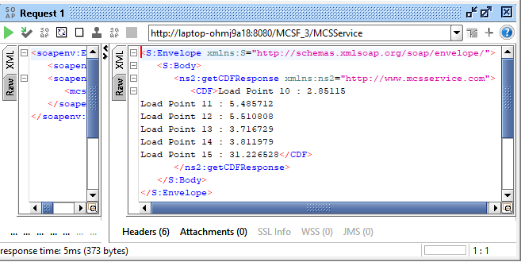
Figure 6: SOAP_UI test response for Customer Damage Function of Feeder-3

Cost worth indices were obtaines [6] as shown in figure-7, figure-8, figure-9.

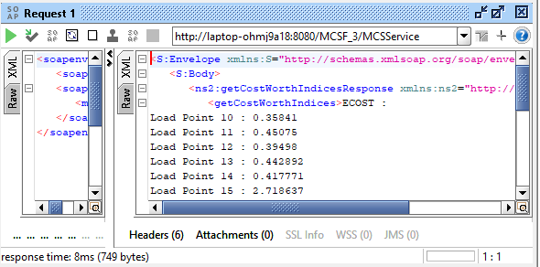
Figure 7: SOAP_UI test response for ECOST of Feeder-3

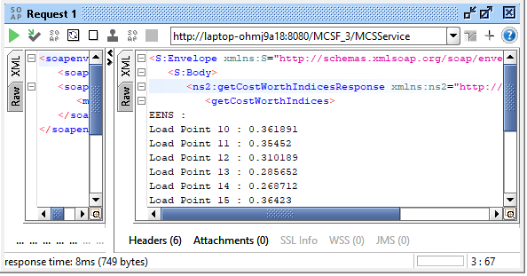
Figure 8: SOAP_UI test response for EENS of Feeder-3

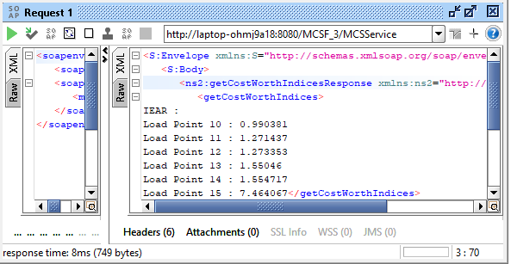
Figure 9: SOAP_UI test response for Customer Damage Function of Feeder-3
SUPPORTING REFERENCES:

- https://www.soapui.org
- R. Billinton and R. N. Allan, Reliability evaluation of power Systems, 2nd ed. New York, NY, USA: Plenum, 1996.
- Roy Billinton and Ronald N. Allan, Reliability evaluation of engineering systems: concepts and techniques, 2nd ed. Springer Science+Buisiness Media New York, 1992.
- R. N. Allan, R. Billinton, I. Sjarief, L. Goel, K. S. So, “A Reliability test system for educational purposes - basic distribution system data and results,” IEEE Transactions on Power Systems, Vo1.6, No. 2, May 1991.
- Roy Billinton and Satish Jonnavithula, “A test system for teaching overall power system reliability assessment,” IEEE Transactions on Power Systems, Vol. 1 1, No. 4, November 1996.
- Roy Billinton and Peng Wang, “Distribution System Reliability Cost/Worth Analysis Using Analytical and Sequential Simulation Technique”, IEEE Transactions on Power Systems, Vol. 13, No. 4, November 1998.

