Real-time Water Quality Monitoring System: an IoT Application

Abstract
There is huge number of disease which is caused through water drinking that being polluted was supplied to the consumer. This is something that cannot be underestimate because it can cause high cost of treatment or death. Its not only cause troubles to the consumer which is human, it is also included all aquatic life and surrounding ecosystem. There is way to overcome this problem that created before which is take the sample of water to the lab. The result of water being polluted or not will be released by the lab. But this system going to take lot of times because there are few process that should be followed. This system is not suitable anymore because it is not portable, easy and fastest. It should be upgraded to the IoT system because it can cut times, internet base and people will be more alert to the quality of water. Therefore, a real-time water quality monitoring system is proposed in this research to reduce number of fatality happened from water.

1 BACKGROUND OF THE PROJECT
Internet of Things is not something new in technology area. The term “Internet of Things”(IoT) itself was first used 1999 by British technology pioneer Kevin Ashton to describe a system in which objects in the physical world could be connected to the Internet by sensors [1]. It also can be marked as medium of communication between people with things and things with things. It is develop widely due to the advanced Wireless Technology. IoT was created to fulfill the objective which is any time, anyone and any place. There are lots of application that used IoT on defined areas such as Building and home automation, Smart cities, Smart manufacturing, Automotive, Wearables and health care. All of these areas are trusted to have high potential for exponential growth.
The IoT means the Internet environment of generating, mutually collecting, sharing, and using information by allowing all the things, such as people, around things, data, etc, to be connected to wired and wireless networks [2]. With this, consumers have extended the scope of connection to the virtual world by communicating with each other widely and gain knowledge about how the things networked. Then, the recent advance in high-speed wireless technologies has accelerated along with the supply of connected devices based on networks such as smartphones, tablet PCs, e-book devices, etc [2].
The WHO (world health organization) estimated, in India among 77 million people is suffering due to not having safe water. WHO also estimates that 21% of diseases are related to unsafe water in India. Also, more than 1600 deaths alone cause due to diarrhea in India daily [4].
In many countries, they still use old and traditional techniques, where the farmer or healthy society which responsible on water quality will visits the fond or the specific areas to monitor and control the water quality manually. They take the water sample to the lab in order to know the values of the water quality parameters and then take appropriate controlling measures. This entire process is tiresome, lengthy and costly due to many process involved. In order to improve the method, they should continuously monitor for some critical parameters and maintain the records. This requires the system to be automated and new which is more innovative technology has to be used to simplify the maintenance complexity, fasten the process and finally earn good profit.
The aim of this paper is to discuss the development application of IoT in the area of healthy monitor specialty on water quality. The device not only displays the result of water quality but will detect the temperature as well. This device was started with detect the surrounding temperature and display the temperature reading on the LCD. When the temperature part was success, the next sensor was attached to the project which is water quality sensor will operate. This sensor will give result on quality of water either it is clean or not. When it is stated clean, means the water unpolluted and save to consume by the consumer.

2. LITERATURE REVIEW
2.1) Introduction
Water quality measurement is a device that created to monitor water quality in a fastest way which is compatible to our lifestyle nowadays. Monitor is not something easy to do since it included many involvements and time. The internet of thing is computing concept that describes a future where every day physical object will be connected to the internet and be able to identify themselves to other devices [5]. IoT often refers to a large network of sensor-enabled devices designed to collect data about their environment, which frequently includes data related to people. This data presumably provides a benefit to the device’s owner, but frequently to the device’s manufacturer or supplier as well [6]. With that, water quality measurement with IoT combination is the best way to fulfill the significance of anytime and anywhere.

2.A) Overview of the project
The system monitoring water quality that used before was outdated and water quality measurement was created to upgrade the system. It was upgraded by using internet connection and Cloud was used to store and analyze the data. In other word, Cloud was used as a metaphor for “the internet” so the phrase cloud computing means “a type of internet-based computing” where different services such as servers, storage and application are delivered to an organization’s computers and device through internet. The ph sensor will detect the ph level of water sample, then the data will be display on the serial monitor. By using internet connection, the project will be connected to the MQTTlens and then the data can be subscribe and publish on that server. The data will be transfer to the smart device such as tablet or telephone. In order to get the data easily through smart phone, the flow of the project need to create on the node.red. After create the flow, the data will display nicely on user interface. With that, people surrounding will able to get the data by surf through their smartphone. This device can publish the water quality widely and faster due to the internet base device. With that, water consumer will be more alert with the water quality in their daily life.

2.B) Related Theories
There are few related theories that can be related to this water quality measurement. In a device-to-cloud communication model, the IoT device connects directly to an Internet cloud service like an application service provider to exchange data and control message traffic. This approach frequently takes advantage of existing communications mechanisms like traditional wired Ethernet or Wi-Fi connections to establish a connection between the device and the IP network, which ultimately connects to the cloud service [6]. The process can be said not much different from water quality measurement with IoT. This is due to the same medium we used which is Cloud and internet based project. Staffs monitor this data remotely and securely provided this data to the requested users which are stored in the cloud. After the water quality parameter data is stored in the cloud, it will be securely provided to invitation users using the cryptographic techniques [5]. There are lots of project previously that people already know.

2.C) Previous work
Here is previous project that have same objective which is to monitor water quality but with different sensor or server. Every methods or projects will have their advantages and disadvantages. Automatic and continuous monitoring of water environment parameters by an automatic monitoring system consisting of monitor and control centers, as well as several monitoring sub-stations. Data can be automatically transferred. Each station provides its real-time water environment parameters. This system can be costly due to involvement of few station.
Another method is by using remote sensing technology. It is detecting the spectrum specifics of an electromagnetic wave (radiation, reflection and scattering) in a non-contacting method with respect to the water body. After the processing of the information from the collection of illustrate spectra, its physics and chemical characteristic are to identified. But, this method can only provide a low accuracy and it is hard to perform a real-time monitoring.
Another method is using another devices. The shell consist ARM7, sensor arranged in bread board and Zigbee module. The ARM7 is connected to the data concentrator using USB cable. The ARM7 send the water quality Parameter data which is read from the sensors to the concentrator through the Zigbee module. The data concentrator is located in the TWAD testing laboratory. The TWAD department staffs monitor this data remotely and securely provided this data to the requested users which are stored in the cloud. After the water quality parameter data is stored in the cloud, it will be securely provided to invitation users using the cryptographic techniques [5]. Below is the system design that used Zigbee in the project.

Picture 2.1 : System design

Even with slightly difference but still give the same output for both projects.

2.D) Other method

Here is another method that they used which is Investigated Underwater wireless sensor network to monitor the quality of water using wireless sensor network (WSN) technology that powered by solar panel [7]. It can be divided into three parts which are data monitoring nodes, data base station and remote monitoring center for the water area being detected. To detect the quality of water on the specific aarea, the data monitoring will be distributed on that specific area. Only 4 parameters such as ph, amount of dissolved oxygen, electrical conductivity rate and temperature that can be collected from each node. The data that being collected will be transferred to a remote monitoring center by the base station via GPRS network[9]. The monitoring center will analyze and process the data collected then give an alarm for emergencies cases. The end user can also realize all the detection on the target water at the specific area via internet. This project can be said as useful project due to the low cost and low power consumption.
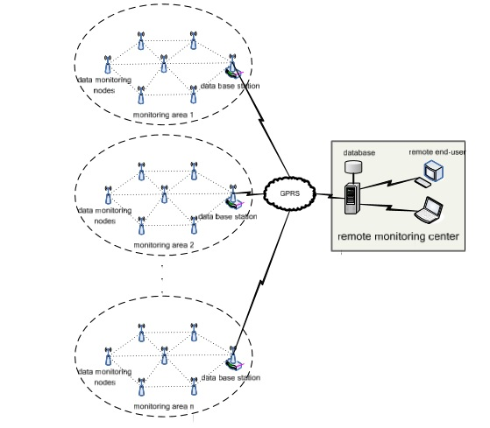

Picture 2.2 : Water environment monitoring system based on WSN

Monitoring of Turbidity, ph and temperature of water based on GSM. This is water quality monitoring project too but as stated before, it is based on SMS (Short Messaging Service) in the GSM (Global System for Mobile Communication) [8]. All the parameters were automatically detected under the control of single chip microcontroller all day. The chip will get the data, process and analyze the data. The data will instantaneously sent to monitoring center by GSM network in form of SMS.

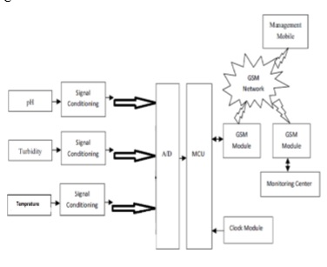
Picture 2.3 : Model development

2.E) Motivation

“After some review on few journals was made, there are few ways that can be used to complete the project that fulfill the criteria needed which is internet based project, low cost and fastest. There are lots of project that done before to monitor water quality and most of the project can be made as reference in order to complete the project. Since water is important in daily life, the project should be develop from previous projects to make it easier to everyone and everything that involved. The high technology life and internet was used everywhere are the best reason to improve the project by using Cloud. “

2.2) Chapter summary

As a conclusion, this chapter was wrote to emphasize the overview of project, related theories that can be relate to the project, the previous work that can make as reference, other methods that can be used to apply to the project and motivation that can be gain from the overview made. There are lots of way that can be apply to fulfill the project objective which one of them is, vary types of sensor used to obtain more details and specific results. If the results include few parameters, it will make people more trust with the project because the parameters would be related each other.

3. METHODOLOGY

3.1 Introduction
The project will present the quality of water at certain place. The result of water quality will be presented in month range. This chapter will show the proposed system used in order to obtain the results. It also will explain in details on how the system or process involved in the project. in this project, there are two parts that included which is hardware and software.

3.2 Hardware design
The components that used in the project are Launchpad, LCD and Sensor. Launchpad CC3200 consist of application Microcontroller, Wi-Fi Network Processor and Power Management Subsystem. It is the latest ARM Cotex-M4 80MHz processor with built-in Wi-Fi. Since the project was internet based, it is suitable to use this device due to its specialty. LCD 430BOOST SHARP96 was used to display the result that obtained from the sensor. The sensor that used will detect the water quality and the result will be display on the LCD. The LCD and sensor will attach to the Launchpad according to the pin on the Launchpad that can be referred from the datasheet and the devices will be connected to the laptop by using cable. Lastly, Ph sensor was used to detect the ph value of the water which will display the data on the serial monitor of the Energia software. The data will directly send to the MQTTlens in order to subcribe and publish the data. The flow of the project will be create in the node.red in order to make people surrounding able to get the data through their smart phone. MQTTlens and node.red will be explain on the software design.

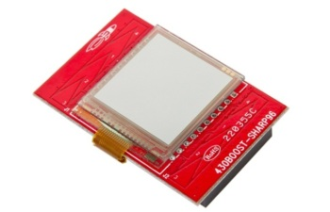
Picture 3.1 : LCD 430BOOST SHARP96[11]
Key features of the device :
-Ultra-low-power consumption
-Provides excellent viewing angles and high-contrast images or text
-Display is controlled serially using SPI
(SPI) = commonly used to send data between microcontrollers and small peripherals such as shift registers, sensors and SD card.
Hardware features :
-Ultra-Low-Power LCD
-Capacitive Touch Slider
-Customizable Power Section
-Fully Customizable Wiring

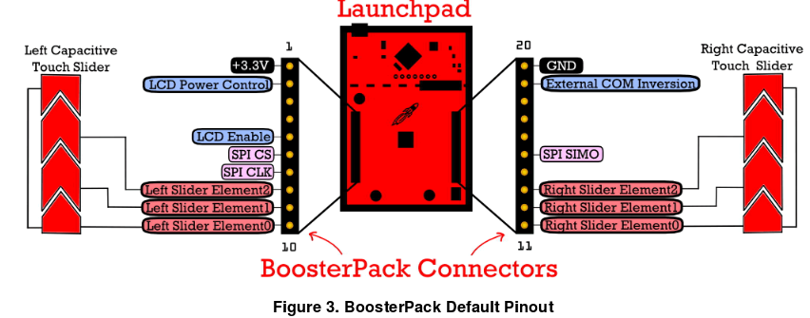
Picture 3.2 : connection of LCD

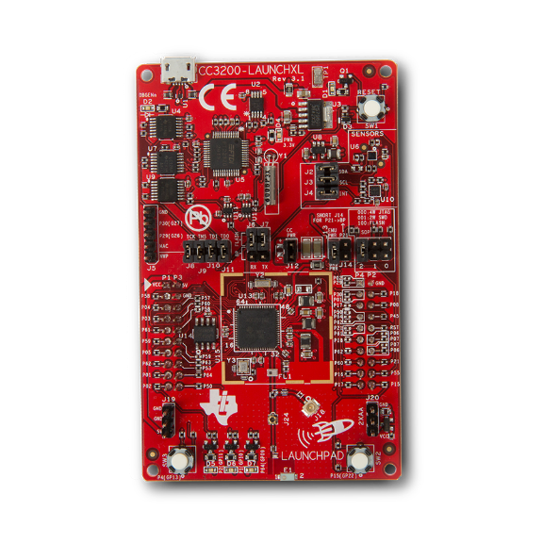
Picture 3.3 : . Launchpad CC3200

This device was used for Internet of Things application for example Cloud Connectivity, Home Automation, Smart Energy and etc. It consist of application Microcontroller, Wi-fi Network Processor and Power Management Subsystem. The Simplelink cc3200 device is a wireless MCU that integrate a high performance ARM Cortex-M4 MCU, allowing customers to develop an entire application with single IC. With On-Chip Wi-fi, internet and robust security protocols, no prior wi-fi experience is required for faster development. cc3200 is a complete platform solution including software, sample applications, tools, user and programming guides, reference designs, and the TI E2E support community. The board itself can can be directly connected to PC for use with development tools. It also has driver support and a software development kit (SDK) with 40+ applications for Wi-Fi protocols, Internet application and MCU peripheral examples.

pH sensor :
The pH sensor which provided a ph 7 solution that always rinse the bulb at the end of the sensor with the voltage reference of 0 mv. The solution of ph 6 and ph 4 was given in order to calibrate the ph sensor at the beginning of the project. This is to make sure the ph sensor work properly. After calibrate the ph sensor, the project will conducted by dissolved the ph sensor on another solution. With that, the ph of water will display together with the voltage of ph in voltage form. Its up to us to display ph of water only or display both ph and voltage.

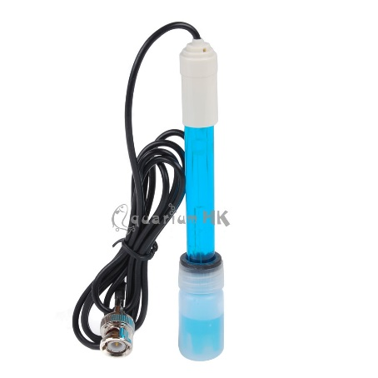
Picture 3.4: E201
Table 3.A: The value of voltage according to the ph value

3.3 Software design
Energia software was used to write the coding and give the instruction to the specific device or components. When the devices connected to the laptop, coding will be typed on the Energia software in order to display the results on the LCD. The other part software in this project is Cloud server. Huge numbers of systems are connected in public or private networks, to provide energetically scalable infrastructure for application, data and file storage. With built-in Wifi on CC3200, it send out data to the cloud and also subscribe to the data from the cloud. It also quick upgrade to the display so that the data will be better represented. After that, MQTT lens server will be used to publish and subscribe the data. The data can be obtained by the others easily. In short, Energia (for programming CC3200), MQTT Lens (to check the cloud setup), node.js (to setup webserver for node-red), node-red (for programming the user interface in webserver as well as smart phone). The application can be downloaded the smart phone and user can store the message on the phone anytime and anywhere.

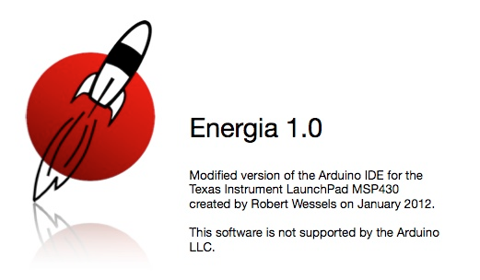
Picture 3.5 : Energia Software

Energia is an open-source electronics prototyping platform started by Robert Wessels in January of 2012 with the goal to bring the Wiring and Arduino framework to the Texas Instruments MSP430 based Launchpad. Energia includes an integrated development environment (IDE) that is based on Processing.
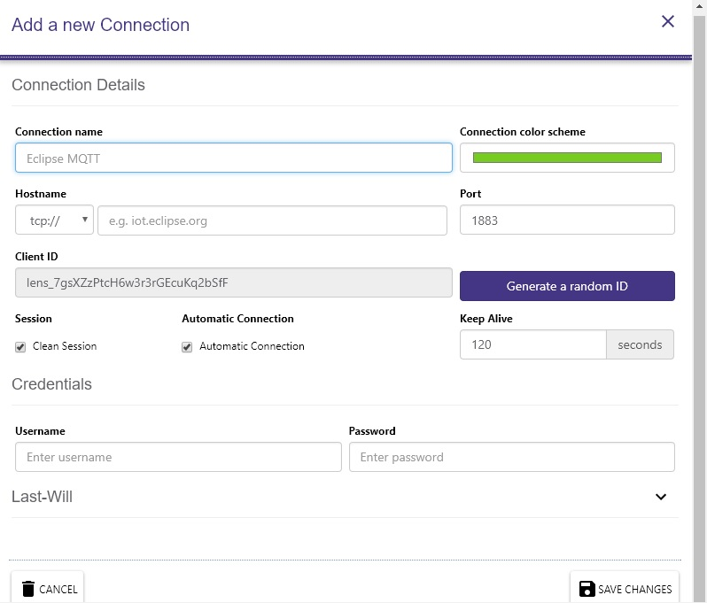
Picture 3.6 : MQTTlens (to connect with coding from Energia Software)

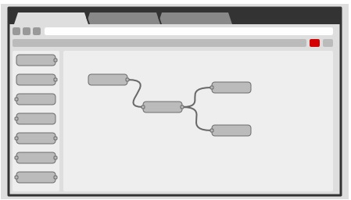
Picture 3.7: Node-RED program for IOT device

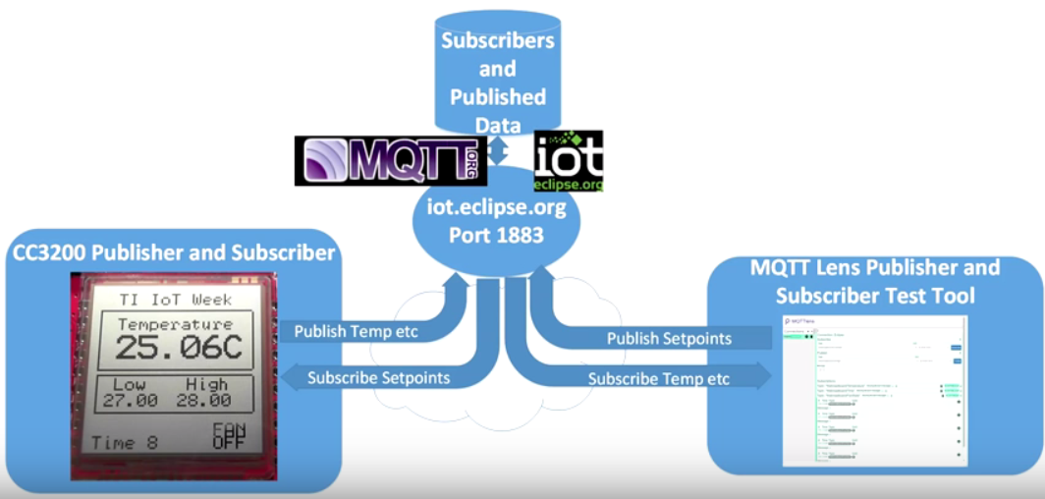
Picture 3.8 : The process describing sending and receiving data from the cloud

Above is the figure that describe on how the flow of sending and receiving data from cloud. This step was continued from previous step. MQTT (picture 3.7) is a medium that will allow us to subscribe to the eclipse server separately. It was used to see what the data is on the MQTT server that’s arriving there and to be able to send a publication to it for the high and low setpoint to see if the CC3200 is going to receive it. MQTT also provides messaging qualities of service with three different level as in table below.

QoS level | Message Delivery | Delivery Semantics | Delivery Guarantees
0 | ≤1 | At most once | Best effort  No guarantees
1 | ≥1 | At least once | Guaranteed delivery  Duplicates possibly
2 | =1 | Exactly once | Guaranteed delivery  No duplicates
TABLE 3.B

Next, Node Red (picture 3.8) which is an application that runs under Windows to subscribe the data and give us a nice little UI display that we can use on smart device. In short, Energia (for programming CC3200), MQTT Lens (to check the cloud setup), node.js (to setup webserver for node-red), node-red (for programming the user interface in webserver as well as smart phone). The application can be downloaded the smart phone and user can store the message on the phone anytime and anywhere.

3.3.A Block diagram

Sensor 1

Cloud
Sharp LCD
Energia / microcontroller
Sensor 2

Laptop/ PC

Smart Phone
MQTT lens
(Publish / Subscribe)

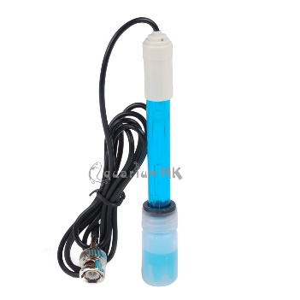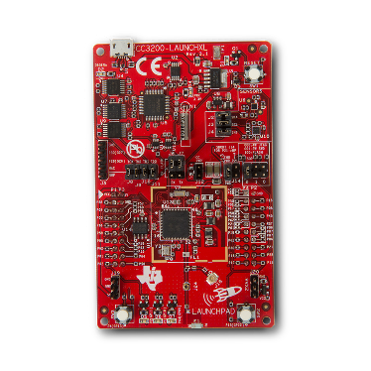
Phsensor Launchpad CC3200

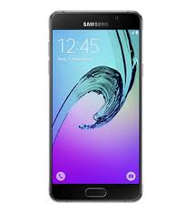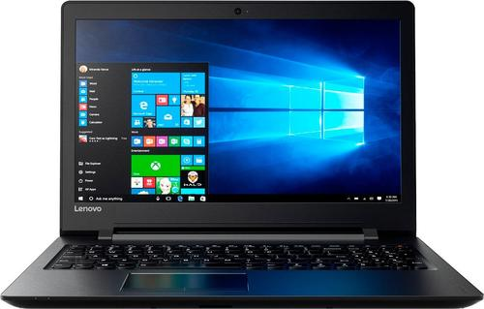

Smartphone Laptop

3.3.B Flow chart

START

READ THE SENSOR

DATA DISPLAY ON LCD

DATA ANALYSE IN CLOUD SERVER

DATA WAS SUBSCRIBE AND PUBLISH THROUGH MQTT LENS

DATA OBTAIN THROUGH SMART PHONE

END

3.4 Collecting data

The quality of water in the specific river will be taking for a month by using the device. The Cloud server and MQTTlens were used as a medium to store, publish and subscribe the data. After draw the flow of the project, the data will be display nicely on the laptop. People surrounding also can get the data through their smart phone same as the data display on the laptop. This is to monitor the quality of water at that specific area.

4. RESULT AND DISCUSSION
4.1 Introduction
This chapter will present the result of the project and discuss on how it works. It will also include the troubleshooting that had been done in order to get the precise data.

4.2 Final Product
The product was assembled as shown in the picture below. It is assembled as in design of project as stated on the previous chapter.
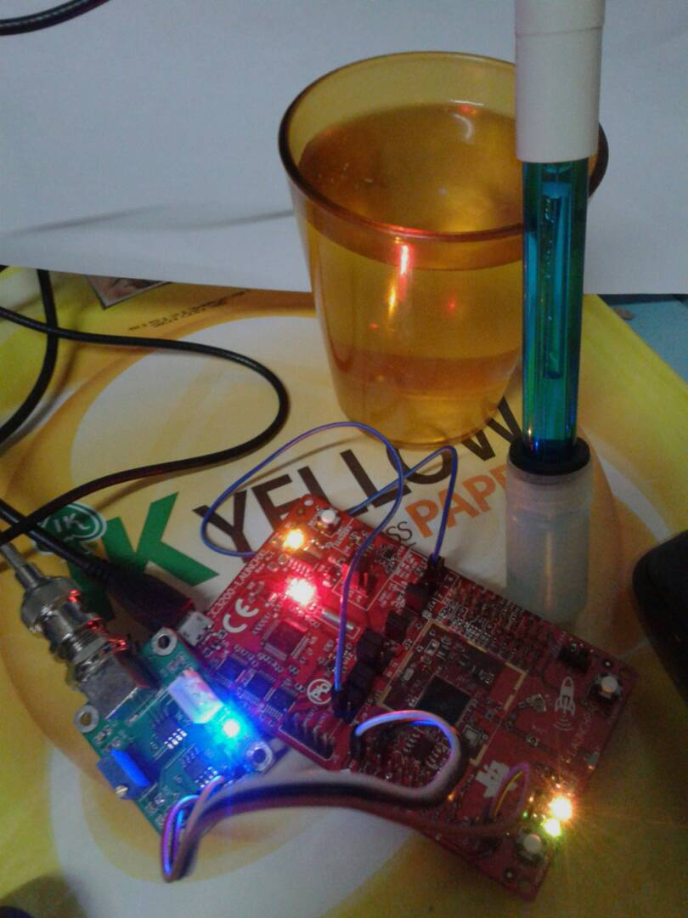
Picture 4.1 : Model of the project
4.3 Project Implementation

The ph sensor that had been connected to the Launchpad cc3200 which connected by the connector will be submerged on the solution with specific ph level. The basic principle of ph meter is to measure the concentration of hydrogen ions. Acid dissolved in water forming positively charged hydrogen ion (H+). In short, the greater the concentration of hydrogen ion, the stronger the acid level. Similarly alkali or bases dissolve in water forming negatively charge hydrogen ion (OH-). The stronger a base is the higher concentration of negatively charge of hydrogen ion. It will determine the ph. Ph meter made up of probe which itself made up of 2 electrodes. This probe passes the electrical signal. At the end of the probe, there are bulb that should be submerged on the solution which will detect the ph level. If the bulb was broke or did not submerged on the solution, the ph level will not detected. As principle stated above, the ph meter will be detected and the ph level will be display on the serial monitor. It is because, the coding that wrote was gave an instruction to display the data on the serial monitor. Here is the normal range of the ph level and the voltage that detected.

pH 0 = +414.12m0V (Acidic)
pH 4 = +177.480mV (Acidic)
pH 7 = 0.000mV (Neutral)
pH 10 = -177.480mV (Basic)
pH 14 = -414.120mV (Basic)

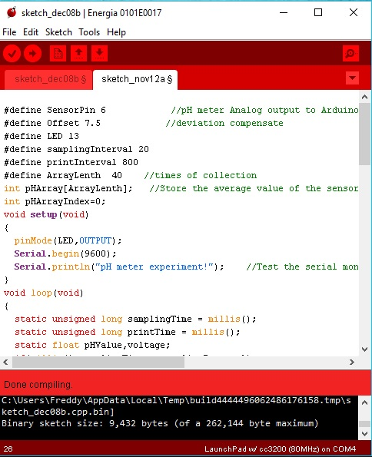

Picture 4.2 : Coding to display the ph level on the serial monitor

After run the coding on the Energia software, the coding will be upload to the Launchpad. The ph sensor will be submerged on the solution and the ph level will be display on the serial monitor according to the range given above. After the data had been display on the serial monitor, the data will be collected and sent to the Cloud by internet. The project will be connected to the MQTTlens. On the Energia, it was already set up the Service Set Identifier as “cnblue” and the password is “eika9394”. Then the data can be monitor at the MQTTlens as shown on the picture 4.3.

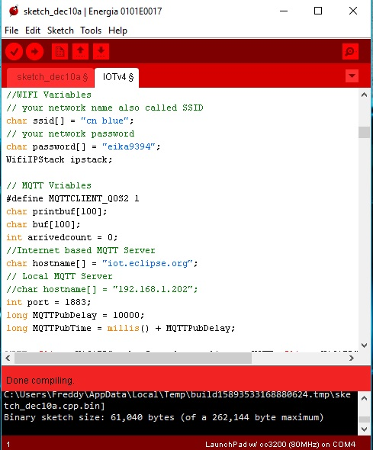
Picture 4.3

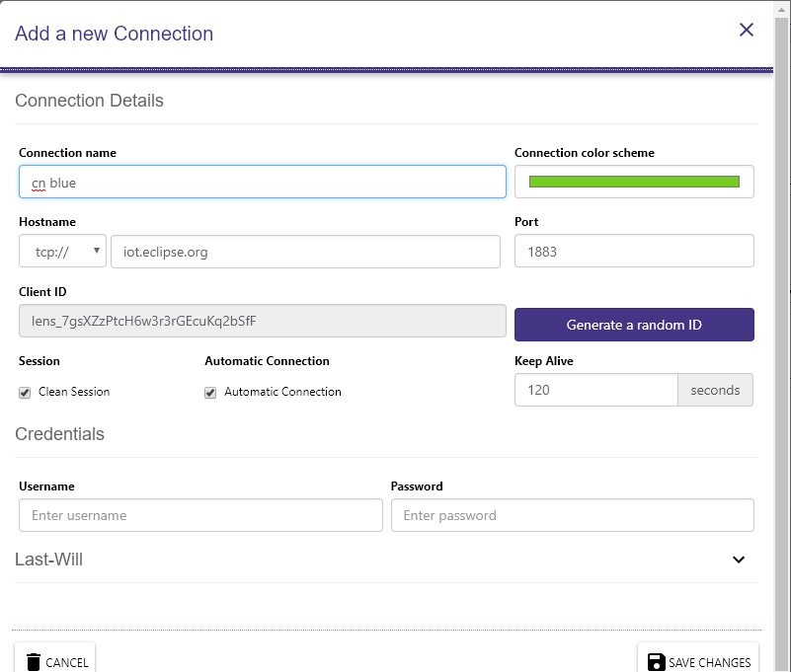
Picture 4.4 : Connection details on the MQTTlens

As on the picture above, the details was fill up same as on the Energia. The MQTTlens was installed on the google chrome. After click the save changes button, it will connect the project and will display the topic to publish and subscribe in order to monitor the data same as display on the serial monitor.
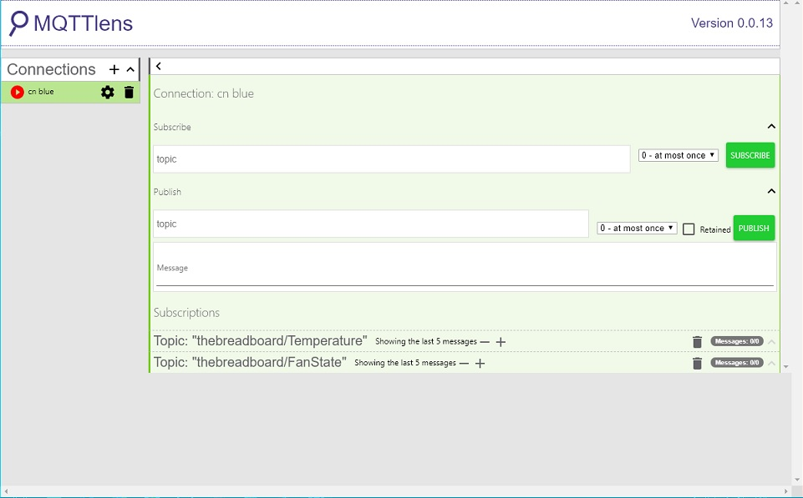
Picture 4.5

As in picture above, after connected to the MQTTlens, it will come out the subscribe and publish page. With that, we need to fill up the subscribe and publish topic just like wrote on the coding. After fill up the topics, the data will display same as on the serial monitor. The flow of the project will be draw on the node.red as in picture 4.6 below. After draw the flow, the data will display nicely as in picture 4.7. With that, people surrounding can get the data through their smartphone same as shown on the picture 4.7.

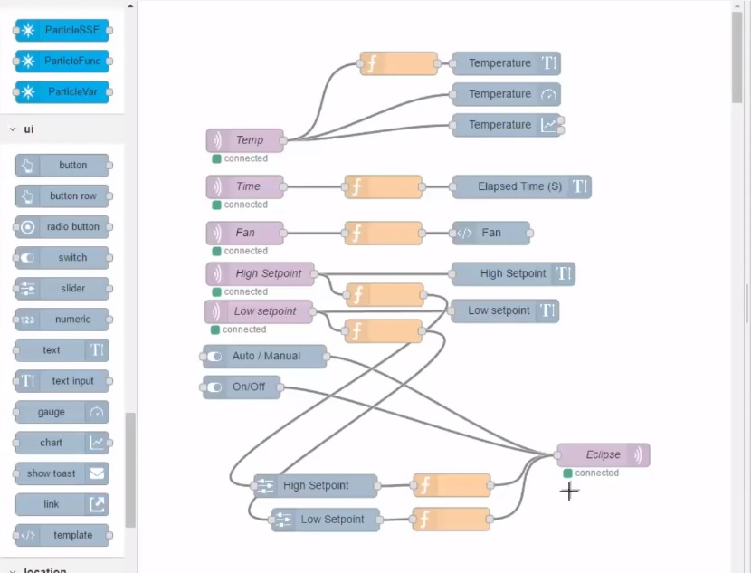
Picture 4.6 : The flow of the tester program
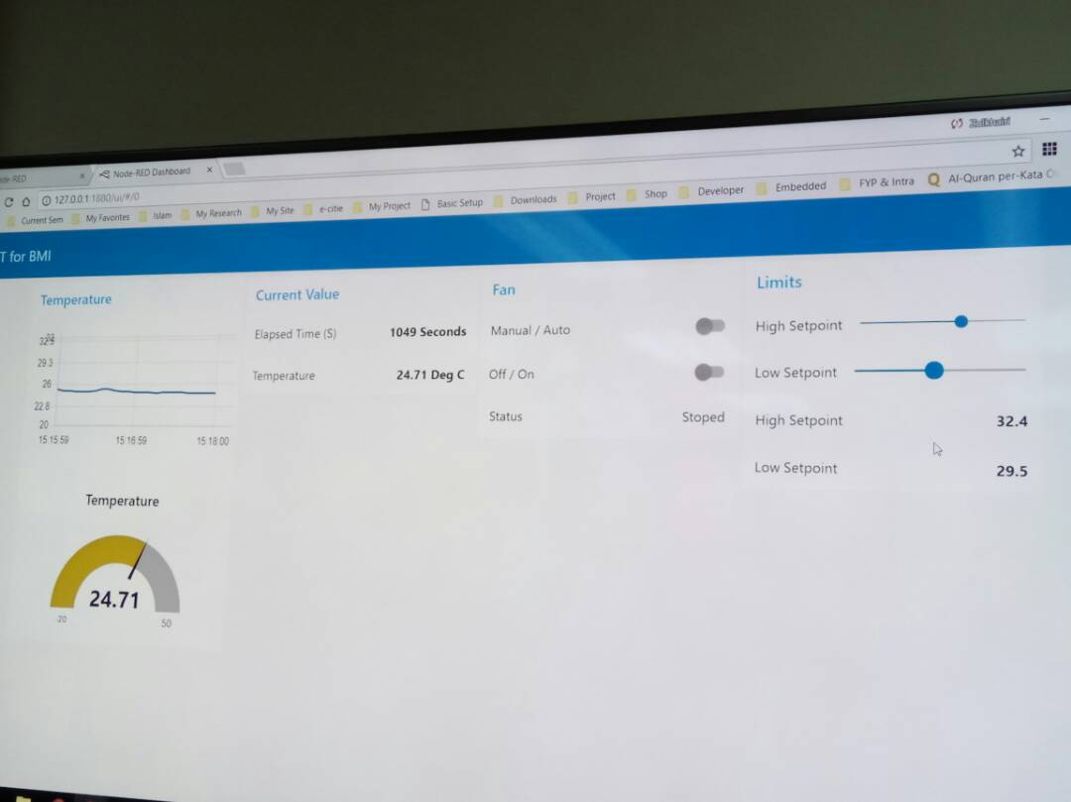
Picture 4.7 : Data display on laptop and smart phone
4.4 DISCUSSION
Before start the main objective of the project, the project was tested with temperature sensor that already attach on the Launchpad. The flow of the project would be same with the main project. This is to make clearer with project and the flow before start the main project. The temperature sensor was tested and the coding was wrote. At first, the coding cannot be run on the Energia Software after try few times. At that time, my laptop used windows 7. After update the windows to windows 10, the coding can be run easily on the Energia Software. After run the coding, its time to upload the coding on the Luanchpad. The coding cannot be upload due to problem with the bootloader on the Launchpad. When seek advices from the supervisor, supervisor give another Launchpad in order to continue the project. It is good to identify the problem before start the main project because it can reduce the error during the main project. After settled the problem, the testing program was continue by display the data on the LCD. The data collected sent to the Cloud and connected to the MQTTlens to monitor the data. the flow of the project was draw on the node.red and the data will display on the smart phone.
The project was faced some problems due to the new type of controller used. Major problem that occurred was, there are lots of debug on the coding used due to Launchpad cc3200. For example, when use the same coding and same sensor but different controller, it will give different result. To make sure what are problem that disturbs the data, Arduino Software was used. When Arduino software used, the data that display on the serial got no debug or problem. When the ph sensor was submerged on the test solution with different ph level, the value of ph level and voltage change gradually according to the solution ph. When use the Energia Software and Launchpad cc3200, the coding need to alter. The offset value must be add or minus on the coding in order to get the value of ph level correctly. That is why the solution with ph 7, ph 4 and ph 6 was given. This is to calibrate the ph sensor and to make sure the data that display was the correct data. When submerged the ph sensor in the solution with ph 7, the voltage should display 0 V and the value of ph is 7. On the Launchpad, pin 6 on port 1 was used as analog pin in order to display the data correctly. If look at the pin diagram of the Launchpad, there are few of analog pins on the board. Port 1, port 3 and port 4 contained ADC pin.

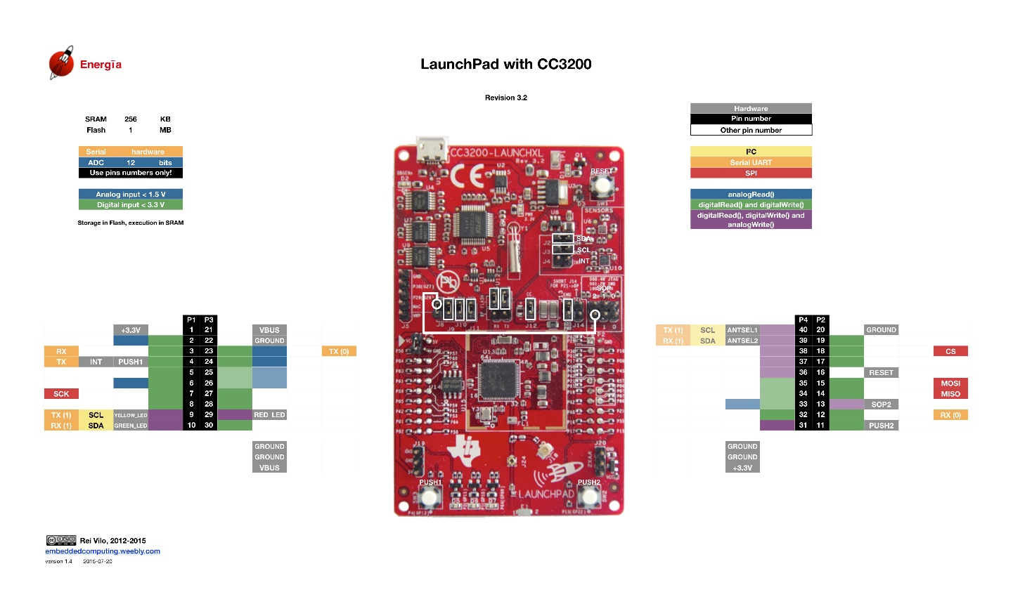
Picture 4.8 : Pin diagram of Launchpad CC3200

If the choosing of pin was correct, the project can be continue by monitor the data on the MQTTlens., draw the flow on the node.red and the data will display nicely as shown on picture 4.6 that test the temperature sensor on the Launchpad.

5. CONCLUSION
As a conclusion, it can conclude as this project did not meet the objective that being proposed from the beginning. One of the objective is to make people surrounding more alert with the water quality because it supposed to be internet based project and informally make people easier to get the data anytime and anywhere. This research has covered more on how to develop the Internet of Thing which is technology or system that highly developing in the world. There are few stages that involved in the Internet of Thing (IoT) which make me get to know those stages. As we know, IoT is something that new and still developing. With that, there are lots of thing that should be learn in order to make our country standing together with the other smart country. If this project was develop, it will give lots of benefit to everyone. It can make it easier to people that responsible on the quality of water that will make everyone more alert with the quality of water that they took every day. The project also did not used high cost if compare with the current system used. It can be considered as low cost project that give advantage to this project itself and everyone.
REFERENCES
[1] Young-Mo Kang, Mi-Ran Han, Kyeong-Seok Han, Jong-Bae Kim, “A Study on the Internet of Things (IoT) Applications” , Vol 9, 2015
[2] Surendra Singh Rathod, Anand Rajawat, “The Research on Cloud Server Storage Security Using TPA”, Vol 5, 2015
[3] Beena.V, Mr. KhajaMoinuddin, “ Water Quality Measurement and Control from Remote Station for Pisiculture Using NI myRIO”, Vol 2, 2015
[4] JAYTI BHATT, JIGNESH PATOLIYA, “IOT BASED WATER QUALITY MONITORING SYSTEM”, 2016
[5] Poonam J. Chavan, Manoj A. Mechkul, “IoT Based Water Quality Monitoring”, 2016
[6] An Overview “ Understanding the Issues and Challenges of a More Connected World”, 2015
[7] Pandian D R, Dr. Mala K, “Smart Device to monitor water quality to avoid pollution in IoT environment”, Vol 12, 2015
[8] Mr.Kiran Patil, Mr.Sachin Patil, Mr. Sanjay Patil and Mr.Vikas Patil, “ Monitoring of Turbidity, ph & Temperature of Water Based on GSM” , Vol 2, 2015
[9] Peng Jiang , Hongbo Xia , Zhiye He, Zheming Wang, “Design of a Water Environment Monitoring System Based on Wireless Sensor Networks”, 2009
[10] Akanksha Purohit, Ulhaskumar Gokhale, “Real Time Water Quality Measurement System based on GSM”, Vol 9, 2014
[11] Texas Instruments Sharp LCD BoosterPack (430BOOST-SHARP96) for the Launchpad journal, 2014
[12] Shailaja.M.Gunda Nikkam, Prof. Dr. V. R. Pawar, “ANALYZING WATER QUALITY FOR INDUSTRIAL APPLICATION UNDER IOT ENVIRONMENT”, Vol 3, 2016
[13] Tito Yuwono, Luqman Hakim, Irfan Ardi, Umar, “The Application of Internet of Things System for Water Quality Monitoring”, Vol 8, 2016
[14] Atlas Scientific Environmental Robotics, Vol 2.6, 2017
[15] Manpreet Kaur Khurana, Rajesh Singh, Anshuman Prakash, Rohit Chhabra, “An IoT Based Water Health Monitoring”, 2016
[16] Texas Instruments CC3200 SimpleLink WiFi and Internet-of-Things Solution, a Single-Chip Wireless MCU, 2015

