Advanced Optimal For DC Motor

**Salam Waley Shneen**

Energy and Renewable Energies Technology Center, University of Technology/Baghdad, Iraq

[salam_waley73@yahoo.com](mailto:Salam_waley73@yahoo.com)

|  |  |  |
| --- | --- | --- |
| **Article Info** |  | **ABSTRACT** |
| ***Article history:***  Received Jun 12th, 201x  Revised Aug 20th, 201x  Accepted Aug 26th, 201x |  | Interest in the drive system which used in many applications is increasing day by day. So, many researchers have focused on the analyses, design and control of these systems. In this study, Optimal for Dc motor in drive system control strategy has been proposed for PSO-PI and fuzzy logic controller (FLC) based Dc motor in drive system. In order to test dynamic performance of PSO-PI based drive System, simulation study was carried out by MATLAB/Simulink. The results obtained from the PSO-PI based drive system are not only superior in the rise time, settling time and overshoot but can prevent from voltage and has improved power quality. |
| ***Keyword:***  Dc motor  PI Controller  FLC  PSO |
| *Copyright © 201x Institute of Advanced Engineering and Science.  All rights reserved.* |
| ***Corresponding Author:***  Salam Waley Shneen,,  Energy and Renewable Energies Technology Center,  University of Technology/Baghdad, Iraq,  52 Industry street, Baghdad, Iraq.  Email: [salam_waley73@yahoo.com](mailto:Salam_waley73@yahoo.com) | | |

1. **INTRODUCTION**

Increasing orientation for the use of Dc motor in industry for many electrical applications, EV,Elevator, Robot ....etc. [1-3]. A way controller (PI) in addition to the controller integral relative formulated and implemented, using speed control drive system and a pilot phase. While the new strategy promotes traditional PI control performance to a large extent, and proves to be a model-free approach completely, it also keeps the structure and features of a simple PI controller [4-5].The use consoles mode instead of Fuzzy-PI control to improve the performance of engines. To control the speed of motor using fuzzy logic (FL) approach leads to a speed control to improve the dynamic behavior of the motor drive system and immune disorders to download and parameter variations [6-7]. In the drive systems, and gains from the traditional can’t usually be set in proportion-integral (PI) controller because of mechanical resonance. As a result, performance degradation control. In our work described in this paper, have been adopted and fuzzy logic controller (FLC) for use in drive systems in order to improve the performance of the DC Motor control. The proposed FLC has been compared with traditional PI control with respect to the DC Motor of response [8-9]. Simulation and experimental results have proved that FLC was proposed is superior to the traditional PI. This FLC can be a good solution for the high-performance DC Motor systems. A modern approach to control the speed of load using particle swarm optimization (PSO) to improve the algorithm parameters observer PI-. Simulate the system under different operating year conditions is prepared and the experimental setup. Use PSO algorithm and optimization make a powerful engine, with faster response and higher resolution dynamic and sensitive to load variation [10].

1. **DC Motor**

The Motor, It is a device converts electrical energy to mechanical energy or a device that produces rotational force which have been developed for different specific purposes that have brought about one of advance in the fields of technology. It is running by DC source. The Motor Classification to, AC (alternating current) electrical motors, [DC (Direct Current) motor](https://www.electrical4u.com/dc-motor-or-direct-current-motor/) and Special Types of Motor. DC Motor, the electrical port include the supply [voltage](https://www.electrical4u.com/voltage-or-electric-potential-difference/) E and [current](https://www.electrical4u.com/electric-current-and-theory-of-electricity/" \o "Electric Current) I is given to the input port and the mechanical port include torque T and speed ω from output port.

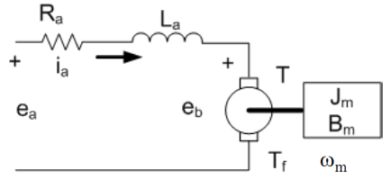

Figure 1. Model of DC Motor

**2.1. Mathematical Model of DC Motor**

In figure(1) the model of DC motor include the Electrical part and Mechanical part which have Electromechanical Relationships to analysis mathematical model of DC motor by the following equation(1-11):

$$T=K_{T}.i_{a}-T_{f} N-m (1)$$

$$e_{a}=i_{a}.R_{a}-e_{b} V (2)$$

$e_{b}=K_{e}.ω_{m} V (3)$

$$P=ω_{m}.T V (4)$$

$$ω_{m}=\frac{K_{T }.e_{a}-\left(T-T_{f}\right).R_{a} }{K_{T }.K_{e} } (5)$$

$$ω_{m}=\frac{e_{a}-i_{a}.R_{a} }{K_{e} } (6)$$

$$ω_{m}=\frac{K_{T }.e_{a}+\left(T_{f}\right).R_{a} }{K_{T }.K_{e} } (7)$$

Electrical Equations and Mechanical Equations (Electromechanical Relationships)

Electrical:

$$e_{a}\left(t\right)=R_{a}.i_{a}\left(t\right)+L\frac{di_{t}(t)}{dt}+e_{b}\left(t\right) (8)$$

Mechanical:

$${T\left(t\right)=j}_{m}\frac{dω_{m (t)}}{dt}+B_{m}.ω_{m (t)} (9)$$

Electromechanical:

$$e_{b}\left(t\right)=K_{E}.ω_{m}\left(t\right) (10)$$

$$T\left(t\right)=K_{T}.i_{a}\left(t\right) (11)$$

Laplace Transform of:

Electrical;

$E_{a}\left(s\right)=L.s.I_{a}\left(s\right)+R_{a}+I_{a}\left(s\right) (12)$

$$I_{a}\left(s\right)=\frac{1}{L.s.R_{a}}\left[E_{a}\left(s\right)-E_{b}\left(s\right)\right] (13)$$

Mechanical;

$$T\left(s\right)=\left(j_{m}.s+B_{m}\right).ω_{m}\left(s\right) (14)$$

$$ω_{m}\left(s\right)=[1/\left(j_{m}.s+B_{m}\right)]. T\left(s\right) (15)$$

Electromechanical;

$$e_{b}\left(s\right)=K_{E}.ω_{m}\left(s\right) (16)$$

$$T\left(s\right)=K_{T}.i_{a}\left(s\right) (17)$$

Where:

ia(t)= armature current, eb(t)= back emf, ea(t)= armature terminal voltage, $ω_{m}$ = motor speed (rad/sec), T= motor torque, Tf= static friction torque, Ra= armature resistance, La= armature inductance, Jm= rotational inertia, Bm = viscous friction, KT = torque constant, Ke=back emf constant and P = shaft power.

**2.2. Transfer Function of DC Motor**

A transfer function for a dc motor that relates input voltage to shaft position. The transfer function for an armature controlled dc motor. Represent a mechanical load using a mathematical model. How negative feedback affects dc motor performance.In figures (2&3),Block diagram of DC Motor with load and Block diagram of DC Motor with no load (Tf=0). A transfer function of DC motor by the following equation (18-24):

m











KT



Ke



-

+ +



Figure 2. Block diagram of DC Motor with load

m











KT



Ke

+

-

Figure 3. Block diagram of DC Motor with no load (Tf=0)

In equations (18-21), F.B, F.W and T.F formula:

$$ω_{m}\left(s\right)=G\left(s\right) (18)$$

$$G\left(s\right)=\frac{K_{T}}{\left(L_{a}.s+R_{a}\right)\left(j_{m}.s+B_{m}\right)} (19)$$

F.W formula:

$$E_{a}\left(s\right)=1+G\left(s\right).H\left(s\right) (20)$$

F.B formula:

$$H\left(s\right)=K_{E} (21)$$

T.F formula:

$$\frac{ω_{m}(s)}{E_{a}(s)}=\frac{G(s)}{1+G\left(s\right).H(s)} (22)$$

Simplify T.F formula:

$$\frac{ω_{m}\left(s\right)}{E_{a}\left(s\right)}=\frac{\frac{K_{T}}{\left(L_{a}.s+R_{a}\right)\left(j_{m}.s+B_{m}\right)}}{1+\left[\frac{K_{T}}{\left(L_{a}.s+R_{a}\right)\left(j_{m}.s+B_{m}\right)}\right].K_{E}}=\frac{K_{T}}{\left(L_{a}.s+R_{a}\right)\left(j_{m}.s+B_{m}\right)+K_{T .}K_{E}}$$

Final T.F formula:

$$\frac{ω_{m}\left(s\right)}{E_{a}\left(s\right)}=\frac{G\left(s\right)}{1+G\left(s\right).H\left(s\right)}=\frac{K_{T}}{L_{a}j_{m}.s^{2}+\left(R_{a}j_{m}+B_{m}L_{a}\right).s+{(K}_{T .}K_{E}+R_{a}.B_{m})} (23)$$

Parameters of DC motor:

$ω_{m}=500{rad}/s$, $I_{a}=2A$, $K_{e}=0.06V\frac{s}{rad}$, $K_{T}=0.06N\frac{m}{A}$, Tf=0.012 N-m , Ra=1.2ohm ,jm=6.2*10-4N-m-s/rad, Bm=1*10-4N-m-s/rad, La=0.02H

$T.F=\frac{ω_{m}\left(s\right)}{E_{a}\left(s\right)}=\frac{16.13}{1+0.201s+0.00333s^{2}}$ (24)

**2.3. Parameters Mathematical results of DC Motor**

Parameters:

Tf=0.012 N-m, Ra=1.2 ohms, Ke =0.06 N-m/A, KT=0.06 V-s/rad , ia=2A and ω=500rad/s $ω=500rad/s$

Mathematical results:

By using: Equation.(1): T=(0.06*2)-0.012=0.108 N-m

Equation.(2):ea=(1.2*2)+(0.06*500)=32.4 Volt

Equation.(4): P=500*0.108=54 watt

Equation.(7): ωm=(0.06*32.4)+[(1.2*0.012)/(0.06*0.06)]=536rad/s

1. **Optimization and Controller**

Optimization and Controller (Classical controller type PI Controller, Expert System type FLC and Optimization type and PSO), Electric system driven is formulated by the motor.

**3.1. PI Controller Modeling**

In the PI controller DC Motor, the actual value is compared with the reference value and the error is the nth sampling interval as

ωe[n] = ωr*[n] – ωr[n] (25)

The output of the DC Motor controller gives the reference. Hence the output of DC Motor controller at the nth sampling interval is

T[n] = T[n-1] + Kp(ωe[n] – ωe[n-1]) + Ki.ωe[n] (26)

For constant air gap flux operation reference quadrature axis current is given as

iq* = T[n]/Kt (27)

The limiter is used to limit the maximum value of output of speed controller. The maximum machine rated current and device current of the converter dictate the limit.

Where,

ωe[n] is speed error at nth instant,ωr*[n] is the reference speed at nth instant

ωr[n] is the actual machine speed at nth instant,ωe[n-1] is the speed error at (n-1)th instant

T[n] is the reference torque at nth instant,T[n-1] is the reference torque at (n-1)th instant

Kp is proportional gain of the speed controller

Ki is integral gain of the speed controller is reference quadrature axis current

Kt is torque constant



Figure 4. Block diagram of the PI controller

**3.2. Fuzzy Logic Controller**

Fuzzy logic controllers have the following advantages over the conventional controllers that they are cheaper to develop, they cover a wide range of operating conditions, and they are more readily customizable in natural language terms. In Mamdani type FIS the crisp result is obtained by defuzzification, in the Mamdani FIS can be used for both multiple input and single output and multiple inputs multiple outputs system as shown in figure 5.

Post

processing

Rule

base

preprocessing

Defuzzification

fuzzification

Inferenc

engine

Figure 5. Arrangement of fuzzy logic controller

The usefulness of fuzzy logic controller is adopted especially in a complex and nonlinear system. The rules of conventional FLC are produced depend on the operator's experience or general knowledge of the system in a heuristic way. The thresholds of the fuzzy linguistic variables are usually chosen arbitrarily in the design process. An improper controller value leads to an adverse consequence, unstable mode, collapse and separation. This work propose PSO to design an Optimal Fuzzy Logic Controller OFLC, the optimized criteria is how to minimizing the transient state. The motor in a nonlinear system, time-change and complex system. The PI control is difficult to realize, which needs the accurate mathematical model with synthesizes the fuzzy control and PI control, the parameters can be adjusted deceptively. The FLC has better performance and robustness than conventional PI controller in the servo motor system. Block diagram of FLC- PI controller as shown in figure 6. It can be overcome by the fuzzy logic controllers. PI control has good robustness, simple in structure, and high reliability which suitable for a deterministic system which has accurate mathematical model. The control system performance rely on PI controller parameters.

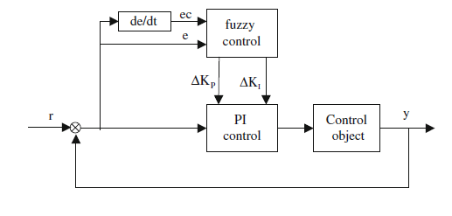

Figure 6. Block diagram of fuzzy PI controller

**3.3. Particle Swarm Optimization**

The biggest characteristic of PSO is in its simple structure, fast convergence, and its ability to prevent falling into a local optimum solution. At the same time, PSO is a random algorithm with a parallel structure. A uniform distribution is used to randomly create a particle swarm. Each particle represents a feasible solution to the problem, the particle swarm refers to the individual’s best experience, and the group’s best experience, and logically chooses the method it will move itself. After continuous iterations, the particle swarm will gravitate towards the optimum solution. For the ith particle and n-dimensional space can be represented as an equation (30), the best previous position of its particle is recorded as equation (31):





The velocity is an essential part of how PSO work so as modified velocity and position of each particle can be calculated using the current velocity and distance from ($P_{{best}_{i,d}}$) to **($g_{{best}_{d}}$):**





Where n is the number of particles in a group; m is number of Dimension m=1, 2,…,. ; It is a pointer of iterations (generations); W is an inertia weight factor; c1, c2 are acceleration constants were often set to be 1.2 according to past experiences; r is random value in the range between [0,1]; $V_{i,m}^{(It.)}$: Velocity of particle no. i at iteration It., $x_{i,m}^{(It.)}$: Current position of particle i at iteration It. $G_{{best}_{m}}$: Global best particle among all the particles in the population. In the above procedures, the parameter determined the resolution, or fitness, with which regions are to be searched between the present position and the target position, the inertia weight is set according to the equation (32).

$W=w_{max}-\frac{w_{max}-w_{min}}{{Iter}_{max}} . Iter$****

Where:

Itermax is the maximum number of iterations and Iter is the current number of iterations.

1. **Advanced Implementation for DC Motor**

To use different control systems, like Classical PI Controller, Expert System Fuzzy Logic Controller and Optimization PSO Controller. It used to control for Implementation for DC Motor. The simulation model as shown in figures (8-11), by used all types to get the result and analysis it with compared to see the advanced implementation for DC Motor:

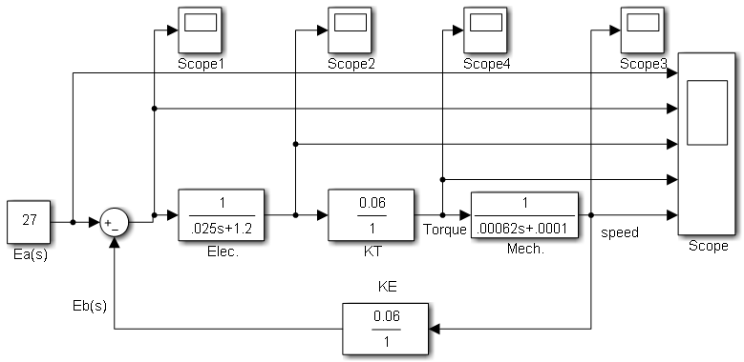

Figure 7.The simulation model for DC Motor

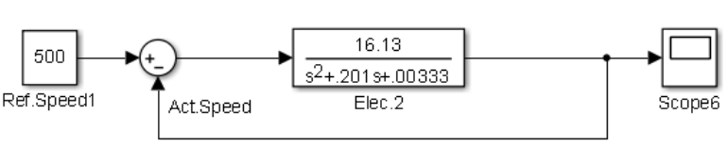

Figure 8.The simulation model for DC Motor without control

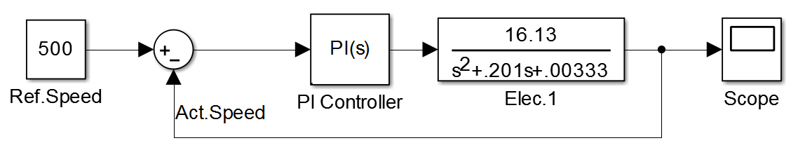

Figure 9.The simulation model for DC Motor with PI control

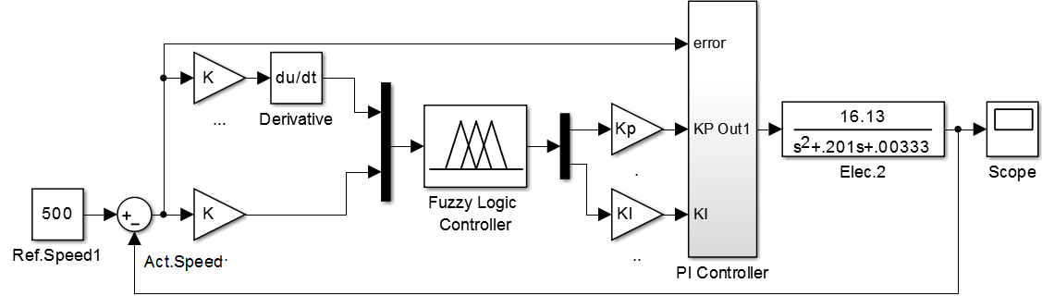

Figure 10.The simulation model For DC Motor with FLC

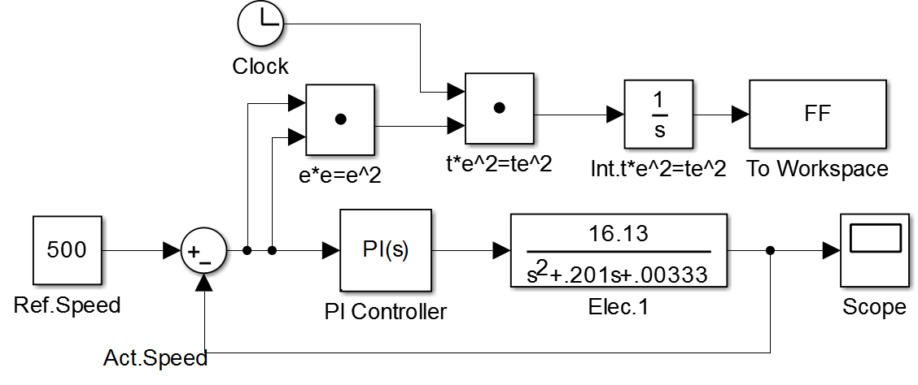

Figure 11.The simulation model For DC Motor with PSO-PI control

1. **RESULTS AND ANALYSIS**

**5.1. The simulation Results:**

**5.1.1. The simulation Results for DC Motor with in and without controller**

By used the simulation model for DC Motor without control in figure (12)and with PI control to get the simulation results for DC Motor with controller in figures (13)

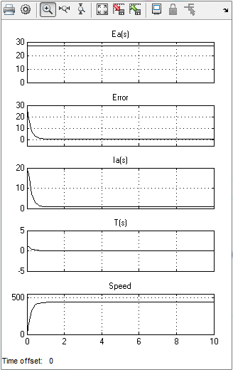

Figure 12 simulation speed response for T.F of DC Motor without Controller



Figure 13 simulation speed response for T.F of DC Motor with PI Controller

**5.1.2. The simulation Results for Three Phase PWM Rectifier with Optimization**

By used the simulation model for Dc Motor with Optimization to get the simulation results for DC Motor with Optimization in figures (14&15)



Figure 14 simulation speed response for T.F of DC Motor with FLC_ PI Controller

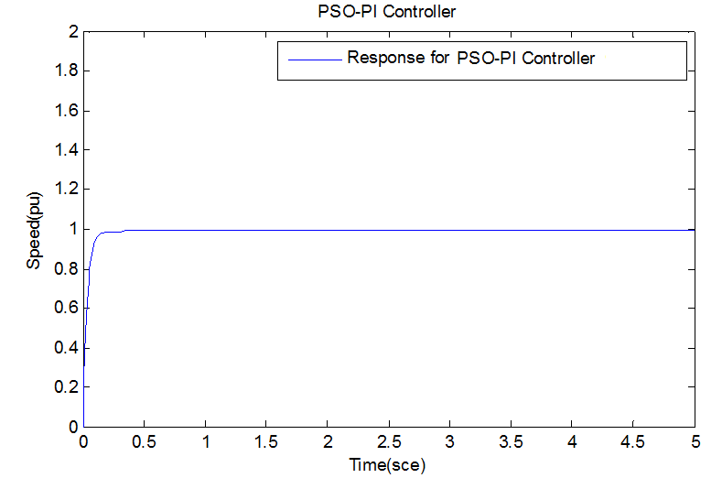

Figure 15 simulation speed response for T.F of DC Motor with PSO_ PI Controller

**5.2. Simulation Analysis**

Final step, use different control systems, Like Classical PI Controller, Expert System Fuzzy Logic Controller and Optimization PSO Controller to analysis all result. Simulation models (Classical PI Controller, Expert System Fuzzy Logic Controller and Optimization PSO Controller of this step as shown in figures (9-11) and simulation results as shown in figure (16): Simulation Response (pu) Of PI Control, Fuzzy_ PI Control &PSO_PI Control. The results obtained from the PSO-PI based PES are not only superior in the rise time, settling time and overshoot but can prevent from voltage and has improved power quality.



a)PI Control b)Fuzzy_PI Control



c) PSO _PI Control d) PI Control, Fuzzy_PI

Control &PSO_PI Control

Figure 16.Simulation Response (pu) Of PI Control, Fuzzy_ PI Control &PSO_PI Control

1. **CONCLUSION**

To use different control systems as a case studies. To achieve this objective which characterizes each part of a system such as a DC Motor module, controller and Optimization. After that to investigate the design connection topology for all components of a DC Motor system in order to study the operation of the system for different environmental conditions. The simulation circuits for DC Motor controllers include all realistic components of the system. These results also confirmed that the maximum permissible value. Modeling, analysis, testing and simulation a DC Motor under different conditions using MATLAB. The performance of DC Motor system are controlled and Optimization by PI, fuzzy and PSO.

**REFERENCES**

1. Song, Yun Seong, and Metin Sitti. "STRIDE: A highly maneuverable and non-tethered water strider robot." Robotics and Automation, 2007 IEEE International Conference on. IEEE, 2007.
2. Liu, Xiaoxing, et al. "Optimal traction control for EV utilizing fast torque response of electric motor." Industrial Electronics Society, 2005. IECON 2005. 31st Annual Conference of IEEE. IEEE, 2005.
3. Huayong, Yang, Yang Jian, and Xu Bing. "Computational simulation and experimental research on speed control of VVVF hydraulic elevator." Control Engineering Practice 12.5 (2004): 563-568.
4. Shneen, Salam Waley, Chengxiong Mao, and Dan Wang. "Advanced Optimal PSO, Fuzzy and PI Controller with PMSM and WTGS at 5Hz Side of Generation and 50Hz Side of Grid." International Journal of Power Electronics and Drive Systems 7.1 (2016): 173.
5. Attiya, Adnan Jabbar, Yang Wenyu, and Salam Waley Shneen. "Fuzzy-PID Controller of robotic grinding force servo system." Indonesian Journal of Electrical Engineering and Computer Science 15.1 (2015): 87-99.
6. Attiya, Adnan Jabbar, et al. "Variable Speed Control Using Fuzzy-PID Controller for Two-phase Hybrid Stepping Motor in Robotic Grinding." Indonesian Journal of Electrical Engineering and Computer Science 3.1 (2016): 102-118.
7. Shneen S W, Mao C. Artificial Optimal Fuzzy Control Strategy for Elevator Drive System by Using Permanent Magnet Synchronous Motor[J]. TELKOMNIKA Indonesian Journal of Electrical Engineering, 2015, 14(3).
8. Waley, A. Salam, Chengxiong Mao, and C. Dan Wang. "Artificial Optimal Fuzzy Control Strategy for Electric Vehicle Drive System by Using Permanent Magnet Synchronous Motor." International Journal of Engineering and Technology 9.1 (2017): 50.
9. Attiya, Adnan Jabbar, Yang Wenyu, and Salam Waley Shneen. "PSO_PI Controller of Robotic Grinding Force Servo System." Indonesian Journal of Electrical Engineering and Computer Science 15.3 (2015): 515-525.
10. Attiya, Adnan Jabbar, Yang Wenyu, and Salam Waley Shneen. "Compared with PI, Fuzzy-PI and PSO-PI Controllers of Robotic Grinding Force Servo System." Indonesian Journal of Electrical Engineering and Computer Science 16.1 (2015): 65-74.

**BIBLIOGRAPHY OF AUTHORS**

|  |  |
| --- | --- |
|  | **Salam Waley Shneen**,received his BSC. Degree in Electrical Engineering &Education University of Technology _Technical Education department .Iraq-Baghdad ,1998. Msc. Degree in Electrical Engineering &Education University of Technology_Technical Education department .Iraq-Baghdad ,2005 . Presently, he is a Ph.D. Degree in Department of Electrical Engineering, from Huazhong University of Science & Technology (HUST), 2016, he joined Lecturer Of Energy and Renewable Energies Technology Center, University of Technology/Baghdad, Iraq. His fields of interest are power electronic, electronic, control and the excitation control of synchronous generator and applications of high power electronic technology to power system.  E-mail:salam_waley73@yahoo.com |